Peter Golaszewski
Database Systems 2
Homework #2

QUESTION 1

Three disadvantages of sequential index files are:

- Finding a certain key in the index involves reading on average N / 2 blocks where N is the total number of blocks. B+ trees do not have this problem the average number of blocks that needs to be read is log N.

- Inserts of records can be expensive because if the index block that we are trying to insert new <key, pointer> pair to is full, we will either have to rebuild the entire index (average of N/2 block reads plug N/2 block writes), or create an overflow block. In the later case, we would loose the sequential placement of consecutive index blocks which could add IO time to later block fetches. Although B+ trees blocks can also become full, this problem is not as significant as it is in case of the index files. In B+ trees splitting a block into two blocks and updating the tree structure is much less expensive.

- Not deleting empty index blocks will slow down the search process because we would be fetching blocks that do not provide us with any information. On the other hand, deleting these empty blocks will cost us IO time directly and in addition, we might be getting rid of blocks that will be used in the future (e.g. if we re-insert the records). Often, DBMS do not delete empty blocks from B+ trees because on average, their existence does not slow down our searching process.

QUESTION 2

Number of records = number of data blocks * number of records per block
= 5,000,000 * 20 = 100,000,000.

Minimum number of distinct search key values = (number of records / maximum number of records per value) = 100,000,000 / 4 = 25,000,000

Size of an index pair = bytes per key value + bytes per pointer = 20 + 6 = 26

Number of index pairs per block = block size / Size of an index pair = 8192 bytes / 26 = 315

Part A: Sparse index size:
Minimum number of sparse index blocks = number of data blocks /
number of index pairs per block = 5,000,000 / 315 = 15,874 blocks

Part B: Second level sparse index:
Minimum number of second sparse index blocks
= minimum number of sparse index blocks / number of index pairs per block
= 15,874 / 315 = 51

Part C: My design:

I recommend using a single sparse index but in order to minimize the number of blocks it uses, I would in addition group data blocks together in small linked lists like this:

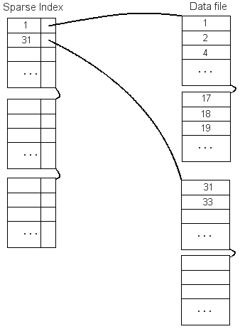

The sparse index from the example above is about half the size of the index from Part A. If the data file linked-lists were 3 blocks each, the size of the index file would be one third of that described in Part A. One could even make the linked-lists compose of 10 or more blocks, but at some point, the index search speed becomes an issue as more time is wasted on reading unnecessary blocks then it is worth.

QUESTION 3

Part A: Looking up key 40:
- Start on the root node
- Since 13 is less then 40, jump to the node referenced by the second pointer
- Since 40 is more then 31 and less then 43, jump to the leaf node referenced by the third pointer
- Since 40 is not among the keys in the leaf node, return “not found”
(tree is not modified)

Part B: Looking up key range from 10 to 20 (inclusive):
- Start on the root node
- Since 10 is less then 13, jump to the node referenced by the first pointer
- Since 10 is more then 7, jump to the leaf node referenced by the second pointer
- Let LIST be an empty set of references to records
- Look through all the keys in the current leaf node
- Since 7 does not satisfy 10 <= 7 <= 20, ignore it
- Since 11 does satisfy 10 <= 11 <= 20 add the record reference to LIST
- Since we reached the end of the list on this leaf and we haven’t found a key that is greater then 20, we jump to the next leaf node
- Look through all the keys in the current leaf node
- Since 13 does satisfy 10 <= 13 <= 20 add the record reference to LIST
- Since 17 does satisfy 10 <= 17 <= 20 add the record reference to LIST
- Since 19 does satisfy 10 <= 19 <= 20 add the record reference to LIST
- Since we reached the end of the list on this leaf and we haven’t found a key that is greater then 20, we jump to the next leaf node
- Look through all the keys in the current leaf node
- Since 23 is greater then 20, we can stop looking for records
- Fetch all blocks that are references within the LIST
- Use record references within the LIST to return the records from the fetched blocks
(tree is not modified)

Part C: Inserting key 1
- Start on the root node
- Since 1 is less then 13, jump to the node referenced by the first pointer
- Since 1 is less then 7, jump to the leaf node referenced by the first pointer
- Because the leaf node is full, we split it into two leaf nodes:
One with keys: 1, 2 and the other with keys: 3,5
- Since we got a new leaf node with starting of 3, we push the 3 to the parent node, so that the parent node now includes 3 and 7 as shown below
- We are done – see the diagram below

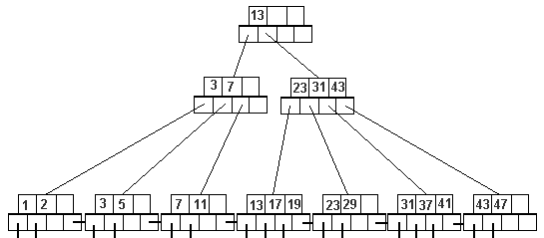

Part D: Inserting keys 14, 15 and then 16

Assuming that we do not perform node splits until it’s necessary to do so:

Inserting 14:
- Start on the root node
- Since 14 is more then 13, jump to the node referenced by the second pointer
- Since 14 is less then 23, jump to the leaf node referenced by the first pointer
- We arrive at the leaf node: <13,17,19>, which is full so we split it into two nodes:
<13,14> and <17,19>
- We push key of 17 up to the parent node
- We arrive at the internal node: <23,31,43>, which is full so we split it into two nodes:
<17, 23> and <31,43>
- We push off the 31 key into the root node.

Inserting 15:
- Again, similarly to the method described above, we find the leaf node that should host the key 15. The lucky node is the <13,14> node.
- Since the node is not full yet we simply insert the key 15 along with the new pointer and we are all set.

Inserting 16:
- Again, we find the leaf node where we want to insert the new key. The node we are looking for is now <13,14,15>.
- The node is full so we split it into two nodes: <13, 14> and <15,16>.
- We want insert key 15 into the parent node to indicate that we created a new leaf node. The parent node is not full yet, so we simply add the new key.

- We are done. See diagram below

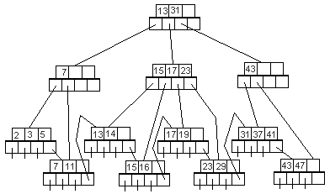

Part E: Delete key 23

- Start on the root node
- Since 23 is more then 13, jump to the node referenced by the second pointer
- Since 23 is equal to 23, jump to the leaf node referenced by the second pointer
- We find the key 23 in the current leaf node (it’s on the first position) and we delete it (along with the record pointer that it corresponds to)
- The rest of the keys and record pointers are shifted left (we only have 29)
- We are done. See diagram below

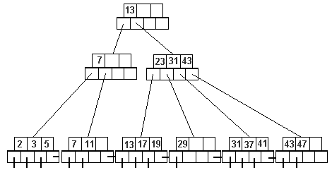

Note: Since there are only 3 keys per block, it’s a little hard to judge when a block should be split or merged (unless it’s a full or an empty block). For example, the leaf node containing 29 could be merged with the leaf node containing 31, 37 and 41. However since we would only have one empty key-slot in both of the resulting blocks, it might be better to forget about the merging. M somebody will shortly try to add new key to the 31-37-41 block. In such case we would split it and have more free space then if we initially decided to merge the blocks.

QUESTION 4

Part A:

Assuming that we can have B+ nodes that are filled entirely (not just %50):

We will have N keys in each block and N + 1 pointers in each block
N * size of a key + (N + 1) * size of a pointer <= total block size – header size
8 * N + (N + 1) * 8 <= 8192 – 32
16 N <= 8152
N <= 509.5

We can store at most 509 keys and 510 pointers in each block (node).

We can store 510 pointers in the root node, so we can have 510 nodes on the second level. Each second-level node can have 510 pointers as well. Total of 260,100 pointers on the second level allows us to have 260,100 leaf nodes. Each leaf node can store 509 pointers to records, so the total number of records we can index with this B+ tree is:

Maximum number of records = 260,100 * 509 = 132,390,900 records

Part B:

To have minimum number of records indexed by a B+ tree with 3 levels, we would have to have:
- Two nodes on the second level (each with only one key and two pointers).
- Four pointers on the second level force us to have at least four leaf nodes (on the third level).
- Now we have two options:
- If we were not merging nodes together and we were letting the leaf nodes say empty, then the answer is: none. We could have a 3-level tree with 4 empty leaf nodes).
- If we do not allow empty leaf nodes to hang around, then each of the four leaf nodes would have to reference at least one record, in which case the answer to this question is: four.

QUESTION 5

First strategy:
- Create empty B+ tree: BT
- For each record REC in R do
BT.Insert(key value in REC, reference pointer to REC)

Second strategy: (bottom-up tree building)
- Temporarily sort relation R by the search key
- For each N records in relation R (where 2 * N is the maximum number of keys per B+ node), we create a leaf node. We repeat this process of grabbing N records at a time until we reach the last record in R. Each time we create a new leaf node, we link the previously created leaf node to it.
- Once we have all the leaf nodes in the linked list, we build the inter-levels of the tree as well as the root node. (again each node should store N key+pointer pairs).

Pros for the first strategy:
- Much easier to implement
- Does not require the initial relation sorting
- Uses little memory

Pros for the second strategy:
- Would be much faster (assuming that sorting does not take too long)
- Would produce a perfect B+ tree (all the nodes are half-full)
- Does not require traversing the tree up and down (less IO time spent on fetching the B+ tree blocks)
- Produces B+ tree that has same-level nodes located in sequence on the disk (might save us a lot of IO time on range queries)

The right strategy might depend on the situation. If the sorting phase takes 3 months, it might be just easier to go with the first strategy. It also depends how well structured we want the tree to have once the indexing is done. Since I am a perfectionist, I prefer the second strategy.

