Problem 1 (a):

Block 1:
- I = 2

Block 2:
- if I > X goto (7)

Block 3:
- Fact = Fact * I
- I = I + 1
- Dumb = 5
- goto (2)

Block 4:
- Factorial = Fact
- return

Problem 1 (b):
I = 2
Block 1:

if I > X goto Block 4
Block 2:

Fact = Fact * I
I = I + 1
Dumb = 5
goto Block 2

Block 3:

Factorial = Fact
return
Block 4:

Problem 1 (c): (8086 Assembly using only AX)

Mov AX, 2
Mov I,AX
L1:
Mov AX,X
Cmp I,AX
Ja L2
Mov AX, Fact
Mul I
Mov Fact, AX
Mov AX,I
Add AX,1
Mov I,AX
Mov AX,5
Mov Dumb,AX
Jmp L1
L2:
Mov AX, Fact
Mov Factorial,AX
Ret

Problem 2:

B1 DOM (1)
B1 DOM (2)
B2 DOM (3)
B3 DOM (4)
B3 DOM (5)
B3 DOM (6)
B2 DOM (7)
B4 DOM (8)

Problem 3:

Program loop: (2) → (3) → (4) → (5) → (6) → (2)

It’s a natural loop because we have a back edge (6) → (2) and (2) is a header.

Problem 4:

DAG for Block 3:

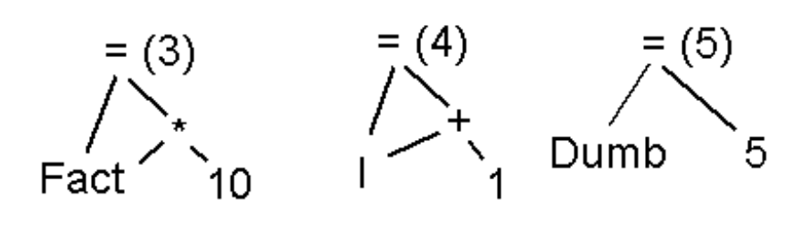

Problem 5 (a):

Adding definition Block 0:

(0) I = 0
(1) Fact = Constant
(2) Dumb = 0
(3) X = Stack
Reaching Definitions: none
Block 0:
Reaching Definitions: 0,1,2,3

Reaching Definitions: 0,1,2,3
(4) I = 2
Block 1:
Reaching Definitions: 1,2,3,4

(5) if I > X goto Block 4
Reaching Definitions: 1,2,3,4,6,7,8
Block 2:
Reaching Definitions: 1,2,3,4,6,7,8
(6) Fact = Fact * I
(7) I = I + 1
(8) Dumb = 5
(9) goto Block 2
Reaching Definitions: 1,2,3,4,6,7,8
Block 3:
Reaching Definitions: 1,2,3,4,6,7,8

Reaching Definitions: 1,2,3,4,6,7,8
(10) Factorial = Fact
(11) return
Block 4:
Reaching Definitions: 1,2,3,4,6,7,8,10

Problem 5 (b):

The Reaching Definitions method would find, that at instruction (10), variable Fact might not be previously defined, which would mean that the result of the function returned at (11) will depend on the Block 0, which might be compiler and platform dependent. The compiler would therefor return a warning message of this kind: “Variable Fact might not be initialized”.
Problem 5 (c):

The method would find that the Dumb variable is loop-irrelevant, and therefor it’s definition can be taken outside of the loop.

Problem 6:

Following optimizations could be performed on the program:

- Since Dumb doesn’t define any other variables within its scope, it can be disregarded.
- Predefinition of Fact should be introduced
- Registers should be assigned to most often used variables, to limit memory references:
AX = Fact
BX = X
CX = I
- Change ‘I=I+1’ to ‘Inc I’

Problem 7:

Mov AX, constant

Mov CX,2
Mov BX,X
L1:
Cmp CX,BX
Ja L2
Mul CX ; AX:DX = AX * CX
Inc CX
Jmp L1
L2:
Mov Factorial,AX
Ret

