TESTING GUIDE

***PREREQS***

Install Oracle Virtual Box

Install Vagrant

Install curl for Windows or Linux, dependent on your HOST

Configure VirtualBox DHCP as below :

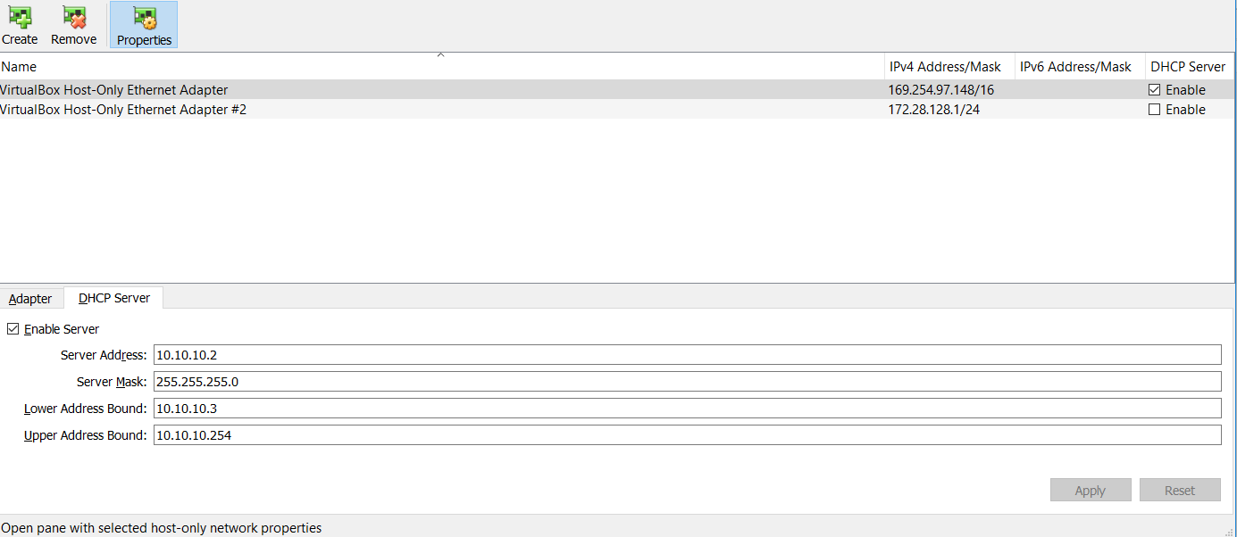

Download all files from this repo & navigate to the downloaded location

Type > **vagrant up** to bring up the environment

***TESTING PHASE***

1. With both WebServers running, you will see the traffic load balanced across both backends :

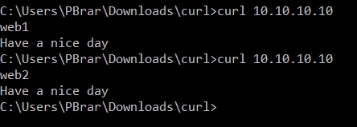

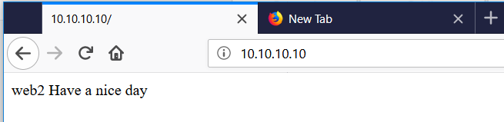

1. Now drop/power off one of the webservers in VirtualBox, and the above tests will only be directed to the same webserver on every time:

