WFM Scheduler
User Guide for WFM Team Leads
How to set up your desk, enter demand, build a weekly schedule, review it and publish it.
Version 1.0 • October 2026
Screens shown are from the current release. The people and numbers in the examples are made up.

What is in this guide
Chapter | Topic | Covers
1 | Welcome | What the scheduler does and the words it uses
2 | Your weekly routine at a glance | The checklist to follow every week
3 | Finding your way around | Desks, the menu, messages
4 | Desk settings | Usually set up once, often by an administrator
5 | Putting agents on your desk | Client Management and the desk spreadsheet
6 | Skills (Specializations)
7 | Managing your agents | Skills, hours, days off, time off
8 | Preferences, exceptions and rest waivers
9 | Planning the week: Schedule Setup
10 | Entering demand: Staffing Requirements | Typing it in, Erlang, or uploading
11 | The Erlang Calculator | Try numbers without changing anything
12 | Running the schedule
13 | Reviewing the result | Score, tabs, and what to look for
14 | Accepting, rejecting and exporting
15 | Constraint Weights | Fine-tuning the rules
16 | Shift-based scheduling | For desks that use fixed shift patterns
17 | Administrator settings | Configuration page
18 | Troubleshooting | Common messages and how to fix them
19 | Glossary

Tip: New to the scheduler? Read chapters 1–3, then follow the checklist in chapter 2. Each step points to the chapter that explains it.

1. Welcome
WFM Scheduler builds your team's weekly schedule for you. You tell it three things:
- Who is available: your agents, their skills, the hours they work and their days off.
- How many people you need: the number of agents required in each half hour (or quarter hour) of the day, per skill.
- The rules: break length, when breaks can happen, how much over- or under-staffing is acceptable.
The scheduler then works out who should work when, and where each break goes. It tries to match demand as closely as possible while following the rules and honouring agents' preferences where it can. You review the result, and when you are happy you Accept it and export it to Excel.
Note: The scheduler suggests a schedule; you stay in charge. Nothing is final until you accept it, and you can always reject a result and try again with different settings.

Key words
Word | What it means
Desk | A team or queue you schedule, for example "Customer Support". Everything you do happens inside one desk.
Agent | A person who can be scheduled. Agents come from BambooHR, your HR system.
Specialization (skill) | A type of work, such as Billing or Spanish. Each agent has one main (primary) skill and can have backup (secondary) skills.
Timeslot | A small block of the day: 15, 30 or 60 minutes. Demand and schedules are built from timeslots.
Demand / FTE | How many agents you need working in a timeslot for a skill. FTE means "full-time equivalent", here simply "agents".
Solve | Asking the scheduler to build a schedule. It takes a few minutes.
Score | How good the result is. Two numbers: Hard (rules broken; must be 0 to be "Feasible") and Soft (quality; closer to 0 is better).
Accept | Saving a schedule permanently so it can be exported and used.

2. Your weekly routine at a glance
Most of the setup is done once. After that, a normal week looks like this:
# | What to do | Where | Chapter
1 | Make sure the right agents are on the desk, with correct skills, hours and days off. | Desk Agents (or Client Management for bulk changes) | 5, 7
2 | Click Refresh from BambooHR to pick up the latest approved time off. | Desk Agents | 7
3 | Add any one-off changes: preferences, reduced hours for a day, rest waivers. | Prefs / Exc links on Desk Agents | 8
4 | Set the dates and opening hours for the week, plus break rules. | Schedule Setup | 9
5 | Enter how many agents you need per timeslot, per skill. | Staffing Requirements | 10
6 | Check the counts at the top of Schedule Setup, then click Solve. | Schedule Setup | 12
7 | Review the result: coverage, agent schedules, preferences, warnings. | Schedule Results | 13
8 | Accept (or Reject and adjust), then Export to Excel. | Schedule Results | 14

Important: Do steps 4 and 5 in that order. The Staffing Requirements page builds its grid from the dates and times you enter on Schedule Setup. If you change the dates or times afterwards, open Staffing Requirements again before you solve (see chapter 10).

3. Finding your way around

Choosing a desk
When you open the scheduler you see Select a Desk. Each card is one desk, showing its description and its standard hours per day. Click a card to open that desk.
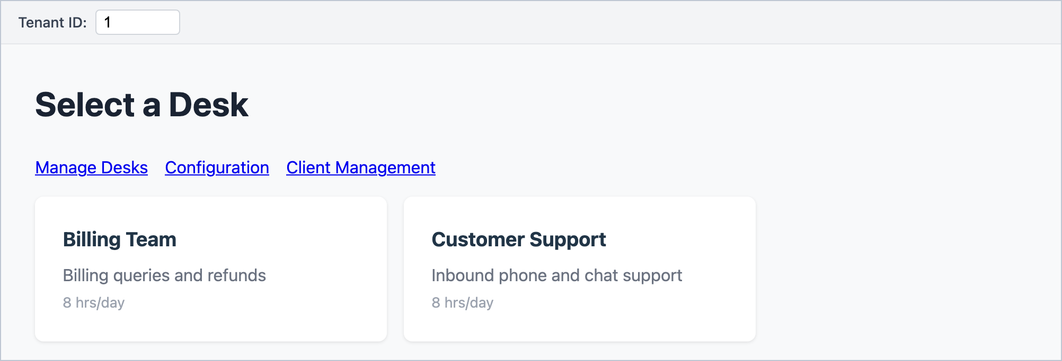
Figure 1 – The desk selector. Click a desk card to start working on it.
The three links above the cards lead to pages that are not tied to a single desk:
- Manage Desks: create, rename or delete desks (chapter 4).
- Configuration: BambooHR connection and which job titles can be scheduled. Usually for administrators (chapter 17).
- Client Management: find people in BambooHR and put them on desks (chapter 5).

The desk menu
Inside a desk, the dark menu on the left shows the desk name at the top and these pages:
Menu item | Use it to…
Switch Desk | Go back to the desk selector.
Desk Management | Change desk-wide settings (chapter 4).
Schedule Setup | Set the week, opening hours and break rules; start a schedule; see past schedules (chapters 9 and 12).
Desk Agents | See and edit everyone on the desk (chapter 7).
Specializations | Create the skills used on this desk (chapter 6).
Shift Library | Fixed shift patterns, for shift-based desks only (chapter 16).
Staffing Requirements | Enter demand (chapter 10).
Erlang Calculator | Try out staffing numbers (chapter 11).
Constraint Weights | Fine-tune the scheduling rules (chapter 15).

Messages
After most actions a small coloured message appears in the top-right corner for about four seconds. Green means it worked, red means something went wrong (read the message, it usually says what to fix), and amber is a warning. Many pages also show red or amber text near the button you clicked.

Things to know before you start
- The "Tenant ID" box at the very top of every page is a technical setting. Leave it as it is.
- Schedule Setup remembers your settings in your web browser, not on the server. If you switch computer or browser, or clear your browsing data, you will need to re-enter the dates and settings.
- Some changes cannot be undone, for example uploading a desk spreadsheet or rejecting a schedule. The scheduler asks you to confirm these. Read the confirmation message before clicking OK.

4. Desk settings
Open Desk Management from the desk selector (Manage Desks) or from the menu. Desks are usually created once, often by an administrator.
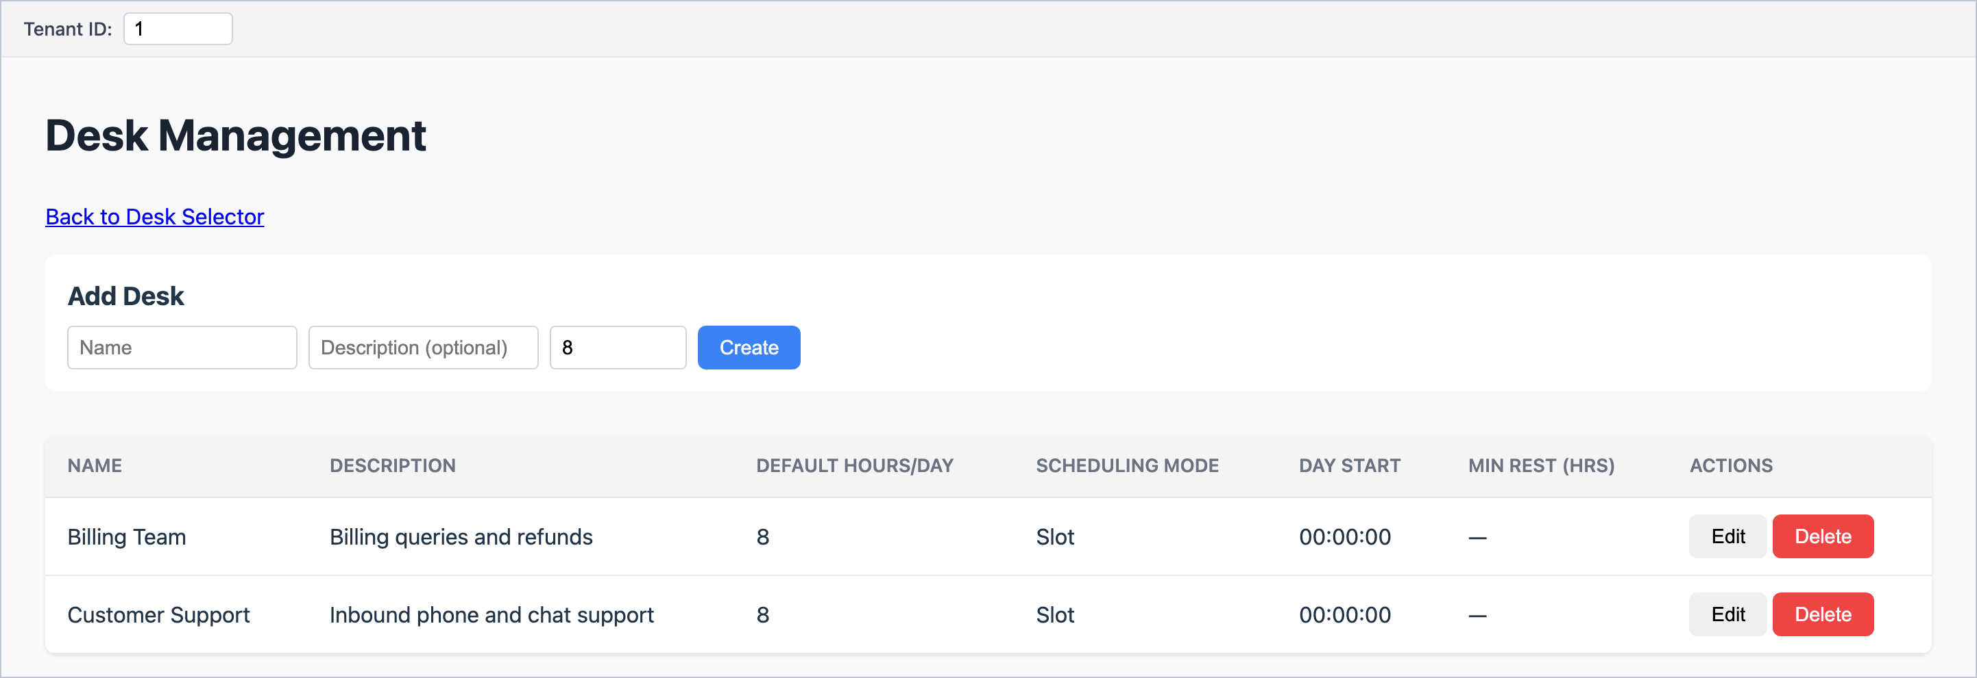
Figure 2 – Desk Management: add a desk at the top; edit existing desks in the table.

Creating a desk
1. Under Add Desk, type the desk Name and an optional Description.
2. Enter the standard Hours/Day agents on this desk work (for example 8).
3. Click Create.

Editing a desk
Click Edit on the desk's row. The row turns into input boxes. Change what you need, then click Save (or Cancel).
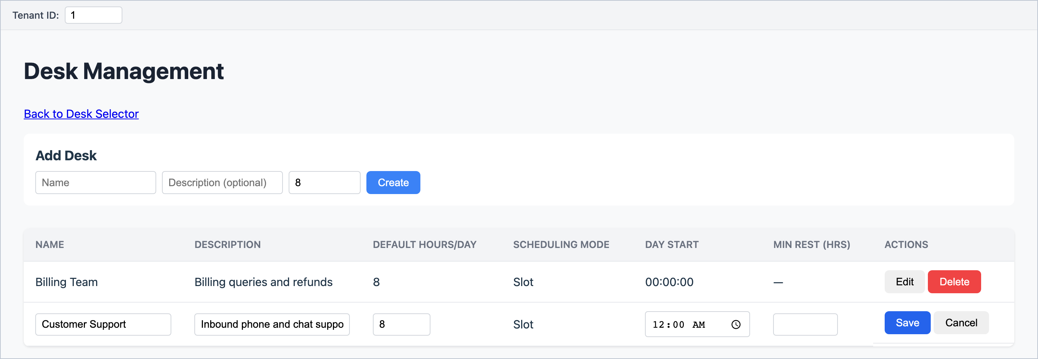
Figure 3 – A desk row in edit mode.
Setting | What it means
Default Hours/Day | The standard working hours per day for agents on this desk, unless an agent has their own hours.
Scheduling Mode | Slot (the default) builds each agent's day from timeslots. Shift gives agents whole shifts from a list of fixed patterns. It is shown here but changed on the Shift Library page (chapter 16).
Day Start | When the desk's "day" begins. Leave it at 00:00 (midnight) unless your desk works overnight. It must be on a quarter hour.
Min Rest (hrs) | The minimum gap between an agent finishing one day and starting the next, for example 11. Leave blank for no rule. Can be waived per agent and date (chapter 8).

Watch out: Day Start is locked for good once the desk has an accepted schedule. Decide on it before you accept your first schedule.

Watch out: Delete removes the desk and all its schedules, demand, skills, shift patterns, preferences and exceptions. Agents are not deleted, just taken off the desk. A desk with an accepted schedule cannot be deleted.

5. Putting agents on your desk
People come from BambooHR. There are two ways to put them on a desk:
Method | Best for | Where
Desk spreadsheet (recommended) | Setting up a desk, or changing many people at once. Lets you set everyone's hours per weekday, rest days and skills in one go. | Client Management
Assign individually | Adding one or two people to an existing desk. | Client Management (Assign Selected) or Desk Agents (Assign Agents)

Method 1: the desk spreadsheet
Open Client Management from the desk selector.
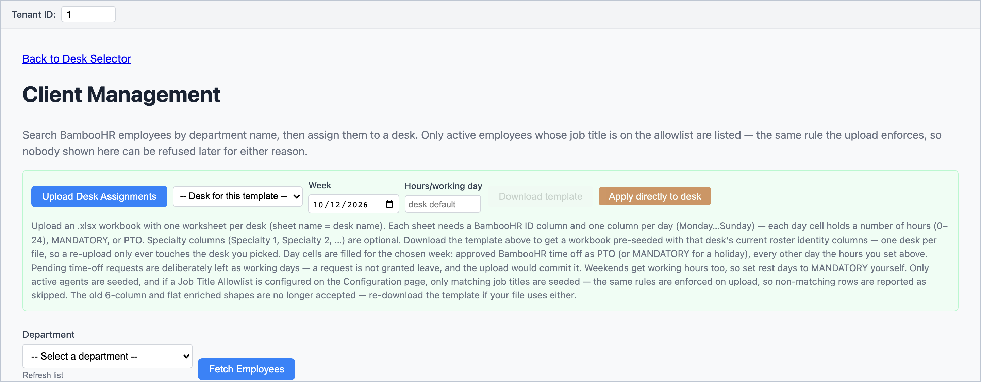
Figure 4 – Client Management. The green panel holds the desk spreadsheet tools.

Step 1: download the template
1. In the green panel, choose your desk in -- Desk for this template --.
2. Pick any date in the Week you are planning. The template uses the Monday–Sunday week containing that date.
3. Optionally enter Hours/working day (leave blank to use the desk's default).
4. Click Download template. An Excel file named after the desk is saved.
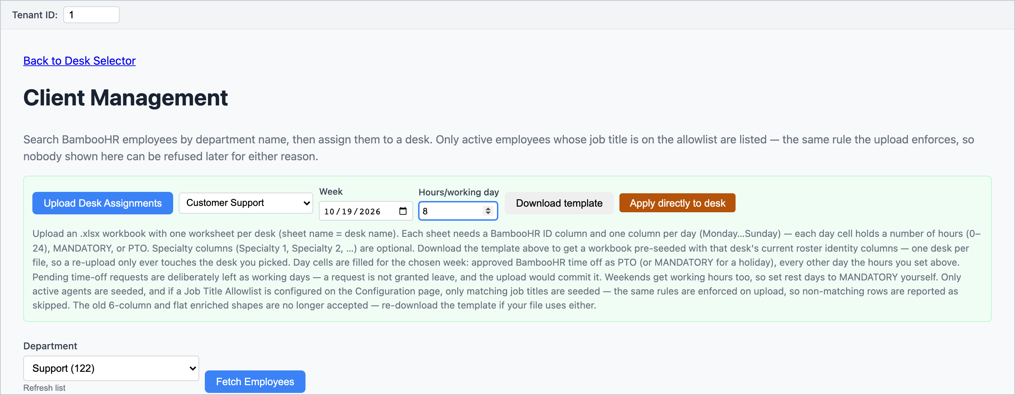
Figure 5 – Desk, week and hours chosen, ready to download the template.
The template lists everyone currently on the desk. Approved BambooHR time off for that week is already filled in as PTO (or MANDATORY for public holidays). Every other day, including Saturday and Sunday, is filled with the working hours.

Step 2: fill it in
Column | What to enter
BambooHR ID | Already filled. Do not change it. Add a new row with someone's BambooHR ID to add them to the desk.
First Name … Active | For information only. BambooHR always wins if they differ.
Monday … Sunday | For each weekday: a number of hours (e.g. 8 or 7.5), MANDATORY for a rest day or holiday, or PTO for time off. Every cell must be filled.
Usual Shift Monday … Sunday | Only for shift-based desks (chapter 16). Leave blank otherwise, but do not delete these columns.
Specialty 1, Specialty 2 | The agent's skills. Specialty 1 becomes their main skill. Names must match the desk's skills exactly (chapter 6).

Watch out: Set rest days to MANDATORY. The template fills weekends with working hours, so if you do not change them, everyone will be treated as working seven days a week.

Watch out: Fill in Specialty 1 for everyone. The template leaves skills blank, and uploading clears the desk's existing skill assignments. An agent without a main skill will not be scheduled.

Tip: Type hours as plain numbers. If a cell holds hours as text (for example '8 with an apostrophe) the whole row is rejected.

Step 3: upload it
1. Click Upload Desk Assignments and choose your filled-in file. The desk is taken from the sheet name, so the dropdown next to the button does not matter.
2. Read the Upload Results window that appears (see below).
3. Click Close, then check the desk on the Desk Agents page.
Important: Uploading replaces the desk. For the desk in the file, the scheduler first removes the current agents, skills, per-day hours, preferences and exceptions, and then adds back exactly what is in the spreadsheet. Re-enter any preferences and exceptions afterwards. This cannot be undone.

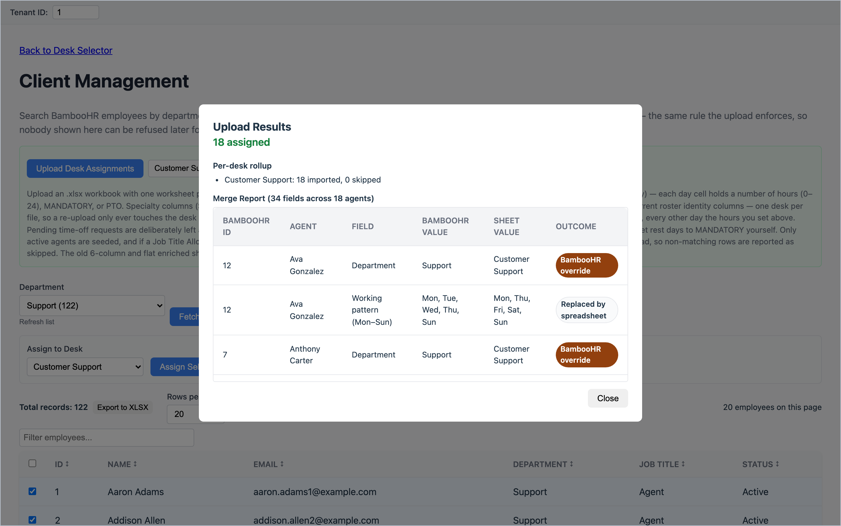
Figure 6 – Upload Results: how many were assigned or skipped, and a "Merge Report" comparing the sheet with BambooHR.
In the results window | What it tells you
N assigned / N skipped | How many rows were imported. If any were skipped, a table lists the row and reason; click Download skipped as CSV to keep a copy.
Per-desk rollup | Imported and skipped counts per desk.
Newly eligible for scheduling | Agents whose working pattern BambooHR did not know. The spreadsheet has now supplied it, so they can be scheduled.
Merge Report | Where the spreadsheet and BambooHR disagree. BambooHR override means BambooHR's value was kept (names, emails, department). Replaced by spreadsheet means your weekly pattern was used.
Warnings | Things that were imported with a change, for example hours over 24 reduced to 24.

Shortcut: Apply directly to desk
Apply directly to desk (orange button) does the download and upload in one step, without a spreadsheet. It is quick, but it cannot set rest days or skills: everyone gets the same hours on all seven days and no skills. Use it only if you will correct hours and skills on the Desk Agents page straight afterwards.

Method 2: assign people individually
1. In Client Management, choose a Department and click Fetch Employees.
2. Tick the people you want.
3. Choose the desk in Assign to Desk, then click Assign Selected.
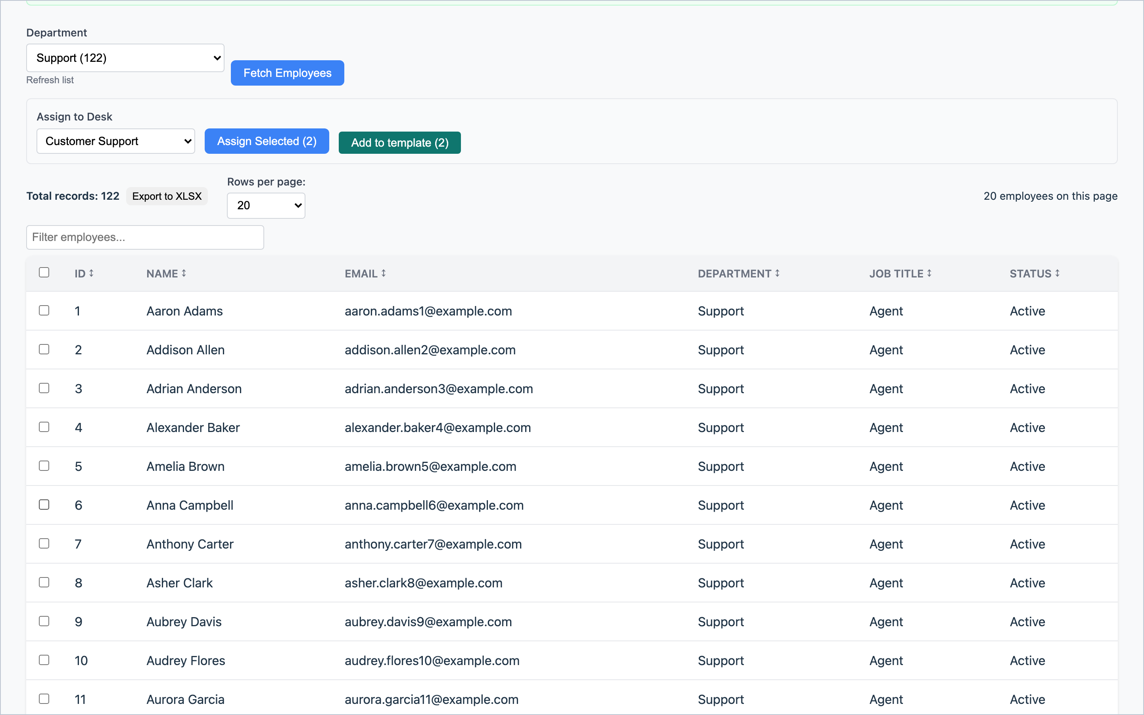
Figure 7 – Searching a department and assigning ticked people to a desk.
People added this way are added to the desk without removing anyone. They start with no skills and no weekly pattern, so set those on the Desk Agents page before you solve (chapter 7). If someone is already on another desk, remove them there first (bottom of Client Management, Desk Agents section, Remove).
Note: Only active people whose job title is on the schedulable list are shown (see chapter 17). If someone is missing, an amber message tells you how many people were hidden and why.

6. Skills (Specializations)
Skills describe the types of work on your desk. Demand is entered per skill, and every agent needs a main (primary) skill to be scheduled. If you do not split work by skill, create a single skill such as "General" and give it to everyone.
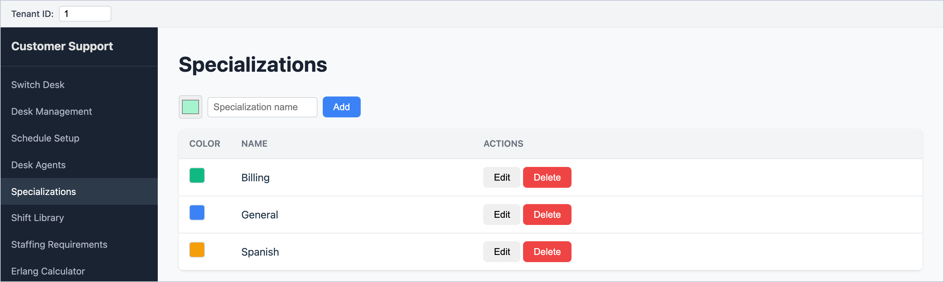
Figure 8 – The Specializations page, with a colour for each skill.
1. Open Specializations from the menu.
2. Pick a colour (click the swatch), type the skill name, and click Add.
3. To rename or recolour, click Edit, change it, and click Save.
Tip: Create skills before uploading a desk spreadsheet. The Specialty columns must match these names. Renaming a skill later means older spreadsheets with the old name will no longer match.

A skill cannot be deleted while it is given to agents or used in demand. Remove it from those first.

7. Managing your agents
Desk Agents lists everyone on the desk. It is where you check and correct skills, hours and days off before each schedule.
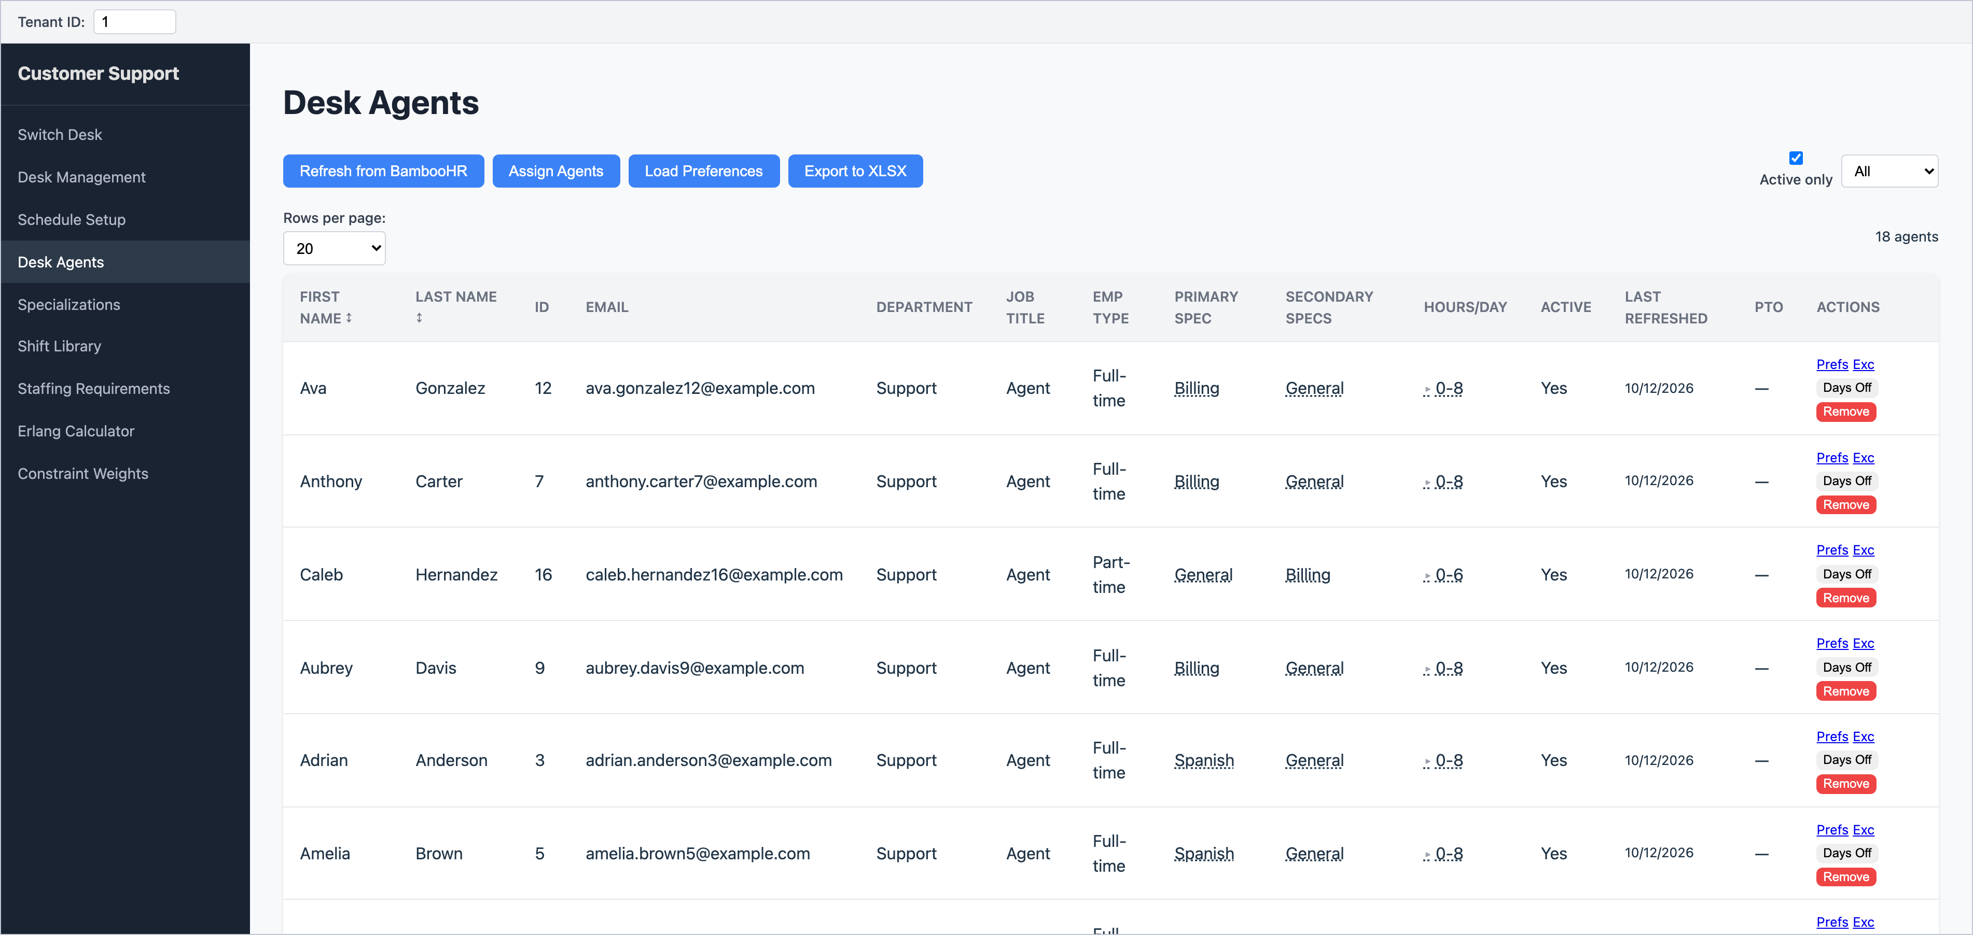
Figure 9 – The Desk Agents page.

Buttons along the top
Button | What it does
Refresh from BambooHR | Updates names, job titles and employment type for people already on the desk, and re-imports their time off from BambooHR (about 12 weeks back to 8 weeks ahead). Do this shortly before each solve.
Assign Agents | Opens a list of people not yet on any desk. Tick them and click Assign.
Load Preferences | Uploads a spreadsheet of start-time and break-time preferences (chapter 8).
Export to XLSX | Downloads the roster, including each person's hours per weekday and skills.
Active only / employment filter | Hide inactive agents; show only full-time or part-time.

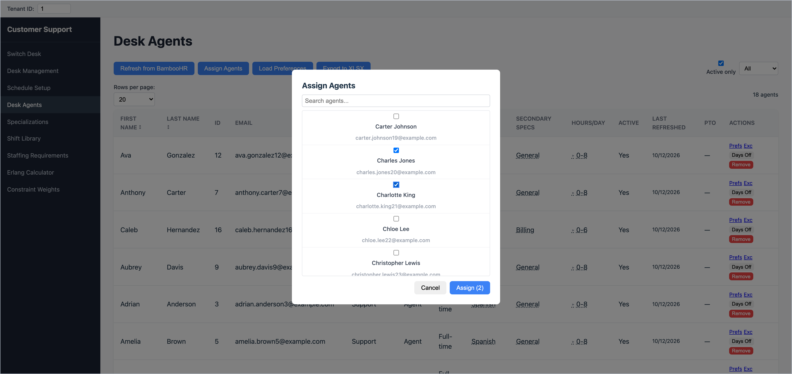
Figure 10 – Assign Agents: tick people and click Assign.

The columns
Column | What it shows
Primary Spec | The agent's main skill. Click it to change.
Secondary Specs | Backup skills the scheduler may use when needed. Click to tick or untick, then Save.
Hours/Day | A summary of the agent's hours across the week (e.g. "0-8" means some days off, others 8 hours). Click it to open the weekly panel.
PTO | A yellow "N pending PTO" badge means time off has been requested in BambooHR but not yet approved. Hover to see the dates.
Actions | Prefs (preferences), Exc (exceptions and rest waivers), Days Off, Remove.

Changing skills
Click the agent's Primary Spec or Secondary Specs. A dropdown and tick boxes appear. Choose the main skill, tick any backup skills, then click Save.
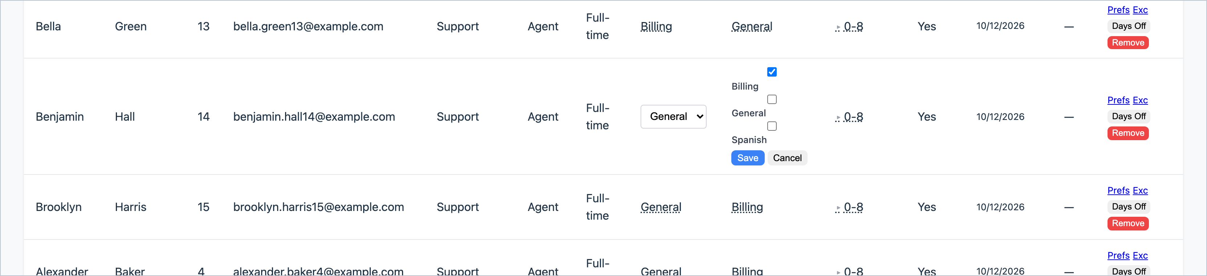
Figure 11 – Editing an agent's skills: choose the main skill, tick backup skills, then Save.
Watch out: An agent with no main skill (shown as "—") is left out of the schedule.

Weekly hours and rest days
Click the agent's Hours/Day value to open the weekly panel. Each weekday shows the agent's hours, or a label:
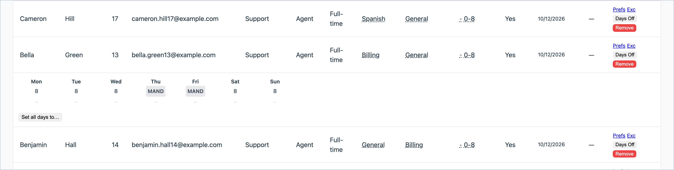
Figure 12 – The weekly panel. This agent works 8 hours on five days and has Thursday and Friday as rest days (MAND).
Shown | Meaning
A number, e.g. 8 | The agent works this many hours that weekday.
MAND | MANDATORY: a fixed rest day. Never scheduled that weekday.
PTO | A weekly time-off label. Blocks that weekday. (Dated time off from BambooHR takes over where BambooHR has data.)
0 | Contracted for no hours that day, so not scheduled.
Grey italic number | Not set, so the desk default is used.

1. Click a weekday's value.
2. Type a number of hours, or pick MANDATORY, PTO or Not set (default) from the list.
3. Press Enter (or click elsewhere) to save. Press Esc to cancel.
Set all days to… gives all seven days the same number of hours in one go. It also removes any MANDATORY or PTO labels, so you will be asked to confirm.
Important: Hours must fit your timeslot length. With 30-minute timeslots use whole or half hours (7.5 is fine, 7.75 is not). With 60-minute timeslots use whole hours. Otherwise the solve is refused with a message naming the agent.

Days off and time off
Click Days Off on an agent's row to see the dated days off imported from BambooHR (holidays, approved and requested time off).
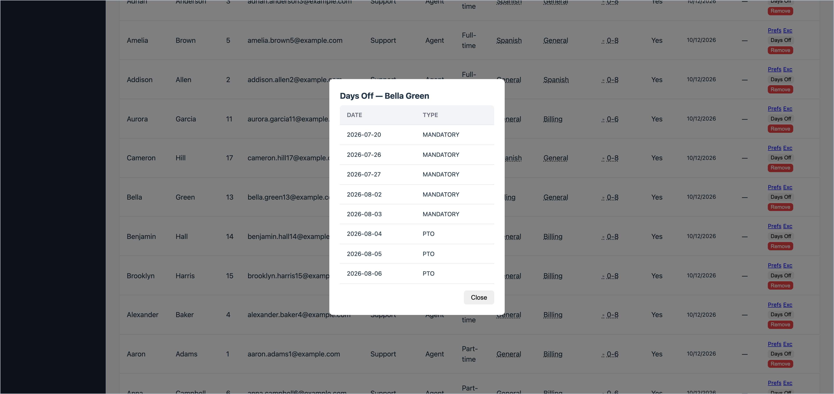
Figure 13 – Dated days off for one agent, imported from BambooHR.
- Days off come from BambooHR and cannot be edited here. If one is wrong, fix it in BambooHR and click Refresh from BambooHR.
- Requested time off already blocks the agent from being scheduled, just like approved time off.
- Weekly rest days (MAND) set in the hours panel are not listed in this window.

Removing an agent
Click Remove and confirm. The agent's preferences, exceptions and skills for this desk are deleted. The person stays in BambooHR and can be assigned again later.

8. Preferences, exceptions and rest waivers
These are optional, one-person adjustments. Open them from the Prefs and Exc links on the agent's row in Desk Agents.

Preferences (Prefs)
A preference tells the scheduler when an agent would like to start, and when they would like their break. It is a wish, not a guarantee: the scheduler honours it when it can without hurting coverage.
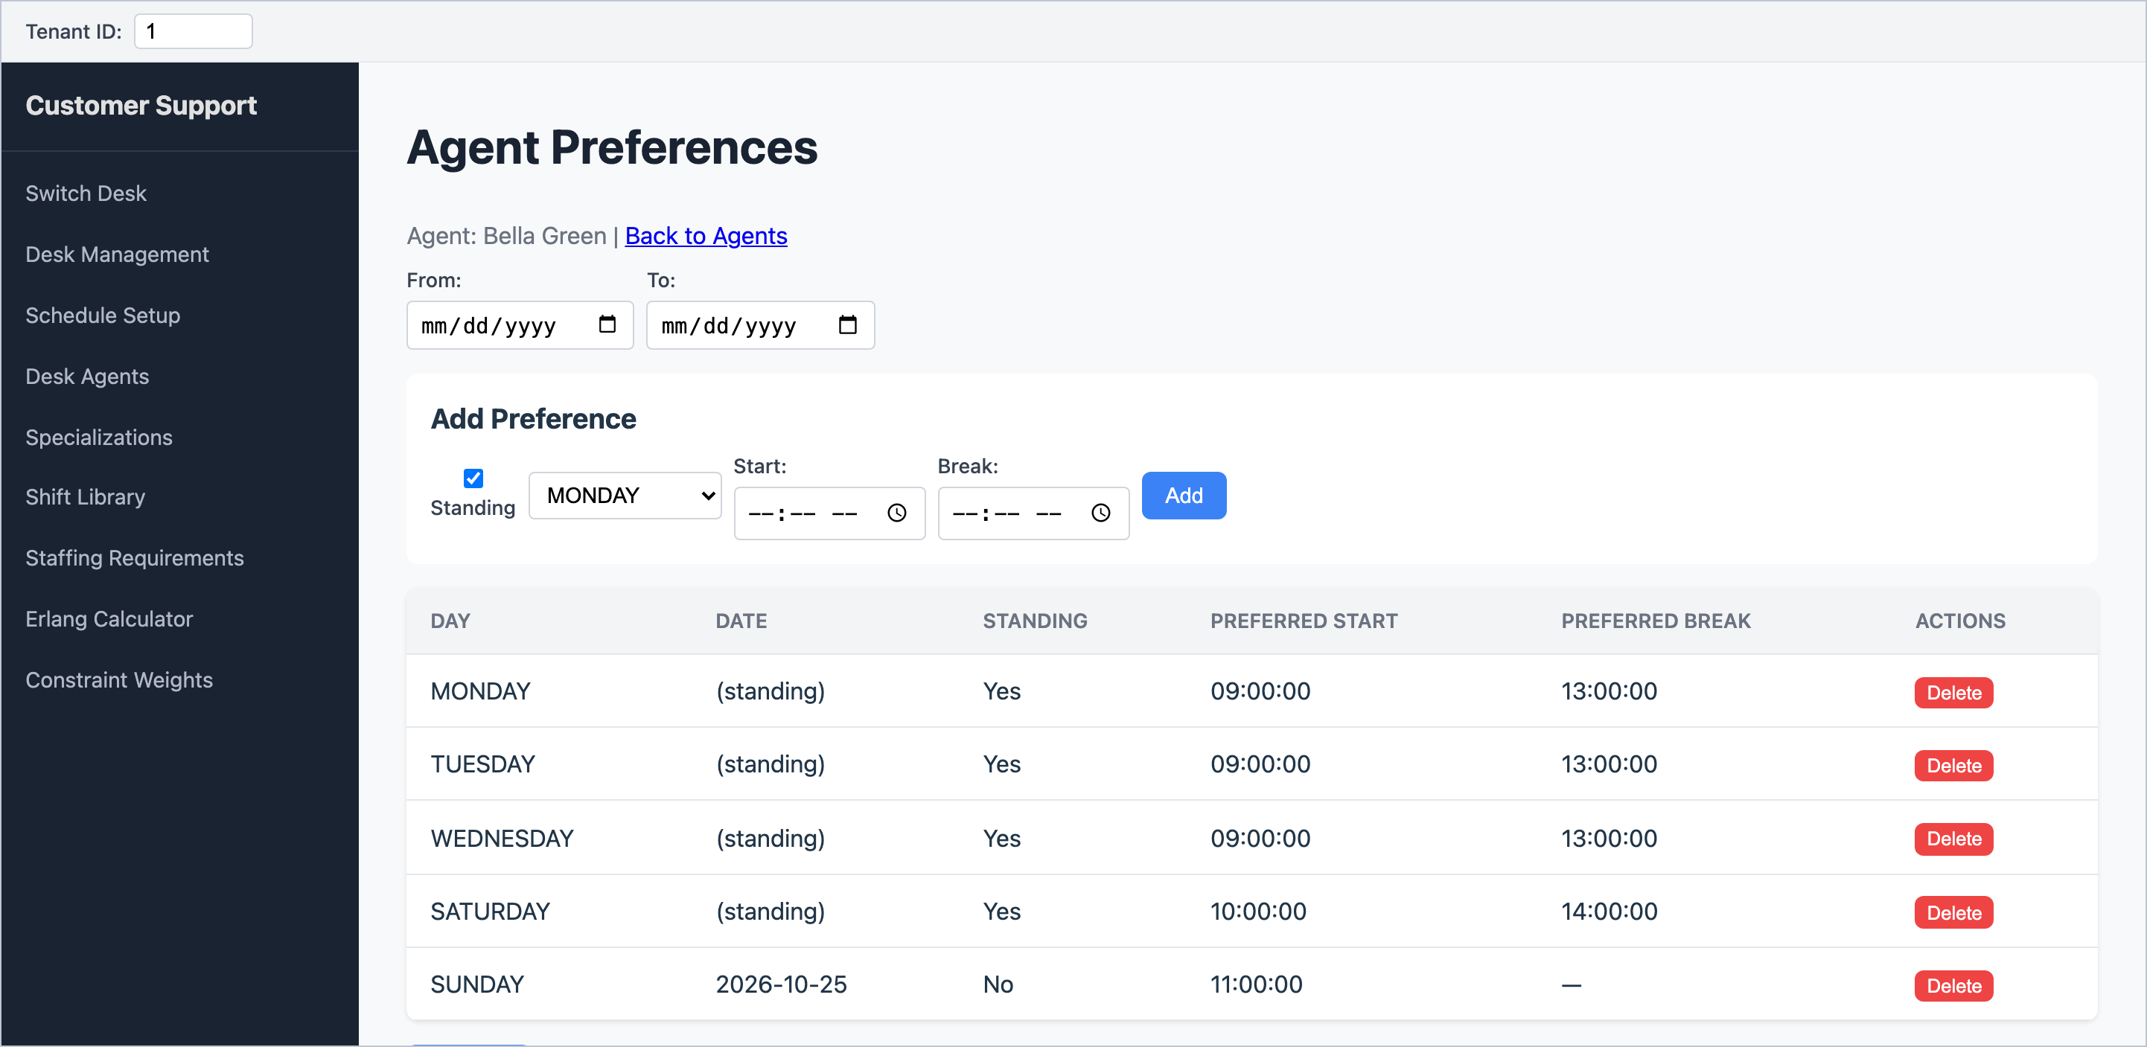
Figure 14 – Agent Preferences: standing (every week) preferences for each weekday.
1. Leave Standing ticked for a preference that applies every week, and choose the weekday.
2. Enter a Start time and/or a Break time.
3. Click Add. The row appears in the table but is not saved yet.
4. Add any more rows, then click Save All.
- Delete on a saved row removes it immediately, without asking.
- If an agent has both a standing preference and a one-off preference for the same date, the one-off wins.
- Preferences on the agent's days off are ignored.
- Break preferences must fit the Break Alignment chosen in Schedule Setup (for example "On the hour" means 13:00 is fine but 13:30 is not). Otherwise the solve is refused.
Tip: For a one-off preference on a single date, untick Standing and pick the date instead of a weekday. One-off preferences can also be loaded from a spreadsheet (below).

Uploading preferences from a spreadsheet
On Desk Agents, Load Preferences imports many preferences at once. Use an Excel file whose first row is a heading row. Columns are read by position:
Column | Content | Example
A | Agent name (for your reference only) | Bella Green
B | Email (must match an agent on this desk) | bella.green13@example.com
C | Date, for a one-off preference | 2026-10-23
D | Day of week, written in full | FRIDAY
E | Preferred start time | 09:00
F | yes for a standing (every-week) preference; anything else for one-off | yes
G | Preferred break time (if blank, start + 5 hours is used) | 13:00

Tip: Format the time columns as Text in Excel and type times with two-digit hours (09:00, not 9:00). Write days in full (MONDAY, not Mon). A single badly formatted row stops the whole upload.

Exceptions (Exc)
An exception changes an agent's working hours for one date, for example 4 hours instead of 8 because of an appointment.
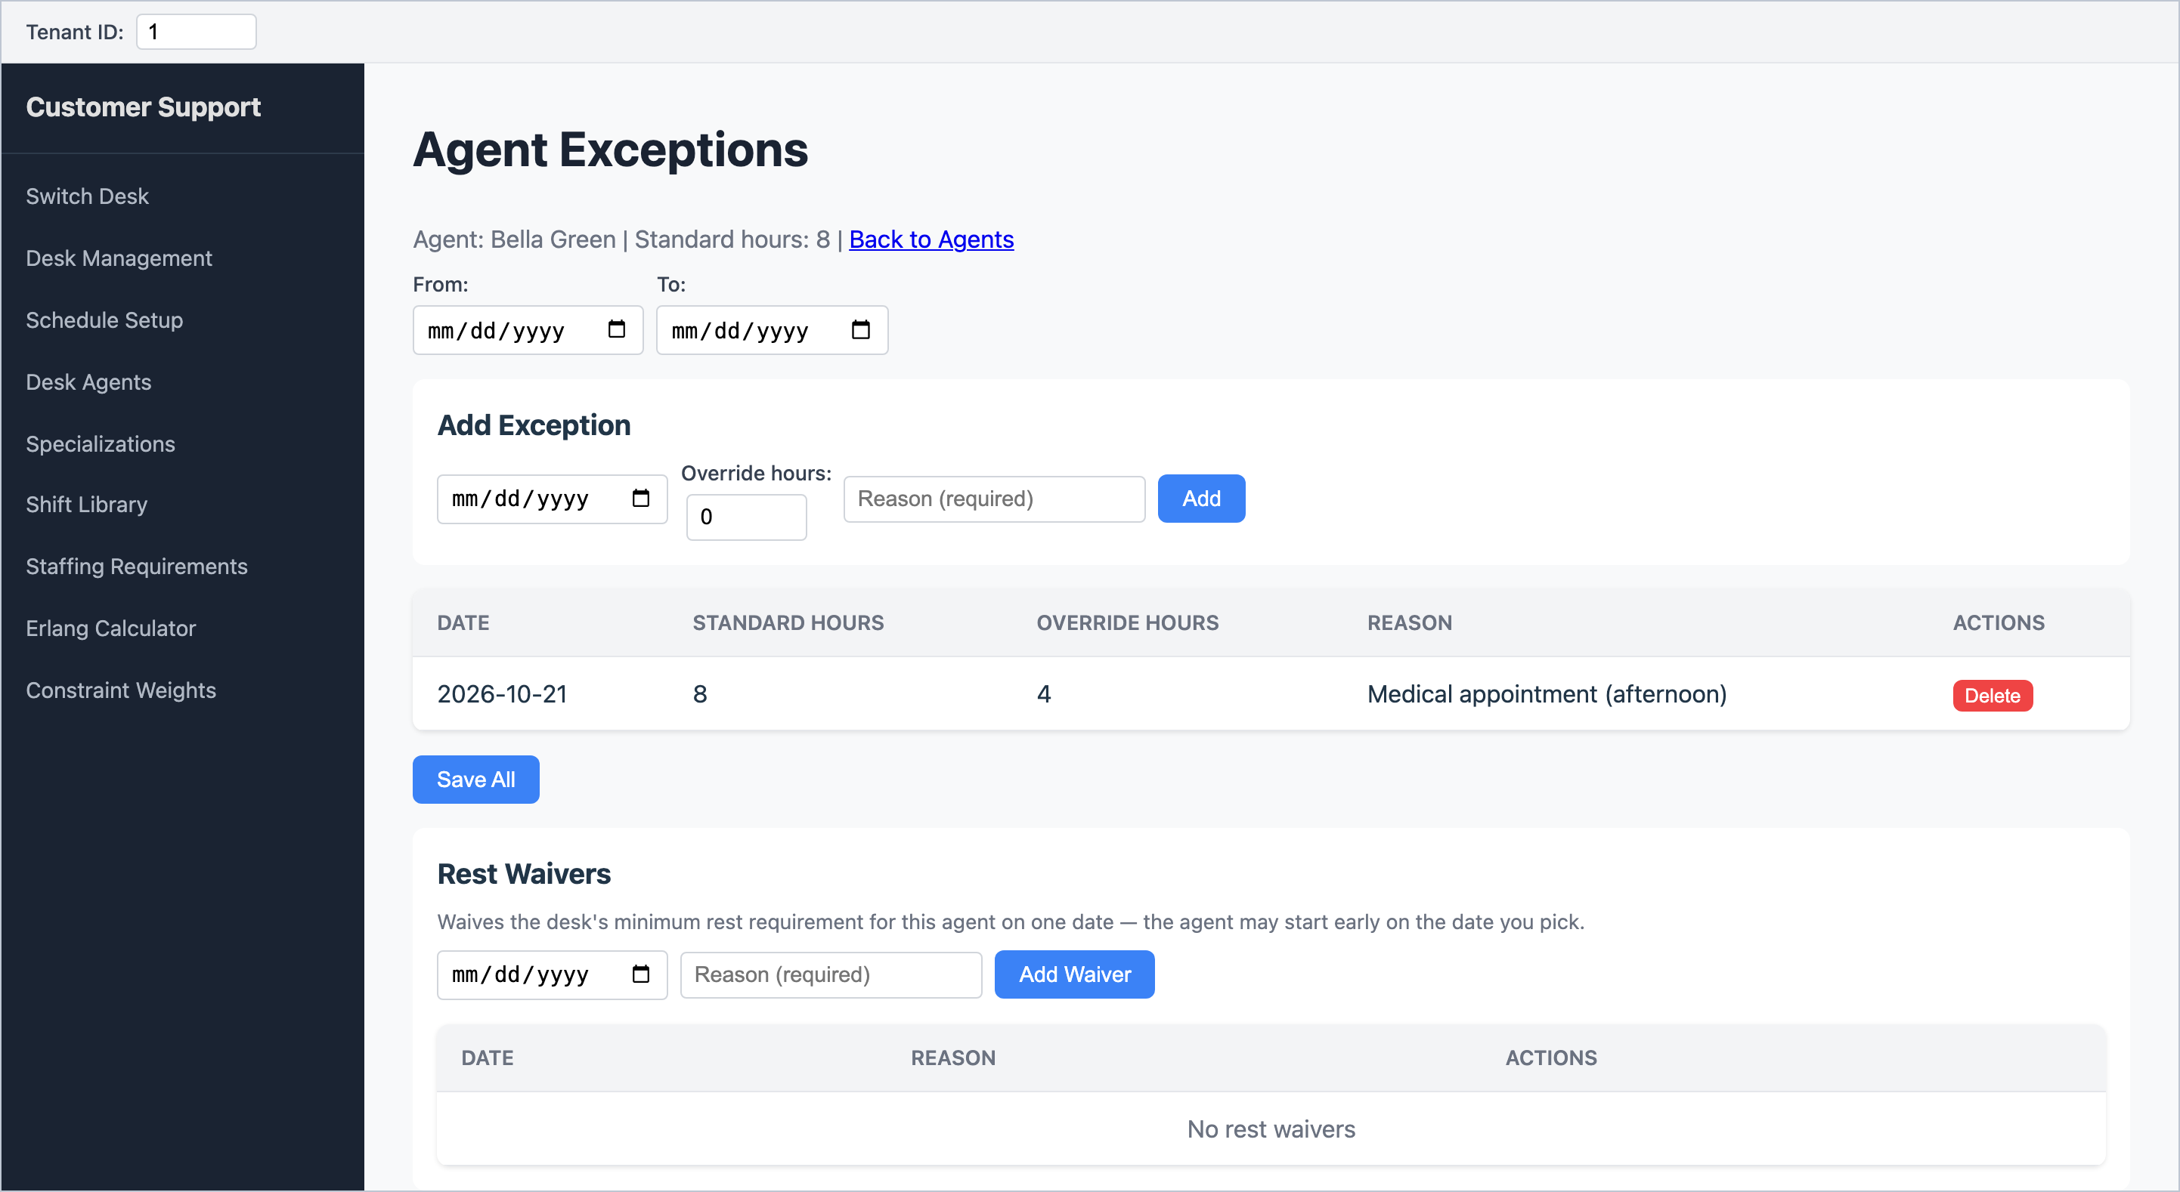
Figure 15 – Agent Exceptions (top) and Rest Waivers (bottom).
1. Under Add Exception, pick the date.
2. Enter the Override hours for that day.
3. Type a Reason (required) and click Add.
4. Click Save All.
Watch out: Override hours starts at 0. If you leave it at 0 the agent will not be scheduled that day at all.

- You cannot add an exception on a date the agent already has a day off. If a BambooHR refresh adds a day off under an existing exception, that row turns grey with "(day off)" and Save All will fail until you delete it.
- "Standard hours" at the top shows the agent's highest daily hours across the week, not necessarily that day's hours.

Rest waivers
If your desk has a minimum rest rule (chapter 4), a rest waiver lets one agent start early on one date, even though they would not have had the full rest since their previous shift. Pick the date of the later shift, enter a reason, and click Add Waiver. Waivers are saved straight away. If the desk has no minimum rest rule, waivers have no effect.

9. Planning the week: Schedule Setup
Schedule Setup is where you say which dates to schedule, when the desk is open, and the break rules. It is also where you start a schedule (chapter 12).
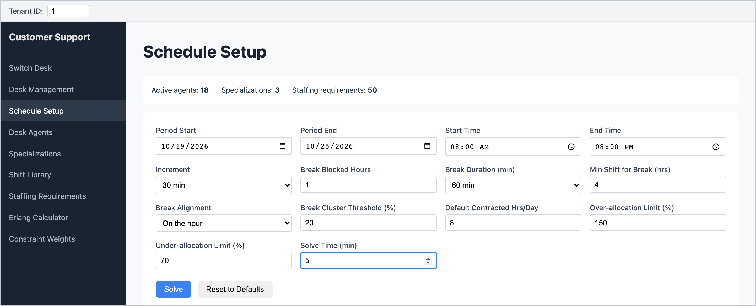
Figure 16 – Schedule Setup with a one-week period, 08:00–20:00, 30-minute timeslots.
The strip at the top shows a quick health check: Active agents, Specializations and Staffing requirements. A red message here (for example "No staffing requirements for selected period") means something needs fixing before you solve. The staffing requirements count stops at 50; it tells you that demand exists, not how much.
Field | What to enter | Default
Period Start / Period End | The first and last day to schedule. Between 1 and 31 days. Start with one week. | —
Start Time / End Time | When the desk opens and closes each day. Shifts are placed inside this window. | 08:00–18:00
Increment | Timeslot length: 15, 30 or 60 minutes. Smaller is more precise but slower to solve. | 15 min
Break Blocked Hours | No break in the first or last this-many hours of an agent's day. | 1
Break Duration (min) | Length of each agent's break. Only lengths that fit the increment are offered. | 60
Min Shift for Break (hrs) | Agents working this many hours or fewer get no break; longer days get exactly one. | 4
Break Alignment | Breaks start on the hour, half hour or quarter hour. | On the hour
Break Cluster Threshold (%) | Used on shift-based desks only: the share of agents allowed on break at the same time before the scheduler tries to spread breaks out. | 20
Default Contracted Hrs/Day | Hours for agents who have no hours of their own. | 8
Over-allocation Limit (%) | The most staff allowed in a timeslot, as a % of demand. 130 means up to 30% over. | 130
Under-allocation Limit (%) | The fewest staff allowed in a timeslot, as a % of demand. 70 means no more than 30% short. | 70
Solve Time (min) | The longest the scheduler will spend. It stops earlier if it stops improving. | 10

- Every change is remembered automatically, in this browser only. There is no Save button.
- Reset to Defaults restores the defaults above and clears the dates.
- If you change the Increment, re-check Break Duration. An old value that no longer fits will make the solve fail.
Tip: Over- and under-allocation limits are strict rules. When demand in a timeslot is very small (1 or 2 agents), one person more or less is already a big percentage. If results keep reporting "Bulk over-allocation limit" or "Bulk under-allocation hard", try widening these limits a little, for example 150% and 60%.

10. Entering demand: Staffing Requirements
Demand is the number of agents you need in each timeslot, for each skill. Open Staffing Requirements from the menu after setting the dates and times on Schedule Setup.
The Period & Timeslot Configuration box at the top repeats the Schedule Setup values (greyed out). To change them, click edit there. When the page opens it builds the timeslot grid for those dates and times.
Watch out: If the dates, times or increment have changed since you last entered demand, the grid is rebuilt and an amber message says that demand for removed timeslots was reset to 0. Check your numbers whenever you see that message.

There are three ways to enter demand. Choose one with the buttons next to Demand Entry:
Mode | Use it when | Saving
Direct | You already know how many agents you need (from a forecast or headcount plan). | Click Save
Erlang C / Erlang X | You have call volumes and want the scheduler to work out the agents needed for a service level. | Saved when you click Calculate
Upload XLSX | Your demand is in a spreadsheet. | Saved on upload

Direct entry
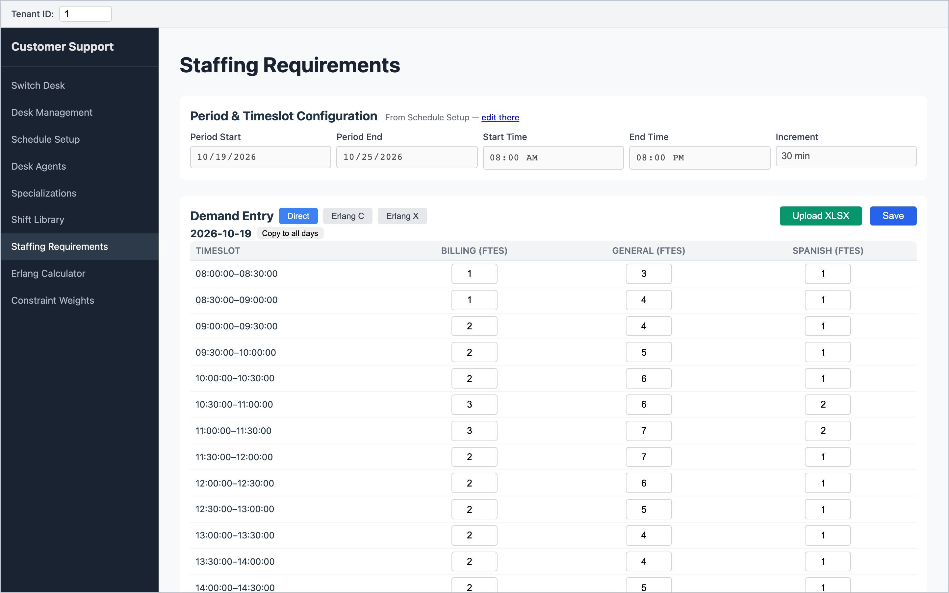
Figure 17 – Direct entry: one table per day, one column per skill.
1. Type the number of agents needed in each box. Whole numbers only.
2. To reuse a day's pattern, fill in that day and click Copy to all days next to its date. This copies to every other day in the period.
3. Click Save (top right). You will see "Saved successfully".
Important: Direct entry is only saved when you click Save. Leaving the page without saving loses your changes, and the page does not warn you.

Note: Setting every box to 0 and clicking Save does not clear old demand. To clear a day completely, use Erlang mode for that date, or ask your administrator.

Erlang C and Erlang X
Erlang is the standard contact-centre formula for turning call volumes into required agents. Erlang C assumes every caller waits as long as needed, so it gives a cautious (higher) answer. Erlang X also allows for callers hanging up and calling back, so it usually asks for slightly fewer agents. If unsure, use Erlang C.
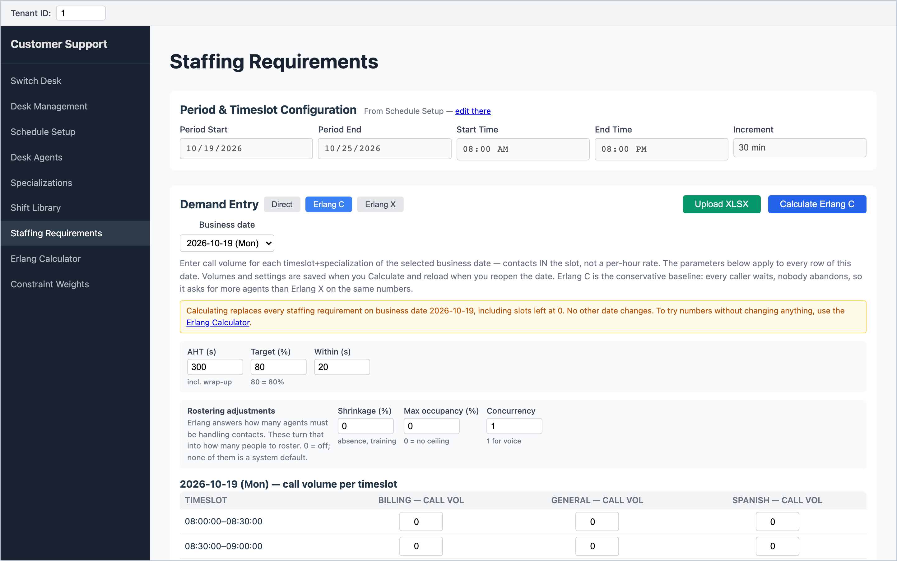
Figure 18 – Erlang C mode: choose the business date and fill in the settings for that day.
1. Click Erlang C (or Erlang X).
2. Choose the Business date to work on.
3. Fill in the day's settings: AHT (s) (average handle time in seconds, including wrap-up), Target (%) and Within (s) (e.g. 80% of calls answered within 20 seconds). For Erlang X, also Patience (s) and Retry (%).
4. Optionally fill in Rostering adjustments: Shrinkage (%) for absence, training and meetings; Max occupancy (%); Concurrency (1 for phone; higher for chat).
5. Type the call volume for each timeslot and skill: the number of contacts in that timeslot, not per hour.
6. Click Calculate Erlang C. The required agents appear, and that date's demand is replaced straight away.
7. To reuse the result, use Copy this result to other dates: tick weekdays or dates, then click Copy result to N date(s).
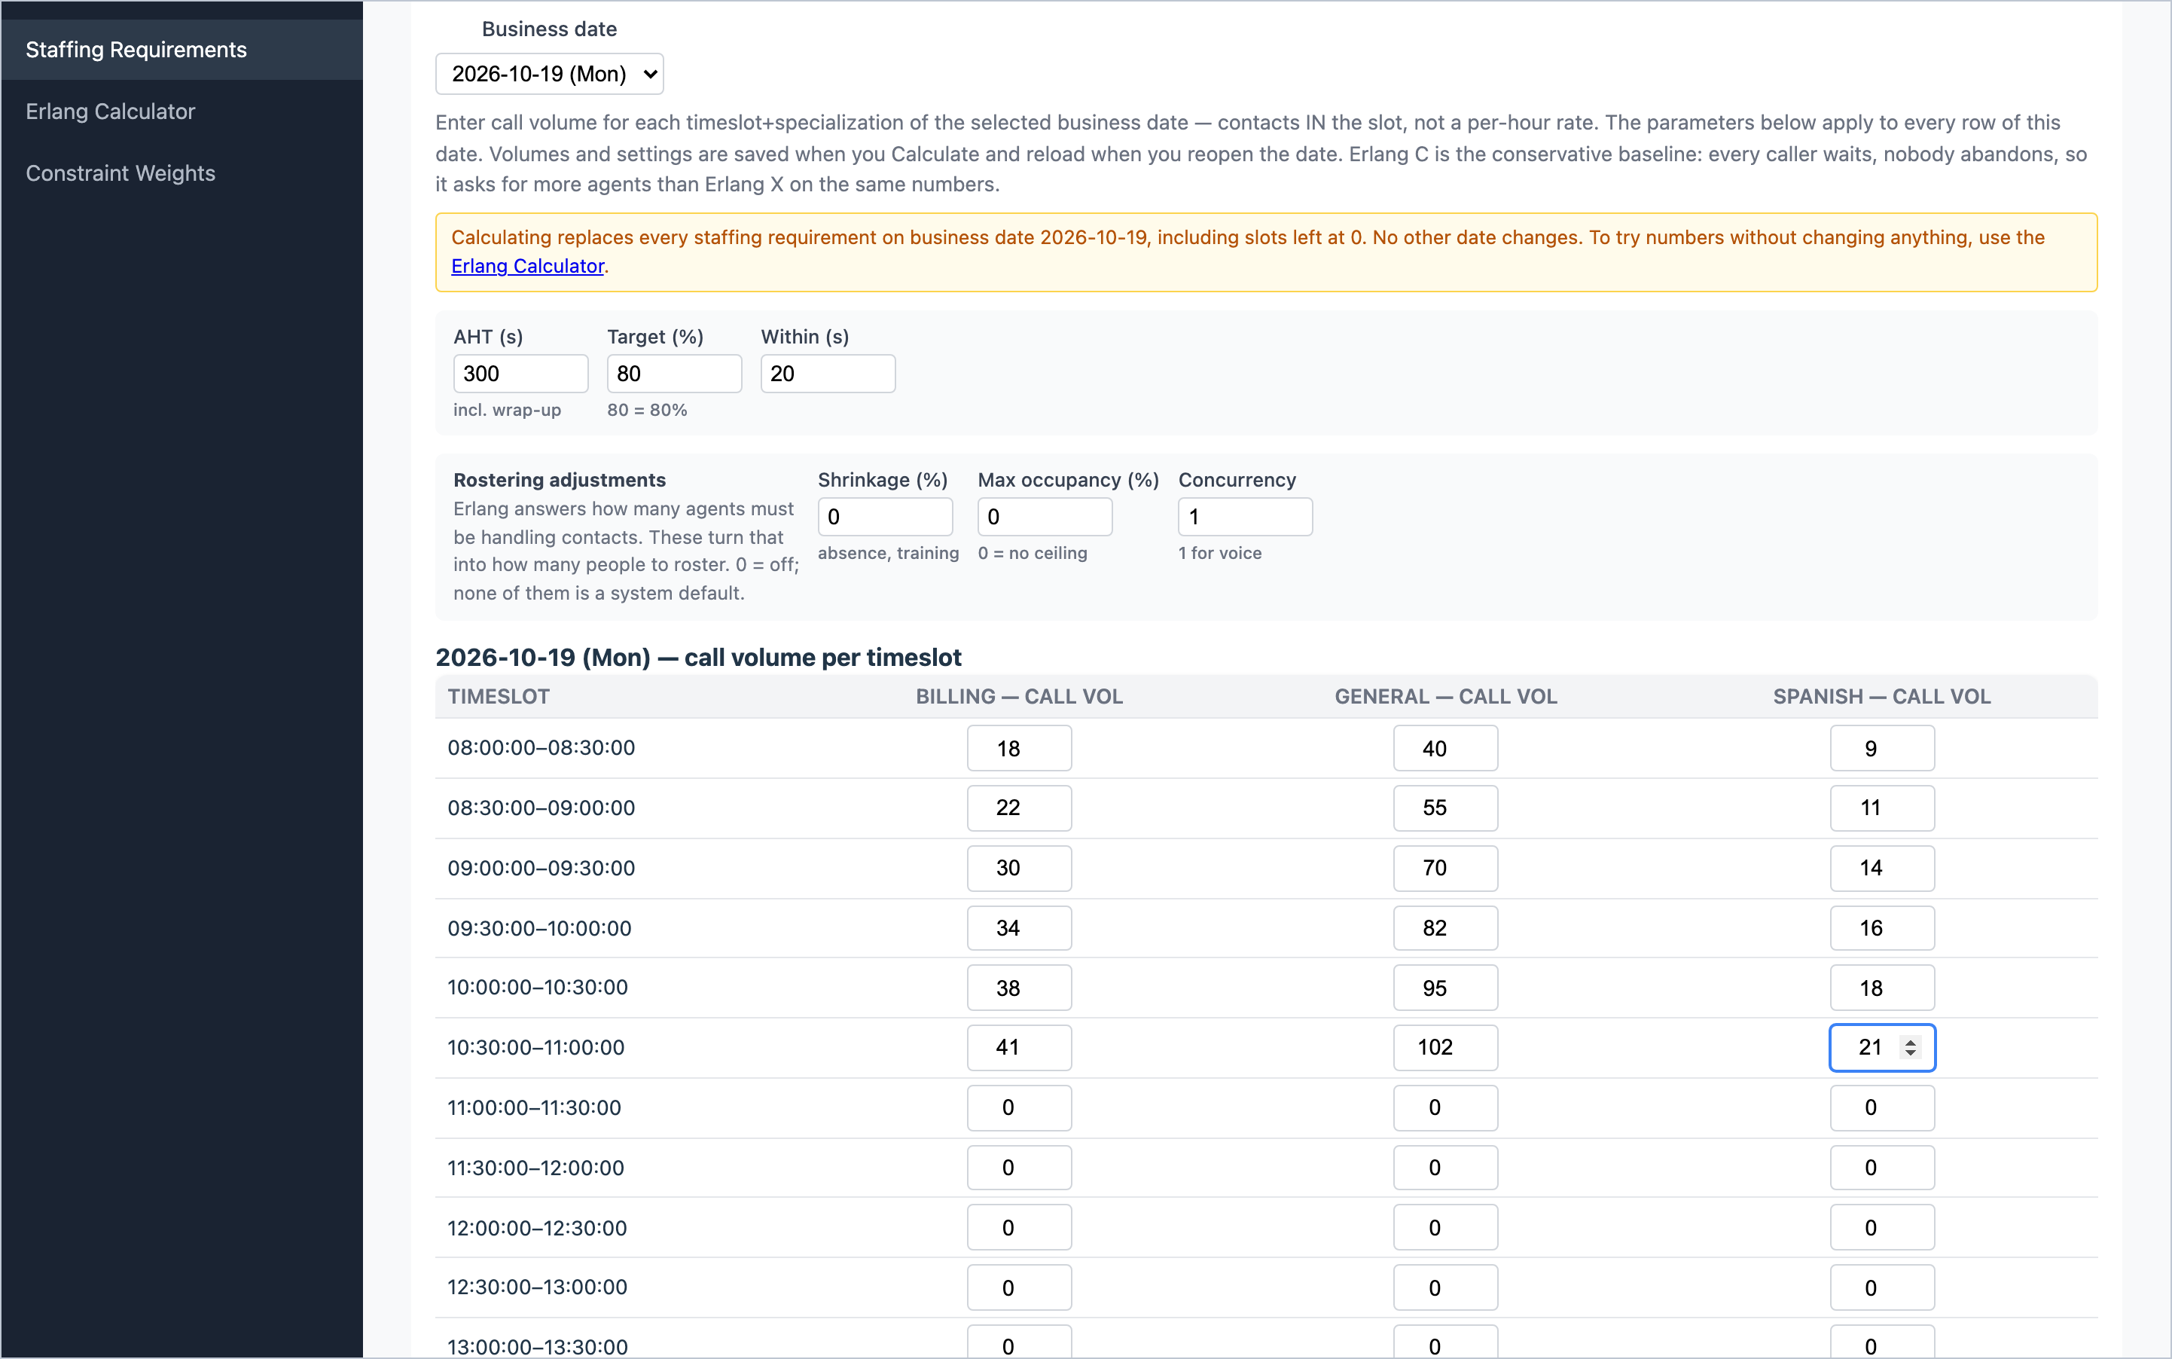
Figure 19 – Call volumes entered per timeslot and skill. The amber note warns that calculating replaces that date's demand.
Important: Calculate overwrites all demand on the selected date, including timeslots you left at 0. Other dates are not changed. The copy panel only appears straight after a calculation; if you leave the page, calculate again to copy.

Tip: Volumes and settings are remembered per date, so reopening a date in Erlang mode shows what you used last time.

Uploading demand from Excel
Click Upload XLSX and choose a file laid out like this:
- One sheet per day. The sheet name must contain the date as yyyy-mm-dd, e.g. "2026-10-19".
- Row 1: leave A1 for a label; from column B, one timeslot start time per column (08:00, 08:30, …).
- From row 2: column A is the skill name (must match the desk's skill); then the number of agents for each timeslot.
Watch out: An upload sets the period, opening hours and increment from the spreadsheet itself, and overwrites those values on Schedule Setup. Check Schedule Setup afterwards. Format row 1 and column A as Text in Excel, so 08:00 is not converted into a time value.

The message after uploading shows how many values were saved and how many skipped. Skipped values usually mean a misspelt skill name or a sheet name without a date.

11. The Erlang Calculator
The Erlang Calculator is a scratch pad for trying numbers. Nothing on this page is saved and it never changes your demand or schedules. It runs Erlang C and Erlang X side by side on the same inputs so you can compare them.
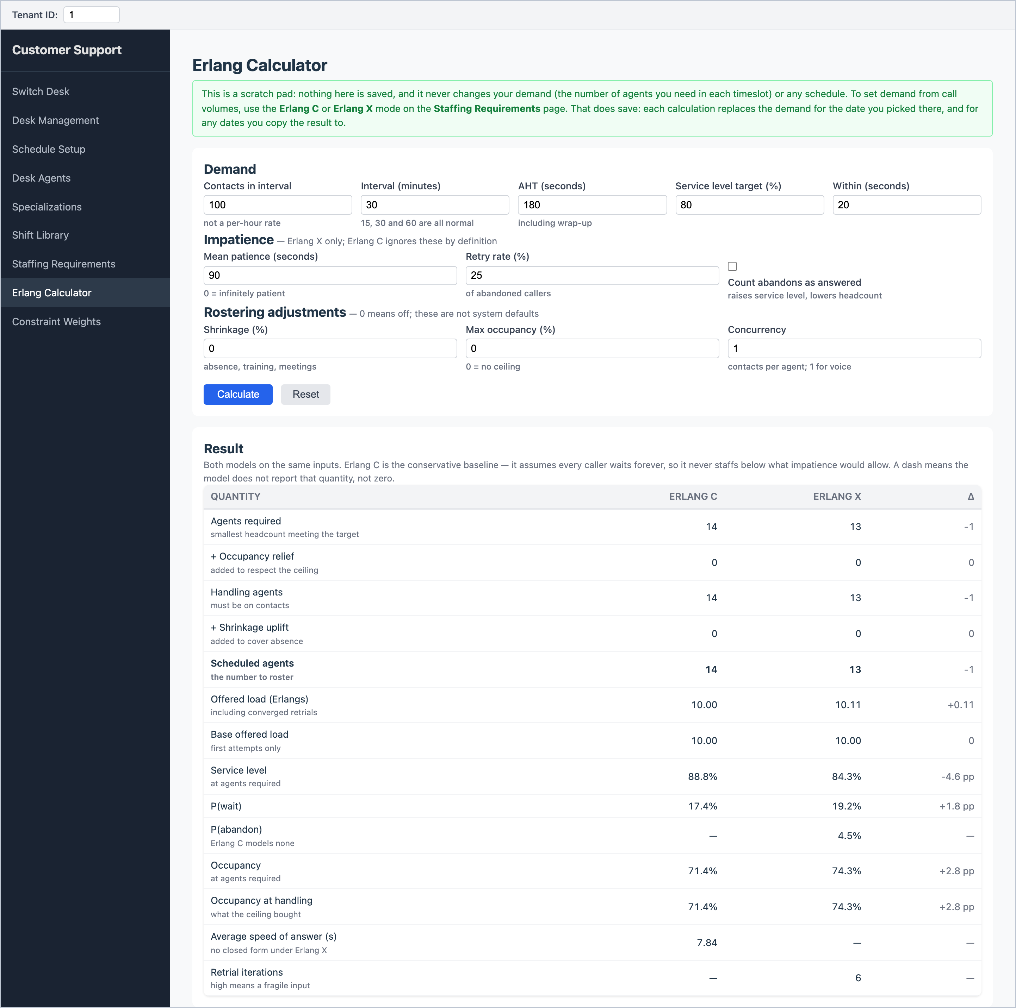
Figure 20 – The Erlang Calculator with the result of both models.
1. Enter Contacts in interval (calls in the period, not per hour), the Interval (minutes), AHT (seconds), and your service level (Service level target (%) within Within (seconds)).
2. For Erlang X, adjust Mean patience and Retry rate.
3. Optionally add Shrinkage, Max occupancy and Concurrency.
4. Click Calculate.
The key line is Scheduled agents ("the number to roster"). This is the figure the Staffing Requirements page would use as demand. Other lines show the expected service level, the chance a caller waits or abandons, agent occupancy and average speed of answer.

12. Running the schedule

Before you click Solve: checklist
- Every agent has a main skill, and their weekly hours and rest days are right (Desk Agents).
- BambooHR has been refreshed recently, so time off is up to date.
- Schedule Setup has the right dates, opening hours and increment.
- Staffing Requirements has been opened since the last change to those dates and times, and demand is entered (and saved, if you used Direct).
- The top of Schedule Setup shows no red messages.

Starting the solve
1. On Schedule Setup, click Solve.
2. The scheduler checks your setup first. If something is wrong, a red message lists every problem (see chapter 18 for fixes). Correct them and click Solve again.
3. If the checks pass, the Schedule Results page opens and the scheduler starts working.
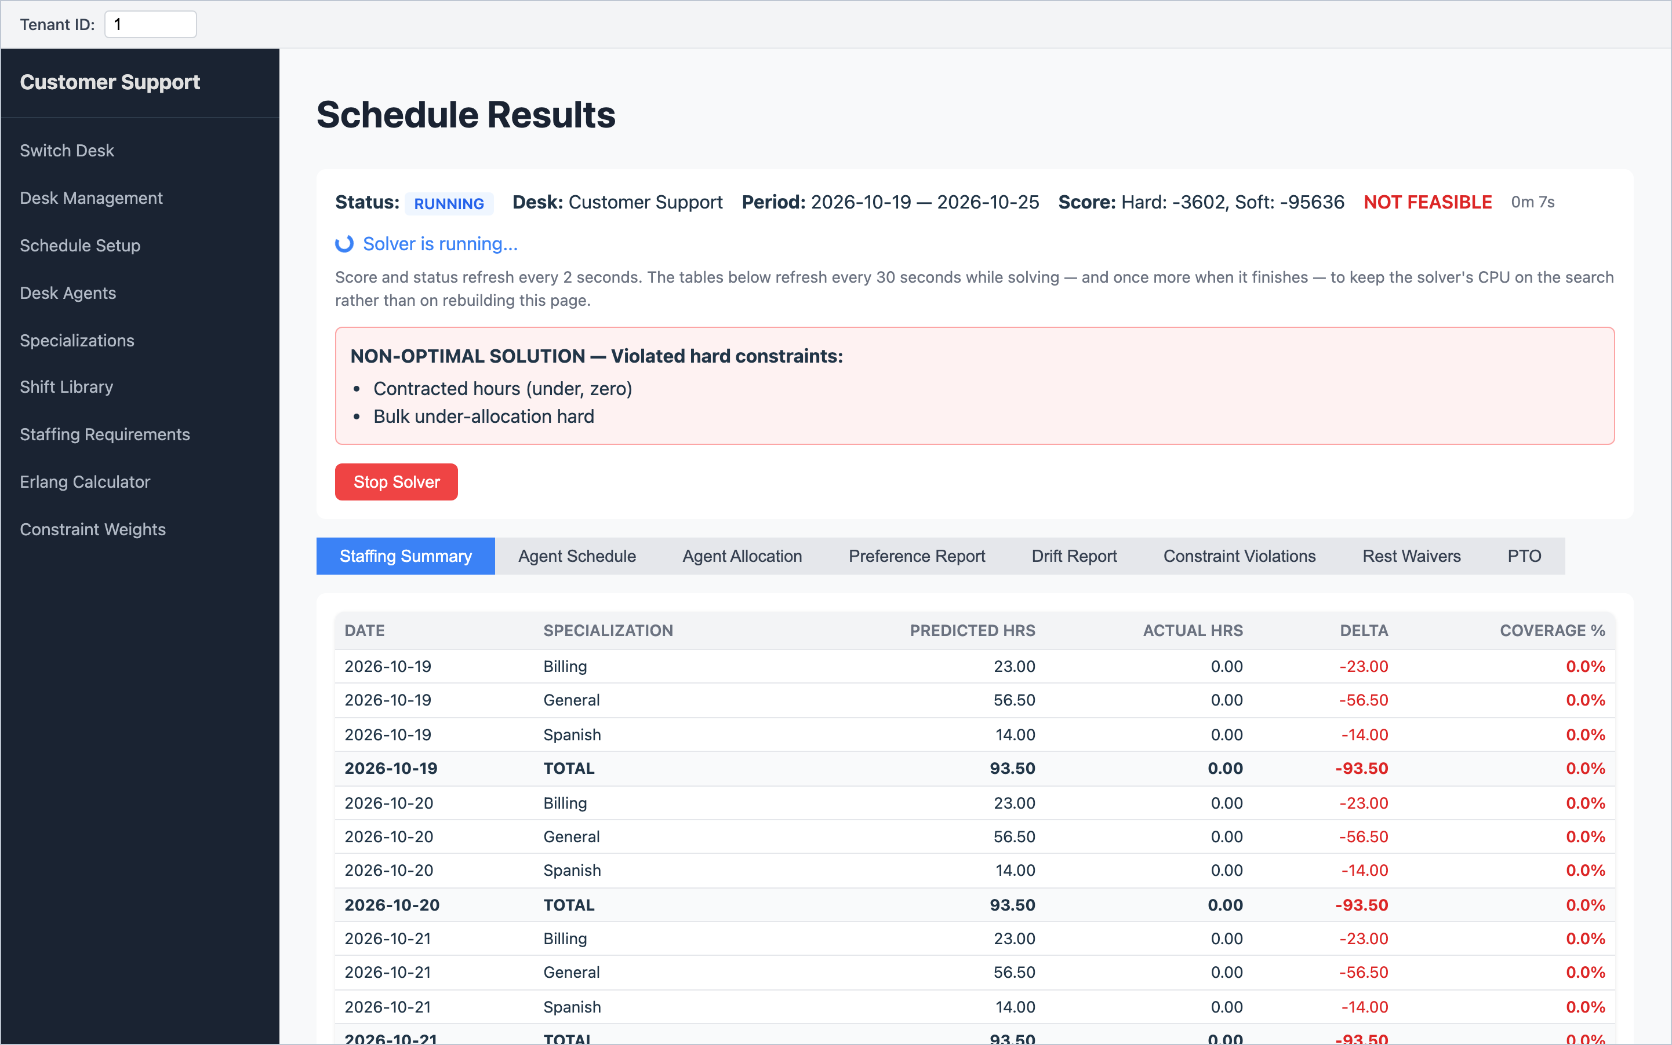
Figure 21 – A solve in progress. The score updates every few seconds; Stop Solver keeps the best result so far.
While it runs, the status shows RUNNING and the score improves every few seconds. The tables below refresh every 30 seconds. It is normal to see "NOT FEASIBLE" early on; the scheduler starts rough and improves.
- Click Stop Solver if the result is already good enough. The best schedule found so far is kept, with status STOPPED.
- Otherwise it finishes by itself (status COMPLETED) when the solve time runs out or it stops improving.
- Only one schedule can be waiting for a decision per desk. Accept or reject it before starting another.
Watch out: A schedule that has not been accepted is only held temporarily. If the system restarts, it is lost and you will need to solve again. Accept good schedules promptly.

13. Reviewing the result
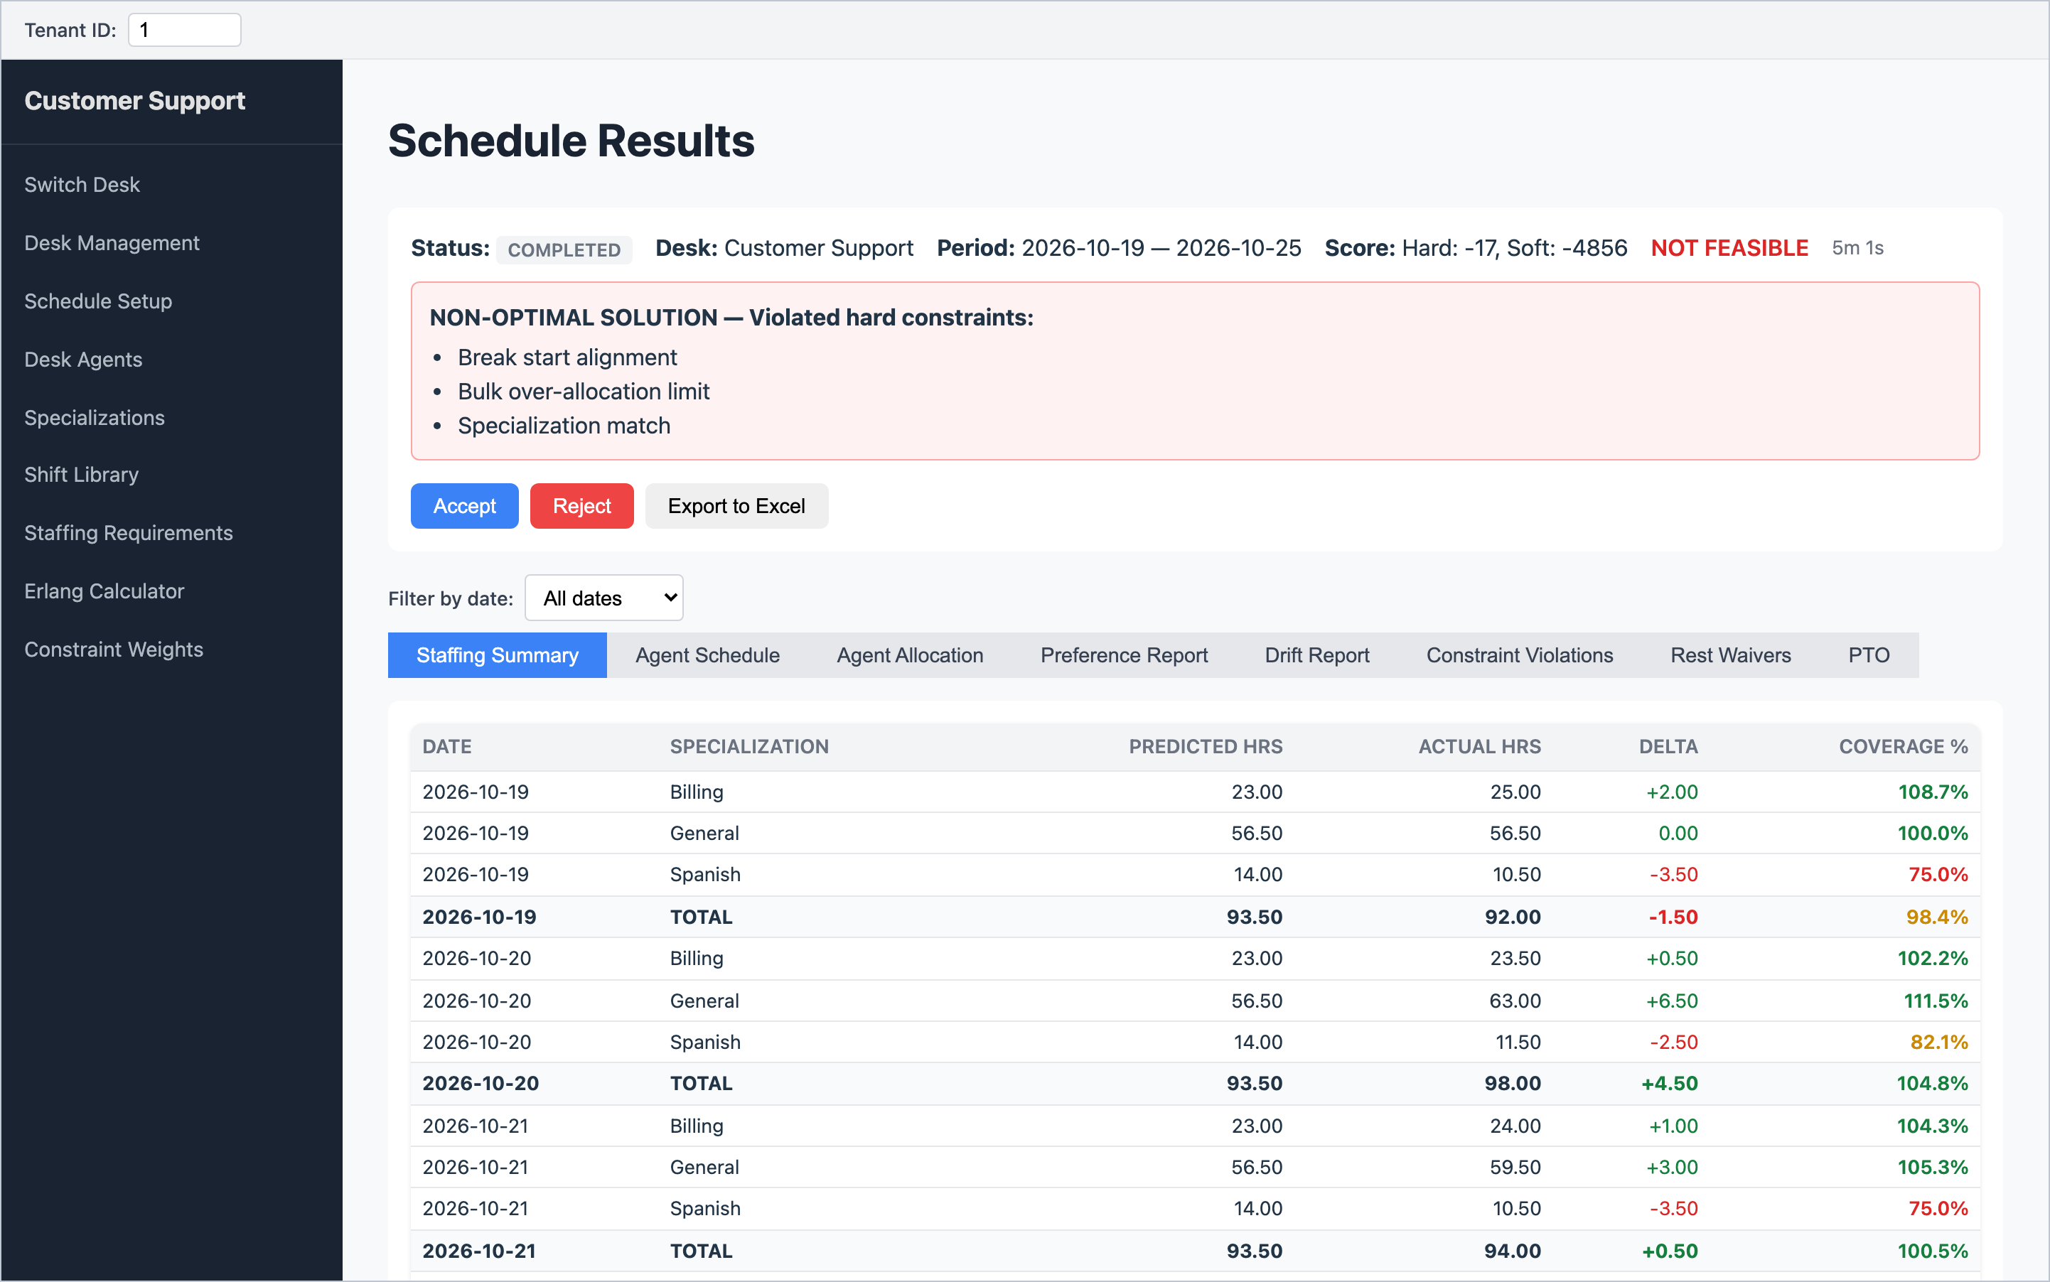
Figure 22 – A finished schedule: status, score, warnings, the Accept / Reject / Export buttons and the Staffing Summary tab.

Reading the score
The score has two parts. Both count penalties, so 0 is perfect and more negative is worse.
Part | Meaning | What you want
Hard | Rules that must not be broken (no work on days off, correct skills, break rules, staffing limits). | 0, shown as Feasible in green.
Soft | Quality: how close coverage is to demand, how many preferences were honoured. | As close to 0 as possible. Some soft penalty is normal.

If Hard is below 0, the page says NOT FEASIBLE and a red box lists which rules were broken. A small number of breaks may be acceptable for your team; you decide. The Constraint Violations tab shows exactly where they happened.
A yellow CAPACITY WARNING means demand is more than your agents can cover, for example "Demand exceeds supply by 48 slots". No setting can fix this; you need more agent hours or less demand.

The tabs
Use Filter by date to look at one day at a time.
Tab | What it shows | What to look for
Staffing Summary | Hours needed vs. hours scheduled, per day and skill, as a coverage %. | Coverage near 100%. Green is 100% or more, amber 80–99%, red below 80%.
Agent Schedule | Each agent's day: shift times, hours, which skill they cover when, and their break. | Sensible shifts and break times.
Agent Allocation | A timeline grid per day: who works which timeslot, coloured by skill; "B" marks a break. | The Over / under row at the bottom: red cells are short, amber are over.
Preference Report | Each preference, what was scheduled, and whether it was honoured. | The overall honoured %. A low figure can mean demand is too tight.
Drift Report | Shift-based desks only. | —
Constraint Violations | Every broken rule, how often, and where. Click a row to see each case. | Anything marked HARD.
Rest Waivers | Waivers that were used or not needed (only if the desk has a minimum rest rule). | —
PTO | Who is off on each date. | Unexpected absences.

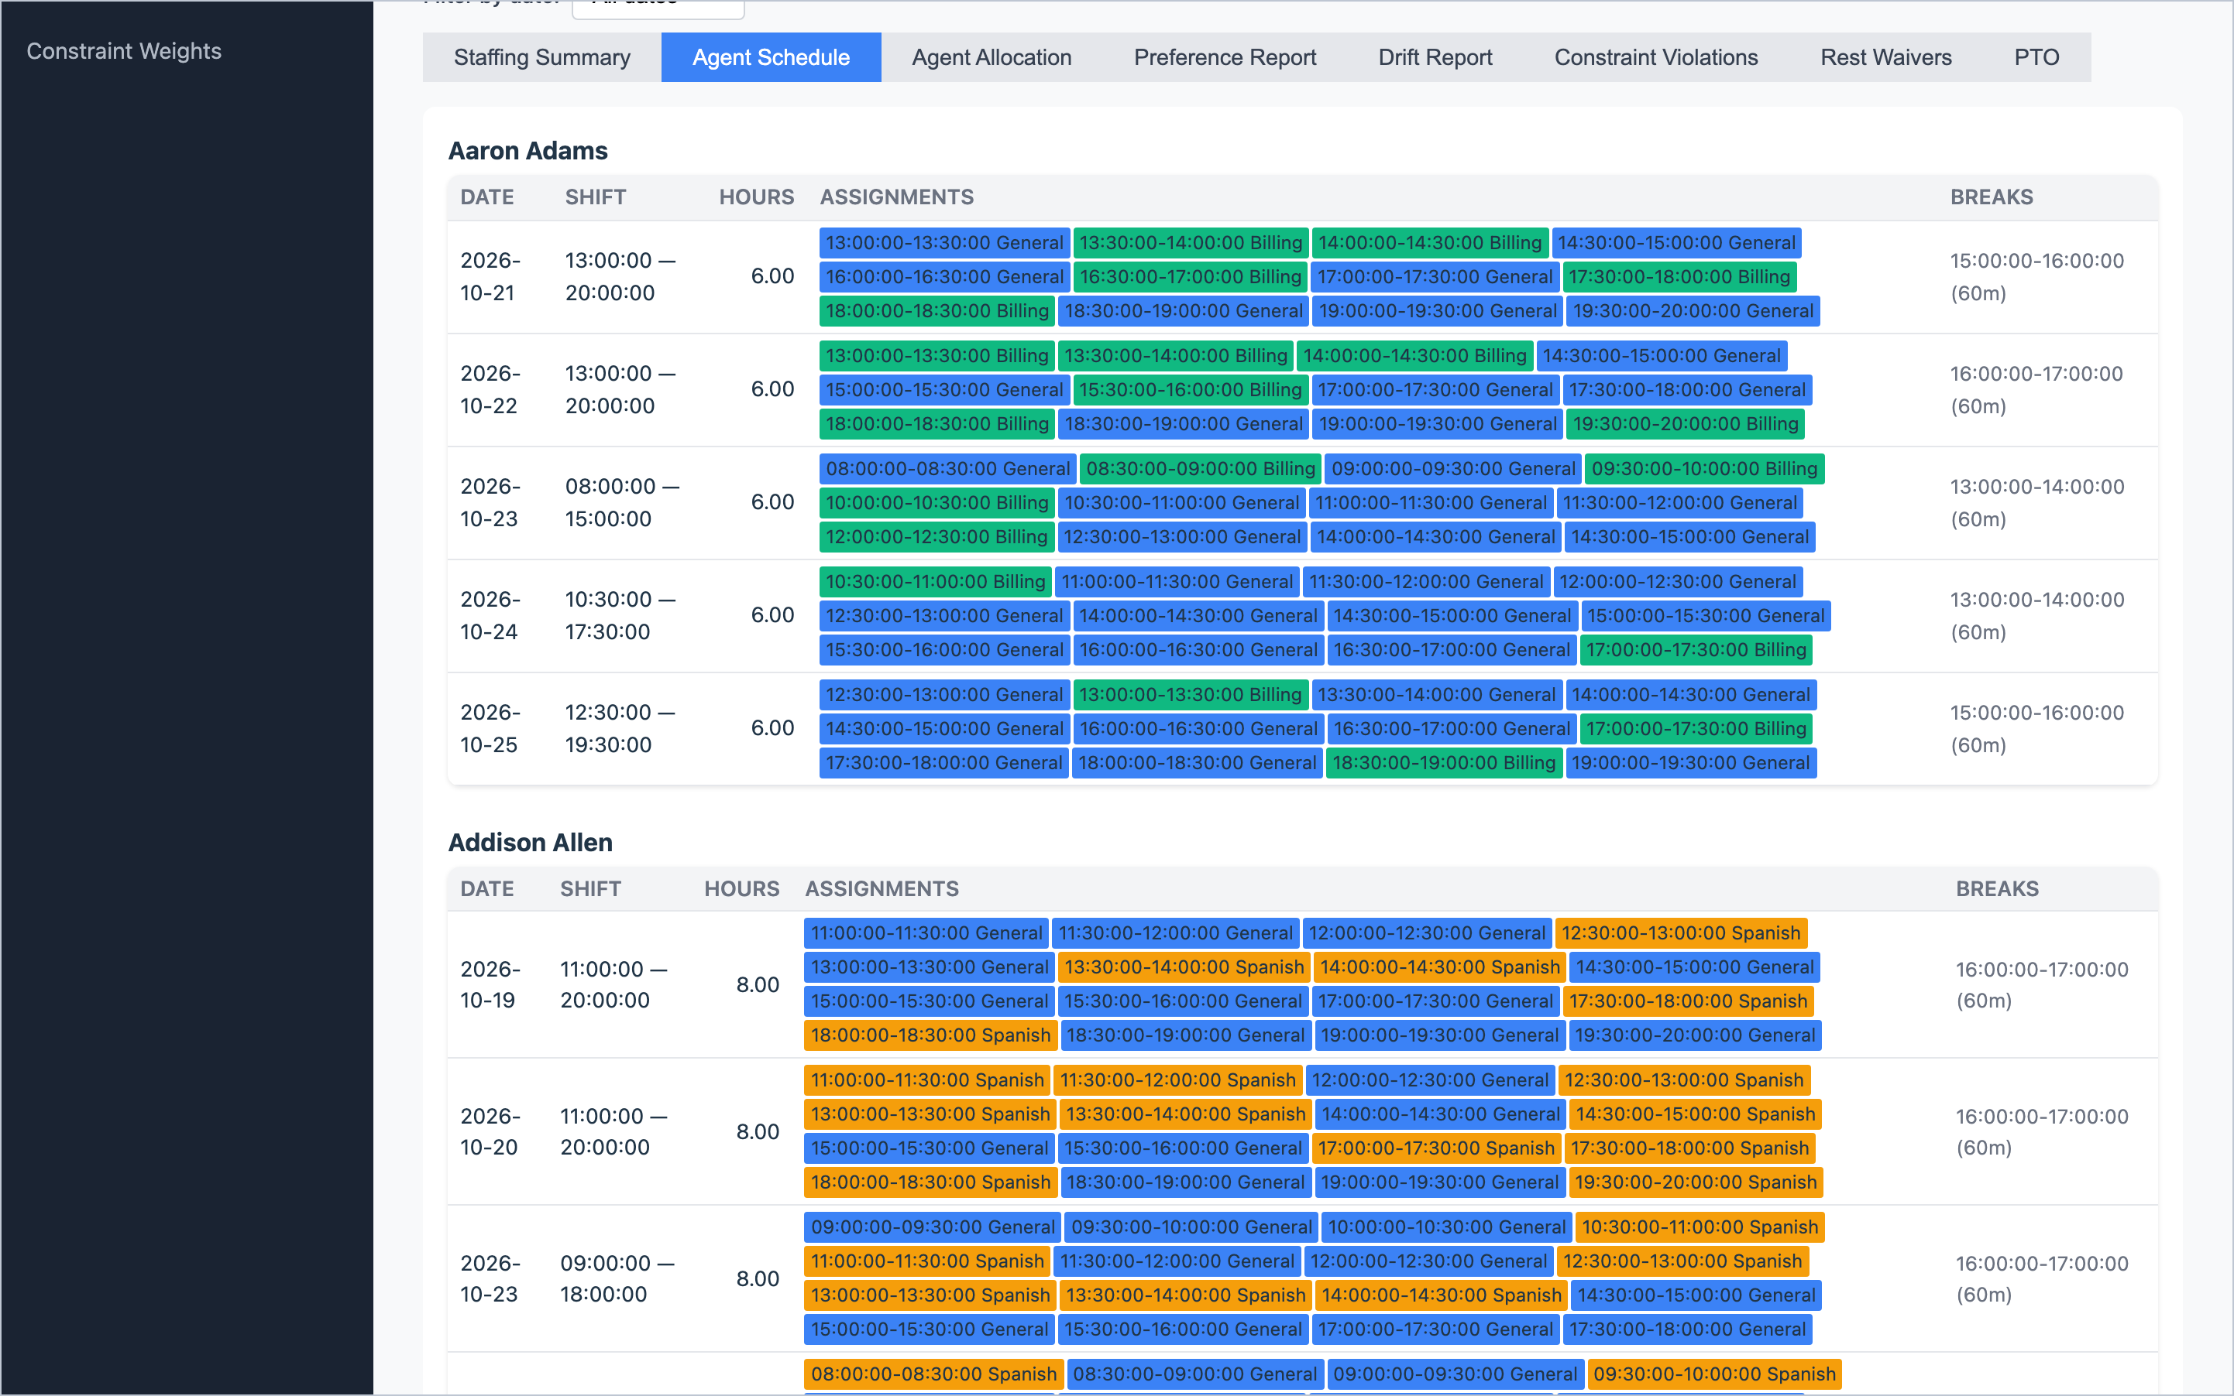
Figure 23 – Agent Schedule: shift, hours, coloured skill blocks and break for each day.
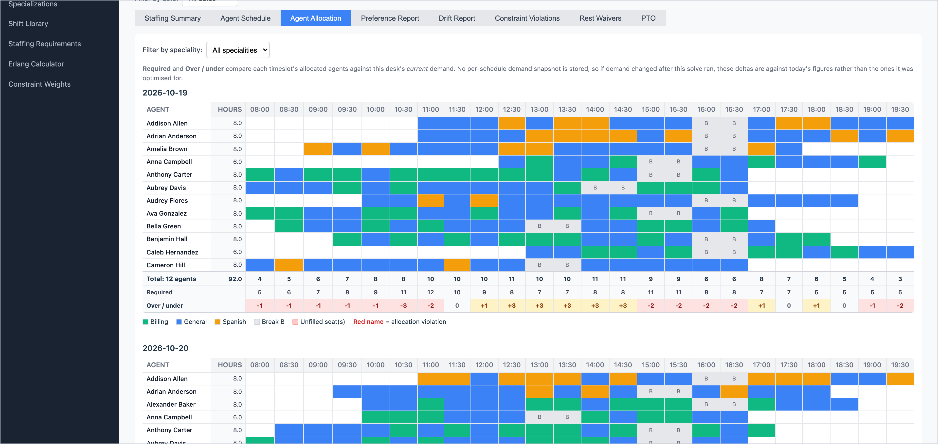
Figure 24 – Agent Allocation: the day as a timeline. The rows at the bottom compare scheduled agents with demand.
In Agent Allocation, the bottom rows read: Total (agents working in each timeslot), Required (your demand) and Over / under (the difference). An agent's name in red means they are involved in a broken rule.
Note: The Required and Over / under rows compare against today's demand. If you have changed demand since the schedule was solved, these rows reflect the new figures.

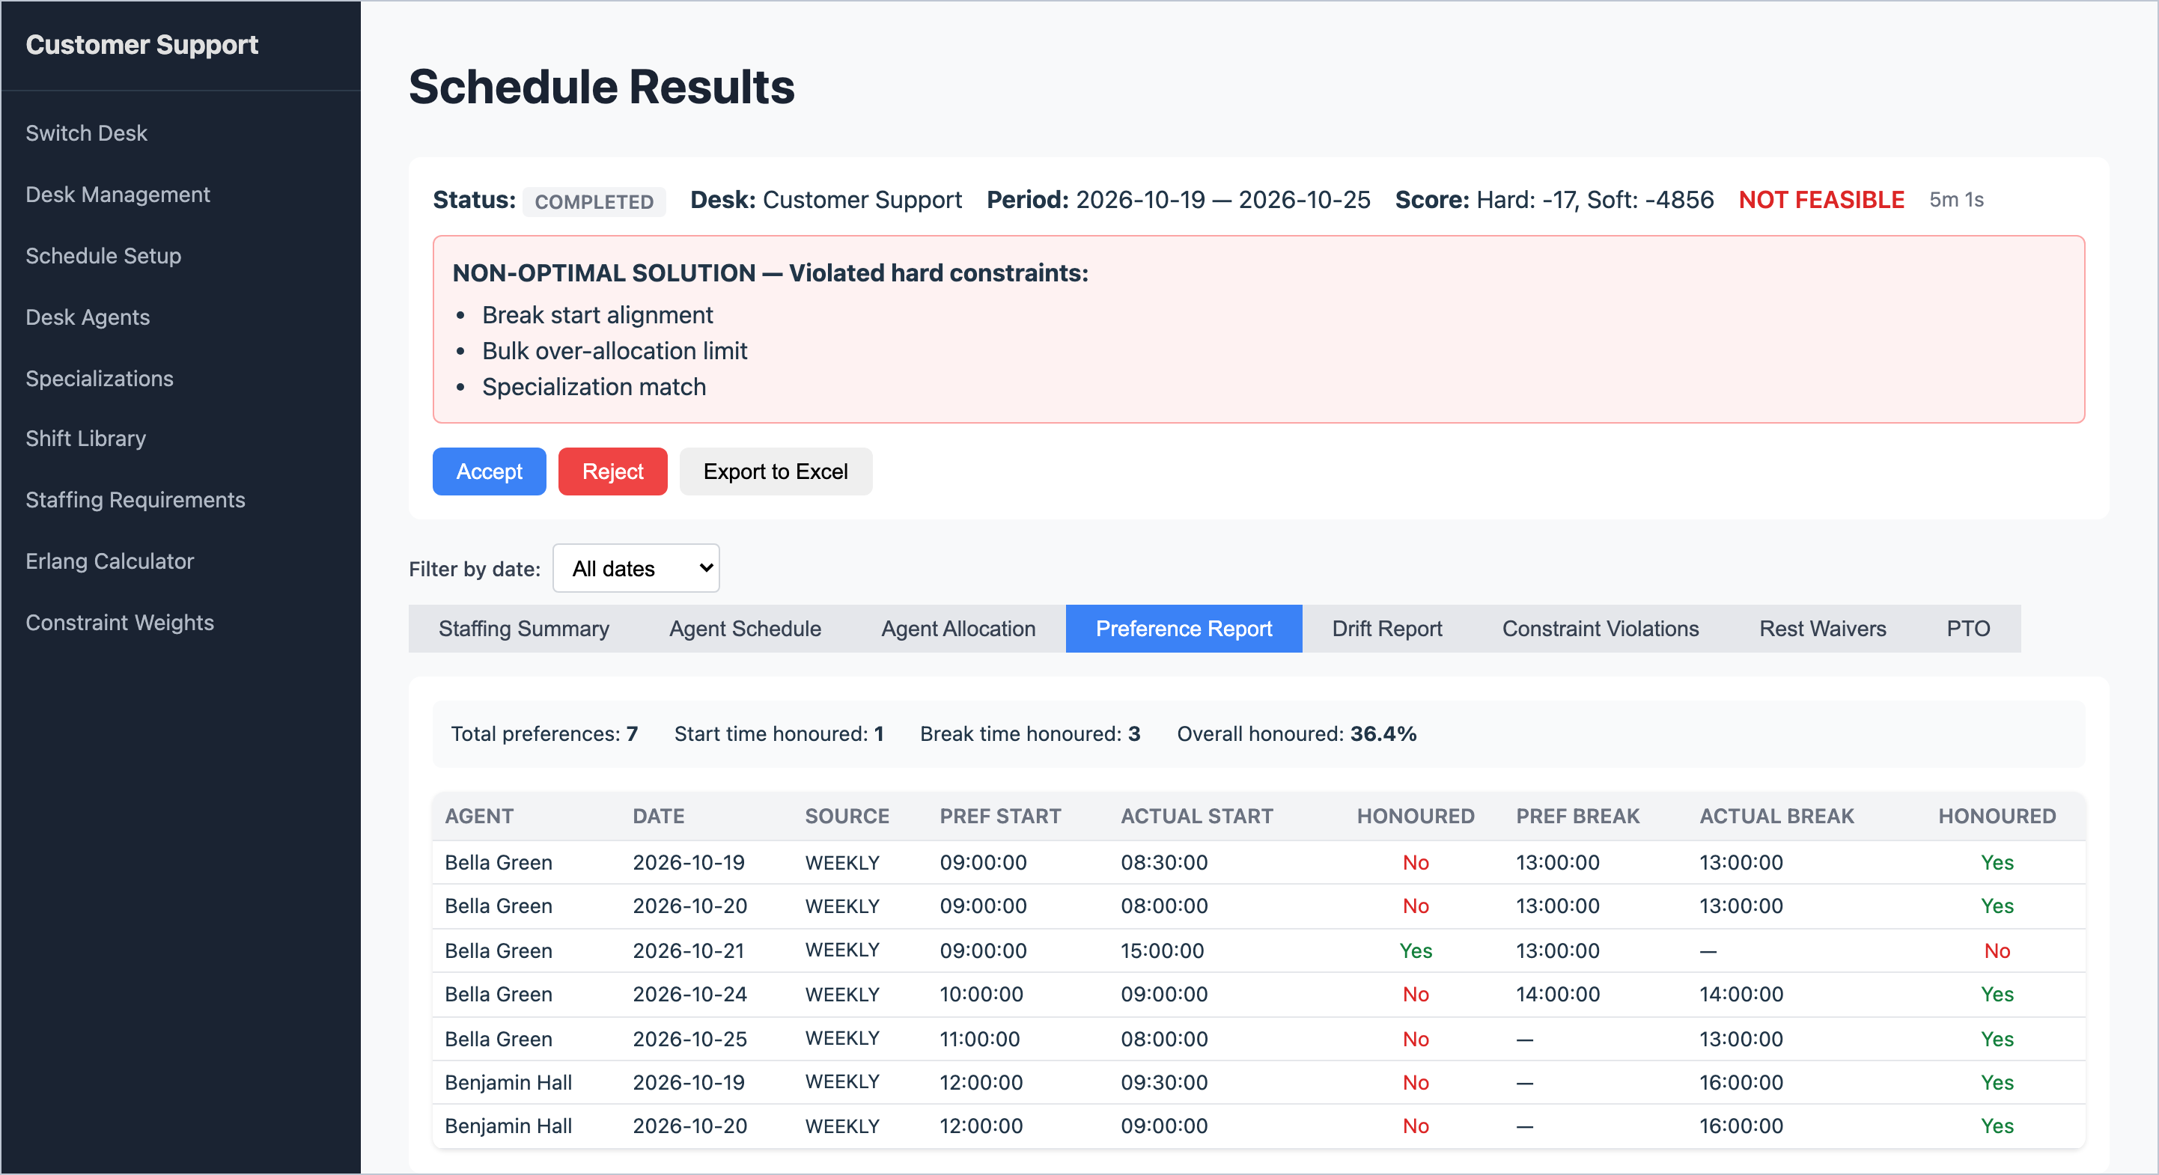
Figure 25 – Preference Report: which start and break preferences were honoured.
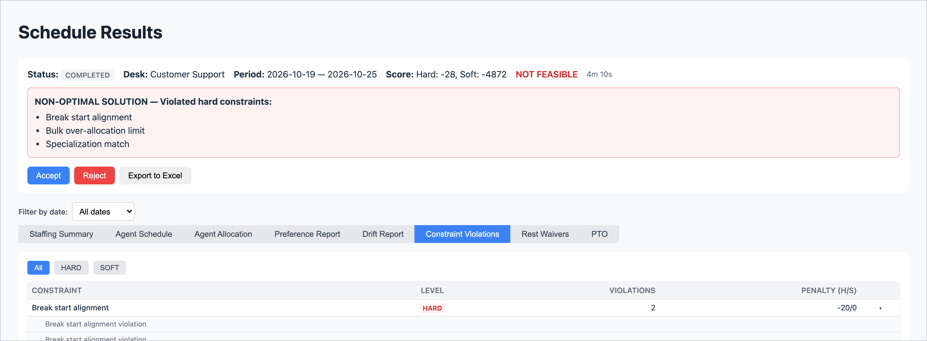
Figure 26 – Constraint Violations: click a rule to see each case.

When the result is not good enough
What you see | Likely cause | Try this
Capacity warning; low coverage on some days | Not enough agent hours for the demand. | Check rest days and time off on busy days; add agents or hours; reduce demand.
"Specialization match" violations | Not enough agents with a skill on some days. | Give more agents that skill as a backup (secondary) skill.
"Bulk over-allocation limit" / "Bulk under-allocation hard" | Timeslots too far above or below demand, often where demand is only 1–2 agents. | Widen the limits on Schedule Setup (e.g. 150% / 60%) or smooth the demand.
"Contracted hours (under)" | Agents could not be given all their hours. | Usually more agent hours than demand. Check demand, or reduce hours.
Break rule violations | Break settings are too tight for the shift lengths. | Shorten Break Blocked Hours, or choose a looser Break Alignment.
Low preference honoured % | Demand leaves little room. | Normal when tight. Raise the preference weights (chapter 15) if preferences matter more.
Still close but not perfect | Not enough solve time. | Increase Solve Time and solve again.

14. Accepting, rejecting and exporting
Button | What it does
Accept | Saves the schedule permanently. If it has broken rules you are asked to confirm. It replaces any earlier accepted schedule for the same dates.
Reject | Throws the schedule away (after you confirm) and returns to Schedule Setup. Your agents, preferences and demand are not affected, so you can adjust and solve again.
Export to Excel | Downloads the schedule as an Excel workbook. Available whenever the solver is not running.

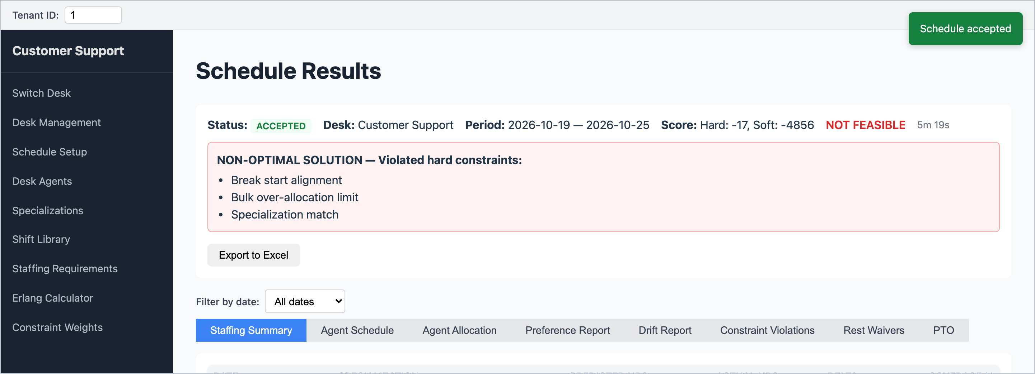
Figure 27 – After accepting: the status changes to ACCEPTED and a green confirmation appears.
Accepted schedules are listed under Past Schedules at the bottom of Schedule Setup. Click View to open one again. Delete permanently removes an accepted schedule.
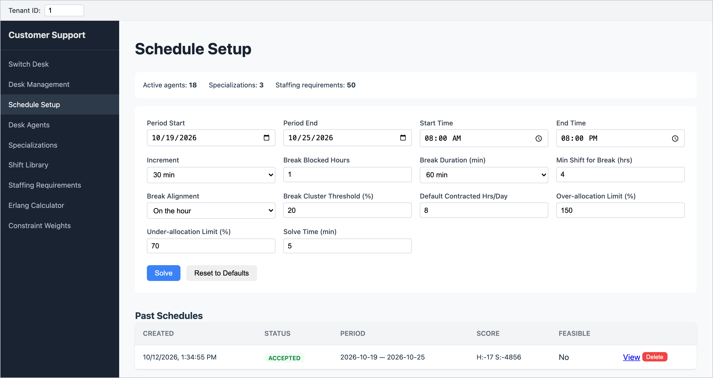
Figure 28 – Past Schedules on the Schedule Setup page.

What is in the Excel export
Sheet | Contents
Overview | Desk, status, period, opening hours, increment.
Staffing Summary | Hours needed vs. scheduled per day and skill, with coverage %.
Agent Schedule | One row per agent per timeslot block: date, start, end, skill, break.
Roster | Agents down the side, days across the top, shift times in each cell (or PTO / MANDATORY). The easiest sheet to share with the team.
Allocation (one per day) | The timeline grid for each day, with breaks marked "B".
Preference Report | Preferences and whether they were honoured.
Constraint Violations | Broken rules, with details.
PTO | Who is off on each date.

15. Constraint Weights
Constraint Weights control how strongly the scheduler treats each rule. Most Team Leads never need to change them; agree any change with your WFM lead or administrator first. Changes apply to the next solve only.
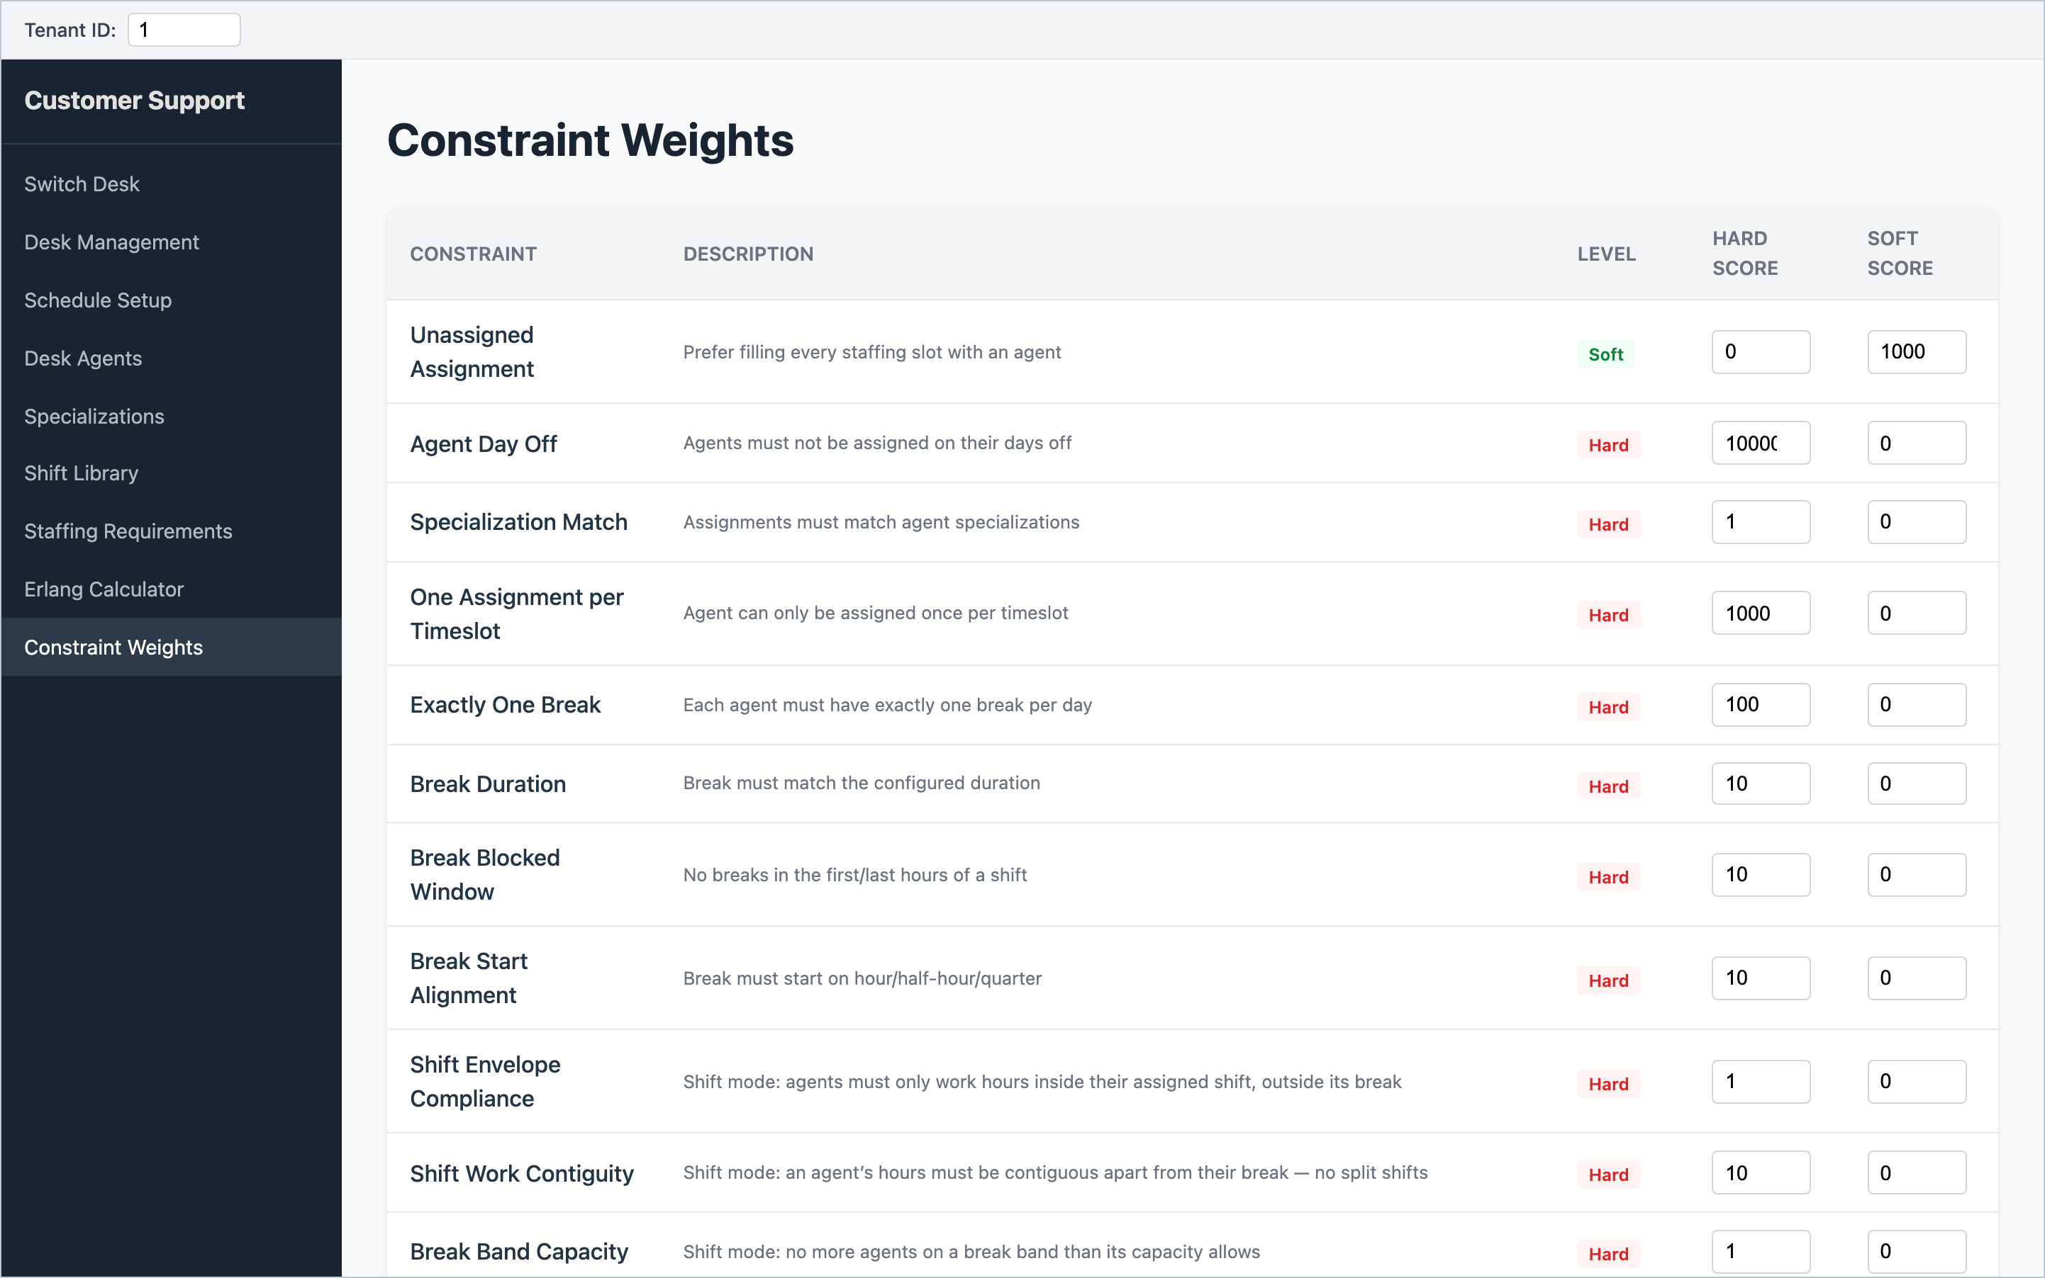
Figure 29 – Constraint Weights: each rule has a Hard and a Soft score.
- A Hard Score above 0 makes the rule mandatory (badge Hard). The bigger the number, the more it matters.
- A Soft Score makes the rule a preference (badge Soft). Bigger means more important.
- Setting both to 0 switches the rule off.
- Click Save to keep changes.
Common adjustments:
If you want… | Change
Agents' start and break preferences honoured more often | Increase the Soft Score of Honour Preferred Start Time and Honour Preferred Break Time.
Agents kept on their main skill where possible | Increase the Soft Score of Prefer Primary Specialization.
Coverage pushed closer to 100% everywhere | Increase the Soft Score of Bulk Under-allocation (Soft).
At least one person in every timeslot, even with no demand | Increase the Soft Score of Minimum Staffing.

Watch out: Reset to Defaults on this page fills in values that differ from the system's original settings (for example, several hard rules drop from 10–10,000 to 1). Write down the current values before pressing it, and remember nothing is changed until you click Save.

16. Shift-based scheduling
By default the scheduler builds each agent's day freely from timeslots (Slot-scheduled). Some desks prefer agents to work fixed patterns such as "Early 08:00–17:00" or "Late 11:00–20:00". For those, switch the desk to Shift-scheduled and build a Shift Library. Most Team Leads will not need this chapter.
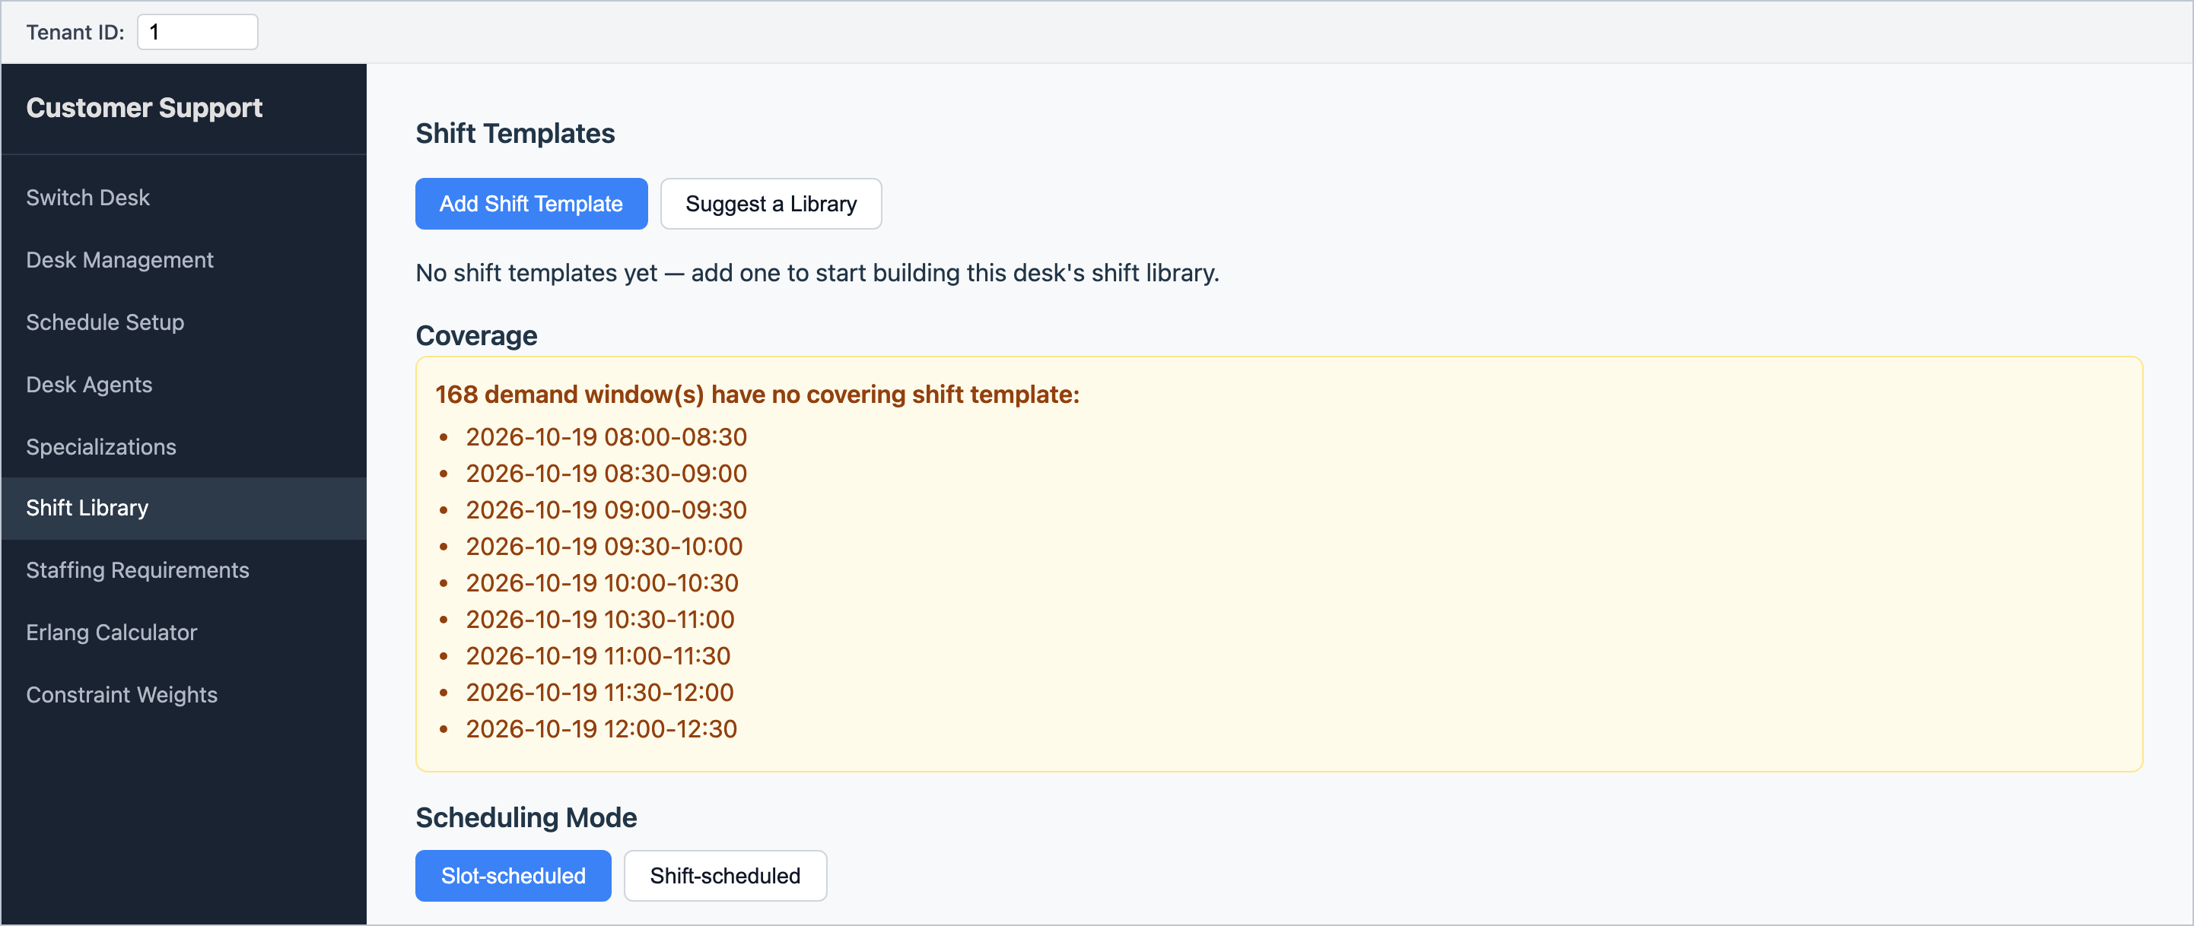
Figure 30 – The Shift Library: templates at the top, a coverage check, and the scheduling mode switch at the bottom.

Adding a shift template
1. Open Shift Library and click Add Shift Template.
2. Enter a Name, Start time and End time.
3. Click + Add Break Band for each place the break may go: the break start time, its Duration (minutes), and optionally a Capacity (the most agents who can take that break slot on one day). Each agent takes exactly one of the bands.
4. Tick the weekdays the shift can be used, and set Effective from (and optionally Effective to).
5. Click Save.
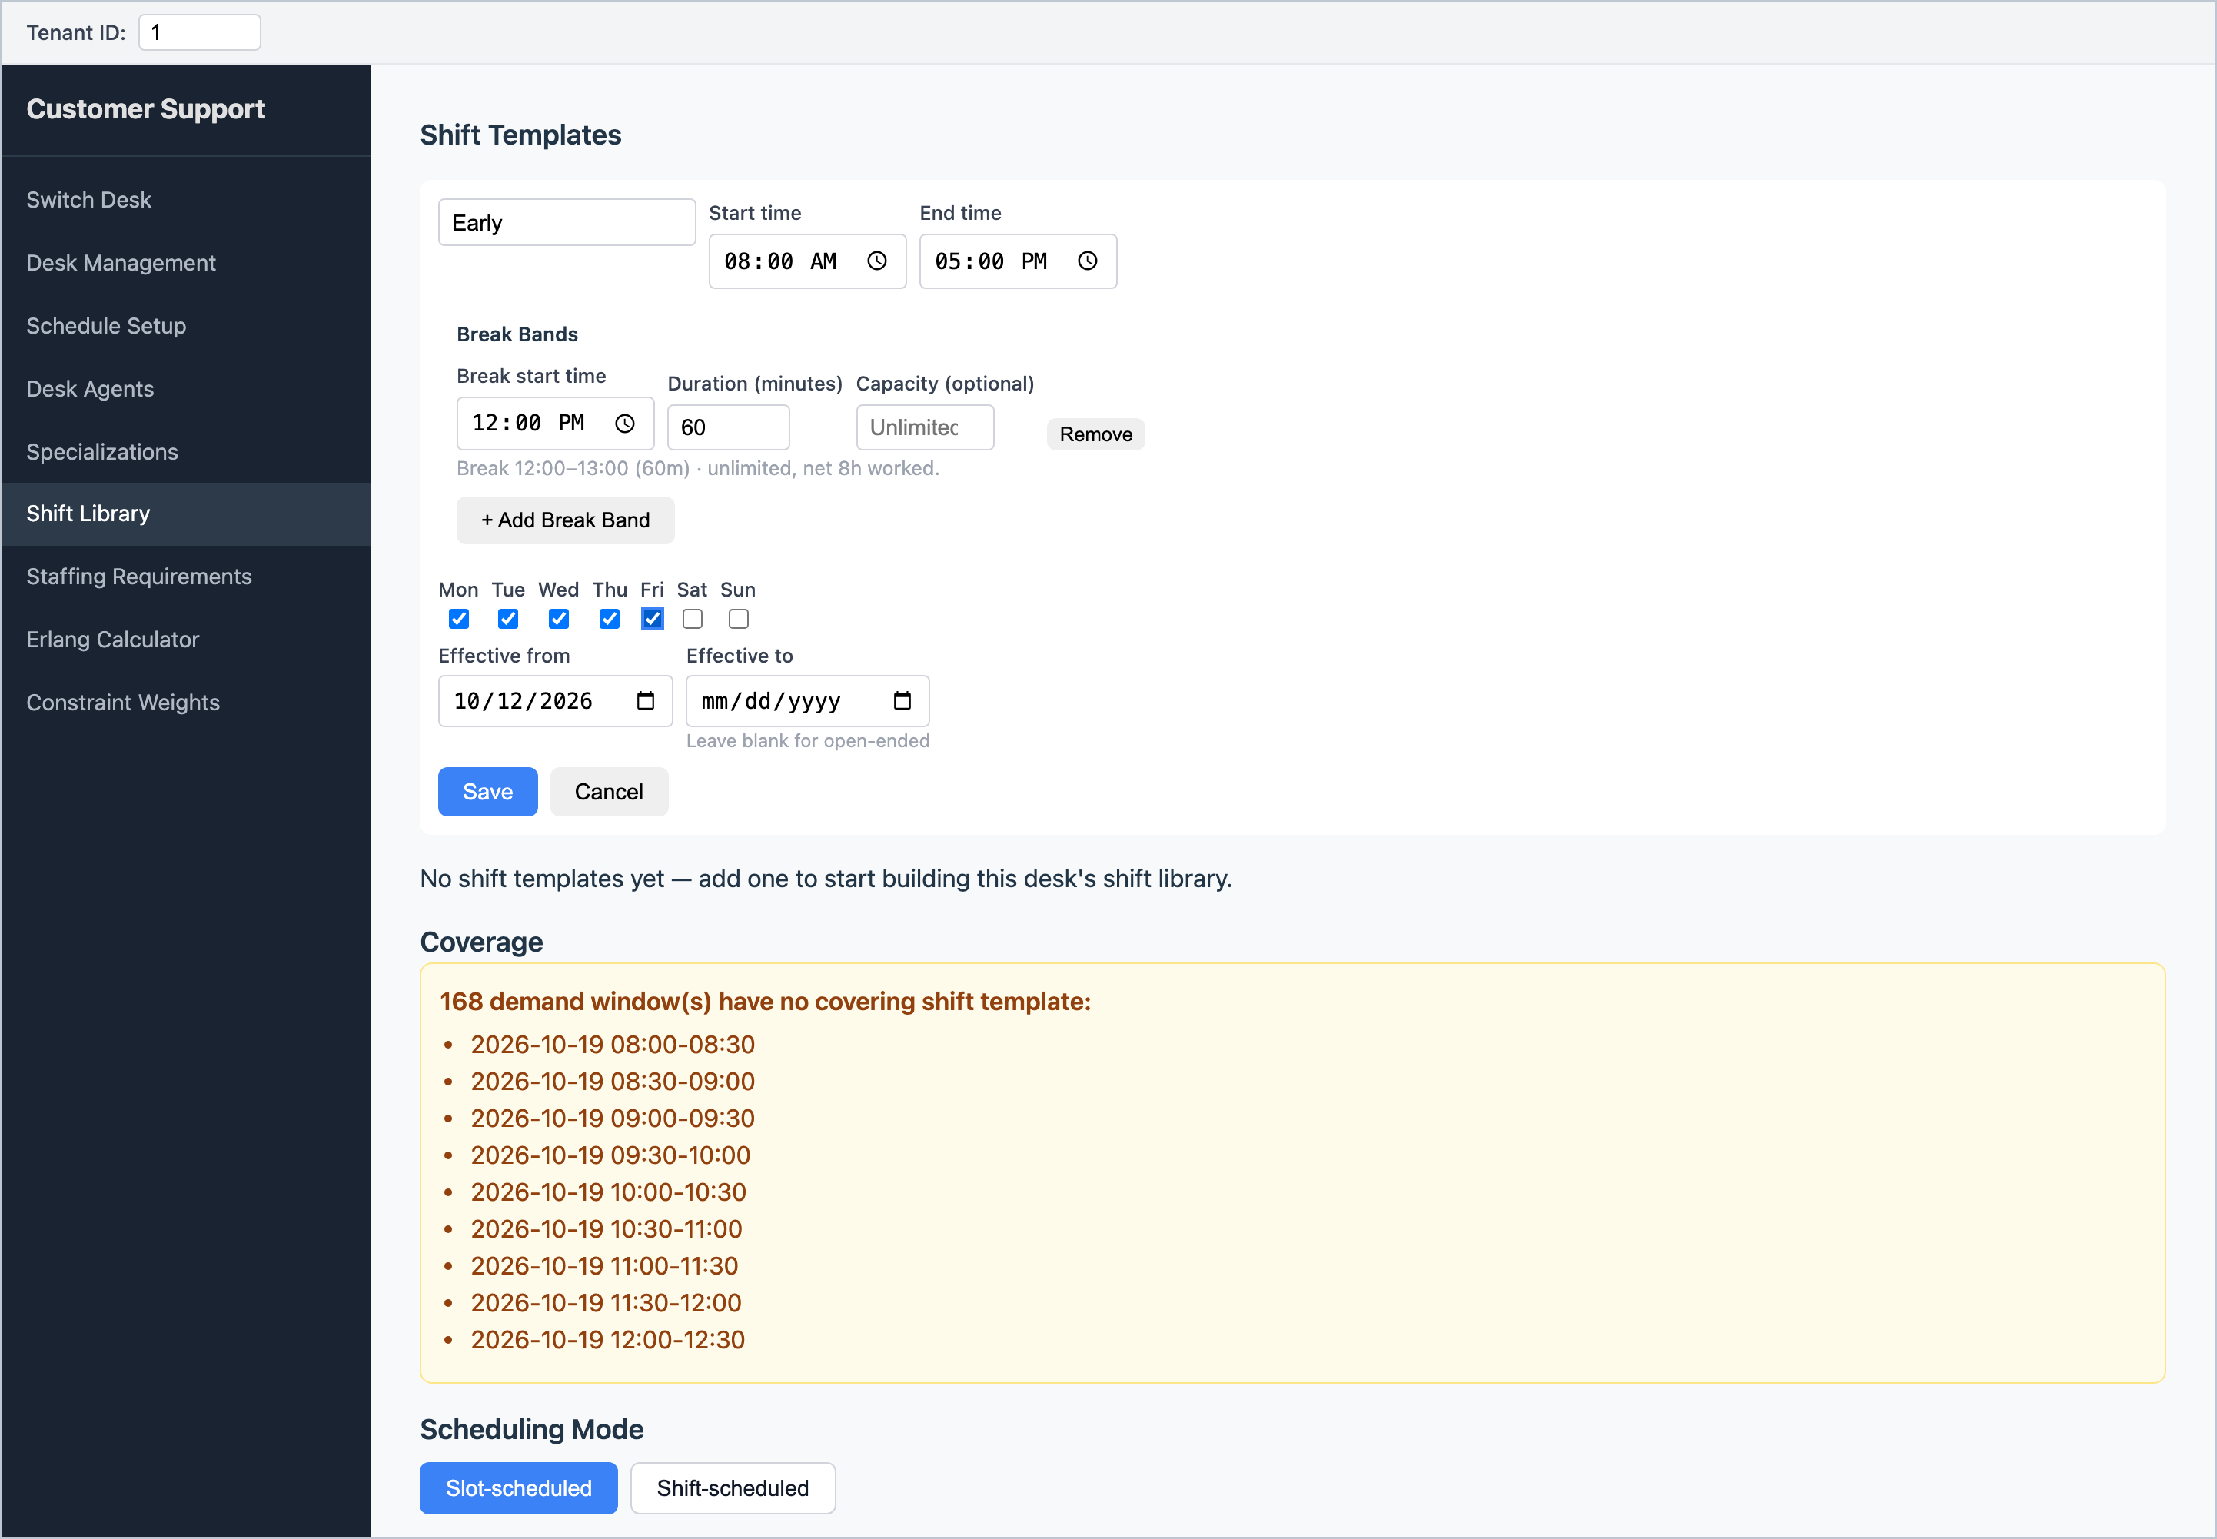
Figure 31 – A new template: "Early", 08:00–17:00, one-hour break at 12:00, Monday to Friday.

Checking coverage and switching mode
- The Coverage box lists any demand timeslots no shift covers. It shows a green tick when everything is covered.
- Warning symbols (⚠) in the template table point out shifts whose hours do not match any agent's hours, or whose break capacity is too small or too loose. Hover over them to read the details.
- When coverage is complete, click Shift-scheduled under Scheduling Mode. The switch is refused (and the reason shown) if demand is missing or not covered. You can switch back to Slot-scheduled at any time, except while a schedule is solving.
- In shift mode, each agent's hours on a day must match the net hours (length minus break) of a shift that runs that weekday.
- Suggest a Library proposes templates from your demand and agents' hours. Suggestions are not saved until you save each one. For desks with long opening hours or many different contract lengths it may decline ("exceeding the cap of 200").
To change a shift from a future date, Retire the current version with an end date the day before the change, then add a new template with the same name starting on the change date. A template that has been used in a schedule cannot be deleted; retire it instead.

17. Administrator settings
The Configuration page (from the desk selector) holds settings that affect every desk. These are normally managed by an administrator.
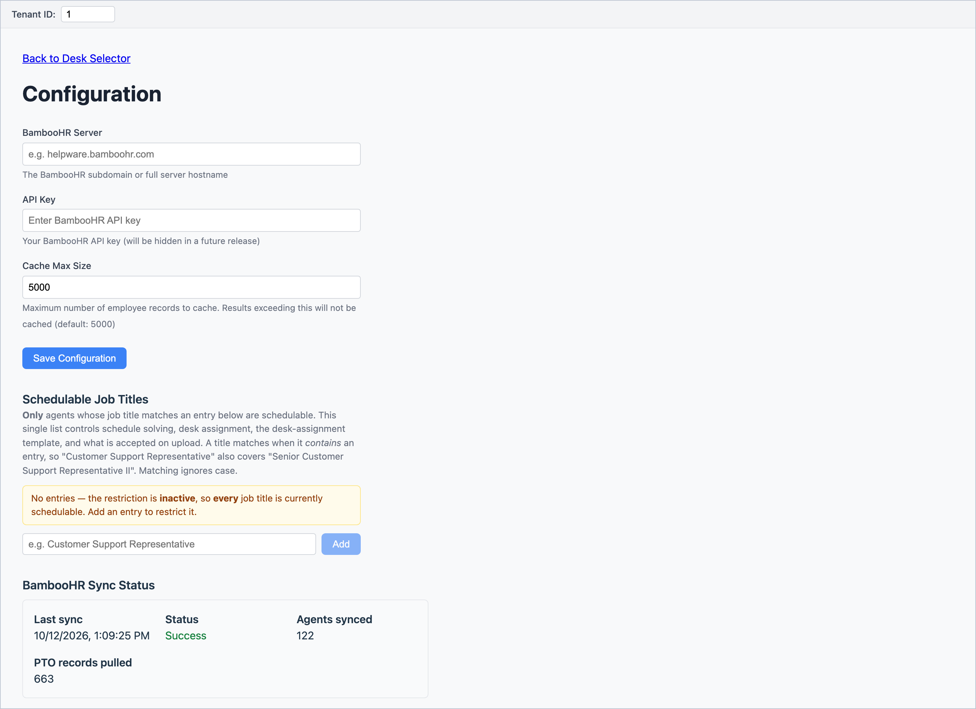
Figure 32 – Configuration: BambooHR connection, schedulable job titles and the last sync status.
Section | What it does
BambooHR Server / API Key | The connection to BambooHR. If these are blank, the system uses built-in test data instead of real employees.
Schedulable Job Titles | Only people whose job title contains one of these entries can be put on desks and scheduled (capitals are ignored). If the list is empty, every job title is allowed.
BambooHR Sync Status | When the last "Refresh from BambooHR" ran and whether it succeeded.

Tip: If a person you expect is missing in Client Management, check their job title against the Schedulable Job Titles list. Matching is by "contains", so "Customer Service Representative" does not match "Customer Support Representative".

18. Troubleshooting
When you click Solve, the scheduler checks your setup first and lists every problem it finds. The most common messages:
Message (or part of it) | What to do
"Please select both a period start and end date" | Fill in Period Start and Period End on Schedule Setup.
"Schedule period must be between 1 and 31 days" | Shorten the period, or check the end date is after the start date.
"No timeslots found for date …" or "… does not match timeslot …" | Open Staffing Requirements once (it rebuilds the grid for the current setup), check your demand, then solve again.
"Agent … must have a primary specialization assigned" | Give that agent a main skill on Desk Agents.
"Agent … has contracted hours … which is not a multiple of …" | Change the agent's hours to fit the increment (e.g. 7.5 rather than 7.75 for 30-minute slots), or use a smaller increment.
"No staffing requirements found for the schedule period" | Enter demand on Staffing Requirements (and click Save in Direct mode).
"No active agents are available …" | Everyone is off for the whole period. Check rest days and time off.
"breakDurationMinutes (…) must be a positive multiple of incrementMinutes (…)" | Re-choose Break Duration on Schedule Setup after changing the increment.
"… preferred break time … does not conform to alignment …" | Change that agent's break preference to fit the Break Alignment, or change the alignment.
"Agent … needs … hours window (incl. break) but coverage window is only …" | Widen Start/End Time, or reduce the agent's hours or the break length.
"Agent … has both an exception and a day off on …" | Delete the exception for that date.
"Specialization '…' has staffing demand but no eligible desk-agent" | Give at least one available agent that skill, or remove that demand.
"A schedule already exists for this desk …" | Open it from Past Schedules (or the results page) and Accept or Reject it first.

Other common questions
Question | Answer
My Schedule Setup values have disappeared. | They are stored in your web browser. A different browser or computer, or clearing browsing data, starts fresh. Re-enter them.
My demand went back to 0. | The dates, times or increment changed, so the grid was rebuilt. Re-enter demand for the new grid.
An agent is never scheduled. | Check they have a main skill, are Active, and do not have MANDATORY, PTO or 0 hours on the days in question. Also check their exceptions (an override of 0 means a day off).
After uploading the desk spreadsheet, preferences and exceptions are gone. | This is expected: the upload replaces the desk. Re-enter them, or upload preferences again.
Someone is on time off but BambooHR has been corrected. | Click Refresh from BambooHR on Desk Agents.
I cannot change Day Start. | It is locked once the desk has an accepted schedule.

19. Glossary
Term | Meaning
Accept | Save a schedule permanently.
AHT | Average handle time: the average length of a contact in seconds, including after-call work.
BambooHR | The HR system the scheduler takes people and time off from.
Break band | In shift mode, one of the allowed break times in a shift template.
Concurrency | How many contacts one agent handles at once (1 for phone, more for chat).
Constraint | A scheduling rule, such as "no work on days off".
Coverage % | Hours scheduled as a percentage of hours needed.
Day Start | The time the desk's day begins (normally midnight).
Demand | The number of agents needed per timeslot and skill.
Erlang C / Erlang X | Formulas that turn call volumes into required agents. Erlang X also allows for callers hanging up.
Exception | Different working hours for one agent on one date.
Feasible | No hard rules broken (Hard score 0).
FTE | Full-time equivalent. In this tool: number of agents.
Increment | The length of a timeslot: 15, 30 or 60 minutes.
MANDATORY | A rest day or holiday: never scheduled.
Occupancy | The share of time agents spend handling contacts.
Preference | An agent's wished-for start or break time. Honoured where possible.
PTO | Paid time off.
Rest waiver | Permission for an agent to have less than the minimum rest before one shift.
Score | Hard and soft penalty totals; 0 is best.
Shrinkage | Time agents are paid but not available (absence, training, meetings), as a %.
Slot / Shift mode | Slot builds each day from timeslots; Shift uses fixed shift templates.
Solve | Ask the scheduler to build a schedule.
Specialization | A skill. Primary = main skill; secondary = backup skills.
Timeslot | A block of the day of the chosen increment.

