OCEANS AND ATMOSPHERE

Southern Ocean Time Series (SOTS)



Quality Assessment and Control Report

Remote Access Sampler: Sample Analysis

**Version 1.0**

Phytoplankton analysis

2009-2018

Ruth S. Eriksen, Diana M. Davies, Cathryn A. Wynn-Edwards, Thomas W. Trull

Australian Government Bureau of Meteorology

Citation

Eriksen, R.S, Davies, D.M, Wynn-Edwards, C.A, Trull, T.W

(2020) Southern Ocean Time Series (SOTS) Quality Assessment and Control Report Remote Access Sampler Sample Analysis. Phytoplankton analysis. Version 1.0 CSIRO, Australia. DOI: XXXXXX

Copyright

© Commonwealth Scientific and Industrial Research Organisation 2017. To the extent permitted by law, all rights are reserved and no part of this publication covered by copyright may be reproduced or copied in any form or by any means except with the written permission of CSIRO.

Important disclaimer

CSIRO advises that the information contained in this publication comprises general statements based on scientific research. The reader is advised and needs to be aware that such information may be incomplete or unable to be used in any specific situation. No reliance or actions must therefore be made on that information without seeking prior expert professional, scientific and technical advice. To the extent permitted by law, CSIRO (including its employees and consultants) excludes all liability to any person for any consequences, including but not limited to all losses, damages, costs, expenses and any other compensation, arising directly or indirectly from using this publication (in part or in whole) and any information or material contained in it.

CSIRO is committed to providing web accessible content wherever possible. If you are having difficulties with accessing this document please contact [csiroenquiries@csiro.au](mailto:csiroenquiries@csiro.au).

Foreword

The Southern Ocean Time Series (SOTS) is a Sub-Facility of the Australian Integrated Marine Observing System (IMOS), funded by the National Collaborative Research Infrastructure Strategy (NCRIS). It is operated under collaborative arrangements among the CSIRO Oceans and Atmosphere, Bureau of Meteorology, and University of Tasmania, including via the Antarctic Climate and Ecosystems Cooperative Research Centre and the Australian Antarctic Program Partnership. The primary focus is sustained observing of ocean properties and processes important to climate, carbon cycling, and ocean productivity.

The SOTS Sub-Facility consists of deep ocean moorings deployed in Subantarctic waters southwest of Tasmania, equipped with autonomous sensors and sample collectors. SOTS moorings are serviced annually and during this time the existing moorings are recovered, and new moorings are deployed. Some sensor data is transmitted from the moorings via satellite in near real time. Other sensor data and samples are recovered during the annual service visit.

This report details the quality assessment and control procedures applied to the phytoplankton samples from the Remote Access Sampler deployed on SOFS and Pulse moorings. The datasets are publicly available via the AODN Portal <https://portal.aodn.org.au/search>.

Contents

Foreword ii

Contents iii

Figures iv

Tables v

Acknowledgments vi

Executive summary vii

1 Introduction 1

1.1 Phytoplankton samples 1

2 Quality assurance of sample collection and analysis 3

2.1 Preparation of the RAS. 3

2.2 Preservation of samples 4

2.3 Analysis of samples 4

2.4 Data entry 8

2.5 Taxonomic entities 9

2.6 Analyst training 9

2.7 Supplementary plankton data 9

3 Quality assessment of the recovered RAS samples 10

3.1 Condition of recovered bags 10

4 Recommendations for Quality Assurance 10

Figures

Figure 1 SEM images summarising five common *Emiliania huxleyi* morphotypes observed at the SOTS: (a) Type A over calcified (AOC), (b) A, (c) B, (d) B/C with central area covered by a thin plate, (e) B/C with open central area and (f) C. SL = Slit Length (yellow bar), TW = Tube Width (red bar). Scale bars = 1 μm. Images R Eriksen, courtesy of AAD, and published in Rigual-Hernandez et al. (2020). 4

Figure 2 Pulse 7 light microscopy images. Top row diatoms and silicoflagellates: 1) *Thalassiosira* sp. chain 2) *Leptocylindrus mediterraneus* (with symbiont *Solenicola setigera*) 3) *Corethron pennatum* 4, 5) *Planktoniella sol* (valve and girdle view) 6) *Guinardia cylindrus* 7) *Rhizosolenia* sp 8) *Chaetoceros* sp. 9) *Cylindrotheca closterium* 10) *Stephanocha speculum* 11) *Dictyocha* cf *stapedia*. Middle; dinoflagellates: 12) *Tripos pentagonus/lineatus* complex 13) *Protoperidinium* sp 14) *Tripos* *symmetricus* 15) *Dinophysis* sp. 16) Gymnodiniod sp. 17) *Karenia* sp. 18) *Oxytoxum* sp. 19) *Prorocentrum* *balticum*. Bottom; ciliates, appendicularia and flagellates: 20) Ciliate 21) *Dinobryon* colony 22) *Eutreptiella* sp 23) *Parvicorbicula* sp 24) *Pyramimonas* sp. 25) *Phaeocystis* *antarctica* 26) *Rhabdonella* sp. 27) *Oikopleura* 28) *Dictyocysta* *mitra* 29) *Salpingella* sp. Scale bars 2-25 are 20 μm; 1, 26-29 are 50 μm. Images R Eriksen, and published in Eriksen et al. (2020). 5

Figure 3 Phytoplankton counts per litre and biovolume µm3 L-1, Pulse7 through to Pulse11 moorings showing the consistency of the data across deployments and the dominance of *Phaeocystis antarctica* in cell numbers but not volume. 6

Figure 4 Phytoplankton counts per litre and biovolume µm3 L-1 per day of the year, Pulse7 to Pulse11. 7

Tables

Table 1. McLane RAS sampler deployments summary for the period 2009 - 2018. Samples were collected in pairs one hour apart (1 for nutrients, 1 for phytoplankton) on each sampling date. 1

Table 2. Instrument deployment and retrieval summary for RAS sampler deployments. * indicates samples archived on SEM filters, ** Mercuric chloride pair archived on SEM filters. 2

Table 3 Attribute statement for Southern Ocean Time Series (SOTS) - Phytoplankton Abundance and Biovolume 8

Acknowledgments

We acknowledge support from the following agencies: the Australian Antarctic Program Partnership (AAPP), the Antarctic Climate and Ecosystems Cooperative Research Centre (ACE CRC), the Integrated Marine Observing System ([www.imos.org.au](http://www.imos.org.au)), University of Tasmania (UTAS), Bureau of Meteorology (BoM), and the Marine National Facility (MNF). In particular, we thank Rick Van den Enden, Karen Westwood and Andrew Davidson from the Australian Antarctic Division (AAD) for ongoing support, expertise and access to instrumentation. We also acknowledge the support of the CSIRO Moored Sensor Systems team, and Claire Davies and Margaret Miller (CSIRO) for database support and development.

SOTS is a member of the OceanSITES global network of time series observatories. ([www.OceanSITES.org](http://www.OceanSITES.org)).

Executive summary

The Southern Ocean Time Series (SOTS) Observatory located near 140E and 47S provides high temporal resolution observations in sub-Antarctic waters. It is focused on the sub-Antarctic Zone because waters formed at the surface in this region slide under warmer subtropical and tropical waters, carrying CO2 and heat into the deep ocean, where it is out of contact with the atmosphere. This process also supplies oxygen for deep ocean ecosystems, and exports nutrients that fuel ~70% of global ocean primary production. This region is also the boundary between the nutrient rich waters of the Southern Ocean and the oligotrophic subtropical gyres to the north. These processes are sensitive to climate change, but the probable nature and impacts are not yet known.

This report details the quality control procedures applied to the data from samples collected by the Remote Access water Sampler (McLane RAS 500) deployed on the SOTS and Pulse moorings between 2009 and 2019. The quality-controlled datasets are publicly available via the IMOS Data Portal. This report should be consulted when using the data. Data users are encouraged to contact the analyst for detailed information on taxonomic entities and groupings.

# Introduction

Detailed descriptions of mooring designs, locations and sample collections are provided in the Southern Ocean Time Series (SOTS) Annual Reports, which are divided into three parts,

**Report 1. Overview**, listing mooring voyages, dates, locations, designs and instruments;

**Report 2. Samples**, detailing the sample collections and

**Report 3. Sensors**, which contains descriptions and data QC procedures of the sensors mounted on the moorings.

The reports are available via the Australian Ocean Data Network (AODN) at:

<https://catalogue-imos.aodn.org.au/geonetwork/srv/eng/metadata.show?uuid=afc166ce-6b34-44d9-b64c-8bb10fd43a07>

## Phytoplankton samples

Briefly, the McLane Remote Automated Sampler (RAS) and instrumentation, covered by a rigid opaque protective shroud was located within the surface mixed layer below the mooring surface float, with the inlet at ~30 m depth for 2009 -2016 (see depth details in Table 1), or for more recent deployments (2018) within the surface float assembly (no shroud) with the inlet hose extending down the mooring chain to 4 m depth. Forty-eight x 500 mL samples were collected as pairs (1 for nutrients, 1 for phytoplankton community) 1 hour apart, at pre-programmed intervals varying between 9 and 14 days depending on the annual deployment duration (Table 2). Sample bags were pre-loaded with preservative, selected to provide the best preservation of the widest range of phytoplankton groups possible. To provide the greatest taxonomic coverage possible, samples are split for both light and electron microscopy examination.

The RAS sampler deployments for the SOTS are summarized in Table 1 (below). FluxPulse (2016 deployment) did not return samples because of mooring failure and the loss of the sampler. SOFS-7 failed early on deployment in 2018, but two samples (1 phytoplankton, 1 nutrient) were collected while the surface assembly was adrift. Pulse-9 and Pulse-10 were recovered before the sampler program was completed, due to logistical constraints associated with ship-time. Some deployments were affected by preservation artefacts as preservation protocols were optimised over time (Table 2). The harsh physical environment compounded by long deployment periods, and small sample volumes make for extremely challenging conditions for biological preservation of the whole phytoplankton community.

This QC report outlines the analysis steps and quality protocols applied to the RAS (McLane RAS 500) phytoplankton samples, and the associated taxonomic resources used to describe phytoplankton community composition at the SOTS site.

Quality Assurance is via careful preparation and deployment of the RAS and handling of the recovered samples. It does not lead to an uncertainty estimate or a quality control flag but is important to understand the overall fidelity of the observations. Because of the constant revision to taxonomic entities and associated difficulties in tracking species name changes, data is managed following the protocols outlined in the Australian Phytoplankton Database (Davies *et al.* 2017), and drawing on protocols developed for the IMOS National Reference Stations (Eriksen *et al.* 2019). Taxonomic composition is determined with reference to taxonomic texts and contemporary nomenclature is verified through resources such as the World Register of Marine Species ([WoRMS](http://www.marinespecies.org/)) and [Algaebase](https://www.algaebase.org/).

Quality Control is applied at the sample level and includes a quality assessment of the recovered RAS and samples. This includes the sample volume collected, data from associated sensors, sample appearance, etc. and leads to overall sample quality control flags as described for the paired nutrient samples by Davies et al (2020). Below sample level, i.e. for the taxonomic identification of specimens, we do not flag each record. However, rules are defined to ensure that if data exists for a specimen, then it is identified to a level at which the analyst is confident and will be comparable from sample to sample. Rules and protocols are based on those developed for the IMOS National Reference Stations (documented in Eriksen et al. (2019)).

Table 1. McLane RAS sampler deployments summary for the period 2009 - 2018. Samples were collected in pairs one hour apart (1 for nutrients, 1 for phytoplankton) on each sampling date.

|  |  |  |  |  |  |  |  |  |  |  |
| --- | --- | --- | --- | --- | --- | --- | --- | --- | --- | --- |
| Site | Mooring design | Deployment year | Latitude  (decimal degrees) | Longitude  (decimal degrees) | UTC Date deployed | UTC Date recovered | Depth (m) | RAS serial number | Total samples  returned | Phytoplankton samples returned |
| Pulse | Pulse-6 | 2009 | -46.3224 | 140.6776 | 2009-09-28 | 2010-03-18 | 32 | 11906-01 | 48 | 24 |
| Pulse | Pulse-7 | 2010 | -46.9347 | 142.2583 | 2010-09-12 | 2011-04-17 | 31 | 11906-01 | 48 | 24 |
| Pulse | Pulse-8 | 2011 | -46.9295 | 142.2147 | 2011-08-03 | 2012-07-19 | 34 | 11906-01 | 48 | 24 |
| Pulse | Pulse-9 | 2012 | -46.8493 | 142.3986 | 2012-07-17 | 2013-05-05 | 38 | 12709-01 | 32 | 16 |
| Pulse | Pulse-10 | 2013 | -46.9378 | 142.2847 | 2013-05-07 | 2013-10-13 | 28 | 11906-01 | 22 | 11 |
| Pulse | Pulse-11 | 2015 | -46.9405 | 142.3262 | 2015-03-25 | 2016-03-19 | 28 | 11906-01 | 48 | 24 |
| SOFS | FluxPulse-1 | 2016 | -46.7240 | 141.9297 | 2016-03-16 | 2016-06-23 | 30 | 12709-01 | 0 | 0 |
| SOFS | SOFS-7 | 2018 | -47.0111 | 142.2135 | 2018-03-06 | 2018-03-16 | 4 | 14384-01 | 2 | 1 |
| SOFS | SOFS-7.5 | 2018 | -47.0227 | 142.2334 | 2018-08-22 | 2019-03-22 | 4 | 14384-01 | 48 | 24 |

Table 2. Instrument deployment and retrieval summary for RAS sampler deployments. * indicates glutaraldehyde preserved samples (or each pair) archived on SEM filters, ** indicates mercuric chloride preserved samples of each pair, taken initially for dissolved component analyses, archived on SEM filters.

|  |  |  |  |  |  |  |  |  |  |  |
| --- | --- | --- | --- | --- | --- | --- | --- | --- | --- | --- |
| Site | Mooring design | Deployment voyage | Retrieval voyage | First sample UTC | Last  Sample  UTC | Depth (m) | RAS name | Phytoplankton samples analysed | Preservative type | Overall comment |
| Pulse | Pulse-6 | SS2009_04 | SS2010_V02 | 2009-09-30 | 2010-03-10 | 32 | Artemis | No* | Glutaraldehyde | Insufficient glutaraldehyde |
| Pulse | Pulse-7 | SS2010_V07 | SS2011_V01 | 2010-09-12 | 2011-04-07 | 31 | Artemis | Yes | Glutaraldehyde buffered with borate | Full complement of samples returned |
| Pulse | Pulse-8 | SS2011_V03 | SS2012_V03 | 2011-08-06 | 2012-07-16 | 34 | Artemis | Yes | 1% low acidity glutaraldehyde | Full complement of samples returned |
| Pulse | Pulse-9 | SS2012_V03 | SS2013_V03 | 2012-07-22 | 2013-04-18 | 38 | Apollo | No ** | 1% low acidity glutaraldehyde | Polymerisation of glutaraldehyde |
| Pulse | Pulse-10 | SS2013_V03 | SS2013_V06 | 2013-05-10 | 2013-10-07 | 28 | Artemis | Yes | 1% low acidity glutaraldehyde | Shortened deployment duration |
| Pulse | Pulse-11 | IN2015_V01 | IN2016_V02 | 2015-03-30 | 2016-09-03 | 28 | Artemis | Yes | 1% low acidity glutaraldehyde | Full complement of samples returned |
| SOFS | FluxPulse-1 | IN2016-V02 | NA | NA | NA | 30 | Apollo | No | 1% low acidity glutaraldehyde | Sampler lost |
| SOFS | SOFS-7 | IN2018_V02 | IN2018_V02 | 2018-03-13 | NA | 4 | Orpheus | Yes | 80µM mercuric chloride | Mooring failure  1 plankton sample |
| SOFS | SOFS-7.5 | IN2018_V07 | IN2019_V02 | 2018-08-27 | 2019-03-22 | 4 | Orpheus | Yes | 80µM mercuric chloride | Full complement of samples returned |

# Quality assurance of sample collection and analysis

## Preparation of the RAS.

Over the lifetime of the project, the configuration of the sampler has undergone design changes, along with the number and type of accompanying sensors. The various configurations and deployments are outlined in the relevant SOTS Annual Reports (Report 2. Samples). The sampler collects whole water samples that are unfiltered, except for passing through a 1000 μm plastic mesh shield on the sample inlet. The most significant difference in design over time is between the Pulse moorings on which the RAS was deployed at ~30m depth, and the SOFS mooring on which the RAS was inside the SOFS mooring surface float with an intake at ~4.5m depth (see Table 1).

Three samplers are rotated on the moorings, as identified with the following serial numbers and names (see Table 1 and Table 2). *Artemis* has had a controller upgrade to allow longer flushing times. *Apollo* was lost with the Flux-Pulse mooring and *Orpheus* is the most contemporary.

RAS3-48-500 11906-01 *Artemis*

RAS3-48-500 12709-01 *Apollo*

RAS3-48-500 14384-01 *Orpheus*

The annual SOTS Report 2. Samples does not exhaustively outline the preparation of the instruments from a quality assurance perspective and additional considerations are as follows. Contamination is minimised for all surfaces of the RAS that are in contact with the sample by cleaning with zero phosphate rinseable detergent (2% Neutracon) followed by copious rinsing with milliQ water of all 49 ports (48 samples and the inlet) via a program that repeatedly steps through the port positions. The quality of the Tedlar sample bags has decreased over the life of the program and they now required increased cleaning prior to installation, and are rinsed at least 3 times with milliQ water to remove fibres, and inspected for failure points. The prime volume milliQ water which displaces all air in the fluid path, is degassed by boiling prior to use. The RAS has collected pairs of samples preserved consecutively with 1% glutaraldehyde (IUPAC pentanedial) and then 80µM mercuric chloride. Because of the possibility of cross-contamination, the distribution valve is parked in the home position once the priming is completed and not driven during pre-loading of these preservatives. This has become less important with a revised operation of the RAS in which all samples are now preserved with mercuric chloride.

A test program is run prior to the final poisoning, battery installation and programming to ensure as far a possible that all aspects of the instrument will function when deployed. The sample log is downloaded after recovery and is retained with the raw data and provides details regarding sample timing, sample numbers, valve flushing and pump operation.

## Preservation of samples

The preservation of biological samples collected remotely in the sub-Antarctic environment is challenging. The RAS sample bags are pre-loaded with preservative, deployed and then remain at the site until the mooring is retrieved. In some instances, up to 18 months may elapse between the preparation of the RAS and its retrieval, potentially contributing to the development of preservation artefacts. Glutaraldehyde is an excellent preservative for many taxa, but maintaining stable pH over such long periods is difficult. Analysis of calcifying organisms (coccolithophorids, forams) preserved in the PULSE deployments lead us to believe that mercuric chloride (HgCl2, also used in the sediment traps) gave superior preservation for this important group of organisms. Additionally, HgCl2 carries less health risks for the analyst, although safety pre-cautions are still necessary. Subsequently, the SOFS deployments utilised 80 µM HgCl2 in all 48 bags. This allows higher sampling resolution (48 time points instead of 24) and greater flexibility in the rationing of sub-samples to various chemical and biological analyses.

## Analysis of samples

Methods of analysis are described in detail in the SOTS Annual Reports, Report 2. Samples section B.4.3 and a more detailed description of a PULSE can be found in Eriksen et al. (2018) and the accompanying supplement. Upon retrieval, samples are stored at 4oC in the dark until processing can commence. The contents of each bag are re-examined for evidence of obvious precipitation (e.g. of polymerized glutaraldehyde, see Table 2) and then gently mixed before decanting into 2 sub-samples. One sample (~100 mL) is dedicated to SEM analyses, while the remaining volume (~300-400 mL) is dedicated to light microscopy. Sample biomass is typically very low (chlorophyll *a* < 0.6 mg/m3) so cells are pre-concentrated by filtration (SEM) or sedimentation (light microscopy) to improve detection limits. Analysis for coccolithophorid abundance and diversity is according to protocols developed by the Australian Antarctic Division (Cubillos *et al.* 2007). General coccolithophorid species diversity, and calcification morphotypes for *Emiliania huxleyi* are assigned according to the definitions of Young et al. (2003). Examples of morphotypes observed at the SOTS are published in Rigual-Hernandez et al. (2020), shown here as Figure 1 .

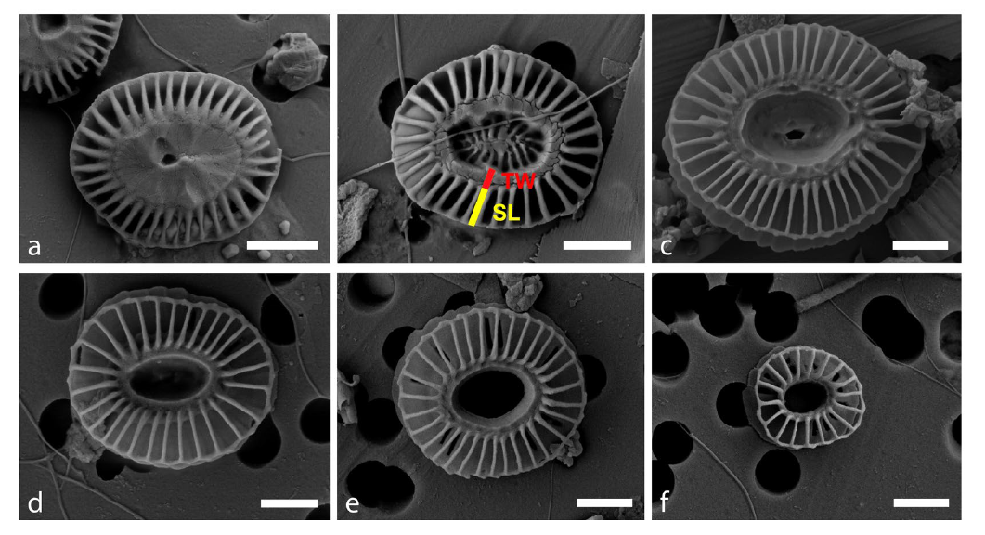

Figure 1 SEM images summarising five common *Emiliania huxleyi* morphotypes observed at the SOTS: (a) Type A over calcified (AOC), (b) A, (c) B, (d) B/C with central area covered by a thin plate, (e) B/C with open central area and (f) C. SL = Slit Length (yellow bar), TW = Tube Width (red bar). Scale bars = 1 μm. Images R Eriksen, courtesy of AAD, and published in Rigual-Hernandez et al. (2020).

General community composition is determined by light microscopy, after sedimentation with alkaline Lugols iodine (recipe as per HELCOM (2017)) to increase settling rates of phytoplankton (Eriksen 2014). Samples are examined in Utermöhl chambers on an inverted microscope to increase the volume of sample analysed, given the low cell biomass observed in most samples. Detailed methods are provided in Eriksen et al. (2018). In brief, fields of view are observed at 320x magnification until 400 cells of the most abundant species have been recorded. This modification to AAD protocols was introduced to improve resolution of community composition, including rare species, versus the standard method of counting 20 fields of view. Cells are identified to the lowest practicable taxonomic level, given the sample condition, preservative used, the limits of light microscopy and published resources available. Where identification to species level cannot be made, size classes are used to allow calculation of biovolumes. Biovolumes are calculated using standard geometries described in Hillebrand (1999), Davies et al. (2017) and the supplementary material provided in Eriksen et al. (2019). Where site-specific biovolumes differ from the CSIRO database, there is capacity to use a biovolume calculated from cells measured in SOTS samples. Examples of specimens observed with light microscopy at the SOTS site are shown in Figure 2.

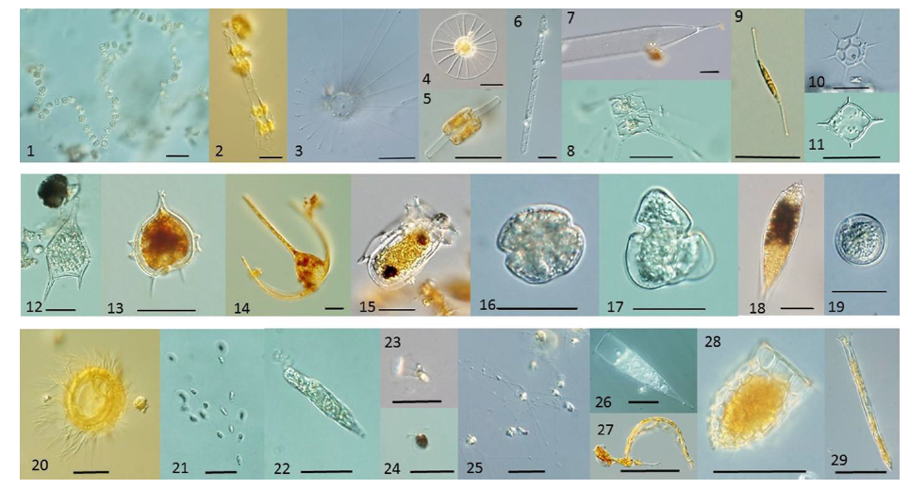

Figure 2 Pulse 7 light microscopy images. Top row diatoms and silicoflagellates: 1) *Thalassiosira* sp. chain 2) *Leptocylindrus mediterraneus* (with symbiont *Solenicola setigera*) 3) *Corethron pennatum* 4, 5) *Planktoniella sol* (valve and girdle view) 6) *Guinardia cylindrus* 7) *Rhizosolenia* sp 8) *Chaetoceros* sp. 9) *Cylindrotheca closterium* 10) *Stephanocha speculum* 11) *Dictyocha* cf *stapedia*. Middle; dinoflagellates: 12) *Tripos pentagonus/lineatus* complex 13) *Protoperidinium* sp 14) *Tripos* *symmetricus* 15) *Dinophysis* sp. 16) Gymnodiniod sp. 17) *Karenia* sp. 18) *Oxytoxum* sp. 19) *Prorocentrum* *balticum*. Bottom; ciliates, appendicularia and flagellates: 20) Ciliate 21) *Dinobryon* colony 22) *Eutreptiella* sp 23) *Parvicorbicula* sp 24) *Pyramimonas* sp. 25) *Phaeocystis* *antarctica* 26) *Rhabdonella* sp. 27) *Oikopleura* 28) *Dictyocysta* *mitra* 29) *Salpingella* sp. Scale bars 2-25 are 20 μm; 1, 26-29 are 50 μm. Images R Eriksen, and published in Eriksen et al. (2020).

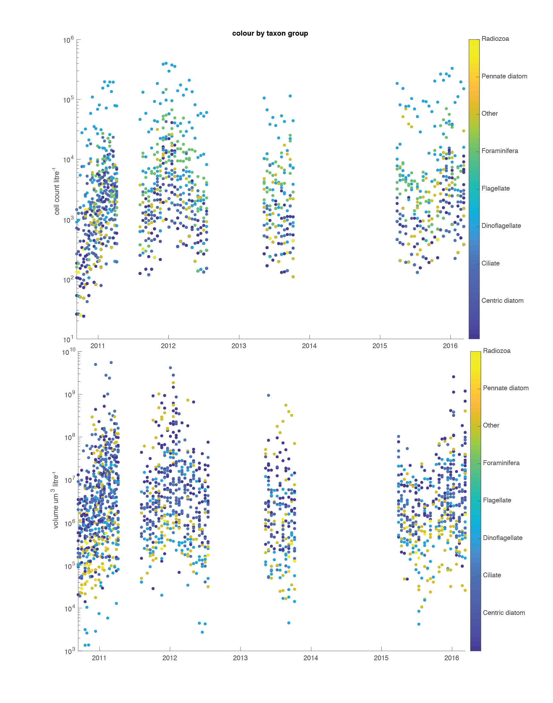

Figure 3 Phytoplankton counts per litre and biovolume µm3 L-1, Pulse7 through to Pulse11 moorings showing the consistency of the data across deployments and the dominance of *Phaeocystis antarctica* in cell numbers but not volume.

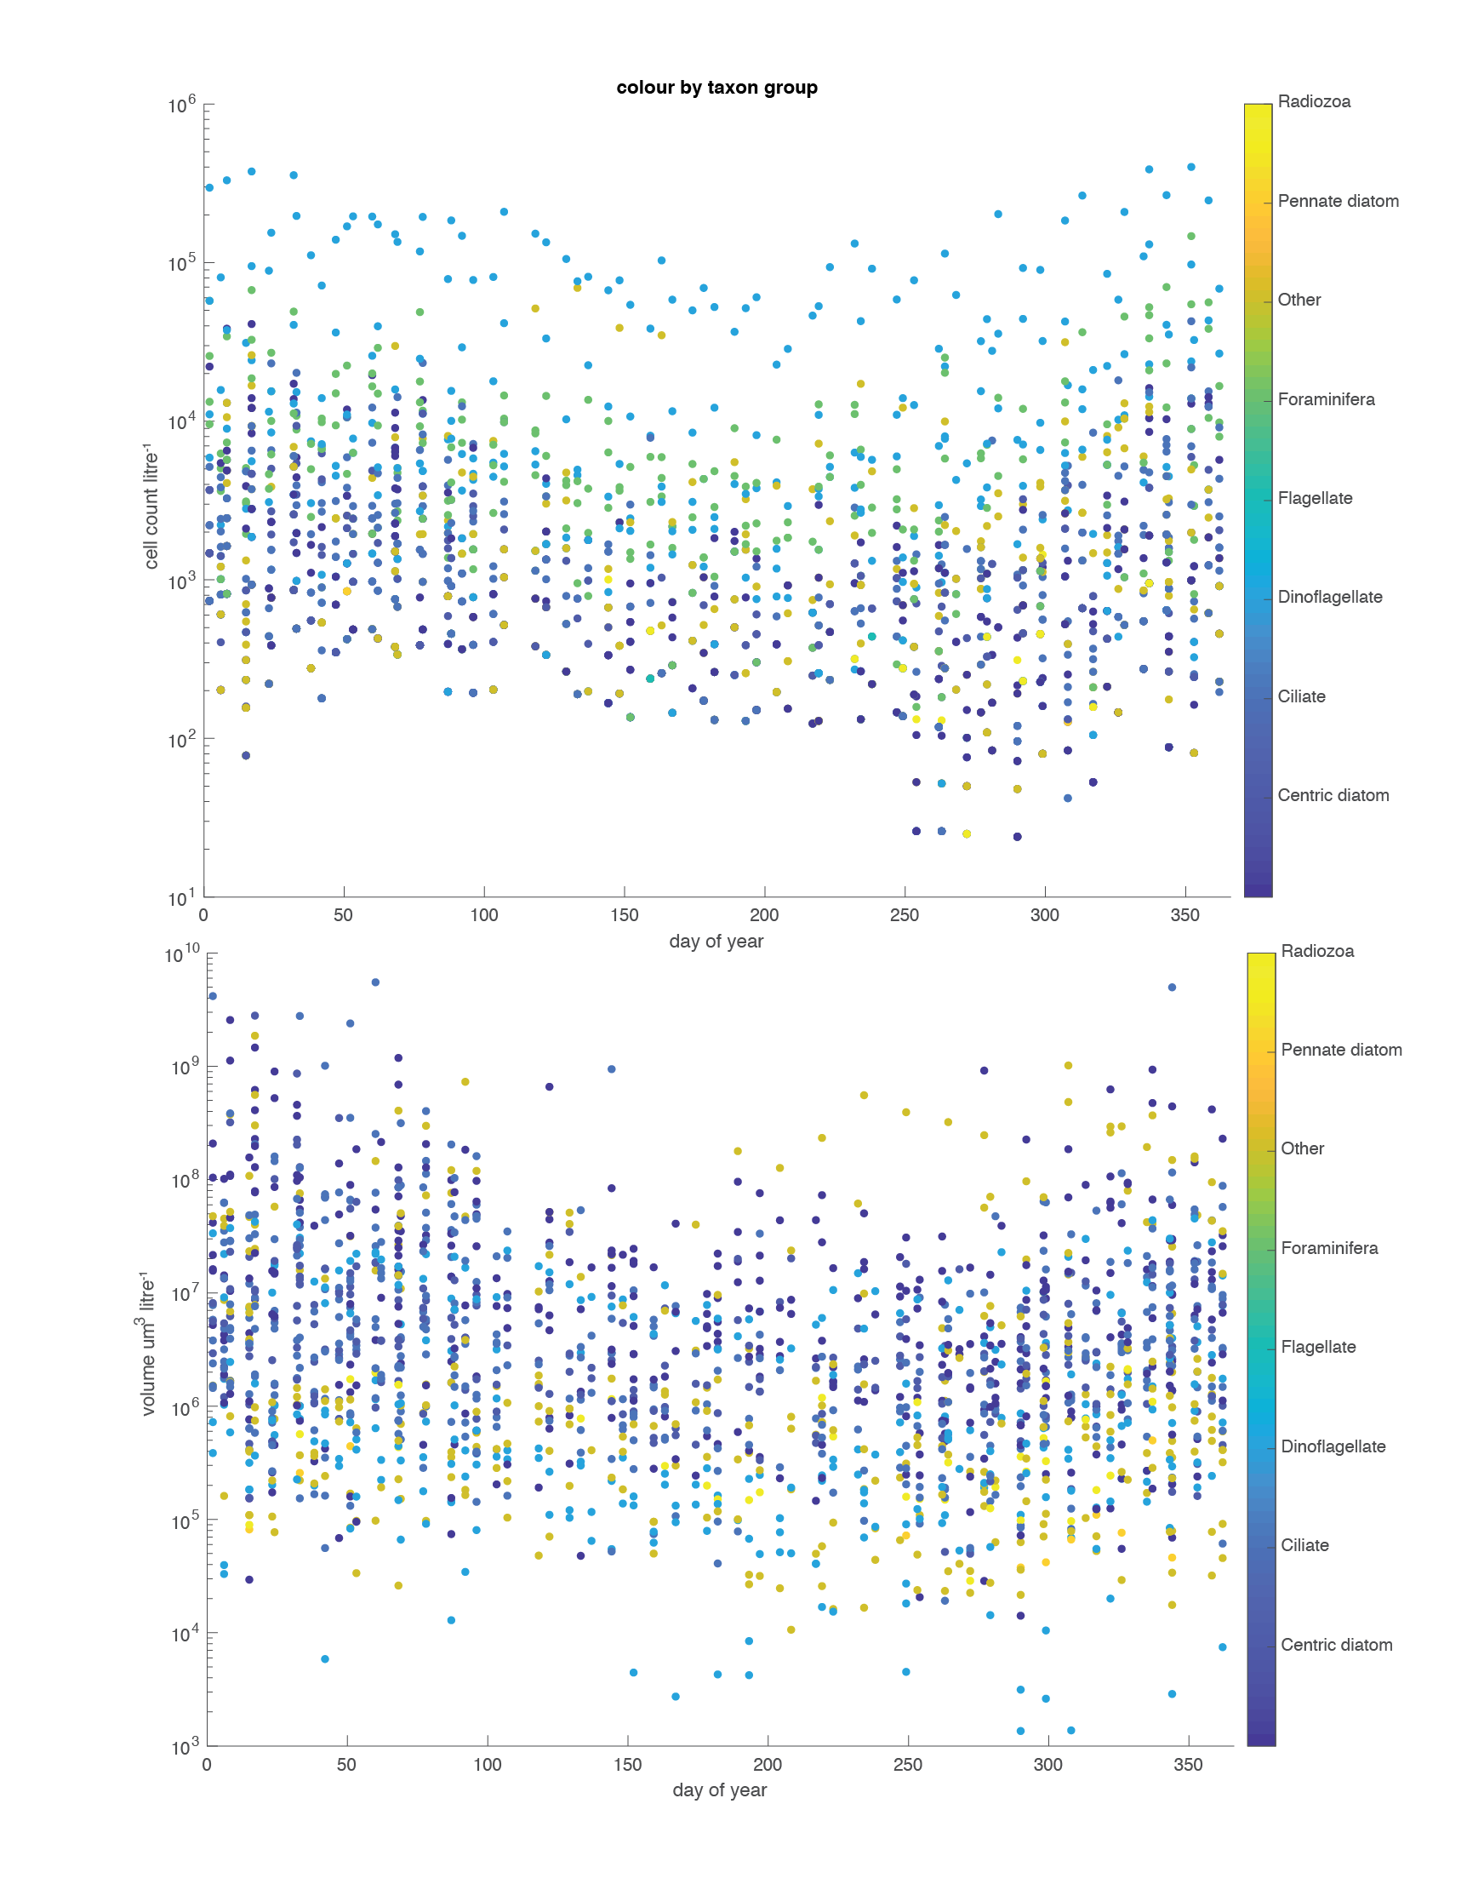

Figure 4 Phytoplankton counts per litre and biovolume µm3 L-1 per day of the year, Pulse7 to Pulse11.

## Data entry

Data is managed through the CSIRO plankton database, built specifically for storage and dissemination of IMOS plankton data. PULSE deployments are discoverable through the [Australian Phytoplankton Database](https://catalogue-imos.aodn.org.au/geonetwork/srv/eng/metadata.show?uuid=75f4f1fc-bee3-4498-ab71-aa1ab29ab2c0), and all SOTS RAS data (PULSE + SOFS moorings) will be discoverable through the AODN as its own data-stream. The inclusion of the SOTS data has been enabled by modifying protocols already in place for the National Reference Stations (Eriksen *et al.* 2019). There are two modes of data entry: batch upload (PULSE deployments) and sample-by-sample entry (SOFS deployments) but QA principles are the same for both modes.

Checks are performed at the point data is added to the database to ensure consistent data entry. Data entry is matched to a unique sample ID (based on the deployment and the bag number in that deployment) so that data cannot be entered twice. Invalid taxa are identified and flagged so that contemporary nomenclature is applied. Data checks include warnings for data that is not a positive, contains non-numeric characters, or is beyond 2 standard deviations of the average entry for that taxa.

Reported fields for each sample are shown in Table 3 (see also the CSIRO Oceans and Atmosphere “[Marlin](http://marlin.csiro.au/geonetwork/srv/eng/search" \l "!745a1023-5846-42da-9abf-df666a3b1c56)” Data Catalogue which contains metadata records for data collections). Some classification fields may be blank, depending on the level to which that taxa has been identified, i.e. if only identified to family, genus and species will be blank.

Table 3 Attribute statement for Southern Ocean Time Series (SOTS) - Phytoplankton Abundance and Biovolume

|  |  |
| --- | --- |
| SOTS_CODE | Sample type identifier (RAS) |
| SOTS_YEAR | Year (date deployed in-water) of deployment |
| SOTS_DEPLOYMENT | Unique deployment identifier for mooring type |
| SAMPLE_NUMBER | Sequence number in pre- programmed sampling program for this deployment |
| SAMPLE_DATE | Date of sample (UTC day resolution) |
| SAMPLE_TIME | Time of sample (UTC) |
| LONGITUDE | Longitude of sample (Decimal degrees WSG84 datum) |
| LATITUDE | Latitude of sample (Decimal degrees WSG84 datum) |
| TAXON_NAME | Taxonomic species information |
| FAMILY | Taxonomic Family (where identified to Family) |
| GENUS_NAME | Taxonomic Genus (where identified to Genus) |
| SPECIES_NAME | Taxonomic Genus (where identified to Species) |
| TAXON_ECO_GROUP | Taxonomic functional group |
| CAAB_CODE | CSIRO unique identifier |
| TAXON_START_DATE | Date from which this taxonomic entity was identified in this data set |
| CELL_PER_LITRE | Calculated phytoplankton abundance for the sample |
| BIOVOLUME_UM3_PER_L | Calculated phytoplankton biovolume for the sample |
| SAMPLE_COMMENTS | Any comment relevant to the sample |
| DEPLOYMENT_VOYAGE | Research voyage Identifier for deployment |
| RETRIEVAL_VOYAGE | Research voyage Identifier for retrieval |
| DEPLOYMENT_DATE | Date of deployment |
| RETRIEVAL_DATE | Date of retrieval |

## Taxonomic entities

New taxa may be added to the database following checking of taxonomic status via [WoRMS](http://www.marinespecies.org/) or [Algaebase](https://www.algaebase.org/). Tracing of the unique AphiaID (Vandepitte *et al.* 2015) for each taxa allows for automatic updating of taxa names, although analysts generally confer with experts before adopting nomenclature that could be contentious within the phytoplankton community. Observations of new taxa require addition to the SOTS site list, highlighting each occasion a new taxa is observed for that site. Each taxa has an associated start and end date of use, enabling us to track changes in identification levels, i.e. as the level of taxa discrimination improves (from genus to species for example) it is possible to track when that name started to be used. The change log tables included in the data downloads should be consulted to determine from what date particular taxa are confidently identified.

“Bucket” categories e.g. *dinoflagellate 10 – 20 µm* are used where it is not possible to confidently discriminate further, allowing some information on functional group, size and biovolume to be recorded. This may be the result of incomplete specimens, preservation artefacts (e.g. Lugols tends to obscure some features), a lack of distinguishing features, or lack of knowledge/resources for a particular taxon. All entries are linked to the sample analyst and comments may be appended to entries where necessary. Photographs may be sent to taxonomic experts where a taxa is new, increases in abundance, or is of particular interest to collaborators or data users.

## Analyst training

As part of the ongoing development of taxonomic expertise, CSIRO instigates and conducts routine taxonomic training for all plankton analysts. External experts are invited to assist with training and identification of problem or difficult groups, based on features that can routinely be discriminated with light microscopy. Taxonomic information is captured through the production of species reference sheets, the generation of taxonomic keys and through collaborative works to review and assess the diversity of Australian and Southern Ocean flora (for example see. Hallegraeff et al. (2020)).

## Supplementary plankton data

Additional contextual data for phytoplankton community composition during PULSE or SOFS deployments is available from the Continuous Plankton Recorder (CPR) tows that are (typically) undertaken on either the transit to or from the mooring location as part of annual maintenance and changeover. SOTS CPR silks are processed at CSIRO in Hobart. Data is available via the AODN for both [phytoplankton](https://catalogue-imos.aodn.org.au/geonetwork/srv/eng/metadata.show?uuid=c1344979-f701-0916-e044-00144f7bc0f4) and [zooplankton](https://catalogue-imos.aodn.org.au/geonetwork/srv/eng/metadata.show?uuid=c1344e70-480e-0993-e044-00144f7bc0f4) abundance, and [zooplankton biomass](https://catalogue-imos.aodn.org.au/geonetwork/srv/eng/metadata.show?uuid=c13451a9-7cfc-091c-e044-00144f7bc0f4).

# Quality assessment of the recovered RAS samples

## Condition of recovered bags

Please refer to Davies et al. (2020) for details pertinent to the assessment of condition of the recovered bags, determination of actual depth of the RAS sampler (pre-2018), seawater temperature, salinity and macronutrient concentrations that are sampled as paired bags on each sample date.

# **Recommendations for Quality Assurance**

Undertake further work on the database to allow processing and upload of samples collected from CTD casts on the annual mooring deployment/retrieval voyages will produce another supplementary data stream for the SOTS site.

Explore analysis techniques that require smaller sample volumes and/or provide complimentary information such as size classes, e.g. the use of rapid image capture devices such as FlowCam, as an approach for RAS deployments with single (unpaired) temporal sampling, such as recently programmed for SOFS-8 to deliver higher temporal resolution. This could provide a more rapid first assessment of biological communities, and aid in targeting samples for more detailed further study.

Continue efforts to optimise preservation strategies in the RAS, and in the sample archives.

References

Cubillos, JC, Wright, SW, Nash, G, de Salas, MF, Griffiths, B, Tilbrook, B, Poisson, A, Hallegraeff, GM (2007) Calcification morphotypes of the coccolithophorid Emiliania huxleyi in the Southern Ocean: changes in 2001 to 2006 compared to historical data. *Marine Ecology Progress Series* **348**, 47-54.

Davies, CH, Coughlan, A, Hallegraeff, G, Ajani, P, Armbrecht, L, Atkins, N, Bonham, P, Brett, S, Brinkman, R, Burford, M, Clementson, L, Coad, P, Coman, F, Davies, D, Dela-Cruz, J, Devlin, M, Edgar, S, Eriksen, R, Furnas, M, Hassler, C, Hill, D, Holmes, M, Ingleton, T, Jameson, I, Leterme, SC, Lonborg, C, McLaughlin, J, McEnnulty, F, McKinnon, AD, Miller, M, Murray, S, Nayar, S, Patten, R, Pausina, SA, Pritchard, T, Proctor, R, Purcell-Meyerink, D, Raes, E, Rissik, D, Ruszczyk, J, Slotwinski, A, Swadling, KM, Tattersall, K, Thompson, P, Thomson, P, Tonks, M, Trull, TW, Uribe-Palomino, J, Waite, AM, Yauwenas, R, Zammit, A, Richardson, AJ (2017) A database of marine phytoplankton abundance, biomass and species composition in Australian waters (vol 3, 160043, 2016). *Scientific Data* **4**,

Davies, DM, Jansen, P, Trull, TW (2020) Southern Ocean Time Series (SOTS) Quality Assessment and Control Report,  Remote Access Sampler Sample Analysis: Macronutrient analysis.

Eriksen, R, Trull, TW, Davies, D, Jansen, P, Davidson, AT, Westwood, K, van den Enden, R (2018) Seasonal succession of phytoplankton community structure from autonomous sampling at the Australian Southern Ocean Time Series site. *Marine Ecology Progress Series* **589**, 13-31.

Eriksen, RS (2014) IOC Taxonomic training in identification and enumeration of harmful algae: Report to Safefish on enumeration methods for marine phytoplankton. Institute for Marine and Antarctic Science.

Eriksen, RS, Davies, CH, Bonham, P, Coman, FE, Edgar, S, McEnnulty, F, McLeod, D, Miller, MJ, Rochester, W, Slotwinski, A, Tonks, ML, Uribe-Palomino, J, Richardson, AJ (2019) Australia’s long-term plankton observations: the Integrated Marine Observing System National Reference Station network. *Frontiers in Marine Science* **6**, 17.

Hallegraeff, G, Eriksen, R, Davies, C, Slotwinski, A, McEnnulty, F, Coman, F, Uribe-Palomino, J, Tonks, M, Richardson, A (2020) The marine planktonic dinoflagellate <i>Tripos</i>: 60 years of species-level distributions in Australian waters. *Australian Systematic Botany* **33**, 392-411.

HELCOM (2017) Monitoring of phytoplankton species composition, abundance and biomass. Helsinki, Finland Available at <https://helcom.fi/action-areas/monitoring-and-assessment/publications/>.

Hillebrand, H, Durselen, CD, Kirschtel, D, Pollingher, U, Zohary, T (1999) Biovolume calculation for pelagic and benthic microalgae. *Journal of Phycology* **35**, 403-424.

Rigual-Hernández, AS, Trull, TW, Flores, JA, Nodder, SD, Eriksen, R, Davies, DM, Hallegraeff, GM, Sierro, FJ, Patil, SM, Cortina, A, Ballegeer, AM, Northcote, LC, Abrantes, F, Rufino, MM (2020) Full annual monitoring of Subantarctic Emiliania huxleyi populations reveals highly calcified morphotypes in high-CO2 winter conditions. *Scientific Reports* **10**, 2594.

Vandepitte, L, Vanhoorne, B, Decock, W, Dekeyzer, S, Trias Verbeeck, A, Bovit, L, Hernandez, F, Mees, J (2015) How  Aphia—The Platform behind Several Online and Taxonomically Oriented Databases—Can Serve Both the Taxonomic Community and the Field of Biodiversity Informatics. *Journal of Marine Science and Engineering***3**, 1448-1473.

Young, JR, Geisen, M, Cros, L, Kleijne, A, Probert, I, Ostergaard, JB (2003) A guide to extant coccolithophore taxonomy. *Journal of Nannoplankton Research, Special Issue* **1**, 1-132.

|  |  |  |
| --- | --- | --- |
|  | | |
| CONTACT US  t 1300 363 400  +61 3 9545 2176  e csiroenquiries@csiro.au  w www.csiro.au  At CSIRO, we do the  extraordinary every day  We innovate for tomorrow and help improve today – for our customers, all Australians and the world.  Our innovations contribute billions of dollars to the Australian economy  every year. As the largest patent holder  in the nation, our vast wealth of intellectual property has led to more  than 150 spin,off companies.  With more than 5,000 experts and a burning desire to get things done, we are Australia’s catalyst for innovation.  CSIRO. WE IMAGINE. WE COLLABORATE.  WE INNOVATE. |  | For further information  Oceans and Atmosphere  Elizabeth Shadwick t +61 03 6232 5571  e Elizabeth.Shadwick@csiro.au |