OCEANS AND ATMOSPHERE
Southern Ocean Time Series (SOTS)

Quality Assessment and Control Report
Remote Access Sampler: Total Alkalinity and Total Dissolved Inorganic Carbon Analyses
Version 1.0
2009-2018

Elizabeth H. Shadwick, Diana M. Davies, Peter Jansen, Thomas W. Trull



Citation
Shadwick, EH, Davies, DM, Jansen, P and Trull, TW (2020) Southern Ocean Time Series (SOTS) Quality Assessment and Control Report Remote Access Sampler: Total Alkalinity and Total Dissolved Inorganic Carbon Analyses, 2009-2018. Version 1.0 CSIRO, Australia. DOI: 10.26198/5f3f23c8b51d6 (http://dx.doi.org/10.26198/5f3f23c8b51d6)

Copyright
© Commonwealth Scientific and Industrial Research Organisation 2017. To the extent permitted by law, all rights are reserved and no part of this publication covered by copyright may be reproduced or copied in any form or by any means except with the written permission of CSIRO.
Important disclaimer
CSIRO advises that the information contained in this publication comprises general statements based on scientific research. The reader is advised and needs to be aware that such information may be incomplete or unable to be used in any specific situation. No reliance or actions must therefore be made on that information without seeking prior expert professional, scientific and technical advice. To the extent permitted by law, CSIRO (including its employees and consultants) excludes all liability to any person for any consequences, including but not limited to all losses, damages, costs, expenses and any other compensation, arising directly or indirectly from using this publication (in part or in whole) and any information or material contained in it.
CSIRO is committed to providing web accessible content wherever possible. If you are having difficulties with accessing this document please contact csiroenquiries@csiro.au.

Foreword
The Southern Ocean Time Series (SOTS) is a Sub-Facility of the Australian Integrated Marine Observing System (IMOS), funded by the National Collaborative Research Infrastructure Strategy (NCRIS). It is operated under collaborative arrangements among the CSIRO Oceans and Atmosphere, Bureau of Meteorology, and University of Tasmania, including via the Antarctic Climate and Ecosystems Cooperative Research Centre and the Australian Antarctic Program Partnership. The primary focus is sustained observing of ocean properties and processes important to climate, carbon cycling, and ocean productivity.
The SOTS Sub-Facility consists of deep ocean moorings deployed in Subantarctic waters southwest of Tasmania, equipped with autonomous sensors and sample collectors. SOTS moorings are serviced annually - the existing moorings are recovered and new moorings are deployed. Some sensor data is transmitted from the moorings via satellite in near real time. Other sensor data and samples are recovered during the annual service visit.
This report details the quality assessment and control procedures applied to the total alkalinity and total dissolved inorganic carbon samples from the Remote Access Sampler deployed on SOFS and Pulse moorings. The datasets are publicly available via the AODN Portal https://portal.aodn.org.au/search.

Contents
Foreword ii
Acknowledgments vi
Executive summary vii
Introduction 1
Laboratory Analyses 5
Quality control for the analysis of total alkalinity 8
The Global Range Test – Total Alkalinity 8
The Multiparameter Test – Total Alkalinity 9
Summary of Alkalinity QC Test Results 11
The Global Range Test – Total Dissolved Inorganic Carbon 12
The Multiparameter Test – Total Dissolved Inorganic Carbon 12
Additional Considerations – Total Dissolved Inorganic Carbon 15
Summary of Total Dissolved Inorganic Carbon QC Test Results 16

Figures
Figure 1. One half of the RAS valve. 6
Figure 2: Profiles of alkalinity collected between 2010 and 2019 at the SOTS site. The upper and lower bounds of the Global Range test are indicated by the dashed lines 8
Figure 3: Alkalinity as a function of salinity from observations collected at the SOTS site between 2010 and 2019. Two quasi-linear relationships occur: a high slope relationship in deep waters and a low slope relationship in shallow waters. 9
Figure 4: The relationship between alkalinity and salinity in the upper 100 m. Linear regression of the observations yields the equation shown; the error associated with the fit is ~8 µmol kg-1. 10
Figure 5: Time series of RAS alkalinity samples (x’s) with deployments distinguished by colour. The expected values on the basis of salinity are shown by the open circles. Alkalinity from CTD samples collected in the upper 100 m at the SOTS site are indicated with grey diamonds. The upper and lower limits of the Global Range Test are indicted by the dashed black lines. 10
Figure 6 Time series of QC Flags assigned to the RAS alkalinity samples based on the Global Range and Multiparameter Tests described above with deployments distinguished by colour as in Figure 5. 11
Figure 7. Profiles of TCO₂ collected between 2010 and 2019 at the SOTS site. The upper and lower bounds of the Global Range test are indicated by the dashed lines. 13
Figure 8. Multi-year records of TCO₂ computed from pCO₂ and alkalinity (estimated from salinity) between 2010 and 2019. The upper and lower bounds of the global range test are indicated by the dot-dashed lines. 14
Figure 9. Time series of RAS TCO2 samples (x’s) with deployments distinguished by colour. TCO₂ from CTD samples collected in the upper 100 m at the SOTS site are indicated with grey diamonds. The upper and lower limits of the Global Range Test are indicted by the dashed black lines, and upper and lower limits of the Multiparameter Test are indicated by the dash-dotted lines 15
Figure 10. Time series of QC flags assigned to the RAS TCO₂ samples based on the global range and multiparameter tests described above with deployments distinguished by colour as in Figure 9 16

Tables
Table 1. Instrument deployment details 2
Table 2. QC flag meanings 3
Table 3 Dilution factors for RAS deployments. RAS1 was fitted with filter holders and GF/F filters. The filters were omitted for RAS2 and the filter holders removed subsequently reducing the volume required to prime the RAS. *RAS1 and RAS2 sample weights were based on the pump log. Sample salinity was usually determined from the SOMMA TCO₂ analysis, but due to calibration issues, salinity from a Guildline salinometer was used for the RAS1 samples. The priming protocol was changed after RAS2 to remove any excess prime volume by reverse pumping the loaded sample bags. **RAS 8 and 9 were deployed in the SOFS float. 7

Acknowledgments
We acknowledge support from the following agencies: the Australian Antarctic Program Partnership (AAPP), the Antarctic Climate and Ecosystems Cooperative Research Centre (ACE CRC), the Integrated Marine Observing System (www.imos.org.au), University of Tasmania (UTAS), Bureau of Meteorology (BoM), the Marine National Facility (MNF) and the Australian Antarctic Division (AAD). We also acknowledge the support of the CSIRO Moored Sensor Systems team and CSIRO Ocean Carbon Observation Team.

SOTS is a member of the OceanSITES global network of time series observatories. (www.OceanSITES.org).

Executive summary
The Southern Ocean Time Series (SOTS) Observatory located near 140°E and 47°S provides high temporal resolution observations in sub-Antarctic waters. It is focused on the sub-Antarctic Zone because waters formed at the surface in this region slide under warmer subtropical and tropical waters, carrying CO₂ and heat into the deep ocean, where it is out of contact with the atmosphere. This process also supplies oxygen for deep ocean ecosystems, and exports nutrients that fuel ~70% of global ocean primary production. This region is also the boundary between the nutrient rich waters of the Southern Ocean and the oligotrophic subtropical gyres to the north. These processes are sensitive to climate change, but the probable nature and impacts are not yet known.
This report details the quality control procedures applied to the total alkalinity and total dissolved inorganic carbon data from samples collected by the Remote Access water Sampler (McLane Labs, Inc., RAS 500) deployed on the SOTS and Pulse moorings between 2009 and 2018. The quality-controlled datasets are publicly available via the AODN Data Portal. This report should be consulted when using the data.

Introduction

Detailed descriptions of mooring designs, locations and sample collections are provided in the SOTS Annual Reports, which are divided into three parts,
Report 1. Overview, lists mooring voyages, dates, locations, designs and instruments;
Report 2. Samples, details the sample collections
Report 3. Sensors contains descriptions and data QC procedures of the sensors mounted on the moorings.
The reports are available at:
https://catalogue-imos.aodn.org.au/geonetwork/srv/eng/metadata.show?uuid=afc166ce-6b34-44d9-b64c-8bb10fd43a07

The RAS sampler deployments are summarized in Table 1 (below). The first attempt to combine the Pulse and SOFS moorings into the single FluxPulse mooring did not return samples because of mooring failure and loss of the sampler. SOFS-7 failed early on deployment and two samples were collected while adrift. Pulse-9 and Pulse-10 were recovered before the sampler programs were completed. For all RAS deployments (1-7) prior to 2017, the samples were collected in pairs, with one of the pairs preserved with glutaraldehyde for phytoplankton identification and the other preserved with mercuric chloride for nutrient, dissolved inorganic carbon, and alkalinity analyses. Thus, the number of total alkalinity, and total dissolved inorganic carbon analyses, is half the number of samples returned. Further sample collection details are provided in the SOTS Annual Reports.

Table 1. Instrument deployment details
Site | Mooring | RAS | Lat  dec deg | Long  dec deg | Deployed | Recovered | Depth m | Serial no. | Samples  Returned
Pulse | Pulse-6 2009 | RAS1 | -46.3224 | 140.6776 | 2009-09-28 | 2010-03-18 | 32 | 11906-01 | 48
Pulse | Pulse-7 2010 | RAS2 | -46.9347 | 142.2583 | 2010-09-12 | 2011-04-17 | 31 | 11906-01 | 48
Pulse | Pulse-8 2011 | RAS3 | -46.9295 | 142.2147 | 2011-08-03 | 2012-07-19 | 34 | 11906-01 | 48
Pulse | Pulse-9 2012 | RAS4 | -46.8493 | 142.3986 | 2012-07-17 | 2013-05-05 | 38 | 12709-01 | 32
Pulse | Pulse-10 2013 | RAS5 | -46.9378 | 142.2847 | 2013-05-07 | 2013-10-13 | 28 | 11906-01 | 22
Pulse | Pulse-11 2015 | RAS6 | -46.9405 | 142.3262 | 2015-03-25 | 2016-03-19 | 28 | 11906-01 | 48
SOFS | FluxPulse-1 2016 | RAS7 | -46.7240 | 141.9297 | 2016-03-16 | 2016-06-23 | 30 | 12709-01 | 0
SOFS | SOFS-7 2018 | RAS8 | -47.0111 | 142.2135 | 2018-03-06 | 2018-03-16 | 4 | 14384-01 | 2
SOFS | SOFS-7.5 2018 | RAS9 | -47.0227 | 142.2334 | 2018-08-22 | 2019-03-22 | 4 | 14384-01 | 48

This QC report outlines the tests performed on total alkalinity (alk) and total dissolved inorganic carbon (TCO₂) concentrations from RAS (McLane RAS 500) samples and the associated allocation of quality control flags.
The QC flags are provided in the on-line netcdf files and follow the Argo Table 2A (IMOS, 2015) Flag convention (equivalent to IMOS Standard Flag, OCEANSITES, and IODE flag conventions) and are as follows:

Table 2. QC flag meanings
n | Meaning
0 | no QC was performed
1 | good data
2 | probably good
3 | bad data that are potentially correctable
4 | bad data
5 | value changed
6 | (mooring not deployed)
7 | not used
8 | interpolated value
9 | missing value

The reported variables use standard names, or long names if no standard name is available, as follows:
time of sample start (yyyy:mm:dd hh:mm:ss UTC, days since 1950-01-01T00:00:00UTC)
sea_water_pressure_due_to_sea_water (dbar)
nominal depth of each variable (m)
sea_water_temperature (ºC)
sea_water_practical_salinity
sample number (position)
sample mass (kg)
moles_of_nitrate_and_nitrite_per_unit_mass_in_sea_water (μmol.kg⁻¹)
moles_of_phosphate_per_unit_mass_in_sea_water (μmol.kg⁻¹)
moles_of_silicate_per_unit_mass_in_sea_water (μmol.kg⁻¹)
moles_of_alkalinity_per_unit_mass_in_sea_water (μmol.kg⁻¹)
moles_of_inorganic_carbon_per_unit_mass_in_sea_water (μmol.kg⁻¹)
A quality assurance flag is associated with the sample number, salinity, depth measured as pressure (dbar), temperature, sample mass and macronutrients.
Depth, temperature, and salinity values are from co-located Seabird CTDs (see the SOTS Annual Reports).
Quality assessment of the nutrient results is reported in Davies et al. (2020).

We recommend the use of data with associated QC flags 1 or 2 and suggest contacting the facility for further information before using data with QC flags 3.
Quality assurance is via careful preparation and deployment of the RAS and handling of the recovered samples and is described in detail in Davies et al., 2020. Quality Control Procedures specific to the total dissolved inorganic carbon and total alkalinity analyses are via:
- The use of certified reference materials.
- Comparison to alkalinity data from Niskin bottles on CTD casts conducted close to the SOTS and Pulse moorings, primarily during deployment and recovery voyages.
- Comparison to TCO₂ data derived from pCO₂ and salinity measured by the sensors in the SOFS surface float.

Laboratory Analyses
The loading of preservatives prior to RAS deployments, and the decanting of samples from the recovered Tedlar sample bags is described in detail in the SOTS Annual Reports, Report 2 (Section B.4.3). Tedlar has been extensively tested for this application including short term (months) storage testing with certified reference materials (Schamberger et al., 2011). Briefly, samples are decanted from the mercuric chloride preserved water for analysis of total alkalinity by dispensing the sample via the 1/8” Teflon tube compression fitting by gentle pressure into 250mL borosilicate glass bottles (Schott). Both TCO₂ and alkalinity are determined from the single 250mL aliquot to conserve sample volume. In contrast, shipboard Niskin bottle sampling is done separately for these two analytes.
The unfiltered samples are analysed by the CSIRO Ocean Carbon Observations Team via (open cell) potentiometric titration (using components from Metrohm), and coulometric titration (using a Single-Operator Multi-Parameter Metabolic Analyzer, SOMMA), for alkalinity and TCO₂, respectively, and following established best practices (Dickson et al., 2007). Analyses of Certified Reference Materials (CRMs; provided by A. G. Dickson, Scripps Institution of Oceanography) are conducted between sample batches, at least three times per day for alkalinity and plotted on a control limit chart to monitor performance. The average values of the CRMs for the analytical period are used to generate a correction factor f = CRM certified value/mean CRM result, and alkalinity results are multiplied by this factor. The uncertainty of measurement is typically ± 2μmol kg⁻¹ (95% confidence interval). For TCO₂, the CRM analyses are conducted at the beginning and end of the day, during which approximately 20 samples are analyzed. The average of the daily CRM is used to correct the TCO₂ by applying a correction (z = CRM certified value – mean CRM result) to the TCO₂ results. The TCO₂ offset is typically 1-2 μmol kg⁻¹ and the uncertainty ±2μmol kg⁻¹ (95% confidence interval).

The alkalinity and TCO₂ data are then assigned flags following the World Ocean Circulation Experiment (WOCE) QC standards: 2 - good, 3 - questionable and 4 -bad. The vast majority of alkalinity samples are considered good at this stage, and subsequent tests are only performed on data with flag 2; many of the TCO₂ samples are flagged 3, due to values being unexpectedly high, and subsequent tests are performed on data with flags 2 and 3. Later these WOCE flag conventions are combined with other quality control test results and translated to the IODE conventions, as shown in Table 2.
A sample dilution factor is calculated from the ratio of the measured salinity obtained during analysis of TCO₂ (using the SBE 4 series CTD with separate temperature sensor in the SOMMA and the salinity as measured by the SBE 16+V2 CTD sensor in the RAS instrument package) and used to correct the alkalinity, TCO₂ and macronutrient concentrations. The CRM is certified for salinity of ~33.5 with an uncertainty of measurement of ±0.05 (95% confidence interval). Unexplained outliers have occurred on occasions. The uncertainty associated with the SBE 16+V2 salinity is ±0.005 (95% confidence interval). Combining the salinity uncertainties for a 460mL sample, the volume uncertainty is ±1.6mL or 0.3%. The average dilution factors for all RAS deployments are summarised in Table 3, and are generally small for each discrete sample. This correction is required because the deionized water used to prime the RAS sample distribution line is collected into the sample bags along with the targeted seawater sample. The actual volume sampled is variable leading to small differences in the dilution and the final concentration of preservative. The prime volume required for RAS1 and 2 was ~10mL due to filter holders which were then removed reducing the volume to ~5mL.
There is the remote possibility that some of the mercuric chloride solution used as a post flush (which remains in the valve until the next sample event, and is normally isolated from the samples), could find its way into samples when the sampler is accelerated on the mooring causing compression of the spring that seals the mating valve surfaces.
The RAS valve configuration and operation could also potentially lead to cross-contamination. The RAS valve has a home port where the two halves of the valve are connected for flushing purposes and it remains in the home position except when sampling (Figure 1). The connecting port drives to the sample position to start a sampling event but in doing so, it drives past all of the completed samples. This potential for cross contamination between samples increases with the number of samples collected i.e. the number of times the valve drives. Sample 1 will have had the home valve drive past it 96 times during which pressure changes or accelerations (especially for RAS installed the SOFS float) could potentially cause cross contamination, which is normally not present because of slow diffusion in the sample delivery tubing. Prior to 2017, when samples were collected in pairs (1 for nutrients, alkalinity and TCO₂; the other for phytoplankton identification) this potential for cross-contamination included possible transfer of the glutaraldehyde preservative used for the phytoplankton samples. Since 2017, mercuric chloride has been used in all the sample types, whether or not collected in pairs.

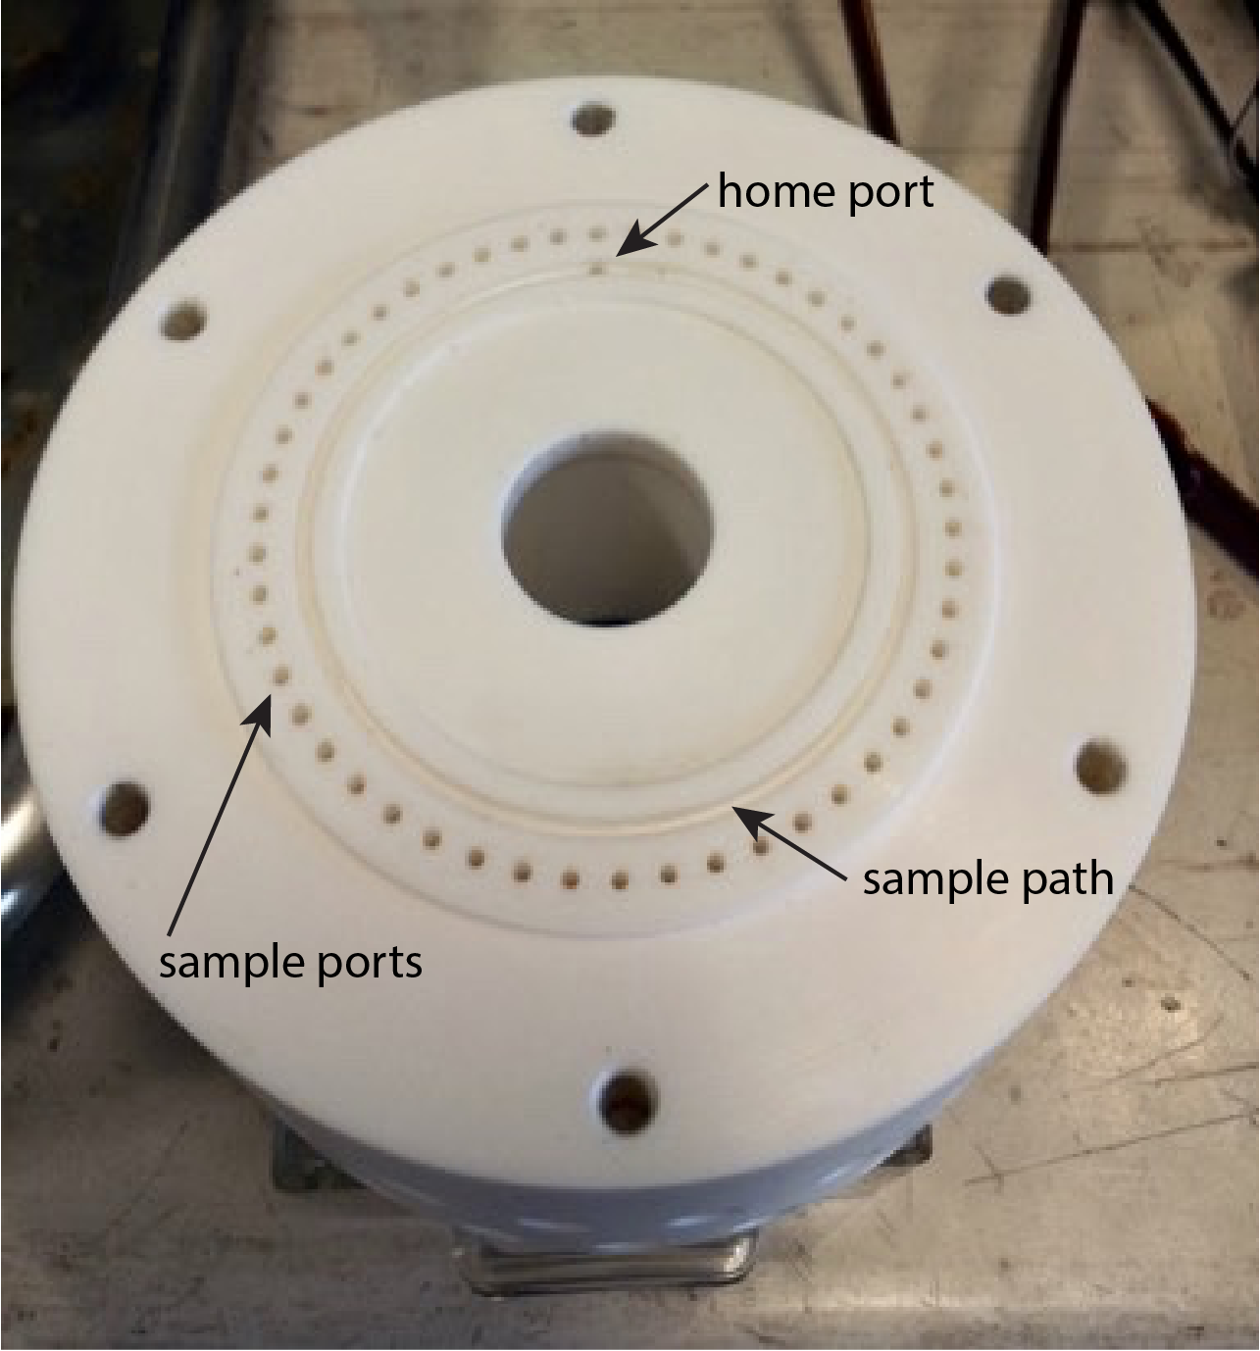
Figure 1. One half of the RAS valve.

Table 3 Dilution factors for RAS deployments. RAS1 was fitted with filter holders and GF/F filters. The filters were omitted for RAS2 and the filter holders removed subsequently reducing the volume required to prime the RAS. *RAS1 and RAS2 sample weights were based on the pump log. Sample salinity was usually determined from the SOMMA TCO₂ analysis, but due to calibration issues, salinity from a Guildline salinometer was used for the RAS1 samples. The priming protocol was changed after RAS2 to remove any excess prime volume by reverse pumping the loaded sample bags. **RAS 8 and 9 were deployed in the SOFS float.

Mooring | RAS | samples  TCO₂/alk | Average  Sample wt  g | SamPle Wt  std Dev | average  Dilution (%) | Average  DILUTION STD DEV (%) | Comment
Pulse-6 2009 | RAS1 | 24 | 460 | * | 2.9 | 1.2 | Sample salinity via Guildline
Pulse-7 2010 | RAS2 | 24 | 460 | * | 2.4 | 0.6 | Empty filter holder
Pulse-8 2011 | RAS3 | 24 | 508 | 24 | 0.8 | 0.4 | Protocol changed
Pulse-9 2012 | RAS4 | 15 | 479 | 4 | 0.9 | 0.18 | Early recovery
Pulse-10 2013 | RAS5 | 11 | 474 | 12 | 1.0 | 0.18 | Early recovery
Pulse-11 2015 | RAS6 | 24 | 489 | 32 | 1.2 | 0.51 | Last use of glutaraldehyde
FluxPulse-1 2016 | RAS7 | - | - | - | - | - | Mooring failure RAS lost
SOFS-7 2018 | RAS8** | 1 | 468 | - | 0.8 | - | Mooring failure surface deployment 4m
SOFS-7.5 2018 | RAS9** | 24 | 398 | 23 | 1.4 | 0.53 | Surface deployment 4m

Quality control for the analysis of total alkalinity
Following correction for dilution, two additional tests are applied to the RAS alkalinity data:
- A Global Range Test based on Niskin bottle samples collected by the ship at the SOTS site between 2011 and 2019; failure of this test results in a Flag 4 – bad data.
- A Multiparameter Test, in which an expected value of alkalinity is computed from a robust relationship between alkalinity and salinity at the SOTS site derived from CTD Niskin bottle samples. Deviations of more than 9 μmol kg⁻¹ from the expected value results in a Flag 3 – i.e. probably bad, possibly correctable.
The final QC flag is the highest flag on completion of the tests. The tests are described in more detail in the following sections.

The Global Range Test – Total Alkalinity
Profiles of total alkalinity from CTD casts at the SOTS site conducted between 2010 and 2019 are shown in Figure 2. The values range from 2280 μmol kg⁻¹ to 2315 μmol kg⁻¹ in the upper 200 m; the maximum observed concentration is on the order of 2360 μmol kg⁻¹ and corresponds to a depth below 2000 m. On the basis of these observations, the lower and upper bounds of the Global Range Test were set to 2260 μmol kg⁻¹, and 2360 μmol kg⁻¹, respectively; values falling outside of these bounds are assigned a Flag 4 – bad data. We note that the majority of the CTD data collected at SOTS is from the March to July period, and may therefore not fully represent the seasonality in alkalinity.
Figure 2: Profiles of alkalinity collected between 2010 and 2019 at the SOTS site. The upper and lower bounds of the Global Range test are indicated by the dashed lines

The Multiparameter Test – Total Alkalinity
The variability of alkalinity in the surface ocean is controlled mainly by the addition (precipitation and sea ice melt) and removal (evaporation and sea ice formation) of freshwater, which also changes salinity. The formation and dissolution of calcium carbonate, and the production and remineralisation of organic matter also impact surface alkalinity. Additionally, convective mixing of alkalinity-rich deep water at a given salinity (from the dissolution of CaCO₃) can alter the surface concentration. Generally, variation in surface salinity is a reliable proxy for variation in surface alkalinity (e.g. Millero et al., 1998; Takahashi et al, 2014).
The relationship between alkalinity and salinity at SOTS from observations collected between 2010 and 2019 is shown in Figure 3. A linear relationship between alkalinity and salinity was derived from observations collected in the upper 100 m at SOTS (Fig. 4). This relationship was used to compute an expected value of alkalinity from measurements of salinity associated with each RAS sample (Fig. 5). If the RAS alkalinity is within 9 μmol kg⁻¹ of the value expected from salinity it is assigned a Flag 2 – probably good. If the values are outside of this range, they are assigned a Flag 3 – probably bad, possibly correctable. The limit for this test (9 μmol kg⁻¹) is consistent with the error associated with the fit of the linear regression to the data, and roughly equal to the range of the observations at constant salinity observed in 2019 (see Fig. 4 and the magenta data in Fig. 3). We note that while the relationship between alkalinity and salinity presented here is robust and captures the seasonal range of salinity observed at the site, we continue to collect alkalinity samples from the CTD and will adjust the relationship accordingly.
Figure 3: Alkalinity as a function of salinity from observations collected at the SOTS site between 2010 and 2019. Two quasi-linear relationships occur: a high slope relationship in deep waters and a low slope relationship in shallow waters.

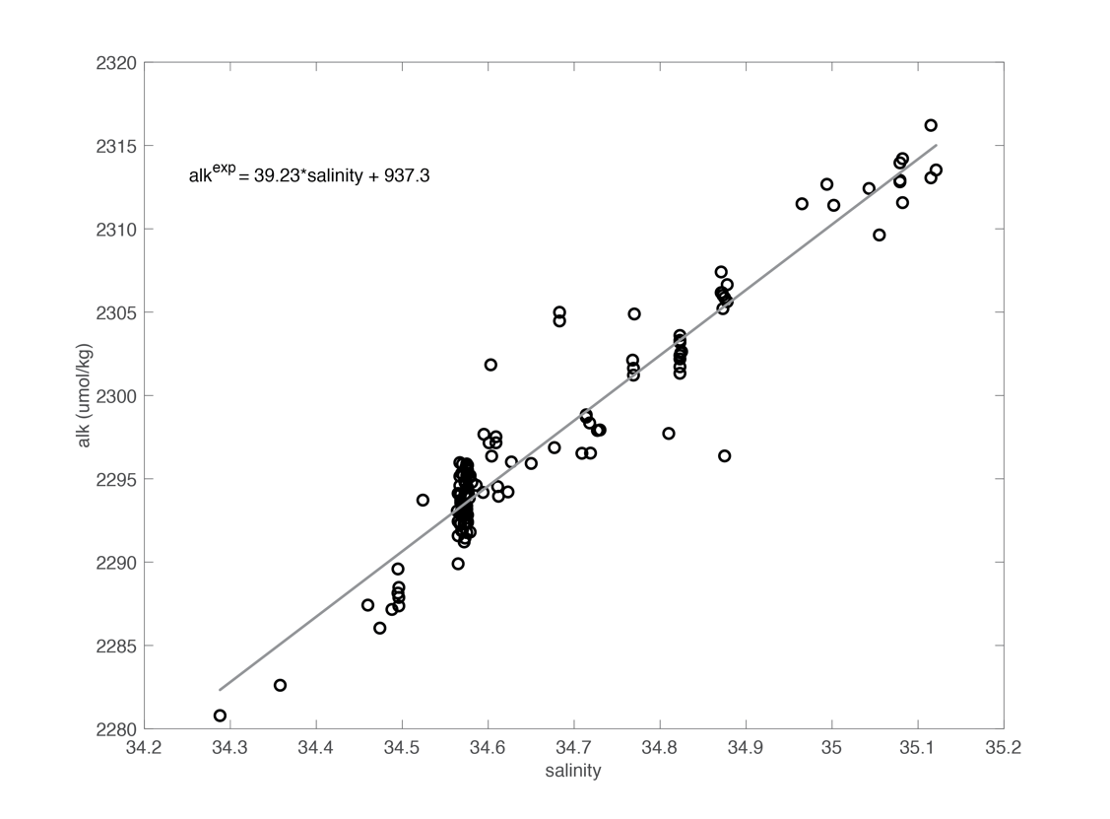
Figure 4: The relationship between alkalinity and salinity in the upper 100 m. Linear regression of the observations yields the equation shown; the error associated with the fit is ~8 µmol kg-1.

Figure 5: Time series of RAS alkalinity samples (x’s) with deployments distinguished by colour. The expected values on the basis of salinity are shown by the open circles. Alkalinity from CTD samples collected in the upper 100 m at the SOTS site are indicated with grey diamonds. The upper and lower limits of the Global Range Test are indicted by the dashed black lines.

Summary of Alkalinity QC Test Results
The majority of the RAS1 alkalinity samples failed the Global Range Test. This derives from two major issues with the samples collected during the RAS1 deployment, as described in the Davies et al., 2020 report on macronutrient concentration: i. glass fibre filters leached silica and probably other ions, and ii. the use of hydrochloric acid as a “biofouling acid flush”, as recommended by McLane Laboratories. After RAS1 the filters were discontinued, and after RAS2 the hydrochloric acid was replaced by mercuric chloride in deionized water. In addition, the priming protocol was changed to prevent cross-contamination of glutaraldehyde from the alternating phytoplankton samples with the nutrient/alkalinity/TCO₂ samples. Glutaraldehyde was discontinued after RAS7. Subsequent deployments indicate that a significant majority of the samples pass the Global Range Test (Fig. 6), though there were several anomalously low values in the 2018/19 RAS9 deployment, and others in the RAS4 and RAS6 deployments, for which we have no satisfying explanation at this time (i.e. the observed alkalinity deficit is greater than can be explained by either biogenic calcification given associated water properties, or organic matter respiration within the sample container). A large proportion of the data also pass the Multiparameter Test, though there remain samples in all deployments, and in all seasons, where the deviation from the values expected from the observed salinity are larger than the chosen limit. There is generally good agreement between the RAS alkalinity and the CTD samples collected from the ship, and these comparisons at the beginning and end of the records (e.g. the ship data on either side of the RAS6 and RAS9 deployments in Fig. 5) indicate that the storage over the 12-month deployment does not adversely impact the alkalinity samples.

Figure 6 Time series of QC Flags assigned to the RAS alkalinity samples based on the Global Range and Multiparameter Tests described above with deployments distinguished by colour as in Figure 5.

Quality control for the analysis of total dissolved inorganic carbon
Following correction for dilution, two additional tests are applied to the RAS TCO₂ data:
- A Global Range Test based on bottle samples collected by the ship at the SOTS site between 2010 and 2019; failure of this test results in a Flag 4 – bad data.
- A Multiparameter Test, in which an expected range of TCO₂ is determined using alkalinity computed as a function of salinity (as described above and shown in Figure 4), and pCO₂ from the MAPCO2 system in the SOFS surface float; failure of this test results in a Flag 3 – probably bad, but possibly correctable.
The final QC flag is the highest flag on completion of the tests. The tests are described in more detail in the following sections.

The Global Range Test – Total Dissolved Inorganic Carbon
Profiles of TCO₂ from CTD casts at the SOTS site conducted between 2010 and 2019 are shown in Figure 7. The values range from ~2070 μmol kg⁻¹ to 2150 μmol kg⁻¹ in the upper 200 m; the maximum observed concentration is on the order of 2250 μmol kg⁻¹ and corresponds to a depth below 1500 m. On the basis of these observations, and the fact that most of the ship data is collected outside of the productive season (i.e., potentially missing the summer surface minimum concentrations), the lower and upper bounds of the Global Range Test were set to 2000 μmol kg⁻¹, and 2300 μmol kg⁻¹, respectively; values falling outside of these bounds are assigned a Flag 4 – bad data. We note that the majority of the CTD data collected at SOTS is from the March to July period, and may therefore not fully represent the seasonality in TCO₂.

The Multiparameter Test – Total Dissolved Inorganic Carbon
The variability of dissolved inorganic carbon in the surface ocean is controlled by a combination of biological (photosynthesis and respiration, the formation of CaCO₃) and physical (evaporation and precipitation, air-sea exchange of CO₂, and the dissolution of CaCO3) processes.
Five parameters of the CO₂ system can be measured directly: TCO₂, total alkalinity, pH, and the partial pressure of CO₂ (pCO₂) or its fugacity (fCO₂) and the concentration of the carbonate anion (CO₃²⁻). Given the equilibration constants for the system of equations that fully describe the dissolution of CO₂ in seawater (Zeebe & Wolf-Gladrow 2001), the measurement of any two parameters allows the remaining parameters to be computed (e.g., by using CO2SYS; van Heuven et al., 2011).
Using the salinity data from the surface sensor on the SOFS mooring, a multi-year record of alkalinity was computed using the relationship described above and shown in Figure 4. This was combined with the multi-year record of surface pCO₂ to computed a multi-year record of TCO₂ (Figure 8; for details on the salinity and pCO₂ sensors see the SOTS Sensor Reports). The multi-year record of TCO₂ suggests that we do not observe values below roughly 2050 μmol kg⁻¹in the summer, and have no observations above roughly 2130 μmol kg⁻¹ in the winter, and these are used as the lower and upper limits for the Multiparameter Test. If the data fall outside these limits that are assigned a Flag 4 – bad.

Figure 7. Profiles of TCO₂ collected between 2010 and 2019 at the SOTS site. The upper and lower bounds of the Global Range test are indicated by the dashed lines.

Figure 8. Multi-year records of TCO₂ computed from pCO₂ and alkalinity (estimated from salinity) between 2010 and 2019. The upper and lower bounds of the global range test are indicated by the dot-dashed lines.

Additional Considerations – Total Dissolved Inorganic Carbon
The time series of RAS TCO₂ data are shown in Figure 9. There appears to be a trend in all deployments with the highest concentrations observed at the beginning of the records, indicating an issue with sample storage and/or preservation. In addition, the annual records from the individual RAS deployments to not exhibit the expected seasonality in TCO₂ (discussed in more detail below). Because we have not yet determined the cause for the unexpectedly high values of TCO₂ (see also Recommendations for Quality Assurance below), we have low confidence in these data. As a result, all data that pass both the Global Range and Multiparameter Tests described above are assigned a Flag 3 – probably bad, possibly correctable.
Figure 9. Time series of RAS TCO2 samples (x’s) with deployments distinguished by colour. TCO₂ from CTD samples collected in the upper 100 m at the SOTS site are indicated with grey diamonds. The upper and lower limits of the Global Range Test are indicted by the dashed black lines, and upper and lower limits of the Multiparameter Test are indicated by the dash-dotted lines

Summary of Total Dissolved Inorganic Carbon QC Test Results
The majority of the RAS samples pass the Global Range Test, with the exception of several samples at the beginning of the RAS4 deployment, and several samples in the middle of the RAS9 deployment. These are coincident with several anomalously low alkalinity samples in the RAS4 and RAS9 deployments (described above). We note that the RAS8 and RAS9 deployments were the first to house the RAS in the SOFS surface float, rather than at 30 m, and unusually the samples contain visible particles such as zooplankton exoskeletons. All deployments had samples that failed the multiparameter test except the single sample collected by RAS8 while adrift, which was recovered and analysed within 3 weeks. The majority of these failures occur early in the deployments, indicating an issue with preservation and storage of the unfiltered samples. We note that for samples in all deployments that pass both the Global Range and Multivariate tests, the expected TCO₂ seasonality with minima in summer due to biological consumption of TCO₂ in photosynthesis, and maxima in winter due to a combination of deep mixing with TCO₂-rich subsurface water and remineralisation of organic matter (e.g., Shadwick et al., 2015) is not clearly captured (and these data are accordingly assigned Flag 3).
Figure 10. Time series of QC flags assigned to the RAS TCO₂ samples based on the global range and multiparameter tests described above with deployments distinguished by colour as in Figure 9

Recommendations for Quality Assurance
Discontinuation of the TCO₂ sampling is recommended, due to persistently high TCO₂, and failure to capture expected seasonality likely due to issues with sample storage and preservation. This will ensure sufficient volume to continue the alkalinity analyses as currently performed. The inclusion of a SBE SeapHOx sensor in future SOFS deployments will yield a time series of pH that can be combined with the surface pCO₂ data to compute an hourly time series of alkalinity which can be used as an additional means to evaluate the RAS alkalinity samples. In addition, we are developing a series of storage experiments in which the RAS sample bags will be used to collect an additional sample from the CTD that will be preserved using the same solution of HgCl₂ used on the RAS sampler on the mooring and stored in the dark at 10°C for 12 months and subsequently analysed. The alkalinity from this stored sample will then be compared to the bottle sample collected on the same CTD to assess the impact of preservation and storage.

References
Davies, DM, Jansen, P and Trull, TW (2020) Southern Ocean Time Series (SOTS) Quality Assessment and Control Report Remote Access Sampler Sample Analysis. Macronutrient analysis. Version 1.0 CSIRO, Australia. DOI: 10.26198/5e156a63a8f75 (http://dx.doi.org/10.26198/5e156a63a8f75)
Dickson, A. G., Sabine, C. L., & Christian, J. R. (Eds.) (2007). Guide to best practices for ocean CO₂ measurement Edited by Dickson, A. G., Sabine, C. L., & Christian, J. R. Sidney, British Columbia: PICES Special Publication, 3.
IMOS (2015). "IMOS NETCDF CONVENTIONS" http://content.aodn.org.au/Documents/IMOS/Conventions/IMOS_NetCDF_Conventions.pdf
Millero, F.J., Lee, K., Roche, M., 1998. Distribution of alkalinity in the surface waters of the major oceans. Mar. Chem. 60, 111–130.
Shadwick, E.H., Trull, T.W., Tilbrook, B., Sutton, A.J., Schulz, E., and Sabine, C.L. (2015). Seasonality of biological and physical controls on surface ocean CO₂ from hourly observations at the Southern Ocean Time Series site south of Australia. Global Biogeochemical Cycles 29.
Shamberger, K., Feely, R., Sabine C., Atkinson, M.J., DeCarlo, E.H., Mackenzie, F., Drupp, P., Butterfield, D. (2011). Calcification and organic production on a Hawaiian coral reef. Mar.Chem. 127, 64-75.
Doi: 10.1016/j.marchem.2011.08.003.
Takahashi, T. et al. Climatological distributions of pH, pCO2, Total CO₂, Alkalinity, and CaCO₃ Saturation in the global surface ocean, and temporal changes at selected locations. Mar. Chem. 164, 95–125 (2014)
van Heuven, S., Pierrot, D., Rae, J. W. B., Lewis, E., & Wallace, D. W. R. (2011). MATLAB Program Developed for CO2 System Calculations. ORNL/CDIAC-105b. ORNL/CDIAC-105b. Carbon Dioxide Information Analysis Center, Oak Ridge National Laboratory, U.S. Department of Energy, Oak Ridge, Tennessee. https://doi.org/10.3334/CDIAC/otg.CO2SYS_MATLAB_v1.1
Zeebe R. E. & Wolf-Gladrow D. A., 2001. CO₂ in seawater: equilibrium, kinetics, isotopes. 346 p. Amsterdam: Elsevier.

CONTACT US  t 1300 363 400  +61 3 9545 2176  e csiroenquiries@csiro.au  w www.csiro.au  At CSIRO, we do the  extraordinary every day  We innovate for tomorrow and help improve today – for our customers, all Australians and the world.  Our innovations contribute billions of dollars to the Australian economy  every year. As the largest patent holder  in the nation, our vast wealth of intellectual property has led to more  than 150 spin-off companies.  With more than 5,000 experts and a burning desire to get things done, we are Australia’s catalyst for innovation.  CSIRO. WE IMAGINE. WE COLLABORATE.  WE INNOVATE. |  | For further information  Oceans and Atmosphere  Elizabeth Shadwick@csiro.au  t +61 3 6232 5271  e Elizabeth.Shadwick@csiro.au  Oceans and Atmosphere  Diana.Davies@csiro.au  t +61 3 6232 5469  e Diana.Davies@csiro.au

Version  1.0 | Date  13 JuLy 2020 | Change Description  Original version | Revision Author  Shadwick et al.

