THE TOGA-COARE BULK AIR-SEA FLUX ALGORITHM
September 2, 2003

C. W. Fairall (NOAA/ERL/ETL, Boulder, USA)
E.F. Bradley (CSIRO Land and Water, Canberra, Australia)

History
The international TOGA-COARE field program took place in the western Pacific warm pool over 4 months from November 1992 to February1993. Development of a bulk air-sea flux algorithm for use by the COARE community began almost immediately. Based on the model of Liu, Katsaros and Businger (1979, LKB), it took account of the light wind, strongly convective conditions over tropical oceans. Version 1.0 was released in November 1993, and included modifications to the basic LKB code for wind roughness length (Smith, 1988), Monin-Obukhov profile functions for strong convection, and low-wind "gustiness" (Godfrey and Beljaars, 1991). Version 2.0 (August 1994) included code to model the ocean cool skin physics (Saunders, 1967), and also daytime near-surface warming based on a simplified version of the Price, Weller and Pinkel (1986) ocean mixing model (Fairall et al., 1996a). These optional features enabled conversion from bulk to true skin temperature for calculating the fluxes. Calculation of fluxes of momentum (Caldwell and Elliott, 1971) and sensible heat (Gosnell, Fairall and Webster, 1995) due to rainfall were incorporated in the code, as was the so-called Webb correction to latent heat flux which arises from the requirement that the net dry mass flux be zero (Webb et al., 1980). The formalism of this version of the algorithm was fully described in Fairall et al. (1996b).
A major modification to the algorithm was made at a COARE Air-Sea Interaction (Flux) Group Workshop (Bradley and Weller, 1995). Transfer coefficients were reduced by six percent to give better average agreement with covariance latent heat fluxes from several COARE ships. This version 2.5, was used successfully on ocean-atmosphere field campaigns by members of the Flux Group, at various locations and from a variety of platforms. At the following workshop (Bradley and Weller, 1997) it was agreed that, after minor faults were corrected, a version 2.5b COARE bulk algorithm "package", consisting of the Fortran source code, a test data set, and the corresponding computed flux results, would be made generally available. This was released at the final Flux Group workshop (Bradley, Moncrieff and Weller, 1997), and available from several archive sites. Shortly after, a Matlab version was posted on the ETL web site.
Version 2.5b had been developed using COARE measurements exclusively, which were limited to wind speeds in the range 0-12 ms⁻¹ and the tropical environment. Nevertheless, the algorithm was frequently applied beyond these limits, including by the authors. Between 1997 and 1999 the NOAA/ETL air-sea interaction database expanded with directly measured covariance and inertial dissipation fluxes from cruises at higher latitudes and in stronger winds. This enabled further development of the COARE algorithm (Bradley et al. 2000, Fairall et al. 2001). In January 2000 version 2.6a was posted in both Fortran and Matlab codes. It was updated in June 2001 with version 2.6bw, which included the option to calculate momentum roughness lengths using surface gravity wave information. At this stage, with little further modification to either physics or parameterizations, the formalism of the algorithm was published (Fairall et al. 2003), as version 3.0a at the suggestion of a reviewer who felt the advances over 2.5b warranted this.

Significant differences between versions 3.0a and 2.5b
COARE 2.5 versions were based on concepts and empirical relationships carried over from LKB, modified as described in Fairall et al. (1996b) on the basis of about 800 hours of quality controlled eddy-flux measurements on Moana Wave during the COARE IOP. These were mostly for wind speeds less than 10ms⁻¹. For versions 2.6 and 3.0, transfer coefficients were obtained using a dataset which combined COARE data with those from three other ETL field experiments, and a reanalysis of the HEXMAX data (DeCosmo et al. 1996). This extended the range to around 20ms⁻¹. The algorithm thus formulated was then validated against a covariance flux database containing 7216 hours of data from all ETL cruises to 1999, including about 800 hours with wind speeds exceeding 10ms⁻¹ and 2200 hours at high latitudes (Fairall et al. 2003).
Specific changes are:
1. The empirical constants in the convective portion of the profile functions have been changed for improved matching to direct profile observations (Grachev et al. 2000).
2. The Kansas stable profile functions (Businger et al. 1991) have been replaced by those from Beljaars and Holtslag (1991) which, based on new profile data taken over the Arctic ice cap (Persson et al. 2002), appear to be a better fit at extreme stability.
3. A fixed value of the Charnock parameter (α=0.011) has been replaced by one with a simple wind-speed dependence above 10 ms⁻¹ based on data from various sources (e.g. Hare et al. 1999). See Fairall et al. (2003), figure 1.
4. The scalar roughness parameters (zot, zoq) were previously obtained using the LKB relationships between roughness Reynolds number (Rr) and its scalar analogues (Rt, Rq). They are now calculated directly as zoq=zot=min(1.15e⁻⁴, 5.5e⁻⁵/Rr^{0.6}), which fits the ETL and HEXMAX data sets (see Fairall et al. 2003, figure 4). The moisture and heat transfer coefficients are now identical and slightly reduced at low winds.
5. The stability iteration loop has been reduced from 20 to 3 by taking advantage of a bulk Richardson number parameterization for an improved first guess (Grachev and Fairall 1997).
6. The latent heat flux has been reformulated in terms of mixing ratio, q, instead of water vapor density, Q, because q is the quantity that is fundamentally conserved during mixing. This eliminates the need for a Webb et al. (1980) correction; however we now return the mean Webb vertical velocity which may be used for correction of trace gas or particle fluxes measured simultaneously.
7. In the cool skin calculation, the Saunders coefficient (xlamx) limit has been reduced from 30 to 6 in the ‘warm skin’ regime to eliminate unreasonable values in very light winds. The cool skin thickness has been capped to prevent excessive thickness under very stable conditions
8. Optional code has been added to account for the effects of surface gravity waves on the velocity roughness, and hence the momentum transfer coefficient. We use either the wave age parameterization of Oost et al. (2002), or the model of Taylor and Yelland (2001) which parameterizes surface roughness in terms of the significant wave height and peak wavelength. This feature would allow the algorithm to be applied, for example, in coastal/shallow waters and is partly in response to requests from some users. It has not been evaluated by the authors, who would welcome feedback.
9. The date is input in Y2K format (YYYY instead of YY).

The bulk algorithm "package"
The "package" consists of an input data file, the bulk algorithm program, and output data files to be found on ftp://ftp.etl.noaa.gov/et7/users/cfairall/bulkalg/cor3_0:
Input data
test3_0.txt (Test data set, without headers, tab delimited)
Programs
cor3_0af.for (fortran source code) and .m (matlab source code). This version is set up to use the Fairall near-surface temperature sensor for Ts bulk.
cor3_0ah.for (fortran source code) and .m (matlab source code). This version is setup to use the MSP 6m-depth temperature sensor for Ts bulk.
Output files
tst3_0af.out and tst3_0ah.out Fortran output files from test data
tst30afo.out and tst30aft.out Fortran output files with waves (jwave=1 or 2)

tst3_0af_out.txt Matlab output file from test data
tst3_0afo_out.txt and tst3_0aft_out.txt Matlab output file files with waves (jwave=1 or 2)
Files with *.mat are in Matlab matrix format

Fortran program
Brief notes about the algorithm and the test data set appears at the head of the fortran file. Here we provide some comments on the structure of the code:
1. The input "read" statement is set up for the test data file test3_0.txt . This consists of four days of Moana Wave COARE data, 26-29 Nov 1992, prepared from Chris Fairall's hourly data file wavhr2_5.asc dated 31/10/96. A full description of the Moana Wave operations, instruments and data set is given at http://www.ncdc.noaa.gov/coare/catalog/data/air_sea_fluxes/moana_flux.html
2. A list of input variables is given, with units etc.. Only the first 11, the critical environmental and position variables, appear in the test data. If time series of p and/or zi are available to the user, they may be added to the “700 read…” input string, and the default values disabled. The remaining input parameters relate to the instrument set-up and are expected to remain fixed for the duration of the observations. They are therefore set in the main program, as are the switches for cool skin, warm layer and wave state options.
3. Properly, wind speed should be relative to the water surface. “u” should be the vector sum of measured wind speed and surface current if available, calculated by the user outside the program.
4. Two sea temperature measurements are given in the test data, one at only 0.05m depth, the other at 6m from Mike Gregg's Advanced Microstructure Profiler which operated from the Moana Wave during leg 1. The data was kindly provided in suitable form by Hemantha Wijesekera (COAS, OSU). It allows a better demonstration of the calculation of skin temperature from the bulk via the warm layer option. “ts_depth” should be set to correspond with whichever of “ts” or “hwt” is selected.
5. If skin temperature (sst) is measured directly with an infra-red radiometer, the warm layer and cool skin codes should be bypassed by setting jwarm and jcool to zero
6. jwave selects the method of calculating zo at the beginning of the main iteration loop in subroutine(ASL), i.e. Smith (1988) or one of the two wind/wave parameterizations. The latter require values for the significant wave height (hwave) and dominant wave period (twave), which are calculated in the code from formulas given by Taylor and Yelland (2001) for fully developed seas. If measurements of hwave and twave are available, they should be added to the input data string and the default values disabled.
7. Structure of the fortran code.
The main program (fluxes) opens the input and output files, reads the data and sets fixed values, defaults and options. It adds a data line number (index) and calls subroutine bulk_flux, passing input data in COMMON.
Bulk_flux defines most physical constants and coefficients and, after determining the proper conditions, calculates and integrates the diurnal warming of the ocean surface, using fluxes and net longwave radiation from the previous time-step and the solar absorption profile. The fraction of warming above the temperature sensor is added to the measurement, and subroutine ASL is called for the flux and boundary layer calculations.
ASL is a descendant of the original LKB code, but almost all operations and parameterizations are changed. After a series of first guesses and operations to characterize the atmospheric surface layer within the framework of Monin-Obhukov similarity theory, the core of the subroutine is an iteration loop. This iterates three times over the fluxes (in the form u*, t*, q*), the roughness parameters (zo, zot, zoq), the M-O stability parameter and profile phi functions, and also calculates gustiness and the cool skin within the loop. Final values are returned to bulk_flux in COMMON.
Finally, bulk_flux calculates the surface fluxes (Wm⁻²), skin temperature (sst), heat and momentum fluxes due to rainfall, neutral transfer coefficients, values of state variables at standard height, etc., and saves the fluxes for the next timestep warm layer integrals. Output files are written before returning to the main program for the next line of input data.
8. Outputs available from bulk_flux are listed at the head of the program. The outputs in tst3_0af.out are given below. To illustrate the warm layer and cool skin, we output the respective delta-temperatures and layer thicknesses. Note that dt_warm is the temperature across the entire warm layer. Only if tk_pwp is less than the sensor depth (ts_depth = 6m in the test case) will tsw=ts +dt_warm. Otherwise, a linear profile is assumed, and the warming above the bulk sensor calculated. The measurement of “ts” at 0.05m depth will generally include most of the warm layer but not the cool skin effect.
Matlab programs

cor3_0af .m and cor3_0ah .m
Read the data, do the warm layer calculations, draw some graphs, write the new files
Call the flux and cool skin subroutine cor30a.m
This routine operates on the data vector
x=[u us ts t qs q Rs Rl rain zi P zu zt zq lat jcool jwarm jwave twave hwave]
and returns a long data vector of 22 quantities described at the end of the routine. Other subroutines used: psiu_30.m, psit_30.m, qsee.m, grv.m
These versions of the test code save a huge time series matrix of variables (including the first 9 components of the original input, the output vector y, and several other quantities of interest) in the parameter dt. This matrix can be saved for subsequent applications. Note: if you are not interested in the warm layer, then fluxes can be computed by calling cor30a(x) as a simple function.

Structure of cor3_0ax.m (by line numbers)
0-60 Descriptions, comments, etc.
63-82 Read in test data set, input to variable names
84-92 Set sensor heights, depth; set calculation condition parameters (cool skin, etc)
94-107 Initialize variables
108-121 Set various physical constants
126-315 Main data processing loop
127-131 Set P, us, and zi (could be part of input string but aren’t in the test data
135-155 Rename input matrix variables into single variables
156-173 Compute physical parameters (e.g., net IR radiative flux) for warm layer routine
175 Check to see if warm layer calculation is active
176-239 Warm layer calculations
240-244 Add warm layer to bulk Ts
245-248 Compute equilibrium wave properties
249-252 Set the bulk x vector and call cor30a
253-282 Extract bulk flux and cool skin variables
283-291 Compute extra variables and save in dt matrix
292-308 Input results to out matrix (for later file write)
309-314 Preserve flux results to pass forward for next warm layer cycle
314 increment loop counter
315 End main calculation loop
316-319 Plot results
321-332 Print output file

Structure of cor30a.m
2-7 Comments
8-26 Pass x vector to name variables
28-50 Set constants and compute physical parameters
51-58 Compute wave and net radiative parameters
61-78 Compute initial guess for transfer coefficients and roughness length
79-95 Compute first guess scaling parameters, select number of iterations required
97-105 Compute Charnock parameter from 10-m wind speed
109-151 Stability and cool skin loop
111 Compute zet from previous u*, q*, T* values
114-123 Compute new values for roughness and scaling parameters
124-130 Compute gustiness
131-137 Compute various heat fluxes for cool skin
138-149 Compute cool skin
151 End main iteration loop
152-156 Compute basic fluxes
157-162 Compute rain heat flux
163-174 Compute Webb velocity and various transfer coefficients

Test input file test3_0.txt
1 Date: YYYYMMDDHHmmss.ss, YYYY=year, MM=month, DD=day, HH=hour, mm=minute,ss.ss=sec
2 U: true wind speed at 15-m height m/s corrected for surface currents
3 Tsea: sea surface temp (at about 0.05m depth) deg.C
4 Tair: Vaisala air temperature (about 15 m) deg.C
5 qair: Vaisala air specific humidity (about 15 m) g/kg
6 Rs: solar irradiance W/m2
7 Rl: downwelling longwave irradiance W/m2
8 Rain: precipitation mm/hr
9 Lat: Latitude (N=+)
10 Lon: Longitude (E=+)
11 MSP: MSP temperature at 6m depth deg.C

Test output files tst3_0af.out and tst3_0ah.out
1 index: data line number
2 xtime: YYYYMMDDHHmmss, date and time as read in (without dec. sec.)
3 hf: sensible heat flux W/m2
4 ef: latent heat flux W/m2
5 sst: sea skin temperature deg.C
6 tau: surface stress N/m2
7 Wbar: mean Webb vertical velocity m/s
8 rf: sensible heat flux due to precipitation W/m2
9 dter: cool skin effect deg.C
10 dt_wrm: warming across entire warm layer deg.C
11 tk_pwp:warm layer thickness m
12 tkt*1000:tkt=cool skin thickness
13 Wg: gustiness velocity m/s

The Matlab and Fortran codes output data files are in the same format. The outputs of the programs have been compared and differ by less than 0.1% for fluxes. As an example, the time series of latent heat flux is shown below.

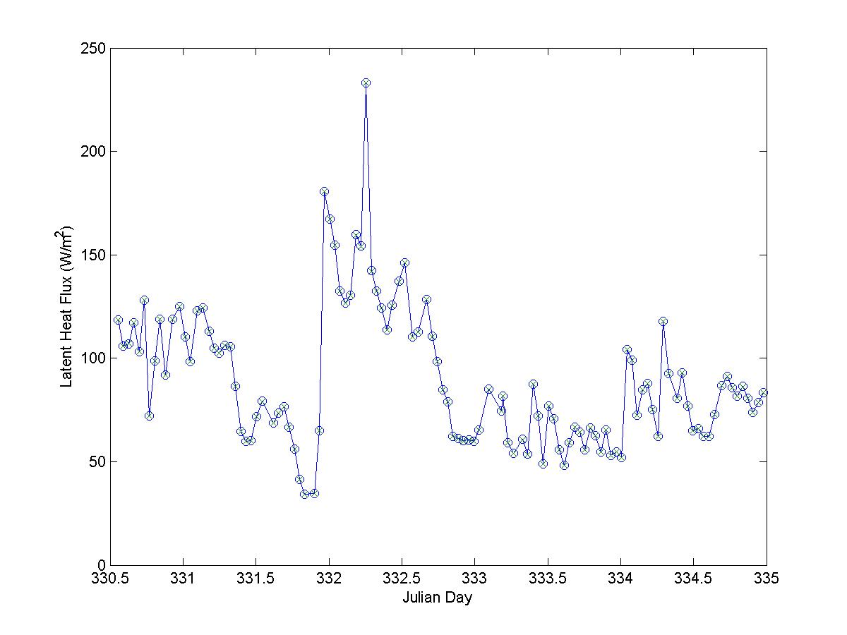
Figure 1. Time series of latent heat flux from the Matlab and Fortran versions of the COARE3.0 algorithm using the test data set. The circles are the matlab values and the x's are the Fortran values.

References
Beljaars, A. C. M., and A. A. M. Holtslag, 1991: Flux parameterization over land surfaces for atmospheric models. J. Appl. Meteor., 30, 327-341.
Bradley, E.F., and R.A. Weller, 1995: Third Workshop of the TOGA COARE Air-Sea Interaction (Flux) Working Group. Honolulu, 2-4 Aug 1995. UCAR/TCIPO. UCAR Communications, PO Box 3000, Boulder CO 80307-3000 USA.
Bradley, E.F., and R.A. Weller, 1997: Fourth Workshop of the TOGA COARE Air-Sea Interaction (Flux) Working Group. Woods Hole, 9-11 Oct 1996. UCAR/TCIPO. UCAR Communications, PO Box 3000, Boulder CO 80307-3000 USA.
Bradley, E.F, M.W. Moncrieff and R.A. Weller, 1997: Joint workshop of the TOGA COARE Flux and Oceans Working Groups, and the GEWEX GCSS Working Group 4. Boulder, Colorado, 14-16 May 1997. NCAR/MMM, PO Box 3000, Boulder CO 80307-3000 USA.
Caldwell, D.R. and W.H. Elliott, 1971: Surface stresses produced by rainfall. J. Phys. Oceanog. 1, 145-148.
DeCosmo, J., K. B. Katsaros, S. D. Smith, R. J. Anderson, W. A. Oost, K. Bumke, and H. Chadwick, 1996: Air-sea exchange of water vapor and sensible heat: The Humidity Exchange Over the Sea (HEXOS) results. J. Geophys. Res., 101, 12001-12016.
Fairall, C.W., E.F. Bradley, J.S. Godfrey, G.A. Wick, J.B. Edson, and G.S. Young, 1996a: The cool skin and the warm layer in bulk flux calculations. J. Geophys. Res. 101, 1295-1308.
Fairall, C.W., E.F. Bradley, D.P. Rogers, J.B. Edson, G.S. Young, 1996b: Bulk parameterization of air-sea fluxes for TOGA COARE. J. Geophys. Res. 101, 3747-3764.
Fairall, C.W., E.F. Bradley, J.E. Hare, A.A. Grachev, and J.B. Edson, 2003: Bulk parameterization of air-sea fluxes: Updates and verification for the COARE algorithm. J. Climate 16, 571-591.
Godfrey, J.S., and Beljaars, 1991: On the turbulent fluxes of buoyancy, heat, and moisture at the air-sea interface at low wind speeds. J. Geophys. Res. 96, 22043-22048.
Gosnell, R., C.W. Fairall, and P.J. Webster, 1995: The sensible heat flux of rainfall in the tropical ocean. J. Geophys. Res. 100, 18437-18442.
Grachev, A.A., and C.W. Fairall, 1997: Dependence of the Monin-Obukhov stability parameter on the bulk Richardson number for unstable conditions over the ocean. J. Appl. eteorol., 36, 406-414.
Grachev, A. A., C. W. Fairall, and E. F. Bradley, 1999: Convective profile constants revisited. Bound.-Layer Meteorol., 94, 495-515.
Hare, J. E., P.O.G. Persson, C. W. Fairall, and J. B. Edson, 1999: Behavior of Charnock’s relationship for high wind conditions. Proc. 13th Symposium of Boundary Layers and Turbulence. AMS. Dallas, TX, Jan. 15-20, paper 5B.8.
Liu, W.T, K.B. Katsaros and J.A. Businger, 1979: Bulk parameterization of the air-sea exchange of heat and water vapor including the molecular constraints at the interface, J. Atmos. Sci. 36, 1722-1735.
Price, J.F., R.A. Weller and R. Pinkel, 1986: Diurnal cycling: Observations and models of the upper ocean response to diurnal heating, cooling, and wind mixing, J. Geophys. Res. 91, 8411-8427.
Saunders, P.M., 1967: The temperature at the ocean-air interface. J. Atmos. Sci. 24, 269-273.
Smith, 1988: Coefficients for sea surface wind stress, heat flux, and wind profiles as a function of wind speed and temperature. J. Geophys. Res. 93, 15467-15472.
Webb, E.K., G.I. Pearman and R. Leuning, 1980: Correction of flux measurements for density effects due to heat and water vapour transfer, Q.J.R. Meteorol. Soc. 106, 85-100.
Yelland, M. and P. K. Taylor, 1996: Wind stress measurements from the open ocean. J. Phys. Oceanogr., 26, 541-558.
For more information, please contact:
Chris Fairall
NOAA/ERL/ETL
325 Broadway
Boulder, CO 80303 USA
e-mail: chris.fairall@.noaa.gov
Phone: +1 303 497-3253
Fax: +1 303 497-6101
OR
Frank Bradley
CSIRO Land and Water
GPO Box 1666
Canberra, ACT 2601 AUSTRALIA
e-mail: frank.bradley@ csiro.au
Phone: +61 2 6246 5575
Fax: +61 2 6246 5560

