Mary Bachran
511 Box Elder Ave.
Paonia, Co 81428

INVOICE
Grant Writing Activities
9-30-24 to 10-31-24

DATE | HOURS | GRANT(S) | ACTIVITY
9/30/24 | 4 | SRTS & SS4A | budget, application and webinar
10/2/24 | 3.5 | SRTS | budget
10/3/24 | 2.5 | SRTS | map
10/9/24 | 3 | SRTS | narrative & map
10/10/24 | 2.5 | SRTS | filling in application
10/11/24 | 0.5 | SRTS | Taking pictures and counting cars
10/15/24 | 3.25 | SRTS | Working on application
10/16/24 | 0.25 | SRTS | Dowloading information
10/21/24 | 2.25 | SRTS & other | Review of narratives, water grant searches
10/23/24 | 0.5 | SRTS | Filling in application
10/24/24 | 0.75 | SRTS | Narratives and car counts
10/30/24 | 3 | SRTS | Editing narratives and entering into portal
10/31/24 | 1.25 | SRTS | Finishing budget and submitting
10/31/24 | 27.25 | Total hours | $1,362.50

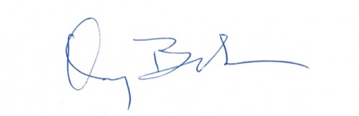
Signed:

