Members: Peter Abada and Ivan Peñas
Github Link: https://github.com/peter-abada/ABADA-GDGRAP1-REPO
(Note that this MP is based on PC02 and that branches from previous assignments are present in this repository, which include activity from another member; only branches with “MP” have been used in the project)

Implementation Summary:
Feature | Summary
3D Models | We have a car model used by the player and ghost cars. Ghost cars do not have transparency. We used the earth and the table as landmarks.
Skybox | Default skybox is used and present. A night-time skybox was implemented, and the player can switch between the two with Q and E.
Lighting | Direction lights are present but no point lights. Direction light intensity depends on if it is day or night.
Cameras | First person camera works.  Third person camera works (click and drag to move camera)
Player Control | W,A,S,D,Q,E,Z controls are present. Space to start and stop ghost cars is also implemented.
Gameplay | All gameplay requirements in the specs are implemented.
OOP | All classes described in the specs are implemented.

Game Map:

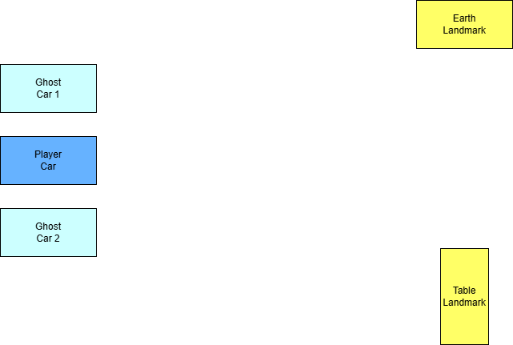

Models Used:
- Player and Ghost Cars
  - 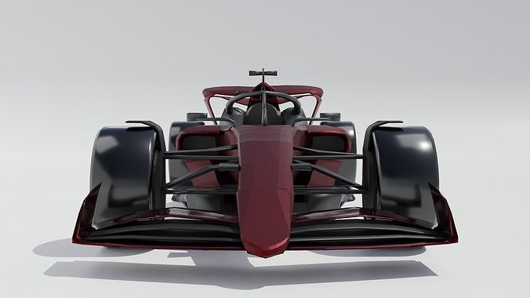
  - https://www.cgtrader.com/items/3597198/download-page?fbclid=IwZXh0bgNhZW0CMTEAAR4Yc4j-NHp6vPOimBdWR4T_ypDdST0wl-H_W6pqr2Weg3TNomjWVCGC-T34gA_aem_z_QWek4x2kkRdnzqpC96eg
- Table Landmark
  - 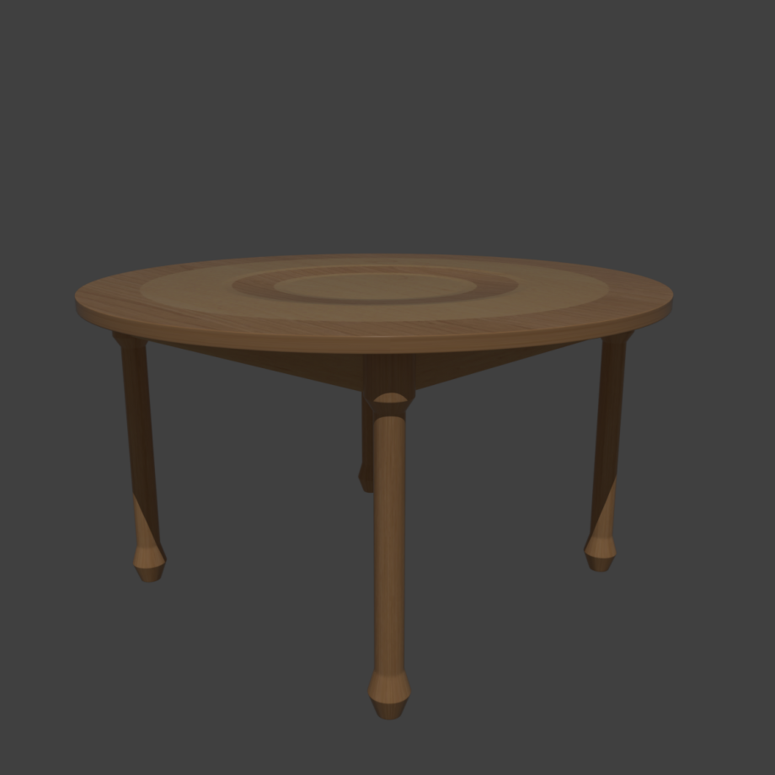
  - https://free3d.com/3d-model/round-table-928375.html?fbclid=IwZXh0bgNhZW0CMTEAAR7NAzpNuP_pnVnNOvqejkJJDtixidTfNBJjgNFQhiV0DA6oMe8Ug0rt3A3jsQ_aem_DXh3eqo9z8BHNPN6S6PskA
- Earth Landmark
  - 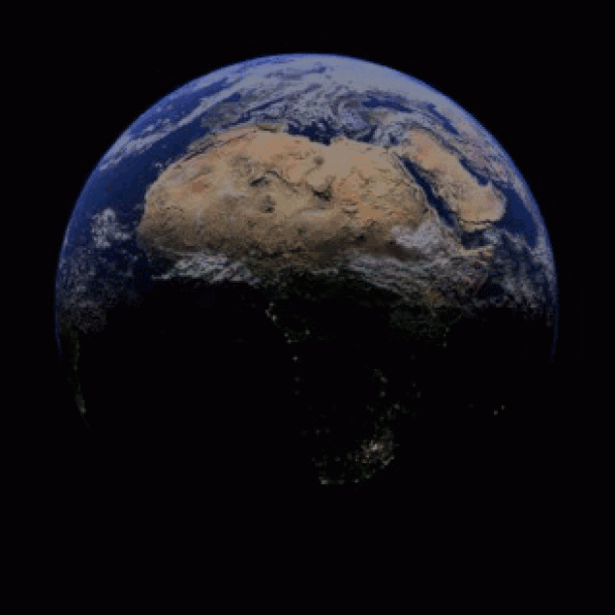
  - https://free3d.com/3d-model/world-16887.html?fbclid=IwZXh0bgNhZW0CMTEAAR6mH0qLBg_Z9VPadRs1eUB5nxNmF_t14h35ZOk63JRXt75vDkPvOnsLPElsig_aem_40JmxFfRa6S2dAFtbLAxkQ

