Effects of the 2021 EITC Expansion on Household Well-being

Peter Amerkhanian, 12/9/2022

# Executive Summary

The Advance Child Tax Credit (CTC) was a temporary expansion of the CTC that dispersed monthly checks ranging from $250 to $300 dollars per child to eligible households. Previous studies have found that income support policies generally can have a variety of positive impacts on households. This report seeks to evaluate the specific impacts of the Advance CTC and how the payments affected household well-being as measured by parent mental health, food sufficiency, and ability to meet expenses. The Census Household Pulse survey data is used, and causal effects of the Advanced CTC are estimated using a general difference-in-differences design. I find that the Advanced CTC clearly reduced the prevalence of household food insufficiency. Effects on ability to meet expenses generally were not identifiable using this experimental design. The payments had no effect on the prevalence of depression but seemed to possibly increase the prevalence of anxiety. Given the unprecedented scope of the Advance CTC payments further study is encouraged, but it is clear that this policy increased food sufficiency while in place.

# Background

In the U.S. tax code, there are two provisions explicitly designed to redistribute money towards low-income tax filers: The Earned Income Tax Credit (EITC) and the Child Tax Credit (CTC).[1] Since its introduction in 1975, the EITC has become the central element of the U.S.’ social safety net.[2] The EITC requires that a filer have earned income less than some cutoff that varies year-to-year – e.g. the cutoff is $59K for a two-parent three-children household in 2023 – and provides a maximum credit of roughly 45% of a family’s pre-tax income.[3] The CTC, introduced in 1997 but greatly expanded by the American Recovery and Reinvestment Act in 2009, is structurally similar to the EITC – there is a phase-in, flat, phase-out structure – but it is targeted towards most families with children rather than just low-income families, and its maximum benefit is much smaller.[4]

In 2021, the CTC was greatly expanded after passage of the American Rescue Plan (ARP). ARP expanded CTC eligibility to almost all families with children in tax-year 2021, with any family earning below $150,000 receiving the full credit.[5] ARP also expanded CTC eligibility to families without income and increased the maximum credit value to $3,000 per-child aged 6-17 and $3,600 per-child under 6. One of the key changes for the purposes of this study is that under ARP, half of the CTC was delivered in monthly installments (up to $250 per-child aged 6-17, $300 per-child under 6) between July and December 2021.

# Literature Review

In a literature review of studies evaluating income supports conducted by the Center for Budget and Policy Priorities (CBPP), the authors found that income support programs (the studies typically examine the EITC) have a variety of positive effects on family well-being as measured by maternal and child health, food sufficiency, parent mental health, child educational attainment, and more.[6] The literature examining the effects of the EITC and pre-expansion CTC are likely relevant to analysis of the Advance CTC, though there is the possibility that the monthly disbursement of the Advance CTC produced novel effects.

The Advance CTC payments have already been the subject of several impact evaluations examining their specific effects on household well-being. (Parolin et. al. 2021) used data from the Census Household Pulse Survey, a nationally representative survey conducted by the Census, and found that the monthly payments reduced household food insecurity, though did not have statistically significant effects on other measures of household material hardship.[7] (Glasner et. al. 2022) utilized the “Understanding America Survey,” a nationally representative panel survey conducted by the University of Southern California, to both replicate the findings in (Parolin et. al. 2021) and further find that the Advance CTC payments had no effect on parent depression or anxiety incidence in recipient households.[8]

# Data and Research Question

My principal research question is: How did the Advance CTC affect household well-being across the dimensions of parent mental health, household food sufficiency, and household ability to meet expenses? I view this question as a synthesis of (Parolin et. al. 2021) and (Glasner et. al. 2022)’s research. I also will examine whether the positive effects of income support programs identified in the CBPP literature review manifested for recipients of the Advance Child Tax Credit. Like (Parolin et. al. 2021) I utilize the Census’ Household Pulse survey and examine the weeks leading up to the Advance CTC payment period, the payment period, and weeks following the end of the payment period.

The Household Pulse Survey (Pulse) is an experimental survey conducted during the pandemic by the United States Census Bureau. It is a nationally representative random survey, though suffers from some non-response bias.[9] I use the Census’ household weights for all calculations.

Like (Glasner et. al. 2022), I first replicate the findings of the Advance CTC’s effects on food insecurity in (Parolin et. al. 2021).[10] I then expand the view of this study to include more measures of household well-being, with a focus on parent mental health and household food sufficiency as measured in the Census Household Pulse Survey.

# Trends in Treatment

Treatment varied considerably among households given differences in family size, propensity to claim tax credits, and age distribution of household children. As an example, I examine heterogeneity in treatment size across income groups in table 2. In percentage terms, fewer low-income households with children, especially very low-income households, received the Advance CTC than did higher income households. However, lower income households in-sample also typically have more children, thus increasing their average benefit size. Having children under 6 increases benefit size from $250 to $300, but I find that the proportion of families with children under 5 (the Pulse does not track whether a family has children under 6) does not vary considerably by income group.

|  |  |  |  |  |
| --- | --- | --- | --- | --- |
| **Income Group** | **Families with Children Received CTC** | **Average Estimated Monthly Benefit** | **Average # Kids** | **Families with Kids Under 5** |
| **<$25k** | 0.55 | 521.21 | 2.01 | 0.36 |
| **$25k - $35k** | 0.64 | 527.32 | 2.04 | 0.35 |
| **$35k - $50k** | 0.65 | 531.64 | 2.05 | 0.39 |
| **$50k - $75k** | 0.67 | 509.06 | 1.96 | 0.37 |
| **$75k - $100k** | 0.68 | 504.53 | 1.94 | 0.41 |
| **$100k - $150k** | 0.69 | 497.01 | 1.91 | 0.38 |
| **$150k - $200k** | 0.63 | 478.16 | 1.84 | 0.36 |
| **>$200k** | 0.49 | 507.45 | 1.95 | 0.38 |

Table 1

Use of the Advance CTC checks varied by household, though most paid off debt or else spent the money rather than saving it. Figure 1 shows that the most popular spending category was food, followed by utilities payments, clothing, and school supplies.

Figure 1

# Empirical Strategy

In order to find the causal effect of the Advance CTC, I estimate several difference-in-difference models as defined in equation (1):

$y_{i}=α_{i}+{ β}_{1}Eligible_{i}+β_{2}Week_{t}+β_{3}Eligible_{i}×1\left(Week_{t}∈\left[34,…, 39\right]\right)+ϵ_{i}$ (1)

Where $β_{3}$ is the effect of the monthly CTC payments and $y_{i}$ is a binary indicator of any of the outcomes I examine (definitions of outcomes are detailed in the appendix). The treatment is defined as the interaction between being eligible for the expanded CTC and being observed between weeks 34 and 39 of the Pulse survey, which roughly correspond to the start of July and December 2021 respectively. Eligibility is defined according to the eligibility requirements for receiving the expanded CTC – families with at least one child under 18 and annual income less than $150,000 for married couples and $112,500 for single households. The Pulse only observed income groups broken up into $25,000 bins, so I use $100,000 as a stand-in for the single household cutoff. I compare this eligibility definition with the data on Advance CTC receipt observed between July and December, presented in **Table 1**, where True Positive denotes that they are both declared eligible and go on to receive the Advance CTC.

|  |  |  |
| --- | --- | --- |
| **Eligibility Definition** | **True Positive** | **False Positive** |
| **Has Kids** | 0.6335 | 0.3665 |
| **Has Kids & Inc<150k** | 0.6612 | 0.3388 |
| **Has Kids & Inc<150k & Married** | 0.7011 | 0.2989 |
| **Has Kids & [(Inc<150k & Married) Or (Inc<100k & not Married)]** | 0.6661 | 0.3339 |

Table 2

I decide to use the third definition: a household is eligible for the Advance CTC payments if they have kids, and either earn less than $150,000 and are married, or else earn less than $100,000 and are single. Although this definition’s True Positive rate is lower than the second, it is closest to the formal definition of eligibility for the full Advance CTC payment.[11]

I find that raw data suggests several effects of the Advance CTC. In Figure 2, there are clearly sharp discontinuities post-treatment in the incidence of food insecurity and receiving free food (row 2). Patterns in mental health (row 1) and household ability to meet expenses (row 3) are less evident in the raw data.

Figure 2

# Effects of CTC

I estimate the parameters of equation (1) for the Advance CTC’s effects on the following dependent variables: whether a parent felt depressed in the last 14 days, whether they felt anxious in the last 14 days, whether their household received free food in the last seven days, whether they describe themselves as experiencing food insecurity, whether they are experiencing difficulties with meeting household expenses, and whether they are confident in being able to pay their next months’ rent. Detailed explanation of how these variables is defined is available in the appendix. I compute estimates with the control group defined as those with no children and the treatment group defined in the following five ways: those who are eligible for the Advance CTC and have any children, those eligible with specifically one child, those eligible with two, eligible with three, and eligible with four children. By including the effects of specific child counts it’s possible to get a general sense of how increases to the Advance CTC monthly check amount affects the outcome of interest. All estimates are shown in table 3.

|  |  |  |  |  |  |
| --- | --- | --- | --- | --- | --- |
|  | Children Generally | One Child | Two Children | Three Children | Four Children |
| Depressed | 0.0002 | 0.0030 | -0.0050 | 0.0081 | -0.0056 |
|  | (0.0043) | (0.0057) | (0.0065) | (0.0113) | (0.0172) |
| **Anxious** | **0.0176\*\*\*** | 0.0169*** | 0.0115 | 0.0210* | 0.0577*** |
|  | (0.0047) | (0.0064) | (0.0073) | (0.0125) | (0.0209) |
| Received Free Food | -0.0181*** | -0.0141*** | -0.0168*** | -0.0218** | -0.0485*** |
|  | (0.0033) | (0.0042) | (0.0053) | (0.0095) | (0.0169) |
| **Food Insecurity** | **-0.0256\*\*\*** | -0.0206*** | -0.0264*** | -0.0375*** | -0.0395** |
|  | (0.0037) | (0.0049) | (0.0058) | (0.0090) | (0.0180) |
| Difficulty with Expenses | -0.0052 | -0.0031 | -0.0111 | -0.0024 | -0.0006 |
|  | (0.0051) | (0.0068) | (0.0080) | (0.0133) | (0.0215) |
| Rent Confidence | 0.0127** | 0.0099 | 0.0184** | 0.0155 | 0.0286 |
|  | (0.0051) | (0.0068) | (0.0080) | (0.0132) | (0.0216) |
| N | 842783 | 713637 | 679113 | 628867 | 608418 |
| Fixed Effects | Week/Group | Week/Group | Week/Group | Week/Group | Week/Group |
| Note: $* p<.05, **p<.01, ***p<.001$, **Bold** denotes parallel trends satisfied for households with children generally. Robust standard errors reported in parenthesis. | | | | | |

Table 3

To probe parallel trends assumptions necessary for difference-in-difference estimates to be validly interpreted as causal effects, I also estimate an event study model. Full results are available in the appendix, but the principal findings of the event study design are that parallel trends were satisfied for only Anxiety, seen in Figure 3, and Food Insecurity, seen in Figure 4.

# Discussion

The finding that receipt of the Advance CTC causes small but statistically significant increases in the incidence of anxiety seems odd at first glance and in light of a body of prior literature that finds that income supports like the EITC and CTC yield the opposite effect.[12] However, (Glasner et. al. 2022) also found positive signed coefficients for the Advance CTC’s effect on anxiety, though their estimates were not statistically significant. It has been theorized that the stigma of participation in benefit programs could potentially lead to increases in depression, though the limited empirical evidence in this area – namely (Bergmans et. al. 2018)’s study of stigma in SNAP recipients – has not borne that theorized effect out.[13] It is possible that the stress of receiving direct cash assistance from the government could provoke an increase in anxiety if recipients are distrustful of the benefit, worried they may have to return it, or otherwise anxious about receiving it. However, given the tenuousness of the pre-treatment parallel trends and the unexpected effect, further research will be required to fully explore mental health responses to the Advance CTC payments.

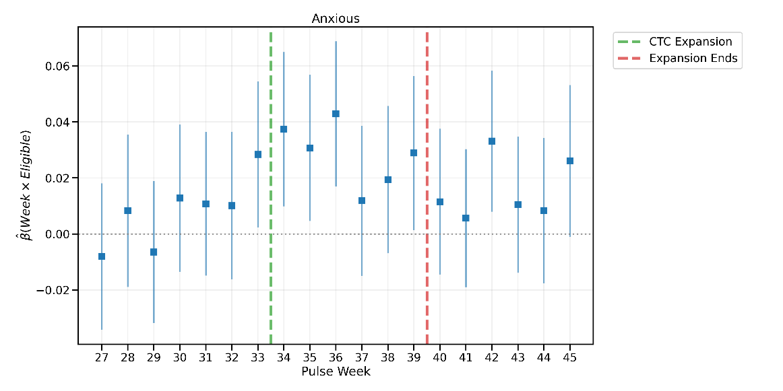

The estimated effects of the Advance CTC on Food Insecurity are more consistent with the literature. These effects are also consistent with the descriptive analysis presented in Figure 1, which showed that the top spending category for the Advance CTC was food. Food Insecurity also quickly rises again after treatment ends, strengthening the claim that treatment had some effect. I find that these effects on food insecurity increase for households with more children, who receive either $250 or $300 more each month for each child: -0.02 for households with one child, -0.026 for two, -0.038 for three, and -0.04 for four. This would suggest that the more money dispersed, the more the incidence of Food Insecurity fell. These effects are corroborated by the fact that, though parallel trends did not hold, I found that households reported receiving free food (from a food pantry, food bank, church, or other place that provides free food) less post-treatment, a reduction that may have been related to Advance CTC payments being spent on food.

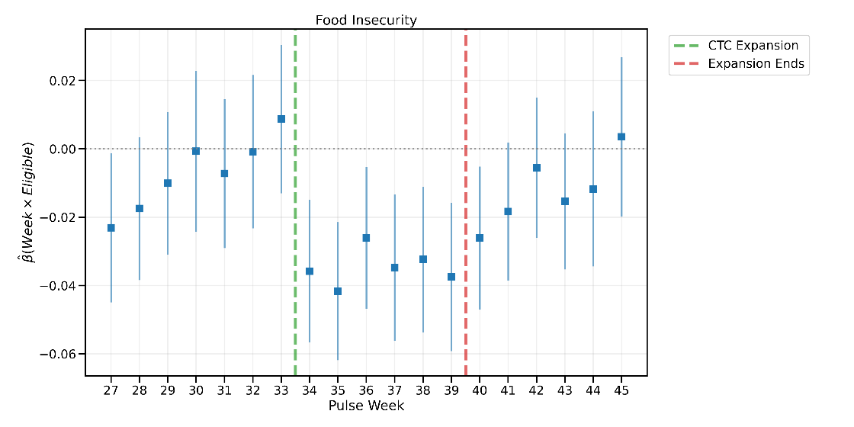

# Opportunities for Further Research

There is still much to explore regarding the Advance CTC payments’ effects on household well-being, even using this same data. For one, this report did not delve into heterogeneity in effects with respect to specific subgroups – certain effects could have been specific to single mother households, for example. There also is opportunity to delve more into the effect of receiving $300 from having a child under 6 years old versus $250 for a child between 6 and 17. However, given that the Pulse only observed whether a household has children under 5 after the rollout of the Advance CTC, this could only be examined through an observational, rather than quasi experimental study.

Another line of inquiry involves exploring effects related to things that the Advance CTC payments were spent on. Much of the Advance CTC payments were spent on food, and this research shows that the payments caused a corresponding reduction in Food Insecurity for recipients. Given that much of the payments were also spent on paying down debt, it would be useful to evaluate whether receiving the payments had any effects on outcomes such as personal debt or households’ monthly interest payments.

# Appendix:

## Dependent Variable Definitions

“Anxiety” is defined as feeling anxious more than half the days over the previous week. “Depression” is defined as feeling depressed more than half the days over the previous week. “Received Free Food” is defined as someone in a household getting free groceries from a food pantry, food bank, church, or other place that provides free food in the last seven days. “Difficulty with Expenses” is defined as finding it somewhat or very difficult to pay for usual household expenses, including but not limited to food, rent or mortgage, car payments, medical expenses, student loans, and so on in the last seven days. “Food Insecurity” is defined as sometimes or often not having enough to eat in the last seven days. “Rent Confidence” is defined as feeling moderately or highly confident about being able to pay the rent or mortgage next month.[14]

## Event Study Estimates

Given the event study specification:

$y_{i}=α_{i}+{ β}_{1}Eligible_{i}+β_{2}Week_{t}+β_{3}Eligible_{i}×Week_{t}+ϵ_{i}$

The table below shows the estimate of $β_{3}$ for various outcomes $y$.

|  |  |  |  |  |  |  |  |
| --- | --- | --- | --- | --- | --- | --- | --- |
| **Coefficient** | **Depressed** | **Anxious** | **Received Free Food** | **Food Insecurity** | **Difficulty with Expenses** | **Rent Confidence** | **Treatment** |
| C(Week)[T.27]:Eligible | -0.0188 | -0.0081 | -0.0204** | -0.0231** | -0.0701*** | 0.0284** | No |
| C(Week)[T.28]:Eligible | -0.0106 | 0.0083 | -0.0113 | -0.0175 | -0.0063 | 0.0284* | No |
| C(Week)[T.29]:Eligible | -0.0003 | -0.0065 | -0.0194** | -0.0101 | -0.0308** | 0.0291** | No |
| C(Week)[T.30]:Eligible | -0.0028 | 0.0128 | -0.0076 | -0.0007 | -0.0117 | 0.0112 | No |
| C(Week)[T.31]:Eligible | -0.0024 | 0.0108 | -0.0268*** | -0.0072 | -0.0016 | 0.0081 | No |
| C(Week)[T.32]:Eligible | 0.0046 | 0.0101 | -0.0289*** | -0.0008 | -0.0215 | 0.0182 | No |
| C(Week)[T.33]:Eligible | 0.0054 | 0.0284** | -0.0169* | 0.0087 | 0.0029 | 0.0251* | No |
| C(Week)[T.34]:Eligible | 0.0045 | 0.0374*** | -0.0425*** | -0.0358*** | -0.0182 | 0.0056 | Treatment |
| C(Week)[T.35]:Eligible | -0.0007 | 0.0307** | -0.0582*** | -0.0416*** | -0.0133 | 0.0459*** | Treatment |
| C(Week)[T.36]:Eligible | 0.0003 | 0.0429*** | -0.0522*** | -0.0261** | -0.0311** | 0.0221 | Treatment |
| C(Week)[T.37]:Eligible | -0.0092 | 0.0118 | -0.0536*** | -0.0347*** | -0.0163 | 0.0216 | Treatment |
| C(Week)[T.38]:Eligible | -0.0036 | 0.0194 | -0.0539*** | -0.0324*** | -0.0120 | 0.0294** | Treatment |
| C(Week)[T.39]:Eligible | -0.0001 | 0.0289** | -0.0382*** | -0.0375*** | -0.0100 | 0.0287* | Treatment |
| C(Week)[T.40]:Eligible | -0.0059 | 0.0115 | -0.0382*** | -0.0261** | -0.0096 | 0.0037 | No |
| C(Week)[T.41]:Eligible | -0.0016 | 0.0057 | -0.0508*** | -0.0184* | -0.0183 | 0.0105 | No |
| C(Week)[T.42]:Eligible | 0.0088 | 0.0331*** | -0.0496*** | -0.0055 | 0.0135 | 0.0075 | No |
| C(Week)[T.43]:Eligible | -0.0082 | 0.0105 | -0.0606*** | -0.0153 | -0.0076 | 0.0076 | No |
| C(Week)[T.44]:Eligible | -0.0020 | 0.0083 | -0.0563*** | -0.0117 | -0.0111 | 0.0088 | No |
| C(Week)[T.45]:Eligible | 0.0100 | 0.0261* | -0.0460*** | 0.0035 | 0.0074 | -0.0016 | No |

Note: $*p<.05, **p<.01, ***p<.001$

# Bibliography

Bergmans, Rachel S., Lawrence M. Berger, Mari Palta, Stephanie A. Robert, Deborah B. Ehrenthal, and Kristen Malecki. “Participation in the Supplemental Nutrition Assistance Program and Maternal Depressive Symptoms: Moderation by Program Perception.” *Social Science & Medicine (1982)* 197 (January 2018): 1–8. https://doi.org/10.1016/j.socscimed.2017.11.039.

Bitler, Marianne, Hilary Hoynes, and Elira Kuka. “Child Poverty, the Great Recession, and the Social Safety Net in the United States.” Working Paper. Working Paper Series. National Bureau of Economic Research, September 2016. https://doi.org/10.3386/w22682.

Bureau, US Census. “Household Pulse Survey Technical Documentation.” Census.gov. Accessed November 11, 2022. https://www.census.gov/programs-surveys/household-pulse-survey/technical-documentation.html.

“Earned Income and Earned Income Tax Credit (EITC) Tables | Internal Revenue Service.” Accessed December 9, 2022. https://www.irs.gov/credits-deductions/individuals/earned-income-tax-credit/earned-income-and-earned-income-tax-credit-eitc-tables.

Glasner, Benjamin, Oscar Jiménez-Solomon, Sophie M. Collyer, Irwin Garfinkel, and Christopher T. Wimer. “No Evidence The Child Tax Credit Expansion Had An Effect On The Well-Being And Mental Health Of Parents.” *Health Affairs* 41, no. 11 (November 2022): 1607–15. https://doi.org/10.1377/hlthaff.2022.00730.

Hoynes, Hilary, and Jesse Rothstein. “Tax Policy Toward Low-Income Families.” Working Paper. Working Paper Series. National Bureau of Economic Research, March 2016. https://doi.org/10.3386/w22080.

Center on Budget and Policy Priorities. “Income Support Associated With Improved Health Outcomes for Children, Many Studies Show.” Accessed December 9, 2022. https://www.cbpp.org/research/federal-tax/income-support-associated-with-improved-health-outcomes-for-children-many.

Parolin, Zachary, Elizabeth Ananat, Sophie M. Collyer, Megan Curran, and Christopher Wimer. “The Initial Effects of the Expanded Child Tax Credit on Material Hardship.” Working Paper. Working Paper Series. National Bureau of Economic Research, September 2021. https://doi.org/10.3386/w29285.

“Phase 3.2 Household Pulse Survey,” n.d., 37.

“The 2021 Child Tax Credit | Information About Payments & Eligibility.” Accessed December 9, 2022. https://www.childtaxcredit.gov/.

1. Hoynes and Rothstein, “Tax Policy Toward Low-Income Families.”
2. Bitler, Hoynes, and Kuka, “Child Poverty, the Great Recession, and the Social Safety Net in the United States.”
3. “Earned Income and Earned Income Tax Credit (EITC) Tables | Internal Revenue Service.”
4. Hoynes and Rothstein, “Tax Policy Toward Low-Income Families.”
5. Parolin et al., “The Initial Effects of the Expanded Child Tax Credit on Material Hardship.”
6. “Income Support Associated With Improved Health Outcomes for Children, Many Studies Show.”
7. Parolin et al., “The Initial Effects of the Expanded Child Tax Credit on Material Hardship.”
8. Glasner et al., “No Evidence The Child Tax Credit Expansion Had An Effect On The Well-Being And Mental Health Of Parents.”
9. Bureau, “Household Pulse Survey Technical Documentation.”
10. Parolin et al., “The Initial Effects of the Expanded Child Tax Credit on Material Hardship.”
11. “The 2021 Child Tax Credit | Information About Payments & Eligibility.”
12. “Income Support Associated With Improved Health Outcomes for Children, Many Studies Show.”
13. Bergmans et al., “Participation in the Supplemental Nutrition Assistance Program and Maternal Depressive Symptoms.”
14. “Phase 3.2 Household Pulse Survey.”