# Asteroids

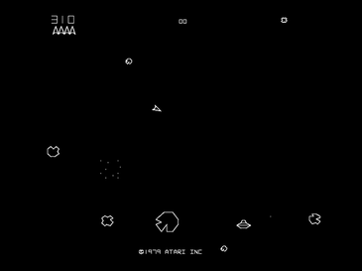This project is based on the 1979 Atari arcade space shooter game **Asteroids**.

In the original game, the player controls a spaceship in an asteroid field which is periodically traversed by flying saucers.

The object of the game is to shoot and destroy asteroids and saucers while not colliding with either or being hit by the saucers' counter-fire.

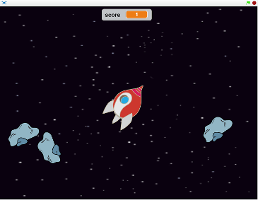Our version includes only the spaceship and the asteroids, but has much better graphics than the original – and can be made using resources already in Scratch!

The player controls a spaceship which moves around deep space dodging the asteroids coming from all directions.

Each asteroid destroyed earns a point.

The game ends when an asteroid collides with the spaceship.  
  
The following **parameters** will be used to change how the game behaves:

* How quickly the spacecraft speeds up when the rocket engine is fired (***thrust***)
* How quickly it slows down when the rocket engine is off (***friction***)
* How far the laser gun will reach (***max_laser***)
* How many asteroids can be visible at the same time (***max_rocks***)
* How close to the spaceship new asteroids can appear (***min_distance***)

## Step 1 - Make the Initial Spaceship

Start Scratch and set the background to "stars", delete the cat sprite, and add the "**Spaceship**" sprite from the library.

Rotate the "\***\*\*spaceship-a\*\***\*" costume to be pointing to the right (90 degrees) and set the centre of the spaceship to line up with the nose and the middle of the window.  
  
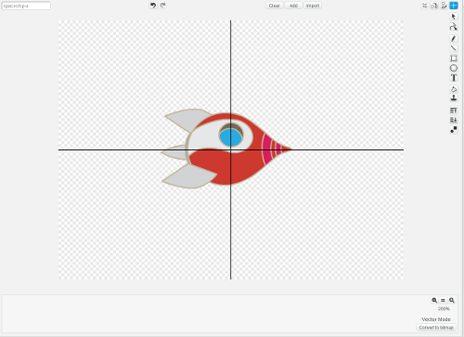

## Step 2 - Make the Spaceship Move

Create two variables which are for this sprite only, "***thrust***" and "***speed***". The variable *thrust* will control how quickly the spaceship will accelerate and *speed* will hold the speed at which it is currently moving. Hide these two variables, and all others you create from now on.  
  
Add this code to the Scripts of Spaceship.  
    
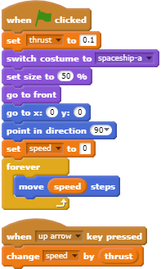I have put ***thrust*** at the top as this is one of the **parameters** I mentioned earlier which will control how the game works.  
  
Start the game running by pressing the green flag and the spaceship will start in the middle of the stage pointing to the right.

Press the ***up arrow*** key and the spaceship will start moving to the right. The longer you hold the key down, the faster it will go.

The spaceship will stop when it hits the right-hand edge because Scratch cannot draw off the stage.  
  
Press the red button to stop the game.

## Step 3 - Add Friction

At the moment, we have no way of slowing down or stopping the spaceship. We could add the *down arrow* key to slow it down, but a more interesting idea is to pretend that a spaceship travelling through space will slow down by itself. If you know your physics, you will know that this is not the case in real life but it makes the game more interesting!  
  
Create a new variable **\*\*\*friction\*\***\* which should be just for this sprite, then change the code slightly by adding a **\*\*set\*\*** block in the *forever* loop as shown.  
   
![Spaceship_2](images/spaceship_2.png)  
  
Start the game again. Pressing the **\*\*\*up arrow\*\***\* key will start the spaceship moving but now when you release it, the spaceship will gently slow down.  
  
## Add Steering  
  
The spaceship moves but only in one direction, so we will now add some steering using the left and right arrow keys. Add these two sequences to the scripts of Spaceship.  
    
![Spaceship_3](images/spaceship_3.png)  
  
Run the game and we can steer the spaceship - but like a car, not like a spaceship! Changing the direction the spaceship is pointing in should not make it change direction unless the rocket engine is being fired (*up arrow*) at the same time. But Scratch will always move a sprite in the direction it is pointing.  
  
We can get around this by having two spaceships, where the second one does nothing except provide the costume which you can see. We could do this with two sprites but it is easier to do it with the existing spaceship plus a **\*\*clone\*\*** of the spaceship.  
  
Create a new variable **\*\*\*course\*\***\* which needs to be available for **\*\*all sprites\*\*** because both spaceships will need to use it. Modify the code of *Spaceship* slightly to make it possible for the second spaceship to know where it is and which way its costume should point. You need to add a **\*\*\*set* block for *speed\*\***\* and a **\*\*\*create clone\*\***\* block.  
    
![Spaceship_4](images/spaceship_4.png)  
  
You also need to change the **\*\*\*up arrow\*\***\* block to point the spaceship in the right direction. The **\*\*\*left arrow\*\***\* and **\*\*\*right arrow\*\***\* also need to be changed to set the **\*\*\*course\*\***\* variable.  
  
![Spaceship_5](images/spaceship_5.png)  
  
Run the game and fly the spaceship around. The **\*\*clone\*\*** spaceship stays in the centre of the stage but turns with the spaceship. The first spaceship moves as before but when you press the **\*\*\*left arrow\*\***\* or **\*\*\*right arrow\*\***\* keys, nothing seems to happen - until you press the **\*\*\*up arrow\*\***\* key to fire the rocket engine. Now the spaceship goes in the new direction.   
  
## Add Code for the Clone Spaceship  
  
Add this code to the Scripts of Spaceship. It tells the **\*\*clone\*\*** spaceship to point whichever way the **\*\*\*course\*\***\* variable says then jump to wherever the Spaceship currently is.  
  
![Spaceship_6](images/spaceship_6.png)  
  
Start the game and drive the spaceship around again. Now you will see that the two spaceships stay on top of the each other. When you turn using the **\*\*\*left arrow\*\***\* and **\*\*\*right arrow\*\***\* keys, you can see one of these changes direction but the other carries on in the same direction - until you fire the rocket engine using the **\*\*\*up arrow\*\***\*. The spaceship which turns is the **clone**.  
   
Change the script of Spaceship slightly so that we can’t see it by adding a **\*\*\*hide\*\***\* block.  
  
![Spaceship_7](images/spaceship_7.png)  
  
Start the game again and drive the spaceship around. When the spaceship is moving and you are not using the rocket engine, you can rotate the spaceship and it does not change direction - until you use the rocket engine using the up arrow. This is much closer to how a real spaceship behaves.  
  
## Add Costumes to Show the Rocket Engine Being Used  
  
Duplicate the costume **\*\*\*spaceship-a\*\***\*, which will be called \***\*\*spaceship-a2\*\***\*. Click **Add** at the top of the screen and select **\*\*\*candle1-a\*\***\* and **\*\*\*candle1-b\*\***\* from the library.   
  
Rotate the two candles and position them so that the flames are at the back of the spaceship.  
   
![Spaceship_8](images/spaceship_8.png)  
  
In vector mode, each image is on a different layer – one on top of the other. We need to move the spaceship to the top layer. Click the spaceship to select it and press the **\*\*Forward a layer\*\*** button (circled in red below) on the right-hand side **\*\*twice\*\*** - and the two candles will now be below the spaceship with only the flames showing.  
  
![Spaceship_9](images/spaceship_9.png)  
   
Adjust the two candles so that the flames look how you like them - the candlestick parts remain hidden underneath the spaceship.  
  
Duplicate this costume to create **\*\*\*spaceship-a3\*\***\*. Swap the two candles around to make the flames slightly different between the two costumes.  
  
![Spaceship_10](images/spaceship_10.png)  
  
## Add Code to Show the New Costumes  
  
Now we can **\*\*add\*\*** this code to the Scripts to use the two new costumes when the up arrow key is pressed.  
  
![Spaceship_11](images/spaceship_11.png)  
  
Run the game and press the up arrow key to fire the rocket engine. Hey that looks good – but… when you release the up arrow, the rocket engine still looks like it is firing. It is easy to check if the **\*\*\*up arrow\*\***\* key is **\*\*not\*\*** being pressed in the clone's forever loop as shown below.  
   
![Spaceship_12](images/spaceship_12.png)  
  
Run the game again and move around the screen. This should now look pretty good!