# Analogue Clock

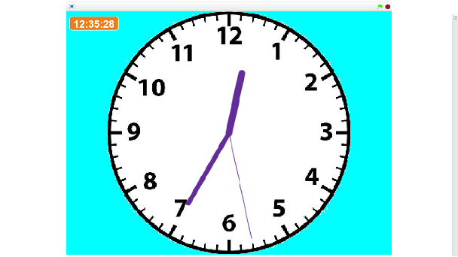Scratch has blocks included which give you the current time in numbers.

This project is to make a useful **analogue** clock which displays the time in an **analogue** fashion - with hands for the hours, minutes and seconds.

## Step 1 – Make a Digital Clock

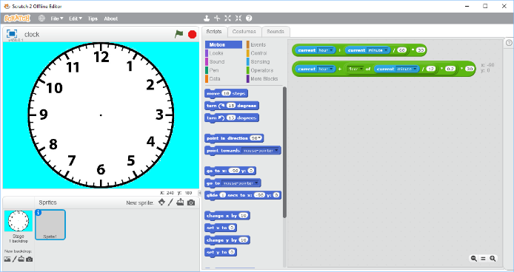The starter project will already be loaded and saved as the project “clock”.

This contains the **clock face** you will need for the clock, and two snippets of code in Sprite1 which you will need later.

The centre of the clock face is at coordinate (0, 0) which is the centre of the Scratch stage.

This step of the project will display the time in numbers, so we can check that our analogue clock is working.

Go to the ***Scripts*** panel of ***Sprite1***.

Create four variables called ***time***, ***hh***, ***mm*** and ***ss***.

Hide all the variables except ***time*** and change this to have a “large readout” display.

Move ***time*** to the top-left corner of the stage.

In the ***More Blocks*** section, create a new block called ***time*** using ***Make a Block***. This will add a block called ***time*** and a definition block called ***define time*** in the Scripts of Sprite1.

Your project should look like this so far.

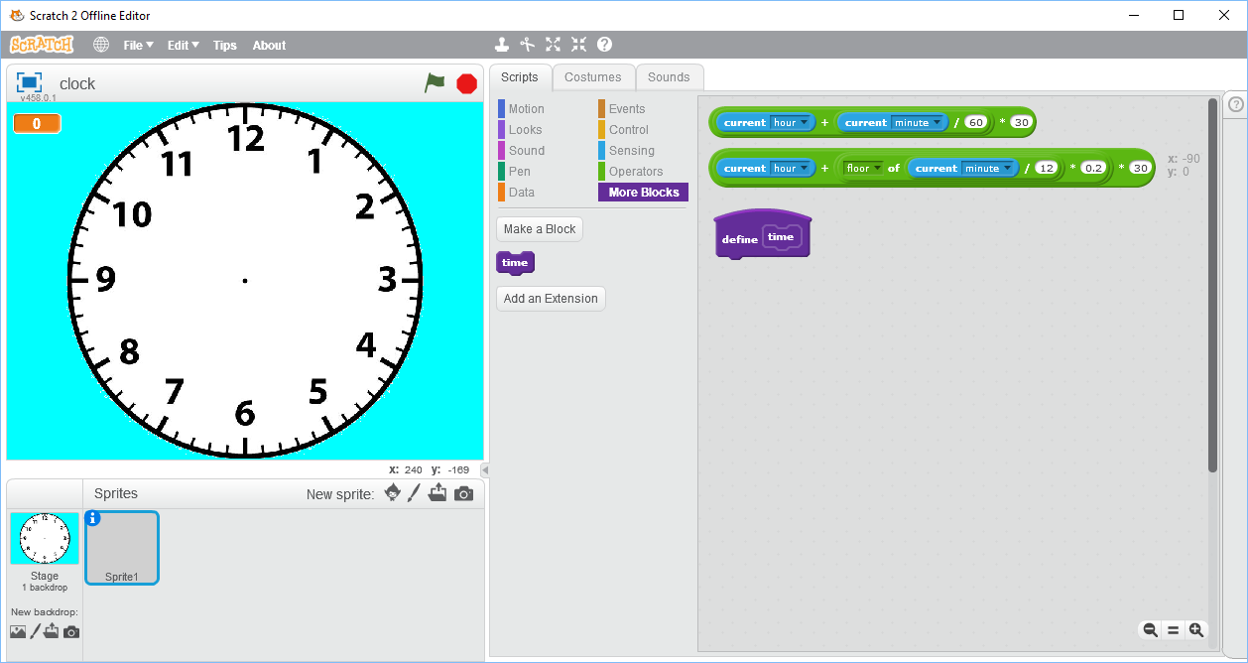

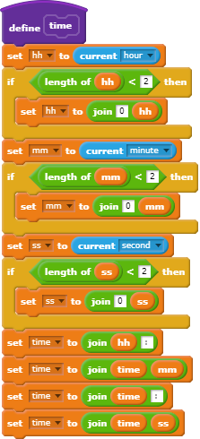Add this code to ***Sprite1*** to show the current computer time.

The variables ***hh***, ***mm***, and ***ss*** will contain the current hours, minutes and seconds of the time. Each will have two digits (numbers) separated by a colon (:) to make it easier to read.

Time in Scratch uses a 24-hour clock. Morning (am) times are shown using the hours 1 to 12 and afternoon (pm) times as the hours 13 to 24.

Therefore, 13:25 is 25 minutes past one in the afternoon (1:25 pm) but 01:25 is 25 minutes past one in the morning (1:25 am).

You also need to add this code to start the clock running when the green flag is clicked.

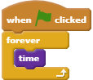

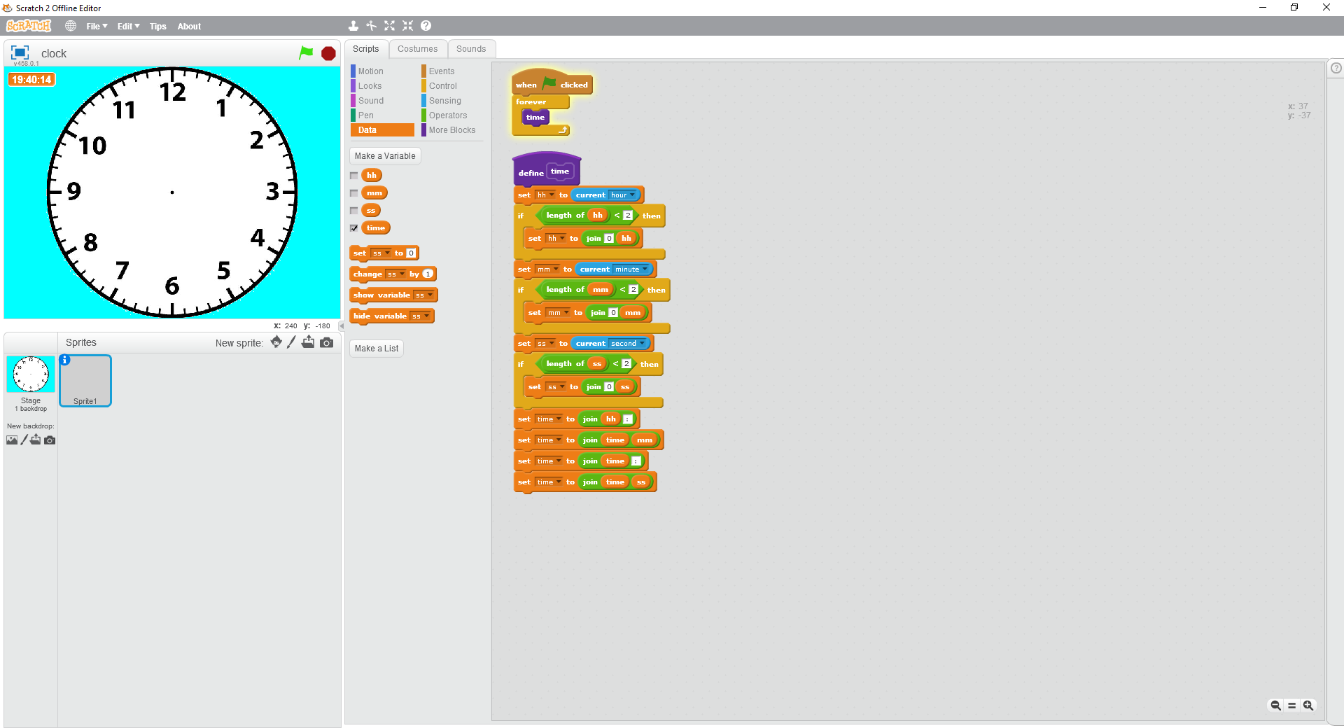

Click the Green Flag to start the clock running.

You should see the current time displayed at the top-left of the stage (19:40:14 in my example, which is 40 minutes and 14 seconds past 7 pm).

If it is not correct, go back and check the code you added compared to my listing above. You can display the ***hh***, ***mm***, and ***ss*** variables to help you to get the code right.

The clock we have made so far is a **digital** one. We will use it to make sure that our **analogue** clock (with hands) is showing the correct time.

**Save your project before continuing.**

## Step 2 – Add the Second Hand

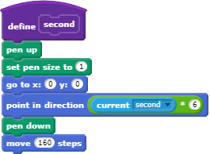Add a new block called ***second*** to your project and add this code. This uses the pen to draw the second hand on our clock face.

A circle consists of 360 degrees (slices of pie) with 0 degrees at the top, 90 degrees at the right-hand side, 180 degrees at the bottom, and 270 degrees at the left-hand side.

There are 60 seconds in a minute, therefore each second needs to move 360 / 60 = 6 degrees.

We start drawing at the centre of the stage (0, 0) and draw in the direction of the number of seconds x 6 degrees. The line is 160 pixels (points of the stage) long which reaches nearly the edge of the clock face.

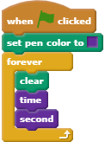To see the second hand of our clock face, we need to change the main program.

Choose a colour for the clock hands, I have used the purple from the “More Blocks” section, but you can choose any colour you like as long you can see it on a white background.

We need to clear the drawing before we draw the clock hands then update the digital clock and draw the second hand.

Click the green flag. You should see the second hand ticking around the clock face (and agreeing with the seconds in the digital clock).

**Save your project before continuing.**

## Step 3 – Add the Minute Hand

The minute hand of our clock is created in almost an identical way to the second hand.

* Create a ***minute*** block.
* Copy the code from the ***second*** block to this.
* Make the minute hand slightly wider, I suggest 7 pixels.
* Adjust the direction of ***current minute*** rather than second but the arithmetic is the same (60 minutes in an hour).
* Make the hand shorter – I suggest 120 steps.
* Add a ***minute*** block to your main program (when green flag clicked).

Test your project and check that both minute and second hands are showing the same time as the digital clock.

**Save your project before continuing.**

## Step 4 – Add the Hour Hand

We cannot do the hour hand in the same way as it would jump by an hour when the hour changes.

Instead we will move the hour hand every 12 minutes as this matches up with the marks on the clock face.

Create a new block ***hour***.

Copy the code from the ***minute*** block to the ***hour*** block and change:

* The hour hand to be slightly wider, I suggest 10 pixels.
* The hour hand to be shorter – I suggest 90 steps.
* Add a call to ***hour*** to your main program (when green flag clicked).
* Point the hand in the right direction using this green block, **which was in the starter project**. Move this into place by “holding” the block by the * next to 30.



It doesn’t matter if you don’t understand the arithmetic. In real life, very often the people coding will be given the arithmetic by an expert who will also check the project later on.

Click the green flag again and check that the hours, minutes, and seconds hands are showing the same time as the digital clock. You can hide the digital clock once you are sure the analogue clock is working.

This version of the clock makes the hour hand move with the 60 marks on the clock face - every 12 minutes.

If you would like the hour hand to move more gradually, use **the second green block in the starter project**. This will move the hour hand every minute.



**Save your project before continuing.**

## Challenges

1. See what happens if you don’t clear the clock before drawing it.
2. Have a different colour for each of the three hands on the clock.
3. Add a tick sound to the second hand and change the sound volume using Scratch so that it is played quietly. **Hint:** Pause the main program for a second every time it paints the clock.
4. Show the date as well as the time (e.g. 19/11/2017).
5. Add a chime on the hour. **Hint:** You will need to use a variable so you can tell when the hour has changed.
6. Show the day of the week in words (e.g. Wednesday). **Hint**: You will need to use a list of the days of the week **starting with Sunday**.