Those Eyes Are Following Me!

* 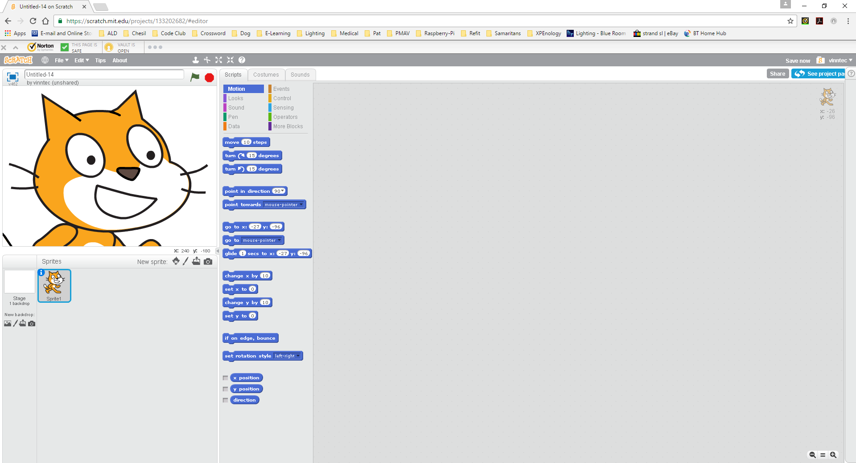Make the cat’s face as big as you can. This is so we can make the eyes more interesting!
* 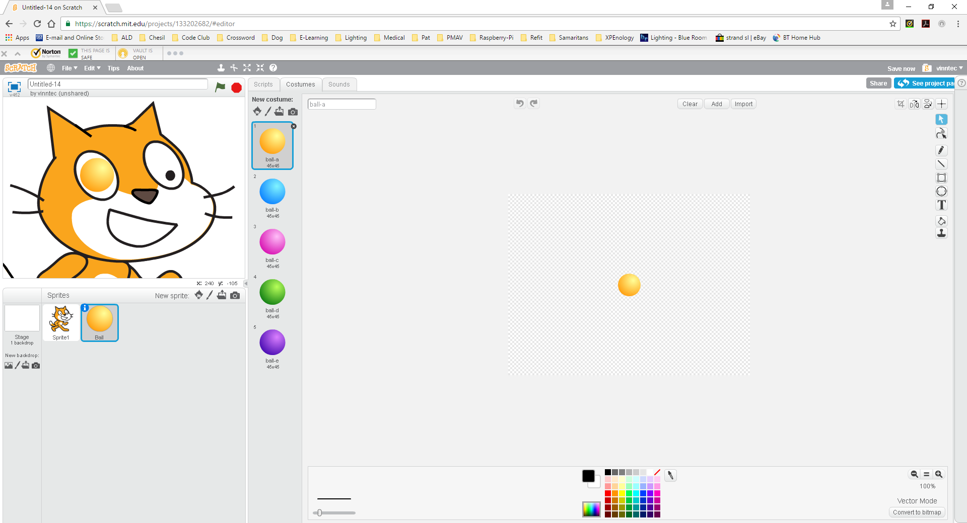Make a second sprite and choose a ball. It is yellow to start with but you can change this to one of the other costumes if you want.
* Place the ball over the cat’s left eye and make it large enough to cover his old iris (the black spot).
* You can see how you can easily choose a different colour from the ones already there. I am going to stick with yellow.
* 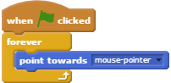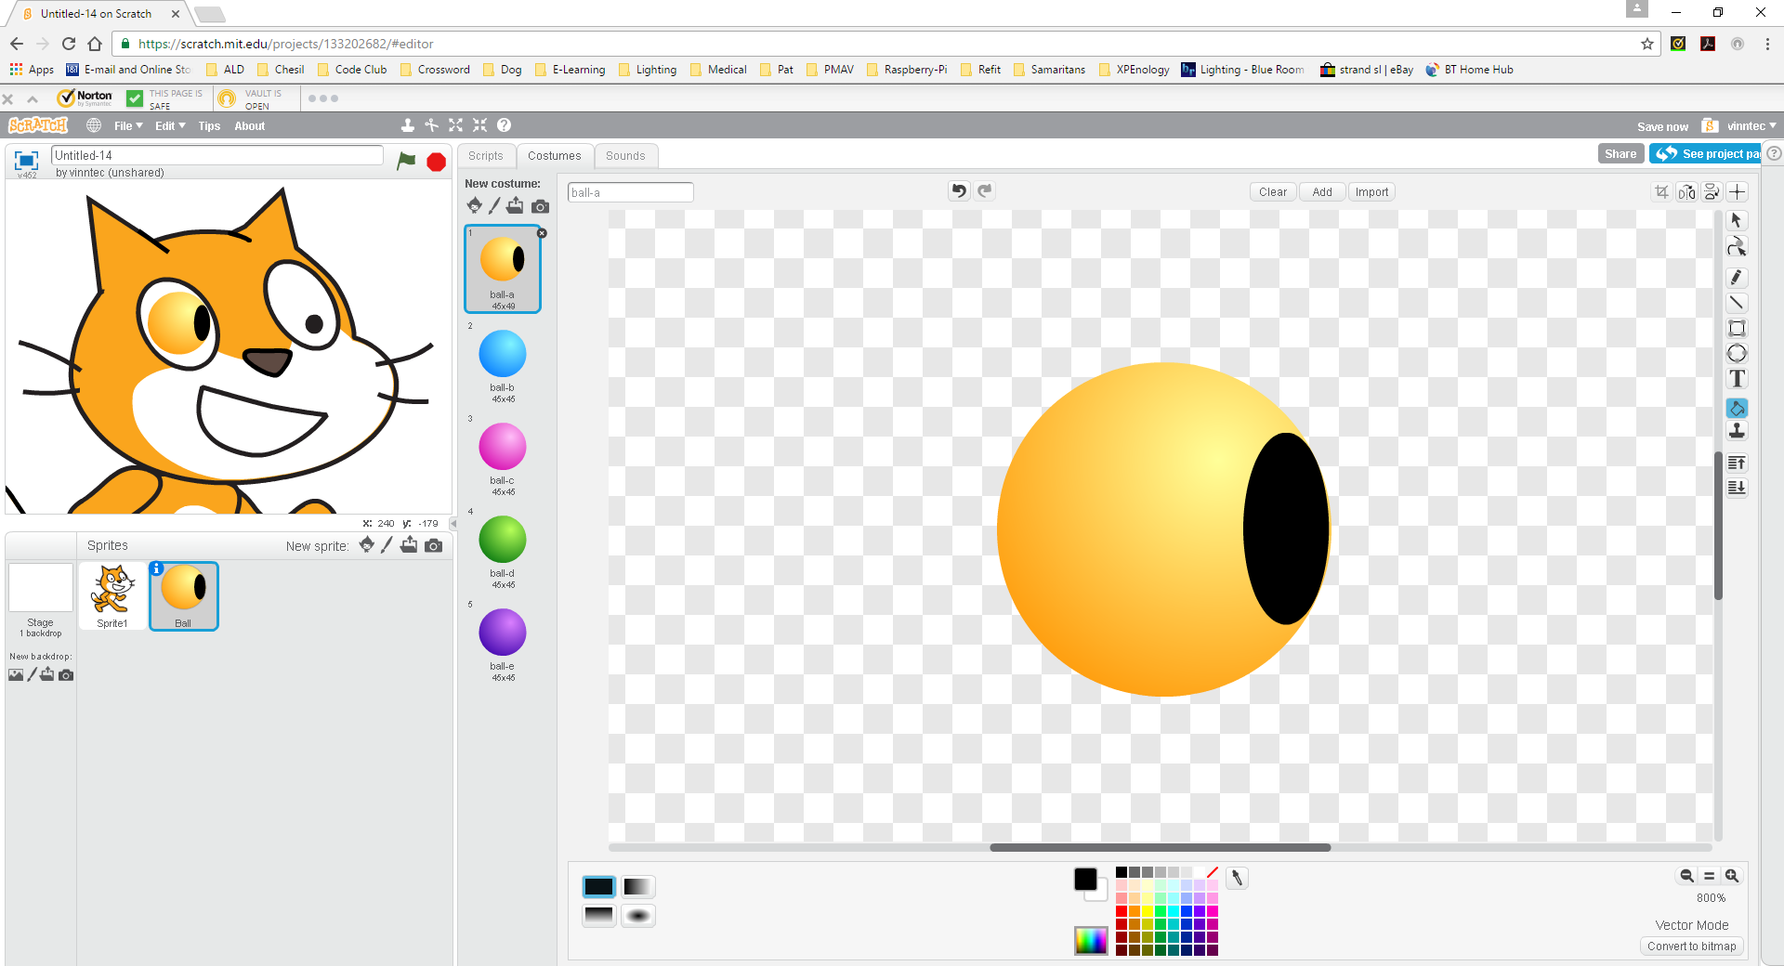Look at the costume you have chosen in the editing window and draw a new iris on the right-hand side of the ball, something like this. Be careful that it **must** be on the right-hand side.
* Now select the “eye” and add these blocks to its script.
* Click the green flag and move your mouse around. Is the eye following the mouse?
* 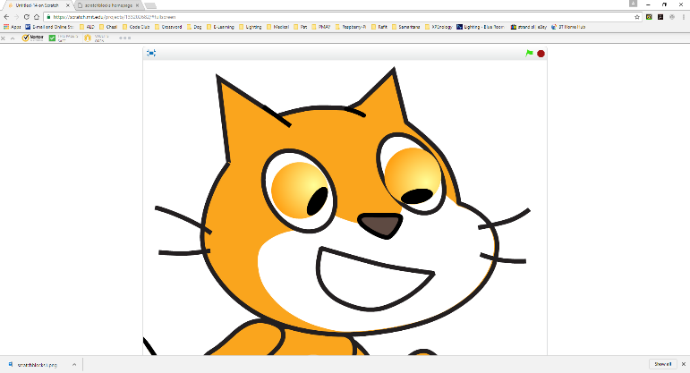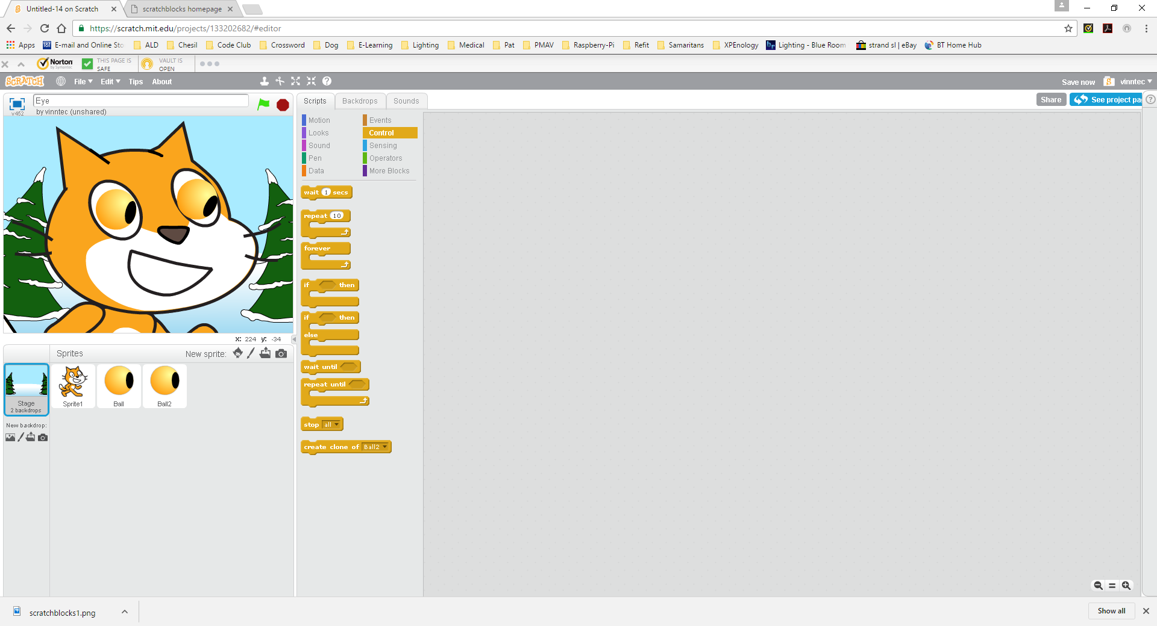Make a copy of the “eye” sprite and move that into the right eye of the cat. Here is my one and you can see both eyes looking at the mouse which is at the top-right of the mouth (you can’t see it on the picture).
* Add a nice stage backdrop, such as a snow scene. You can choose whichever background you like, I have chosen “winter”.
* Now a challenge! Add a fourth sprite and make it move around the screen by itself in front of the cat. It can be anything you like and remember you can use the “if on edge, bounce” block to make it easier. You can also make it keep moving and follow the mouse cursor or you can drive it around the screen like you did with the car game – it is up to you.
* 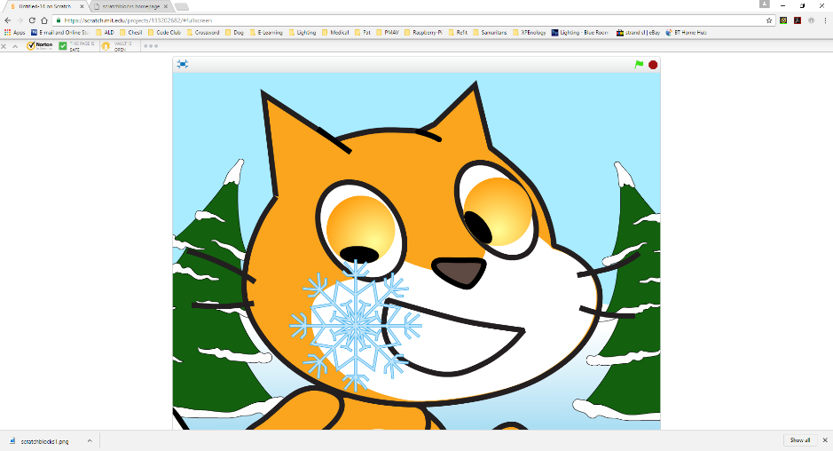Change the scripts for the two eyes so that they follow the moving sprite rather than the mouse cursor.
* Here is my one following a snowflake bouncing around the screen!
* Is there a good place to put a sound in? If you like, choose a suitable sound and add it to the relevant script. In my one I added a tinkle sound when the snowflake touches the edge of the stage.
* Next challenge is more difficult! Choose two keys and make the right-eye rotate left and right when you press the key, otherwise stay where it is. Now do the same for the other eye using two different keys. Can you move the eyes to follow your moving object (in my one the snowflake)? You might need to slow your moving object down as this is much harder to do than you think!