# PONG Game

**Pong** is one of the earliest arcade video games and the first sports arcade video game. It is a table tennis sports game featuring simple two-dimensional graphics.

1. Load the “pong starter” project. This will give you the pitch, the ball, and the two paddles needed to play the game. There is **no code** yet.  
    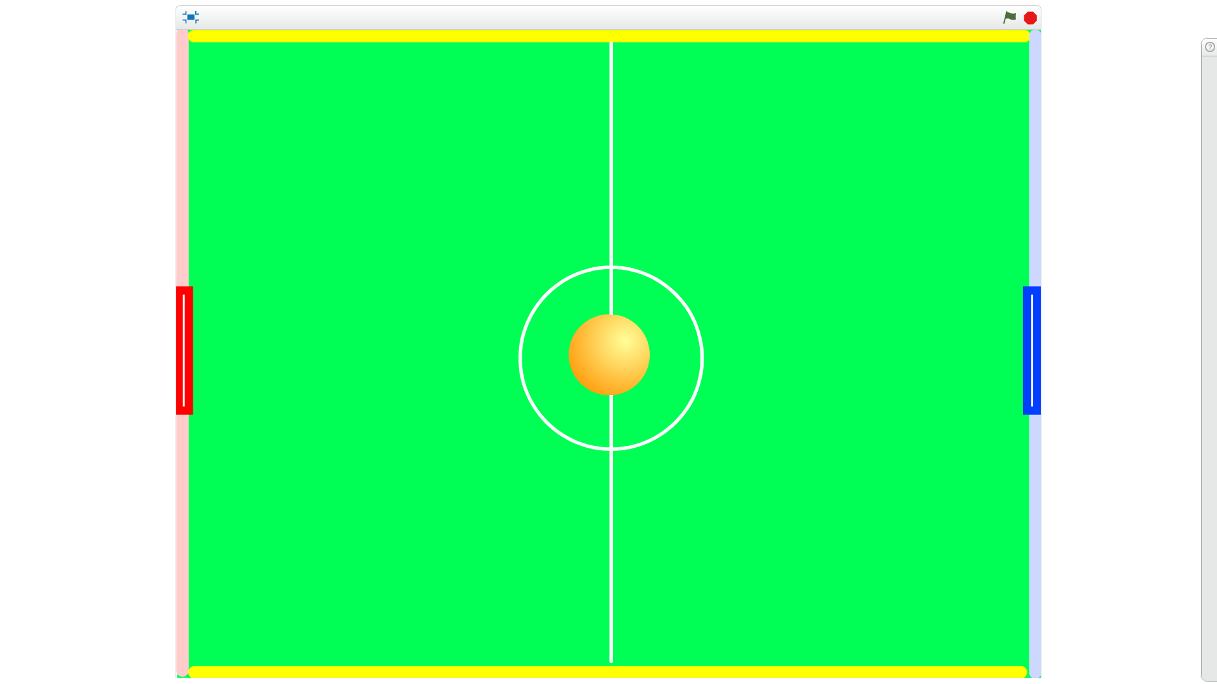
2. Do a **SAVE AS** to save your copy of the game straight away.
3. This is a simple game to play that your parents or grandparents will know all about:
   1. There is a **ball** on the centre spot. When you press the spacebar, it will start to move randomly to the left or right.
   2. There are two **paddles** either side (red and blue) which each player moves up and down to make the ball bounce back.
   3. The yellow lines at the top and bottom are there to make the ball bounce easily back into play.
   4. The pink line on the left and the light blue line on the right are the goals. If the ball touches either of these, it is a goal and the other player has one added to their score.
   5. Another ball is **spawned** on the centre spot and moves randomly to the left or right.
   6. The first player to get 5 goals wins.
4. First make 4 variables:
   1. **red score** The score of the player with the red paddle
   2. **blue score** The score of the player with the blue paddle
   3. **x move** How much to move the ball in the x direction (left to right)
   4. **y move** How much to move the ball in the y direction (up and down)
5. 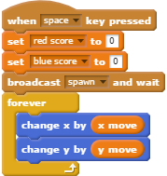Show **red score** and **blue score** on the pitch and change them to be “**large readout**”. Move **red score** to be at the top of the screen just to the left of the centre line, and **blue score** just to the right. Hide the other two. 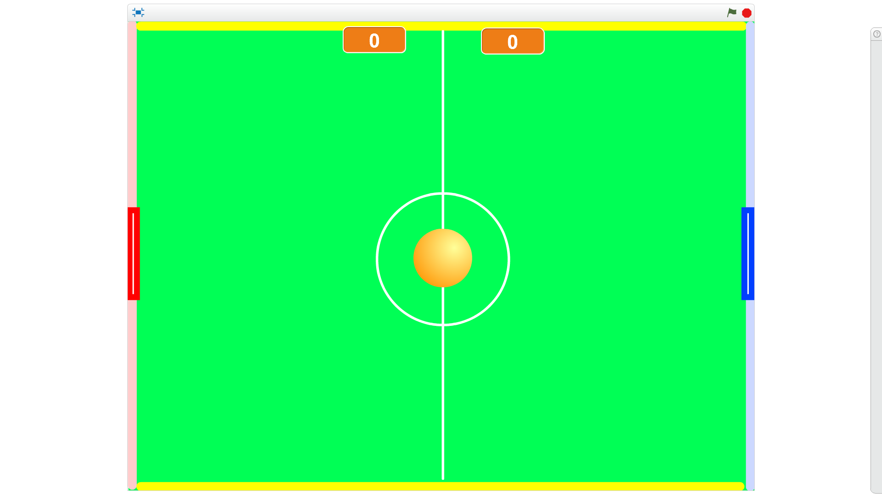
6. Add this script **to the ball sprite**. The game starts when you press the spacebar. You first set the score for each player to 0, then send a message “spawn” and wait for a reply. The game will now go on forever moving the ball by x move and y move.
7. 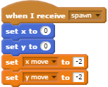Add this second bit of code to the ball sprite, to **spawn** a new ball on the centre spot and make it start moving. For the time being, the ball will always move to the left (x move is negative) and down (y move is negative).
8. Press the **spacebar** to test the game so far. The ball should move towards the left and down. Press the red stop button to stop the game.
9. **Save your game**.
10. The next thing to do is change the first bit of code (just the bit by the curly brackets) so that the ball bounces on the top and bottom of the pitch. It does this by checking if it is touching anything **yellow** then changes the **y direction** the other way around. If it was moving up it will now move down and if it was moving down it will now move up.   
    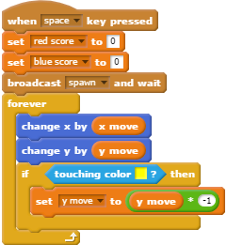
11. 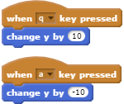Test the game by pressing the **spacebar** on the keyboard. The ball should now spawn as before but “bounce” off the bottom of the pitch. As the top of the pitch is also yellow it will also bounce off there (but it won’t do that yet). Press the red stop button to stop the game.
12. **Save your game**. It is always a good idea that whenever you have got a bit working properly, to save your work.
13. Now let’s make the two paddles move. Add this code to the **red** paddle. Choose two letters on the left-hand side of the keyboard – one to the move the paddle up (+10) and one to move the paddle down (-10). I used **q** and **a** but you might prefer something else.
14. Press each of the two keys you chose. Does the red paddle move up and down?
15. Copy the code to the blue paddle, and change the keys to two different ones on the right-hand side of the keyboard – for instance **up arrow** and **down arrow**. Test that the blue paddle moves up and down as expected.
16. **Save your game**.
17. Go back to the code for the **ball**, and change it so that the ball will bounce off the two paddles. Note that “Red” and “Blue” are the names of the paddle sprites, not the colours.  
    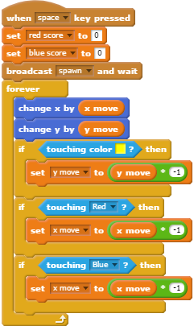
18. Press the spacebar to test your game (make sure the game is stopped first). When the ball bounces off the bottom, move the red paddle so that the ball bounces off it and over to the other side. Move the blue paddle so that the ball bounces back. The ball is moving quite slowly at the moment so you should be able to send the ball backwards and forwards quite easily.
19. **Save your game**.
20. Now change the code so that when the ball touches the pink line on the left of the pitch, a goal for the Blue Player is scored. Check also for Blue now having 5 wins to end of the game, otherwise say “Goal!” then spawn a new ball to continue the game.  
    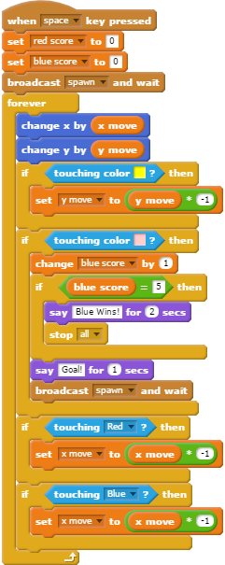
21. Move the red paddle to the top of the screen so it is out of the way then test your game by pressing the spacebar. Let the ball bounce off the bottom and hit the pink line – you should see blue’s score increase and the ball say “Goal!” Let the game continue for four more balls and the fifth one should say “Blue Wins!” and the game end.
22. **Save your game**.
23. Copy the new bit of code you just made and change the copy as shown - only the first 4 blocks of the copied code needs to be changed for this to work for Red.  
    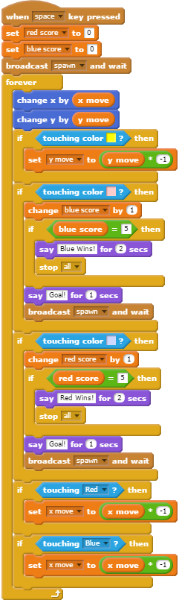
24. Test the game. This time you will need to use the red paddle to bounce the ball back to the other side, and move the blue paddle out of the way so the ball hits the light blue line. Does it say “Goal!” each time and change Blue’s score? Does the game end with the right message when Blue gets 5 goals?
25. **Save your game**.
26. This is a complete working game, but it is too easy as the ball does the same thing at the start of every game. It would be better if the ball could:
    1. sometimes go to the left and sometimes to the right?
    2. go at different speeds each time?
27. Let’s first change the “spawn” code so that the ball sometimes goes left and sometimes goes right. We can do this by generating a random number between 1 and 2 and treating 1 to mean left, and 2 to mean right. Now the ball will sometimes go to the left and down, and other times to the right and up.  
    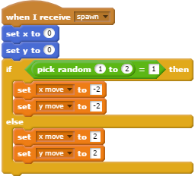
28. Test the game and let the game spawn several balls. Do they randomly go left or right?
29. **Save your game**.
30. This is better, but the ball still goes at the same speed. It would be better if it started at a random amount by how much x and y change each time around. This is again done using random numbers. It can go left or right at three different speeds, then up and down at 3 different speeds.   
    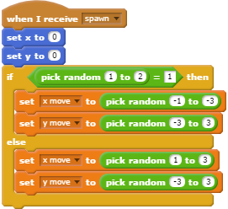
31. Test your game by pressing the space bar. The ball movement should now be more interesting – until **y move** is set to 0, when the ball just goes from side to side forever unless one of the players moves their paddle out of the way! This is because we have chosen any number from -3, -2, -1, 0, 1, 2, 3. We can easily fix this by adding an extra bit of code at the end to check if **y move** is 0 and if so, change it to 1.  
    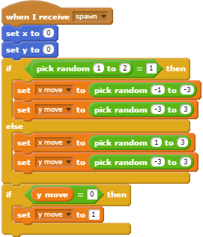

# Challenges

1. Make the ball speed up each time it touches one of the paddles. **Hint**: You multiply **x move** by -1 to change direction. What if you changed this slightly?
2. In the original PONG game, there was a “beep” when the ball touched one of the paddles. Can you find a suitable sound and add it to your code?
3. When a goal is scored the ball says “Goal!”. Wouldn’t the sound of the crowd cheering be better as well – or instead?
4. … and when the game ends?
5. Test the game now and you should have a complete working game which is pretty good!
6. **Save your game**. Try the challenges.