1. Describe the method
1.1 Preparing the images.
The first step in the method is to read the supplied images. After this the images are converted from RGB to grayscale. This allows us to apply the Local Contrast Normalization filter on them. The filter is applied in order to achieve consistency in the range of intensity values in the images. Please note that there is a slight mistake in the functionality of the provided code for Local Contrast Normalization in the lcn.m file. The mistake was that the final step of the normalization had no effect as it was not being outputted.
Picture of before and after filtration
1.2 Extracting the descriptors
The learning and classification phases of the method depend entirely on forming the descriptors of every image. The descriptors are a number of fixed-size intensity vectors, extracted from a fixed number of random position in every image. The number of descriptors per image varies for the different tests that have been performed. The ideal range for this number is 500-2000 as low values benefit performance and high values trade that performance for classification accuracy.
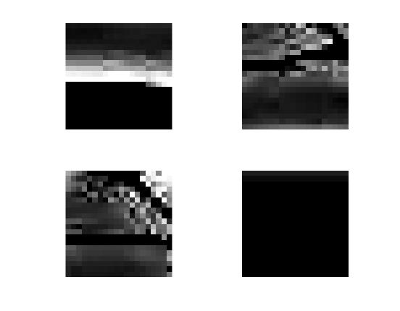
Illustration 1: Descrptior of size 20x20px of a single image.
1.2 Producing the Codebook
Ideally we would like to be able to use all of the extracted descriptors from all of the training images in the task of classifying the test images. However this is not feasible in practice due to the sheer number of descriptors that have to be extracted per training image. Performing any form of computation on them becomes immensely computationally expensive as we supply new training data. In order to reduce the number of descriptors used in the classification we can use a codebook []. A codebook is a set of the “most important” descriptors. It is obtained by clustering all of the descriptors and taking the centroids of each clustered class. To performed this clustering we have used the K-means algorithms. It is very important to note that clustering is only performed on the training images. Otherwise we would be learning from training images for which we cannot know the correct category by definition.

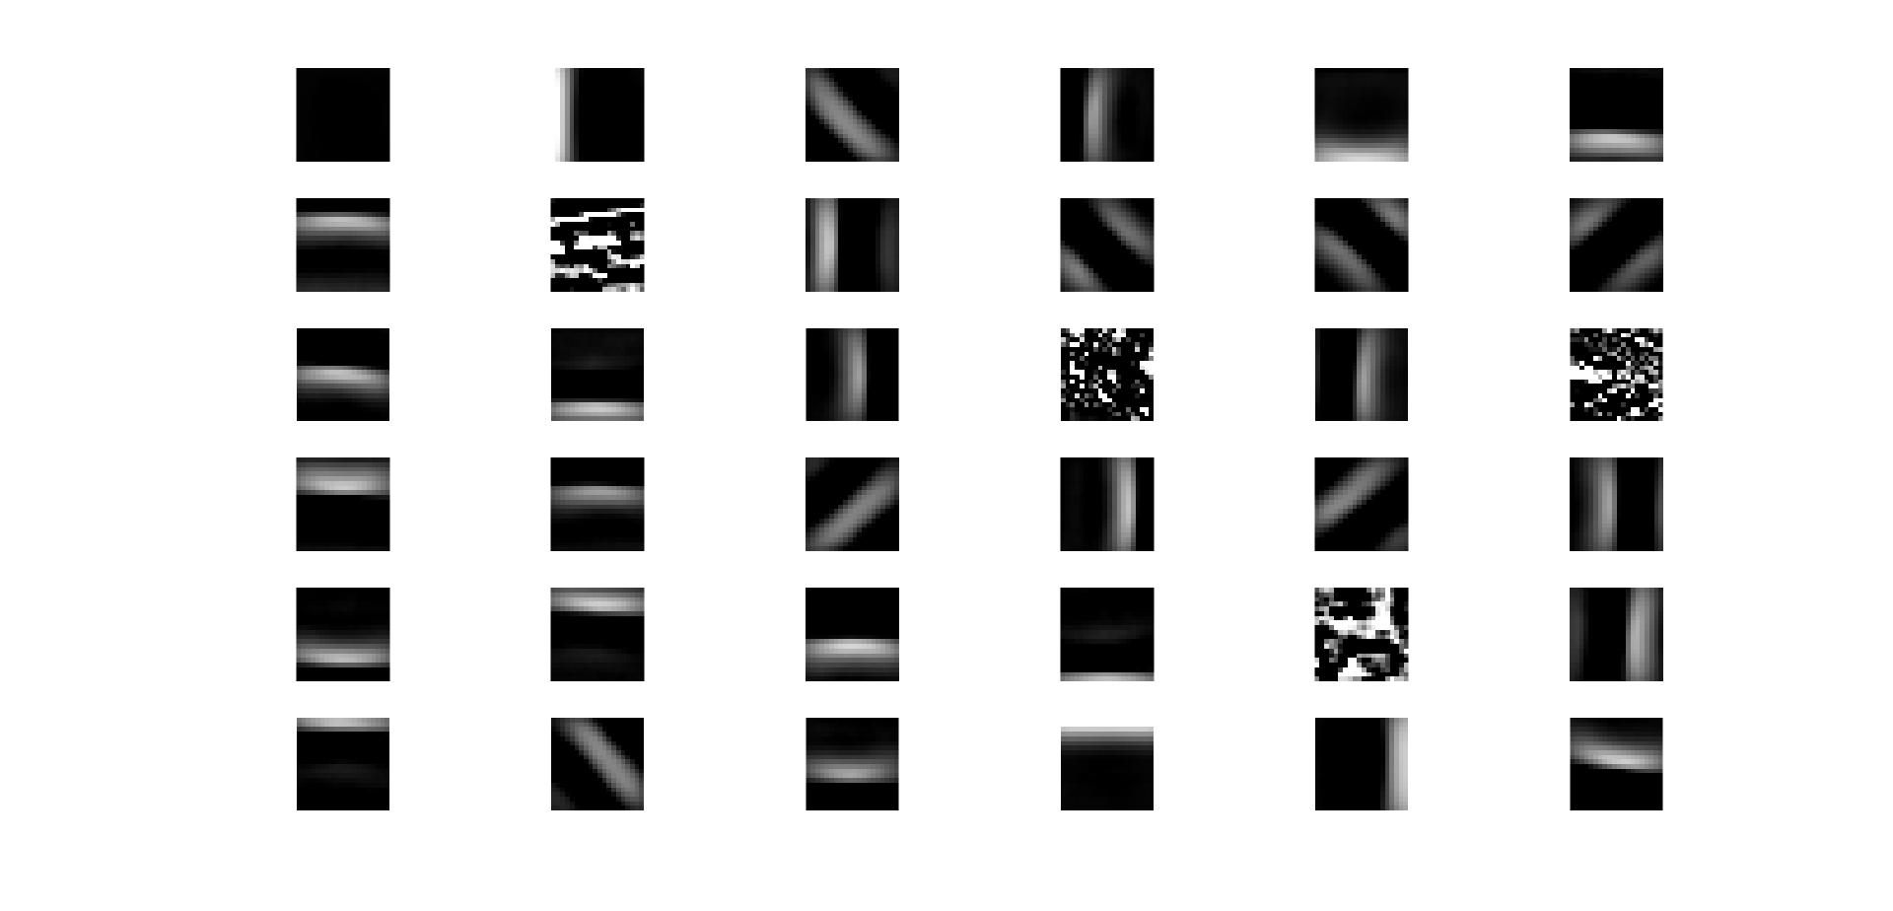
Illustration 2: Codebook with 5000 descriptors per image with 20x20px descriptiors.

1.4 Building normalized histograms
The next step in the method is to characterize all of the images (training and data) based on how close each of their descriptors is to any of the codewords in the codebook. This characterization is in the form of a normalized probability histogram where each of the bins is the normalized number of times a descriptor in the image is closest to a certain codeword. By “closest” we mean distance in terms of euclidean distance in 500 dimensional space. This calculation is performed with the provided nearestneighbour.m function.
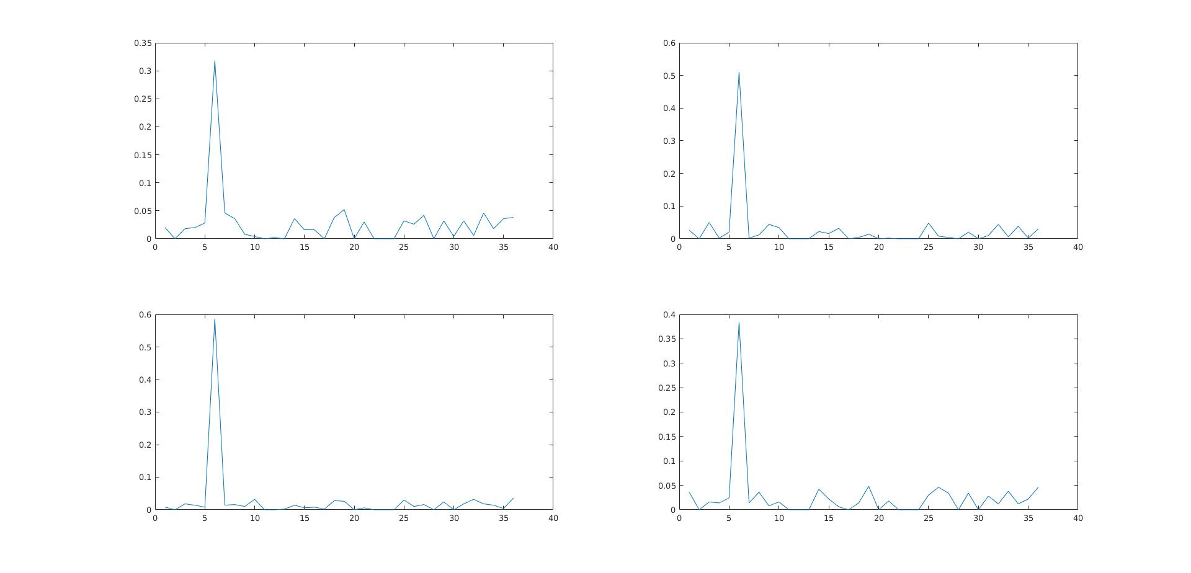
The histograms were taken from four random images from each of the categories. Clearly on the codewords is prevalent in all of then. Unsurprisingly this is the codeword with zero intensity.
1.5 Classifying images based on the histograms, NN, Bayes, Decision Tree
The last step in this method is to classify the test images into one of the four categories. This can be done using any supervised machine learning classifier. For the purposes of this coursework I have chose to evaluate the performance with tree different methods. The first one is comparing the histogram of a test image to all of the histograms of the training images and finding the one it’s closest to (e.g. it’s nearest neighbour). The two other methods are using the most basic machine learning classifiers Neive Bayes and a Binary Decision Tree. The performance and accuracy of all methods is discussed at length in the
1.6 Commend on the parameters used.

2. Evaluating the method
2.1 Testing methodology
I have divided the available images into test and training through random selection. Every time the program is run five images from every category are selected at random to be test images. This method adds an additional layer of randomness and removes the bias introduced by selecting the test images manually. Picking five images from every category has the advantage of allowing the method to be able to learn from 180 images while keeping enough test images to obtain reliable measurements. In order to obtain more reliable results every test is run ten times and the average time is taken.
2.2 Effects of patchNum and codebookSize
Here are the effects of the patchNum and codebookSize parameters. Clearly more of both is better but computation is slow boho. Here we are using NN to label at the end.

Looking at the graph it is clear that going horizontally and vertically improves the accuracy. Ideally it would be best to use as many features and codewords as possible. That has a toll on the computation efficiency though.
2.3 Effects of different learning.
Here is the accuracy of all the. The best is 90% with bayes, but overall give the standart devitation we cannot reliable determine which method is better than the other.

And here are the confusion matrices for the 3 best scores and the 3 worse scores.

And the best case is

Clearly the last category is the easiest to assess and stuff.
2.6 Testing binary histograms
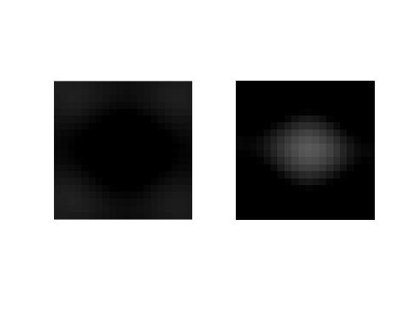
Illustration 3: Codewords with binary histogram
Another test I ran was with binary histograms. That is – only record wheter a feture is there or not. The resutls are worse and normalising them makes it sad sad. The result was the following confusion matrix:

This shows that all of the test images are classified as butterflies. This is because most of the other images have a clear background and the program has learned how to differentiate between rich background and no background. This is the same for all the cassifiers. It turnout out that all the histograms are the same and this is just the first iamge or something.
2.6 Strengths of the algorithm
It has achieved good accuracy.
2.7 Weaknessess of the algorithm
In order to get better acuracy we have to compute more. Sad Sad.

3. How you might improve this given more time
I will do an SVN, according to [] it is waaay better and shit.
I would do Hog desc []
I would do Deep Feature Learning []

4. Present the code

