Overview

Two types of user;
- Admin – the task that can performed are;
  - Add planets (and other bodies!).
  - Edit planets (and other bodies!).
  - Review submissions for updates by Guest user. Can either reject in which case the update is discarded, or accept in which case the planet can be updated.

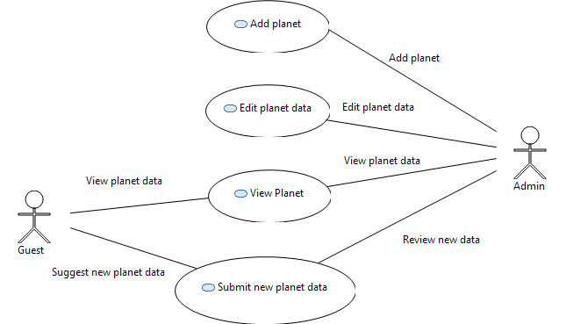

Use Cases

Add Planet

Summary: Add a new planet (or other body to the solar system).
Actor: Admin
Preconditions: Has logged in.

Steps;
    - From main menu select 'Add Body'
    - Display empty input form and the user enters the plant details, contain the following items;
      - Name
      - Distance from the sun.
      - Dimensions, diameter and mass.
      - Image.
      - Wikipage Link
      - Google Space link (later).
      - Add other links and feeds.
    - Click 'Save' button.
    - Will then be taken to the 'View Planet' use case.

View Planet

Summary: View the solar system and individual plant data.
Actor: All actors
Preconditions: None

Steps;
    - Main page, list of planets in the solar system, ordered by the distance from the sun.
    - Click on a planet,
    - View of the all the plant data

Edit Planet

Summary: Edit existing planet data.
Actor: Admin
Preconditions: Has logged in.

Steps;
    - Main page, select a planet..
    - View a plant,, menu has had an 'Edit' option added.
    - From the menu select edit.
    - Display input form, repopulated wth the current data.
    - User updates and saves.

Submit new Planet Data

Summary: Add a new planet (or other body to the solar system).
Actor: Guest and Admin
Preconditions: Guest is viewing a planet, Admin user logged in.

Steps;
    - Guest selects 'Add more information' from menu (or a button?).
    - Display input form, enter following;
      - The users name
      - One line Summery
      - Textbox where the Guest enters the suggested change
      - Links and Feeds
    - Guest clicks submit.
    - Admin user 'x updates to review' screen notification is incremented by one.
    - Adimn clicks on 'x updates to review'. If there is just one update submission then skip to step 7. If more than update submission then display a list of all the pending submissions.
    - Admin selects one of the submissions.
    - Edit planet screen is displayed to the user. This is sane screen as per the 'Edit Planet' plus lists the changes submitted by the guest user.
    - Two options for the Admin user;
      - The suggested changes are not required, Admin clicks 'Reject' button, nothing is saved.
      - Admin user applies some or all the suggested changes, clicks 'Save' button and the updated planet data is saved.
    - The Guest user's suggested changes are removed from the pending submissions list.
    - Admin user 'x updates to review' screen notification is reduced by one.

