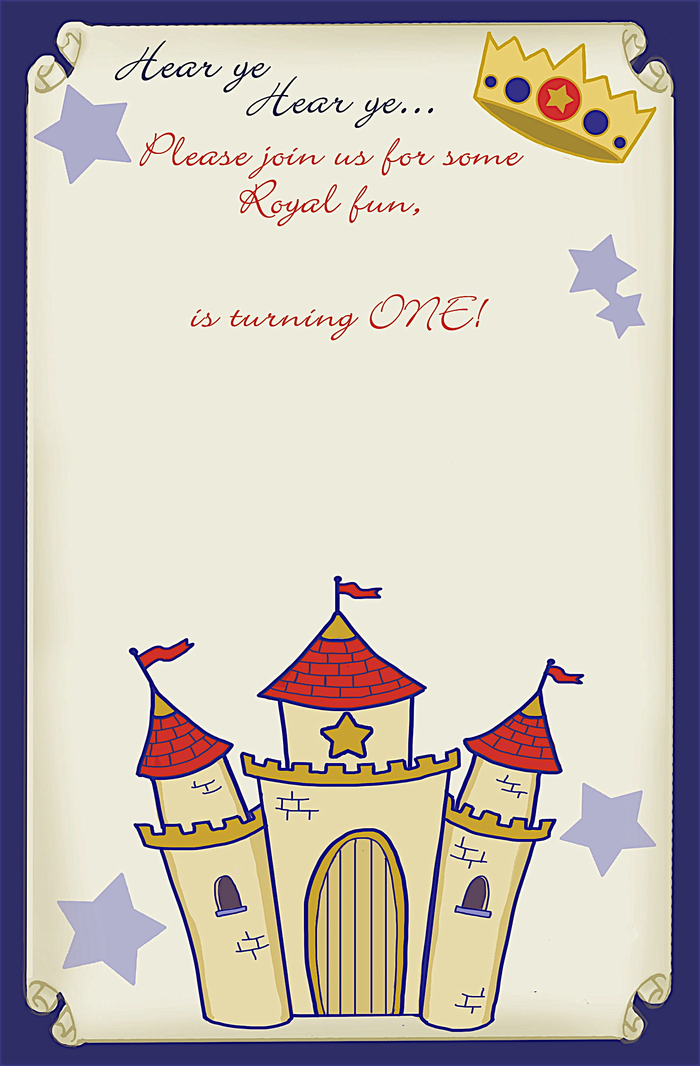
Saturday, March 14, 2010 at 1:00p.m. til 4:00p.m.

Grand Ball Plaza
111 Anystreet Drive
Anycity, ST 12345

RSVP to Rosie at (123)456-7890
Saturday, March 14, 2010 at 1:00p.m. til 4:00p.m.

Grand Ball Plaza
111 Anystreet Drive
Anycity, ST 12345

RSVP to Rosie at (123)456-7890
Leland Smith
Leland Smith

an invitation
created especially for you!

©www.celebrationsoflifestore.com

an invitation
created especially for you!

©www.celebrationsoflifestore.com

