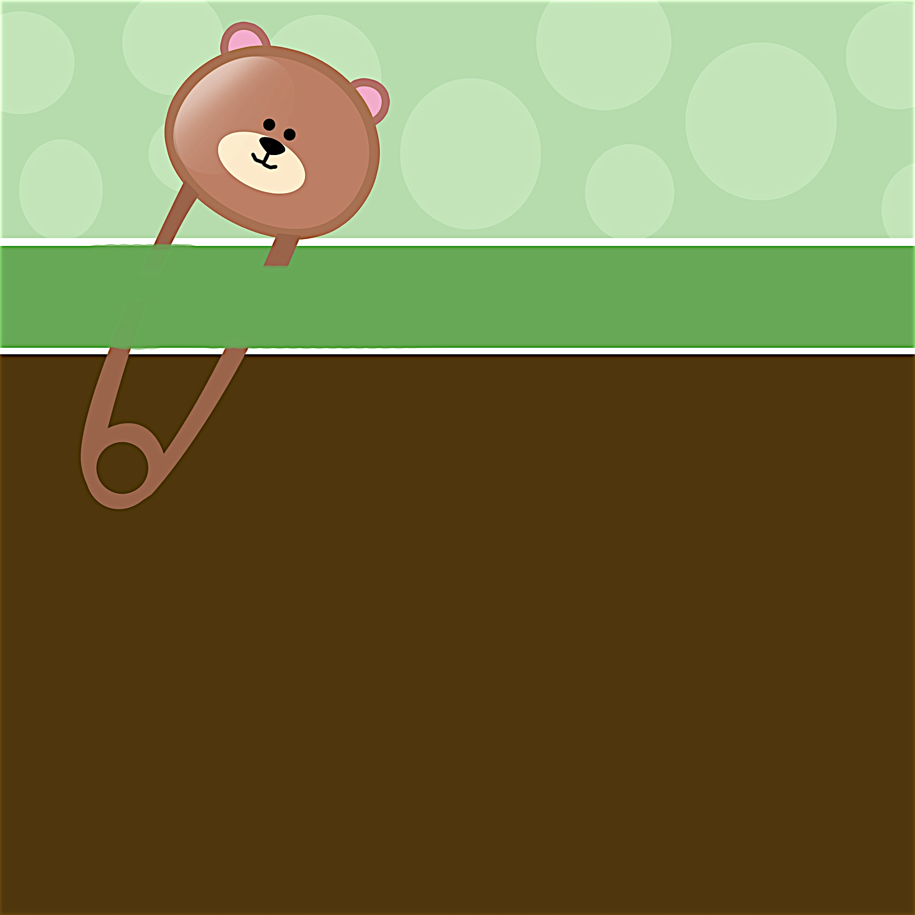
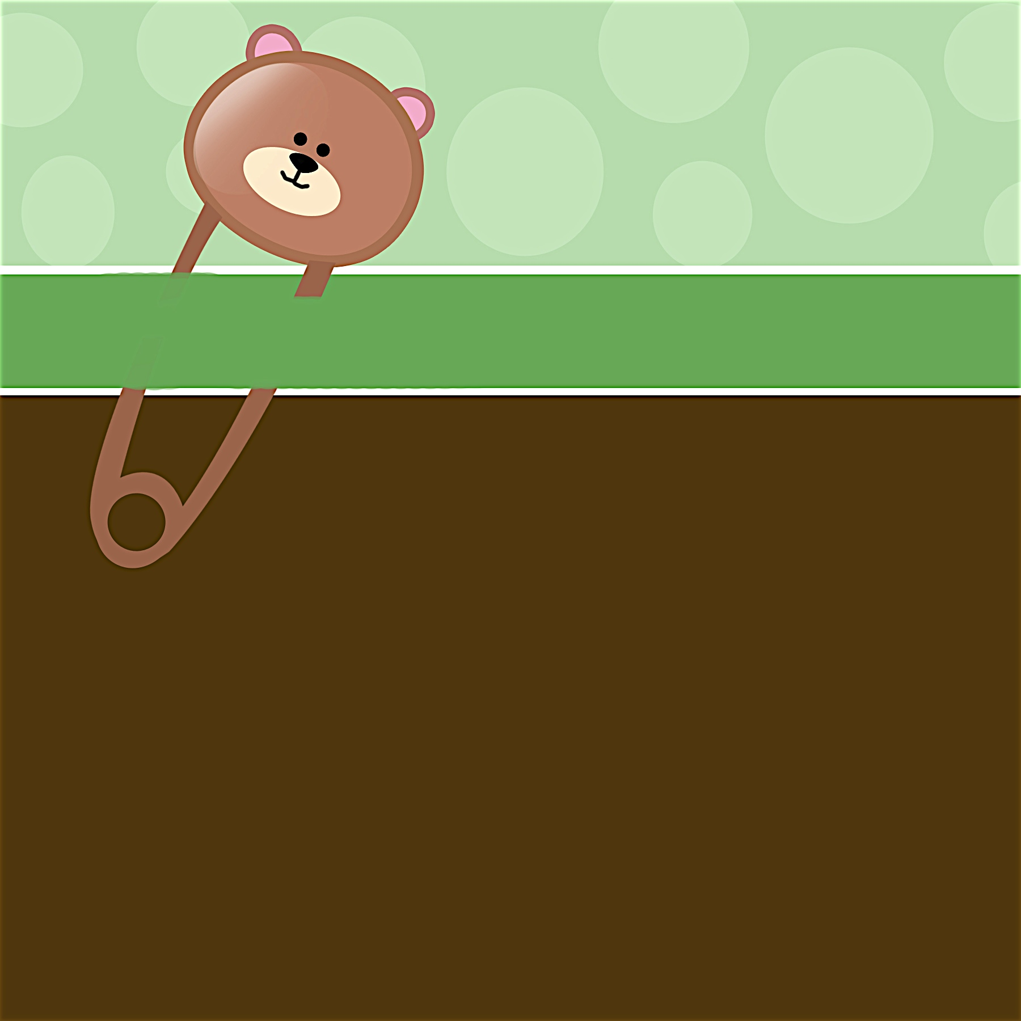
Janet Anderson
Given with love by Debbie Smith
Saturday, April 3 at 1:30 p.m.

Debbie Smith’s Home
111 Main Street, Anycity, ST 94844

RSVP by March 15th to
debbiesmith@gmail.com
(925) 333-3324

Registered at Babies R Us

Janet Anderson
Given with love by Debbie Smith
Saturday, April 3 at 1:30 p.m.

Debbie Smith’s Home
111 Main Street, Anycity, ST 94844

RSVP by March 15th to
debbiesmith@gmail.com
(925) 333-3324

Registered at Babies R Us

IT'S TIME FOR A
BABY CELEBRATION!
Please join us...
Please join us...
IT'S TIME FOR A
BABY CELEBRATION!


an invitation
created especially for you!

© www.celebrationsoflifestore.com
an invitation
created especially for you!

© www.celebrationsoflifestore.com

