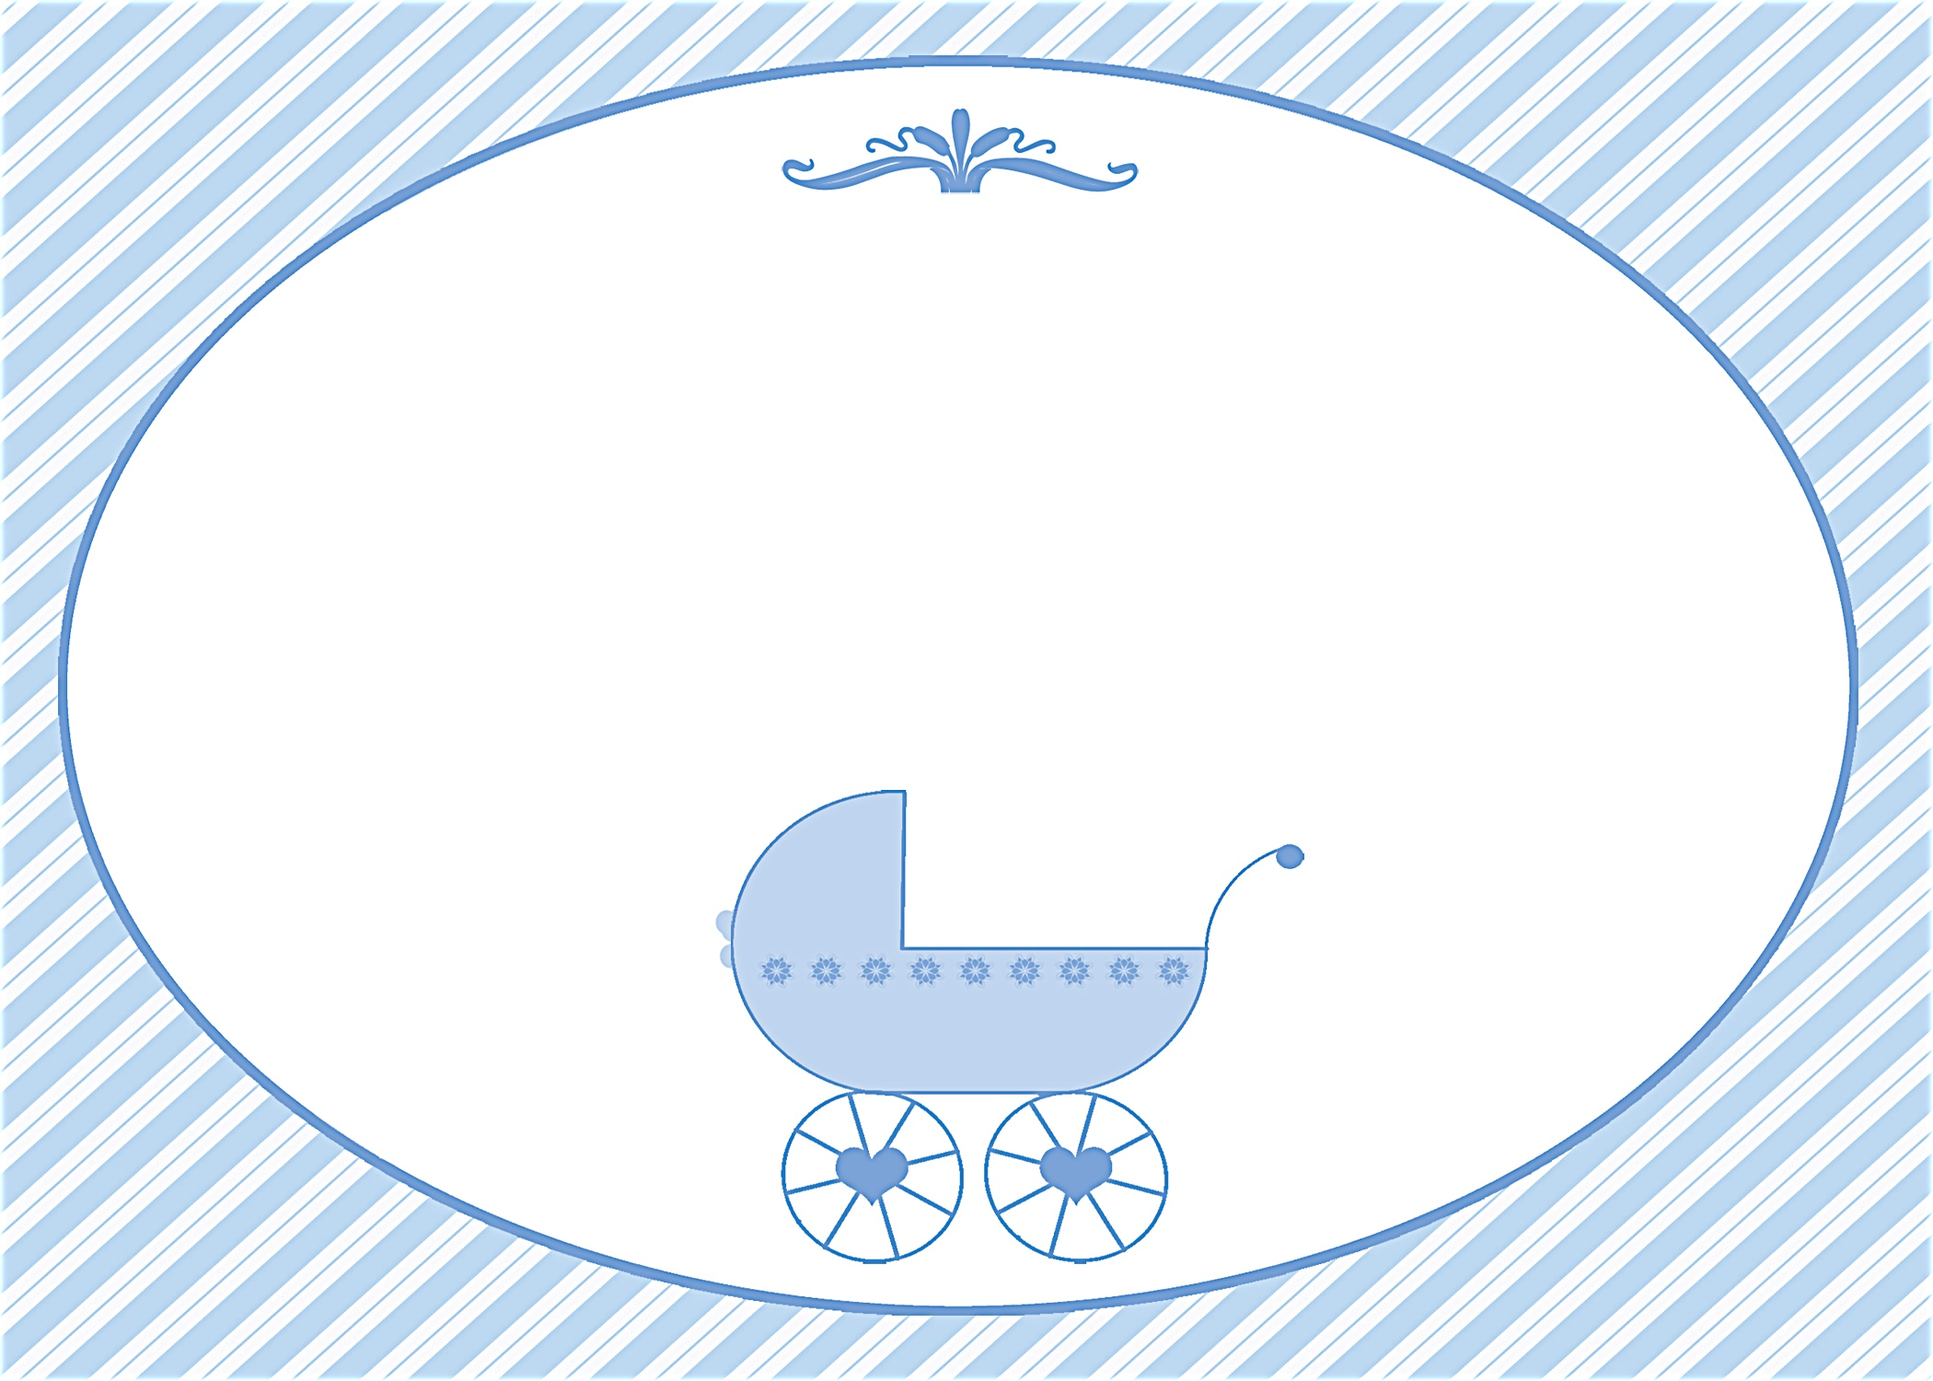
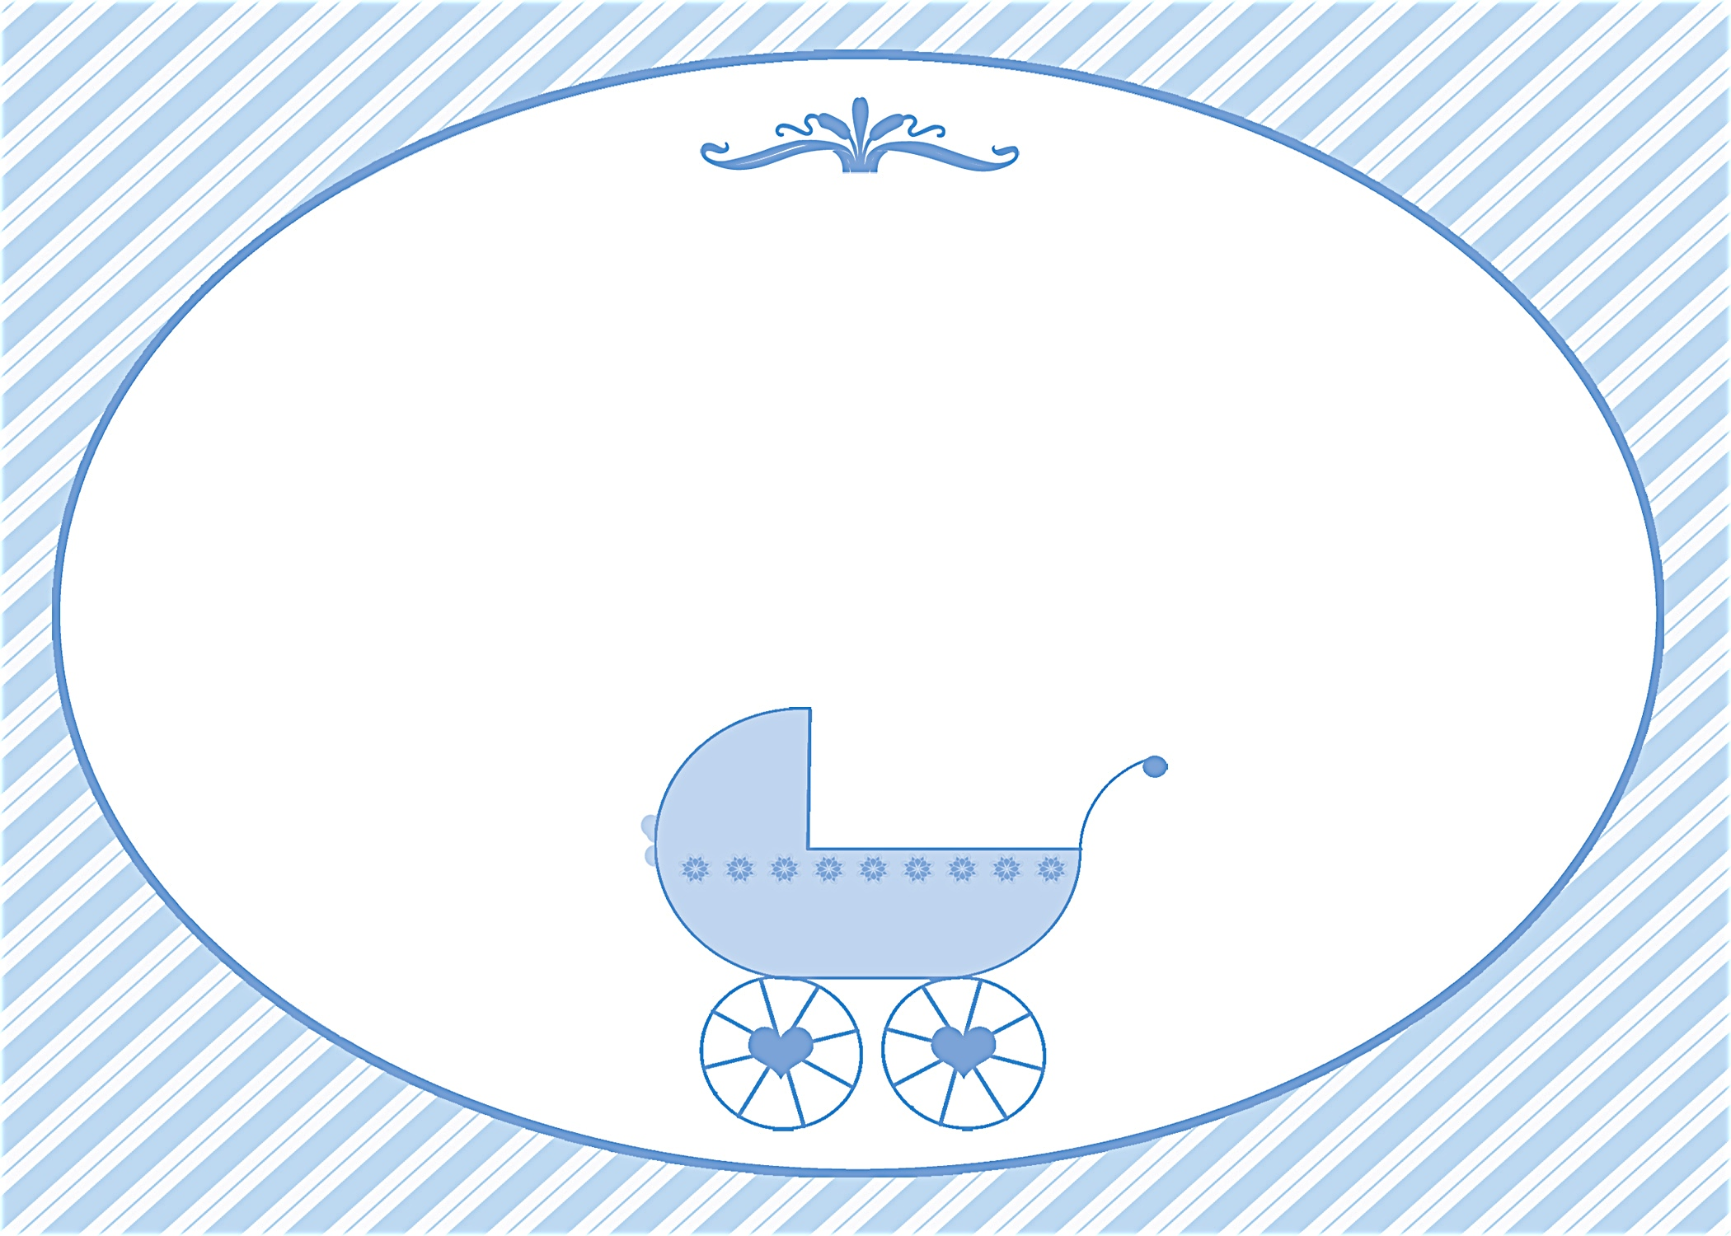
Please join us in honoring the mommy-to-be
Janet Anderson
Saturday, April 3 at 1:30 p.m.
Debbie Smith’s Home at 111 Main Street
Anycity, ST 94844

RSVP by March 15th to debbiesmith@gmail.com or (925) 333-3324
Registered at Babies R Us

Please join us in honoring the mommy-to-be
Janet Anderson
Saturday, April 3 at 1:30 p.m.
Debbie Smith’s Home at 111 Main Street
Anycity, ST 94844

RSVP by March 15th to debbiesmith@gmail.com or (925) 333-3324
Registered at Babies R Us

Baby Shower
Baby Shower


an invitation
created especially for you!

©www.celebrationsoflifestore.com

an invitation
created especially for you!

©www.celebrationsoflifestore.com

