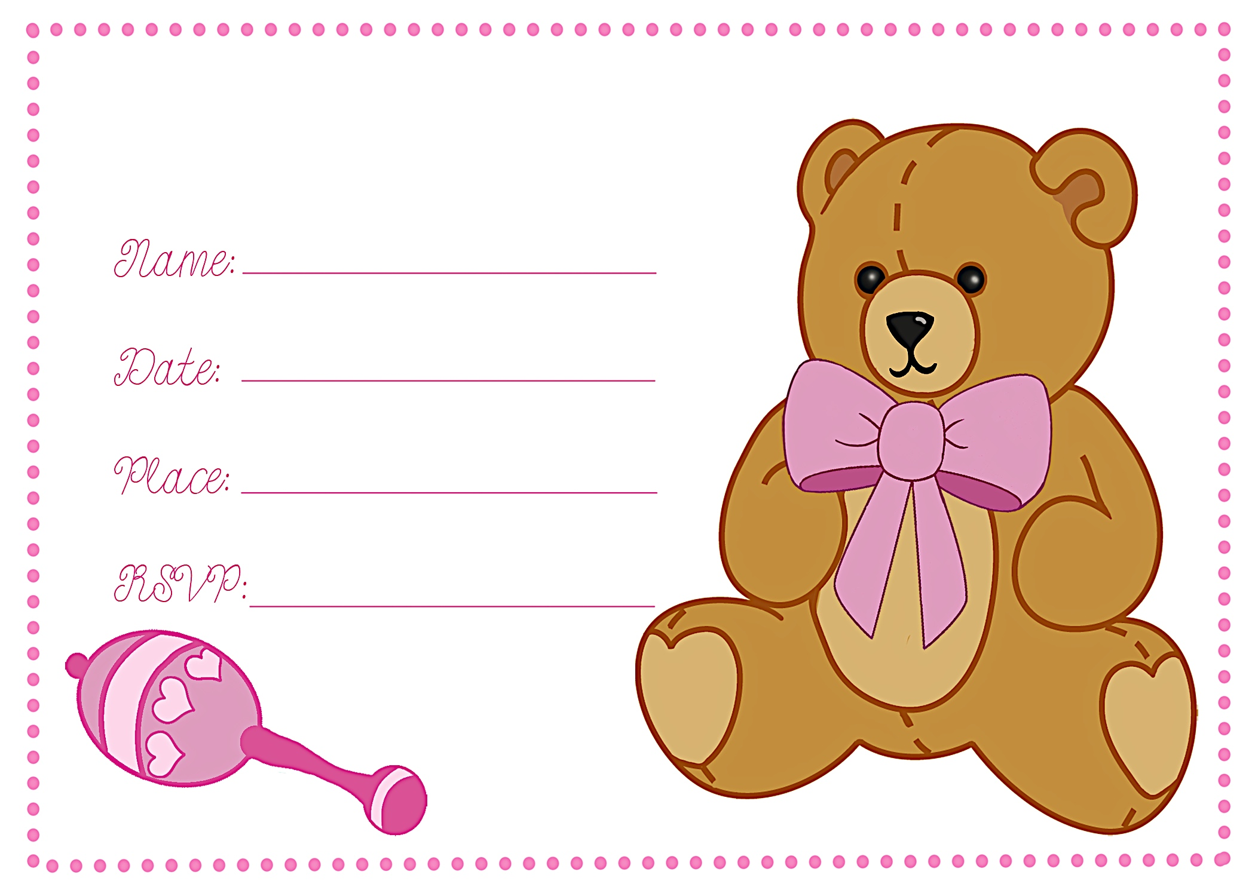
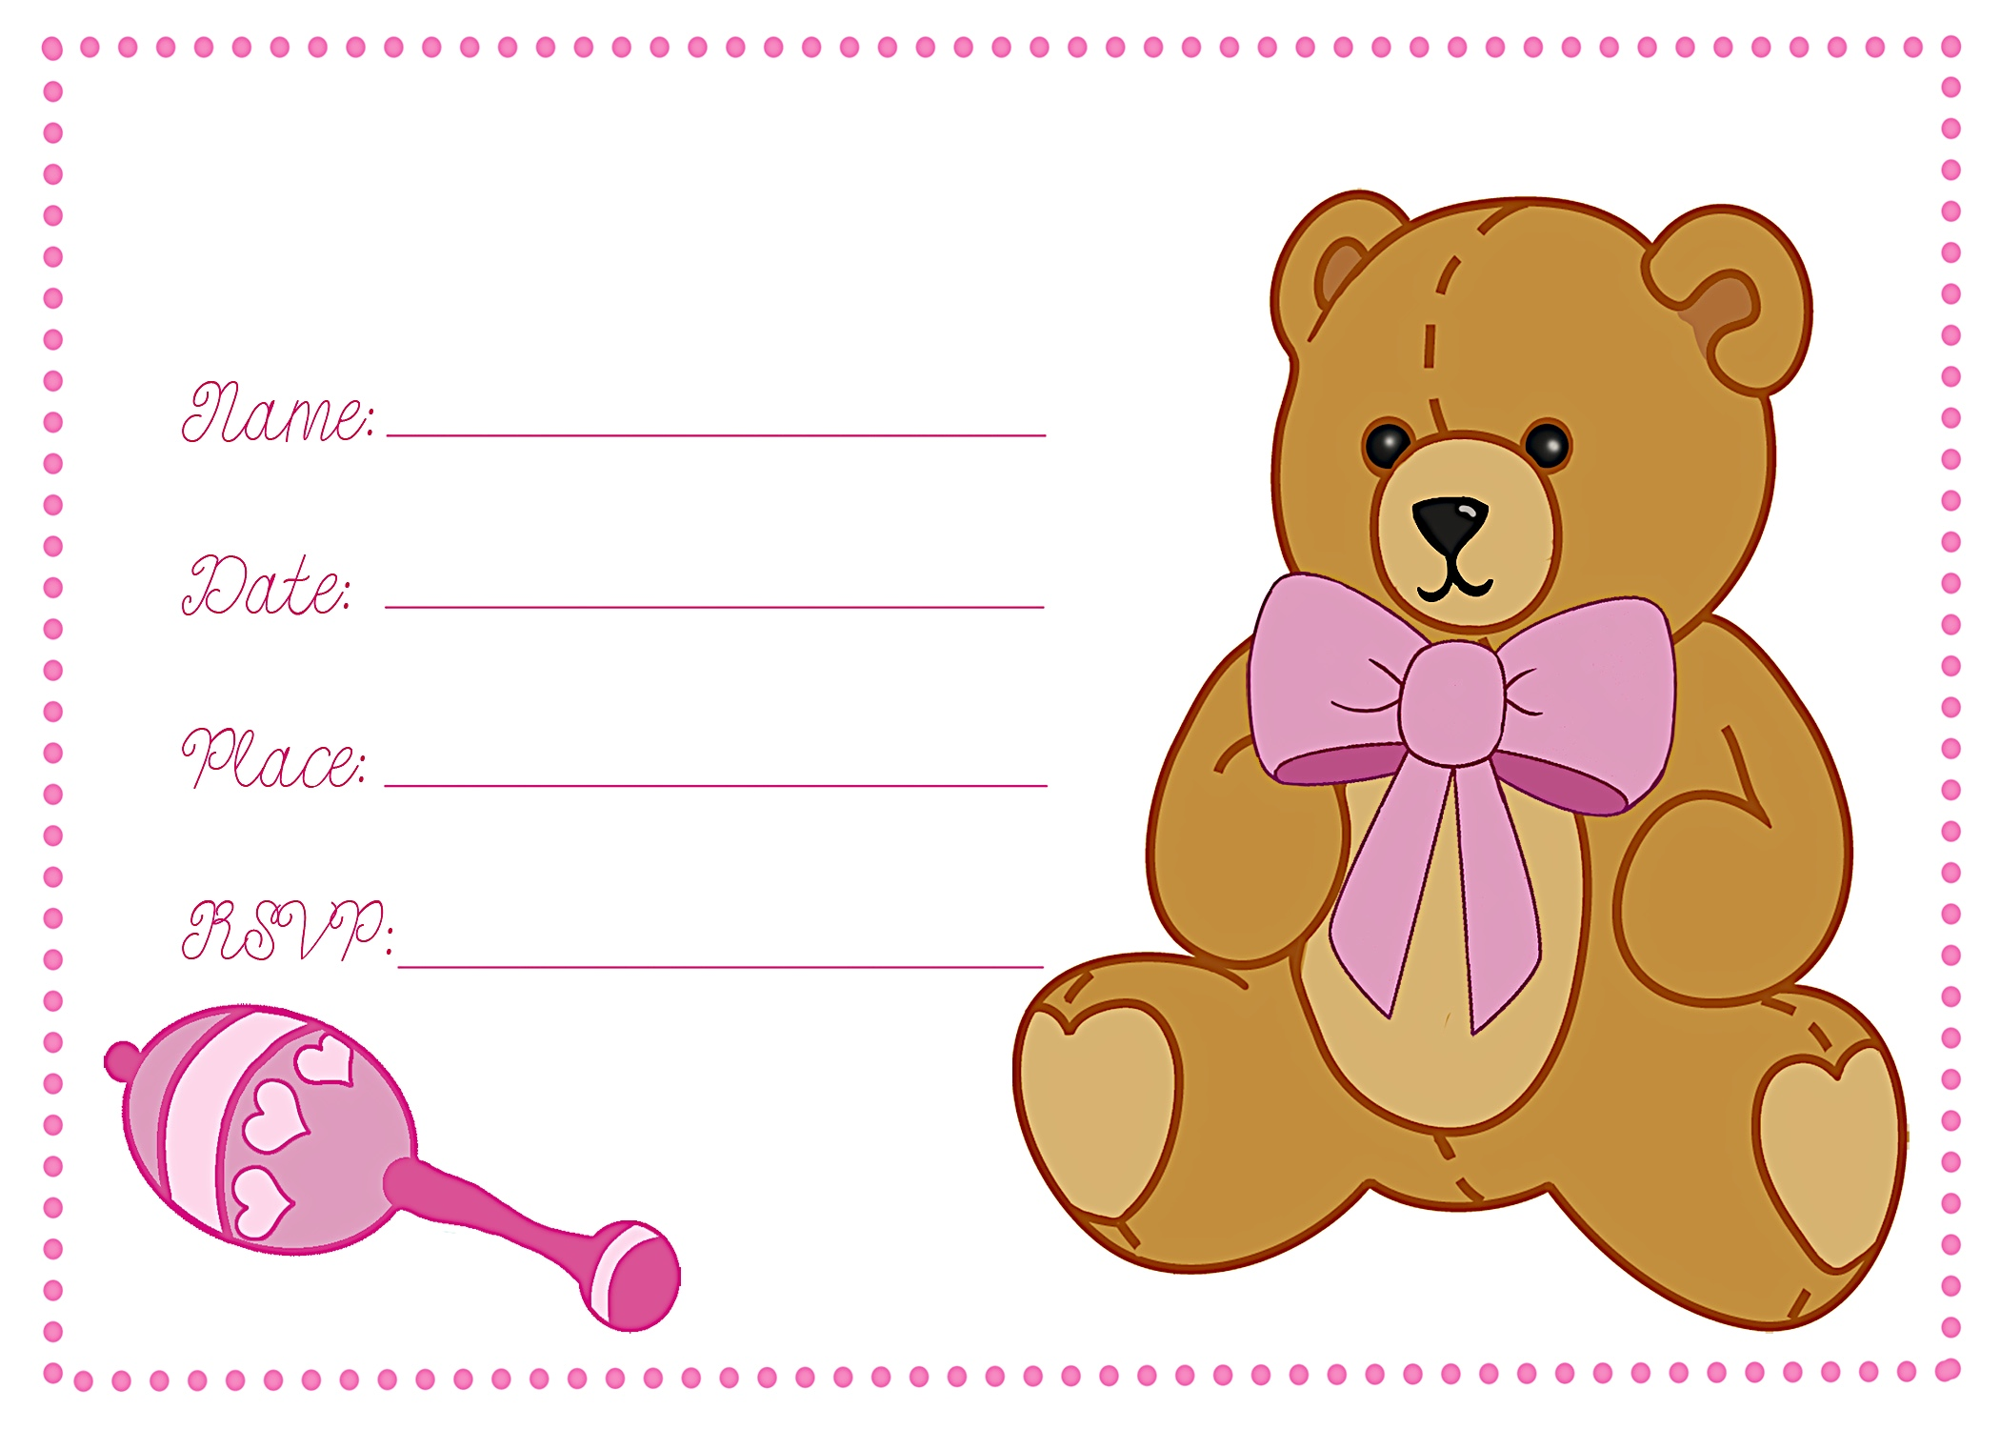
Registered at Baby ‘R Us
Registered at Baby ‘R Us
Lisa Anderson
January 13, 2012 AT 1:00 P.M.
Diane’s House 111 Main Street
diane@gmail.com
Lisa Anderson
January 13, 2012
Diane’s House 111 Main Street
diane@gmail.com
Baby Shower
Baby Shower


an invitation
created especially for you!

©www.celebrationsoflifestore.com

an invitation
created especially for you!

©www.celebrationsoflifestore.com

