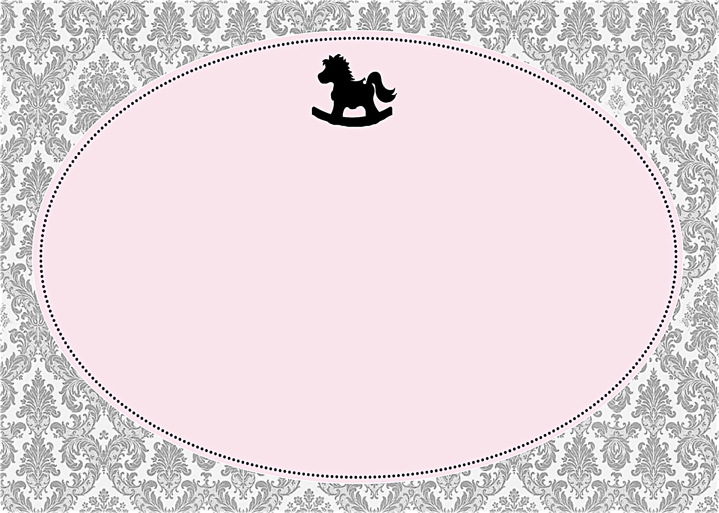
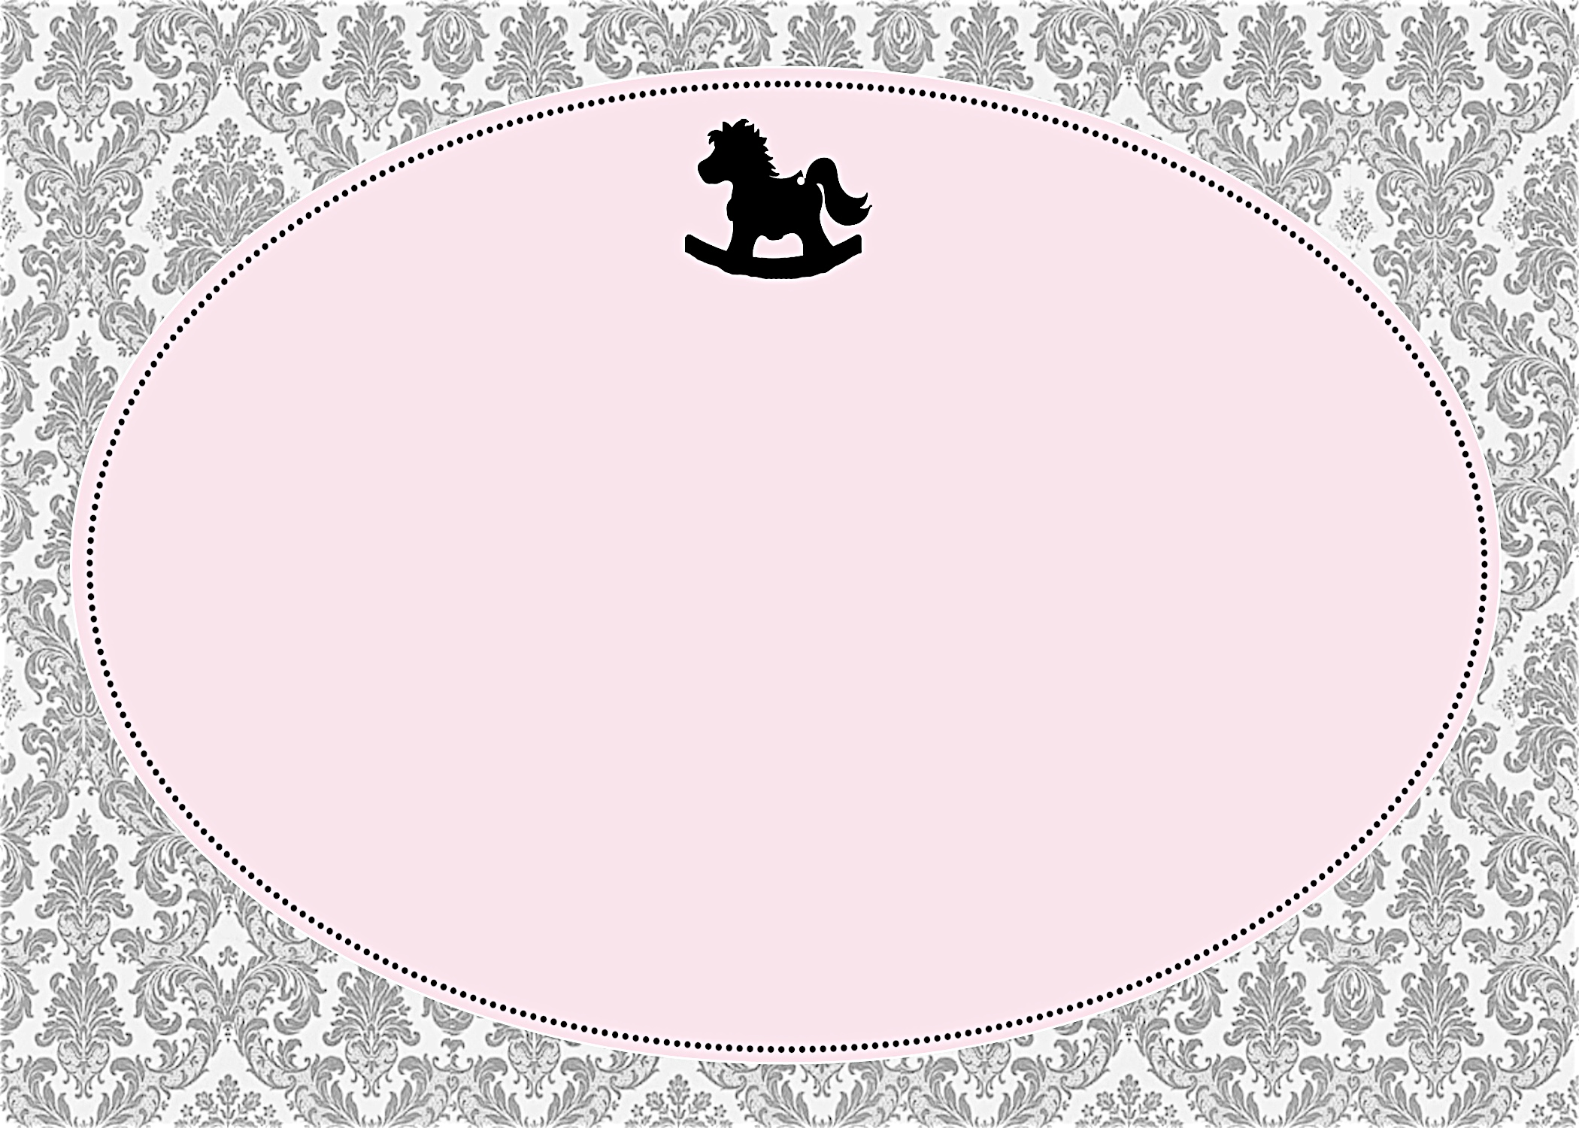
Please join us in honoring the mommy-to-be
Janet Anderson
Saturday, April 3 at 1:30 p.m.

Debbie Smith’s Home
111 Main Street Anycity, ST 94844

RSVP by March 15th to debbiesmith@gmail.com
(925) 333-3324

Registered at Baby “R Us
Please join us in honoring the mommy-to-be
Janet Anderson
Saturday, April 3 at 1:30 p.m.

Debbie Smith’s Home
111 Main Street Anycity, ST 94844

RSVP by March 15th to debbiesmith@gmail.com
(925) 333-3324

Registered at Baby “R Us


an invitation
created especially for you!

©www.celebrationsoflifestore.com

an invitation
created especially for you!

©www.celebrationsoflifestore.com

