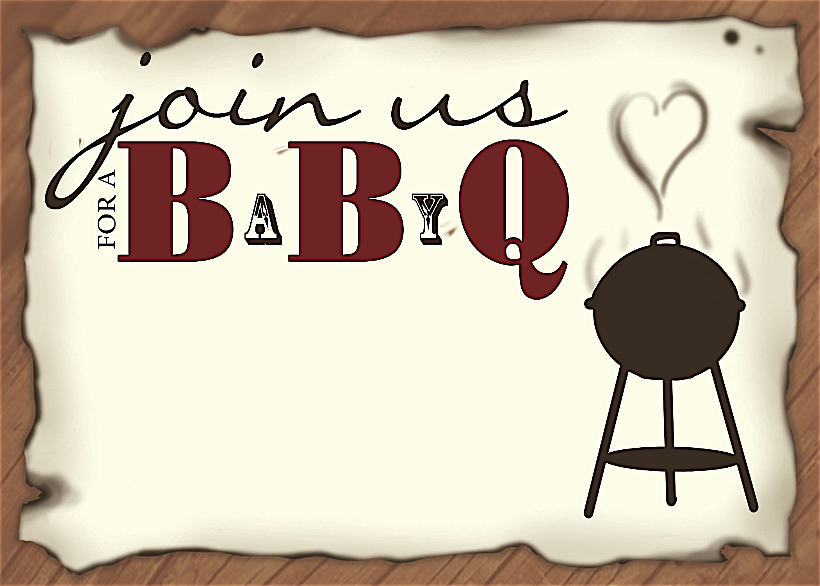
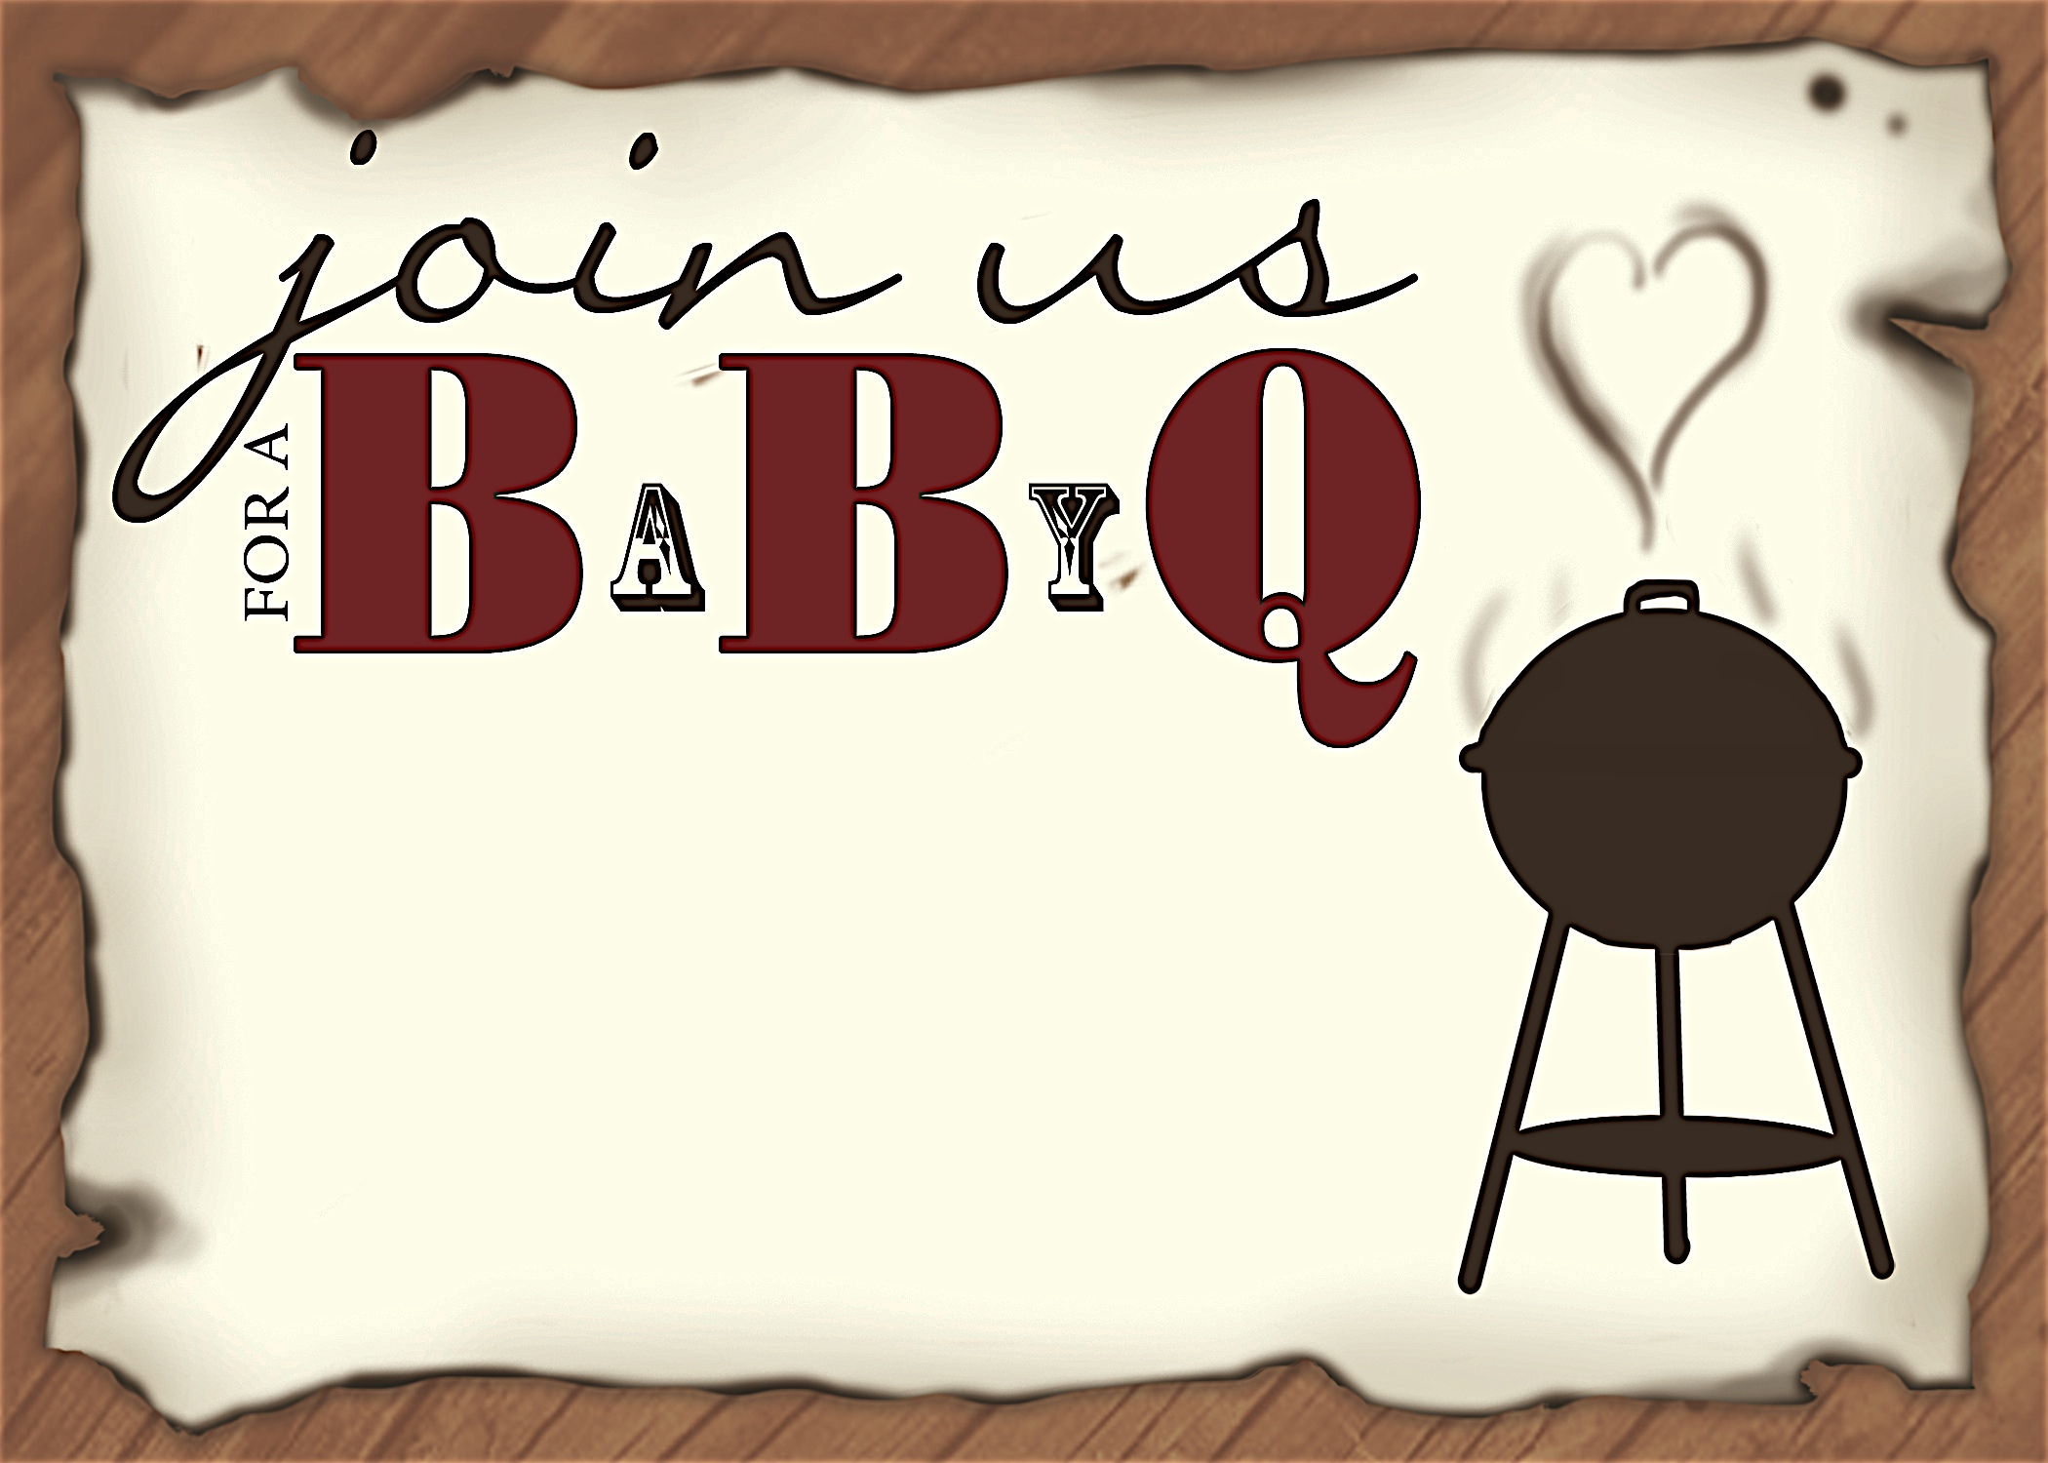
Please join us in honoring the parents-to-be
Lisa and John
Saturday, April 3 at 1:30 p.m.

Debbie Smith’s Home
111 Main Street Anycity, ST 94844
RSVP by March 15th to debbiesmith@gmail.com
(925) 333-3324
Registered at Baby ‘R Us
Please join us in honoring the parents-to-be
Lisa and John
Saturday, April 3 at 1:30 p.m.

Debbie Smith’s Home
111 Main Street Anycity, ST 94844
RSVP by March 15th to debbiesmith@gmail.com
(925) 333-3324
Registered at Baby ‘R Us
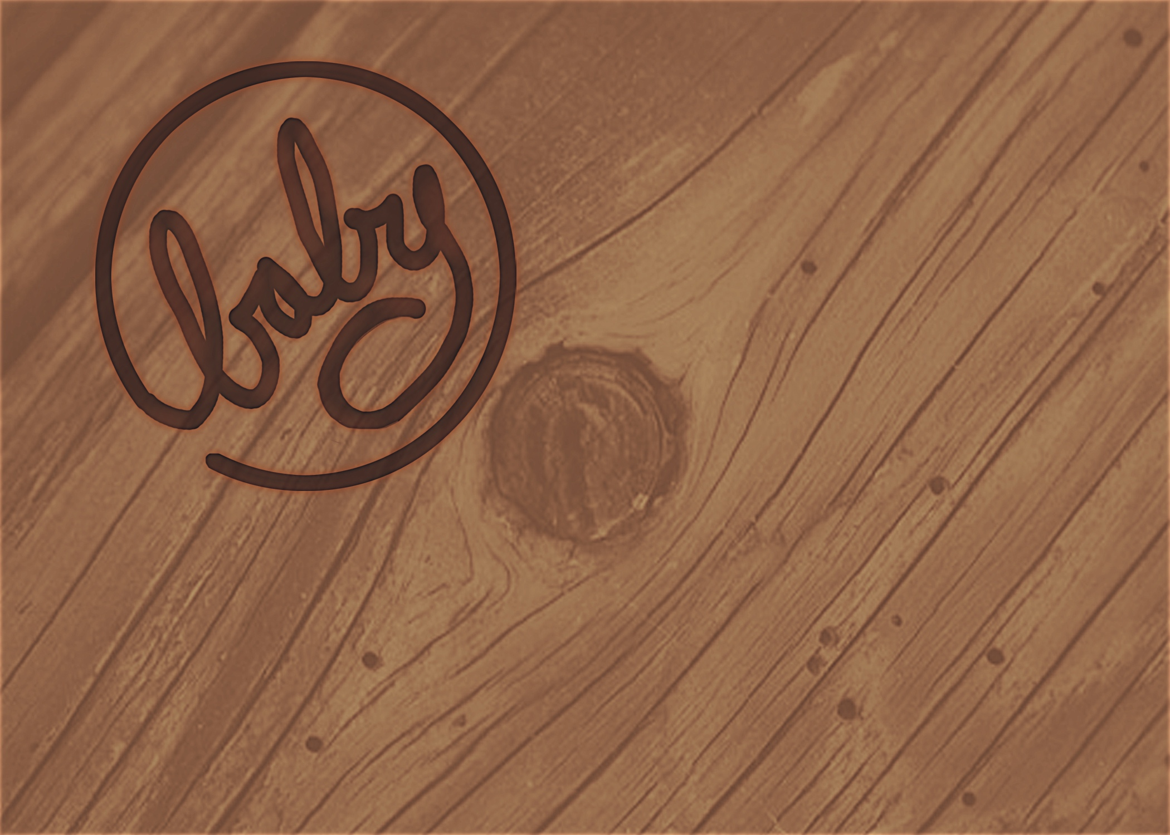
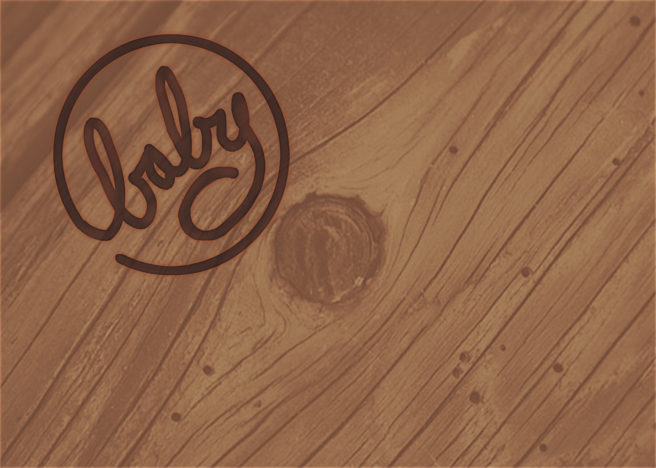
an invitation
created especially for you!

©www.celebrationsoflifestore.com

an invitation
created especially for you!

©www.celebrationsoflifestore.com

