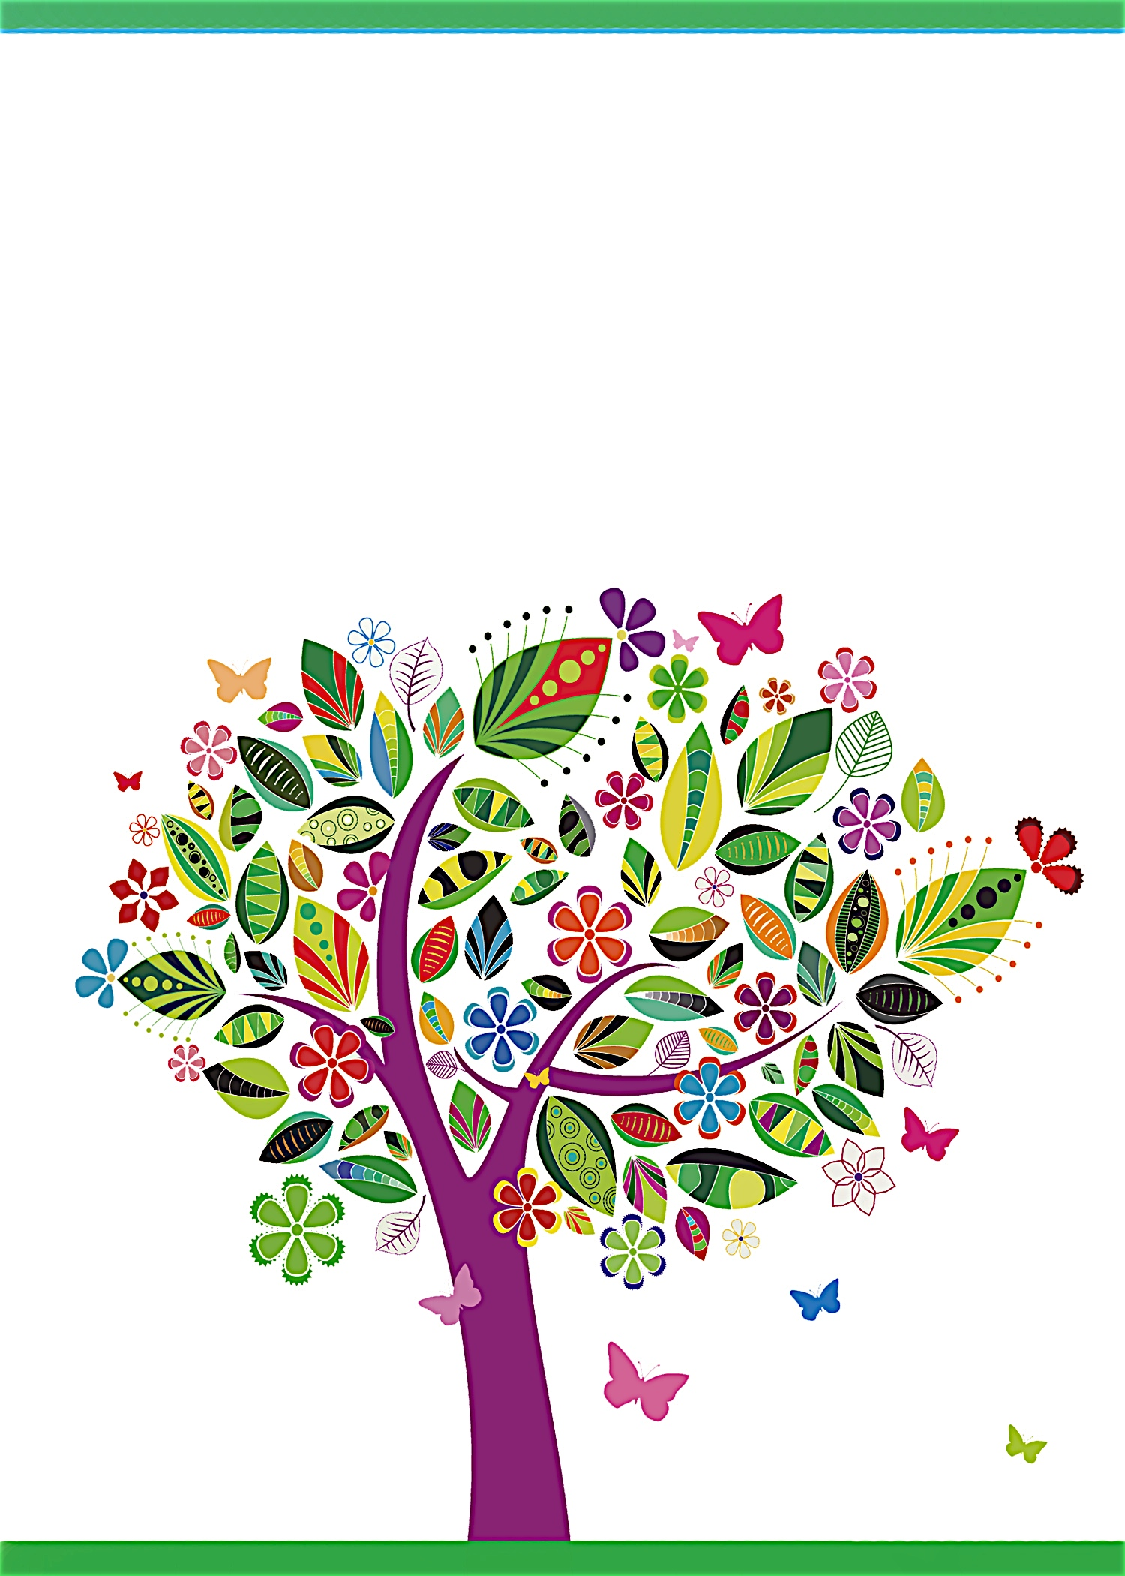
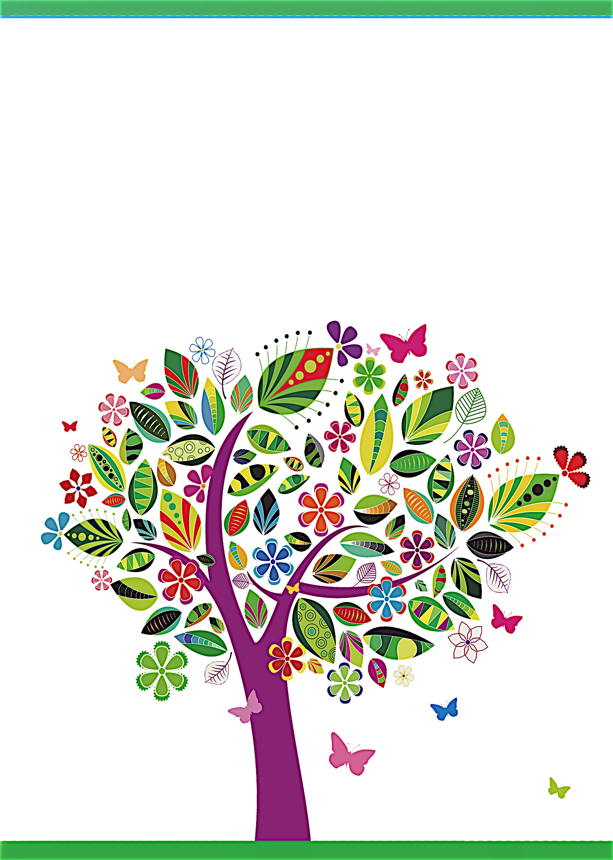
Registered at Baby ‘R Us
Registered at Baby ‘R Us
on Saturday, April 3 at 1:30 p.m.
Debbie Smith’s Home at 111 Main Street, Anycity, ST 94844
RSVP by March 15th to debbiesmith@gmail.com
(925) 333-3324
for Janet Anderson
on Saturday, April 3 at 1:30 p.m.
Debbie Smith’s Home at 111 Main Street, Anycity, ST 94844
RSVP by March 15th to debbiesmith@gmail.com
(925) 333-3324
for Janet Anderson
Baby Shower
Baby Shower


an invitation
created especially for you!

©www.celebrationsoflifestore.com

an invitation
created especially for you!

©www.celebrationsoflifestore.com

