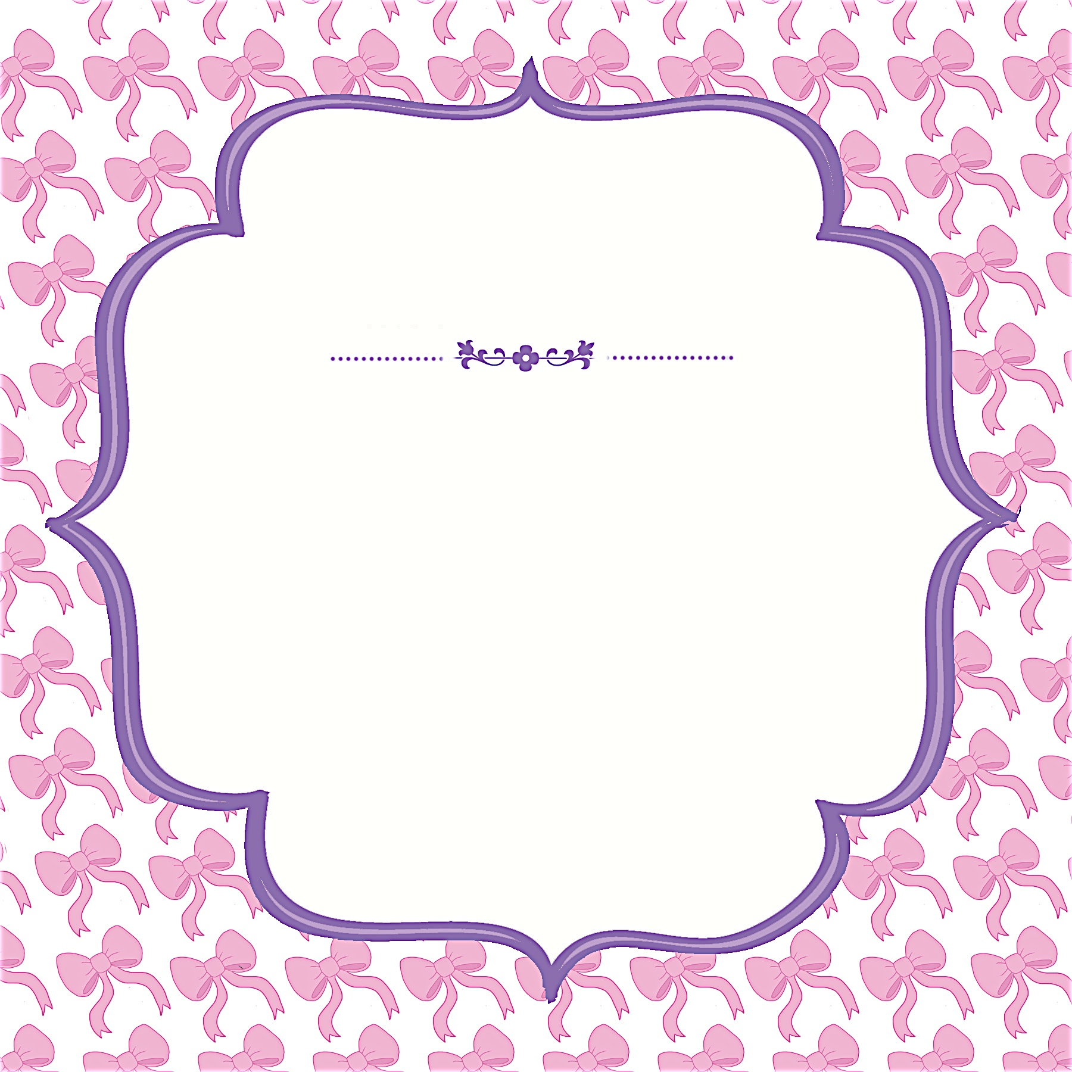
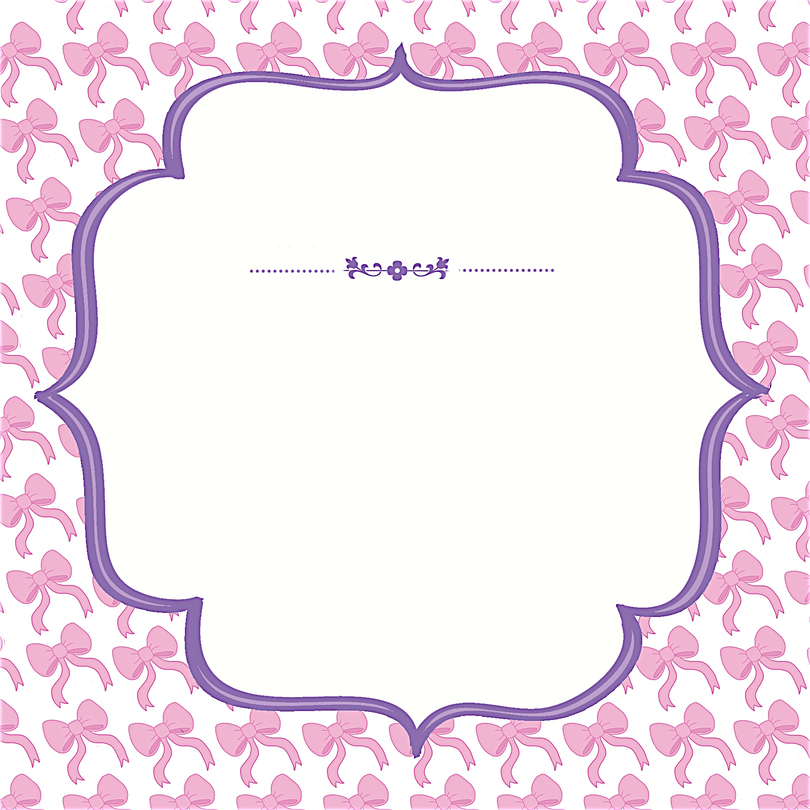

JANET ANDERSON
Saturday, April 3 at 1:30 p.m.
Debbie Smith’s Home
111 Main Street, Anycity, ST 94844

RSVP by March 15th
to debbiesmith@gmail.com
(925) 333-3324

Janet is registered at Babies R Us

JANET ANDERSON
Saturday, April 3 at 1:30 p.m.
Debbie Smith’s Home
111 Main Street, Anycity, ST 94844

RSVP by March 15th
to debbiesmith@gmail.com
(925) 333-3324

Janet is registered at Babies R Us
A Baby Shower
A Baby Shower


an invitation
created especially for you!

©www.celebrationsoflifestore.com
an invitation
created especially for you!

©www.celebrationsoflifestore.com

