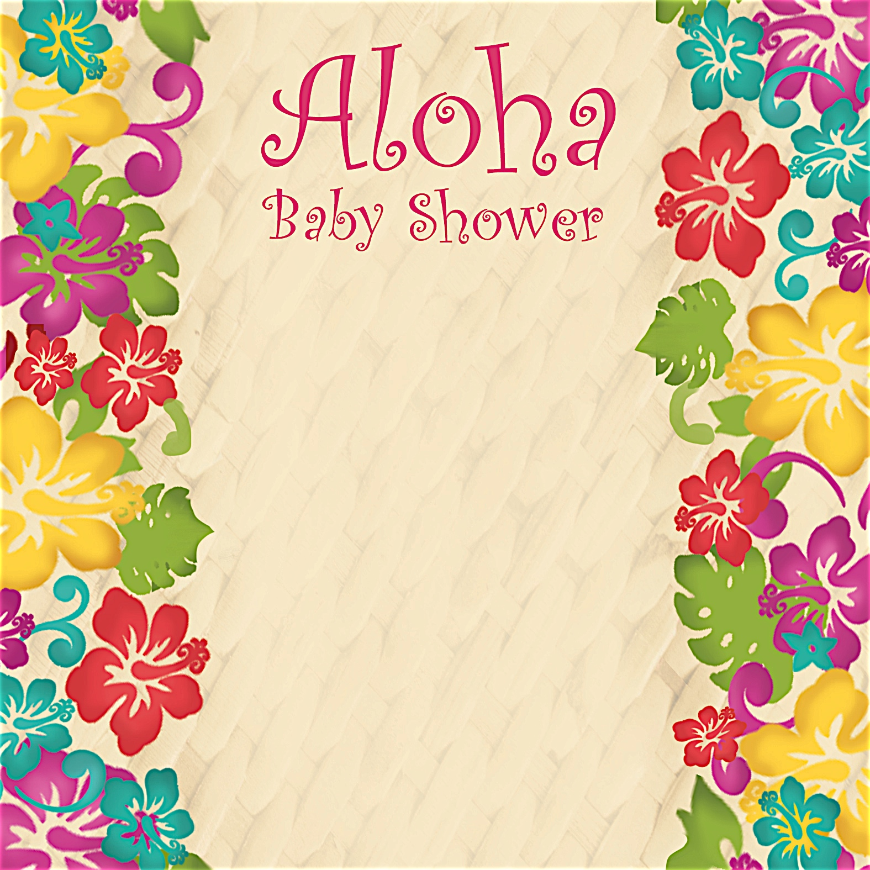
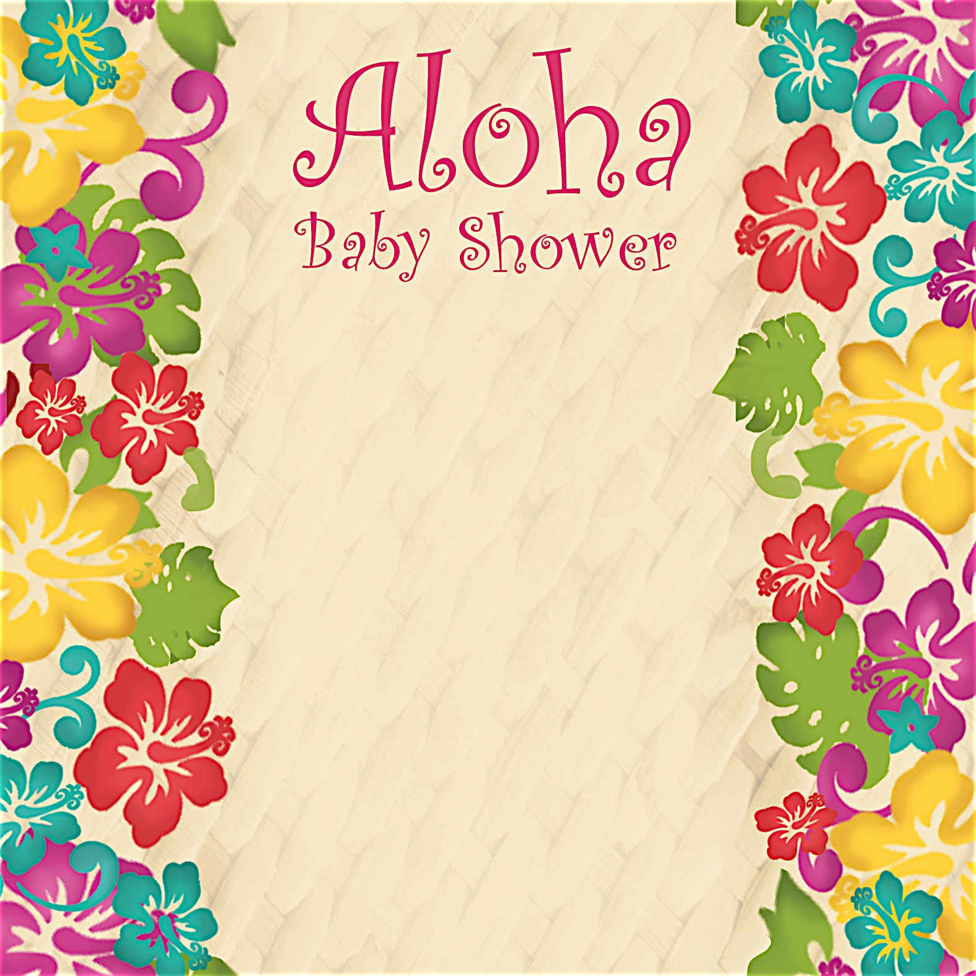
Leilani Puno

given with love by Debbie Smith
Saturday, April 3 at 1:30 p.m.

Debbie Smith’s Home
111 Main Street
Anycity, ST 94844

RSVP by March 15th to
debbiesmith@gmail.com
(925) 333-3324

Registered at
Babies R Us

Leilani Puno

given with love by Debbie Smith
Saturday, April 3 at 1:30 p.m.

Debbie Smith’s Home
111 Main Street
Anycity, ST 94844

RSVP by March 15th to
debbiesmith@gmail.com
(925) 333-3324

Registered at
Babies R Us



an invitation
created especially for you!

© www.celebrationsoflifestore.com
an invitation
created especially for you!

© www.celebrationsoflifestore.com

