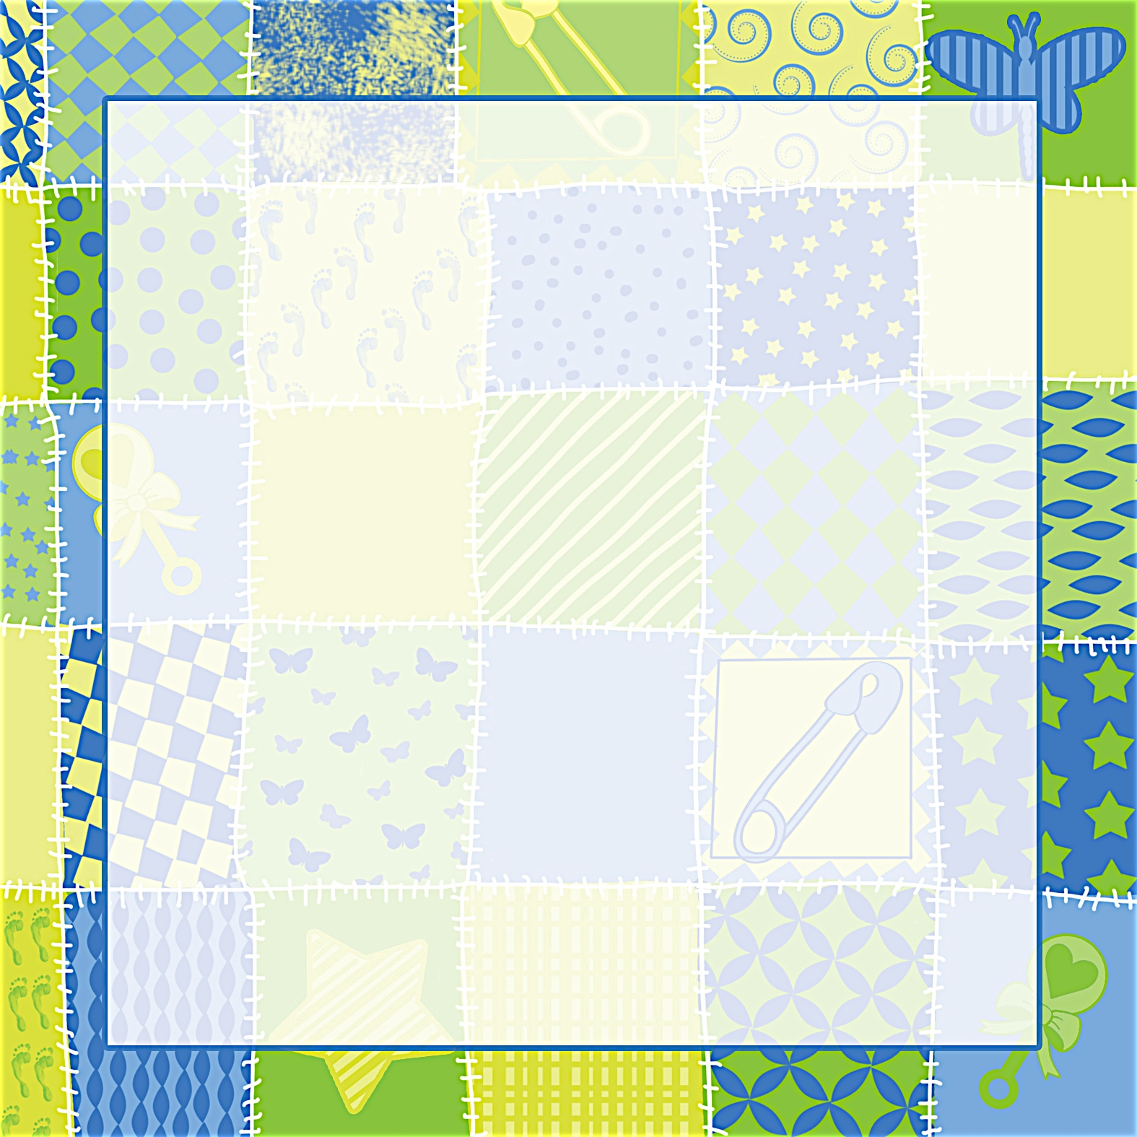
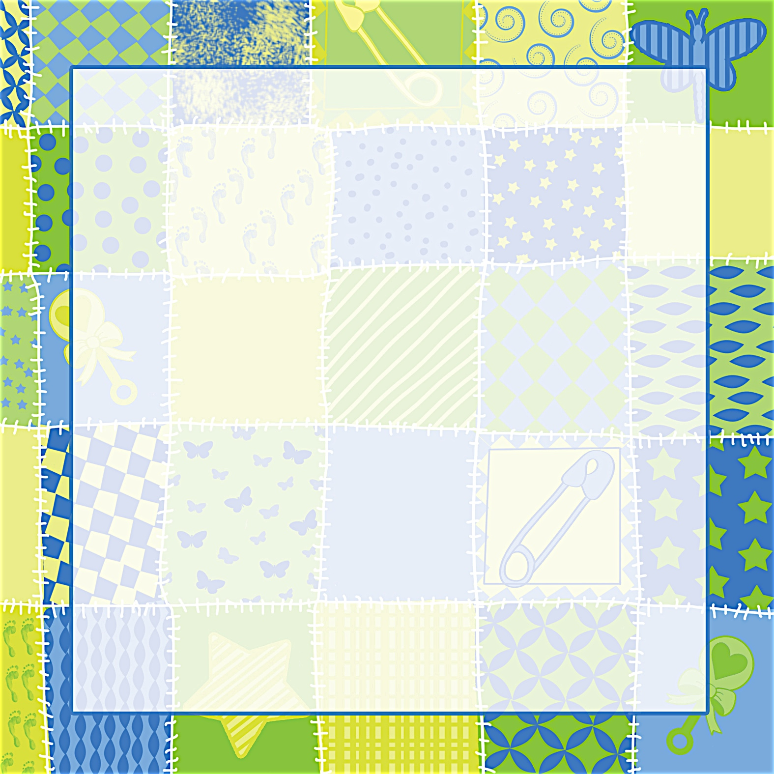
Janet Anderson

Given with love by Debbie Smith
Saturday, April 3 at 1:30 p.m.

Debbie Smith’s Home at 111 Main Street
Anycity, ST 94844

RSVP by March 15th to debbiesmith@gmail.com
(925) 333-3324
Registered at Babies R Us

Janet Anderson

Given with love by Debbie Smith
Saturday, April 3 at 1:30 p.m.

Debbie Smith’s Home at 111 Main Street
Anycity, ST 94844

RSVP by March 15th to debbiesmith@gmail.com
(925) 333-3324
Registered at Babies R Us

It's a Baby Shower
Please join us...
It's a Baby Shower
Please join us...


an invitation
created especially for you!

© www.celebrationsoflifestore.com
an invitation
created especially for you!

© www.celebrationsoflifestore.com

