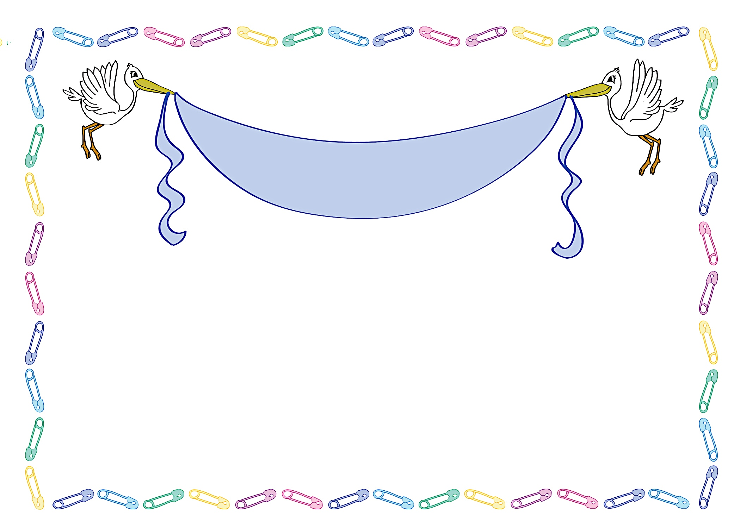
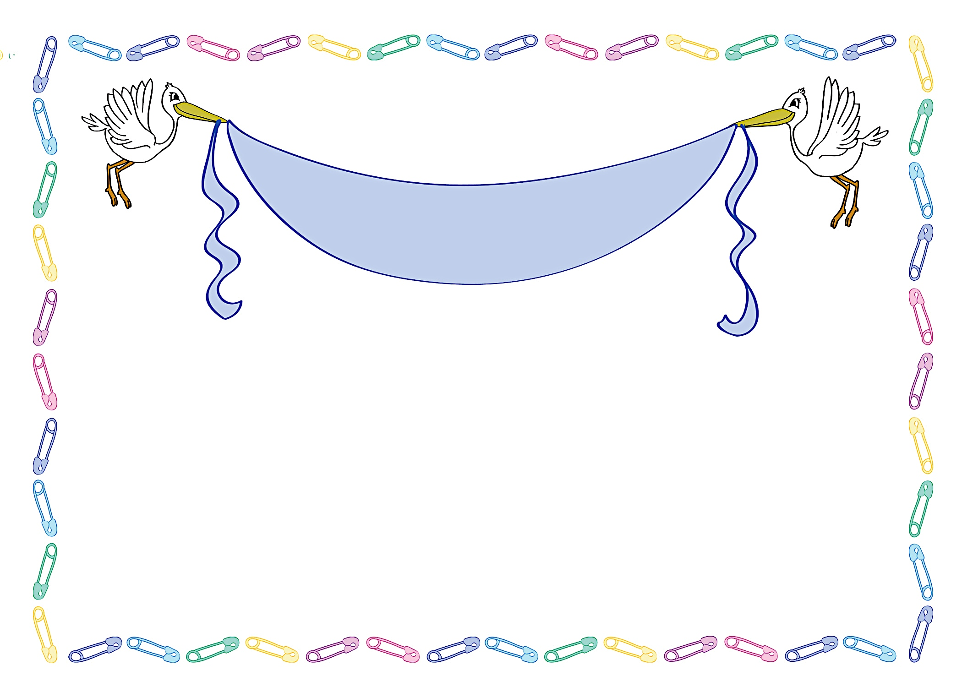
Janet & Marc Anderson
Saturday, April 3 at 1:30 p.m.

Debbie Smith’s Home at 111 Main Street Anycity, ST 94844
RSVP by March 15th to debbiesmith@gmail.com
(925) 333-3324

Registered at Baby “R Us
Janet & Marc Anderson
Saturday, April 3 at 1:30 p.m.

Debbie Smith’s Home at 111 Main Street Anycity, ST 94844
RSVP by March 15th to debbiesmith@gmail.com
(925) 333-3324

Registered at Baby “R Us
New Baby
New Baby
JOIN US IN A CELEBRATION FOR
JOIN US IN A CELEBRATION FOR


an invitation
created especially for you!

© www.celebrationoflifestore.com
an invitation
created especially for you!

© www.celebrationoflifestore.com

