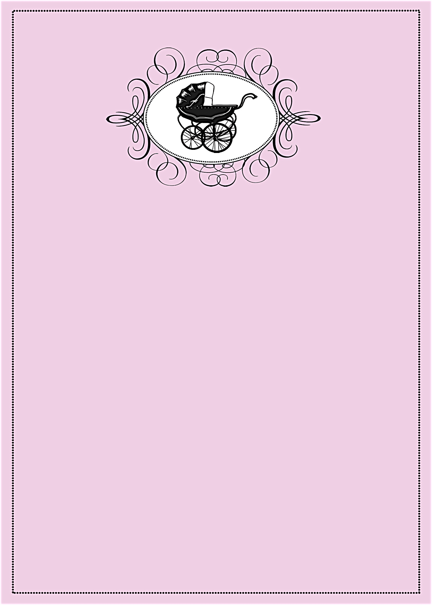
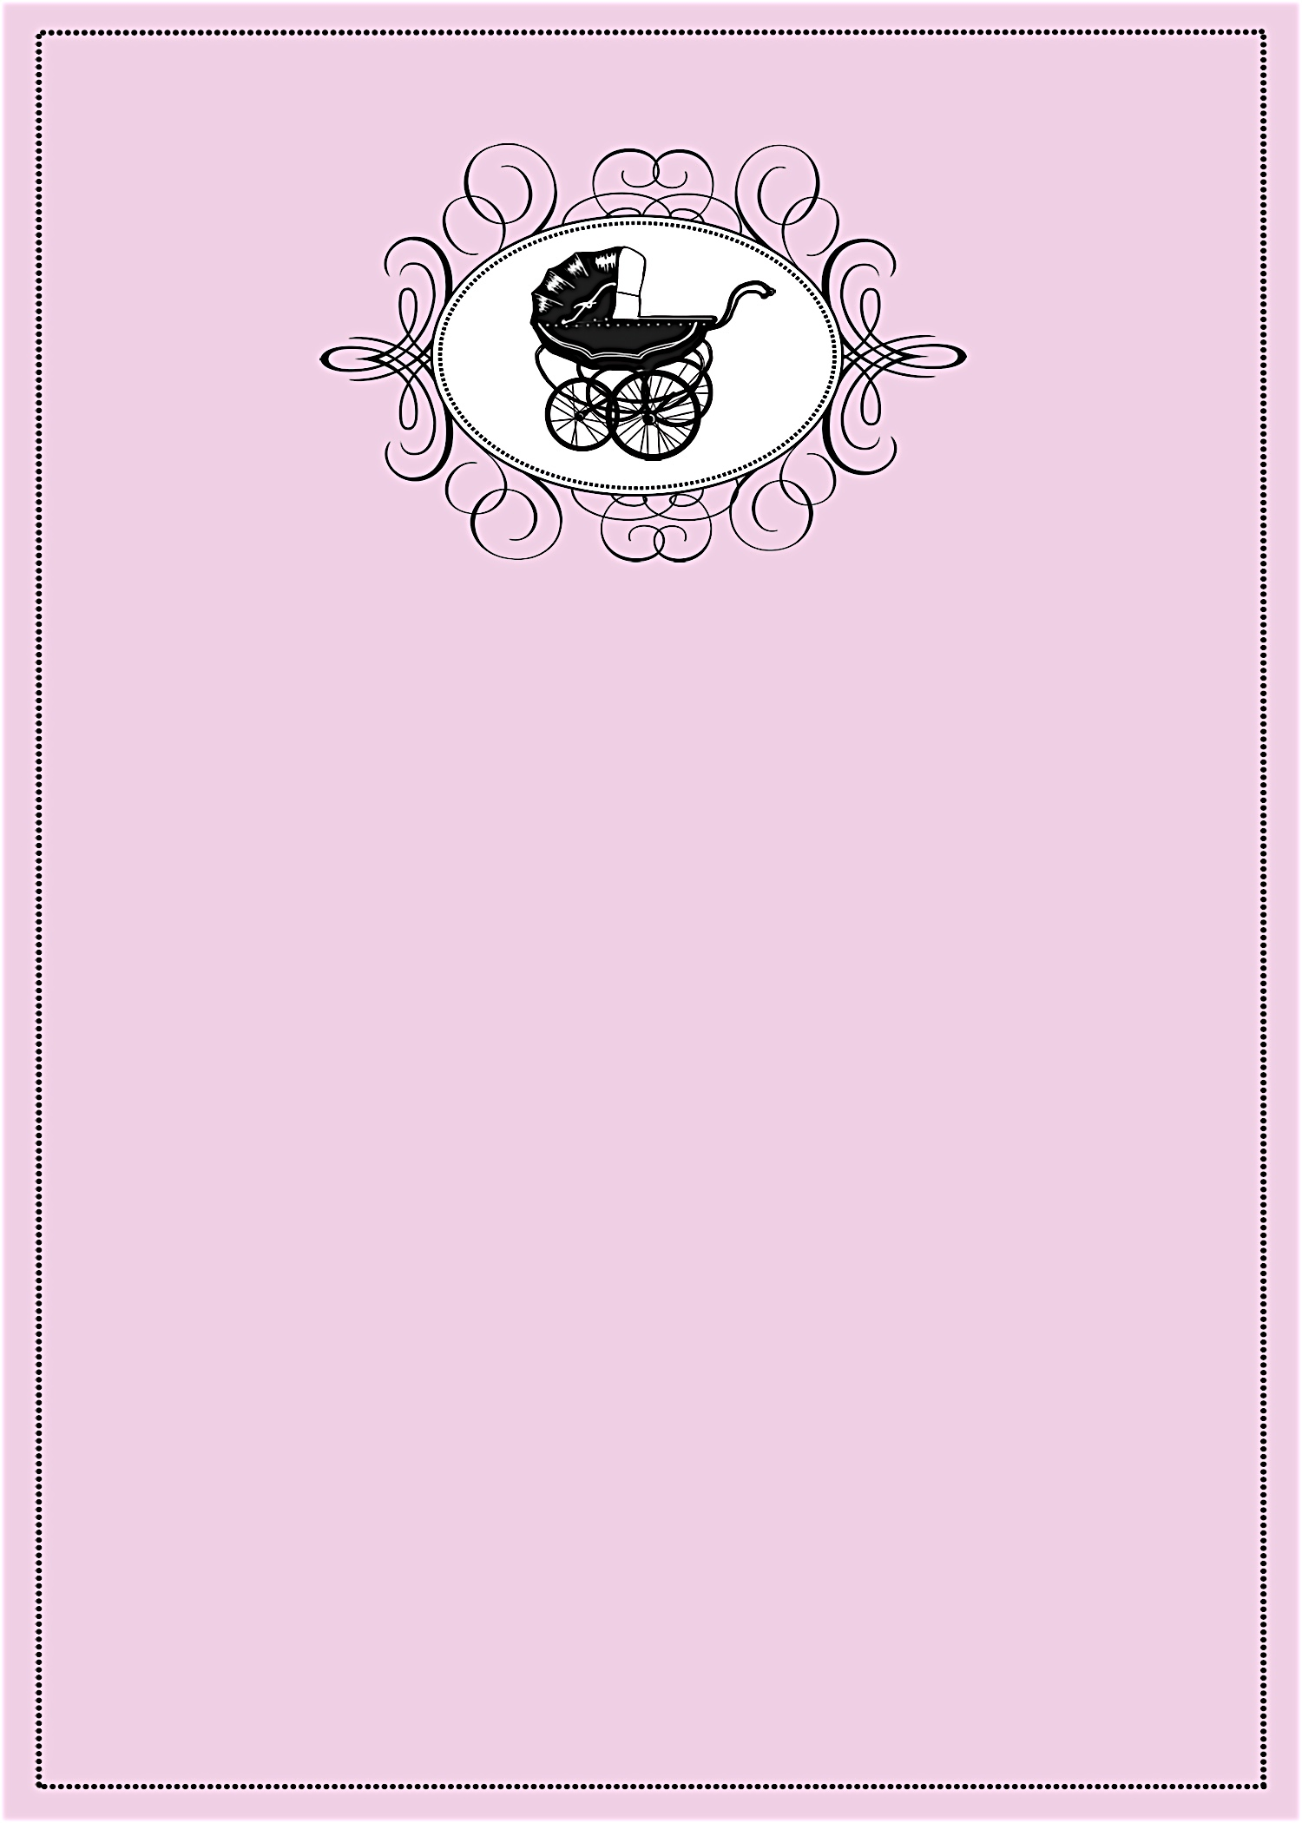
A Baby Shower in Honor of
Janet Anderson
A Baby Shower in Honor of
Janet Anderson
given with love by Debbie Smith
Saturday, April 3 at 1:30 p.m.

Debbie Smith’s Home
111 Main Street
Anycity, ST 94844

RSVP by March 15th to debbiesmith@gmail.com
(925) 333-3324

Registered at Babies R Us
A Baby Shower in Honor of
Janet Anderson
A Baby Shower in Honor of
Janet Anderson
given with love by Debbie Smith
Saturday, April 3 at 1:30 p.m.

Debbie Smith’s Home
111 Main Street
Anycity, ST 94844

RSVP by March 15th to debbiesmith@gmail.com
(925) 333-3324

Registered at Babies R Us


an invitation
created especially for you!

©www.celebrationsoflifestore.com

an invitation
created especially for you!

©www.celebrationsoflifestore.com

