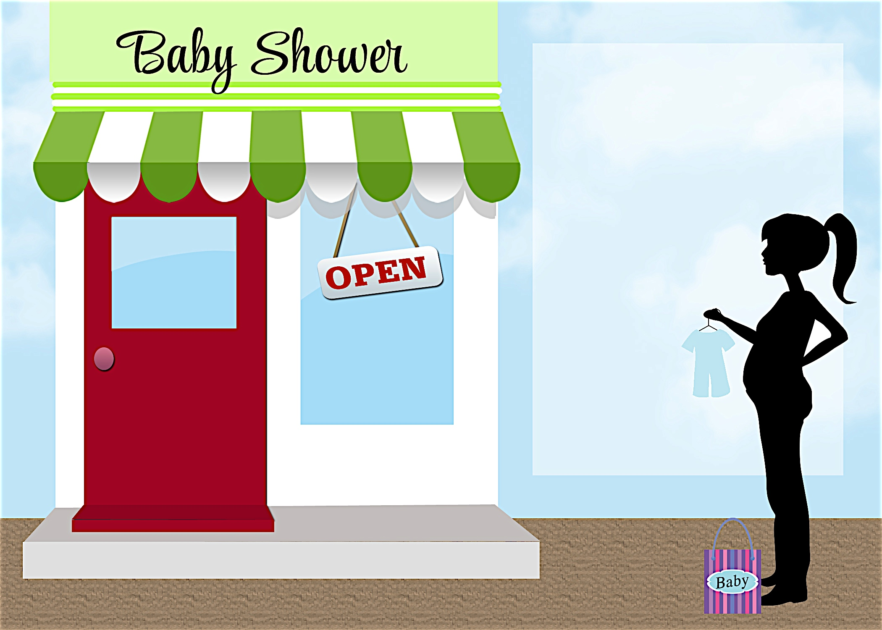
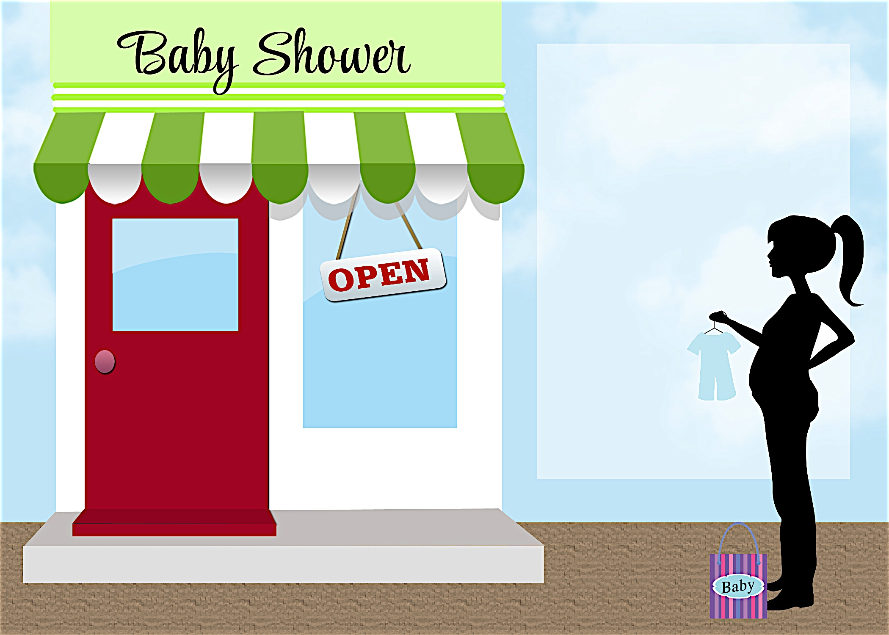
Please join us in honoring the mommy-to-be
Janet Anderson
Saturday, April 3 at 1:30 p.m.

Debbie Smith’s Home
111 Main Street
Anycity, ST 94844

RSVP by
March 15th to
(925) 333-3324

Registered at
Babies R Us

debbiesmith@gmail.com

Please join us in honoring the mommy-to-be
Janet Anderson
Saturday, April 3 at 1:30 p.m.

Debbie Smith’s Home
111 Main Street
Anycity, ST 94844

RSVP by
March 15th to
(925) 333-3324

Registered at
Babies R Us

debbiesmith@gmail.com

SPECIALS
on the Baby Boy!
SPECIALS
on the Baby Boy!


an invitation
created especially for you!

© www.celebrationoflifestore.com
an invitation
created especially for you!

© www.celebrationoflifestore.com

