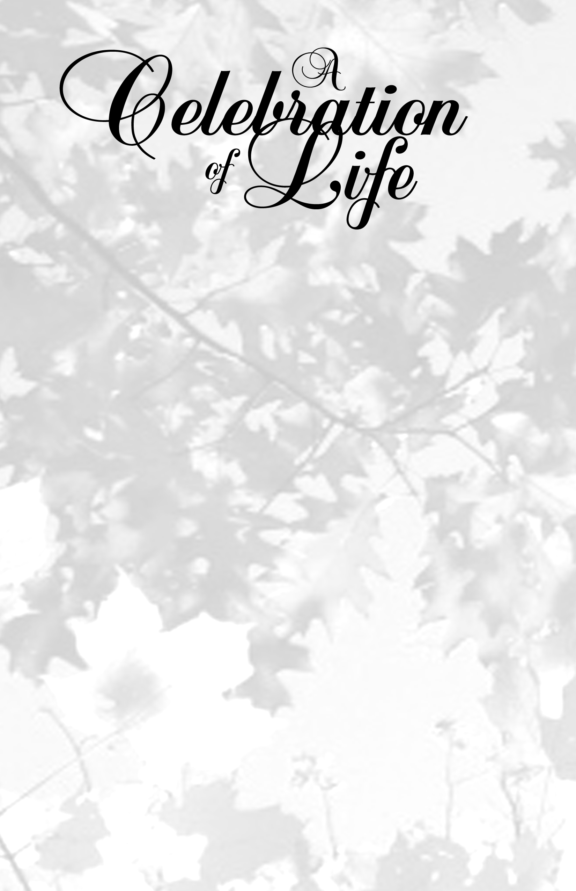

Name of Loved One

August 13, 1943 - December 29, 2005

First Community Church
111 Main Street
Any City, ST 83733
Pastor John Smith, Officiating

Life Is But A Stopping Place

A Poem can go in this area if desired.

Life is but a stopping place,

A pause in what's to be,

A resting place along the road,

to sweet eternity.

We all have different journeys,

Different paths along the way,

We all were meant to learn some things,

but never meant to stay...

Our destination is a place,

Far greater than we know.

–Author unknown

The family wishes to express their sincere gratitude to all those who have support us during this time of loss.

– The Smith Family

Name of funeral location here
address of funeral location
city, state, zip, phone number

Acknowledgements
© www.FuneralProgram-Site.com
Place your photo here per our instructions. Failure to do so could result in layout problems.


Celebrating the Name of Loved One

Obituary

Betty passed peacefully from this life the morning of July 16th after a gradual decline in health. She was surrounded and supported by her loving family and caregivers during the last days of her life. Betty was born in Rock Springs, WY, but has been a San Franciscan since 1945. In 1971, after raising her four boys and a daughter, Betty, and her husband Ernie, retired in (or move to) beautiful Guerneville, CA where she lived the remainder of her life.

Betty is survived by four children (and spouses): Adele Westly (Mike), Michael (Noreen), David (Carole) and Paul (Sue) Gaines; daughter-in-law Louise Gerards; eleven grandchildren: Justine Anderson and Jamie Ander, Deanne Hayes and Debbie Johnes, Rachel and Jonah Little, Alisha Myer, and Christian, Marc, Eric and Carlin Tims; and eight great grandchildren: Grace, Gage, Curtis and Bradley Josephs, Austin and Jackson Houston, and Dylan and Shay Richmond. Betty is also survived by her brother Art Landers and sister June Bailey. She was preceded in death by her husband Ernest, her son Peter, daughter-in-law Madie Kristal, brothers Nels, Bobby and Tommy Little, and sisters Lucy Smith, May Day and Pearl Transferson.

A memorial service will be held on Thursday, July 30th at 11:00am. Location: Pleasant Hills Memorial Park, 1700 Pleasant Hills Road, Sebastopol, CA 95472. In lieu of flowers, donations may be made to (NAME and ADDRESS).

Musical Prelude . . . . . . . . . . . . . . . . . . Name of song

Processional

Viewing of Remain

Closing and Sealing of Casket

Musical Selection . . . . . . . . . . . . . . . . . Name of song

Prayer . . . . . . . . . . . . . . . . . . . . . . . .. . . . Name of person

Scripture

Old Testament . . . . . . . . . . . . . . . Name of scripture

New Testament . . . . . . . . . . . . . . Name of scripture

Selection . . . . . . . . . . . . . . . . . . . . . . . . . Name of person

Special Tribute . . . . . . . . . . . . . . . . . . . . Name of person

Hymn . . . . . . . . . . . . . . . . . . . .. . . . . . . . Name of person

Reflections (2 Minutes Please)

Obituary . . . . . . . . . . . . . . . . . .. . . . . . . . Name of person

Eulogy . . . . . . . . . . . . . . . . . . .. . . . . . . . Name of person

