# 素材库1号文件示例文档

## 程序及文档使用说明

程序基于星球成员[@岛主](https://t.zsxq.com/194kSUKnL)上传的python文件修改并打包。程序增加了文件选择和保存功能，方便从本地选择和保存文件，修复了段落末尾不能出现“”的问题。

此文档为图片/文字素材库1号文件，其中<文献>为大纲等级二级标题格式。

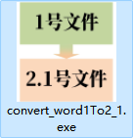利用提供的素材库处理程序，基于该文档可生成2.1号文件。

* Step1：下载上传的程序文件
  + - * + 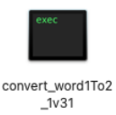Windows系统：convert_word1To2_1.exe
        + Mac系统：convert_word1To2_1
* Step2：按要求准备好素材库1号文件，格式参考本文档，<文献>设置为标题2格式。
* Step3：双击运行程序，出现如下界面

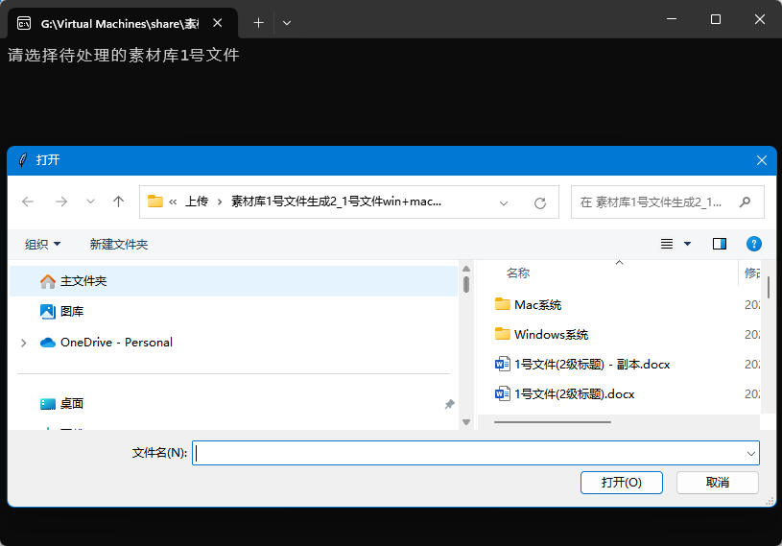

图 1 素材库1号文件选择界面

提示选择你的“素材库1号文件”，同时打开系统的文件选择窗口（如图 1）。

选择文件后，点击<打开>，程序会自动执行生成2.1号文件，并提示保存（如图 2）

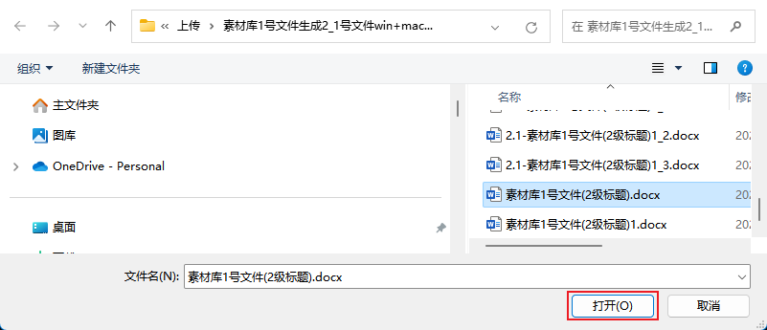

图 2 打开素材库1号文件

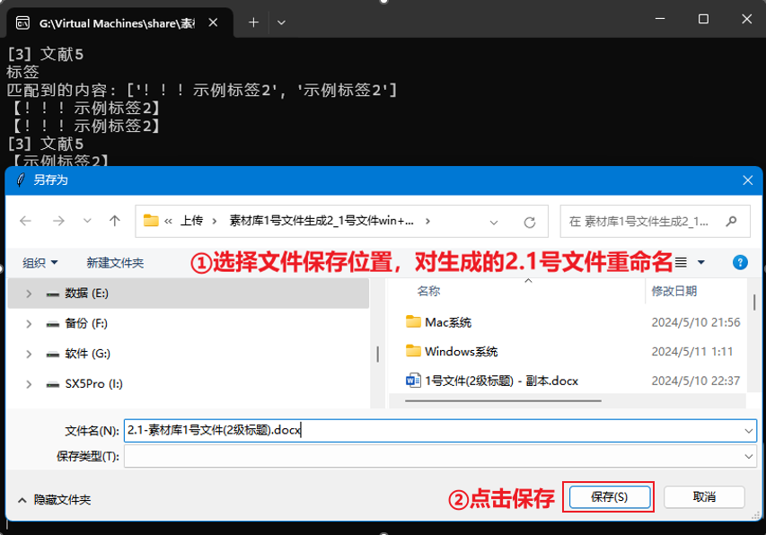

图 3 保存生成的素材库2.1号文件

如文件有重名，则会提示是否替换，请选择“是”。为避免误操作，文件不会被替换，会另存为<文件名>_1.docx文件。

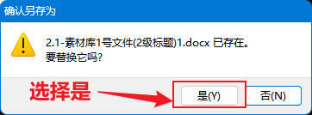

图 4 重名时，选择“替换”保存

之后会弹出“程序运行成功”提示（如图 5），即可在保存位置打开生成的2.1号文件查看（如图 6）。

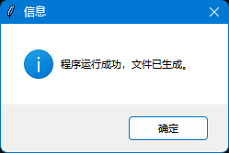

图 5 程序正确运行提示

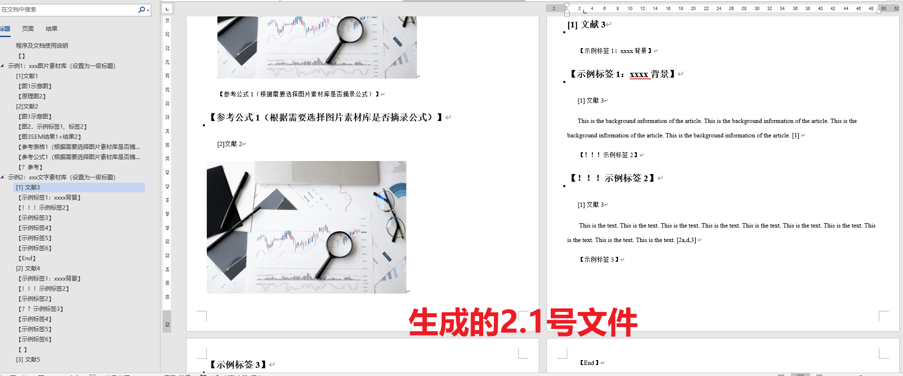

图 6 生成的2.1号文件

# 示例1：xxx图片素材库（设置为一级标题）

## [1]文献1

【图1示意图】



【原理图2】



## [2]文献2

【图1示意图】命名根据个人需要



【图2，示例标签1, 标签2】



【图3SEM结果1+结果2】



【参考表格1（根据需要选择图片素材库是否摘录表格）】



【参考公式1（根据需要选择图片素材库是否摘录公式）】



【？参考】

# 示例2：xxx文字素材库（设置为一级标题）

## [1] 文献3

【示例标签1：xxxx背景】This is the background information of the article. This is the background information of the article. This is the background information of the article. This is the background information of the article. [1]

【！！！示例标签2】 This is the text. This is the text. This is the text. This is the text. This is the text. This is the text. This is the text. This is the text. This is the text. This is the text. [2a,d,3] 【示例标签3】This is the text. This is the text. This is the text. This is the text. This is the text. This is the text. This is the text. This is the text. This is the text. This is the text. This is the text. This is the text. This is the text. This is the text. [4]

【示例标签4】This is the text. This is the text. This is the text. This is the text. This is the text. This is the text. This is the text. This is the text. This is the text. This is the text. This is the text. This is the text. This is the text. This is the text. 3b,6a,d]【示例标签5】This is the text. This is the text. This is the text. This is the text. This is the text. This is the text. This is the text. This is the text. This is the text. This is the text. This is the text. This is the text. This is the text. This is the text. [5b,7] 【示例标签6】This is the text. This is the text. This is the text. This is the text. This is the text. This is the text. This is the text. This is the text. This is the text. This is the text. This is the text. This is the text. This is the text. This is the text..[5b,8] This is the text. This is the text. This is the text. This is the text. This is the text. This is the text. This is the text. This is the text. This is the text. This is the text. This is the text. This is the text. This is the text. This is the text.【End】

## [2] 文献4

【示例标签1：xxxx背景】This is the background information of the article. This is the background information of the article. This is the background information of the article. This is the background information of the article. [1]

【！！！示例标签2】 This is the text. This is the text. This is the text. This is the text. This is the text. This is the text. This is the text. This is the text. This is the text. This is the text. [2a,d,3] 【示例标签2】This is the text. This is the text. This is the text. This is the text. This is the text. This is the text. This is the text. This is the text. This is the text. This is the text. This is the text. This is the text. This is the text. This is the text. [4]

【？？示例标签3】This is the text. This is the text. This is the text. This is the text. This is the text. This is the text. This is the text. This is the text. This is the text. This is the text. This is the text. This is the text. This is the text. This is the text. 3b,6a,d]【示例标签4】This is the text. This is the text. This is the text. This is the text. This is the text. This is the text. This is the text. This is the text. This is the text. This is the text. This is the text. This is the text. This is the text. This is the text. [5b,7] 【示例标签5】This is the text. This is the text. This is the text. This is the text. This is the text. This is the text. This is the text. This is the text. This is the text. This is the text. This is the text. This is the text. This is the text. This is the text..[5b,8] This is the text. This is the text. This is the text. This is the text. This is the text. This is the text. This is the text. This is the text. This is the text. This is the text. This is the text. This is the text. This is the text. This is the text.

This is the text. This is the text. This is the text. This is the text. This is the text. This is the text. This is the text. This is the text. This is the text. This is the text. This is the text. This is the text. 【示例标签6】This is the text. This is the text.[5b,8] This is the text. This is the text. This is the text. This is the text. This is the text. This is the text. This is the text. This is the text. This is the text. This is the text. This is the text. This is the text. This is the text. This is the text.【】

## [3] 文献5

【示例标签1：xxxx背景】This is the background information of the article. This is the background information of the article. This is the background information of the article. This is the background information of the article. [1]

【！！！示例标签2】 This is the text. This is the text. This is the text. This is the text. This is the text. This is the text. This is the text. This is the text. This is the text. This is the text. [2a,d,3] 【示例标签2】This is the text. This is the text. This is the text. This is the text. This is the text. This is the text. This is the text. This is the text. This is the text. This is the text. This is the text. This is the text. This is the text. This is the text. [4]

【？？示例标签3】This is the text. This is the text. This is the text. This is the text. This is the text. This is the text. This is the text. This is the text. This is the text. This is the text. This is the text. This is the text. This is the text. This is the text. 3b,6a,d]【示例标签4】This is the text. This is the text. This is the text. This is the text. This is the text. This is the text. This is the text. This is the text. This is the text. This is the text. This is the text. This is the text. This is the text. This is the text. [5b,7] 【示例标签5】This is the text. This is the text. This is the text. This is the text. This is the text. This is the text. This is the text. This is the text. This is the text. This is the text. This is the text. This is the text. This is the text. This is the text. [5b,8] This is the text. This is the text. This is the text. This is the text. This is the text. This is the text. This is the text. This is the text. This is the text. This is the text. This is the text. This is the text. This is the text. This is the text.

This is the text. This is the text. This is the text. This is the text. This is the text. This is the text. This is the text. This is the text. This is the text. This is the text. This is the text. This is the text. 【示例标签6】This is the text. This is the text.[5b,8] This is the text. This is the text. This is the text. This is the text. This is the text. This is the text. This is the text. This is the text. This is the text. This is the text. This is the text. This is the text. This is the text. This is the text.