**Usan field**

* bounding shales and the stress-field variability in a highly compartmentalized environment
* Usan Tertiary reservoirs have multiple turbidite-sand bodies of 3- to 30-m thickness with permeability up to 3,000 md and are separated by 3- to 20-m-thick shale layers, making them difficult to complete. In a smaller scale, some of the reservoir targets have verythin (<5 cm) to medium (5–10 cm) laminated shale intercalations
* Oil density ranges from 20 to 40°API, and insitu viscosity ranges from 0.2 to 4 cp. Oil is slightly undersaturated, with an average reservoir pressure 10 to 20 bar above saturation pressure.

**Amenam-Kpono Oil and Gas Field**

* It is 7km long and 4km wide with an average thickness of 250m. Porosity is 15% and permeability is several hundred millidarcy. Reservoir pressure is 350bar to 500bar and the temperature is
* 130°C to 150°C. Oil is light at 43° to 47°.
* In 2002, the FSO Domy was replaced by the FSO Unity. Originally built in Ulsan, South Korea, it receives crude at a rate of 230,000bpd from the Amenam-Kpono field as well as the Alfia, Ime, Edikan, Ofon, and Odudu Fields. Amenam-Kpono field will provide the largest amount of input to the FSO Unity, some 125,000bpd during the first phase of its development. The field is linked to the vessel via a 38km pipeline.

**Messla oil field**

* an early stage of development the field is estimated to contain approximately 3 billion bbl of original oil-in-place
* The reservoir consists of two sandstones separated by a continuous shale bed. Porosity values average 17% and the permeability 500 md.
* The oil column averages approximately 90 ft (27 m) and is productive from an average depth of 8,800 ft (2,682 m) over 200 sq km. Early 1978 production is in excess of 100,000 b/d of 40° API oil with a cumulative production of 45 million bbl.

**Thar Jath field**

* contains in excess of 1.2 billion STOIIP, 75% of the STOIIP comprises 20° API oil with 120-160 cP viscosity while the remaining STOIIP comprises 16° API with viscosity > 680 cP viscosity.
* Thar Jath oil field is located in Block 5A, in the Muglad Basin of South Central Sudan, about 950 km south of Khartoum and was discovered in May 1999. The oil
* accumulation in the field covers an approximately 13 km by 5 km area. Thar Jath field is composed of two reservoirs, ARA and BEN sands. These are shallow
* reservoirs, approximately 1100 to 1250 m depth with high porosity ranges from 18 to 35% and permeability from 100 to more than 10000 mD comprising of moderate to unconsolidated sands

**HEGLIG OIL FIELD**

* The Heglig well No.5 tested the Bentiu No.2 zone over an interval of 5276' - 5348'. The well flowed 1886 bopd of 29 degrees API clean oil on a 1 1/4 inch choke. The Aradeiba "A" Sandstone will also be tested in this well before it is readied for production. Additional recoverable oil reserves will be booked and reported as soon as final engineering data is compiled. This year the company has previously reported the addition of approximately 88 million barrels to its prior recoverable reserve base of 307 million barrels from a similar discovery tested during the last quarter. Independent engineers have used cut-offs for recoverable reserves of 20 per cent recovery of oil in place, 15 per cent porosity and 100 - 300 millidarcies of permeability

**Agbami field**

* Permeability range: 150–2,000 md
* 45–47°API oil with low (0.26-cp)
* viscosity
* Mobility ratio less than unity
* Highly undersaturated oil, by up to
* 3,500 psi
* Injected gas is first-contact miscible
* with oil at reservoir conditions
* With favorable reservoir and fluid
* properties, high net-/gross-pay ratio, and
* structural dip (10–30°), gravity-stable
* gas and water fronts should result in
* good oil recovery. However, uncertainty

**The Kingfisher Field, Uganda**

* The Kingfisher oil is a sweet low sulphur oil of c. 30-32 o API
* Reserves are estimated to be in the region of 200 mmbo and plans are in preparation for the development of the field.
* The field is approximately 16 km long by 3.5 km wide and covers an area of 37.5 km2
* The Kingfisher South structural culmination lies under a narrow strip of land, some 10 km by 2 km, located adjacent to the basin bounding fault and which represents a surface expression of the Kingfisher structure.
* Log analyses show the formation to have good to excellent porosities with layer averages typically in the range 22-24%. Initial core analysis on Kingfisher-3A indicates that reservoir permeabilities are excellent with values typically in the range 100-10,000mD. The arithmetic mean horizontal permeability is 1,769mD. These permeabilities are commensurate with those indicated from tests on wells Kingfisher-1A and Kingfisher-2. When tested in Kingfisher-2, the three main reservoir sands flowed at an aggregate rate of 14,364 bopd.
* Original oil in place for Kingfisher is currently estimated to be in the region of 600 mmbo, while recoverable reserves are expected to be c. 200 mmbo.

**Unity Oil**

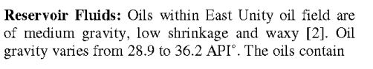

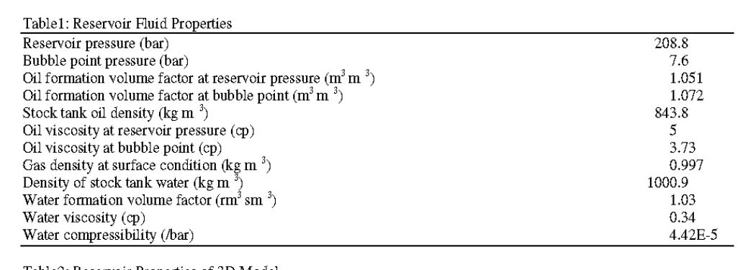

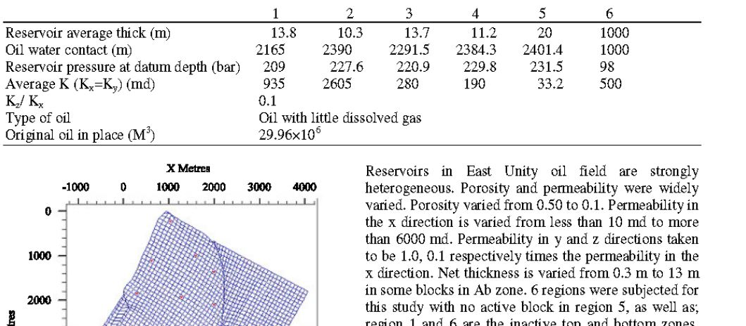

**Okoro Field**

* In March 2012, three drill stem tests (“DSTs”) were undertaken and completed. The purpose of the tests was to obtain fluid samples and pressure data in order to establish reservoir connectivity, heterogeneity and quantify permeability and porosity. The tests successfully confirmed a high quality 38° to 40° API oil, multi Darcy permeabilities and average porosity of between 30% to 35%, in the subject reservoirs. The pressure data also obtained has helped with the Company’s structural understanding of the field and supports the pre drill volumetric estimates (Pmean STOIIP of 157 mmbbls).

**ASIA**

Papua New Guinea

• Main formations Toro A,B,C sands

• STOOIP about 600 MMstb

• EUR about 350 MMstb

• Peak oil rate 130,000 stb/d

• Gascap about 1.2 TCF OGIP

• Permeability 400 md

• Porosity 13%

• Viscosity 0.3 cP

BUALUANG FIELD

Primary T4 reservoir is a braided

fluvial channel sand

Very high NTG of almost 93%

Excellent poro-perm, with porosities

>30% and kh exceeding 1000mD

Reservoir thickness exceeds column

height with underlying active aquifer

Reservoir temperature ~161 deg F

and pressure 1600 psia

Fluid properties

Low GOR – 4 scf/stb

Moderate gravity of 27 API

Low wax

Relatively high viscosity: 8.5 cp

The Marlim field

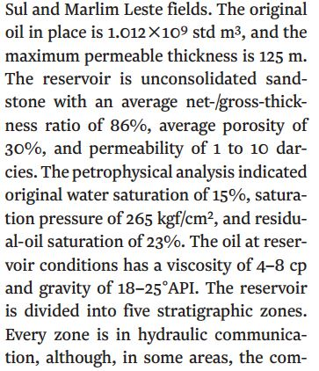

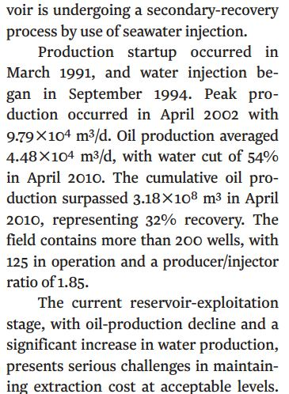

Mangala field

We calculate from Cairn and from reservoir pressure

and temperature data from the Phoenix oil and gas*

acreage the following data:

- Average Mangala reservoir pressure 1400psi (low)

- Average Mangala reservoir permeability (quality)

1000mD

- Oil specific gravity 25API (low)

- Average initial flow rates of 2000b/d (confirmed

from well testing).

 Using this main data and other reservoir assumptions

we can calculate that a single well could drain from a

40acre area.

 Cairn plans to drill 115 wells in phase 1 of

development and 45 in phase 2.

 Initial drilling of 30 wells and water injectors would

test the waterflood techniques and provide early cash

flow.

 Assuming this to be the case we would anticipate an

average 60,000b/d in the first year of production

growing to a theoretical plateau of between

150,000b/d and 200,000b/d. We assume a

100,000b/d plateau in our valuation.

This close up picture shows a very ‘sandy’ plug being cut from the core and clearly

shows the good quality very porous and permeable qualities. The actual

permeability here is likely to be between 2000mD and 3000mD (very high)

Core samples are cut across the reservoir to allow the physical properties of the

rock to be determined such as permeability (flowability) and porosity

Aude Aude lumut oil field

