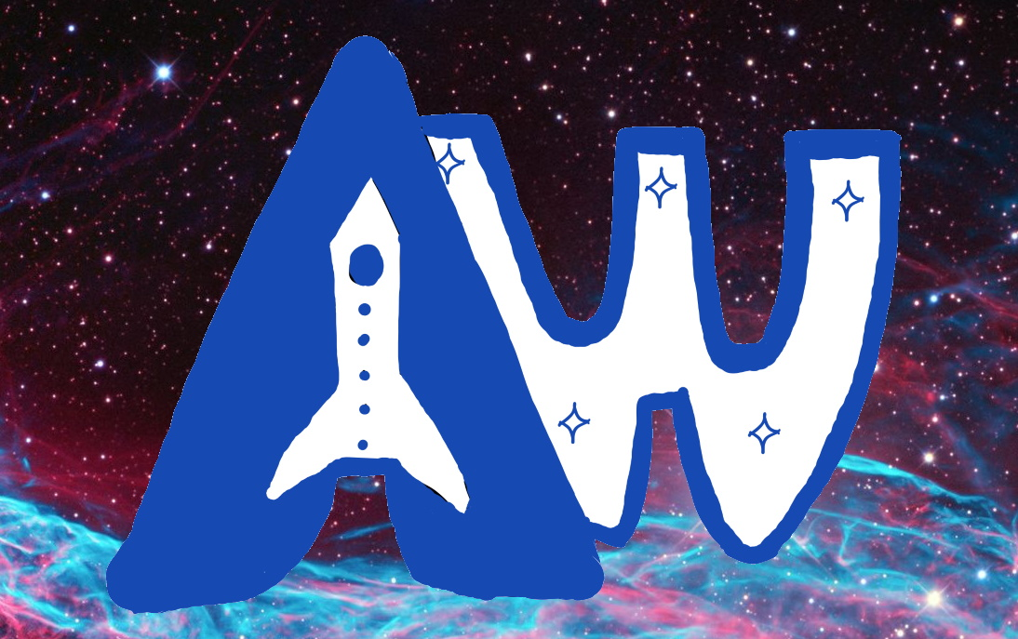
Figure 1: Astro World Themed Park Logo

Design Report

Website Design & Implementation Assessment

Part A

Introducing the Design Report
The design report is vital for the client as it demonstrates the design and thought process that was taken to implement and create the desired website implementation. This creates a bond between the client and the web designer to have trust and understanding on the website. Resultantly, the website designed will benefit the client as it may increase the reach to potential customers, allow for customers to find information about the theme park themselves and connect customers with services. In terms of the target audience, it would be for potential customers of theme park who are interested in the theme park.
The design report will guide the reader through all the steps taken to develop the website, from the conception of the topic to the completion of the website. This includes the introduction of the website topic, development of target audience, a series of user tests, including the paper prototyping user test, the aesthetic user test and the high-fidelity user test. The design report will be presented in a professional manner, illustrated by the wide use of typography and range of media including images, texts and tables.

Introducing the Web Designer
As the web designer and the author of this design report, I believe it would be of benefit for the client to know a little about who I am. This as previously mentioned above, aims to further create a trusting bond between the client and the web designer.
My name is Peter Tran and I like to believe that I am highly ambitious and optimistic. I am currently in my 2nd year of software engineering at UQ. I enjoy problem solving, working in teams, and programming is one of my passions. In my spare time, I partake in socials sports, mostly including football and badminton. I am always looking to expand my array of skills to learn and to experience firsthand, the real world.
Personally, I believe my design thought process and skills at the start of the courses was very poor, and this is one of the main reasons I chose to choose DECO1400 as an elective, even though there are other courses out there that would be more suitable for my software engineering degree. My skills are beginner level, however I did previously take a basic web design course in high school. My web design skills will be shown throughout the design report which I aim to improve by the end of the course.
The learning strategy for me is to ensure that I am giving 100% of my effort and not being complacent. Thus, I will aim to attend every weekly tutorial and practical and watch the lectures, ensuring that I actively participate in class and engage in the learning.
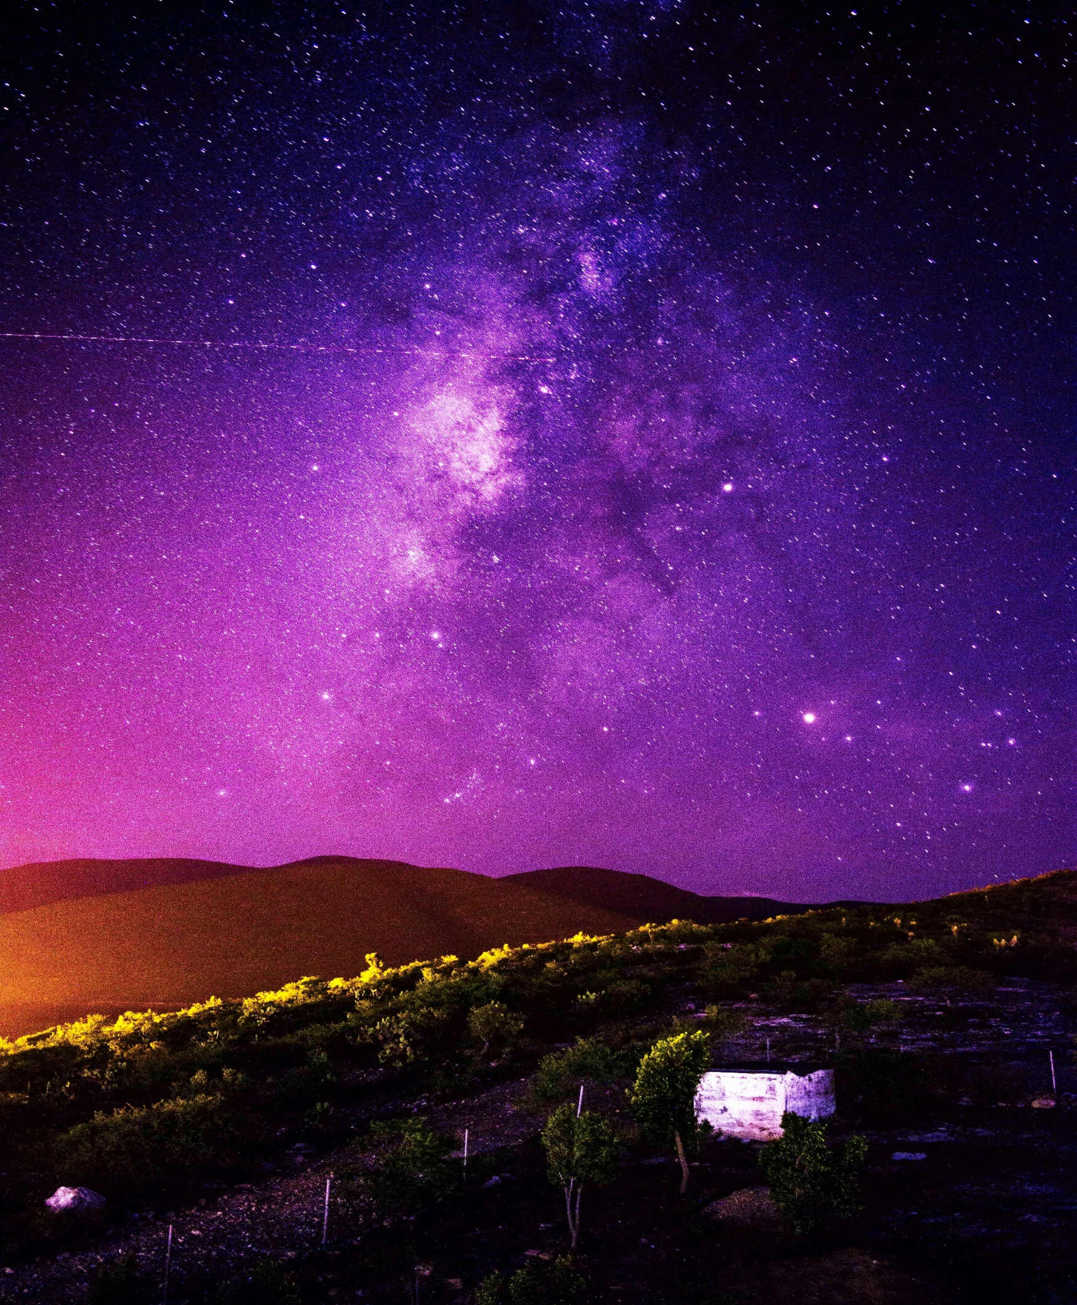
Figure 2: https://www.pexels.com/photo/purple-night-sky-photo-544268/

Responding to the Brief

Introducing the Website Topic
As per the website project brief, the topic for the website was to choose an unusual location and activity and implement that into an interactive and engaging themed resort website. The first step in the design process was to brainstorm possible ideas for the themed resort.
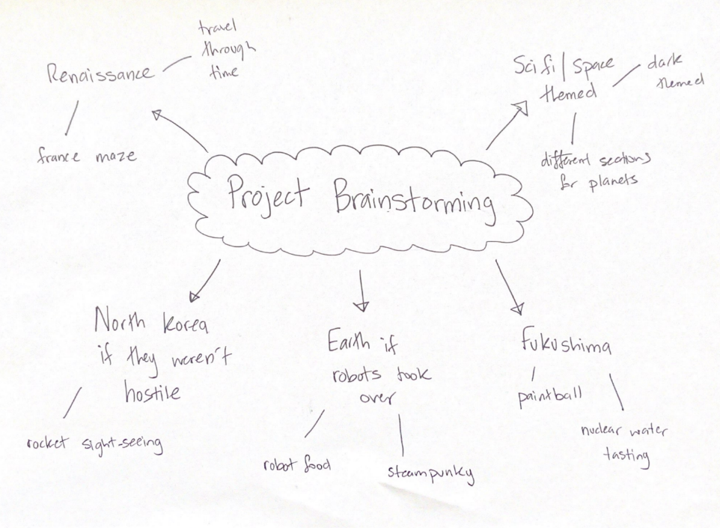
As seen above, a myriad of ideas was generated, and in the end, a sci fi/space themed resort was chosen as the website topic. The idea I had in mind was a resort that required guests and customers to travel interstellar to different planets and as well as am emulate a science fictional futuristic world. In terms of activities, these can include augmented virtual reality, hyper sonic speed roller coasters, zero gravity sighting, golf on the moon and much more. Overall, I believe this idea to fun and engaging, appropriate for the given website project specification.
Figure 3: project brainstorming drawing
A topic was then generated from the resultant idea and was uploaded to ‘CampusWire’, the preferred discussion site for this course for approval.
“From giant robots to interplanetary colonisation to hyper speed roller-coasters, the contemporary and innovate Future Sci Fi Themed Park welcomes and caters for all ages young and old. Guest accommodation will range from a selection of themed hotels including: alien abduction scene, space station and interstellar spacecraft. Guests will be able to experience what the future will be like through augmented virtual reality and as well as action packed roller-coaster.
Website will possibly have an interactive map of the themed park in which when viewers click on a location, it will expand to give more information including where in the universe the scenario or theme is based.”
This topic was approved by the instructor, with further feedback to improve the current idea.
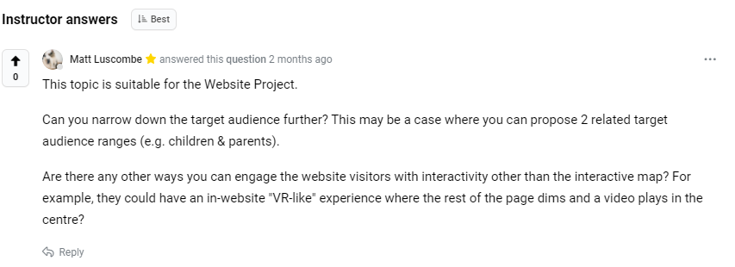
Figure 4: feedback from instructor for website topic
Final website topic:
In the end, after many revisions, the final website topic I chose was an interstellar Sci Fi themed park where customers can choose to travel to 1 of 3 different planets. Each planet is a part of a package that includes experiences catered towards the destination. As an example, guests choosing to stay on Uranus may decide to try the Deluxe Geothermal Natural Hot Spring, or on Jupiter, attendees may like the interplanetary rollercoaster through the mantles of the giant gas planet.
Inspiration for the website topic was taken from the ‘Cyberpunk’ website where the topic is to advertise and promote the game. Although ‘Cyberpunk’ tells a narrative of a future dystopian world, the theme resort will show the opposite, of what technology could become and the benefit it would bring.
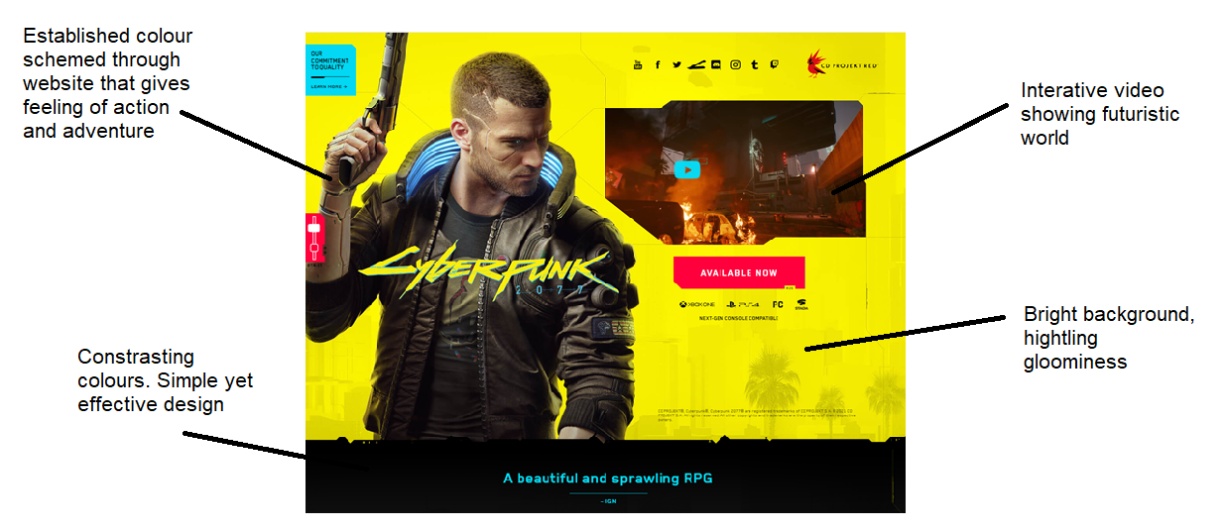
Figure 5: cyberpunk website home
Notably, it features a large map that can be clicked on to view different areas of the game which would be appropriate to incorporate something similar in my own website. In addition, the website features radiate a contemporary feel with its heavy use of interactivity and visual aesthetics.

Introducing the Target Audience
As a website designed for a Sci-Fi Space themed park, the target audience would be potential guests and customers. As part of the design process, we were required to create fictional personas that tells a narrative as to why they would be interested in a website about the theme park, emphasising their goals, pain points and as well as technical skill. Presented below are two different personas of potential consumers that may visit the website. The personas have been intentionally created differently to represent unique views and perspective.

Persona 1: ‘Tom Brown’
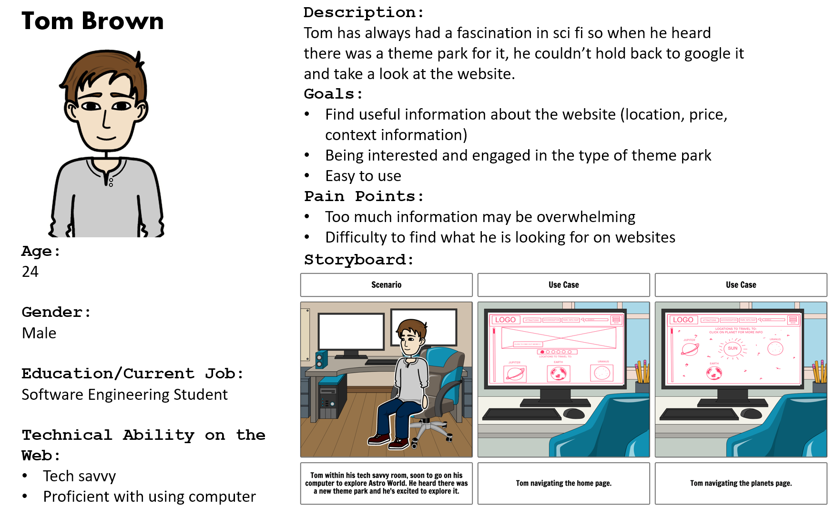
Figure 6: persona for Tom Brown
The persona, ‘Tom Brown’ represents a potential customer who is interested in going to the park and would like to find out more about information. As a ‘millennial’ aged 24 and a student studying a STEM degree, he grew up during the digital age and is quite versed in using technology such as browsing the internet. As a result, he would most likely use his computer and/or mobile phone to access the internet.
Although important, Tom would value functionality over ease of use as he is already quite familiar with the layout of typical websites. His pain points include websites that contain to much information and ultimately overwhelms the user.
Persona 2: ‘Eddie’
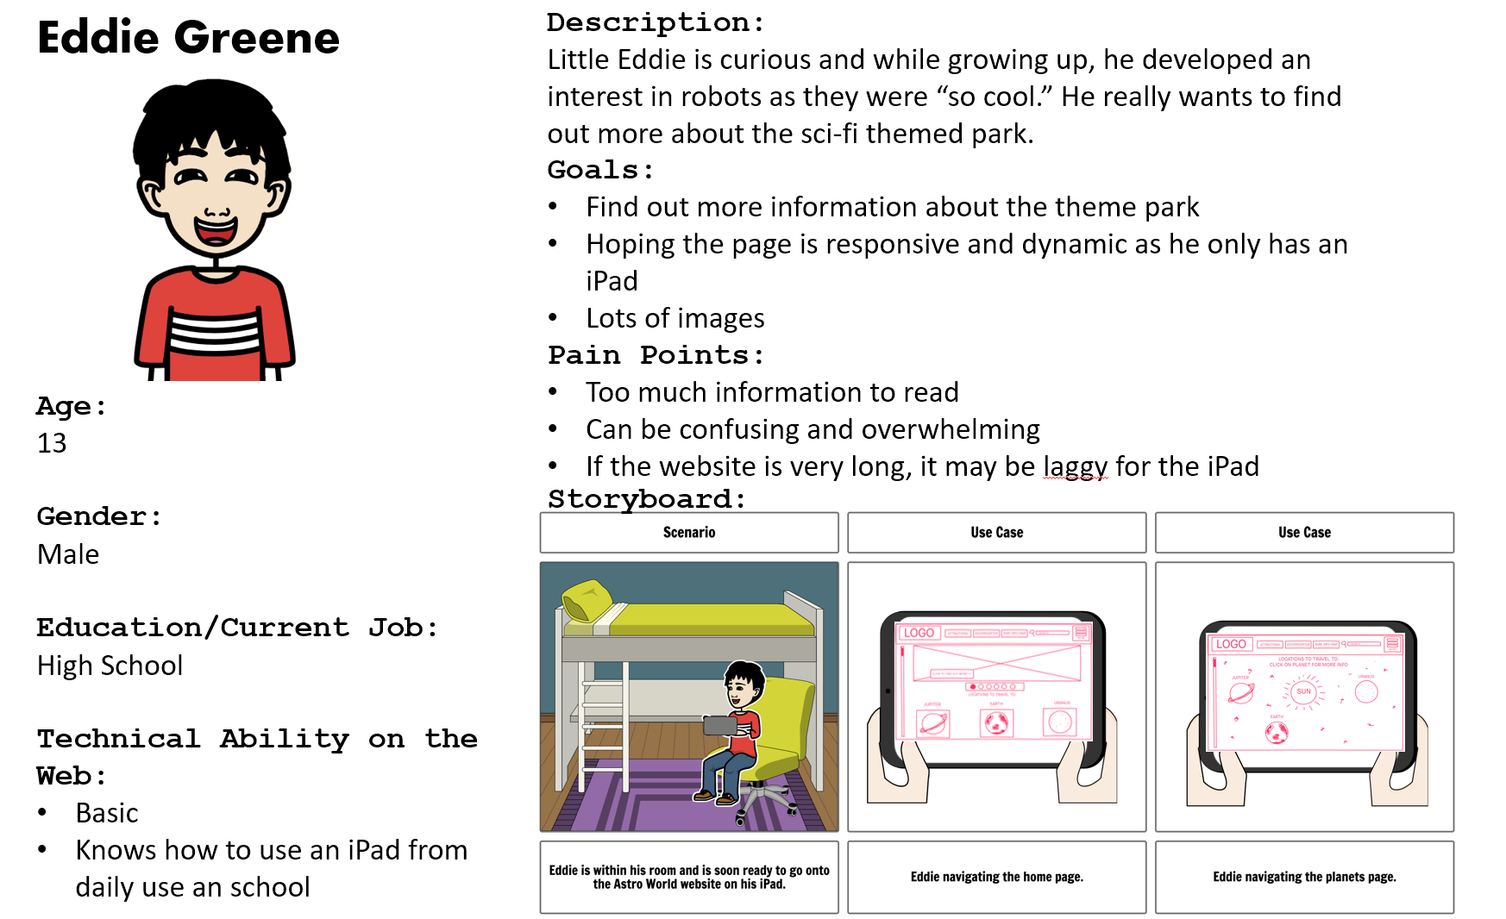
Figure 7: persona for Eddie Greene

In contrast to the first personas, ‘Eddie Greene’ is younger and much less experienced in using technology, however shared the same fascination and curiosity for Sci-Fi as the first persona. “Eddie” exemplifies a narrative of a typical child who gets easily distracted and does not like reading long paragraphs. As a result, purposeful images and diagrams are required to appeal to him.

Additionally, the website must be easy to useful, with clear and intuitive design to navigate through. In Eddie’s case, he would value ease of usability and aesthetics the most.

He would mostly likely use his tablet to view the website as he does not own a mobile phone, nor does he know how to use a computer. Therefore, considerations have to be made to ensure the resultant website is fluid and responsive to suit major media platforms.

Navigation & Organisation
Figure 8: https://www.pexels.com/photo/purple-night-sky-photo-544268

Card Sort User Test
The first stage of the website development is to investigate topics and content that may be included on the website. Card sorting is an effective method that can be used to sort ideas and content of websites into categories and shows its relevance. It involves testing users to sort cards that have key words representing the content of the website to view whether there is cohesion and if the content is appropriate.
There are two types of card sorting, open card sort where the user defines the categories him or herself, and closed card sort where the categories are already organised. An open card sort is preferred as there are no predetermined set of category names. Also, closed card sorting does not reveal how users conceptualise and view sets of content. It does not reveal how users naturally and instinctively use a website. Users will name each group themselves and if they are struggling, hints will be given to help them.
As part of the card sort, a user testing plan was generated. Users were asked to perform an open card sort, whereby the specific heading and topic of each category are unknown.

Card Sort Testing Plan (summarised):

These are the main contents that I believe should be on the theme park website.
Objects/content items (nouns) | Actions/tasks for users on the website (verbs)
Main Page/ Home Page (events) | View upcoming events
Navigation Bar | Leave reviews and recounts
Attractions | Book accommodation
Contacts (view location, phone etc) | Search for interests
Search Bar | Download and look at interactive map
Infographics | Contact the theme park via email or phone
Moving Images (slideshow) | View different type of attractions
Map | Sort attractions via type (rides, shows, food)
Cart
Accommodation
Park Information
Frequently used content and infrequently used content were also listed.
Frequently used content | Infrequently used content
Main Page/ Home Page (events) | Terms and conditions
Search Bar | Possible subscribe to mail
Attractions | Social media handles
Infographics/images | Contacts (search on google maps)
Map
Cart
Accommodation
Park Information

Task
Depending on how the card sort results are, if the user is able to accurately sort the cards, then it shows that my content is well structured and aligns with user expectations. If it does not, then it suggests that some content is unexpected or not relevant. I will ask the users why they assigned certain content in certain categories for feedback.
During the test, the users were asked to narrate their thoughts and when needed, ask questions to clarify. Afterwards, a series of questions were asked to the user for their feedback. A table summary of the card sort results is shown below and overall, the users were mostly able to sort the card as how I had designed them to be done.

Results:

User 1 | Categories
Feedback: | Accommodation | Attractions | Functionality
Content was value so categories were hard to find

Similar content such as leisure activities and attractions could be matched together although felt like they could be belong to different categories

Divided into 3 categories

User 2 | Categories
Feedback: | Functionality | Accommodation | Classification | Events | Rides
Some elements were difficult to understand properly and as a result misintepreted and placed in the wrong category

Overall, mostly clear and easy to work with

Divided into 5 categories

Following the card sort evaluation, user feedback proved to be beneficial in regard to some design decisions. This in hand, further enhanced the functionality and elements of the website. For example, content such as shopping/checkout were removed as users deemed them unnecessary and redundant. Feedback from the card sort was also used to add essential and missing elements such as booking ability. Additionally, verbal feedback from testers indicated that the terminology used for some content were confusing and difficult to understand; particularly if they were from an international country. As a result, ‘funhouse’ was removed within my final design. Similarly, vague terms that were not clear to users were removed to reduce confusion. This would be beneficial for young target audiences such as Eddie, whose persona was outlined above. Nevertheless, the most impactful feedback that was received from this evaluation method was the choice of categories. Where User 1 selected three categories, in comparison User 2 selected a total of 5 categories. A combination of both results was included in my final design with a total of three categories chosen. As seen in the card sort table results, both users selected ‘Attractions’ as a heading; as thus, this category was to be included. Following that, I combined the categories of ‘event’ and ‘rides’ from User 2 to be the final design heading ‘Attractions’, as chosen by User tester 1. The remaining content information was then summarised and placed within a new category ‘Park Info/Map’ within the final design of my website.

Navigation & Organisation Systems
For the website, a simple navigation system has been chosen as to help with accessibility and ease of use, as the design should be familiar to other typical websites and to the user.
When the website is viewed on a desktop or tablet, the menu will be a simple navigation bar on the top of the page. Featuring standard functionality such as a search bar and links
Example 1: Top Navigation Bar Menu (https://www.awwwards.com/)
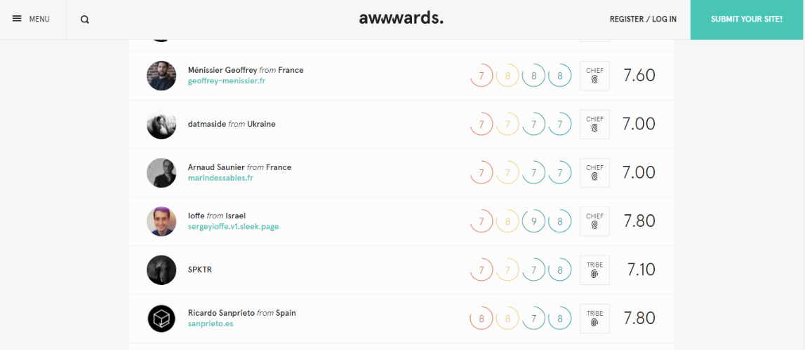
Figure 9: awwards home page
Additionally, to support mobile use when the screen size to decreased to the proportions of a phone, the navigation bar will disappear and instead be replaced a hamburger menu. When clicked, it will pop out all the navigation links. This is done as so either the nav bar does not take up space on a mobile and/or the nav links font size being too small to read.
Example 2: Hamburger Menu (https://martingarrix.com/)
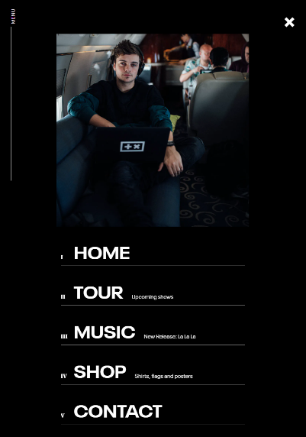
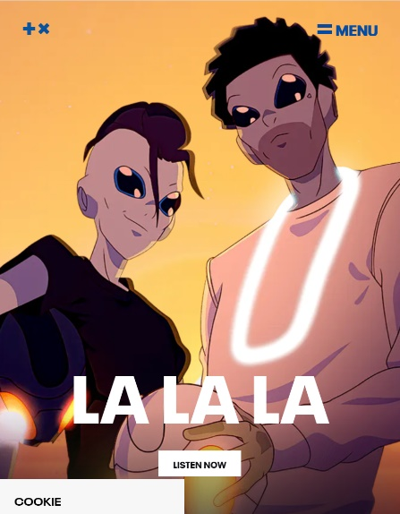
Figure 10: martingarrix home page

Site Map & Content Architecture
A site map and content architecture were generated to formally show the layout of the website.
Prototype Site Map:
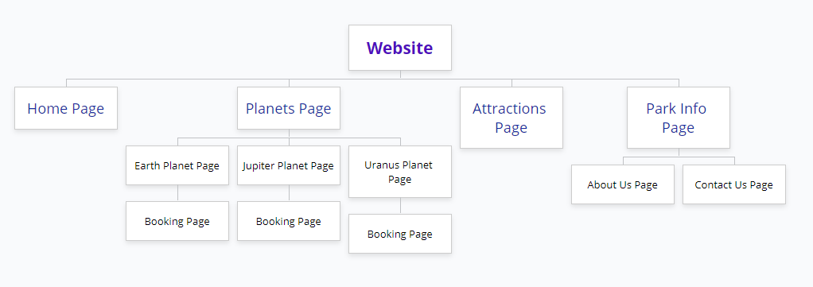
Figure 11: prototype site map
The home page and the attractions page are standalone and do not immediate have any children pages that it directly links to. The planets page shows all the different planets that guests can stay at. These include Earth, Jupiter and Uranus. Furthermore, customers can be directed to a booking page from the plant page that will allow them to reserve a date and make a booking. The Park info page will include two sub pages that link to the About Us Page and the Contact Us Page. Overall, the website is quite small, however I believe this is adequate given the scope of the website project.
Final website Site Map:
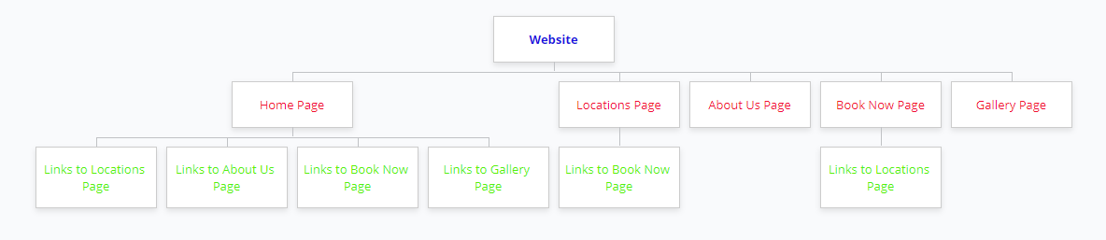
Figure 12: final site map
Through testing, it was discovered that instead of redirecting to different pages, users preferred if a pop up was displayed.

Paper Prototype User Test
The next part of the design process was to develop a paper prototype and to test it on users. Paper prototyping is a low cost however effective procedure used to test whether the website meets the target audiences’ expectations and need. To prepare for the paper prototype testing, 4 mockup web pages were created on Invision, which allows for interactivity and link to be added. As a result, users sent a link were able to directly use the paper prototype as how a normal website would be used
The paper prototype user test was conducted during the university had to go online lockdown due to a COVID-19 outbreak. The tutorial was done on a zoom session and Invision was much preferable over actual paper as it could be performed online.
A paper prototype was created for the user to see a general insight of the structure, organisation, flow, and functionality of the website. The user will be asked to complete a series of task on the website using the paper prototype. Through this testing plan it is hoped the feedback received from the user will give insight on how the usability of the website can be improved.
Testing Plan (summarised):
Tasks | Description, Observation and Feedback
Go to the accommodation page/locations to travel page: | There are two ways of completing the task. It is hoped that the user will either click the accommodation tag in the navigation bar or click on one of the planets in on the home page. This will take the user to another page depending on which method the user tool. While the users completed the task, it is observed that users knew straight away to click on the planets. It is noted that instead of clicking from the home page, users are more inclined to click the ‘accommodation tag’ in the navigation bar.
Find where you can search for something on the website? | It is hoped the user clicks on the search bar located on the top right-hand corner. It is observed that all users knew straight away where to search for something on the website.
Find where you can find more information/links navigation on the website? | It is hoped the user finds the side bar, by clicking the more button located on the top-left hand corner. It is observed that most users could intuitively click on the more buttons. This results in a larger navigation bar to appear however users have stated that the additional navigation links are unnecessary.
Find how to book accommodation at a planet? | It is hoped the user will navigate to the accommodation page, click on the appropriate planet, and then click the book button. It is observed that most users knew how to book accommodation after some time, however one user struggled with their attempt as they did not click on a planet, and instead assumed booking would be done directly on the accommodation page. Overall, the booking system can be revised and improved.
What are the methods to return back to the home page? | To get back to the home page, it was tested whether users were able to click the logo on the top left of the page to return.  Although there was no explicit sign saying “index” or “home”, all users were able to intuitively click the logo on the navigation bar.

Screenshots of the paper prototype:
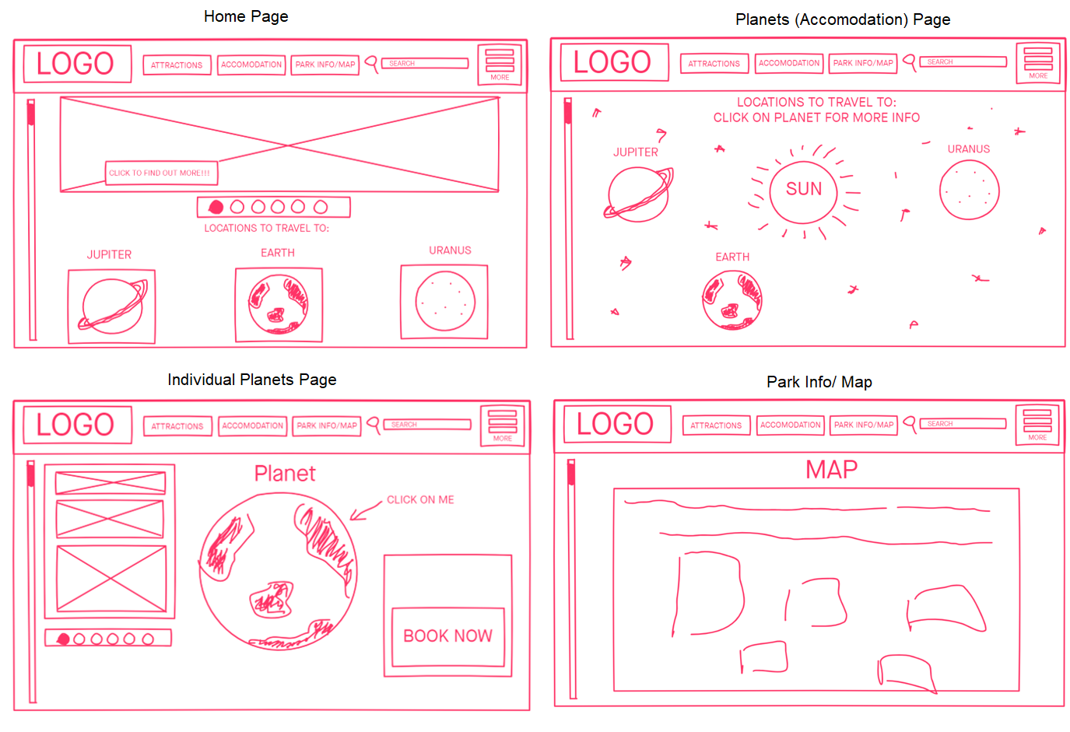
Overall, all users were able to complete the tasks successfully and with ease. The design implications of the paper prototype were substantial and greatly shaped the future iterations of the website. Most of the layout and functionality on this paper prototype received positive feedback and will be incorporated in the final website implementation. Most users liked the clickable solar system map showcasing the different planet, as it is a good example of interactivity and responsiveness as the map changes size depending on the size of the media.
The paper prototype pages included a vertical sliding bar on the left-hand slide used to scroll vertically. I incorporated this in originally as I thought it would be unique and distinct from another website and improve user experience. However, most users stated that it be removed as it does not follow typical website layout, resultantly affecting ease of use and accessibility. Another takeaway from the test was the hamburger menu. Users critiqued that the icon should only appear when the screen is decreased in size to a mobile view, where it is necessary for a hamburger menu as the navigation would not fit otherwise.

Visual Organisation & Interactivity
Various notes were taken from the Visual Organisation Table Discussion. I learnt that it is vital for web pages to be consistent in layout. For example, when updating the style of the website, make sure that it is applied to all the web pages otherwise it will severely affect the appeal and professionalism of the site. Also discussed was using links with meaningful names, and to use separate dropdown tab to link related topics, instead of listing all the links together and being unorganised. Additionally, the website needs to be responsive to different screen sizes so in addition to a desktop view, a mobile view must also be considered.
The new wireframes and layout have been changed accordingly to the feedback received in the paper prototype testing stage. Annotations have been included to help explain the content of the website.
Final Layout of Pages:
Home Page:
Desktop/Tablet View | Mobile View
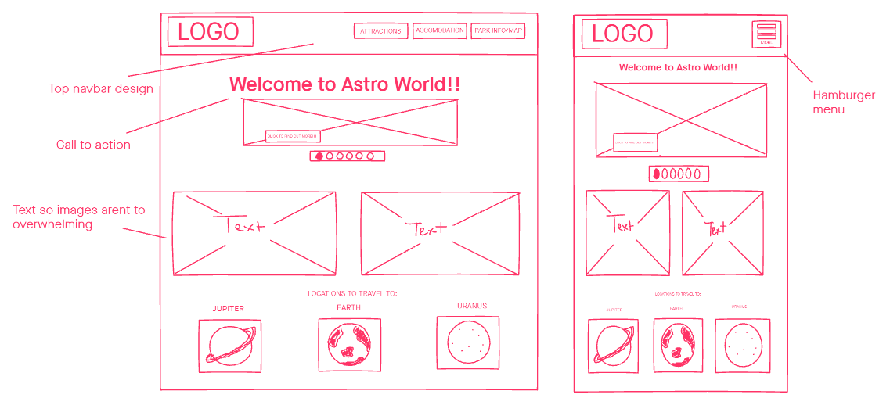

Individual Planet Page:
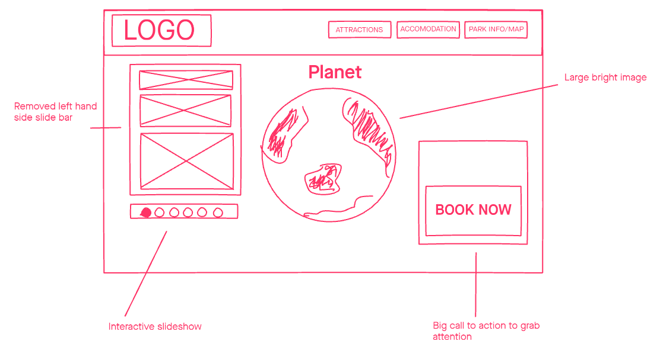
Planets (Accommodation) Page:
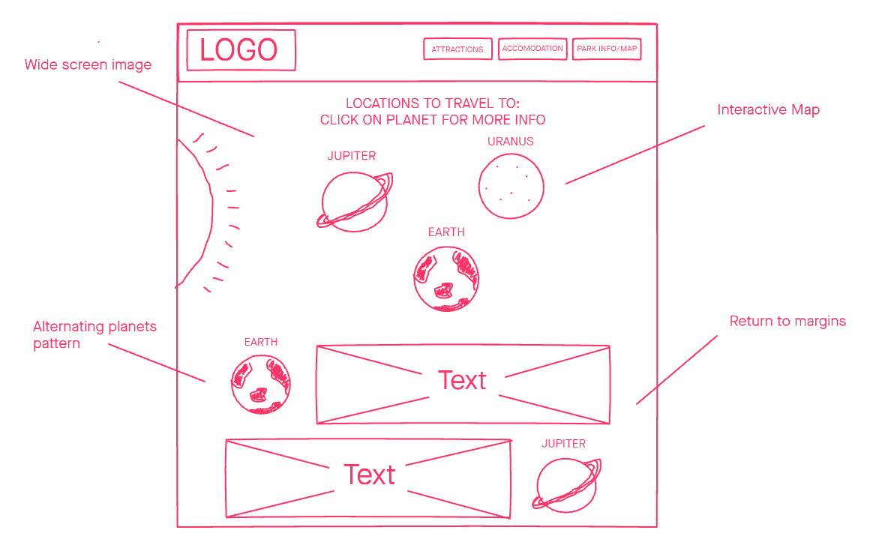
Each page features large and bright images to draw in the user’s attention pleasingly and aesthetically. In terms of interactivity, the user will be able to click on the planets on the ‘Planets (Accommodation) Page’ that will send them to the resultant specific planets page. When in mobile view, the link will disappear, and the navigation bar will collapse into a hamburger icon that can be clicked to expand to show all the link. This adds interactivity and allows so the navigation is still accessible while the screen is small.

Part B

Aesthetics

Aesthetic Prototype User Test
With the feedback attained from the paper prototyping adequate and as well as knowledge gained from the lectures and research onto the website topic, it is now adequate to develop visual aesthetics for the website. Invision was used again to overlay images and colour over the paper prototype.
An aesthetics prototype has been created to illustrate the possible look and aesthetics of the website. The aesthetics prototype uses the layout of the previously created paper prototype as the foundation. Images, texts, and layout has been placed on top of the pre-existing elements in the low fidelity paper prototype as to create a low-mid fidelity aesthetic prototype.
Likewise, with the other user tests, I had to develop a testing plan for the aesthetic prototype user test that was used to evaluate and get feedback from the testers. Unlike other user tests, no tasks are given to the user and the tester is just required to critique the appearance of the website and how they feel about it. Subsequently, they will answer question that I had prepared.

Testing plan (summarised):
The aim of the aesthetic prototype is to test the visuals of the website and to get quality feedback from others. This feedback will be used to improve and enhance the website.
The user will give feedback on the view of the website, including the fonts, colours, layout. This in turn will be acted on to improve the website.
Instructions:
- Let the user look through the mock-up pages of the website without any external input from the creator
- Let the user narrate through their critique and their first opinions of the website
- Importantly, ask the user for what they think the strength and more importantly the weaknesses of the website is in terms of aesthetics
- Ask the user what could be improved and what could be added or modified to the current setup as to improve the work
- Answer any questions that the user has
- Finally ask questions to the user about the website
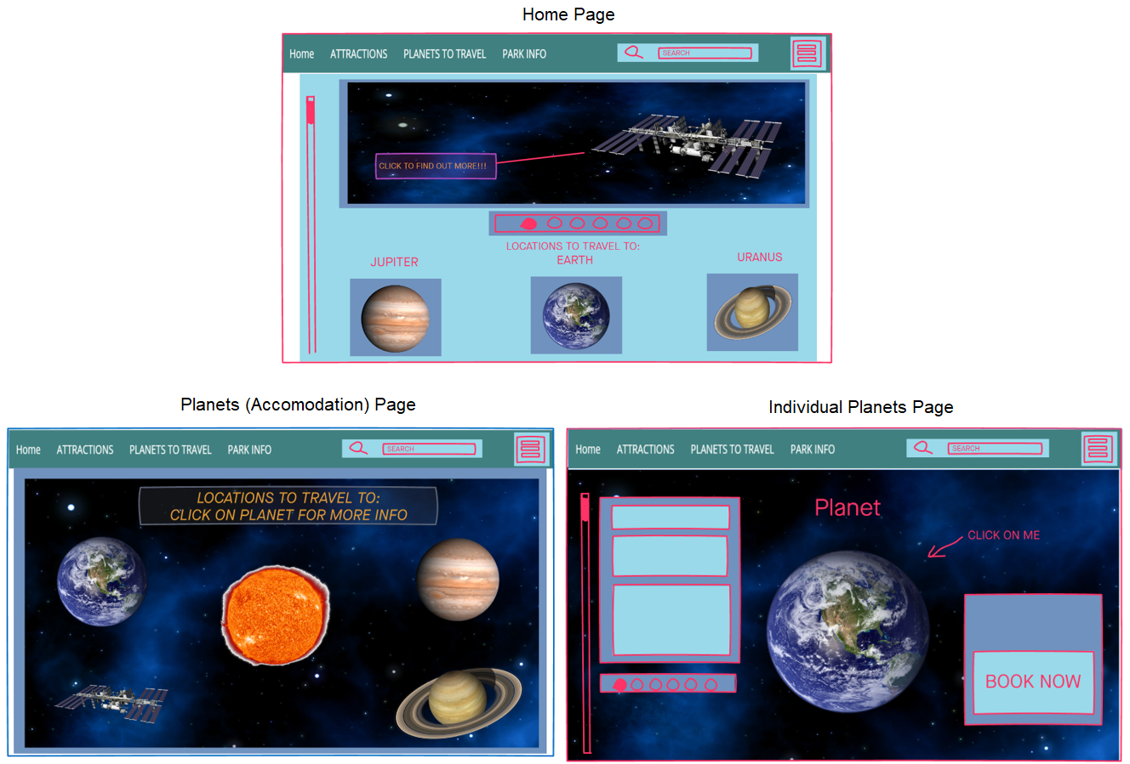
Screenshot of the aesthetic prototype are pasted below.

Question | Response and Feedback
Overall, what is your opinion of the look of the website? | Colours clashing, not matching and no evident colour scheme. Mostly impactful was poor colour choice, makes the website look very not cohesive.  Choice of outline is poor.
Does the aesthetic match the theme of the website? (Space related) | To an extent. Does have space background, however, causes difficulty in choosing other colours. Red for buttons is not really space, red is more really a colour associated with anger, love, passion etc.  Not neutral, however images are reflected in the theme.
Does the website look how you expect it to look? | Scroll bar on left, should be on the right
What do you dislike about the looks of the website? | Cohesion of the colour scheme
Is there anything that can be done to improve the look of the website? | Cohesive colour, get rid of harsh outlining colours

Overall, the aesthetics of the website was evaluated as quite poor and inadequate. I had expected this outcome, after I had completed creating the aesthetic prototype. Although I had considered and done research on elements of aesthetics and colour theory, I had executed the implementation quite badly however I needed feedback as to what do to improve. This reflects my design skills as a developer and is one of the main reasons I chose to commence this course to improve my prowess.

Most testers did not find the website attractive and from the feedback, it is evident that I need to fully reconsider my choices of colours for further iterations. Firstly, although the space background is relevant to the website topic, the bright blue and black emphasis is difficult to work with as I am restricted with only placing bright images and objects to create proper contrast.
Invision was used to create the prototype but it does not feature the ability to change fonts and other layouts so typography was affect and cannot be satisfactorily assessed.

Style Guide
Building on the feedback from the aesthetic prototype testing, the look of the website has been revised while maintaining the same layout and functionality.

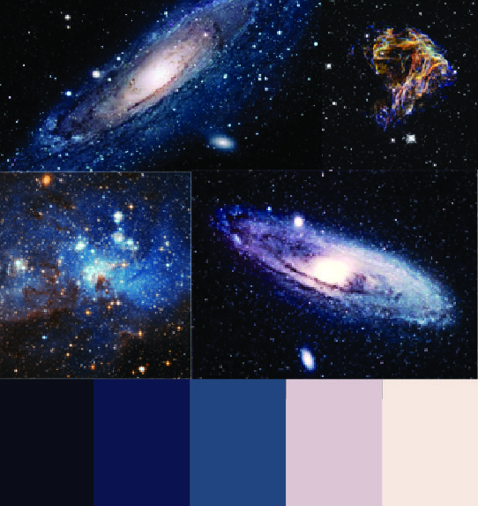
It has to be noted that aesthetic is an opinion based evaluable so it is impossible to achieve perfect aesthetic that will be pleasing to everything.
Figure 13: colour palette for space theme

Additionally, I personally suffer from moderate to high red-green colour blindness (protanopia). As a result, it is sometime difficult for me fairly review aesthetics as it will usually look significantly different from what others see. Moreover, working with especially red is tedious, as I can generally not tell the distinction between shades of red.

According to the U.S. National Library of Medicine, approximately 5% of the world’s population has some form of colour blindness, with 99% of the population having a form of red-green disorder. Therefore, consideration should be taken to use a colour-blind friendly palette. Following colour theory, colours used should avoid the use of rainbow spectrums and an appropriate palette to use would be a scale of blues as blue colour-blindness is sufficiently rarer.

I have attempted to use space themed colours to match my website topic of Sci Fi space. As a result, my website mainly consists of white, contrasted with dark blue and purple accents and this is the palette that I have chosen for the website.

In the Aesthetics Table Discussion was conducted like any of the other table discussions. The presenter would demonstrate a website with poor aesthetics and contrast it with a website that had excellent aesthetics. Aesthetic does not just refer to the visual appearance of the website, but also the aesthetics of use, the experience of using the website. It is a crucial part of a website and can affect the credibility and perception a user may have. Aesthetic plays a huge role and encompasses all the content and layout of the website, including buttons, images, sections, font, and most substantially colour. Therefore, it is important for me to test my website design with others to evaluate my website’s look and appearance.
An original logo was designed for the theme park, Astro World. This adds a unique feeling to the website

Home Page
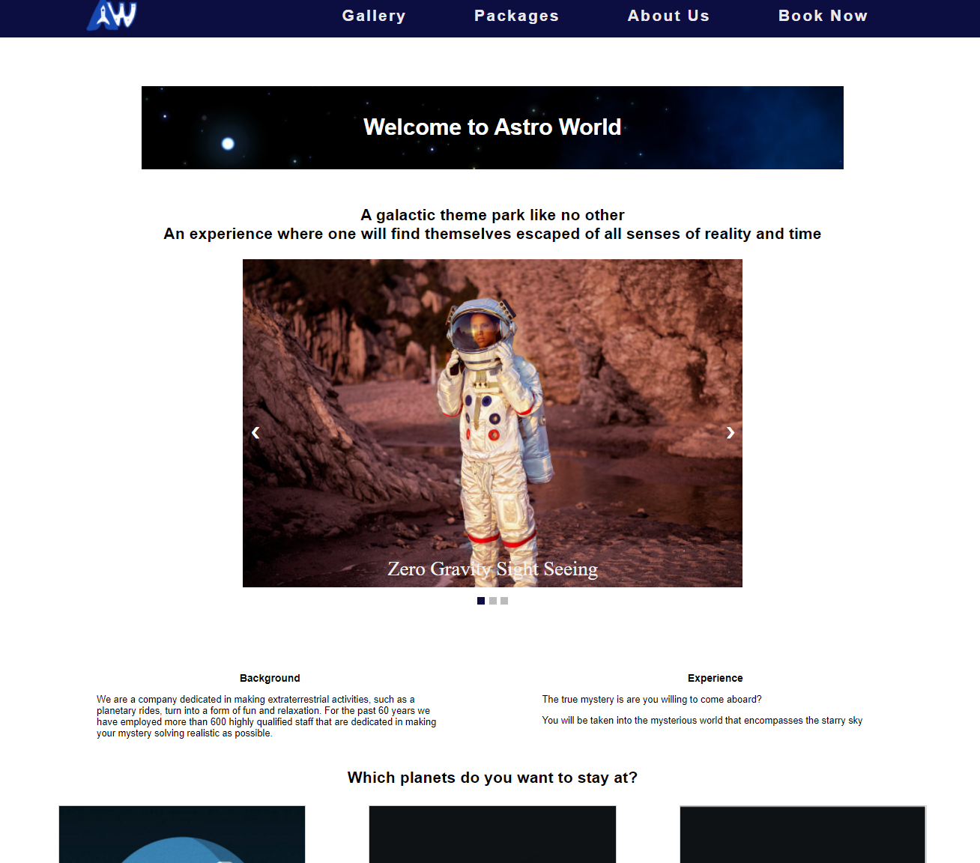
Call to action.
Impactful images to draw use attention.
Navigation link changes when on current page.
Standard font Helvetica Ariel size 1.2em
Bold and larger text used to differentiate header.
Packages Page
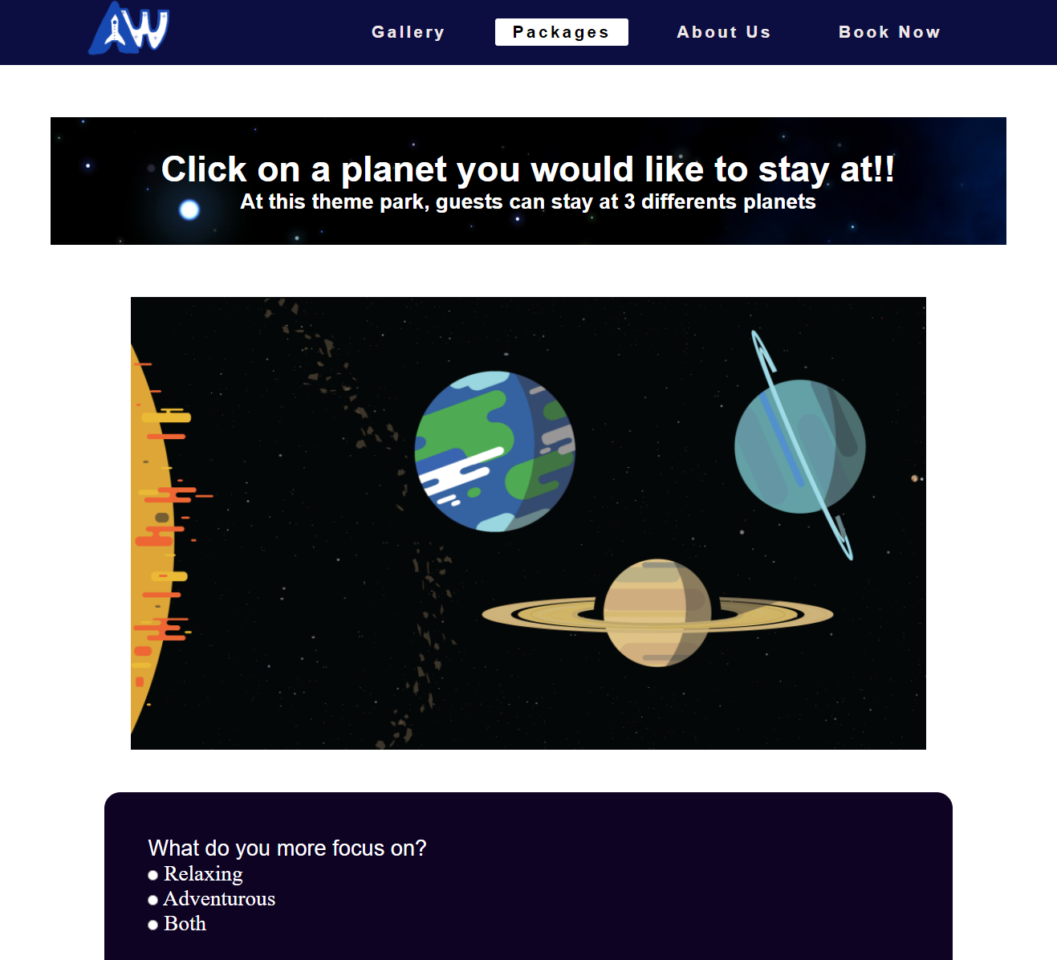
Dark blue and purple theme evokes feelings of stability. Linking it with the theme of space.
Colour same as navigation bar to maintain consistency.
Cursor changes to clickable and planet enlarges on hover.
Original logo for the theme park (Astro World).

Book Now Page
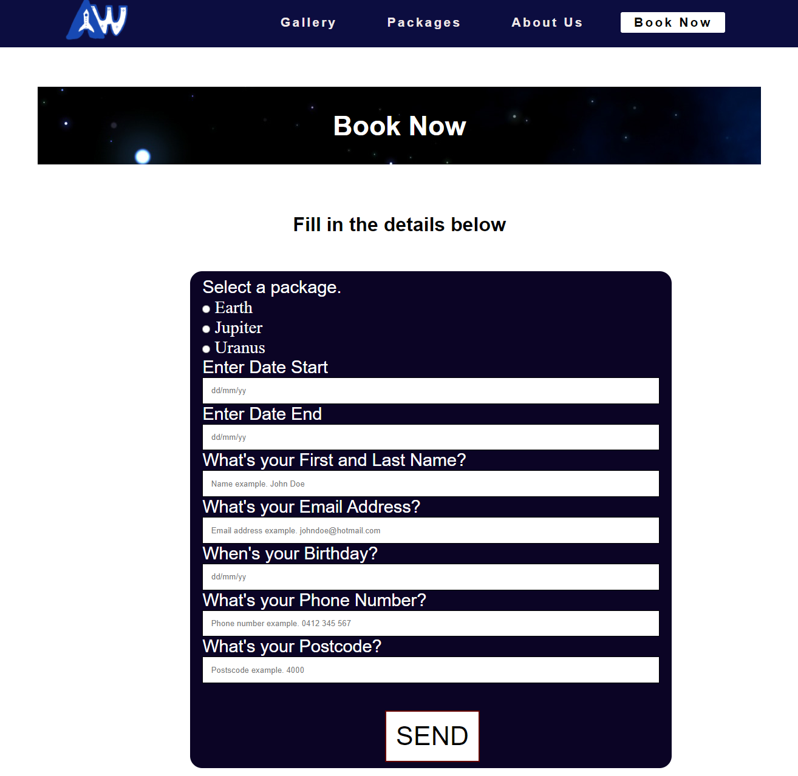
Changes colour and enlarges on hover.
Significant white space to represent the emptiness of space, relating to the website topic.
Image background for page header.

Functionality

Hi-Fi Prototype User Test
The final user testing required as part of the design process is the high-fidelity prototype user test. A hi-fi prototype was created for the user to see the mostly complete general insight of the structure, organisation, flow, and functionality of the website. The prototype created is similar to the mock ups produced for the Style Guide, though functionality is coded in for supplementary and added features.
Testing Plan (summarised):
The user will be asked to complete a series of task on the website using the high-fidelity prototype. Through this testing plan it is hoped the feedback received from the user will give insight on how the usability of the website can be improved.
Screenshots of website:

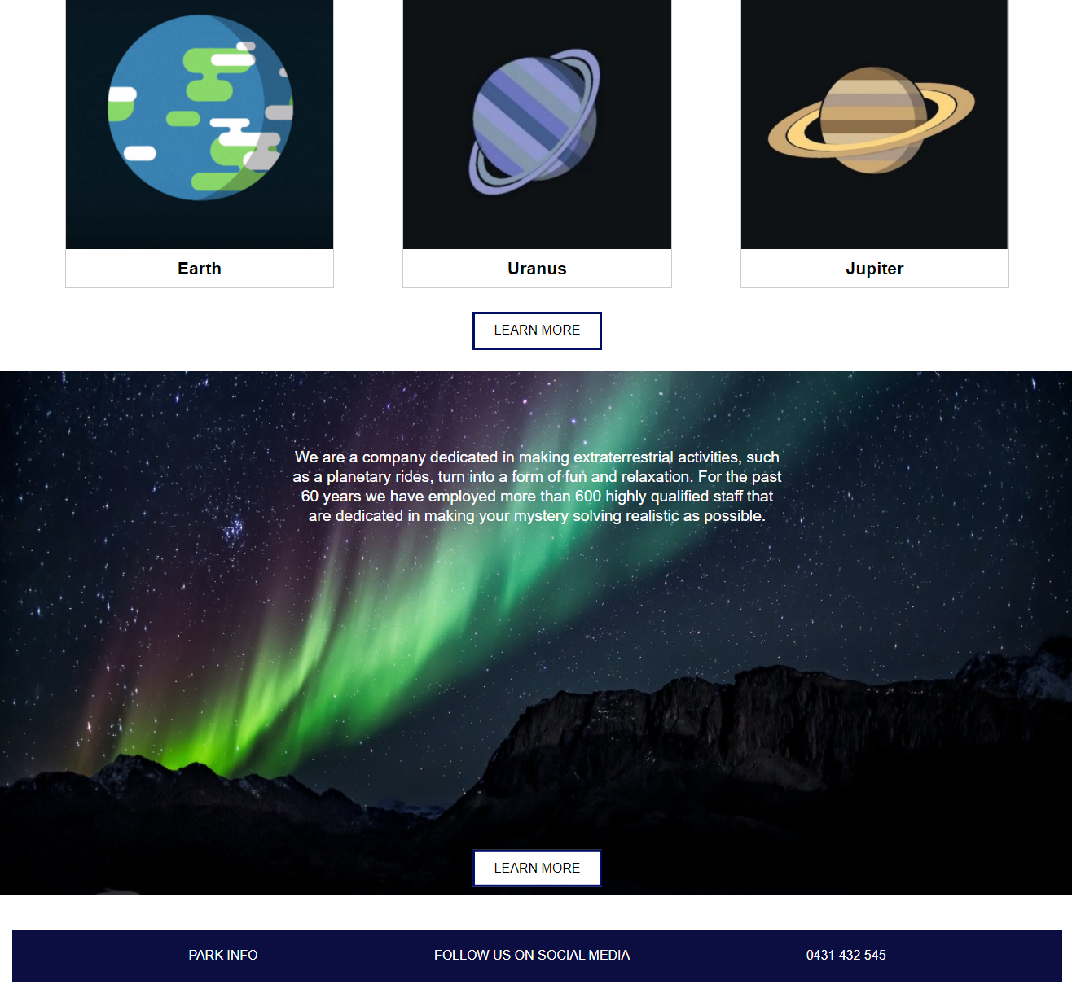
Home Page
Image slideshow to cycles through the experiences.
Button changes colour and enlarges on hover.
Clickable image link that directs to the respective planet section on another page.
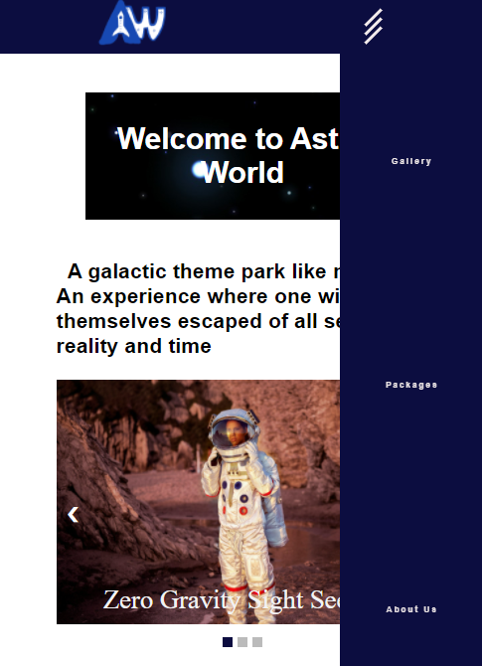
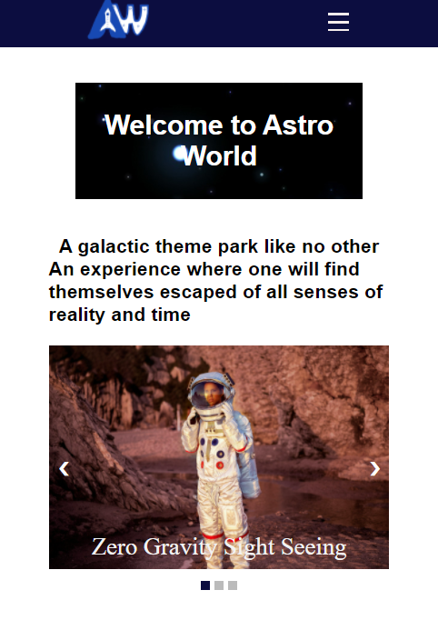
Mobile View of Home Page
When clicked, all the stripes of the icon will fluidly rotate to demonstrate animation.
When in mobile view, navigation link disappears, and hamburger menu icon appears.
Book Now Page
JavaScript form validator will display error if there are empty field, otherwise it will alert the user that they have successfully submitted.

Packages Page
Imaged mapped to clicking on planets will redirect to the specific planets section below.
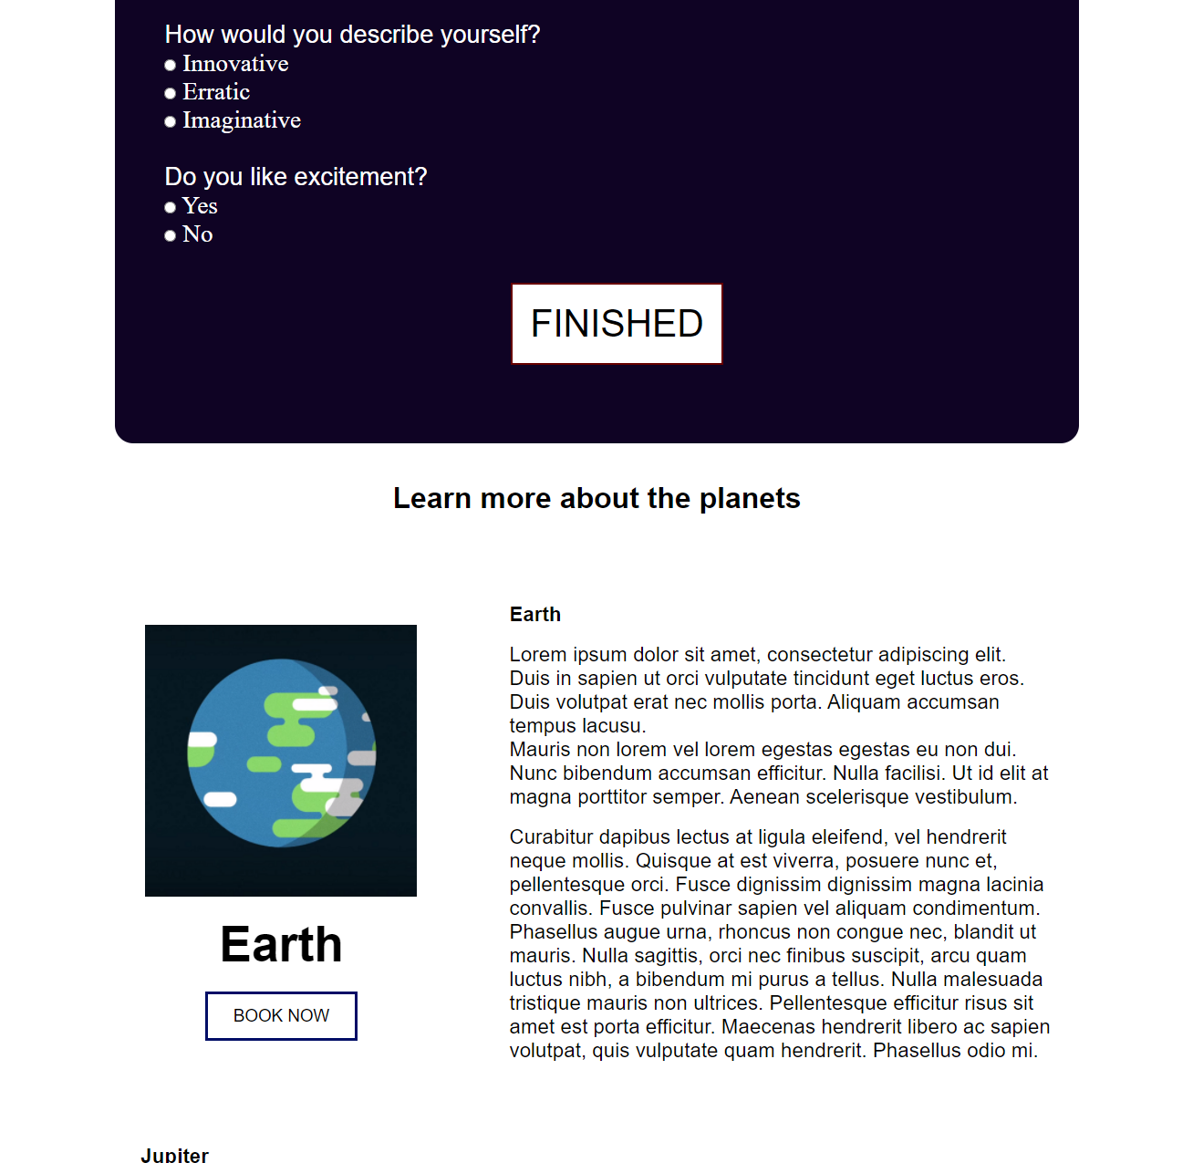
Form survey created that depending on what users select, will recommend a planet to travel to.
Form survey created that depending on what users select, will recommend a planet to travel to.

Task | Response and Feedback
Go to the accommodation page/locations to travel page: | User had to guess where to go, however, knew it would be in the heading, heading was in intuitive location.  The packages heading is vaguely named. User thought it meant live delivery post packages -> more suited to have heading such as location as it is where we want to travel to
Find and book a package (additionally try leaving the fields blank)? | Font family inconsistent in the form, not cohesive  A reset button would be nice to include for the form.  Booking successful confirmation is small, preferably it should be larger and centre of the screen, or change to new screen saying, ‘booking confirmed’.  After booking confirmation, no directive to do something after, such as direction to go back home or continue to browse.
Use the survey to find a suitable package for them? | Similar feedback to previous.  Font family inconsistent in the form, not cohesive  A reset button would be nice to include for the form.
Navigate to the different packages via the index/home page? | Intuitive, relatively easy

Users generally found no large faults with the website and the whole experience was mostly deemed enjoyable. Additional feedback included that user noticed that the background in the header banner was disrupted due to repeating background implementation, causing it to look unprofessional. Also observed was that text was placeholder Latin which I will replace will real text for the final edition of the website. Visually, most users found the colour flow to be aesthetic and thought it fit the space theme well. The book now forms, and recommendation survey form used to suggest a package, were given very positive reviews and all users thought it was a quality implementation. Overall, these results are pleasing to achieve as the indicate that the website is satisfactory.

Technical Implementation
Interactions | HTML, CSS, JavaScript | Meaningfulness and Implementation
When screen size is adjusted to mobile view, the navigation links will be replaced with hamburger menu icon that displays the links. The hamburger menu icon is animated and will rotate when clicked on | HTML, CSS and JavaScript | This is a meaningful interaction as it manipulates the presentation in response to the user changing screen size and is related to the dynamic navigation inside a page.  HTML is used to create the navigation bar and add the content of the links, CSS is used using @media and other styling to cause the website to change when the max width of the website is decreased to mobile view size. Also, the amination of the hamburger menu icon is done using keyframes and transitions.  Finally, JavaScript is used to add an event handler to the hamburger menu icon so clicking it will toggle between closing and open the side navigation bar.
The form in the ‘Book Now’ webpage is validated and will display an error message if any fields are empty, otherwise it will alert the user that they have successfully booked. | HTML, CSS and JavaScript | This is a meaningful interaction as it creates text and manipulates the elements of the HTML DOM to display an error message if the user has left any fields empty. Additionally, JavaScript is used to check whether all the field are empty or not.  HTML is used to create the form itself and CSS is used to make it visually appealing.
The recommendation survey in the ‘Packages’ webpage takes in user’s input and opinions to recommend a planet to travel to. | HTML, CSS and JavaScript | This is a meaningful interaction as it contributes to the user experience. It allows the user directly input their opinion, reduce stress of picking a location, increase ease of use and is overall engaging.  JavaScript is used by assigning each option of the survey a number, and then using maths to calculate what would be the ideal location for the user to go. The image of the recommended planet will also be displayed, and as well as the text using Java Script. If the fields are empty when submitting the form, the user will also be notified of this.
On the ‘Packages’ webpage, clicking on a planet on the solar system interactive map will redirect the user to the specific planet, regardless of screen size. | HTML, CSS and JavaScript | This is a meaningful interaction as it affects the dynamic navigation inside a page and contribute to user engagement will allowing the user to navigate using the map instead of searching through the webpage otherwise.  A JavaScript plugin ‘Image Resizer’ is to dynamically and responsively change where the mapping is on the image depending on the size of the screen. As a result, the user will always be redirected to the right place. HTML was used to create and place the image and CSS was used to size the image.
Google Maps iframe to show location of where to find the theme park on Earth. | HTML, CSS, JavaScript | This is a meaningful interaction as it provides the user with information about where the theme park is located, and the user can interact with the map. Additionally, as it is an interactive Google Maps iframe, most users will already be use to using the map.  This is done using HTML iframe tag and JavaScript plugins.
On the ‘Home Page’ there is a slideshow that will cycle through the images when the arrows or the index is clicked | HTML, CSS, JavaScript | This is a meaningful interaction as it allows the user to view multiple relevant images of the without changing pages or scrolling for more.  HTML is used to place the images and have preloaded on the website while JavaScript is used to set the images to either display or hide. Event handlers are also used to track with the arrows or index buttons are clicked.
The navigation bar will be stuck to the top of the screen when scrolling down. | HTML, CSS, JavaScript | This is meaningful as it allows the user to access the navigation bar not matter how far the user as scrolled. As a result, the website will be easier to use, and user engagement will increase.  JavaScript is used to create a ‘Sticky’ nav bar that causes the navigation bar to stay in one position when scrolling
On the ‘Home Page’ the learn more buttons will change colours and enlarge on hover. On click, the ‘Learn More’ buttons will direct the user to respective webpage depending on which section the button was located in | HTML, CSS | This is meaningful as it provides user feedback and makes the website feel interactive and engaging. This is created by CSS on hover properties, and HTML <a> tags links.

To ensure the website is accessible, the alt tags for all the images and figures have been included with meaningful descriptions. Additionally, the website follows typical website format including well laid out navigation bar and semantics. Although the website was developed on Google Chrome, the website was also tested on Firefox and Edge and was fully functional.

Progressive enhancement is enforced as the website was created using only the most basic of web technologies (e.g. only HTML, CSS, JavaScript, and limited plugins). Subsequently the website should work regardless of what browser is being used. In terms of responsive design, the website was created using mobile view first approach, due to it being easier to scale to desktop view. Downscaling from desktop view to mobile view is more difficult so doing to will ensure the website functions correctly and look aesthetic regardless of the screen size. The content of the website follows the W3C (World Wide Consortium) guidelines for web accessibility. This includes the use of headings correctly to organise the structure of the website. As screen readers usually use the heading structures to navigate through the webpages of the site. For example, use of <h1> tags for main heading while the preceding <h2>,<h3>, etc… tags for lesser important content.

There was not much to learn from the Responsive Design, Accessibility and Progressive Enhancement Table Discussions as most of the content was already covered in the lectures. These were the main points that I took away from the Table Discussions:

- For accessibility, website content should be able to be understood by someone who completed secondary education.
- Tab, enter, shift should be able to be used to navigate through the website.
- Text should be able to be resized up to 200% without losing any content.
- Forms should be validated to ensure user types in correct fields (e.g., email address)
- Alt text for images and non-text

The one point I had to think differently about was how text be able to be resized up to 200% without losing any content because as I was designing my website, it never occurred to me how much a user may want to increase the size of the text and content. As an outcome, this was barely considered when developing the website.

Conclusion

Conclusion

In total, I feel like the website project has been a success. I personally believe I have achieved my goals for taking this course which was to improve my design skills and website coding prowess.
The amount of work and time I dedicated to participating in this course initially shocked me. From the participation marked practicals and tutorials to the late nights I spent polishing my prototype user tests, this course has taken the most time out of all my course. However, I am glad I decided to take this course as my developer skills and the way I think about the design process has fundamental changed in a positive manner. If given another chance, I would have tried to get more feedback on my website topic at the start to support in developing ideas.
The finished website resulted far better than I had expected that I could have created at the beginning of the course. As stated in the introduction, my learning strategy was to ensure that I am giving 100% of my effort and not being complacent. Thus, I attended every weekly tutorial and practical and watched the lectures. This learning strategy worked for me and if I had to chance to start again, I would try to get more feedback and constructive criticism from users test as that is one of the most.

References

Cyberpunk 2077 — from the creators of The Witcher 3: Wild Hunt. (2021). Retrieved 5 May 2021, from https://www.cyberpunk.net/au/en/

Awwwards - Website Awards - Best Web Design Trends. (2021). Retrieved 5 May 2021, from https://www.awwwards.com/

Martin Garrix | Official Website. (2021). Retrieved 5 May 2021, from https://martingarrix.com/

Conditions, G. (2020). Color vision deficiency: MedlinePlus Genetics. Retrieved 6 June 2021, from https://medlineplus.gov/genetics/condition/color-vision-deficiency/#statistics

Space Color Palettes. (2021). Retrieved 6 June 2021, from http://www.colorhunter.com/tag/space/1

