VLSI Internship – Task 2
Introduction to Verilog HDL and RTL Design of Basic Combinational Circuits
Student: Ajay Raja G
Branch: Electronics and Communication Engineering (ECE)

Objective
To design and simulate basic combinational circuits using Verilog HDL, verify their functionality using testbenches, and analyze the generated waveforms.

Design Logic
Implemented circuits:
- AND Gate
- OR Gate
- NAND Gate
- NOR Gate
- XOR Gate
- NOT Gate
- Half Adder
- Full Adder
Half Adder:
Sum = A ^ B
Carry = A & B
Full Adder:
Sum = A ^ B ^ Cin
Cout = (A & B) | (A & Cin) | (B & Cin)

Simulation Results

1. AND Gate
AND Gate was simulated using a Verilog testbench in EDA Playground. The waveform matches the expected truth table.
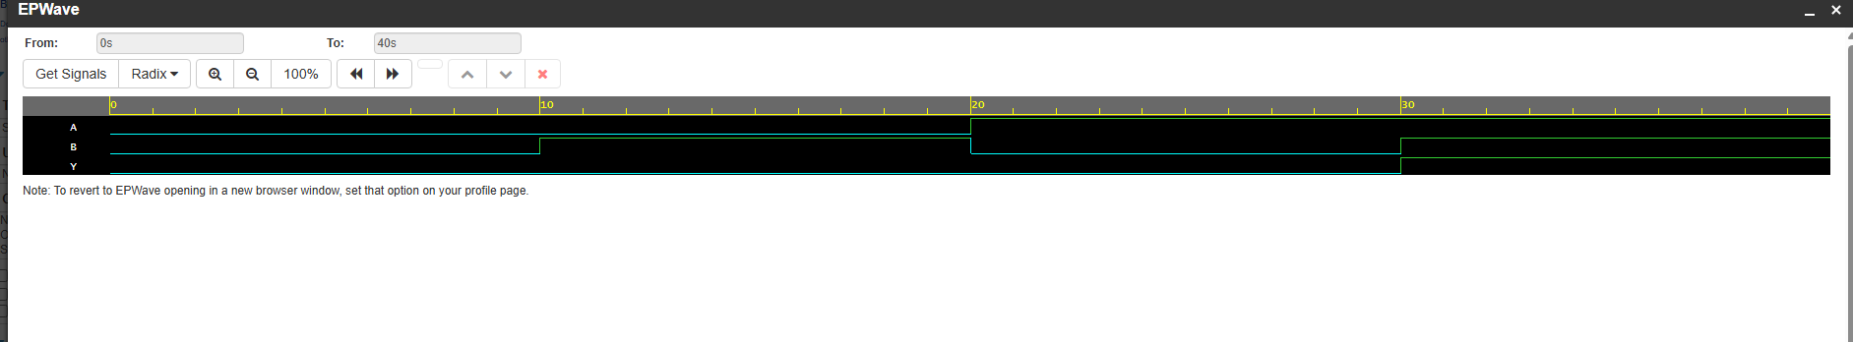
Figure 1: AND Gate Waveform

2. OR Gate
OR Gate was simulated using a Verilog testbench in EDA Playground. The waveform matches the expected truth table.
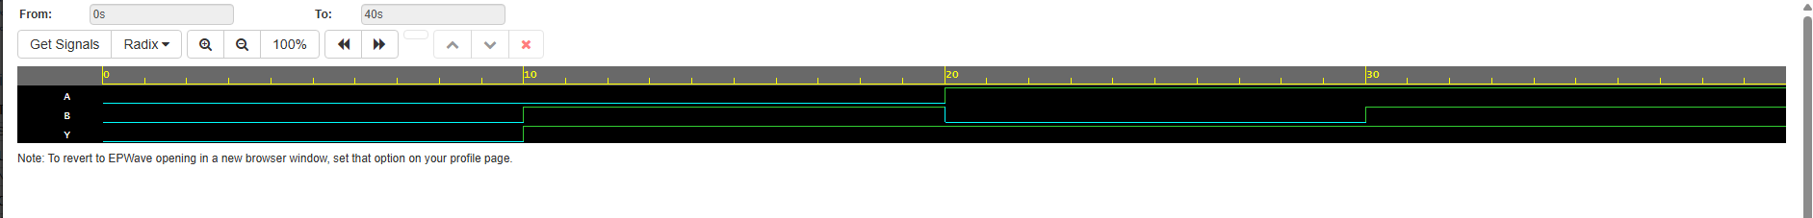
Figure 2: OR Gate Waveform

3. NAND Gate
NAND Gate was simulated using a Verilog testbench in EDA Playground. The waveform matches the expected truth table.
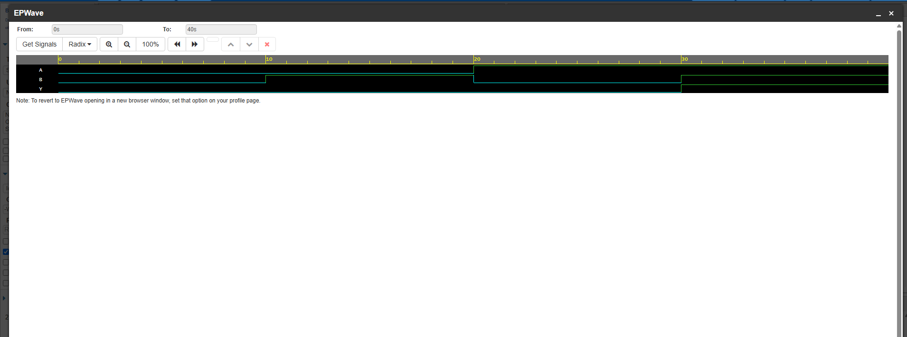
Figure 3: NAND Gate Waveform

4. NOR Gate
NOR Gate was simulated using a Verilog testbench in EDA Playground. The waveform matches the expected truth table.
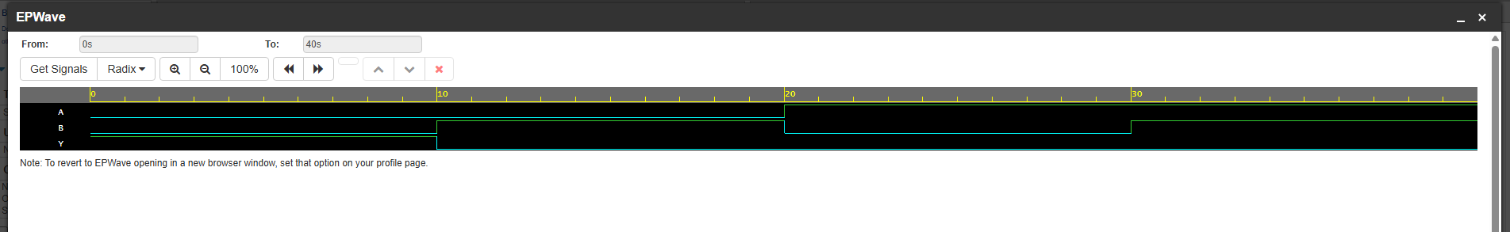
Figure 4: NOR Gate Waveform

5. XOR Gate
XOR Gate was simulated using a Verilog testbench in EDA Playground. The waveform matches the expected truth table.
Figure 5: XOR Gate Waveform

6. NOT Gate
NOT Gate was simulated using a Verilog testbench in EDA Playground. The waveform matches the expected truth table.
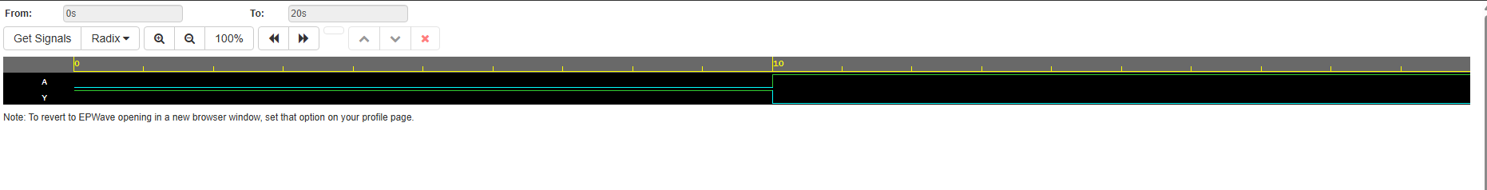
Figure 6: NOT Gate Waveform

7. Half Adder
Half Adder was simulated using a Verilog testbench in EDA Playground. The waveform matches the expected truth table.
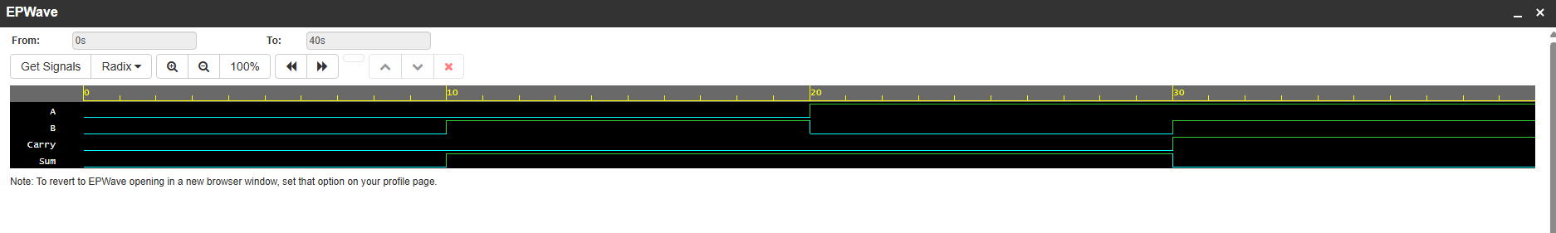
Figure 7: Half Adder Waveform

8. Full Adder
Full Adder was simulated using a Verilog testbench in EDA Playground. The waveform matches the expected truth table.
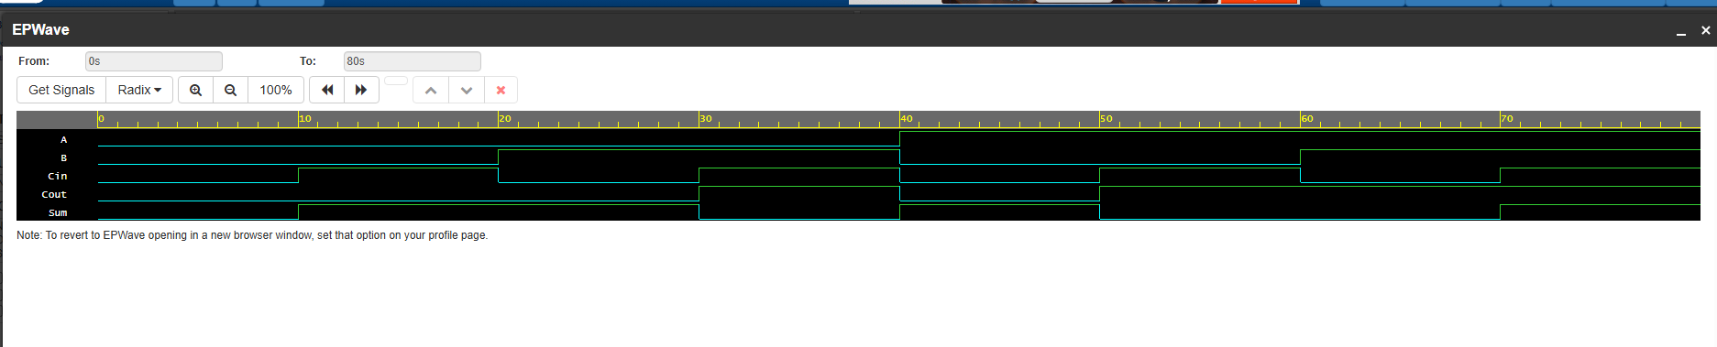
Figure 8: Full Adder Waveform

Conclusion
All required Verilog modules and testbenches were successfully implemented and verified through simulation. The observed waveforms match the expected outputs, confirming correct functionality.

