Given the following diagram and complete the following tasks:

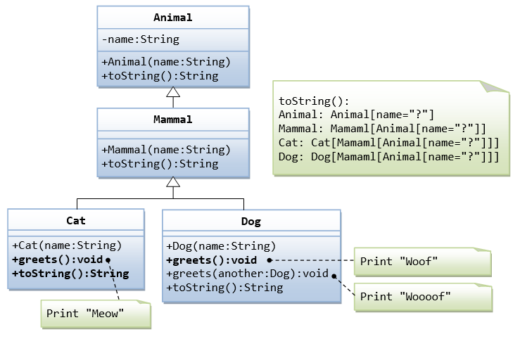

1. Write a base class called Animal, which contains:

* A member variable name (string).
* A constructor that initializes the name to the given values.
* A toString() method that returns "An animal with name of xxx".

1. Write a derived class of Animal called Mammal, which contains:

* No member variables.
* A constructor that initializes the name of base class to the given values.
* A toString() method that returns "A mammal, which is an animal with name of xxx".

1. Continuely write two derived classes of Mammal called Cat and Dog.

The Cat class contains:

* No member variables.
* A constructor that initializes the name of base class to the given values.
* A toString() method that returns "A cat, which is a mammal and an animal with name of xxx".
* A greets() method that print out "Meow".

The Dog class contains:

* No member variables.
* A constructor that initializes the name of base class to the given values.
* A toString() method that returns "A dog, which is a mammal and an animal with name of xxx".
* A greets() method that print out "Woof".
* A greets(const Dog& another) method that print out "Woooof".

1. Write a main program (in main_init.cpp) to test out methods in class Animal, Mammal, Cat and Dog.