Given the following diagram and complete the following tasks:

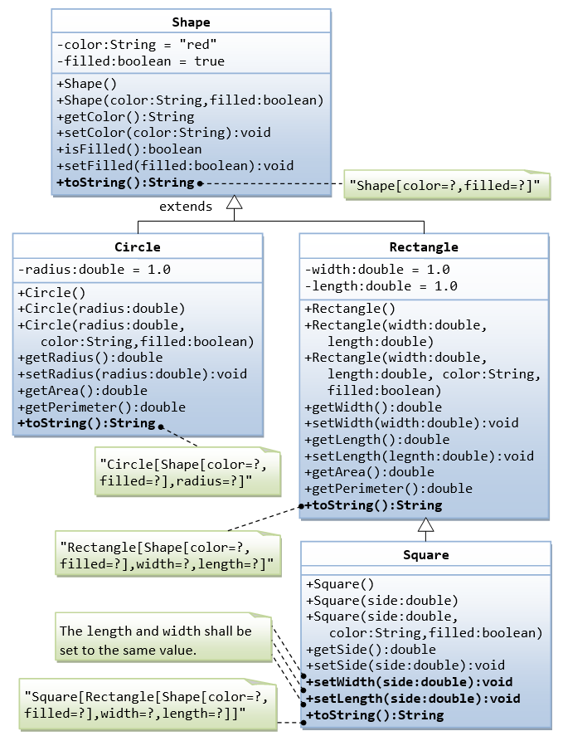

1. Write a base class called Shape, which contains:

* Two member variables color (string) and filled (bool).
* Two constructors: default constructor that initializes the color to "green" and filled to true, and a constructor that initializes the color and filled to the given values.
* Getter and setter for all the member variables. By convention, the getter for a boolean variable xxx is called isXXX() (instead of getXxx() for all the other types).
* A toString() method that returns "A Shape with color of xxx and filled/Not filled".

1. Write two derived classes of Shape called Circle and Rectangle.

The Circle class contains:

* An member variable radius (double).
* Three constructors:
  + - The default constructor initializes the radius to 1.0.
    - A constructor that initializes radius with given values.
    - A constructor that initializes radius, color and filled with given values.
* Getter and setter for the member variable radius.
* Methods getArea() and getPerimeter() which returns the area and perimeter of the circle.
* Override the toString() method inherited, to return "A Circle with radius=xxx, which is a derived class of yyy", where yyy is the output of the toString() method from the base class.

The Rectangle class contains:

* Two member variables width (double) and length (double).
* Three constructors:
  + - The default constructor initializes the width and length to 1.0.
    - A constructor that initializes width and length with given values.
    - A constructor that initializes width, length, color and filled with given values.
* Getter and setter for all the member variables.
* Methods getArea() and getPerimeter() which returns the area and perimeter of the rectangle.
* Override the toString() method inherited, to return "A Rectangle with width=xxx and length=zzz, which is a derived class of yyy", where yyy is the output of the toString() method from the base class.

1. Write a class called Square, as a derived class of Rectangle. Convince yourself that Square can be modeled as a derived class of Rectangle. Square has no member variable, but inherits the member variables width and length from its base class Rectangle.

* Provide the appropriate constructors (as shown in the class diagram). Hint:  
  Square(double side) : Rectangle(side, side) {};
* Override the toString() method to return "A Square with side=xxx, which is a derived class of yyy", where yyy is the output of the toString() method from the base class.
* Do you need to override the getArea() and getPerimeter()? Try them out.
* Override the setLength() and setWidth() to change both the width and length, so as to maintain the square geometry.

1. Write a test program to test all the methods defined in Shape, Circle, Rectangle, Square.