

$ make menuconfig

1



$ make freescale_imx28evk_defconfig

1

**make defconfig**

**make menuconfig**

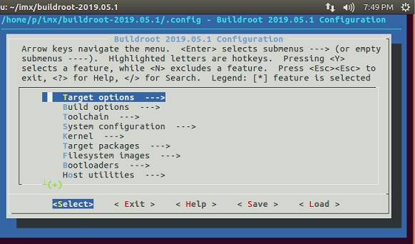

**Toolchain**

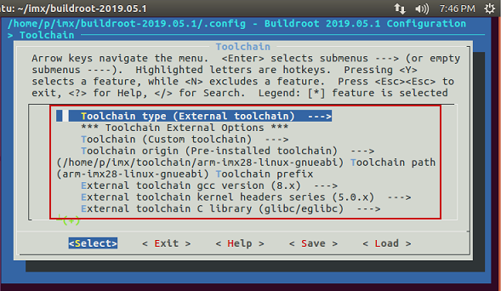

**System configuration**

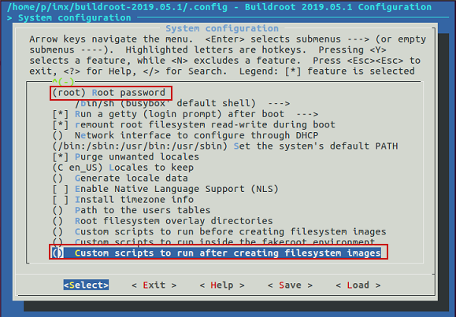

**Kernel**

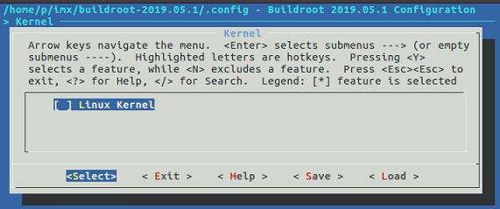

**Bootloaders**

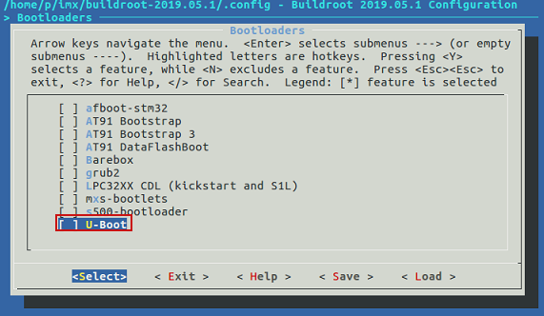

**Filesystem images**

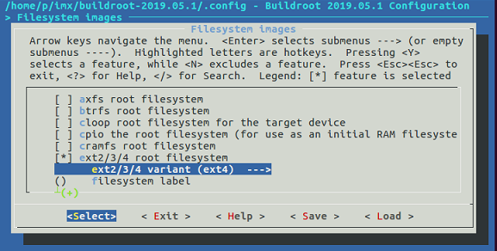



$ make

1