*MyFeedback* Project Definition

# Information

|  |  |
| --- | --- |
| School | Drexel University FA22 Q2 “Winter” |
| Class | SE420 “FOSS Engineering” |
| Instructor | [Gregory Hislop](mailto:hislop@drexel.edu) |
| Students | [Peter Mangelsdorf](mailto:pjm349@drexel.edu) (Organizer, Users, Stakeholders) |
| [Hoang Nguyen](mailto:hn374@drexel.edu) (Diagrams) |
| [Jay Patel](mailto:jp3592@drexel.edu) (Epics) |
| [Charles Porter](mailto:cap399@drexel.edu) (Epics) |
| [Eric Savoy](mailto:ets43@drexel.edu) (Description, Questions, Names) |
| Due | 2022-01-15 |
| Team | Blue |
| Assignment | A2 (Group) Project Definition |

# Contents

Information 1

Contents 1

Overview 2

Stakeholders 2

Students 3

Instructors 3

Institution Administrators 3

Government Officials 3

Institution IT Departments 4

Users 4

Students 4

Instructors 4

Data Scientists 4

Institution Administrators 5

System Maintainers 5

Epics 5

Epic 1: Gathering Student Sentiments 5

Epic 2: Generating Reports 6

Epic 3: Give Feedback 6

Epic 4: View Student Feedback from Other Courses 6

Epic 5: View which courses are performing well/poorly 7

Epic 6: Maintain System 7

Epic 7: Manage Roles 8

Epic 8: Receive/Remove Student Data 8

Epic 9: Communication Channels 8

Diagrams 9

Diagram 1: Basic Interactions 9

Questions 10

Who should be able to see the data? 10

What external services, tools, or platforms should this work with? 11

What data protection policies should be obeyed? 11

What data assurance and introspection systems need to be in place? 11

Who will maintain this project into the future? 11

If this is Intended for any Institution, Should Ease of Installation be a Feature? 11

How Complex Should Role Management Be? 12

How Sophisticated Should Evaluation Creation be? 12

How Much Data Analysis Support is Sought? 12

Product Name Suggestions 12

Discussion 13

# Overview

*MyFeedback* is an institution-agnostic course evaluation platform. It improves the efficiency which an educational institution can collect feedback from students on their courses and take actions to improve them. The major stakeholders include students, instructors, administrators, government officials, and IT departments. The users include students, instructors, administrators, data scientists, and system maintainers. The major functions of the system will include gathering student sentiments, generating reports, giving feedback, viewing feedback, viewing which classes are doing particularly well or poorly, and maintaining the system.

# Stakeholders

## Students

|  |  |
| --- | --- |
| Description | * (Includes parents and scholarship-awarding-institutions) * (Also users of the system) |
| Relationships | * Depend on system to collect and report their sentiments |
| Authority | * If not satisfied with efficacy of system, may impose penalties |

## Instructors

|  |  |
| --- | --- |
| Description | * (Includes Teachers’ Unions and Associations) * (Also users of the system) |
| Relationships | * Depends on system to provide accurate, useful feedback on courses |
| Authority | * Chooses what to put in surveys, and to what extent to rely on the system (the system needs to be good enough to get buy-in) |

## Institution Administrators

|  |  |
| --- | --- |
| Description | * (Includes foundations and other funding associations) |
| Relationships | * Oversee project over long period of time |
| Authority | * Choose whether to fund the project or not |

## Government Officials

|  |  |
| --- | --- |
| Description | * FERPA, Title X, and other acts require federal and state authorities to ensure quality of education |
| Relationships | * Communicates with Institution Administrators at high level * Works with System Maintainers |
| Authority | * Can require institutions to comply with guidelines * Can forbid use of certain software or require extensive verification * Can strip institutions of qualitifications/certificates |

## Institution IT Departments

|  |  |
| --- | --- |
| Description | * Programmers and Technicians dedicated to one or more IT projects at an Institution * (Also users of the system) |
| Relationships | * Hires System Maintainers * Reports to Institution Administrators * Works with Government Officials to certify systems |
| Authority | * If system becomes too difficult to maintain, will have difficulty hiring new maintainers * Chooses how to adjust system for compliance |

# Users

## Students

|  |  |
| --- | --- |
| Description | * Typically 17-22 years of age maturing adults |
| Relationships | * Takes courses from Instructors and accrue opinions |
| Authority | * Ultimately choose whether or not to take a survey * Choose responses to a survey * Choose whether survey is understandable (accessibility) * Access to third-party social media to talk about surveys |

## Instructors

|  |  |
| --- | --- |
| Description | * Typically 30-60 years of age educated adults * Research/niche focused (may not be focused on psychology) |
| Relationship | * Give and Design courses for Students |
| Authority | * Design surveys for Students * Releases surveys to Students * Controls release method of surveys to Students * Read surveys/survey data |

## Data Scientists

|  |  |
| --- | --- |
| Description | * Typically 25-45 years of age educated adults * Maybe focused on other areas of institution |
| Relationships | * Oversee survey and question design * Communicate with Instructors regarding survey design * Prepare experiments and reports * Present reports to Administrators and Instructors |
| Authority | * Chooses which experiments to run * Chooses what reports to generate and present |

## Institution Administrators

|  |  |
| --- | --- |
| Description | * Typically 35-70 years of age educated adults * Maybe focused on other areas of institution |
| Relationships | * Receives reports from Data Scientists |
| Authority | * Chooses how many resources to allocate to course feedback * Chooses how to use feedback data at institutional level |

## System Maintainers

|  |  |
| --- | --- |
| Description | * Typically 25-55 years of age educated adults * Hired by institution to maintain their/shared feedback system * Can include Code Processing, Data Storage, Security, Documentation, User Interfaces |
| Relationships | * Changes architecture of system over time * Communicates to Data Scientists and Instructors what changes happen |
| Authority | * Choose which tools and technologies to use |

# Epics

## Epic 1: Gathering Student Sentiments

|  |  |
| --- | --- |
| Role | Teacher |
| Intent | Gather Student Sentiments |
| Reason | Improve course |
| Method | 1. Access *MyFeedback* for their institution 2. Generate a survey using survey building tools (allocates space in Storage) 3. Tag and document survey for longevity 4. Get review by psychologist/data scientist 5. Create issuing periods 6. Monitor and read feedback in real time |

## Epic 2: Generating Reports

|  |  |
| --- | --- |
| Role | Data Scientist |
| Intent | Generate New Reports |
| Reason | Improve Executive Decision making/Adjust for new theories |
| Method | 1. Access *MyFeedback* for their institution 2. Generate a new experiment (allocates space in Storage) 3. Use Jupyter Notebooks to design an experiment 4. Upload final experiment notebook to Storage 5. Schedule processing time/periods on External Service for experiment 6. Build report in Tableau |

## Epic 3: Give Feedback

|  |  |
| --- | --- |
| Role | Student |
| Intent | Express Sentiments |
| Reason | Express experiences/feedback to improve course. Air grievances, offer what went well, and what could be improved. |
| Method | 1. Access MyFeedback for their institution 2. Access the evaluations for a class they were in 3. Fill in evaluations and submit |

## Epic 4: View Student Feedback from Other Courses

|  |  |
| --- | --- |
| Role | Student |
| Intent | View student feedback from other courses |
| Reason | Allow students the option to view course feedback other students have written. Allows students to make an informed decision on which courses they wish to take. |
| Method | 1. Access *MyFeedback* for their institution 2. Ability to search all classes the institution offers 3. View individual student feedbacks for institution classes |

## Epic 5: View which courses are performing well/poorly

|  |  |
| --- | --- |
| Role | Institution Administrator |
| Intent | View which courses are performing well/poorly |
| Reason | To see quickly which classes are receiving positive student feedback and which classes are receiving negative student feedback. Analyze the health of classes to improve the state of the institution. |
| Method | 1. Access *MyFeedback* via an administrative portal 2. Run report on selected classes 3. View data on evaluations from students 4. Rank classes by best performing to worst performing |

## Epic 6: Maintain System

|  |  |
| --- | --- |
| Role | System Administration |
| Intent | Maintain System |
| Reason | Need an effective way to maintain course evaluation system (system updates, bug fixes, adding/removing system features) |
| Method | 1. Access *MyFeedback* via an administrative portal 2. Change elements of system through UI 3. Change elements of system from command line or terminal 4. Extensive documentation of system functions |

## Epic 7: Manage Roles

|  |  |
| --- | --- |
| Role | System Administrator |
| Intent | Manage system permissions/roles |
| Reason | Need an effective way to manage permissions/roles within a system. |
| Method | 1. Access *MyFeedback* via an administrative portal 2. View all users who are currently using the system 3. Access interface which allows the quick change of user roles 4. View report showing which users are linked to which roles and the number of users in each role |

## Epic 8: Receive/Remove Student Data

|  |  |
| --- | --- |
| Role | Student/ Government Official |
| Intent | Receive/Remove Student Data |
| Reason | As a student, I would like to see what data the institution has collected on me. I would also like a way to formally request certain data be removed. As a government official, I would like a way to view which data has been collected on students to ensure data privacy compliance. |
| Method | 1. Access *MyFeedback* for their institution 2. Access request form via a UI 3. Fill out form with identifying information, method for info retrieval, and which data to receive/remove. |

## Epic 9: Communication Channels

|  |  |
| --- | --- |
| Role | Everyone |
| Intent | Communicate Effectively |
| Reason | Improve team functions with rapid communication. As a user, I would like quick communication with other users of the system. |
| Method | 1. Access *MyFeedback* via an administrative portal 2. Access a sub feature with real time communication between members of the system 3. Quickly transfer documents such as quizzes/reports between users of the system 4. Send instant messages to users of the system |

# Diagrams

## Diagram 1: Basic Interactions



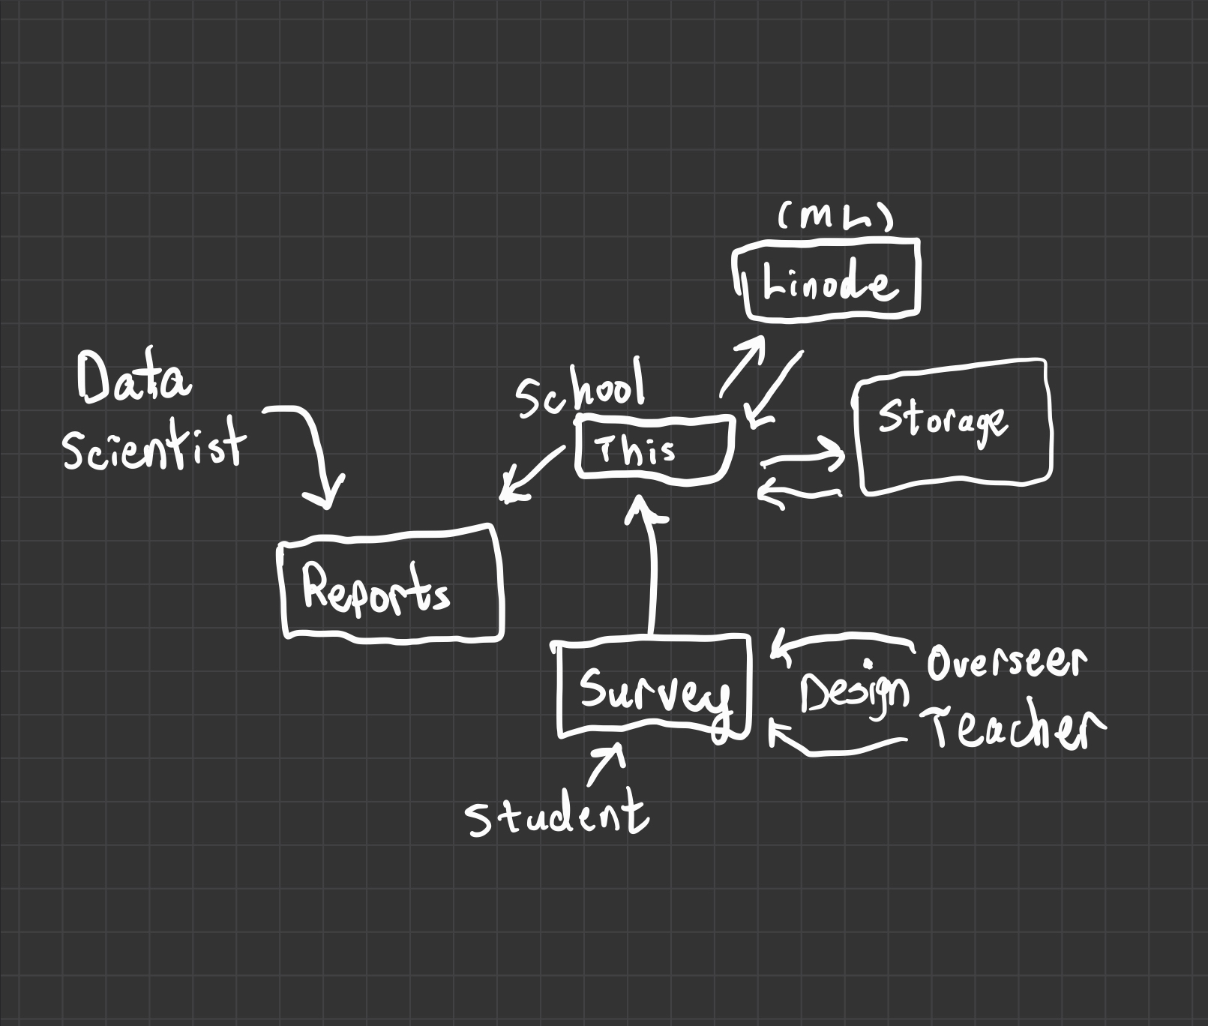

* Teachers design surveys for their classes
* Psychologists review surveys for bias and collection clarity
* Students receive and complete surveys
* Survey data collected and stored on Amazon S3/Google Firebase
* Data Scientists design machine learning/analysis in Jupyter Notebooks
* Linode/External Service runs experiments/data analysis
* Data Scientists design reports in Tableau
* Administrators make executive decisions from reports
* Teachers can also get reports

# Questions

## Who should be able to see the data?

Should anyone be able to see course feedback? How can people “own” their data?

* Neil: Should students be able to view the data on different professors?
* Mike: like an enhanced "rate my professor"?
* Greg: Should students even be allowed to see any data?
* Greg: Many instructors do not like sharing course evaluation data, because it reflects on them
* Greg: Course feedback can also be inaccurate, accidentally or deliberately
* Greg: So never judge off of one feedback user, look for patterns

Also “What does the Administration Side of Things Look Like?”

* Kat: 1. "Where do questions come from?"
* Kat: 2. "What happens after an evaluation is filled out?"
* Greg: Faculty can view past responses as well, but only from their own course and section
* Greg: There are questions regarding whether this is the way things should be
* Greg: A form is the same for all courses
* Greg: There are schools that allow instructors to set their own questions

## What external services, tools, or platforms should this work with?

Consider Zapier, and the struggles of “merely integrating services”. Should this use Google Forms/Microsoft Surveys as opposed to some in-house solution? Should this integrate with JIRA/Management tools or Outlook calendars?

## What data protection policies should be obeyed?

Is this designed to operate in Europe? Does GDPR need to be complied with? How can the data be exported for external auditing? Can the system handle deletion of users? Does data need to be anonymized?

* Greg: FERPA and other federal regulations (USA)
* Greg: European Regulations
* Greg: Depends on students feeling comfortable participating
* Greg: There are considerations for research

## What data assurance and introspection systems need to be in place?

How do we guarantee that the information shown is accurate? How do we prevent against malignant professors or students?

## Who will maintain this project into the future?

Note the lack of maintenance/upgrades to many school IT systems.

## If this is Intended for any Institution, Should Ease of Installation be a Feature?

From the data analysis support, looks like there is a lot of work to do regarding integrating with other platforms.

## How Complex Should Role Management Be?

Any number of optional supporting roles could be added/removed at any time. How sophisticated should any rule/permission/interaction system be for regulating these roles?

## How Sophisticated Should Evaluation Creation be?

Should advanced features including templates, longtime form/feedback management, tagging (management as an information system), and management of results be included?

* Greg: Focus on a minimum viable product, not a maximal imaginable product

## How Much Data Analysis Support is Sought?

Supporting data science experiments to achieve data driven change? A big part of data science in knowledge management, how should this be integrated? Drexel uses JIRA on the inside, it might be best to allow universities to provide their own solution.

* Greg: "we collect data to use it"
* Greg: This is another major focus area
* Greg: "First question should be 'what are we going to do with this data?'"
* Greg: How do teachers use this data?
* Greg: What does this imply about types of querying and reporting, what are different roles doing with this data, how do we ensure data is actually being used?
* Greg: Figuring out a minimum viable project is going to be very hard
* Greg: How do you architect the system to allow for future improvements?
* Greg: "Make sure that users actually use the features"
* Greg: "Think in terms of layers, allow for future layers, and for now focus on first few layers only"
* Greg: "Operations Research is a higher level. Machine Learning is a part of this"

# Product Name Suggestions

* MyFeedback
* CourseEval
* StudentVoice
* CourseWorks

# Discussion

* Peter: Is a quiz enough? Should instead focus on data collection, management, analysis
* Peter: Very few students complete course evaluations
* Hoang: Need to set scope of project
* Hoang: Teachers change their own courses
* Hoang: How to motivate students/whose responsibility is it to collect data
* Eric: Making the data public can help people choose classes
* Peter: What is everyone interested in?
* Peter: Data Science, Databases, UI
* Hoang: Frontend Web Development, Some Backend
* Eric: Frontend Web Development, Some Backend, Likes Java
* Jay: Can manage with Java
* Charles: Experience with Java, Python, System Design
* Peter: Web frameworks?
* Hoang: React is becoming industry standard, angular is phasing out
* Charles: Do we need to deliver a project/code? (Get clarification from professor)
* Peter: Does not think looking at course evaluation products useful, is too generic to need such niche focus
* Peter: Instead focus on a minimal dashboard, do not present much ui to students, focus more on data collection, storage, processing (all go to other tools)
* Eric: We should look at AEFIS, decide what should change
* Jay: If people like the website, they are more likely to interact with it
* Hoang: I think the quiz is all the students interact with
* Peter: Will try to argue about maintainability
* Hoang: Divide up everything
* Hoang: How to communicate?
* Peter: Teams
* Greg: (Quiz Program?) Put these big questions on a “Questions List”. The whole point of saying “quiz systems” was to show that they exist in the OS world. A course evaluation program is similar to a quiz, but the bigger point is about collecting and managing the data. “Is there some exam system you can repurpose to your own ends”
* Greg: (How to ask you questions) Save them for in-class. (This week will be difficult, will be attending multiple conferences/events).
* Greg: (Deliverable Code?) Not decided yet, goal is not to produce a course evaluation system, goal is to figure out how we would build such a system. Want to move past concept definition quickly (one week), then find pieces to compose this project, then prototype/experiment. Course objectives are navigating OS, using OS, building OS. This project is a vehicle to achieving those goals. (Next time, there are other things to help explore OS).
* Greg: (Diagram?) Not interested in UML, only stuff you can draw on a whiteboard quickly. “Systems Reference” diagram (big-architecture, interactions). Not UI diagrams. Develop a “common mental model”. Too high level to be thinking about UI right now. Informal diagram. Bring your diagrams in on Wednesday. (No class on Monday). Next Wednesday will spend time reviewing diagrams.
* Greg: This is a hard assignment, concepts-specific
* Peter: (self) How does Zapier handle integrations across platforms/services?
* Peter: (Self) Put notes on OneNote