Notes

# Information

* 2022-02-07
* Adhoc Notes In-Class

# Todo

* CourseEval GitLab Team Blue Setup
* Drexel Gitlab Invite Team
* <https://gitlab.cci.drexel.edu/courseeval>
* <https://docs.gitlab.com/ee/user/project/members/>
* Peter: Cannot login to the Drexel Gitlab Instance, have emailed Drexel ihelp
* Peter: (Peter) Ask all teams on Discord which option they are pursuing, perhaps coordinate efforts

# Diagram

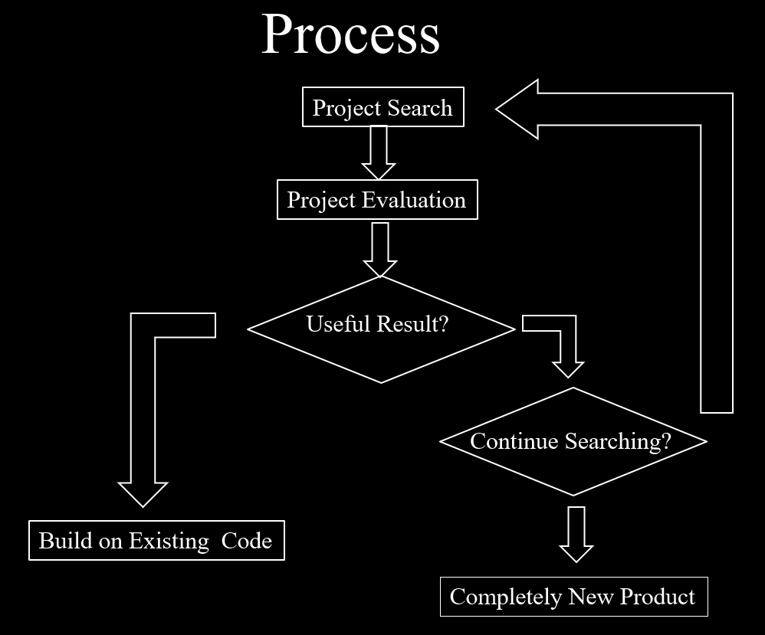

# Discuss Options

|  |  |  |  |  |
| --- | --- | --- | --- | --- |
| **Red** | **Blue** | **Green** | **Orange** | **Purple** |
| EvaP (40) | [Sakai Evaluation System](https://github.com/sakaicontrib/evaluation) (44/60) | EvaP (34) | Lime Survey (25) | EvaP (23) |
| Sakai/ EVALSYS (28) | [EvaP](https://github.com/e-valuation/EvaP) (51/60) | Sakai/EVALSYS (22) | EvaP (22) | Fui-kk (17) |
| OSTSEEE (20) |  | ostseee (22) | OhMyForm (20) | Evals (12) |
| FUI-KK (18) |  | fui-kk (21) | FUI-KK (13) | JHUReviews (11) |
| Course Evaluation System (17) |  | uq-seqat (9) | QST (13) | Course Evaluation System (0) |

* Comparison Matrix:  
  <https://docs.google.com/document/d/1RbJk5vPcjZ21d7ZDMsZzCbDpMoOvk1rPYWlanIstudY/edit>
* Working on Github until Gitlab is resolved: <https://github.com/peter201943/course-eval>

## Sakai or EvaP

* Sakai: <https://github.com/sakaicontrib/evaluation>
* EvaP: <https://github.com/e-valuation/EvaP>
* Potential Solution: Try downloading each and testing ease of running

## Python versus Java

* The team has no opinion on either option (Django or Java)

## Larger Ecosystem versus Independent

* Larger Ecosystem: Easier for IT to handle
* Independent: Easier to implement *\*just this part\** as opposed to a whole ecosystem

## Deciding on System

## Meta Tasks

* Workflow Style/Pace/Habits
* Maybe Scrum
* Deciding on Labels/Tags
* Goals? Intents?
* Jay: Likes UI
* Peter: Ease of install
* Jay: Improve docs
* Charles: Get a good grade
* Peter: (Greg) Ease of running a Docker image on Tux
* Peter: (Peter) Create tasks regarding running on a server
* Peter: (Peter) Create Azure Instance, Learn, Rent, Etc
* Peter: Documentation, currently on OneNote (not popular with everyone else at the moment)
* Peter: (Sakai) investigate writing adapters
* Peter: (Peter) Talk to Jeff Salvage regarding working with Java projects
* Peter: We should delegate investigating setting up each environment and share our configs once successful

# Full Class Options Comparison

* Team Orange: Top choice is LimeSurvey
  + [GitHub - LimeSurvey/LimeSurvey: The most popular FOSS online survey tool on the web.](https://github.com/LimeSurvey/LimeSurvey)
  + [LimeSurvey - Wikipedia](https://en.wikipedia.org/wiki/LimeSurvey)
  + Good Issue Tracking
  + Greg: Good choice
* Team Purple: Top Choice is EvaP
  + Tech, Licensing
  + Greg: Most popular across teams
* Team Red: Top Choice is EvaP
  + Found an institution using it
  + Greg: Any evidence of other institutions using this?
* Team Blue: Top choice is Sakai
  + [GitHub - sakaiproject/sakai: Sakai is a freely available, feature-rich technology solution for learning, teaching, research and collaboration. Sakai is an open source software suite developed by a diverse and global adopter community.](https://github.com/sakaiproject/sakai)
  + [Sakai Learning Management System | Sakai LMS](https://www.sakailms.org/)
  + [sakai.rutgers.edu : Gateway : BigBlueButton Status](https://sakai.rutgers.edu/portal/site/!gateway/page/cc79c981-5920-40cb-a26e-2a608be63187)
  + [Sakai (software) - Wikipedia](https://en.wikipedia.org/wiki/Sakai_(software))
  + Greg: Why is Sakai rated lower than EvaP if it’s your top choice?
  + Greg: Think weights need rethinking
  + Greg: Change your evaluation methods to reflect which choice you think is best
  + Greg: Sakai is a very well known, widely used, well-established
  + Greg: “Like SAP but for universities”
  + Greg: How integrated are Sakai’s modules?
  + Greg: At Drexel, maybe too much to change all these systems at once
  + Greg: Investigate following an adapter pattern
  + Greg: Need info from the Course Registration System
* Team Green: Top Choice is EvaP
  + User base, documentation, tech