Table of Contents

2. Literature Review 2

2.1. Introduction to IoT, WSN and LPWAN. 2

2.2. Issues encountered by remote networks 3

2.3. Overview of LPWAN: 3

2.3.1. ALOHA Principles: 4

2.4. Cellular-based systems: 5

2.4.1. LTE-M: 5

2.4.2 NB-IoT: 6

2.5. Unlicensed-band systems: 6

2.5.1 Sigfox: 6

2.5.2 LoRa and LoRaWAN: 7

References: 11

# 2. Literature Review

## 2.1. Introduction to IoT, WSN and LPWAN.

The Internet of Things (IoT) is the connectivity, communication, data transmission and collation between smart devices and associated embedded systems. This connectivity can be achieved using various types of networks and host devices within various types of applications. Networks can range from personal area networks (PAN) and local area networks (LAN) to remote wide area networks (WAN). IoT applications within PAN networks focus around personal health care and monitoring. LAN based IoT implementations are mostly used within smart homes and industrial automation. As for IoT use cases within WAN environments these include renewable energy monitoring such wind and solar farms and agriculture amongst many others (Kjellby et al., 2019). These IoT networks commonly consist of wireless sensor networks (WSN) which provide the necessary infrastructure for IP based communications. WSN allow for the wireless collation of data from sensors without the need for the of a centrally management system or pre-existing physical infrastructure (De Gante et al., 2014).

WSNs enable the random deployment of sensors, intrinsically allowing for deployments in remote inaccessible locations. Such networks are achieved through the collective utilisation of both sensing and processing capabilities of individual sensors. Therefore, as long as a communication channel can be established and maintained, a large number of sensors can be deployed for the desired scenario. WSN infrastructure hardware varies depending on the design being implemented but mainly consist of servers, routers, switches, and nodes.

Similar to other types of networks serval routing and access protocol have been developed and effectively applied to WSN, aiding applications and system operations. These protocols include, Medium Access Control (MAC) protocol, Low Energy Adaptive Clustering Hierarchy (LEACH), Ad hoc On-Demand Vector (AODV) routing protocol and Sensor Protocols for Information via Negotiation (SPIN). This paper will be focusing technologies based of the energy consumption optimised MAC protocol, as envisioned deployments are battery powered and thus have limited operating time (Modieginyane et al., 2018).

## 2.2. Issues encountered by remote networks

Various hurdles are present when WSNs are implemented in any type of IoT environment, these obstacles are amplified when catering for long range and/or isolated scenarios such in the case of the agriculture monitoring system (Lavric and Popa, 2017).The primary difficulties faced by sensor networks are related to resource limitations imposed by the nature of the devices used for the sensory network in place. These devices have limited physical hardware real estate to accommodate for sufficient resources such as robust communication hardware, computational throughput, and effective long-lasting power delivery (De Gante et al., 2014).

## 2.3. Overview of LPWAN:

Low Power Wide Area Networks (LPWAN) are technologies that fulfil the need of long-range transmission, similar and exceeding that provided by cellular technology, for low power wireless devices. LPWAN therefore allow for WSNs to be deployed and interact with wireless nodes across a wide geographic area. Such gains in range when using LPWANs are achieved with the trade-off of greatly diminished data rates that traditional Wide Area Networks (WAN) (Trasviña-Moreno et al., 2016). LPWAN implementations for constrained environments generally aim to satisfy the following exceptions: upwards of ten years of battery life with transmission coverage ranging from to one thousand kilometres over an uplink with an upper limit of 200Kbps communicating packets ranging between ten to one thousand bytes. These specifications can be achieved by devices ranging with costs ranging between three and seven dollars (Chaudhari et al., 2020).The two most prevalent types of LPWAN technologies are those which operate in unlicensed Industrial, Scientific and Medical (ISM) band and those which operate within 3GPP cellular-based systems. The main technologies available in by cellular networks are Narrowband IoT (NB-IoT) and long-term evolution (LTE)-M. With the most prevalent technologies operating in the ISM band being Sigfox and LoRa (Chaudhari et al., 2020).

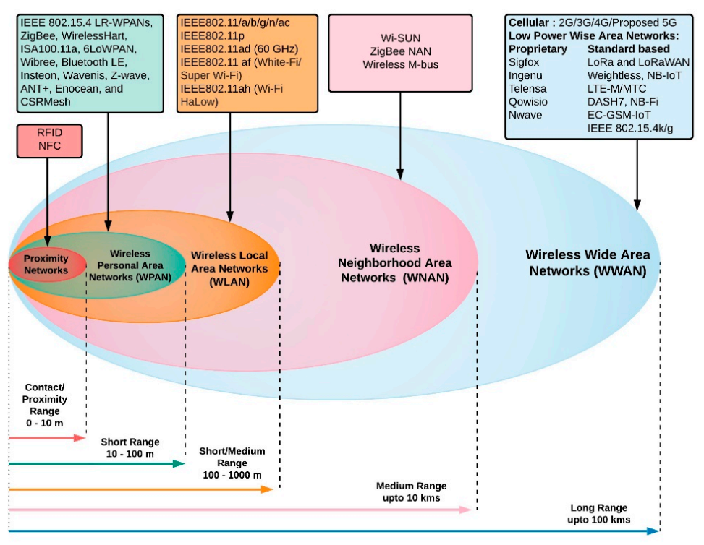

Figure 1. Graphical representation of range provided by different wireless communication technologies. This study will be focusing on the Wireless Wide Area Networks (WWAN) technologies.   
 (Chaudhari et al., 2020)

### 2.3.1. ALOHA Principles:

All the systems listed hereunder use one of two versions of the ALOHA principles. Cellular based technologies use the slotted ALOHA approach, communication medium is only accessible for the nodes during specific time-frequency block. While the unlicensed band technologies discussed used pure ALOHA (Khalifa and Stanica, 2019).

As highlighted in Laya et al’ s 2016 work, ALOHA principles were the result one of the earliest demonstrations of wireless data networks by the University of Hawaii in the early 70’s. These basic principles dictate that multiple nodes may communicate to the same endpoint over a medium without the need of a pre-established connection, contention based. Any collisions that occur are compensated for with a retransmission occurring after a random period has elapsed.

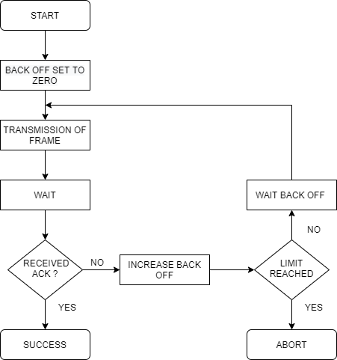

Figure 2. ALOHA Principles flow chart.

## 2.4. Cellular-based systems:

Both of the technologies listed below are essential in the cellular space given that legacy, low cost solutions currently being used to fulfil the need for M2M communications, such as 2G, are on the way out and will soon cease to exist (Wixted et al., 2016).

### 2.4.1. LTE-M:

LTE-M is a 3rd Generation Partnership Project (3GPP) standard-based technology operating in the licences LTE spectrum, providing connectivity for machine to machine (M2M) traffic using pre-existing LTE networks. A key differentiator of LTE-M when compared to the rest of the technologies discussed hereunder is that it supports applications where the transmitter may be mobile in short range deployments. This is due to the fact that the base technology use is LTE. It may also be used for both real-time and non-real time applications with base stations supporting upwards of 100,000 nodes requiring low throughput but can support applications with bandwidth requirements of up to 1Mbps Similar to the rest of the rest of the technologies being discussed LTE-M has a how power requirements (Chaudhari et al., 2020).

### 2.4.2 NB-IoT:

Another 3GPP standard-based technology is NB-IoT. This technology operates in unused narrow bands of the available LTE cellular networks and can operate side by side with other 3GPP technologies such as global systems for mobile (GSM) in the licensed frequency bands of 700, 800 and 900 MHz. Requires a minimum bandwidth of 180 kHz for communication establishment with support of 50,000 devices per base station. NB-IoT reduces unnecessary LTE functionalities optimising for infrequent, low power transmissions of 1600 Byte payloads using orthogonal frequency-division multiplexing (OFDM) modulation for downlink and single carrier frequency division multiple access (SC-FDMA) of uplink transmissions. Both of these modulation types are different variations on the quadrature phase shift Keying (QPSK) modulation (Chaudhari et al., 2020).

## 2.5. Unlicensed-band systems:

### 2.5.1 Sigfox:

One of the most popular LPWAN technologies operating in the unlicensed ISM bands is Sigfox. Sigfox is proprietary ultranarrow band LPWAN network operator that achieves long-range communications using the slow modulation techniques. Uplink transmissions are modulated using differential binary phase shift keying (DBPSK) while the Gaussian frequency shift keying (GFSK) modulation is used for down link communications. As a way to ensure transmission reliability and success messages from nodes are retransmitted multiple times resulting in high energy usage. Sigfox cannot be deployed as a private network as all technologies and networks are owned and operated by Sigfox and users can subscribe to the service similar to cellular subscriptions (Chaudhari et al., 2020).

### 2.5.2 LoRa and LoRaWAN:

Out of the four LPWAN technologies highlighted in LoRa and LoRaWAN is the only viable solution for creating a private LPWAN network without the need for licencing or subscriptions to any third-party provider.

#### 2.5.2.1. LoRa:

Another main competitor for ISM based LPWAN technologies is LoRa. LoRa operates with in the 868 MHz ISM frequency in Europe while using the 915 MHz and 433 MHz frequencies for North America and Asia, respectively. As a physical layer technology LoRa uses chirped spread spectrum (CSS) modulation for bidirectional communications and employs ALOHA principles, these are expanded upon further on. Data rates for LoRa are dependent on the spreading factor (SF) being used (Chaudhari et al., 2020).The six SFs used by LoRa, ranging from SF7 to SF12, allow for trade-offs between range and data rate with the highest data rate of 50 kbps but shortest range achieved when using SF7 and longest range with the lowest data rate of 300 bps achieved when using SF12 (Mekki et al., 2019).

#### 2.5.2.2. LoRaWAN:

While LoRa is the physical modulation used and thus only relates to the lowest levels of the networking model LoRaWAN bridges the link from the datalink layer up to the application layer allowing connectivity to the Internet (Chaudhari et al., 2020). The topology used in a LoRaWAN network is a star-of-stars where end nodes, the sensory devices themselves, communicate with a gateway which then relays the received messages to a centralised network server. Communications between end nodes and gateways are achieved via a single hop over a wireless connection. The rest of the network, gateway to network server are connected through non LoRa based network mainly IP over a traditional internet connection (Adelantado et al., 2017).

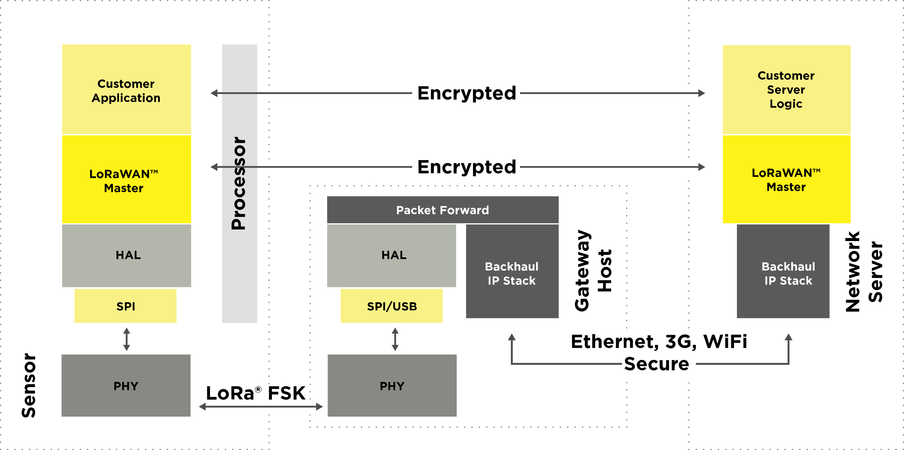

Figure 3. Break down of components within a LoRaWAN network. (About LoRaWAN® | LoRa Alliance®, 2020)

LoRaWAN support three device categories with the main class required for any communication over a LoRaWAN network being class A. As stated previously class a device use pure ALOHA for uplinks, after a successful uplink frame is sent a class A device may receive replies during two downlink windows. Class B devices are used for application with greater downlink needs synchronising periodically with gateways opening up more windows for downlink traffic. Class C devices are continuously listening to receive communications over the channel and only stop when transmitting (Adelantado et al., 2017).

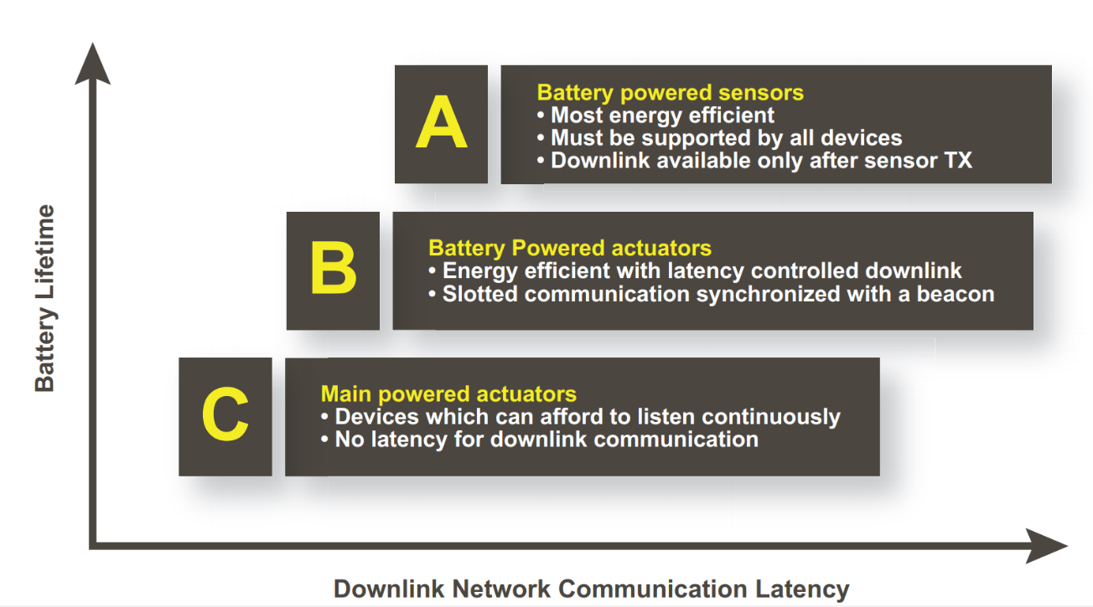

Figure 4. LoRaWAN device classes. (What is LoRaWAN® | LoRa Alliance®, 2020)

* **Highlight LoRa Frame**
* **Break down of LoRaServer ?**
* **LoRaWAN servers: Public private, TTN** 
  + **Interfacing application wise**

# References:

* Kjellby, R., Cenkeramaddi, L., Froytlog, A., Lozano, B., Soumya, J. and Bhange, M., 2019. Long-range & Self-powered IoT Devices for Agriculture & Aquaponics Based on Multi-hop Topology. *2019 IEEE 5th World Forum on Internet of Things (WF-IoT)*,.
  + (Kjellby et al., 2019)
* Lavric, A. and Popa, V., 2017. Internet of Things and LoRa™ Low-Power Wide-Area Networks: A survey. *2017 International Symposium on Signals, Circuits and Systems (ISSCS)*,.
  + (Lavric and Popa, 2017)
* De Gante, A., Aslan, M. and Matrawy, A., 2014. Smart wireless sensor network management based on software-defined networking. 2014 27th Biennial Symposium on Communications (QBSC),.
  + (De Gante, Aslan and Matrawy, 2014)
* Modieginyane, K., Letswamotse, B., Malekian, R. and Abu-Mahfouz, A., 2018. Software defined wireless sensor networks application opportunities for efficient network management: A survey. *Computers & Electrical Engineering*, 66, pp.274-287.
  + (Modieginyane, Letswamotse, Malekian and Abu-Mahfouz, 2018)
* Robert, J., Rauh, S., Lieske, H. and Heuberger, A., 2018. IEEE 802.15 Low Power Wide Area Network (LPWAN) PHY Interference Model. *2018 IEEE International Conference on Communications (ICC)*,.
  + (Robert, Rauh, Lieske and Heuberger, 2018)
* Trasviña-Moreno, C., Blasco, R., Casas, R. and Asensio, Á., 2016. A Network Performance Analysis of LoRa Modulation for LPWAN Sensor Devices. *Ubiquitous Computing and Ambient Intelligence*, pp.174-181.
  + (Trasviña-Moreno, Blasco, Casas and Asensio, 2016)
* Chaudhari, B., Zennaro, M. and Borkar, S., 2020. LPWAN Technologies: Emerging Application Characteristics, Requirements, and Design Considerations. *Future Internet*, 12(3), p.46.
  + (Chaudhari, Zennaro and Borkar, 2020)
* Mekki, K., Bajic, E., Chaxel, F. and Meyer, F., 2019. A comparative study of LPWAN technologies for large-scale IoT deployment. *ICT Express*, 5(1), pp.1-7.
  + (Mekki, Bajic, Chaxel and Meyer, 2019)
* Laya, A., Kalalas, C., Vazquez-Gallego, F., Alonso, L. and Alonso-Zarate, J., 2016. Goodbye, ALOHA!. *IEEE Access*, 4, pp.2029-2044.
  + (Laya et al., 2016)
* Wixted, A., Kinnaird, P., Larijani, H., Tait, A., Ahmadinia, A. and Strachan, N., 2016. Evaluation of LoRa and LoRaWAN for wireless sensor networks. *2016 IEEE SENSORS*,.
  + (Wixted et al., 2016)
* Adelantado, F., Vilajosana, X., Tuset-Peiro, P., Martinez, B., Melia-Segui, J. and Watteyne, T., 2017. Understanding the Limits of LoRaWAN. *IEEE Communications Magazine*, 55(9), pp.34-40.
  + (Adelantado et al., 2017)
* Khalifa, A. and Stanica, R., 2019. Performance Evaluation of Channel Access Methods for Dedicated IoT Networks. *2019 Wireless Days (WD)*,.
  + (Khalifa and Stanica, 2019)

Lora-alliance.org. 2020. *About Lorawan® | Lora Alliance®*. [online] Available at: <https://lora-alliance.org/about-lorawan> [Accessed 16 May 2020].

(About LoRaWAN® | LoRa Alliance®, 2020)

Lora-alliance.org. 2020. *What Is Lorawan® | Lora Alliance®*. [online] Available at: <https://lora-alliance.org/resource-hub/what-lorawanr> [Accessed 16 May 2020].

(What is LoRaWAN® | LoRa Alliance®, 2020)

<https://medium.com/coinmonks/lpwan-lora-lorawan-and-the-internet-of-things-aed7d5975d5d>

<https://www.researchgate.net/figure/Structure-of-a-LoRa-frame-n-14_fig3_307965130>