Table of Contents

3. Methodology 2

3.1. Simulation environments 2

3.2. Technology and approach 2

3.3. Scenario, hardware, and topology 3

3.3.1. Scenario 3

3.3.2. Hardware and topology 3

3.4. Testing: 5

# 3. Methodology

## 3.1. Simulation environments

In order to evaluate the right technology to be implemented in this study an in-depth evaluation of available tool kits has been carried out. Simulation tools are key elements in enabling researchers to setup and test different environments. Traditional simulators such as GNS3 and CISCO packet tracer can be used to mimic generic networking devices. These simulators have been found not to support LPWAN technologies. Focus was then shifted to other robust low-level network centric simulators. Different simulators were tested including NS-3 with extensions for different LPWAN technologies, CupCarbon and COOJA simulator found packaged with the InstantContiki OS. Through these trials it was identified that simulating the required environment was not be the best approach. None of the simulators were sufficient to comprehensively test different LPWAN technologies. In those instances where an LPWAN the technology was correctly simulated the software did not provide the necessary tools to carry out the required testing.

## 3.2. Technology and approach

As previous test yield no effective base on which to build out the test scenario and referring to the research carried out in the previous section it was determined that the study should be built around a single LPWAN technology with an implementation based on physical hardware. LoRa and LoRaWAN were chosen among the other LPWAN solutions in light of the following factors. LoRa is the only technology that allows any operator being and individual, company or service provider to setup a private LPWAN network without the need of radio frequency licencing and registration with authorities. A LoRa based LPWAN enables the provider to have end to end ownership of all hardware within the infrastructure without it being prohibitively expensive.

## 3.3. Scenario, hardware, and topology

### 3.3.1. Scenario

There are massive remote vineyards in Sicily, which require various aspects related to the vines health to be monitored including humidity, sun exposure and air quality. Both traditional wired and wireless network would be impractical in such scenario given the vast amount of low maintenance sensory devices that would need to be deployed.

### 3.3.2. Hardware and topology

#### 3.3.2.1. Topology overview

A LoRaWAN LPWAN network consists of three main components. The IoT sensory device, the LoRa node, which collects the required data and is in most cases embed with a device responsible of communicating that data over some sort of network, in this case LoRa, so it can then be processed. Figure 3.1

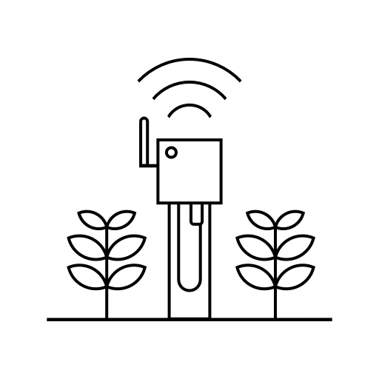

Wireless battery-operated device with embedded sensors.  
Physical Hardware

Figure 3.1 LoRa Node

The LoRaWAN gateway is the second device required in the topology acting as a hub for all nodes to wirelessly communicate collected data. The gateway connects to the final component of the network, the LoRaWAN server, through any traditional conduit such as ethernet based IP networks. The networks server is used to connect the LoRa network to other networks such as the internet enabling end users to interface with the LoRa network and collected data. Figure 3.2

3.3.2.2. Implemented hardware

LoRaWAN Server  
Virtual Machine

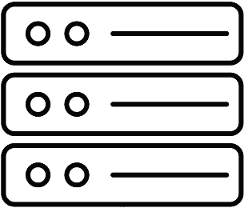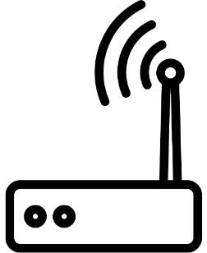

LoRaWAN Gateway  
Physical Hardware

IP Backhaul

Figure 3.2 LoRa Gateway and Server

##### LoRa Node:

The LoRa node used for this study was based on a Raspberry Pi 4 (RPI) Model B running Raspbian Buster as the operating system with a Pi Supply LoRa Node pHAT. (Figure 3.3) The LoRa module used in the Pi HAT was a Rakwireless RAK811 and supports implementations as a Class A and C device within a LoRaWAN network using the European ISM bands. The combination of the Raspberry Pi and premade module allowed for quick set up, customisation and troubleshooting. Interactions with the RAK811 module where achieved through a python library provided by the manufacturer.

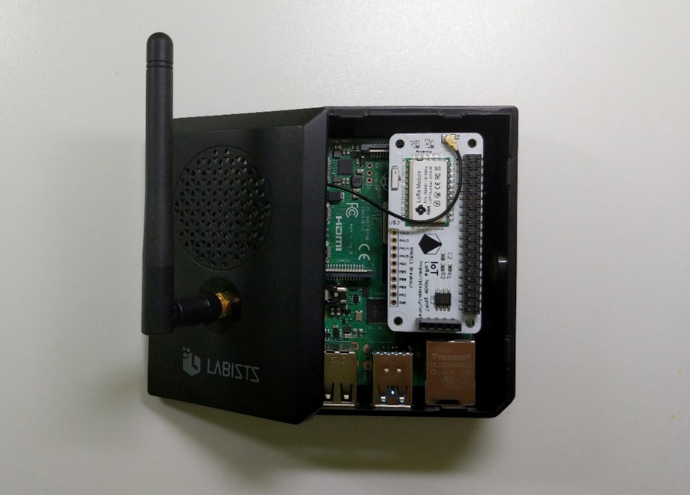

Figure 3.3 LoRa node used for the study.

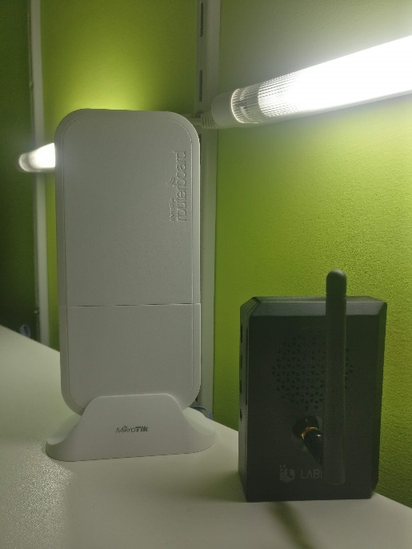

Figure 3.4 LoRa gateway used for the study

##### LoRaWAN Gateway and Server:

Several options were available for this component of the network including Raspberry Pi based solutions. An RPI was not used to create the LoRaWAN gateway given certain limitations imposed by such devices including LoRa channel limitations. Most RPI based gateways do not support the full 8 channels used in LoRaWAN and also given the fact the an RPI is not a device optimised for networking communications. The selected gateway was a MikroTik wAP LR8, this being the European variant supporting at 863-870 MHZ frequency. The LR8 runs RouterOS and includes a UPD packet forwarder essential to communicate with LoRa servers. (Figure 3.4)

A variety of different LoRaWAN servers have been tested including online hosted solutions for both public and private LoRaWAN networks. All locally hosted private LoRaWAN servers where setup as virtual machines with networking to allow communication with the gateway.

## 3.4. Testing:

### 3.4.1. Node to Public LoRaWAN network

This test was conducted to determine what setup up is required to connect and successfully transmit data a public LoRaWAN network. Main setup of the node was done at this point including the installation of the operating systems on the RPI, mounting of the pHAT and creation of test python script using to enable LoRa based communications.

The Things Network public LoRaWAN network chosen to carry out the initial test. This required setting up an *Application* on the public network enabling the node to establish communications.

Authentication with the server would be achieved by using the node’s unique physical identifier and an application identifier and key generated when creating the application on the LoRaWAN server. Connectivity test were conducted from two locations, indoor around 4 meters from ground level and outdoor at around 10 meters from ground level.

Accepted to achieve!!

### 3.4.1. Node and Gateway to Public LoRaWAN network

The second test conducted revolved around the need to increase coverage of a locally available public LoRaWAN network to suit the needs of the scenario at hand. This may be due to various factors but is mainly done when the designated area for implementation does not have sufficient coverage. LoRaWAN authentication process and payload communication analysis including payload encryption had been conducted on the results produced from this test.

Setup required for this test comprised of creating a backbone network that provided internet connectivity to the gateway, setup of the gateway as part of The Things Network and configuration of the gateway to connect to the network. The same script from the previous test was then used to establish transmit a short string of data over the network.