Manuscript Supplemental Figures
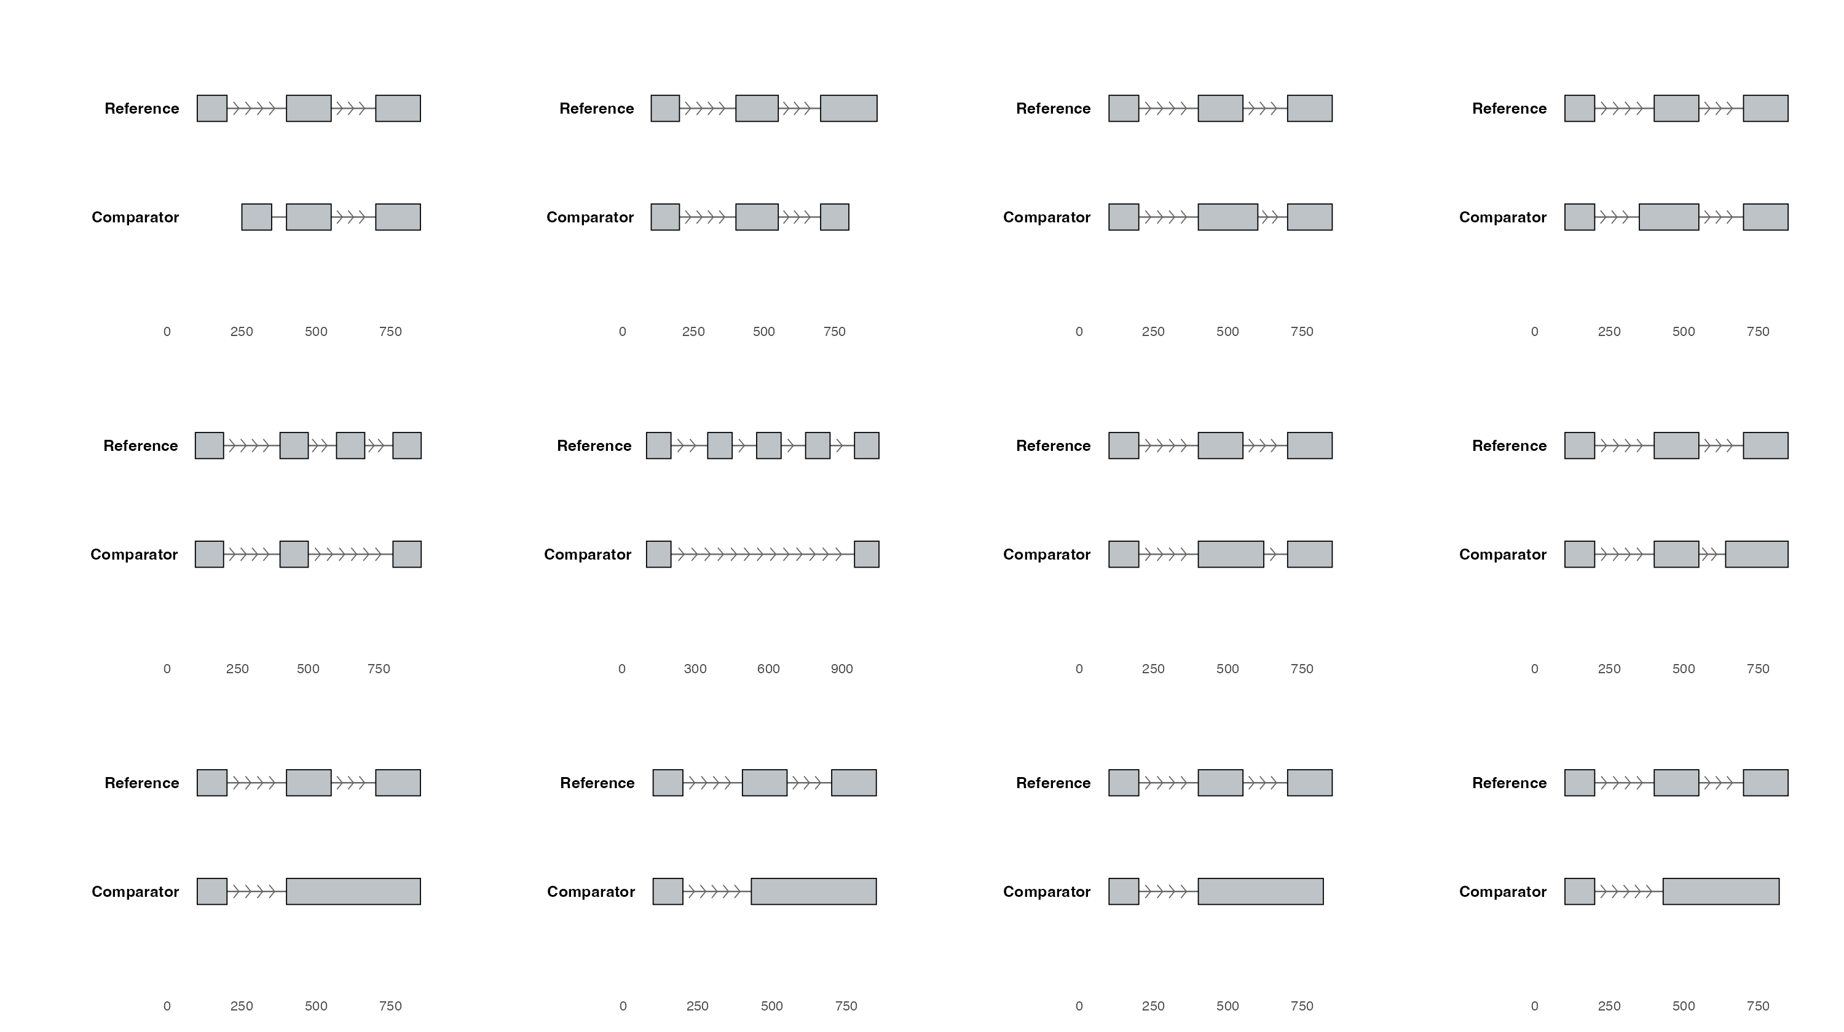
SF24 | Twelve Isopair Splice Event Categories. Schematic of the twelve splice-event types identified when comparing a paired isoform (Comparator, bottom track) to the gene's dominant non-NMD isoform (Reference, top track). Grey boxes, exons; horizontal lines with chevrons, introns (chevrons point in the direction of transcription, 5′ → 3′). Categories: transcript-end variants (Alt TSS, Alt TES); alternative splice sites (A5SS, A3SS); exon skipping (Skipped Exon, Missing Internal); and intron retention in six forms (Partial IR 5′, Partial IR 3′, Full IR, IR diff 5′, IR diff 3′, IR diff 5′ + 3′).

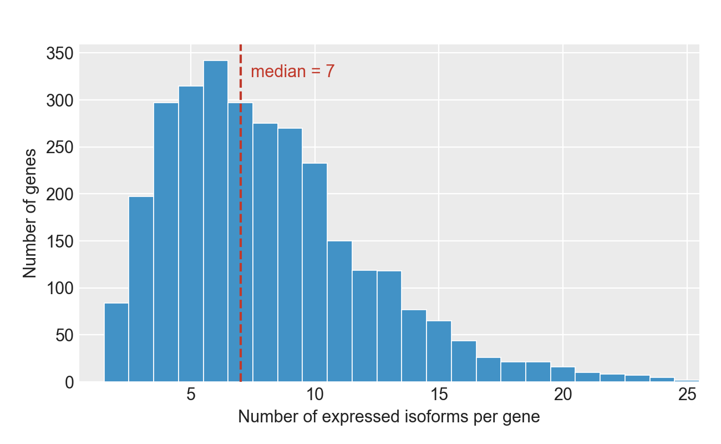
SF25 | Isoforms per Gene in Isopair Analysis. Distribution of the number of expressed isoforms per gene across the 3,009 genes for which gene-matched NMD-susceptible / reference / non-NMD isoform triplets could be constructed. The median gene contributes 7 isoforms (dashed line). Counts include all long-read isoforms passing the expression filter in at least one of the four cell types (AT2, LAE, FB, MV) under DMSO.

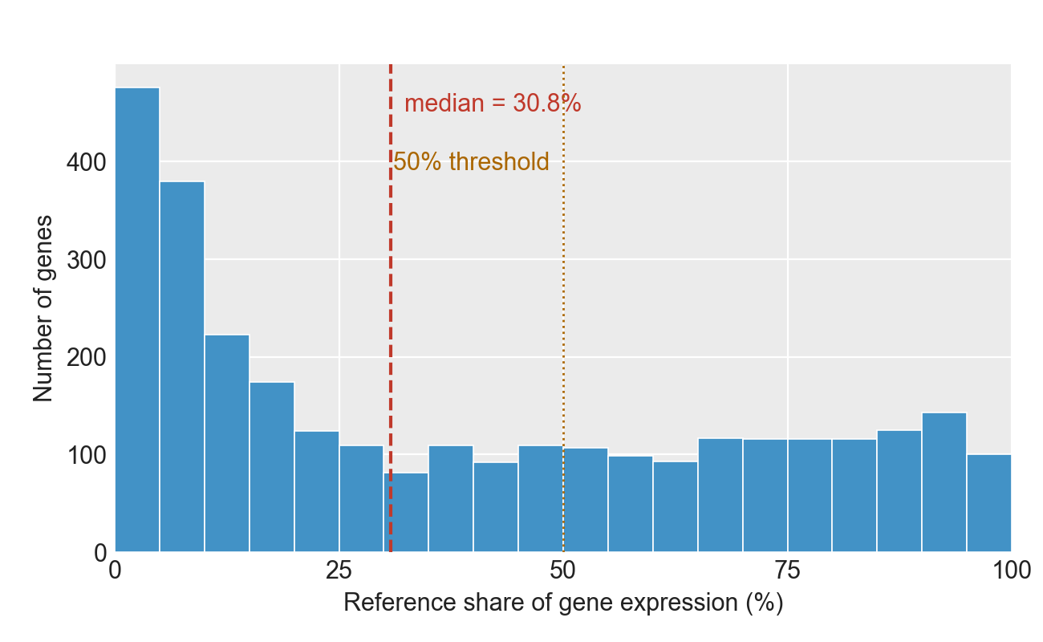
SF26 | Reference Share of Gene Expression. Distribution across 3,009 genes (each contributing a gene-matched NMD-susceptible / reference / non-NMD isoform triplet) of the reference isoform's DMSO 4-cell-type mean expression as a fraction of the parent gene's total non-NMD expression. Reference isoforms are the highest-expressed non-NMD isoform per gene under DMSO across AT2, LAE, FB and MV. Dashed line, median; dotted line, 50% threshold.

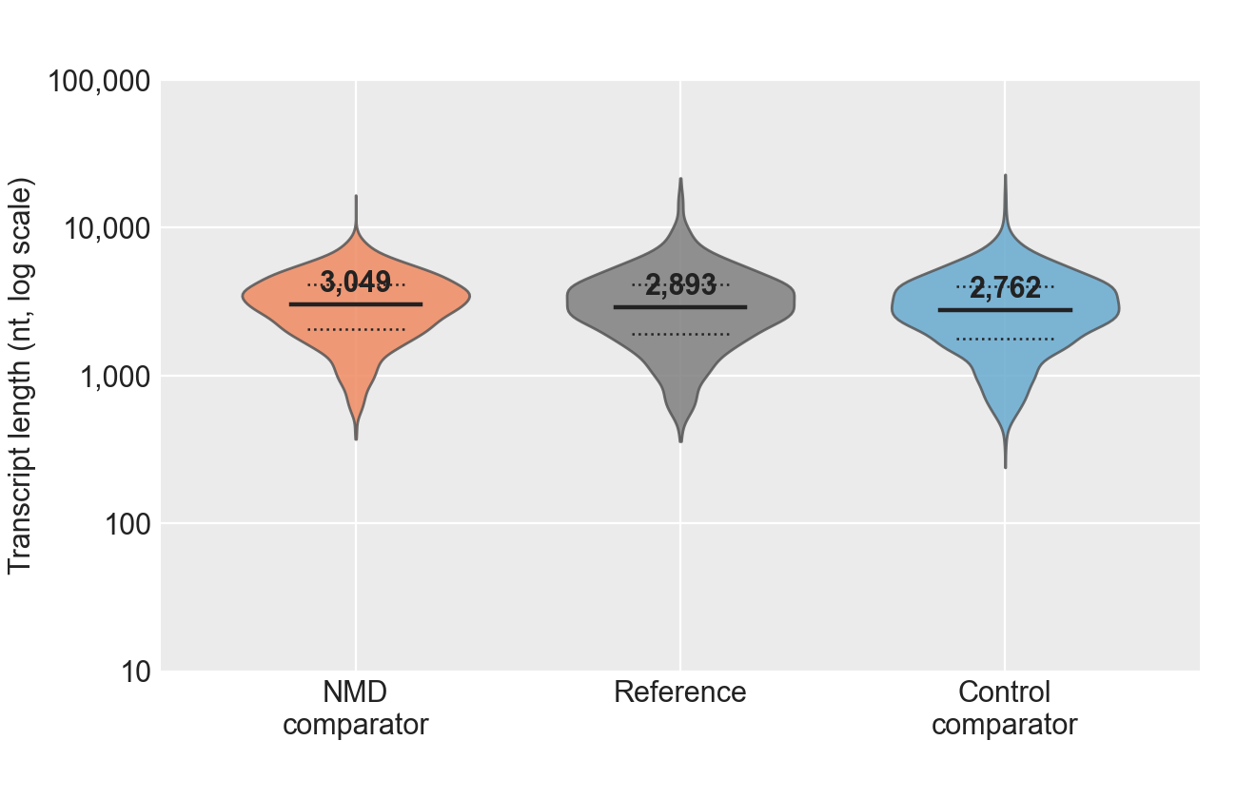
SF27 | Transcript Length by Isopair Analysis Category. Violin plot of transcript length (log10 nt) for the 3,009 gene-matched isoform triplets: NMD comparator (orange), Reference (grey), Control comparator (blue). Reference is the highest-expressed non-NMD isoform per gene under DMSO across the four cell types (AT2, LAE, FB, MV); the NMD and Control comparators are the paired NMD-susceptible and non-NMD non-reference isoforms from the same gene. Solid black bar, median; dotted bars, 25th and 75th percentiles.

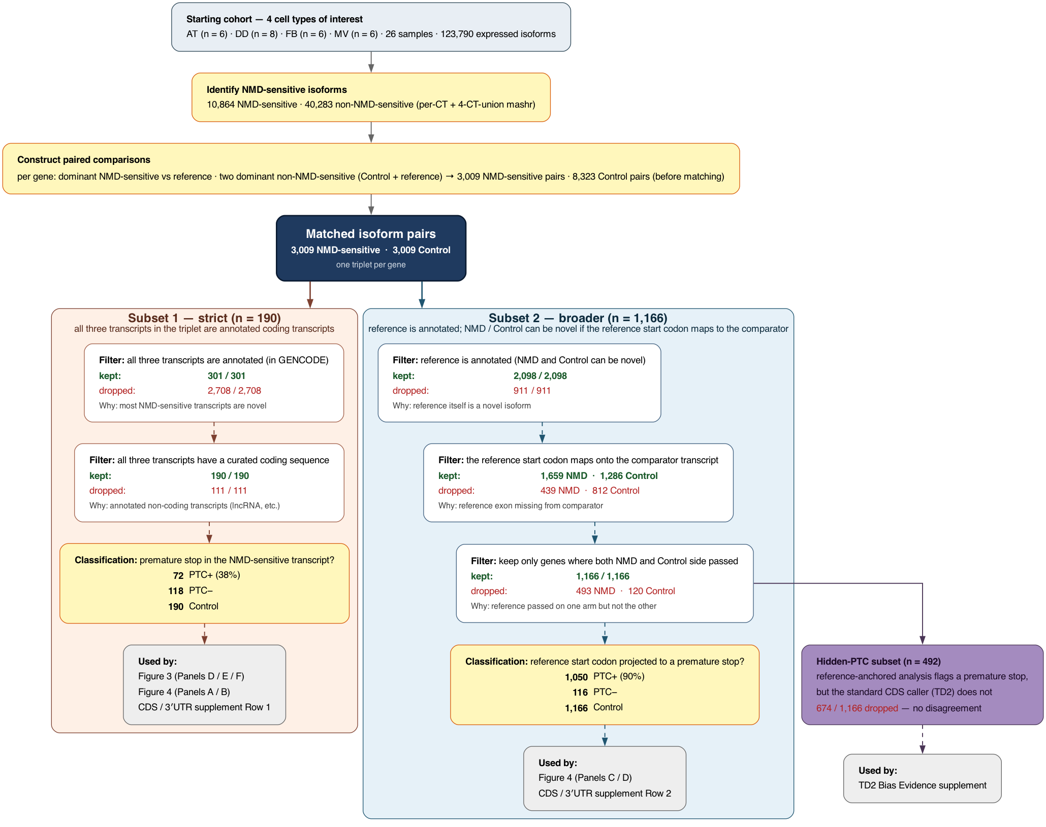
SF28 | Pair-analysis cohort flowchart. Flow of the isoform-pair analyses, from the four-cell-type starting cohort through the two subsets used in the main figures and supplements. Every filter step shows the number of pairs kept and dropped, and a one-line description of why each dropout happened.
Starting cohort and upstream steps (top column). The flowchart begins with the manuscript-scope cohort — 26 samples (AT2 n = 6, LAE n = 8, FB n = 6, MV n = 6) and 123,790 expressed isoforms. From this cohort each isoform is classified as NMD susceptible or non-NMD (per-cell-type + 4-cell-type-union mashr framework), and paired comparisons are constructed (per gene: the dominant NMD-susceptible isoform against a reference, together with two dominant non-NMD isoforms — one as reference, one as Control). Before gene-matching this produces 3,009 NMD-susceptible pair candidates and 8,323 Control pair candidates.
Matched isoform pairs (central navy box). Pairs are then matched across the two arms so that each gene contributes a single triplet — one reference transcript, one NMD-susceptible comparator, and one Control comparator — yielding 3,009 NMD-susceptible pairs and 3,009 Control pairs. This central cohort is the starting point for both downstream subsets.
GENCODE-restricted subset (left, orange cluster; n = 190). The strictest cohort: all three transcripts of the triplet are annotated coding transcripts (in GENCODE, with a curated coding sequence). Two filters reduce the starting 3,009 to 190 pairs. The first — requiring all three transcripts to be annotated — drops 2,708 pairs because most NMD-susceptible transcripts are novel isoforms discovered by long-read sequencing and are absent from GENCODE. The second — requiring a curated coding sequence on all three — drops a further 111 pairs that are annotated but non-coding (long non-coding RNAs and similar). The NMD-susceptible comparator in each of the 190 surviving pairs is then classified by whether its own annotated stop codon sits more than 50 nt before the last exon-exon junction: 72 are PTC+ (38 %), 118 are PTC−, and the 190 Control comparators are not stratified by PTC status. This subset is consumed by Figure 3 Panels D / E / F, Figure 4 Panels A / B, and SF32.
Reference-AUG-traceable subset (right, blue cluster; n = 1,166). Broader cohort that keeps pairs where the NMD-susceptible or Control comparator is novel, as long as the reference transcript is annotated and the reference start codon can be projected onto the comparator. Three filters narrow the starting 3,009 to 1,166. Requiring the reference itself to be annotated drops 911 pairs whose reference is novel. Requiring that the genomic position of the reference start codon falls within an exon of the comparator drops a further 439 NMD-susceptible and 812 Control pairs whose comparator transcript is missing the relevant exon. Re-matching to keep only genes where this mapping succeeded on both arms drops 493 NMD-susceptible and 120 Control pairs, leaving 1,166 / 1,166. Each NMD-susceptible comparator is then classified by where the reference start codon — projected onto that comparator's transcript — leads: a premature stop versus an extended or matched open reading frame. 1,050 of 1,166 (90 %) carry a premature stop under this projection; 116 do not. This subset is consumed by Figure 4 Panels C / D and SF35.
Occult-PTC sub-cascade (purple, off the reference-AUG-traceable subset; n = 492). Sub-subset of the reference-AUG-traceable subset in which the TransDecoder2 CDS caller (the program SQANTI3 uses to annotate novel isoforms) did not flag a premature stop, but the reference-anchored analysis did. 674 of the 1,166 pairs are dropped because there is either no premature stop at all or both methods agree. In the remaining 492 pairs, TransDecoder2 has selected a coding sequence that starts downstream of the reference start codon — long enough to extend the coding sequence past the would-be premature stop into an in-frame coding region. The biological ribosome would in general initiate at the upstream reference start codon, so TransDecoder2's downstream call misses a real NMD substrate. This subset is consumed by SF33/SF34.
Colour coding. Dark slate, upstream steps (raw matrix to pair construction). Yellow, NMD classification and per-subset PTC classification. Dark navy, central matched-pair hub. Orange cluster, GENCODE-restricted subset. Blue cluster, reference-AUG-traceable subset. Purple, occult-PTC subset. Grey, downstream figure and supplement consumers.

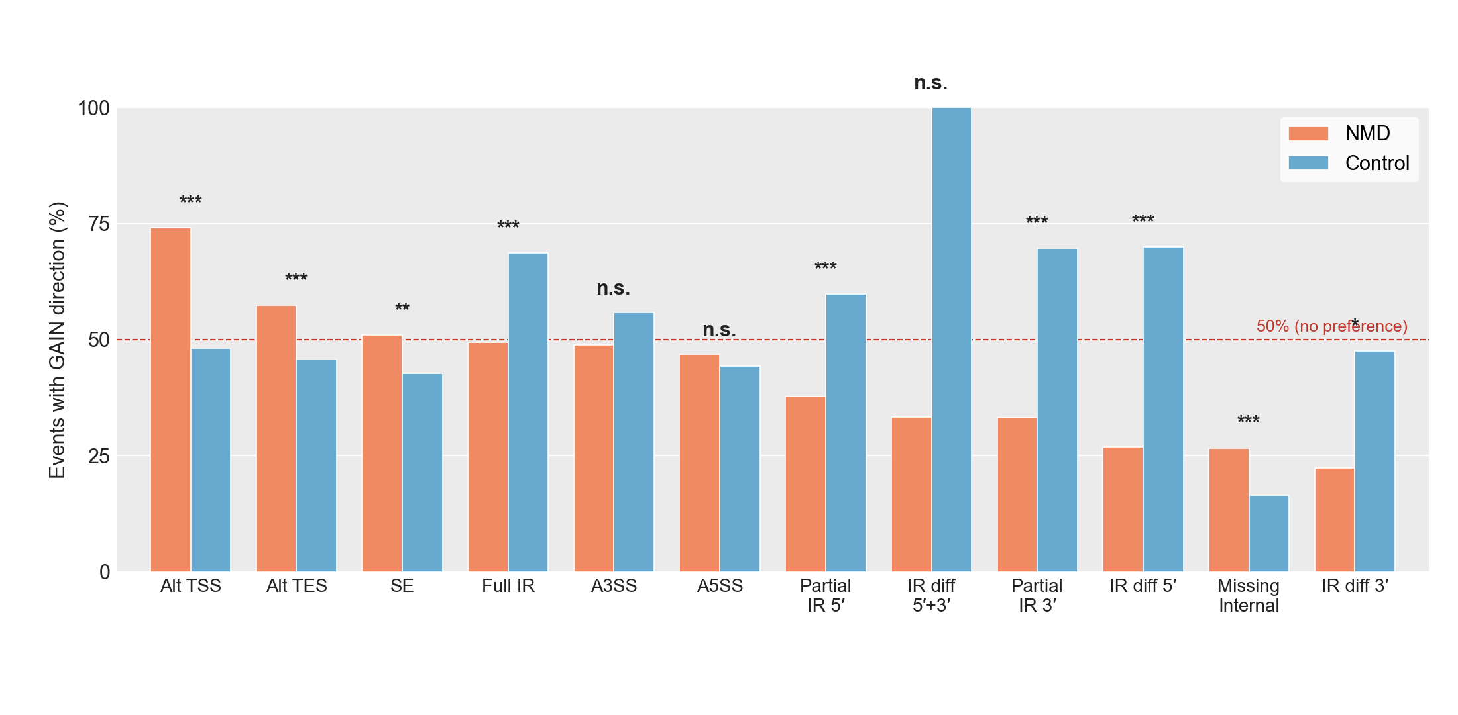
SF29 | GAIN Direction by Splice Event Type. Percentage of detected splice events (across 3,009 gene-matched isoform triplets, both NMD and Control comparators) in which the comparator has additional sequence relative to its reference isoform (GAIN direction). One bar-pair per event type — NMD comparators (orange) vs Control comparators (blue) — sorted by NMD-side %GAIN, descending. Dashed line, 50% (no directional preference). Direction is defined from the comparator's perspective (see SF24 for event-type definitions). Significance stars, Fisher's exact test on the 2 × 2 (GAIN/LOSS × NMD/Control) count table per event type.

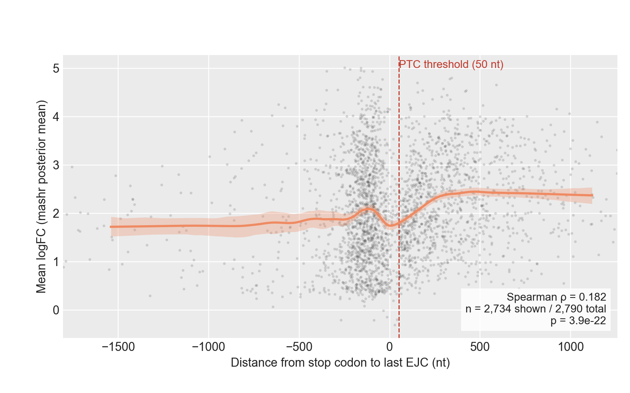
SF30 | NMD-Response Magnitude vs Stop-Codon Distance to Last EJC. Per-comparator NMD-response magnitude (mashr posterior-mean log2 fold-change under SMG1 inhibition, averaged across AT2, LAE, FB and MV) plotted against the distance from the comparator's stop codon to the transcript's last exon-junction complex. Positive values, stop codon upstream of the last EJC (candidate NMD substrate); negative values, stop codon downstream of the last EJC. Grey points, individual comparators (1st–99th percentile of x-axis shown); orange line, local-linear smoother; orange band, bootstrap 95% CI. Dashed red line, the operational 50-nt PTC threshold. Population: 2,790 gene-matched NMD comparators with both a stop-codon-to-last-EJC distance defined and a mashr posterior-mean estimate. Spearman ρ = 0.182, p = 3.9 × 10⁻²².

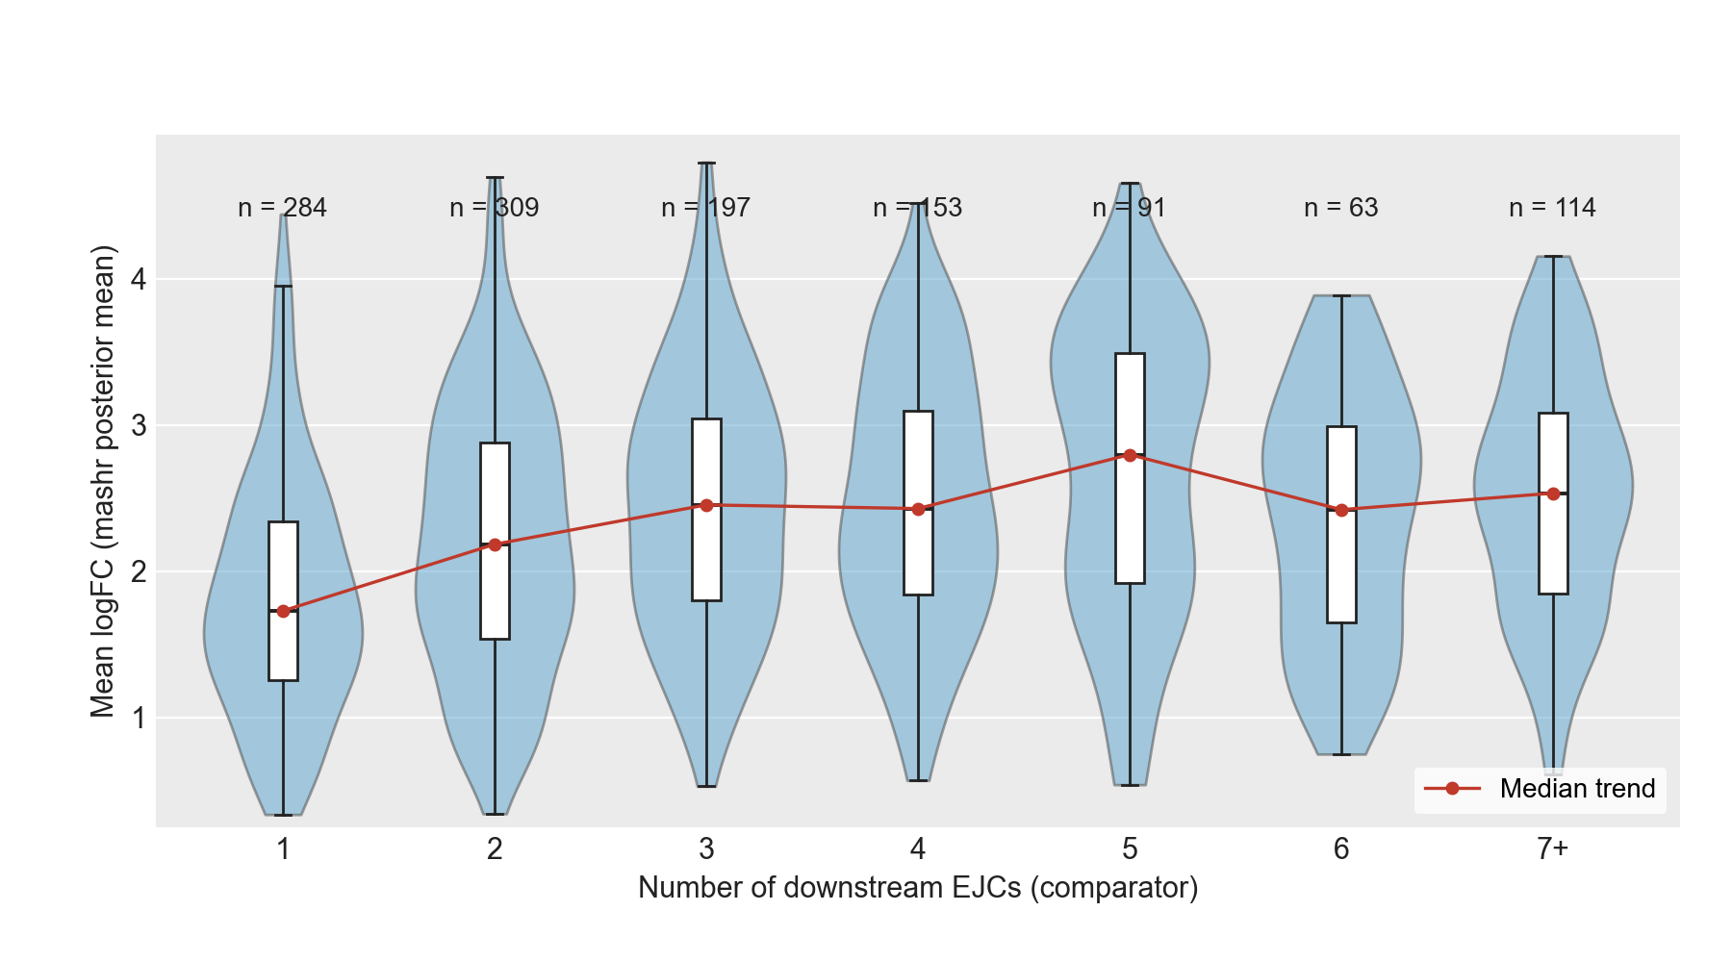
SF31 | NMD Effect Size by Downstream EJC Count in PTC-Positive NMD Comparators. Distribution of NMD-response magnitude (mashr posterior-mean log2 fold-change under SMG1 inhibition, averaged across AT2, LAE, FB and MV) as a function of the number of exon-junction complexes downstream of the comparator's stop codon. Restricted to PTC-positive NMD comparators (stop codon > 50 nt upstream of the last EJC; n = 1,211) drawn from the same population as SF30. Downstream-EJC counts of 7 or more are collapsed into a single "7+" bin. Violin, kernel density; overlaid box, interquartile range and median; red line, per-bin median trend. Per-bin sample counts are shown above each violin.

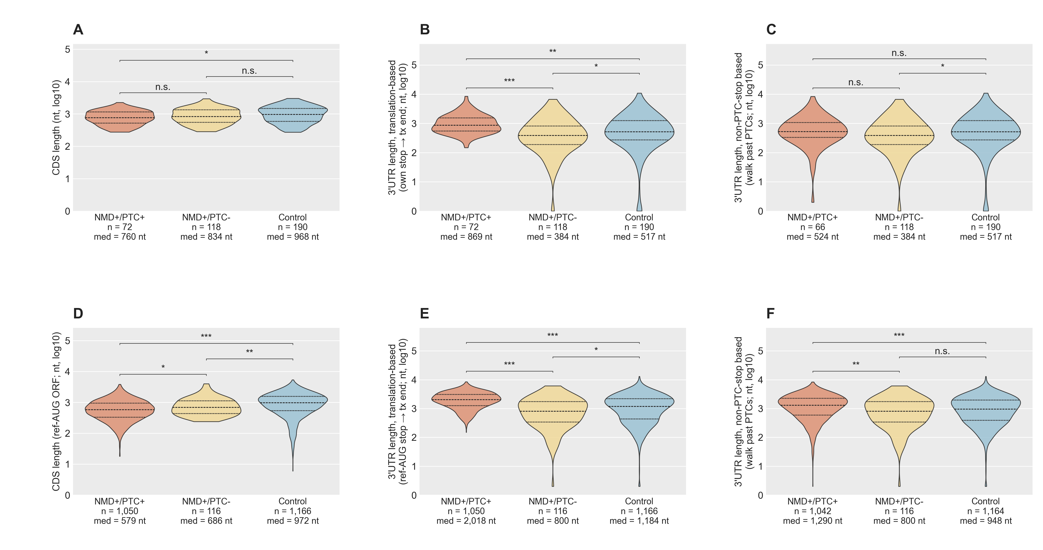
SF32 + SF35 | Coding-sequence length and two complementary 3′UTR-length measures, at two cohort scopes. Row 1 (n = 190 GENCODE-restricted) supports SF32; row 2 (n = 1,166 ref-AUG-traceable) supports SF35.
The figure presents the same three measures (coding-sequence length; 3′UTR length under a naïve translation-based measure; 3′UTR length under a bias-corrected measure that walks past any premature stop codon) at two complementary cohorts. The top row uses the strict annotated cohort in which all three transcripts of every triplet are annotated coding transcripts (n = 72 NMD with a premature termination codon; n = 118 NMD without; n = 190 Control; the cohort that supports Figure 3 Panels D–F and Figure 4 Panels A and B). The bottom row uses the broader cohort in which the reference transcript is annotated and the reference start codon can be projected onto each comparator (n = 1,050 NMD with a premature termination codon; n = 116 NMD without; n = 1,166 Control; the cohort that supports Figure 4 Panels C and D). Premature-termination-codon classification in the top row is taken from each comparator's own annotated stop codon under the canonical 50-nt rule; in the bottom row it is taken from the reference start codon projected onto the comparator transcript, which avoids the systematic premature-termination-codon-avoidance bias of the TransDecoder2 CDS caller (documented in SF33/SF34).
(A) Coding-sequence length is similar across the three groups in the annotated cohort (medians 760 / 834 / 968 nt). NMD-susceptible isoforms with a premature termination codon have a modestly shorter coding sequence than Controls (Hodges–Lehmann shift = −186 nt, p = 5×10⁻³), consistent with the premature termination codon truncating the open reading frame. Coding-sequence length is not a confound for the 5′UTR and 3′UTR differences shown in the other panels.
(B) 3′UTR length under the translation-based measure (transcript length minus annotated stop position). NMD-susceptible isoforms with a premature termination codon appear to have substantially longer 3′UTRs than Controls (medians 869 vs 517 nt; p = 1×10⁻⁴), but this is a measurement artifact: the post-stop region in these isoforms includes the coding sequence between the premature stop and the natural stop.
(C) 3′UTR length under the bias-corrected measure that walks past any premature stop codon (translates downstream from the annotated start, skipping stops that would themselves be classified as premature, until reaching the first non-premature stop). Under this corrected measure, NMD with a premature termination codon and Controls are indistinguishable (medians 524 vs 517 nt; p = 0.90), confirming that the apparent inflation in Panel B was the measurement, not the biology. NMD-susceptible isoforms without a premature termination codon retain a significantly shorter 3′UTR than Controls (median 384 vs 517 nt; p = 0.03). Six of the 72 NMD-with-PTC isoforms (8%) had no non-premature stop downstream in the comparator transcript and are dropped from this panel (n = 66 displayed).
(D) Coding-sequence length on the broader cohort, anchored on the reference start codon projected onto the comparator. NMD-susceptible isoforms with a premature termination codon have the shortest open reading frame (median 579 nt vs 972 nt in Control), as expected from the premature stop. NMD-susceptible isoforms without a premature termination codon sit between (median 686 nt).
(E) Translation-based 3′UTR length on the broader cohort. The same artifact apparent in Panel B is again present (median 2,018 nt in NMD+PTC vs 1,184 nt in Control).
(F) Bias-corrected 3′UTR length on the broader cohort. After correction, NMD-with-PTC moves from 2,018 down to 1,290 nt, much closer to the Control median of 948 nt. The directional pattern from the annotated cohort is preserved at the broader cohort and remains statistically detectable, but it is quantitatively much smaller than the translation-based gap. This argues against extended 3′UTR length as the dominant mechanism for the residual NMD-without-PTC isoforms.
Violins show per-group density on a log scale; horizontal lines mark q25 (dotted), median (dashed), and q75 (dotted). Stars: p < 10⁻¹⁰, *p < 10⁻⁴, p < 10⁻³, *p < 0.05, n.s. otherwise (two-sided Wilcoxon rank-sum).
Abbreviations. NMD, nonsense-mediated decay; PTC, premature termination codon; CDS, coding sequence; UTR, untranslated region.

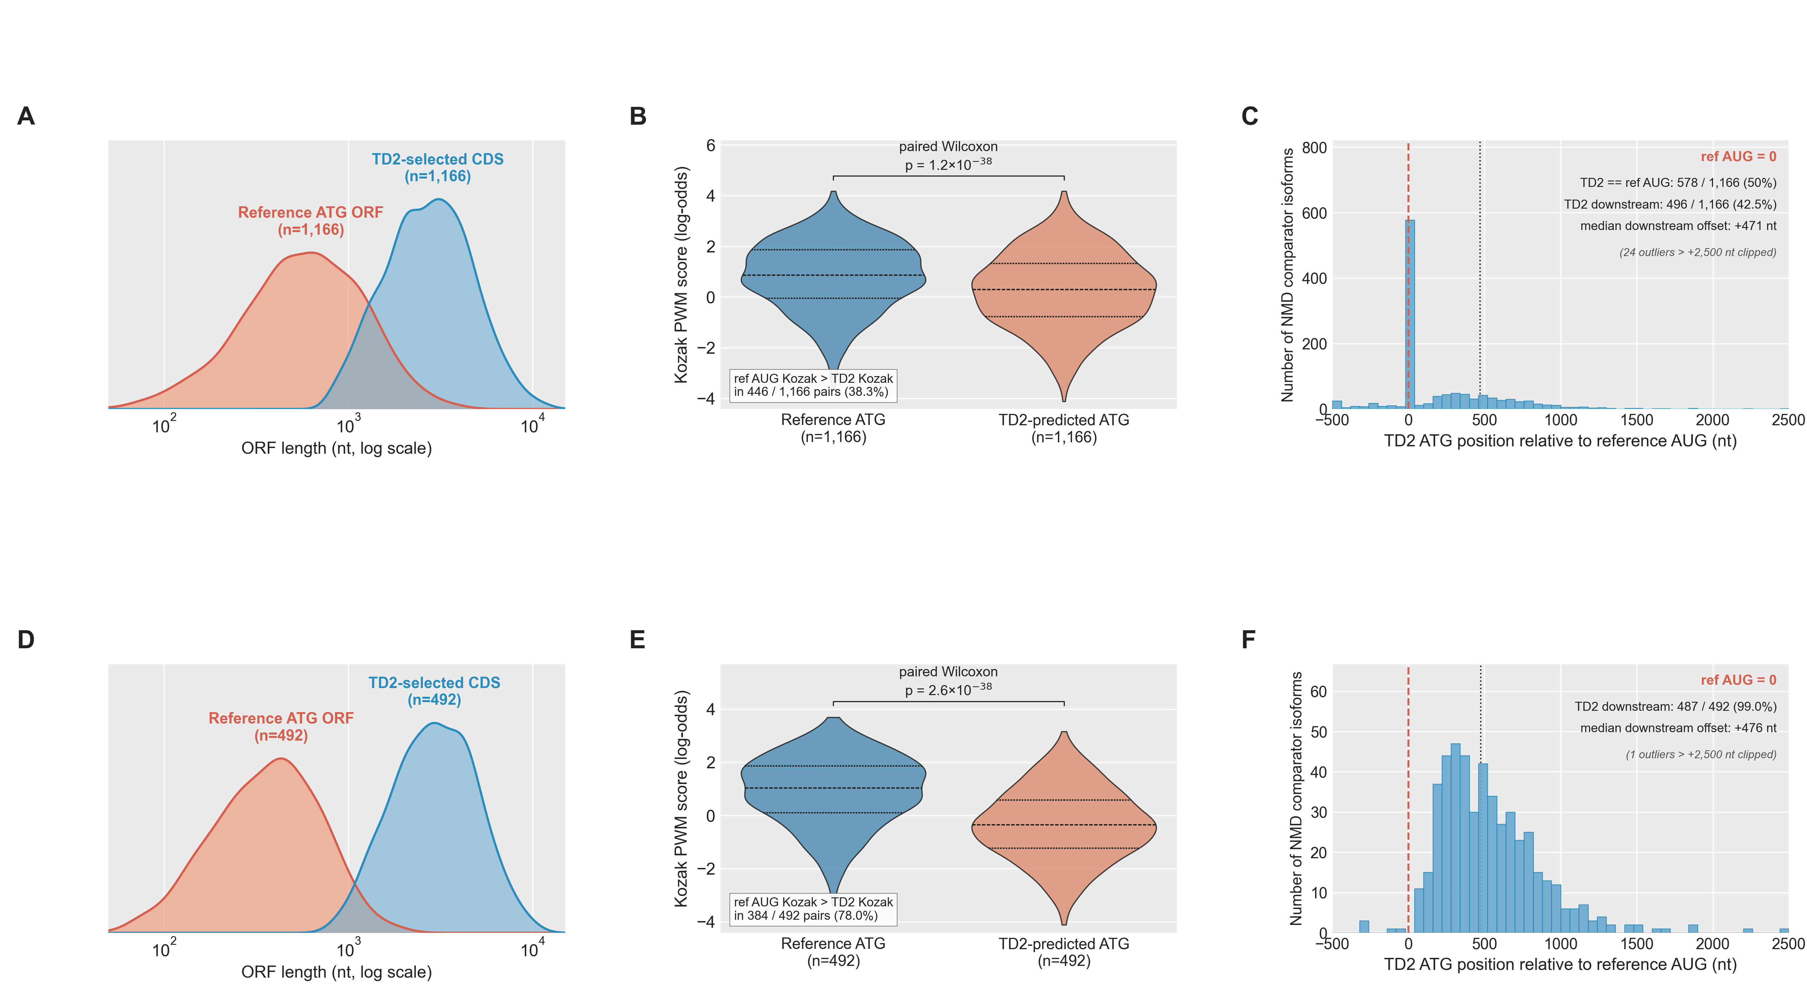
SF33 + SF34 | TransDecoder2 open-reading-frame length, start-codon position and Kozak strength versus reference-anchored open reading frames. Row 1 (n = 1,166) and row 2 (n = 492 occult-PTC subset) together support SF33 (length and position panels) and SF34 (Kozak panels).
Three orthogonal observations of the same systematic bias, presented at two complementary cohorts. The top row uses the 1,166 gene-matched pairs in which the reference start codon could be projected onto the comparator transcript (the same cohort as Figure 4 Panels C and D); within this cohort TransDecoder2 picked the same start codon as the reference in 50 % of pairs (578 / 1,166) and a different start codon in 50 % (588 / 1,166). The bottom row uses the occult-PTC subset of the top row (n = 492) — pairs in which projecting the reference start codon onto the comparator revealed a stop codon > 50 nt upstream of the last exon-junction complex (a premature termination codon) that TransDecoder2's own open reading frame had skipped over. The bias is most pronounced in the occult-PTC subset by construction.
(A, D) Open-reading-frame length. Distribution of open-reading-frame length under the TransDecoder2-chosen start codon (blue) versus under the reference start codon projected onto the same transcript (coral). The TransDecoder2-selected open reading frame is ~5× longer than the reference-anchored open reading frame on the broad cohort (Panel A; medians 2,758 vs 588 nt) and ~8× longer on the occult-PTC subset (Panel D; medians 2,934 vs 380 nt). TransDecoder2 systematically picks longer reading frames that bypass the premature stop.
(B, E) Kozak context. Paired Kozak position-weight-matrix scores at the reference start codon versus at the TransDecoder2 start codon, scored on the NMD-susceptible isoform. The reference start codon has systematically stronger Kozak context than the TransDecoder2 pick on both the broad cohort (Panel B; paired Wilcoxon p = 1.2 × 10⁻³⁸; medians 0.86 vs 0.29; reference stronger in 446 of 1,166 pairs) and the occult-PTC subset (Panel E; p = 2.6 × 10⁻³⁸; medians 1.04 vs −0.35; reference stronger in 384 of 492 pairs, i.e., 78 % of pairs follow the bias direction).
(C, F) Position of the TransDecoder2 start codon relative to the reference. Position in transcript coordinates with the reference start codon at 0 (red dashed line). On the broad cohort (Panel C) a large spike at 0 reflects the 50 % of pairs in which TransDecoder2 chose the same start codon as the reference; 43 % of pairs (496 / 1,166) have the TransDecoder2 start downstream (median offset +471 nt) and 8 % (92 / 1,166) have it upstream. On the occult-PTC subset (Panel F) the spike at 0 disappears: 99 % (487 / 492) of TransDecoder2 starts are downstream of the reference (median offset +476 nt); only 1 % (5 / 492) are upstream. The contrast between the two rows shows that TransDecoder2's start-codon disagreement with the reference is most extreme — and almost always in the downstream, premature-termination-codon-avoiding direction — in exactly the population where the bias is biologically engaged.
Abbreviations. NMD, nonsense-mediated decay; PTC, premature termination codon; PWM, position weight matrix.

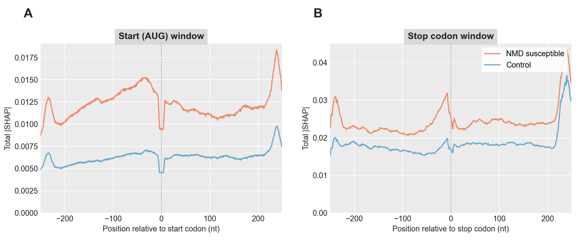
SF36 | Total |SHAP| Across the AUG and Stop-Codon Windows. Per-position |SHAP| summed across the nine input channels of the deep-learning model, comparing NMD susceptible (orange) and Control (blue) transcripts on the held-out test set (NMD n = 2,268, Control n = 7,863). Each transcript's AUG and stop windows are centred on its main open reading frame's start and stop codons. Main open reading frames are chosen with the following priority: the annotated reference CDS (projected from the gene's dominant non-NMD isoform) when available; otherwise the TransDecoder2-called CDS; otherwise the highest-Kozak-scoring open reading frame (see Methods, Main open reading frame selection). Values are smoothed with an 11-nt rolling mean over the raw per-position |SHAP| to abstract over trinucleotide-frame periodicity. A) AUG window covering positions –250 to +249 relative to the start codon. B) Stop-codon window covering the same relative range around the stop codon. Pooled across 5 DeepSHAP runs (500 background samples each).

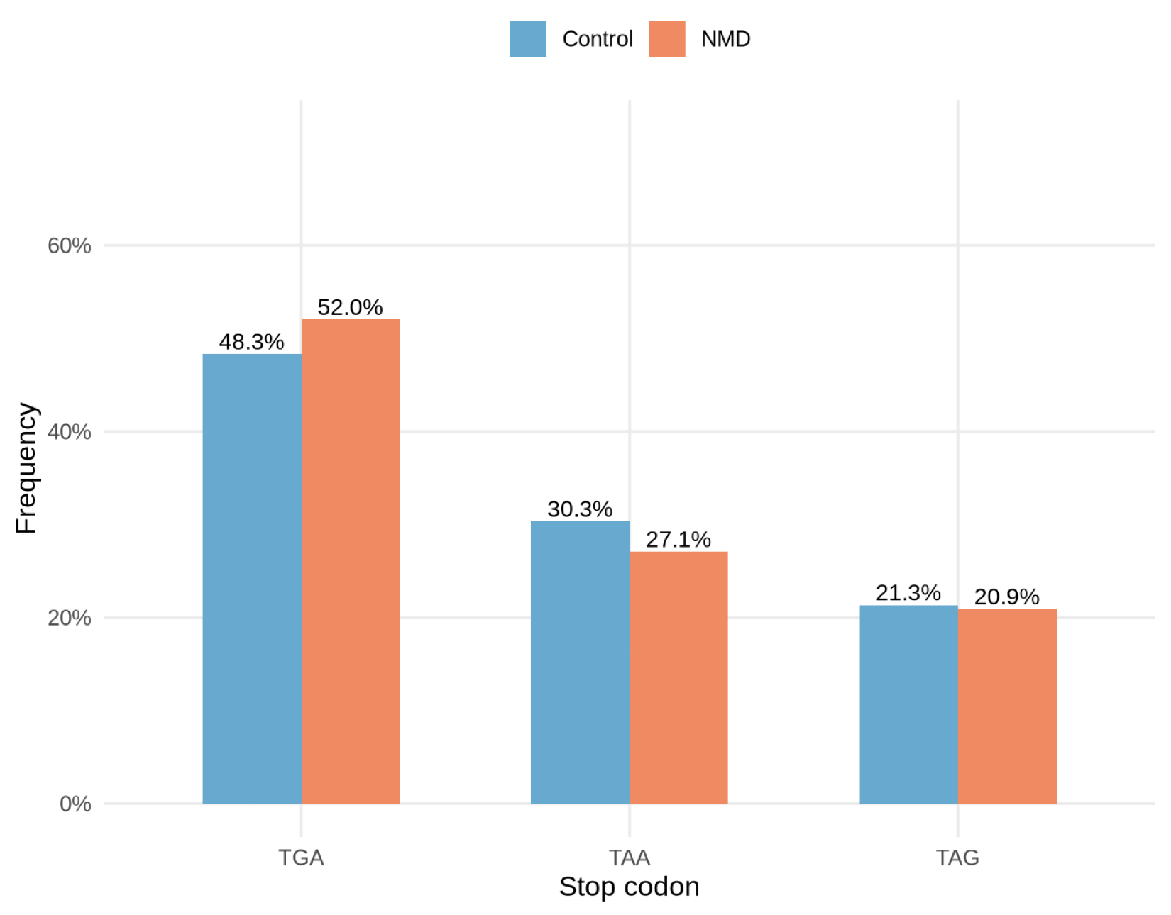
SF37 | Stop-codon usage in NMD susceptible vs non-NMD isoforms. Within-class frequency of the three canonical stop codons (UGA / UAA / UAG) at the main open reading frame of each transcript in the deep-learning model's held-out test set (n = 2,268 NMD susceptible, n = 7,863 non-NMD). Main open reading frames are chosen with the following priority: the annotated reference CDS (projected from the gene's dominant non-NMD isoform) when available; otherwise the TransDecoder2-called CDS; otherwise the highest-Kozak-scoring open reading frame (see Methods, Main open reading frame selection). Percentages: UGA 55.9 % vs 48.1 %; UAA 23.9 % vs 29.9 %; UAG 20.2 % vs 22.0 %.
Abbreviations. NMD, nonsense-mediated decay; UGA / UAA / UAG, the three canonical stop codons in RNA notation.

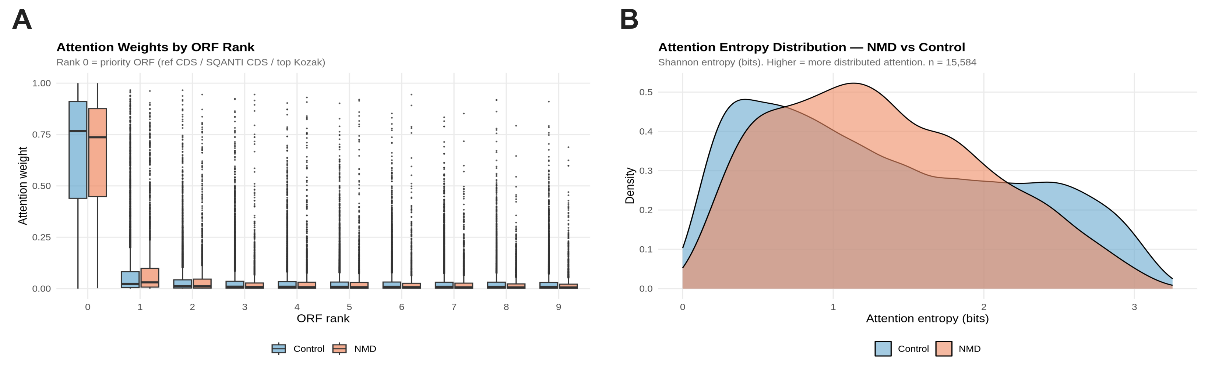
SF38 | Attention distribution across the model's five candidate open reading frames, NMD susceptible vs non-NMD. The deep-learning model evaluates each transcript at up to five candidate open reading frames and learns an attention weight for each. The candidates are ranked by a priority rule that prefers the annotated reference CDS first (projected from the gene's dominant non-NMD isoform when available), then the TransDecoder2-called CDS, then the open reading frame with the strongest Kozak start context. Most attention concentrates at the main (rank-0) open reading frame in both classes.
(A) Attention weight per candidate open reading frame rank, by class (NMD susceptible in coral, non-NMD in blue). Most attention concentrates at the rank-0 open reading frame in both classes (median ~0.74–0.76). The median rank-0 attention is slightly lower in NMD, with a corresponding shift of attention onto ranks 1–4 and a long tail of NMD isoforms placing more than 25 % of attention on a non-rank-0 candidate.
(B) Shannon entropy of the per-isoform attention vector across the five candidate open reading frames (higher entropy, more broadly distributed attention). The NMD density is shifted toward higher entropy than the Control density, quantifying the broader spread shown in Panel A.
Abbreviations. NMD, nonsense-mediated decay.

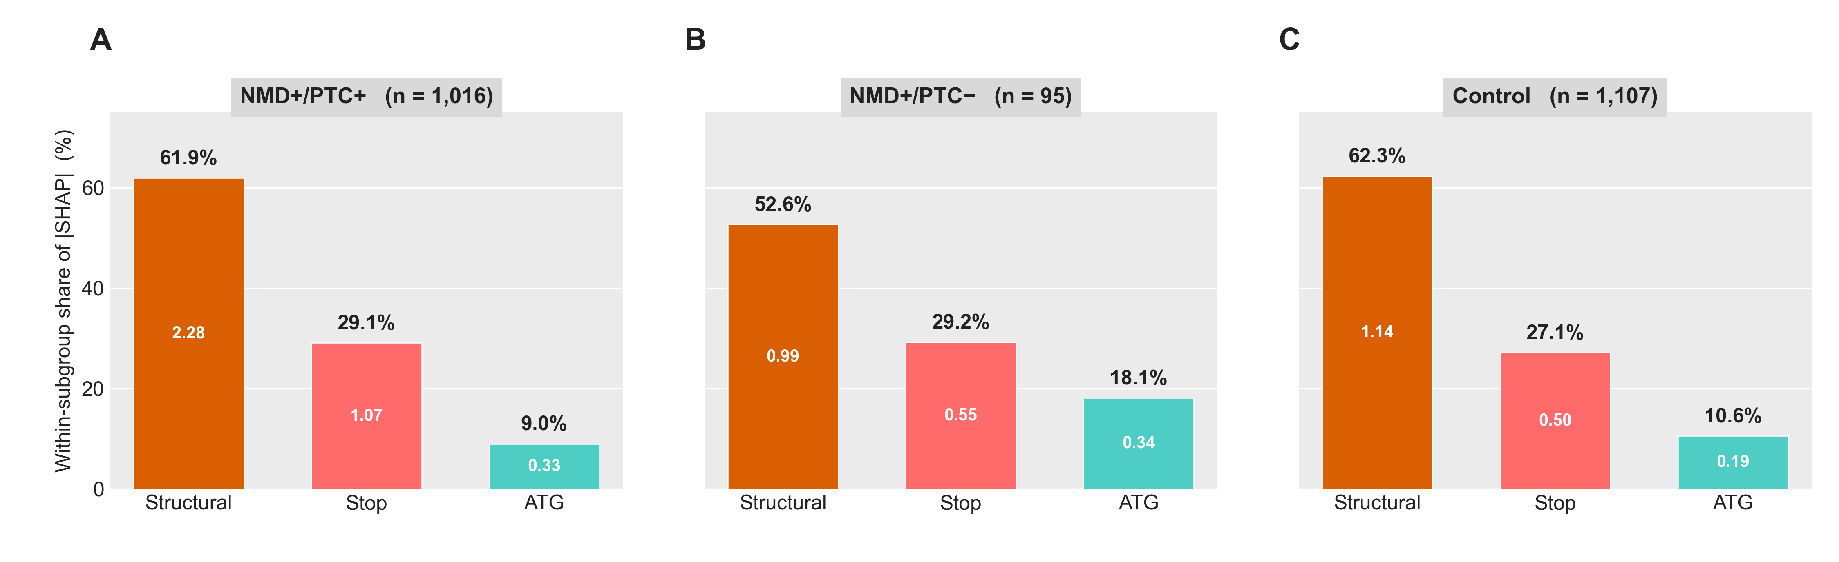
SF39 | Branch-level Shapley attributions of the deep-learning model, stratified by isoform PTC subclass. Shapley attributions of the model's NMD prediction across its three input branches — the start-codon window, the stop-codon window, and a set of structural features — measured at the branch-aggregation point of the trained network (the same attribution method as in Figure 5 Panel C). Attributions are stratified across three isoform subclasses defined in Figure 4 Panels C and D: NMD susceptible with a premature termination codon (NMD+/PTC+, n = 1,016), NMD susceptible without a premature termination codon (NMD+/PTC−, n = 95), and matched non-NMD Controls (n = 1,107). Attributions are computed for every isoform in the subgroup.
Each panel matches the style of Figure 5 Panel C: bars are ordered structural / stop / start; the value inside each bar is the mean absolute Shapley attribution at that branch; the percentage above each bar is that branch's share of the within-subclass total attribution. The vertical scale is identical across the three panels so heights can be compared directly.
(A) NMD susceptible with a premature termination codon (NMD+/PTC+). Structural features dominate (62 % of total branch attribution); the stop-codon window contributes 29 %; the start-codon window contributes 9 %. This pattern mirrors the pooled attribution shown in Figure 5 Panel C — when a premature termination codon is present, the structural and stop-codon features carry the prediction.
(B) NMD susceptible without a premature termination codon (NMD+/PTC−). The structural share drops to 53 % (no premature termination codon means no excess downstream-junction signal); the stop share is essentially unchanged at 29 %; the start-codon-window share doubles to 18 %. The model relies more heavily on start-codon context to call NMD in these isoforms.
(C) Non-NMD Controls. The proportional profile resembles NMD+/PTC+ (62 % / 27 % / 11 %) but at lower absolute magnitude across all three branches.
The start-codon-window share in NMD+/PTC− is ~2-fold higher than in NMD+/PTC+ (18 % vs 9 %), quantifying the shift toward start-codon information when a premature termination codon is not present.
Abbreviations. NMD, nonsense-mediated decay; PTC, premature termination codon.

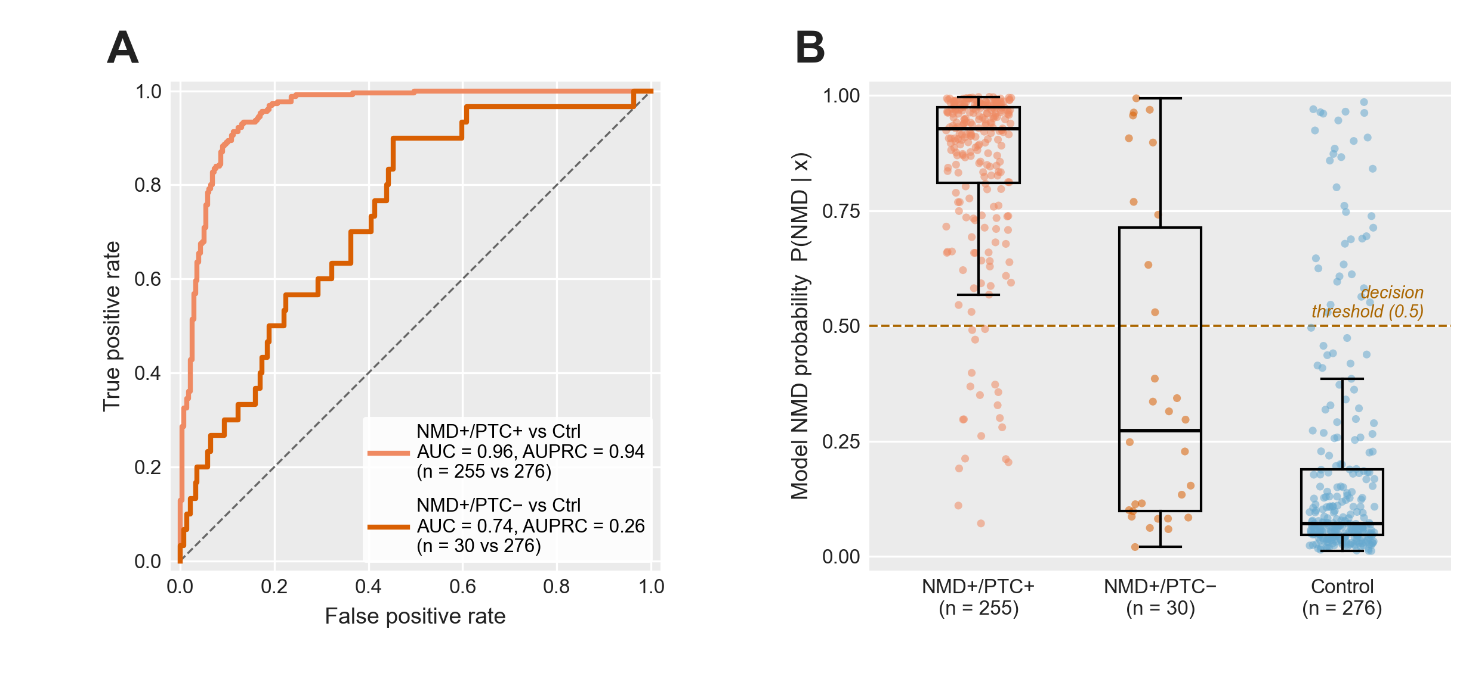
SF40 | Deep-learning model discrimination by PTC subclass on the held-out test set. Held-out test-set performance of the trained NMD predictor, restricted to isoforms in the same 1,166 gene-matched pairs used by Figure 4 Panels C and D and Figure 5 Panel G, and stratified by the same three subclasses: NMD susceptible with a premature termination codon (NMD+/PTC+, n = 255), NMD susceptible without a premature termination codon (NMD+/PTC−, n = 30), and matched non-NMD Controls (n = 276). Subgroup sample sizes reflect held-out-test-set membership rather than the total subgroup.
(A) Receiver-operating-characteristic curves for the two NMD-vs-Control contrasts, using the model's predicted NMD probability as the score. The NMD+/PTC+ vs Control contrast achieves AUC = 0.96 (AUPRC = 0.94). The NMD+/PTC− vs Control contrast achieves AUC = 0.74 (AUPRC = 0.26). Diagonal, chance. The substantial AUC drop indicates that NMD-susceptible isoforms without an annotated premature termination codon are intrinsically harder for the model to discriminate from non-NMD isoforms — consistent with the loss of structural and stop-window signal shown in SF39.
(B) Distribution of the per-isoform predicted NMD probability by subclass. NMD+/PTC+ isoforms cluster at high probability (mean = 0.85), comfortably above the 0.5 decision threshold; non-NMD Controls cluster at low probability (mean = 0.19); NMD+/PTC− isoforms straddle the threshold (mean = 0.39), placing many of them on the Control side of the decision boundary. Boxplots show median, IQR, and 1.5×IQR whiskers; the dashed horizontal line marks the 0.5 default decision threshold.
Abbreviations. AUC, area under the receiver-operating-characteristic curve; AUPRC, area under the precision–recall curve; NMD, nonsense-mediated decay; PTC, premature termination codon; IQR, interquartile range.

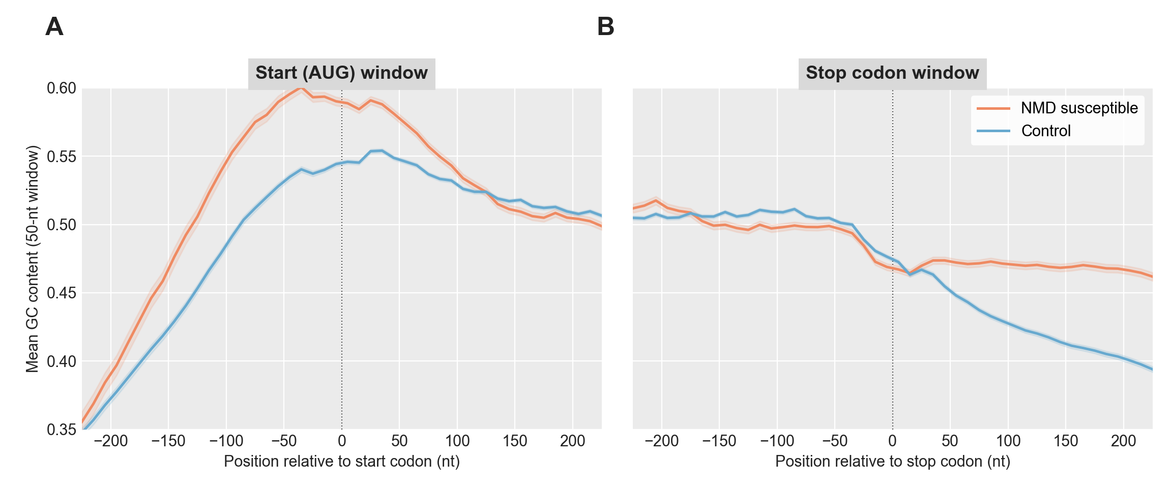
SF41 | Rolling GC Content Across the AUG and Stop-Codon Windows. Mean rolling GC content per position of the transcript sequences supplied to the deep-learning model, comparing NMD susceptible (orange) and Control (blue) transcripts on the held-out test set. Each transcript's window is centred on its main open reading frame's start or stop codon. Main open reading frames are chosen with the following priority: the annotated reference CDS (projected from the gene's dominant non-NMD isoform) when available; otherwise the TransDecoder2-called CDS; otherwise the highest-Kozak-scoring open reading frame (see Methods, Main open reading frame selection). NMD susceptible transcripts are restricted here to those whose main open reading frame is the annotated reference CDS (n = 1,743 of 2,268 NMD test transcripts, 76.9%), so that position 0 is the reference stop codon rather than a downstream TransDecoder2 stop codon; Control transcripts are unrestricted (n = 7,863). GC content is computed in a 50-nt sliding window with a 10-nt step from the model's one-hot nucleotide input channels; shading, ± 1 standard error of the mean. A) AUG window. B) Stop codon window.

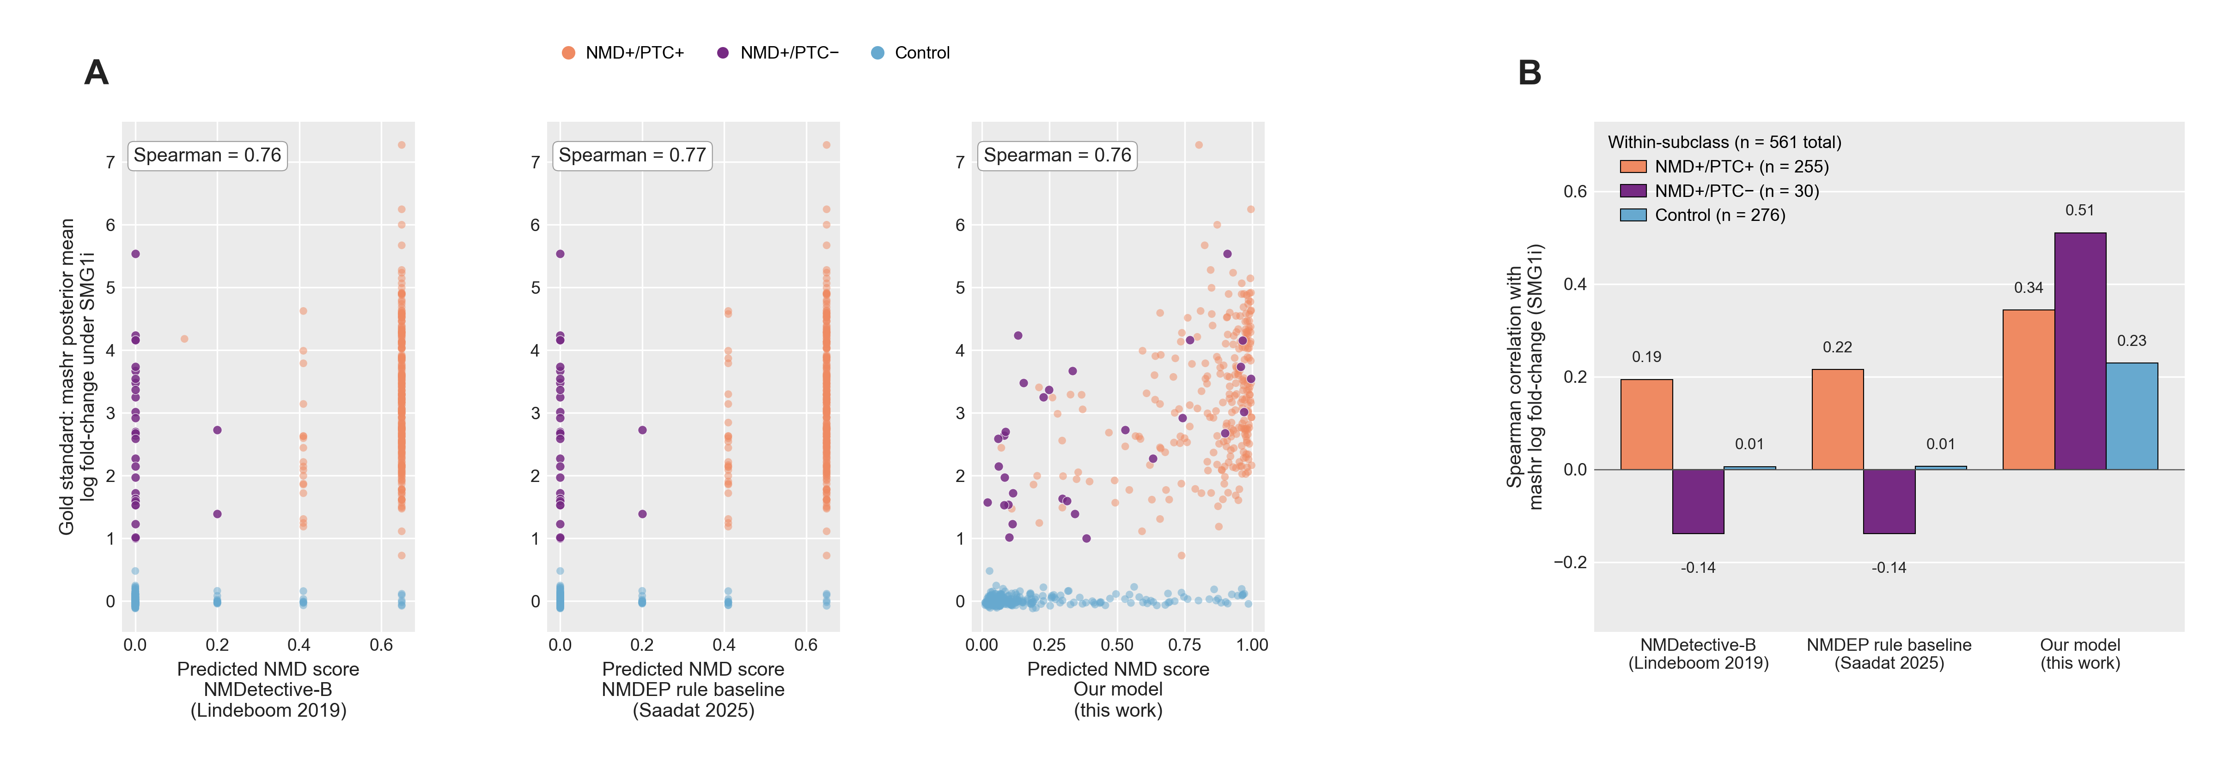
SF42 | Head-to-head correlation of three NMD predictors with the mashr gold standard, pooled and per PTC subclass. Three NMD-prediction models are scored against the same continuous gold standard — the mashr posterior-mean log₂ fold-change of each transcript under SMG1 inhibition — on the held-out test set of long-read-observed transcripts (chromosomes 1, 3, 5, 7; n = 561 total: 255 NMD-susceptible with a premature termination codon (NMD+/PTC+), 30 NMD-susceptible without a premature termination codon (NMD+/PTC−), and 276 non-NMD Controls). The models compared are NMDetective-B (Lindeboom et al. 2019), the NMDEP rule-tree baseline (Saadat & Fellay 2025), and the deep-learning model developed here.
(A) Predicted NMD score (x-axis) versus the gold-standard log fold-change (y-axis), one subpanel per model. Each point is one transcript, coloured by subclass. Pooled Spearman correlation is annotated. All three models reach a similar pooled correlation (0.76–0.77), driven by the easy separation of NMD-susceptible transcripts from Controls.
(B) Within-subclass Spearman correlation per model — the same scoring restricted to one PTC subclass at a time, isolating each model's ability to rank-order NMD susceptibility among transcripts of the same class. The deep-learning model achieves Spearman 0.34 (PTC+), 0.51 (PTC−), and 0.23 (Control). The two rule-tree models achieve ≤0.22 within PTC+, ≤0.01 within Controls, and are anti-correlated with the gold standard within PTC− (Spearman −0.14), because every PTC− transcript is by definition not flagged as a premature stop by the rule cascade despite being a real NMD substrate.
Abbreviations. mashr, multivariate adaptive shrinkage; NMD, nonsense-mediated decay; NMDEP, neural-network NMD efficacy predictor (Saadat & Fellay 2025); PTC, premature termination codon; SMG1, suppressor of morphogenesis in genitalia-1 (the kinase whose inhibition stabilises NMD substrates).

