Manuscript Supplemental Figures
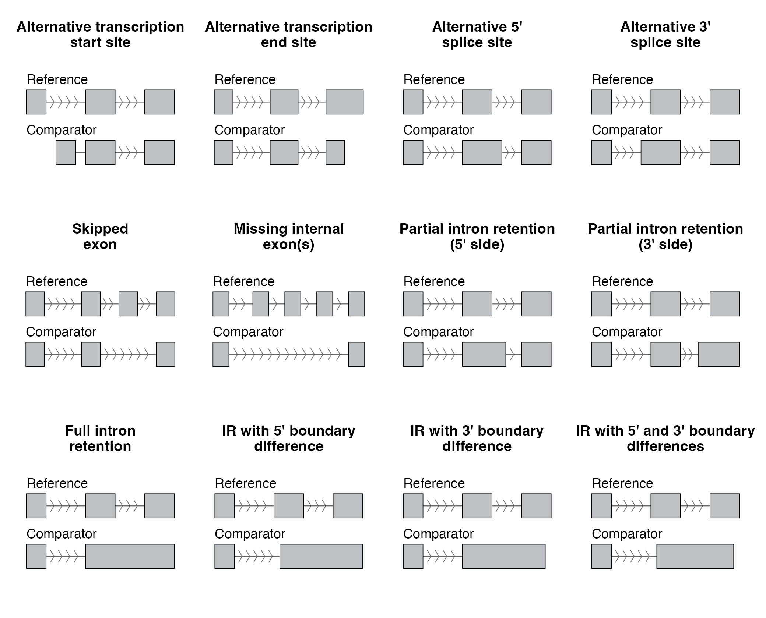
SF24 | Twelve Isopair Splice Event Categories. Schematic of the twelve splice-event types identified when comparing a paired isoform (Comparator, bottom track) to the gene's dominant non-NMD isoform (Reference, top track). Grey boxes, exons; horizontal lines with chevrons, introns (chevrons point in the direction of transcription, 5′ → 3′). Categories: transcript-end variants (Alt TSS, Alt TES); alternative splice sites (A5SS, A3SS); exon skipping (Skipped Exon, Missing Internal); and intron retention in six forms (Partial IR 5′, Partial IR 3′, Full IR, IR diff 5′, IR diff 3′, IR diff 5′ + 3′).

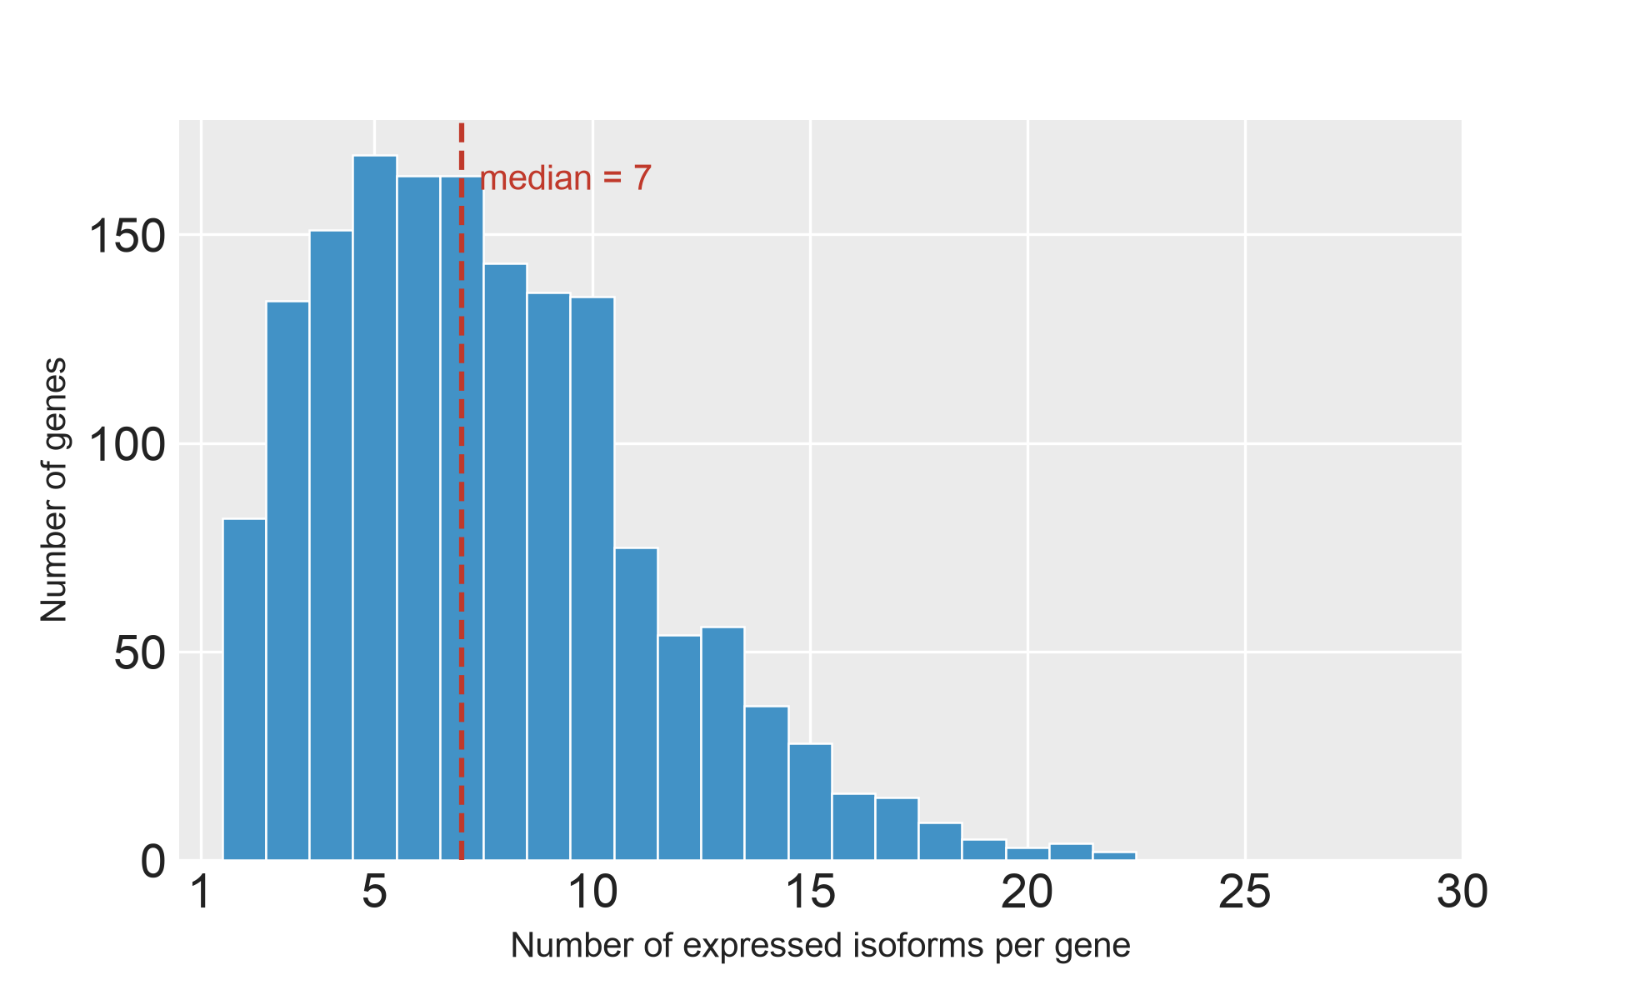
SF25 | Isoforms per Gene in Isopair Analysis. Distribution of the number of expressed isoforms per gene across the 1,585 genes for which gene-matched NMD-susceptible / reference / non-NMD isoform triplets could be constructed. The median gene contributes 7 isoforms (dashed line). Counts include all long-read isoforms passing the expression filter in at least one of the four cell types (AT2, LAE, FB, MV) under DMSO.

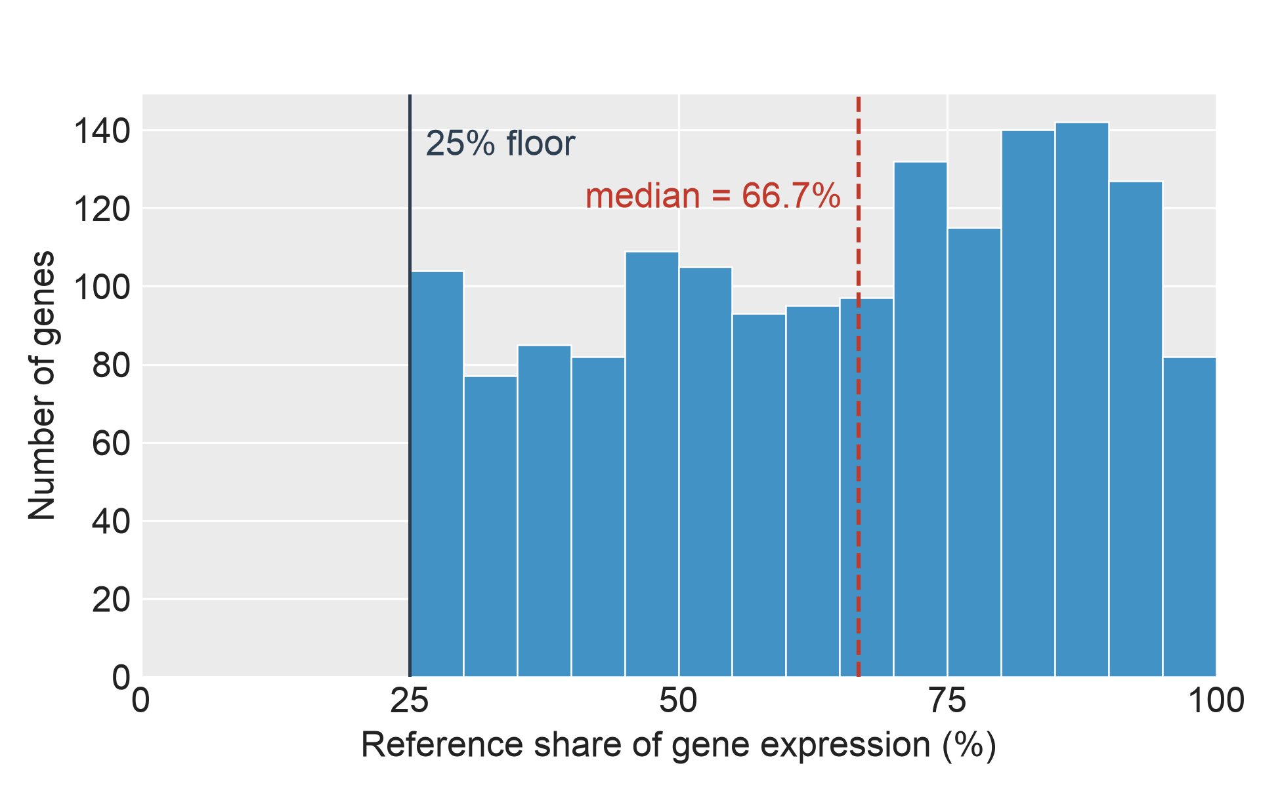
SF26 | Reference Share of Gene Expression. Distribution across 1,585 genes (each contributing a gene-matched NMD-susceptible / reference / non-NMD isoform triplet) of the reference isoform's DMSO 4-cell-type mean expression as a fraction of the parent gene's total non-NMD expression. Reference isoforms are the highest-expressed non-NMD isoform per gene under DMSO across AT2, LAE, FB and MV. Dashed line, median; dotted line, 50% threshold.

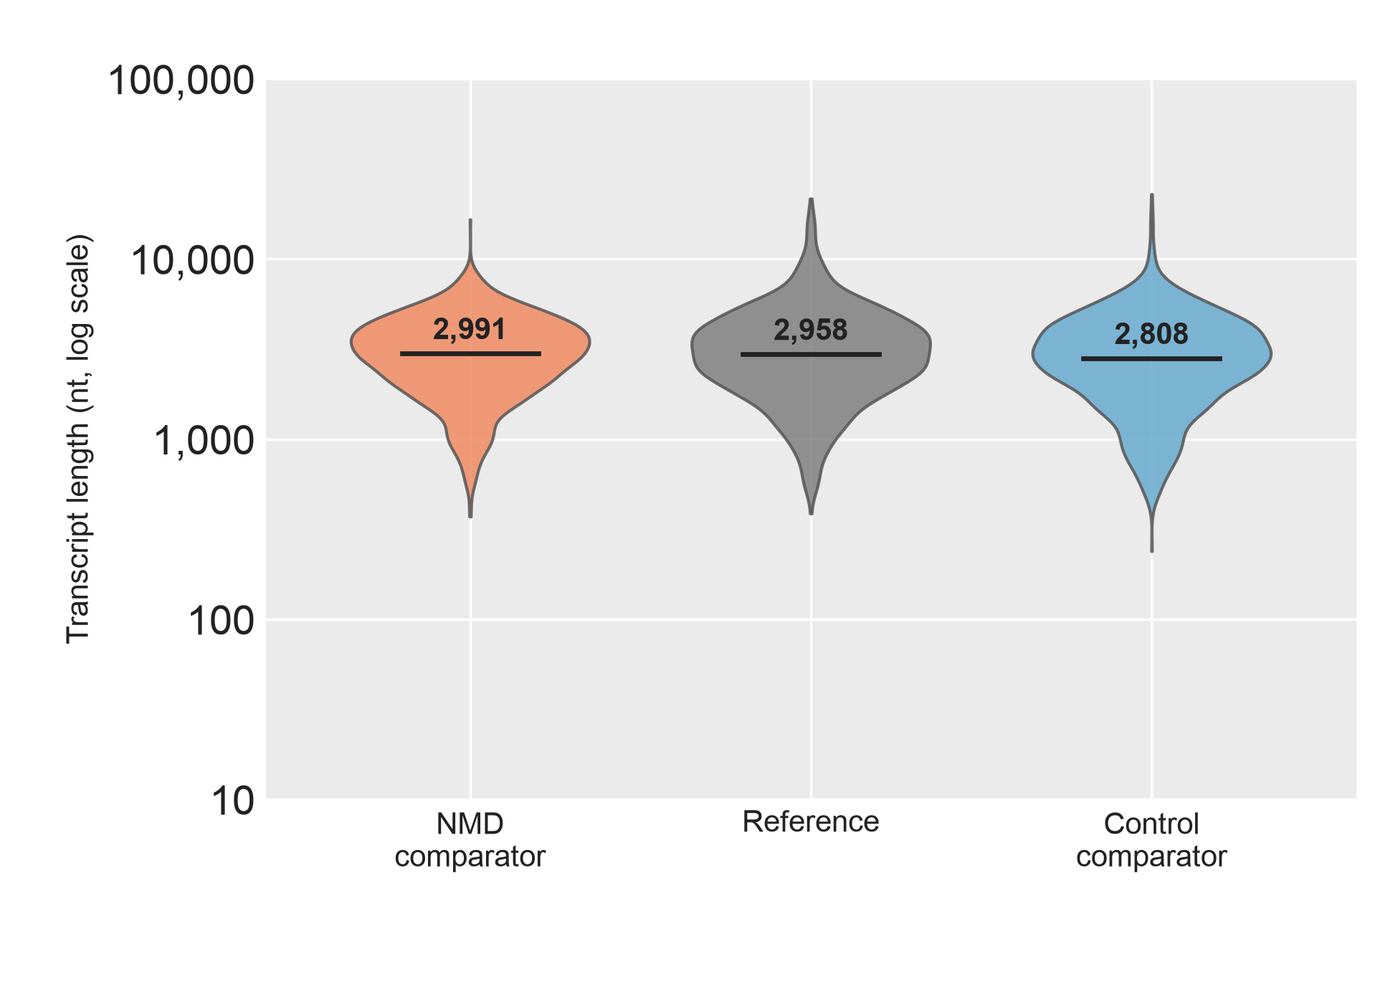
SF27 | Transcript Length by Isopair Analysis Category. Violin plot of transcript length (log10 nt) for the 1,585 gene-matched isoform triplets: NMD comparator (orange), Reference (grey), Control comparator (blue). Reference is the highest-expressed non-NMD isoform per gene under DMSO across the four cell types (AT2, LAE, FB, MV); the NMD and Control comparators are the paired NMD-susceptible and non-NMD non-reference isoforms from the same gene. Solid black bar, median. Abbreviations. nt, nucleotides.

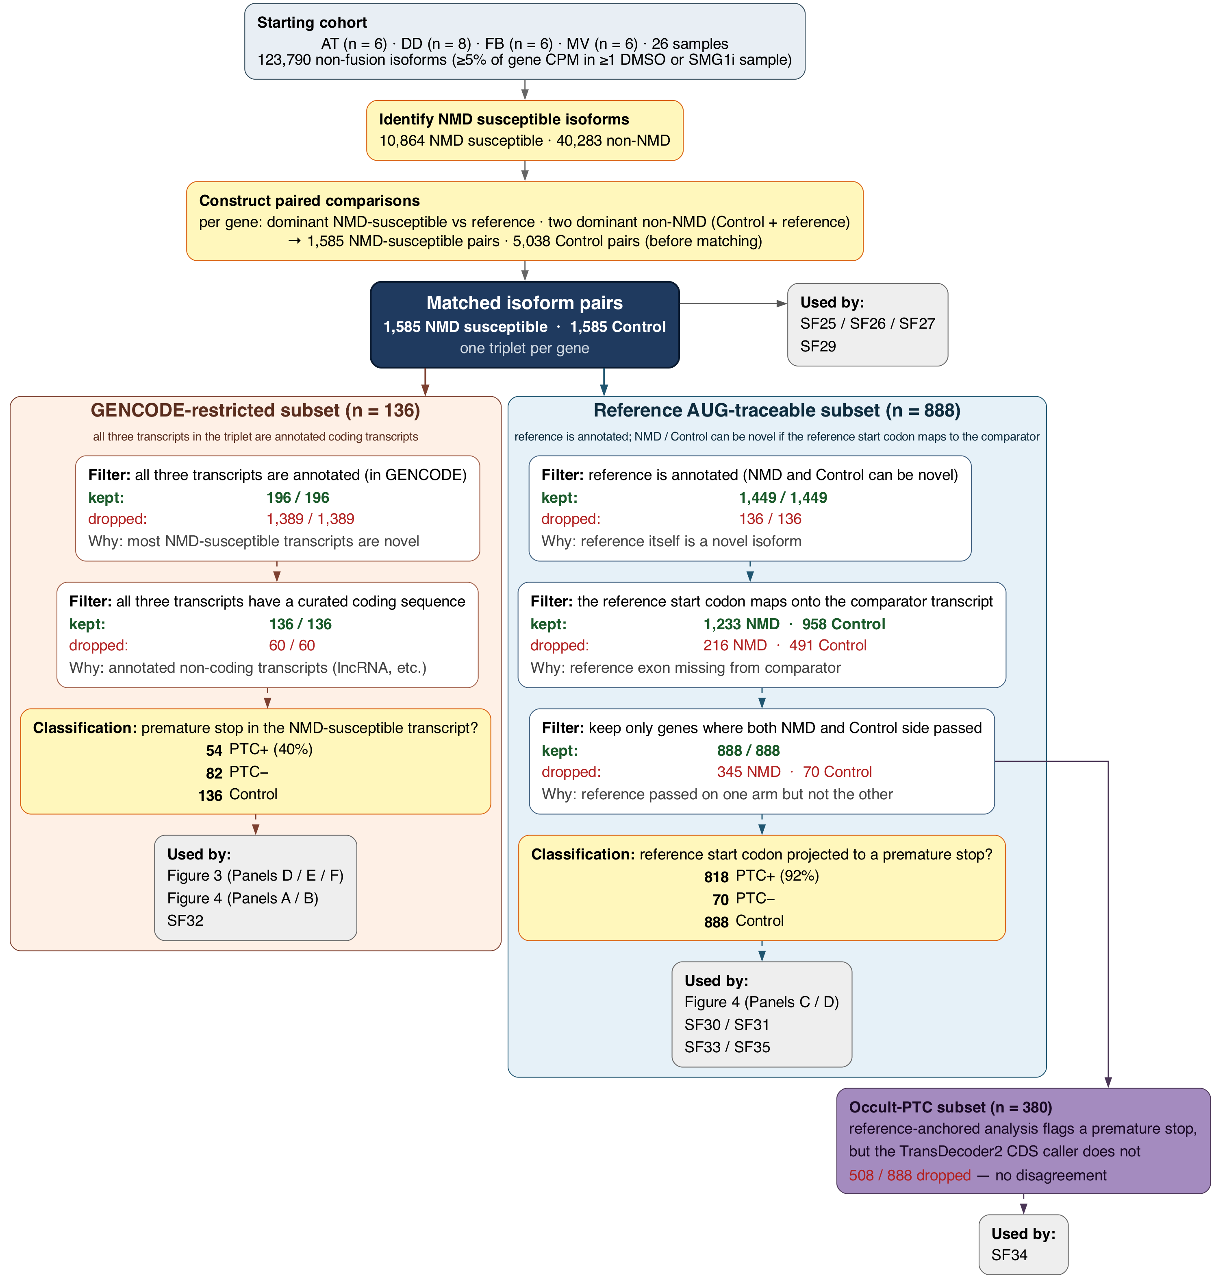
SF28 | Isopair Analysis Flowchart. Data flow for the isoform pairs analyses. Every filter step shows the number of pairs kept and dropped, and a one-line description of why each dropout happened.

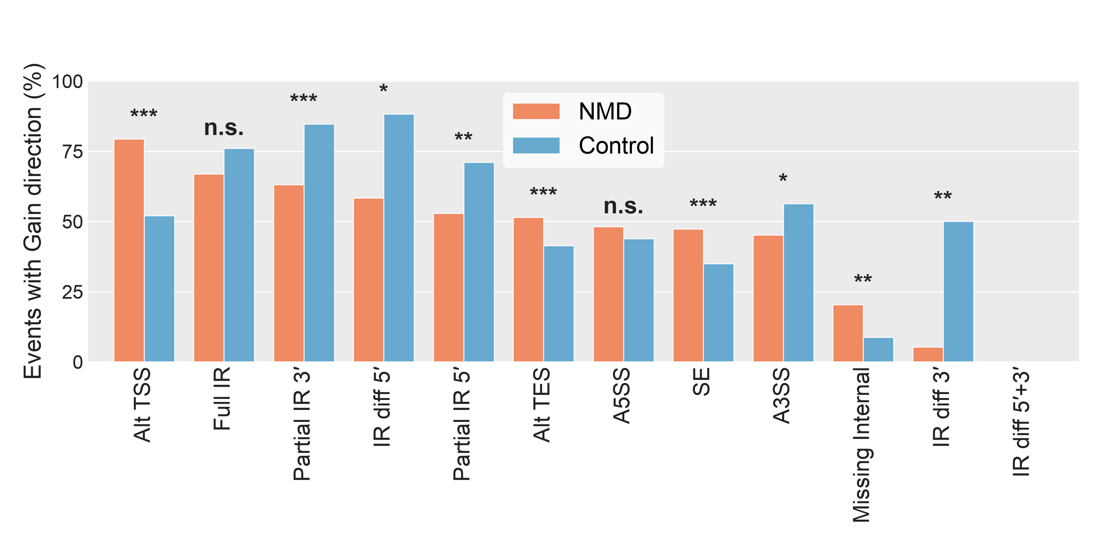
SF29 | Gain Direction by Splice Event Type. Percentage of detected splice events (across 1,585 gene-matched isoform triplets, both NMD and Control comparators) in which the comparator has additional sequence relative to its reference isoform (Gain direction). One bar-pair per event type — NMD comparators (orange) vs Control comparators (blue) — sorted by NMD-side %Gain, descending. Dashed line, 50% (no directional preference). Direction is defined from the comparator's perspective (see SF24 for event-type definitions). Significance stars, Fisher's exact test on the 2 × 2 (Gain/Loss × NMD/Control) count table per event type.

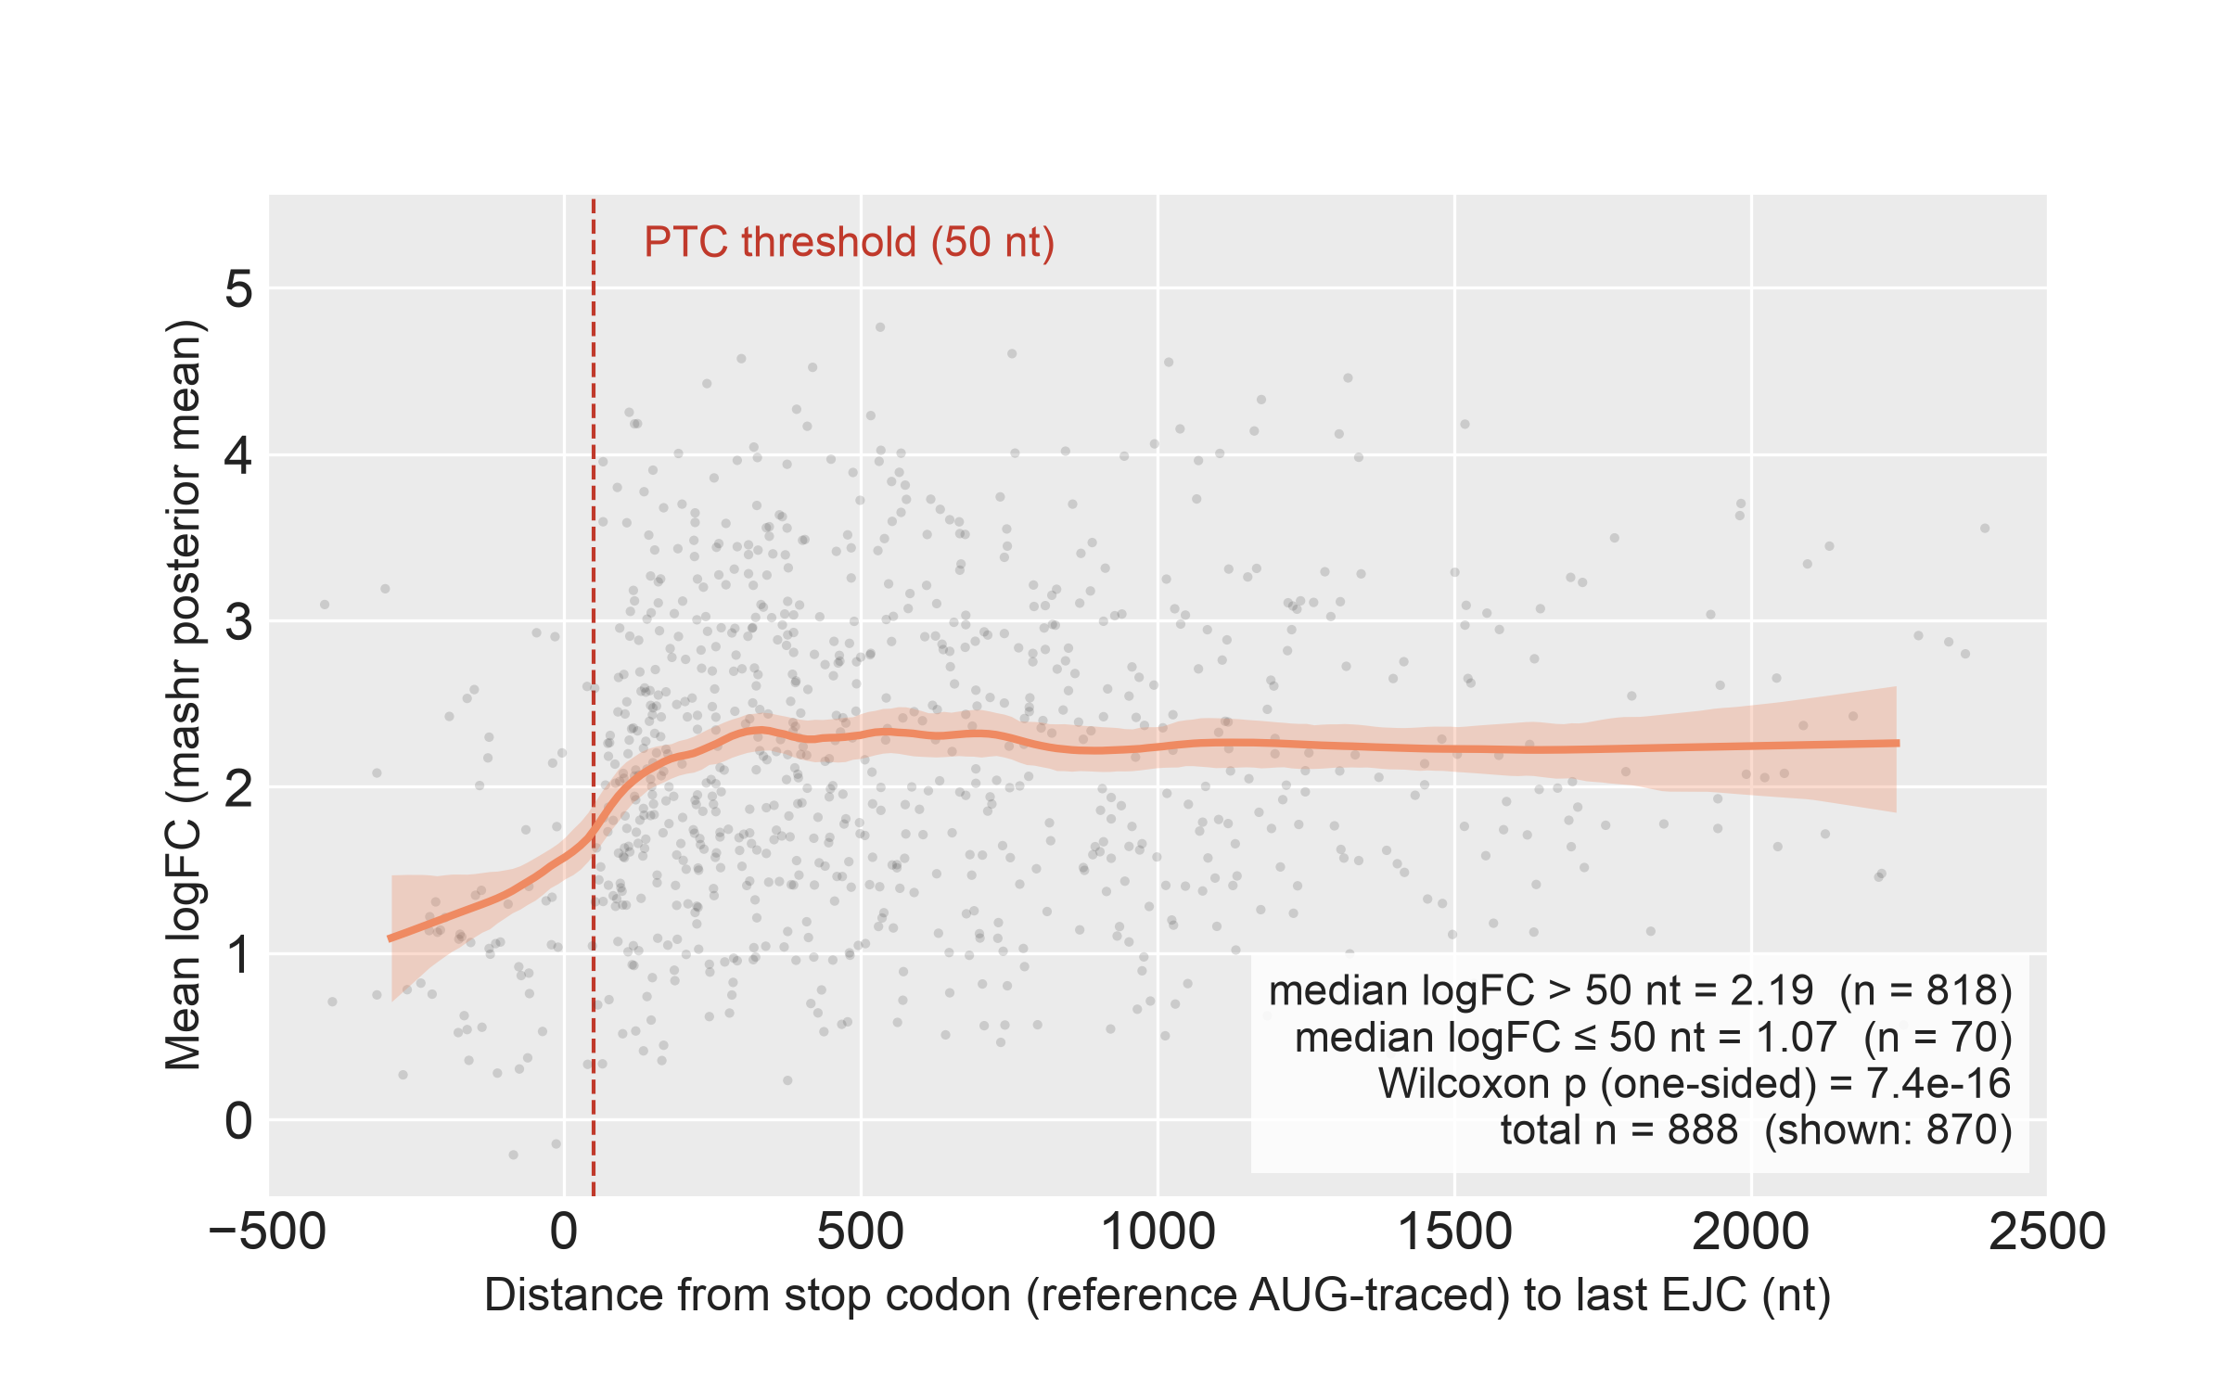
SF30 | NMD-Response Magnitude vs Stop Codon Distance to Last EJC. Per-comparator NMD-response magnitude (mashr posterior-mean log₂ fold-change under SMG1 inhibition, averaged across AT2, LAE, FB and MV) plotted against the distance from the comparator's stop codon to the transcript's last exon-junction complex. Positive values, stop codon upstream of the last EJC (candidate NMD substrate); negative values, stop codon downstream of the last EJC. Grey points, individual comparators (1st–99th percentile of x-axis shown); orange line, local-linear smoother; orange band, bootstrap 95% CI. Dashed red line, the operational 50-nt PTC threshold. Population: n = 888 comparators (all of Subset 2, gene-matched reference AUG-traceable). Stop anchor: reference AUG-traced (the first in-frame stop reached after projecting the reference gene's AUG onto the comparator); this avoids the attenuation that would arise from TD2 anchoring on non-PTC main ORFs. Median log₂ fold-change is 2.19 above the 50-nt threshold and 1.07 at or below it (Wilcoxon one-sided p = 7.4 × 10⁻¹⁶). Abbreviations. nt, nucleotides; ORF, open reading frame.

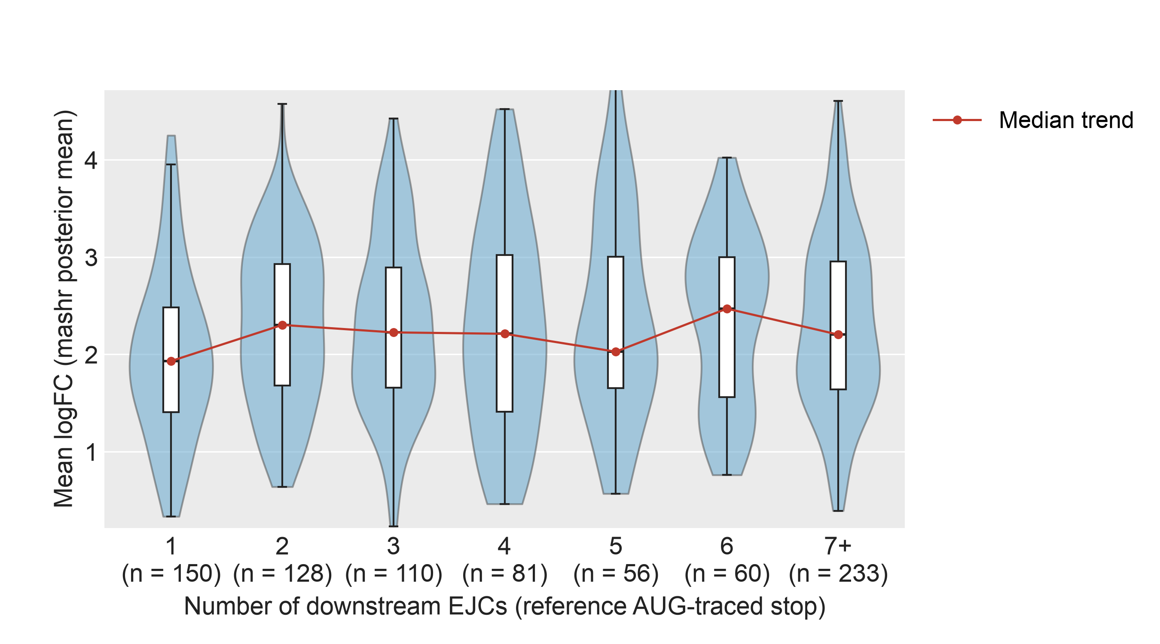
SF31 | NMD Effect Size by Downstream EJC Count in PTC-Positive NMD Comparators. Distribution of NMD-response magnitude (mashr posterior-mean log₂ fold-change under SMG1 inhibition, averaged across AT2, LAE, FB and MV) as a function of the number of exon-junction complexes downstream of the comparator's stop codon. Restricted to comparators with at least one downstream EJC (n = 818), drawn from the same Subset 2 population as SF30. Downstream-EJC counts of 7 or more are collapsed into a single "7+" bin. Violin, kernel density; overlaid box, interquartile range and median; red line, per-bin median trend. Per-bin sample counts are shown above each violin. Stop anchor: reference AUG-traced, matching SF30.

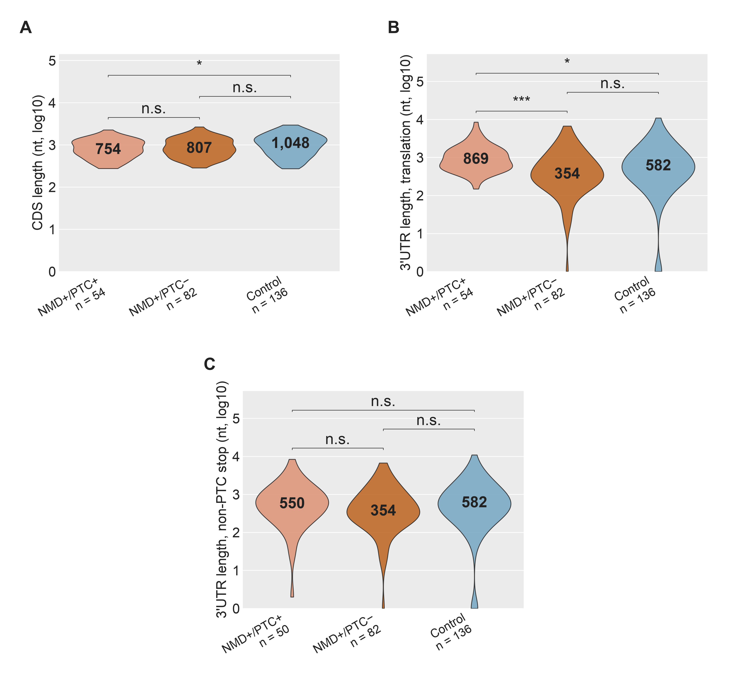
SF32 | CDS and 3′UTR Length Across Isoform Classes in the GENCODE-Restricted Isoform Pairs Subset. Restricted to triplets in which all three transcripts are annotated coding transcripts (n = 72 NMD+/PTC+, 118 NMD+/PTC−, 190 Control). Stop anchor: each isoform's own annotated CDS. (A) CDS length; (B) 3′UTR length from the annotated stop to transcript end; (C) 3′UTR length after walking past any premature stop to the first non-premature stop (Panel C NMD+/PTC+ n = 66; 6 comparators lack a downstream non-premature stop and are dropped). Solid black bar inside each violin, median. Two-sided Wilcoxon rank-sum: *p < 0.05, **p < 10⁻³, ***p < 10⁻⁴; n.s. otherwise. Abbreviations. CDS, coding sequence; PTC, premature termination codon.

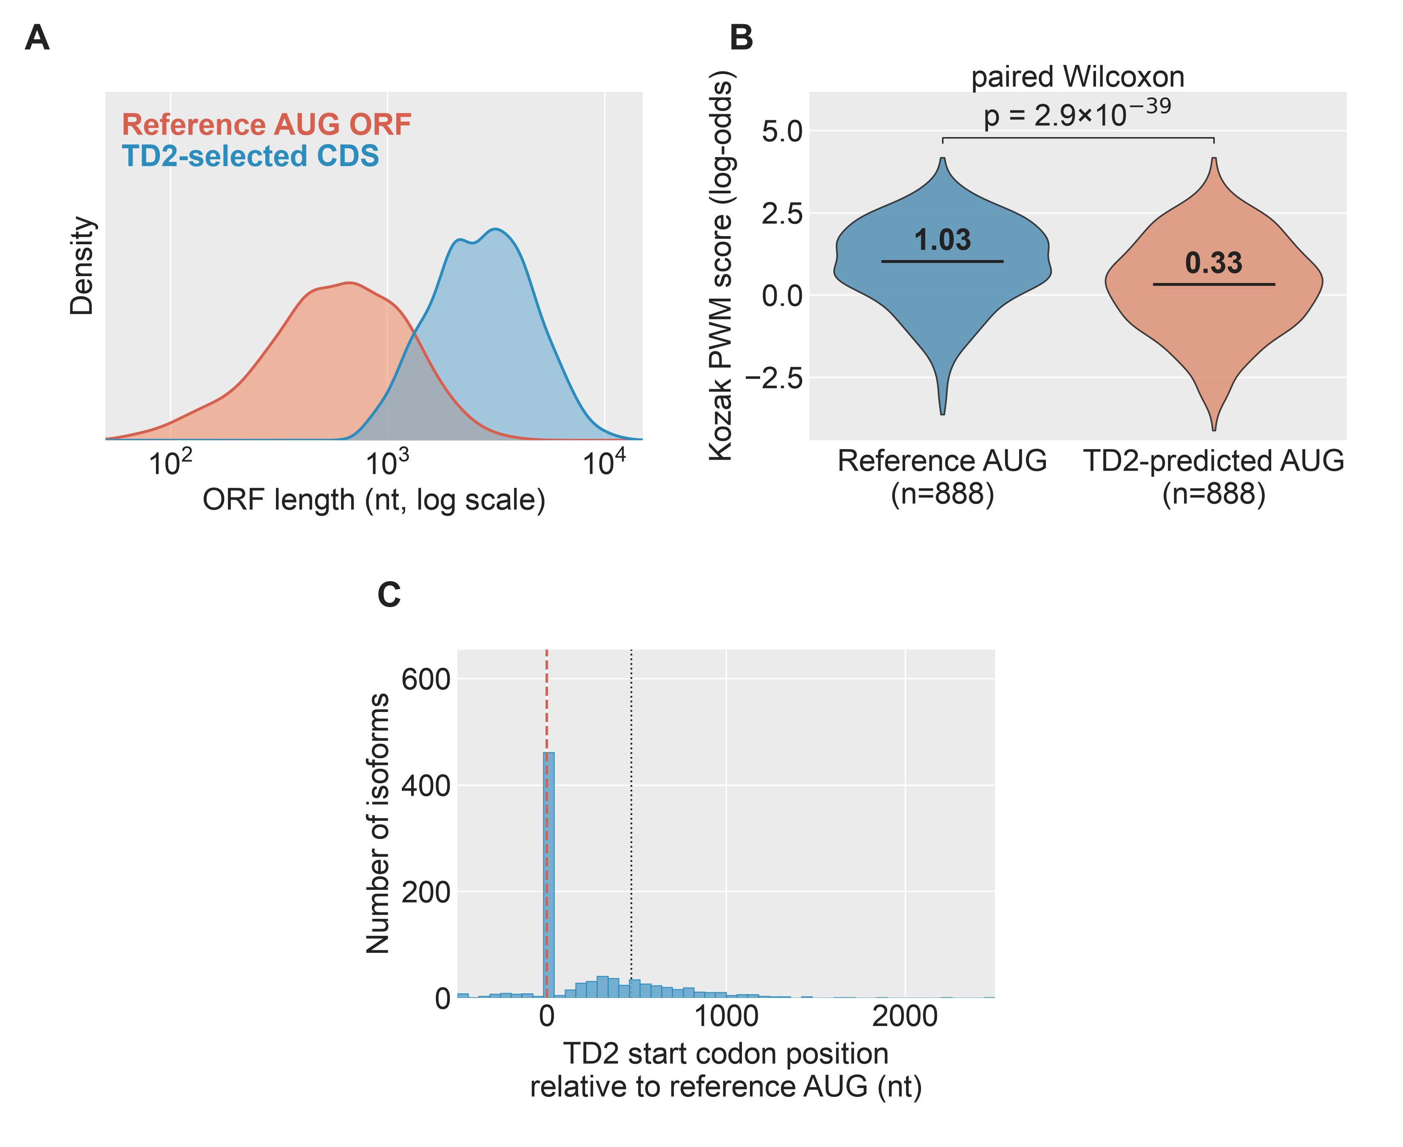
SF33 | TD2 Versus Reference AUG-Traced ORFs, Reference AUG-Traceable Cohort. n = 888 gene-matched NMD comparator pairs. (A) ORF-length distribution under the TD2 call versus under the reference AUG projected onto the same transcript. (B) Paired Kozak PWM score at the reference AUG versus at the TD2-predicted start codon. (C) Position of the TD2 AUG relative to the reference AUG (0 = same site). Solid black bar inside each violin, median. Abbreviations. ORF, open reading frame; PWM, position weight matrix; TD2, TransDecoder2.

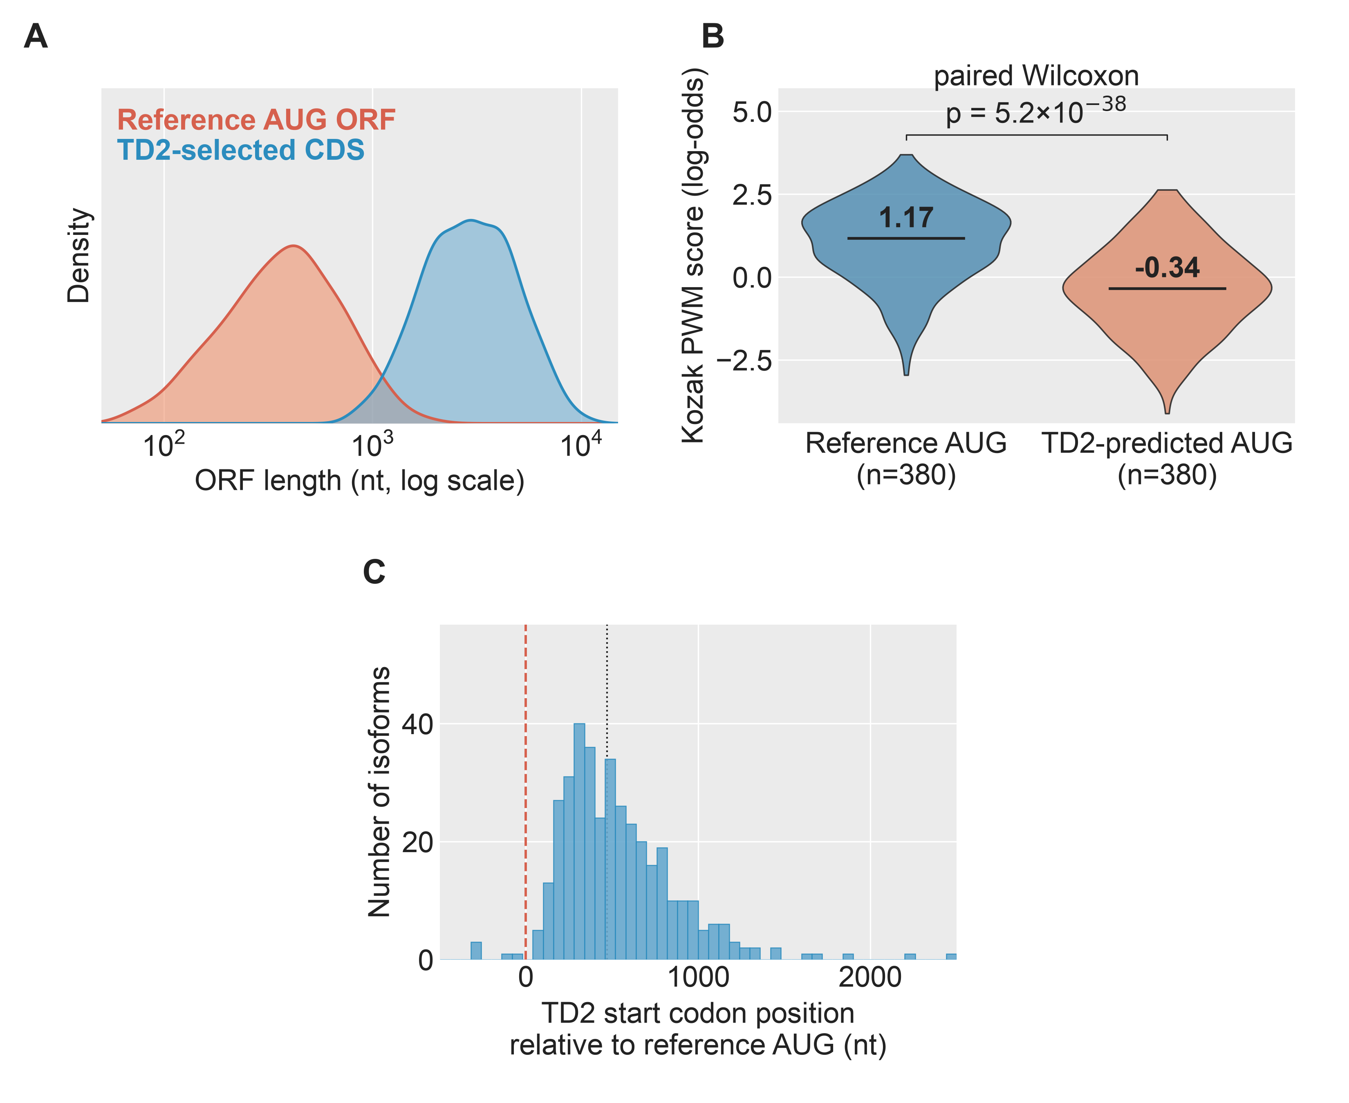
SF34 | TD2 Versus Reference AUG-Traced ORFs, Occult-PTC Subset. Restricted to the n = 380 comparators in which projecting the reference AUG revealed a PTC that the TD2 CDS call did not. Panels A–C match SF33. Abbreviations. CDS, coding sequence; ORF, open reading frame; PTC, premature termination codon; TD2, TransDecoder2.

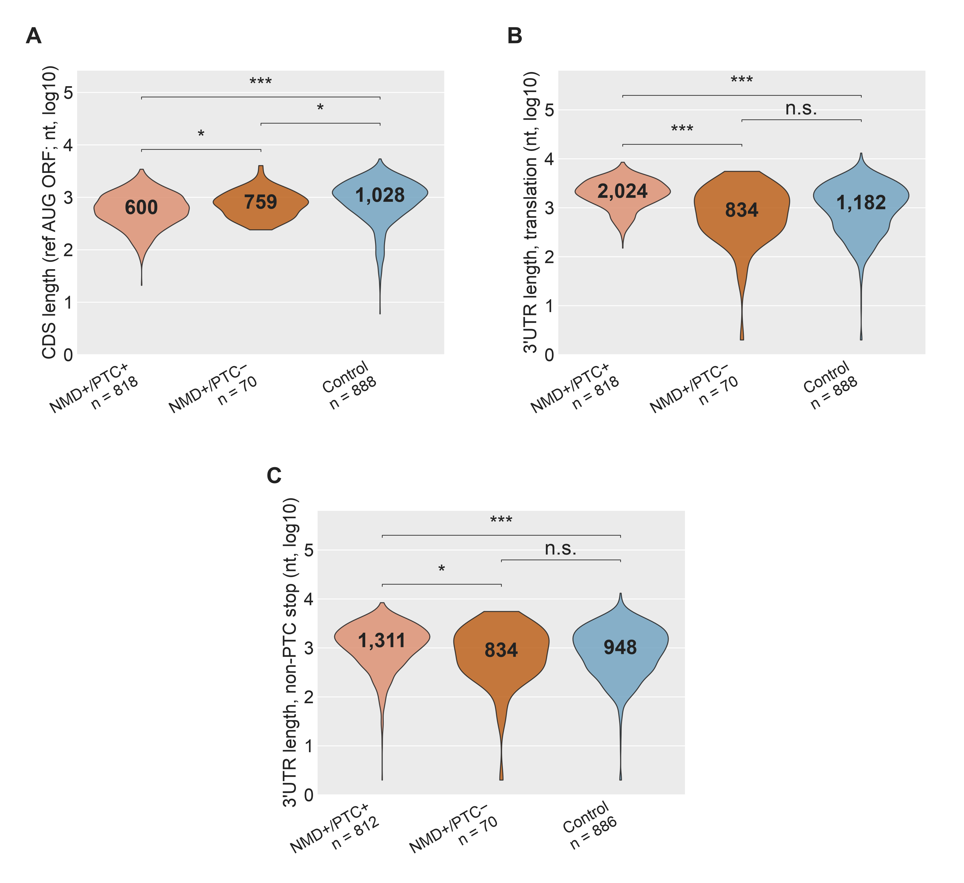
SF35 | CDS and 3′UTR Length Across Isoform Classes, Reference AUG-Traceable Cohort. Restricted to gene-matched pairs in which the reference AUG projects onto the comparator transcript (n = 818 NMD+/PTC+, 70 NMD+/PTC−, 888 Control). Stop anchor: the reference gene's AUG projected onto the comparator, which is unbiased with respect to TD2's PTC-avoidance (see SF33). Panels A–C match SF32. Solid black bar inside each violin, median. (Panel C NMD+/PTC+ n = 812 and Control n = 886; comparators without a downstream non-premature stop are dropped.) Two-sided Wilcoxon rank-sum: *p < 0.05, **p < 10⁻³, ***p < 10⁻⁴; n.s. otherwise. Abbreviations. CDS, coding sequence; PTC, premature termination codon; TD2, TransDecoder2.

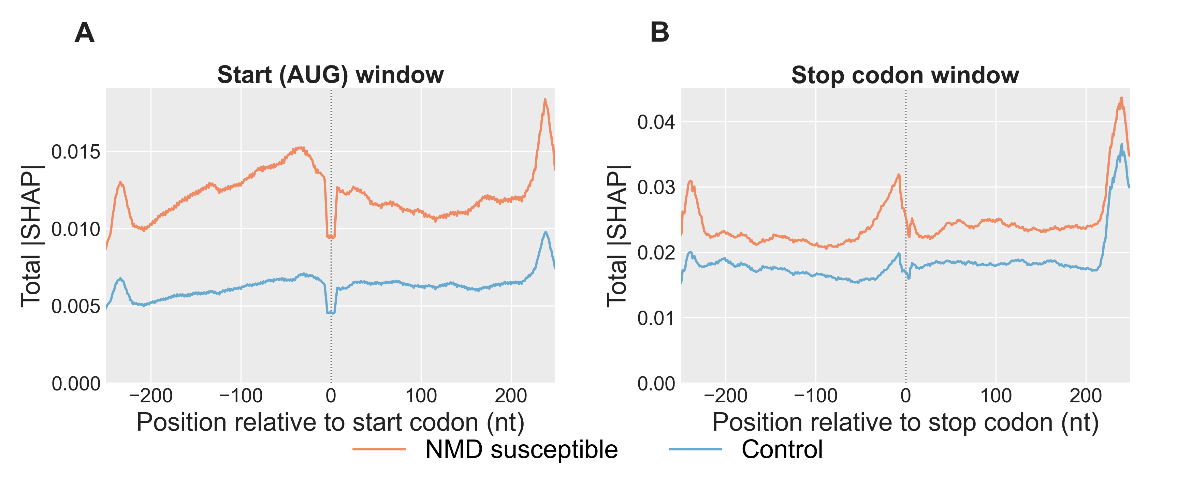
SF36 | Total |SHAP| Across the AUG and Stop Codon Windows. Per-position |SHAP| summed across the nine input channels of the deep-learning model, comparing NMD susceptible (orange) and Control (blue) transcripts on the held-out test set (NMD n = 2,268, Control n = 7,863). Each transcript's AUG and stop windows are centered on its main ORF's start and stop codons. Main ORFs are chosen with the following priority: the annotated reference CDS (projected from the gene's dominant non-NMD isoform) when available; otherwise the TransDecoder2-called CDS; otherwise the highest-Kozak-scoring ORF (see Methods, Main ORF selection). Values are smoothed with an 11-nt rolling mean over the raw per-position |SHAP| to abstract over trinucleotide-frame periodicity. A) AUG window covering positions –250 to +249 relative to the start codon. B) Stop codon window covering the same relative range around the stop codon. Pooled across 5 DeepSHAP runs (500 background samples each). Abbreviations. nt, nucleotides; ORF, open reading frame.

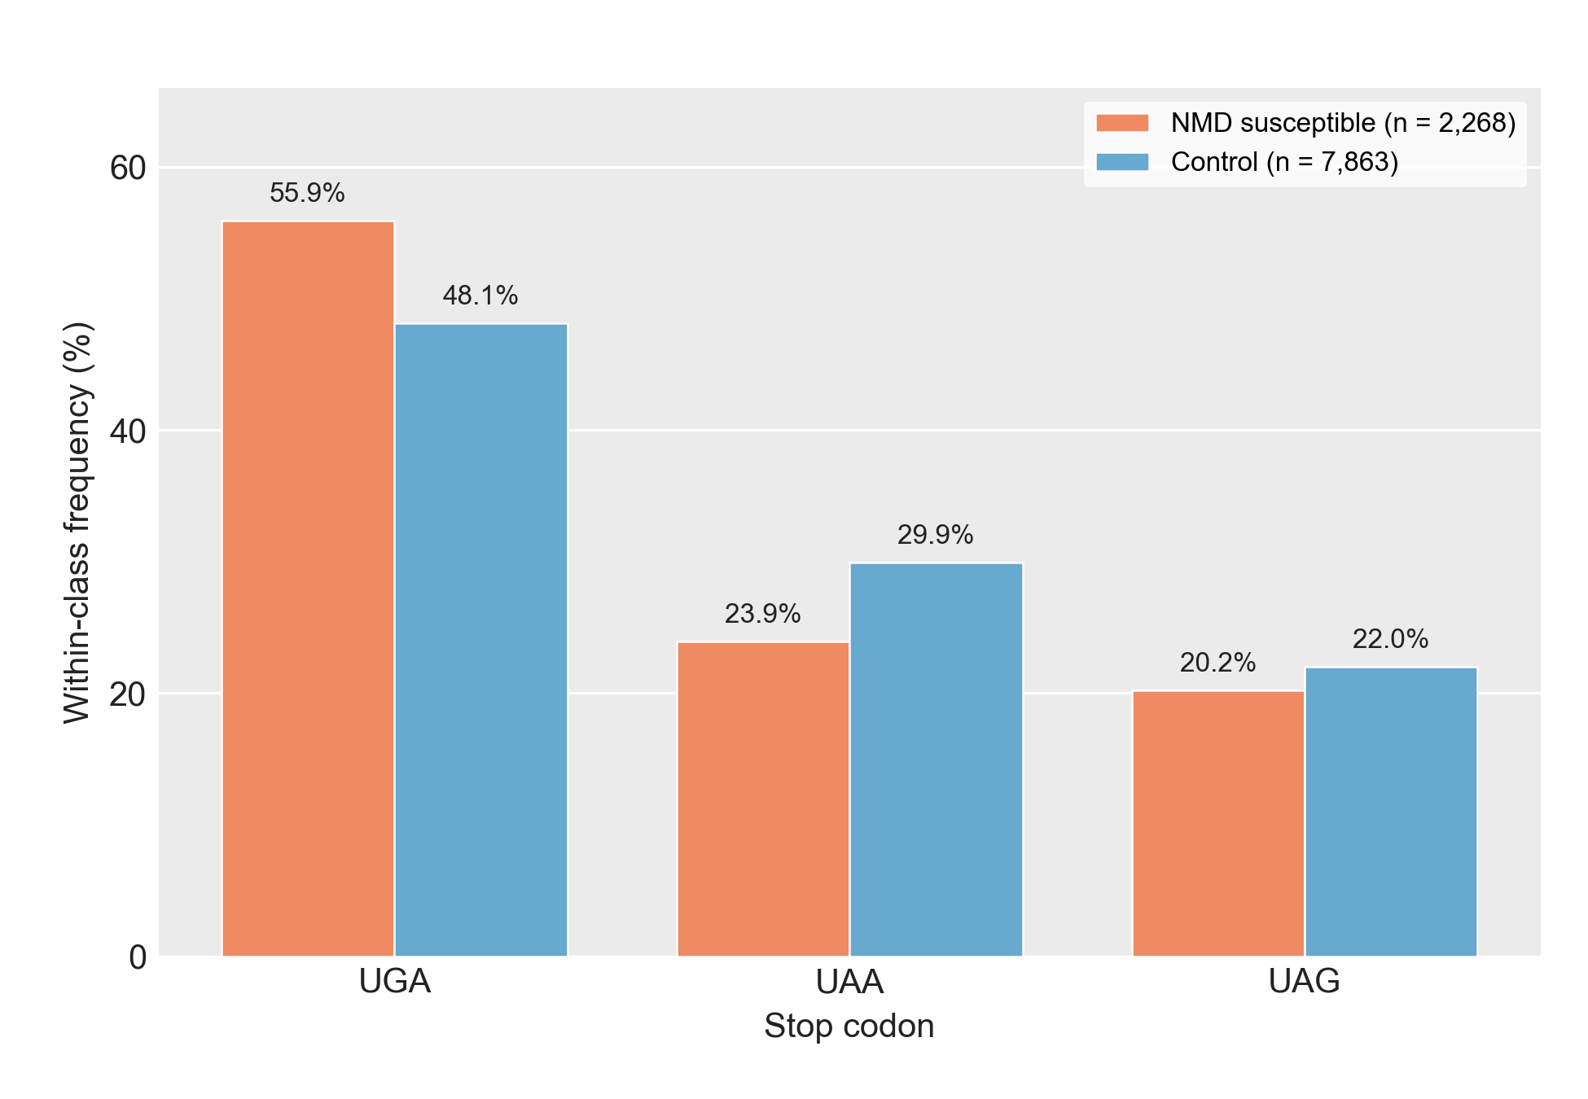
SF37 | Stop Codon Usage in NMD Susceptible vs Non-NMD Isoforms. Within-class frequency of the three canonical stop codons (UGA / UAA / UAG) at the main ORF of each transcript in the deep-learning model's held-out test set (n = 2,268 NMD susceptible, n = 7,863 non-NMD). Main ORFs are chosen with the following priority: the annotated reference CDS (projected from the gene's dominant non-NMD isoform) when available; otherwise the TransDecoder2-called CDS; otherwise the highest-Kozak-scoring ORF (see Methods, Main ORF selection). Percentages: UGA 55.9% vs 48.1%; UAA 23.9% vs 29.9%; UAG 20.2% vs 22.0%. Abbreviations. ORF, open reading frame; UGA / UAA / UAG, the three canonical stop codons in RNA notation.

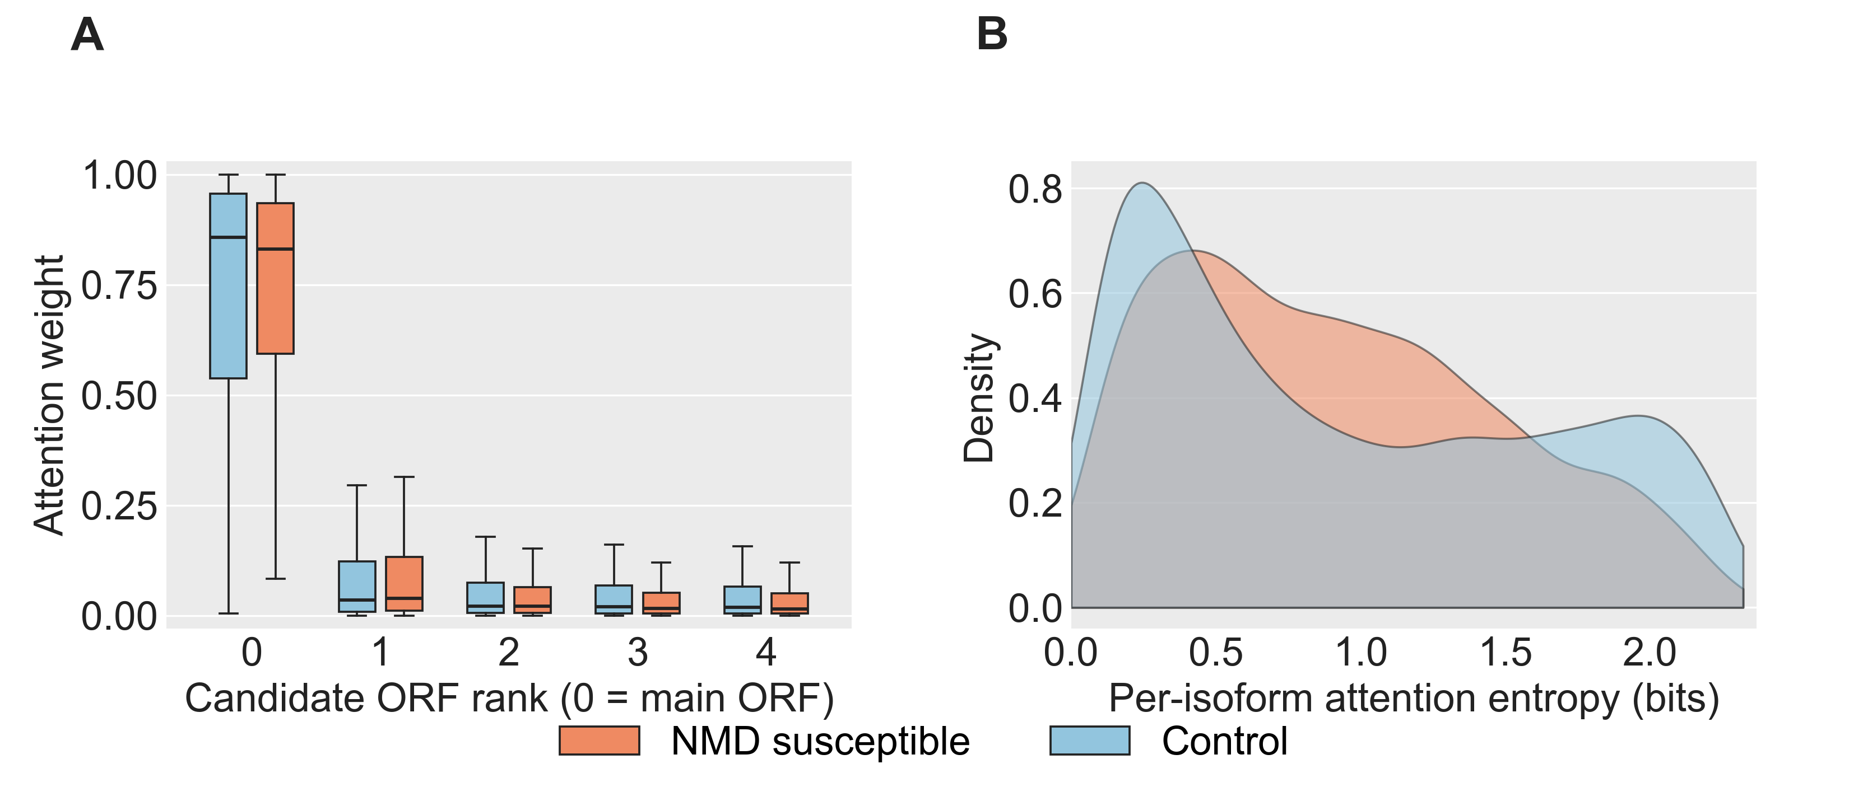
SF38 | Attention Distribution Across the Model's Five Candidate ORFs, NMD Susceptible vs Non-NMD. Held-out test set (NMD n = 2,268; Control n = 7,863). ORF candidates are ranked by the priority described in Methods; rank-0 is the main ORF. (A) Attention weight per candidate ORF rank, by class. (B) Shannon entropy of the per-isoform attention vector across the five candidates; higher entropy indicates more broadly distributed attention. Abbreviations. ORF, open reading frame.

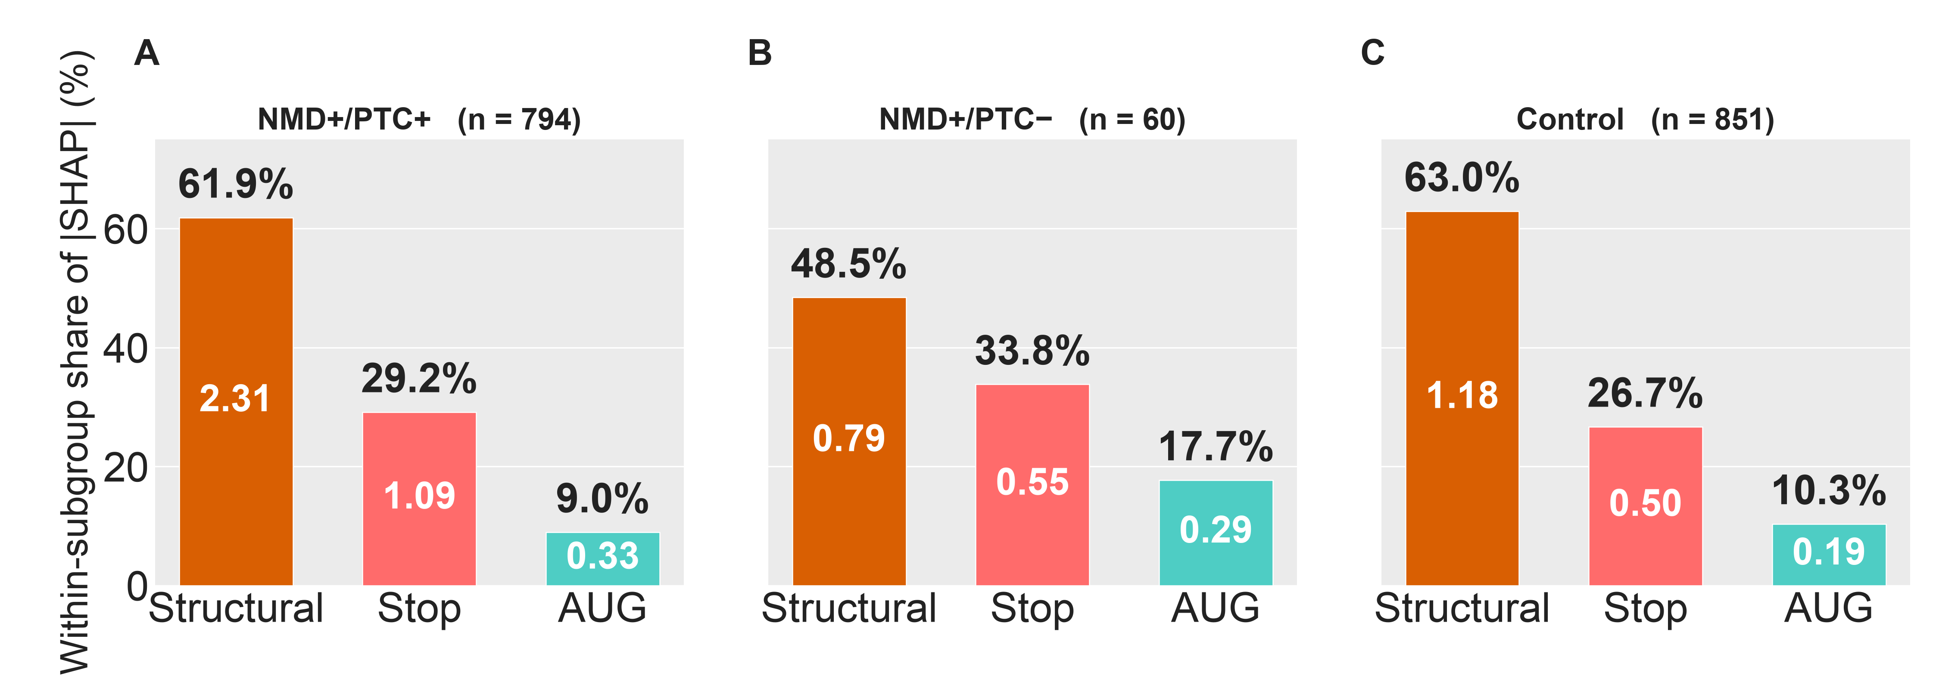
SF39 | Branch-Level Shapley Attributions of the Deep-Learning Model, Stratified by Isoform PTC Subclass. Attributions of the model's NMD prediction across the three input branches (start codon window, stop codon window, structural features), computed for every isoform in each subclass. Subclasses: NMD+/PTC+ (n = 1,016), NMD+/PTC− (n = 95), Control (n = 1,107). Interpretability is computed on all reference AUG-traceable isoforms (not restricted to the held-out test set), so subgroup sample sizes are larger than in SF40, which reports discrimination on the held-out test subset only. (A) NMD+/PTC+. (B) NMD+/PTC−. (C) Control. Within each panel, bars are ordered structural / stop / start; the value in each bar is the mean absolute Shapley attribution at that branch; the percentage above each bar is that branch's share of the subclass total. Abbreviations. PTC, premature termination codon.

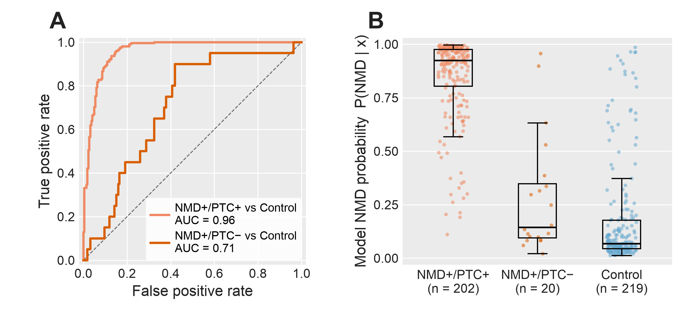
SF40 | Deep-Learning Model Discrimination by PTC Subclass on the Held-Out Test Set. Held-out test-set performance of the trained NMD predictor, stratified by the three subclasses: NMD+/PTC+ (n = 255), NMD+/PTC− (n = 30), and Control (n = 276). Subgroup sample sizes reflect held-out-test-set membership. (A) ROC curves for the two NMD-vs-Control contrasts, using the model's predicted NMD probability as the score; AUC annotated per contrast; diagonal, chance. (B) Distribution of per-isoform predicted NMD probability by subclass. Abbreviations. AUC, area under the ROC curve; PTC, premature termination codon; ROC, receiver-operating-characteristic.

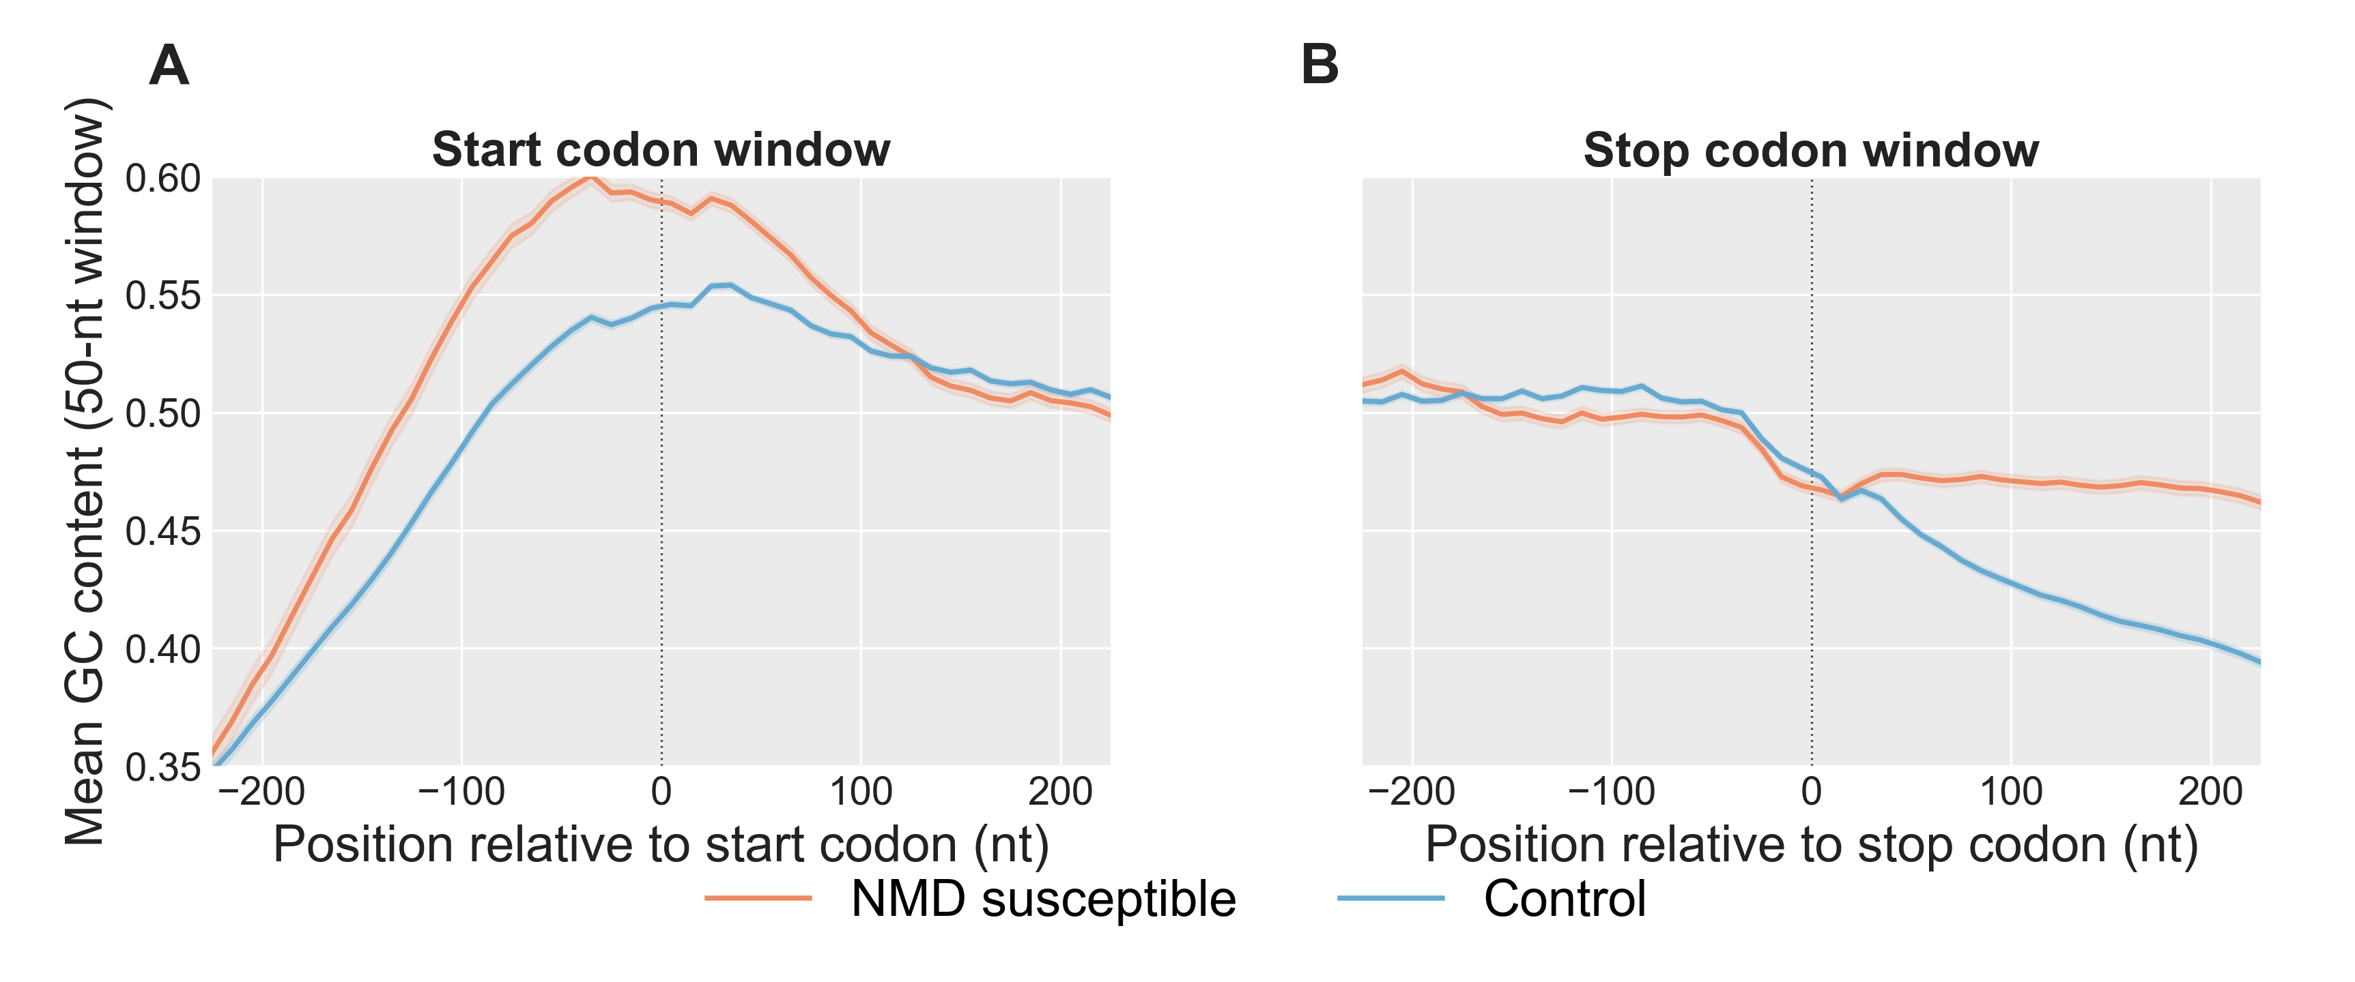
SF41 | Rolling GC Content Across the Start Codon and Stop Codon Windows. Mean rolling GC content per position, comparing NMD susceptible (orange) and Control (blue) transcripts on the held-out test set. Windows are centered on each transcript's main ORF start or stop codon; main ORFs are chosen as described in Methods. NMD susceptible transcripts are restricted to those whose main ORF is the annotated reference CDS (n = 1,743 of 2,268 NMD test transcripts, 76.9%), so that position 0 is the reference stop codon; Control transcripts are unrestricted (n = 7,863). GC content is computed in a 50-nt sliding window with a 10-nt step from the model's one-hot nucleotide input channels; shading, ± 1 SEM. (A) Start codon window. (B) Stop codon window. Abbreviations. CDS, coding sequence; GC, guanine + cytosine; nt, nucleotides; ORF, open reading frame; SEM, standard error of the mean.

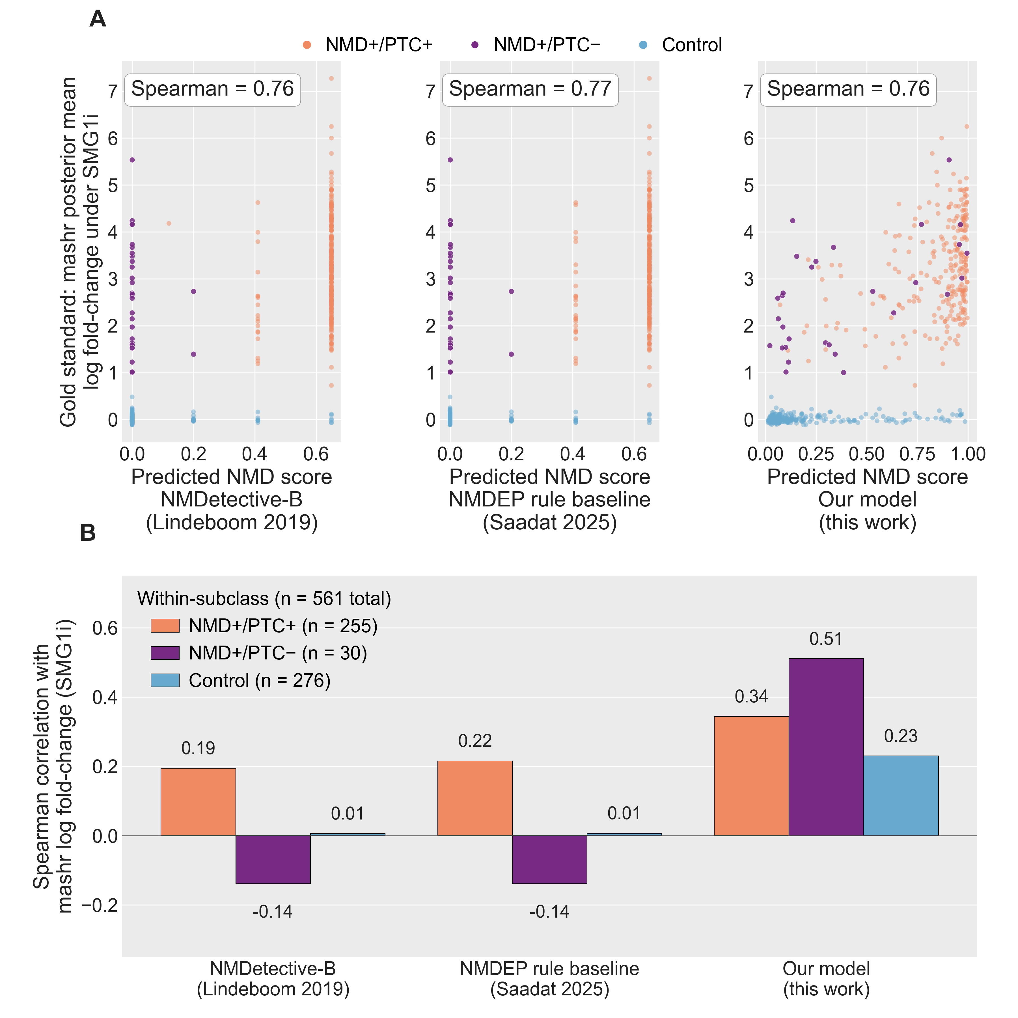
SF42 | Head-to-Head Correlation of Three NMD Predictors With the mashr Gold Standard, Pooled and per PTC Subclass. Predictors scored against the mashr posterior-mean log₂ fold-change under SMG1 inhibition on the held-out test set of long-read observed transcripts (chromosomes 1, 3, 5, 7; n = 561: NMD+/PTC+ 255, NMD+/PTC− 30, Control 276). Predictors: NMDetective-B (Lindeboom et al. 2019); NMDEP rule-tree baseline (Saadat & Fellay 2025); the deep-learning model. (A) Predicted NMD score versus gold-standard log₂ fold-change, one subplot per model; points colored by subclass; pooled Spearman correlation annotated. (B) Within-subclass Spearman correlation per model. Abbreviations. mashr, multivariate adaptive shrinkage; NMDEP, NMD efficacy predictor; PTC, premature termination codon.

