Manuscript Supplemental Figures
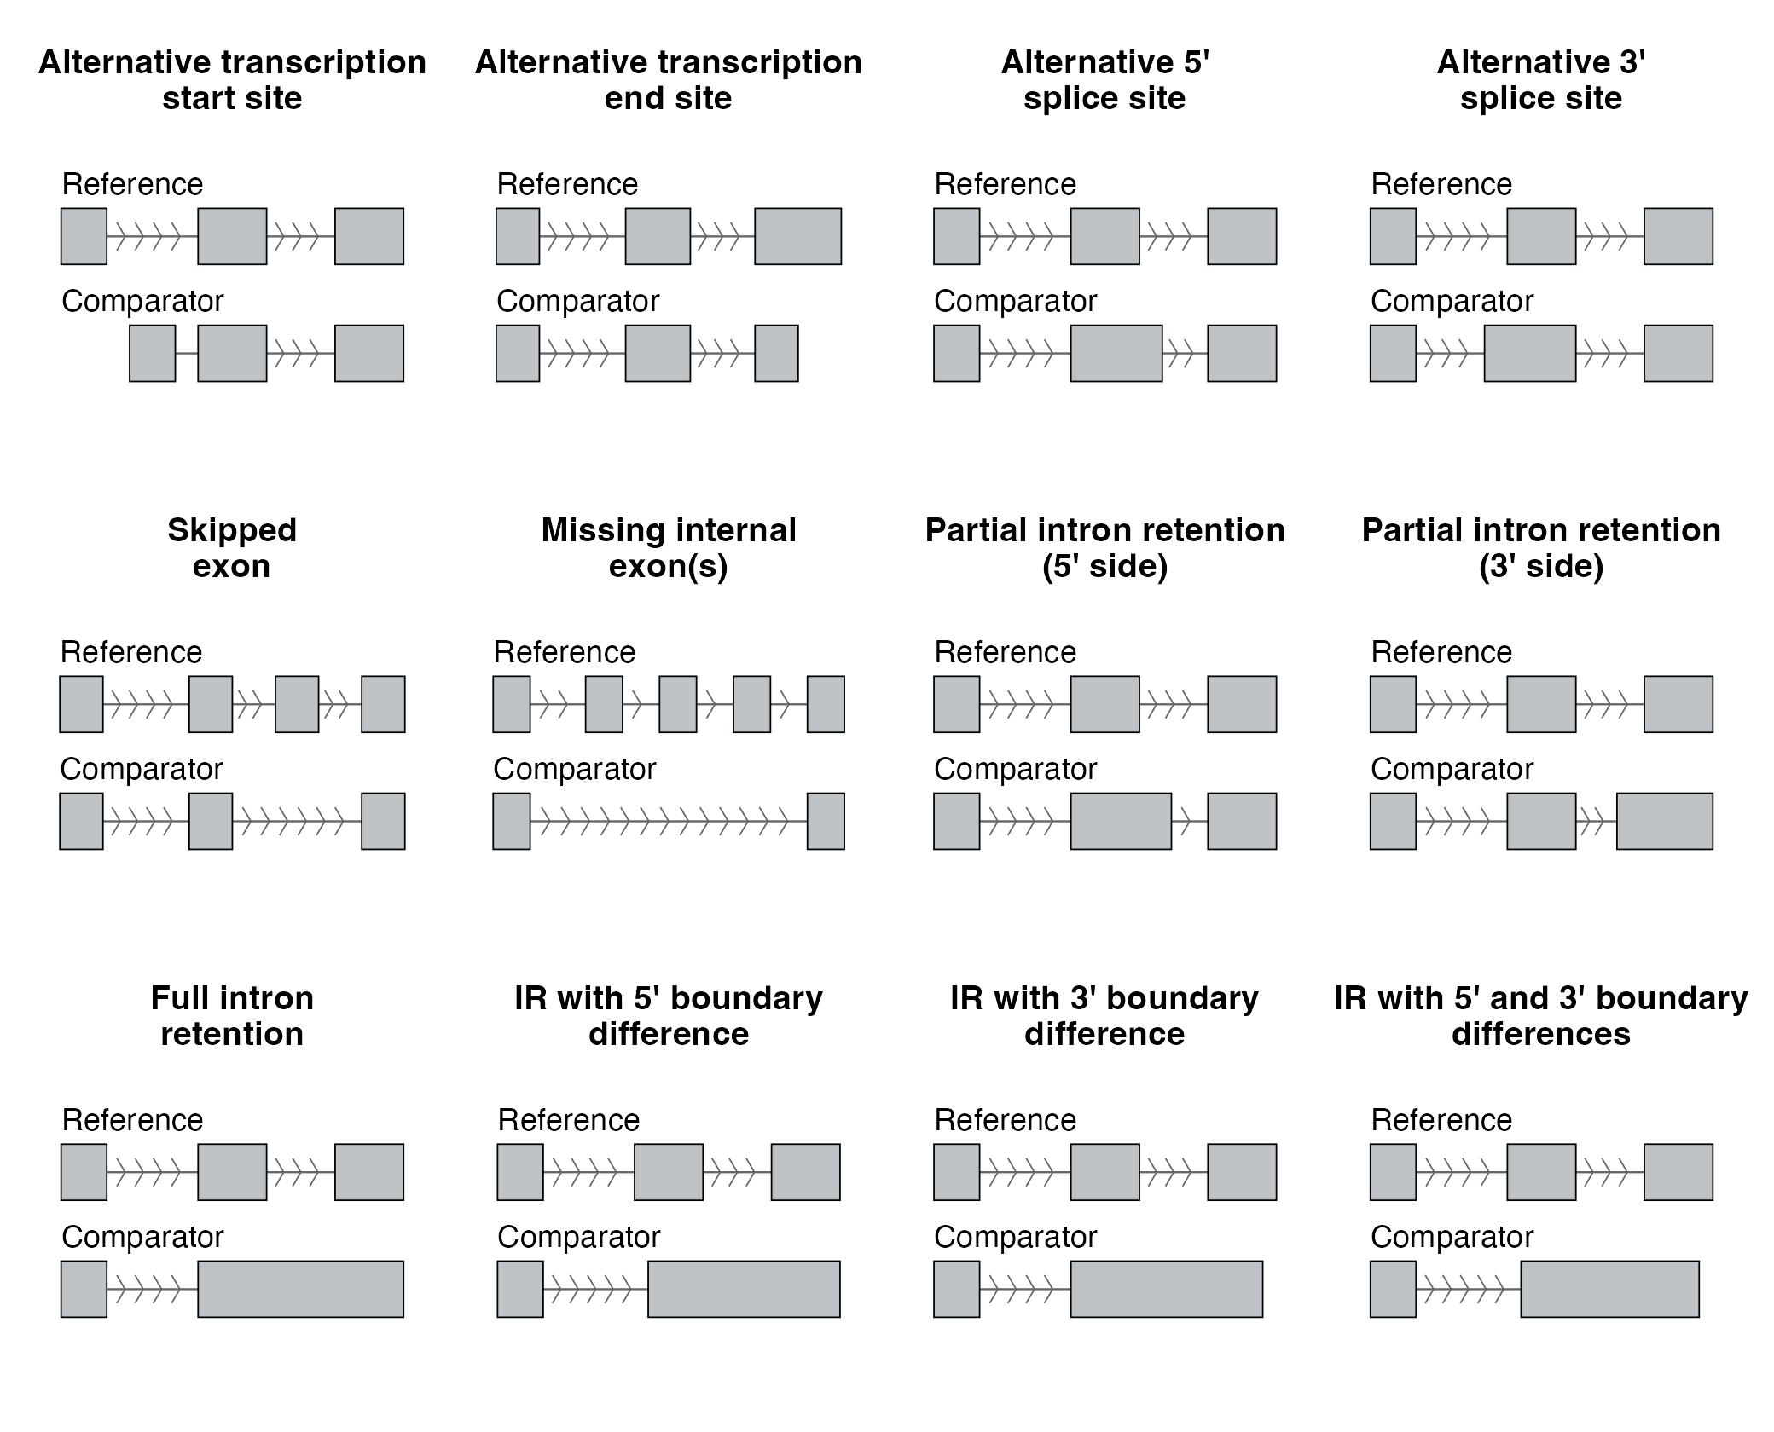
SF24 | Twelve Isopair Splice Event Categories. Schematic of the twelve splice-event types identified when comparing a paired isoform (Comparator, bottom track) to the gene's dominant non-NMD isoform (Reference, top track). Grey boxes, exons; horizontal lines with chevrons, introns (chevrons point in the direction of transcription, 5′ → 3′). Categories: transcript-end variants (Alt TSS, Alt TES); alternative splice sites (A5SS, A3SS); exon skipping (Skipped Exon, Missing Internal); and intron retention in six forms (Partial IR 5′, Partial IR 3′, Full IR, IR diff 5′, IR diff 3′, IR diff 5′ + 3′).

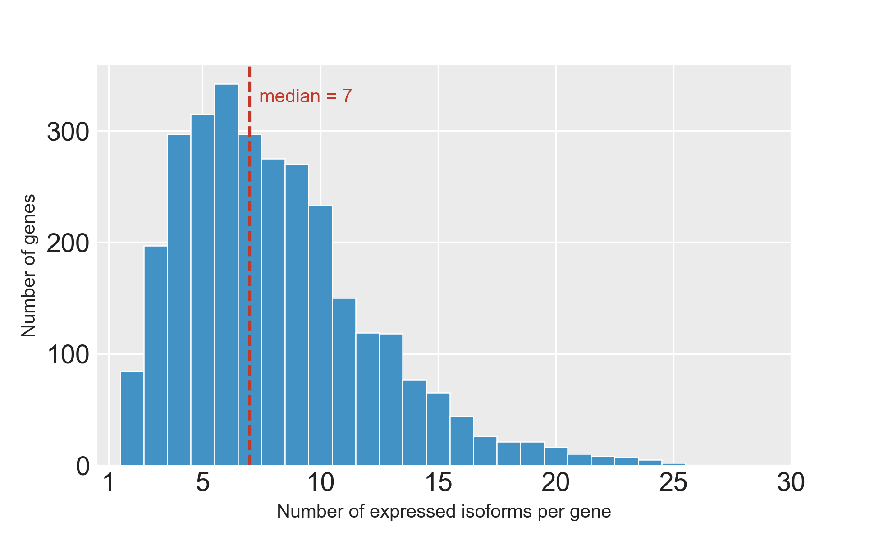
SF25 | Isoforms per Gene in Isopair Analysis. Distribution of the number of expressed isoforms per gene across the 3,009 genes for which gene-matched NMD-susceptible / reference / non-NMD isoform triplets could be constructed. The median gene contributes 7 isoforms (dashed line). Counts include all long-read isoforms passing the expression filter in at least one of the four cell types (AT2, LAE, FB, MV) under DMSO.

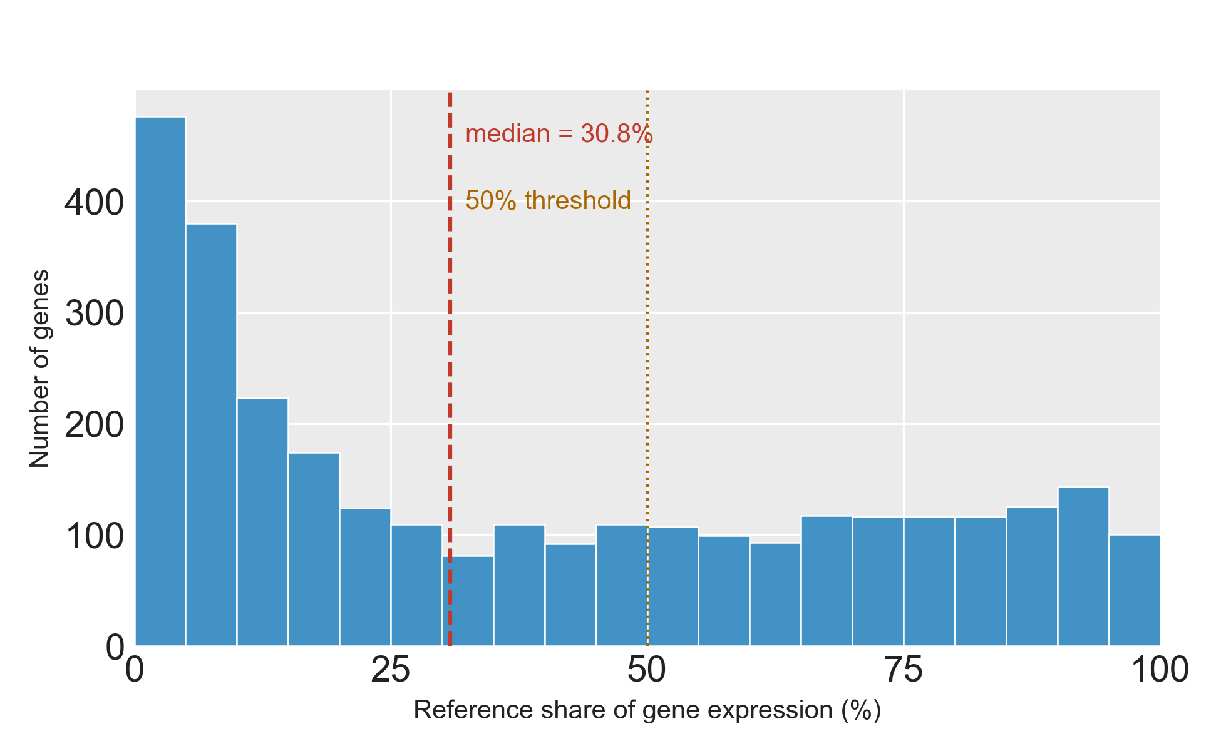
SF26 | Reference Share of Gene Expression. Distribution across 3,009 genes (each contributing a gene-matched NMD-susceptible / reference / non-NMD isoform triplet) of the reference isoform's DMSO 4-cell-type mean expression as a fraction of the parent gene's total non-NMD expression. Reference isoforms are the highest-expressed non-NMD isoform per gene under DMSO across AT2, LAE, FB and MV. Dashed line, median; dotted line, 50% threshold.

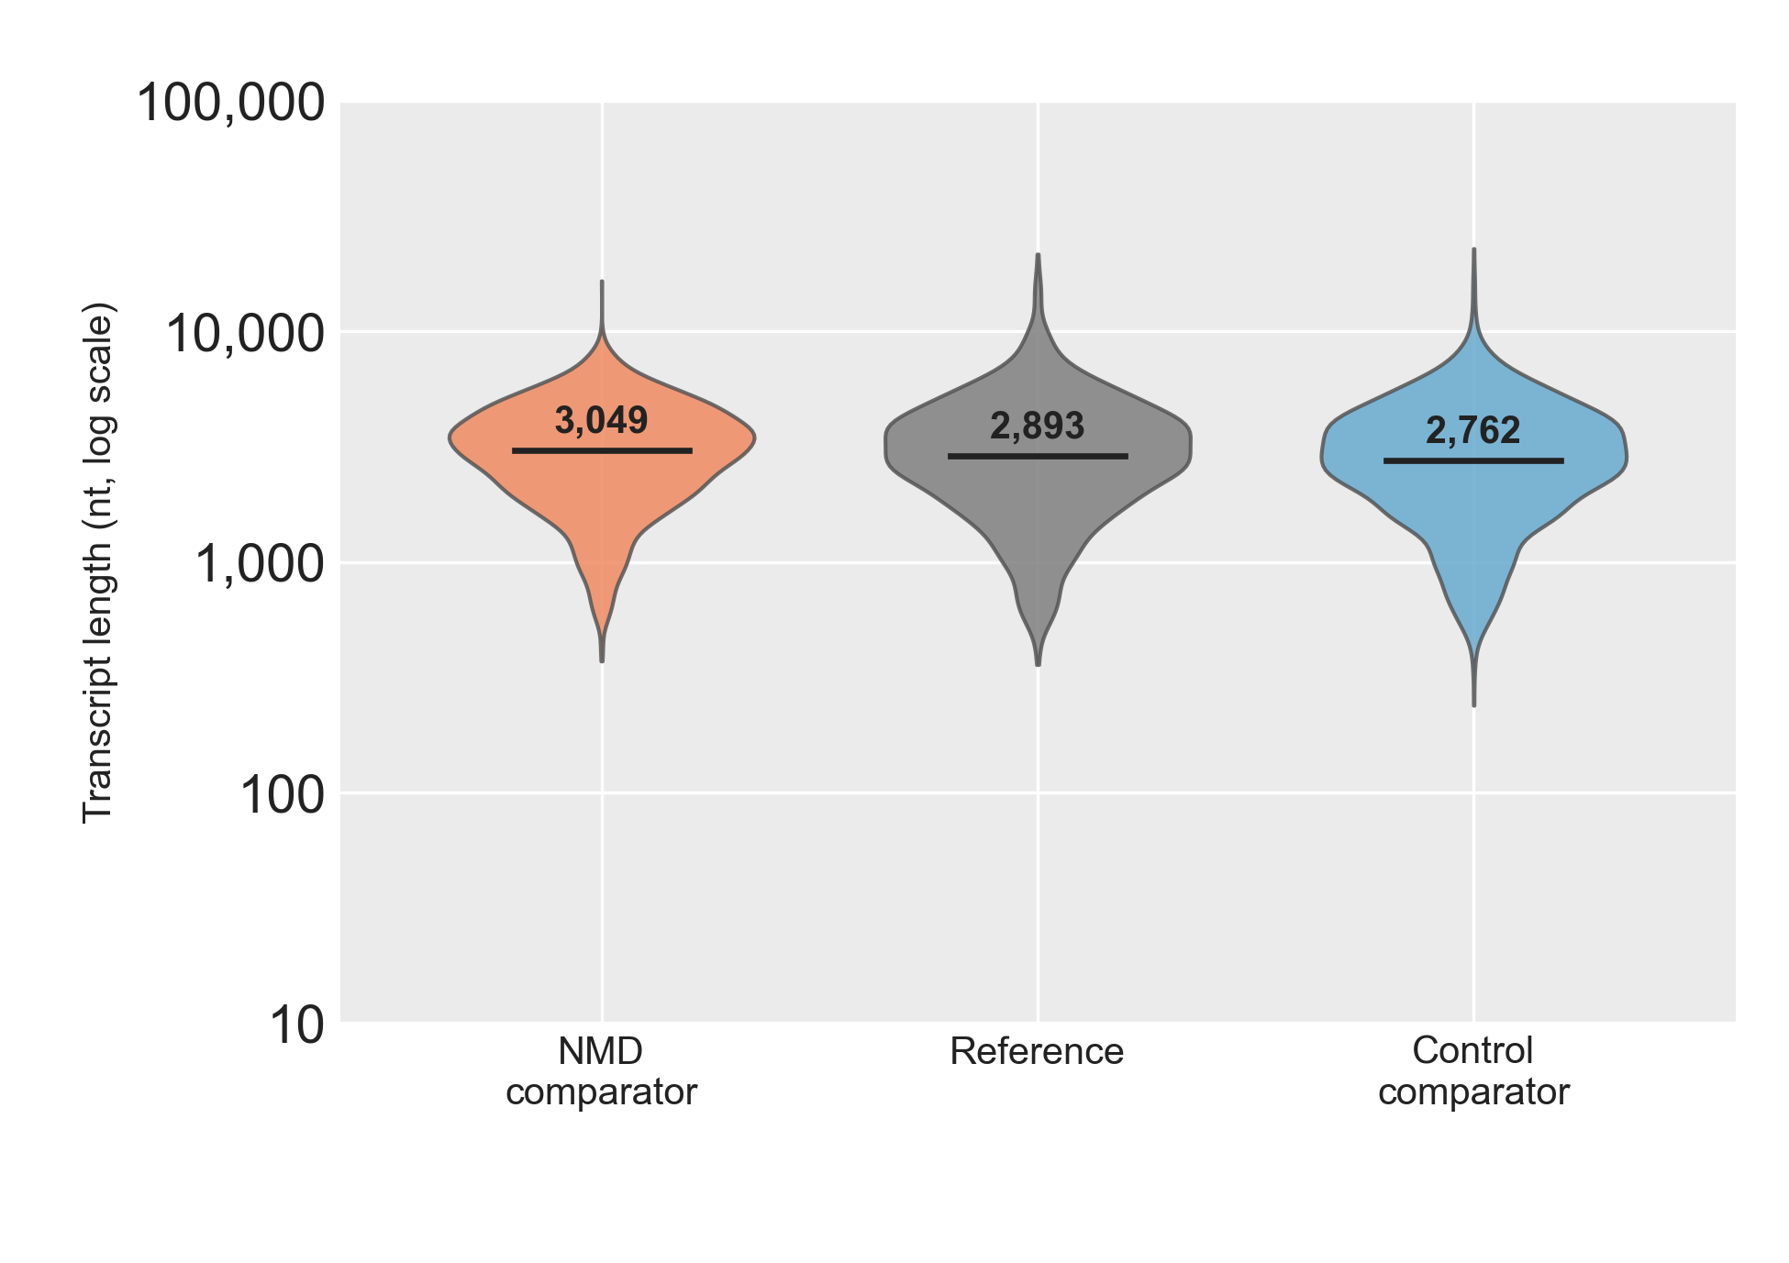
SF27 | Transcript Length by Isopair Analysis Category. Violin plot of transcript length (log10 nt) for the 3,009 gene-matched isoform triplets: NMD comparator (orange), Reference (grey), Control comparator (blue). Reference is the highest-expressed non-NMD isoform per gene under DMSO across the four cell types (AT2, LAE, FB, MV); the NMD and Control comparators are the paired NMD-susceptible and non-NMD non-reference isoforms from the same gene. Solid black bar, median; dotted bars, 25th and 75th percentiles.

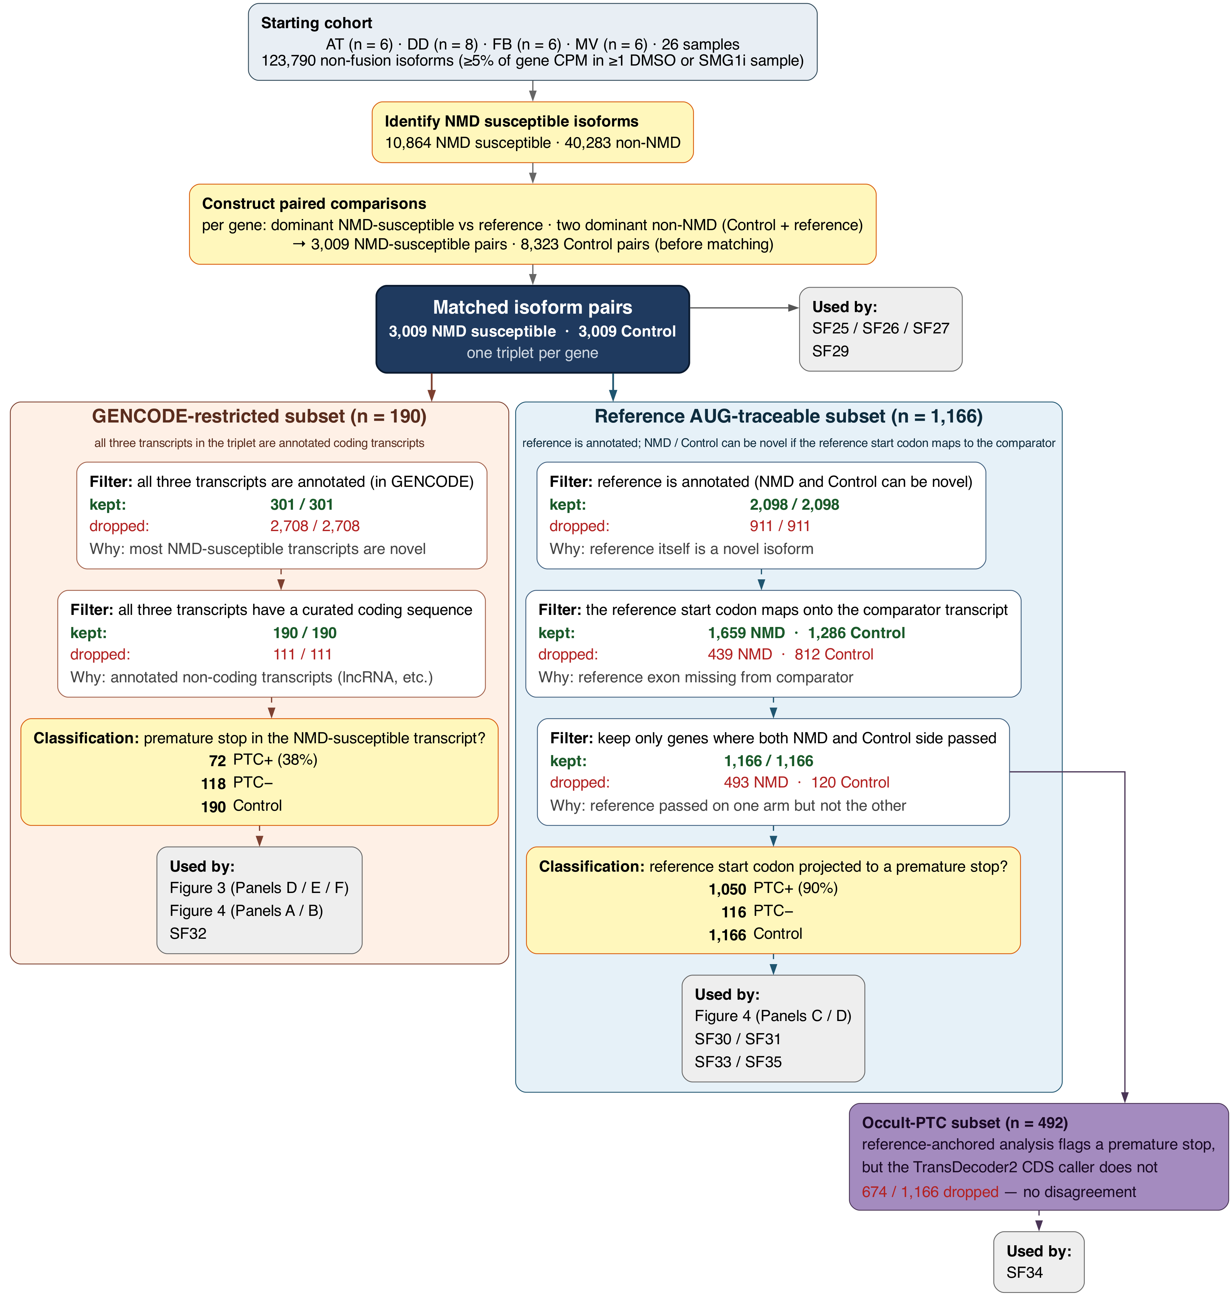
SF28 | Isopair analysis flowchart. Data flow for the isoform pairs analyses. Every filter step shows the number of pairs kept and dropped, and a one-line description of why each dropout happened.

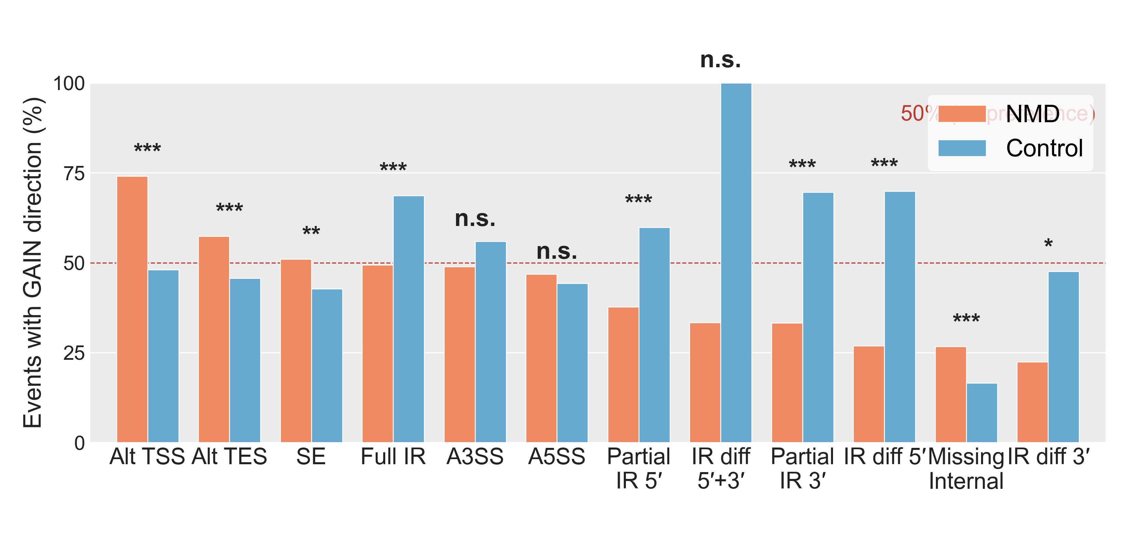
SF29 | GAIN Direction by Splice Event Type. Percentage of detected splice events (across 3,009 gene-matched isoform triplets, both NMD and Control comparators) in which the comparator has additional sequence relative to its reference isoform (GAIN direction). One bar-pair per event type — NMD comparators (orange) vs Control comparators (blue) — sorted by NMD-side %GAIN, descending. Dashed line, 50% (no directional preference). Direction is defined from the comparator's perspective (see SF24 for event-type definitions). Significance stars, Fisher's exact test on the 2 × 2 (GAIN/LOSS × NMD/Control) count table per event type.

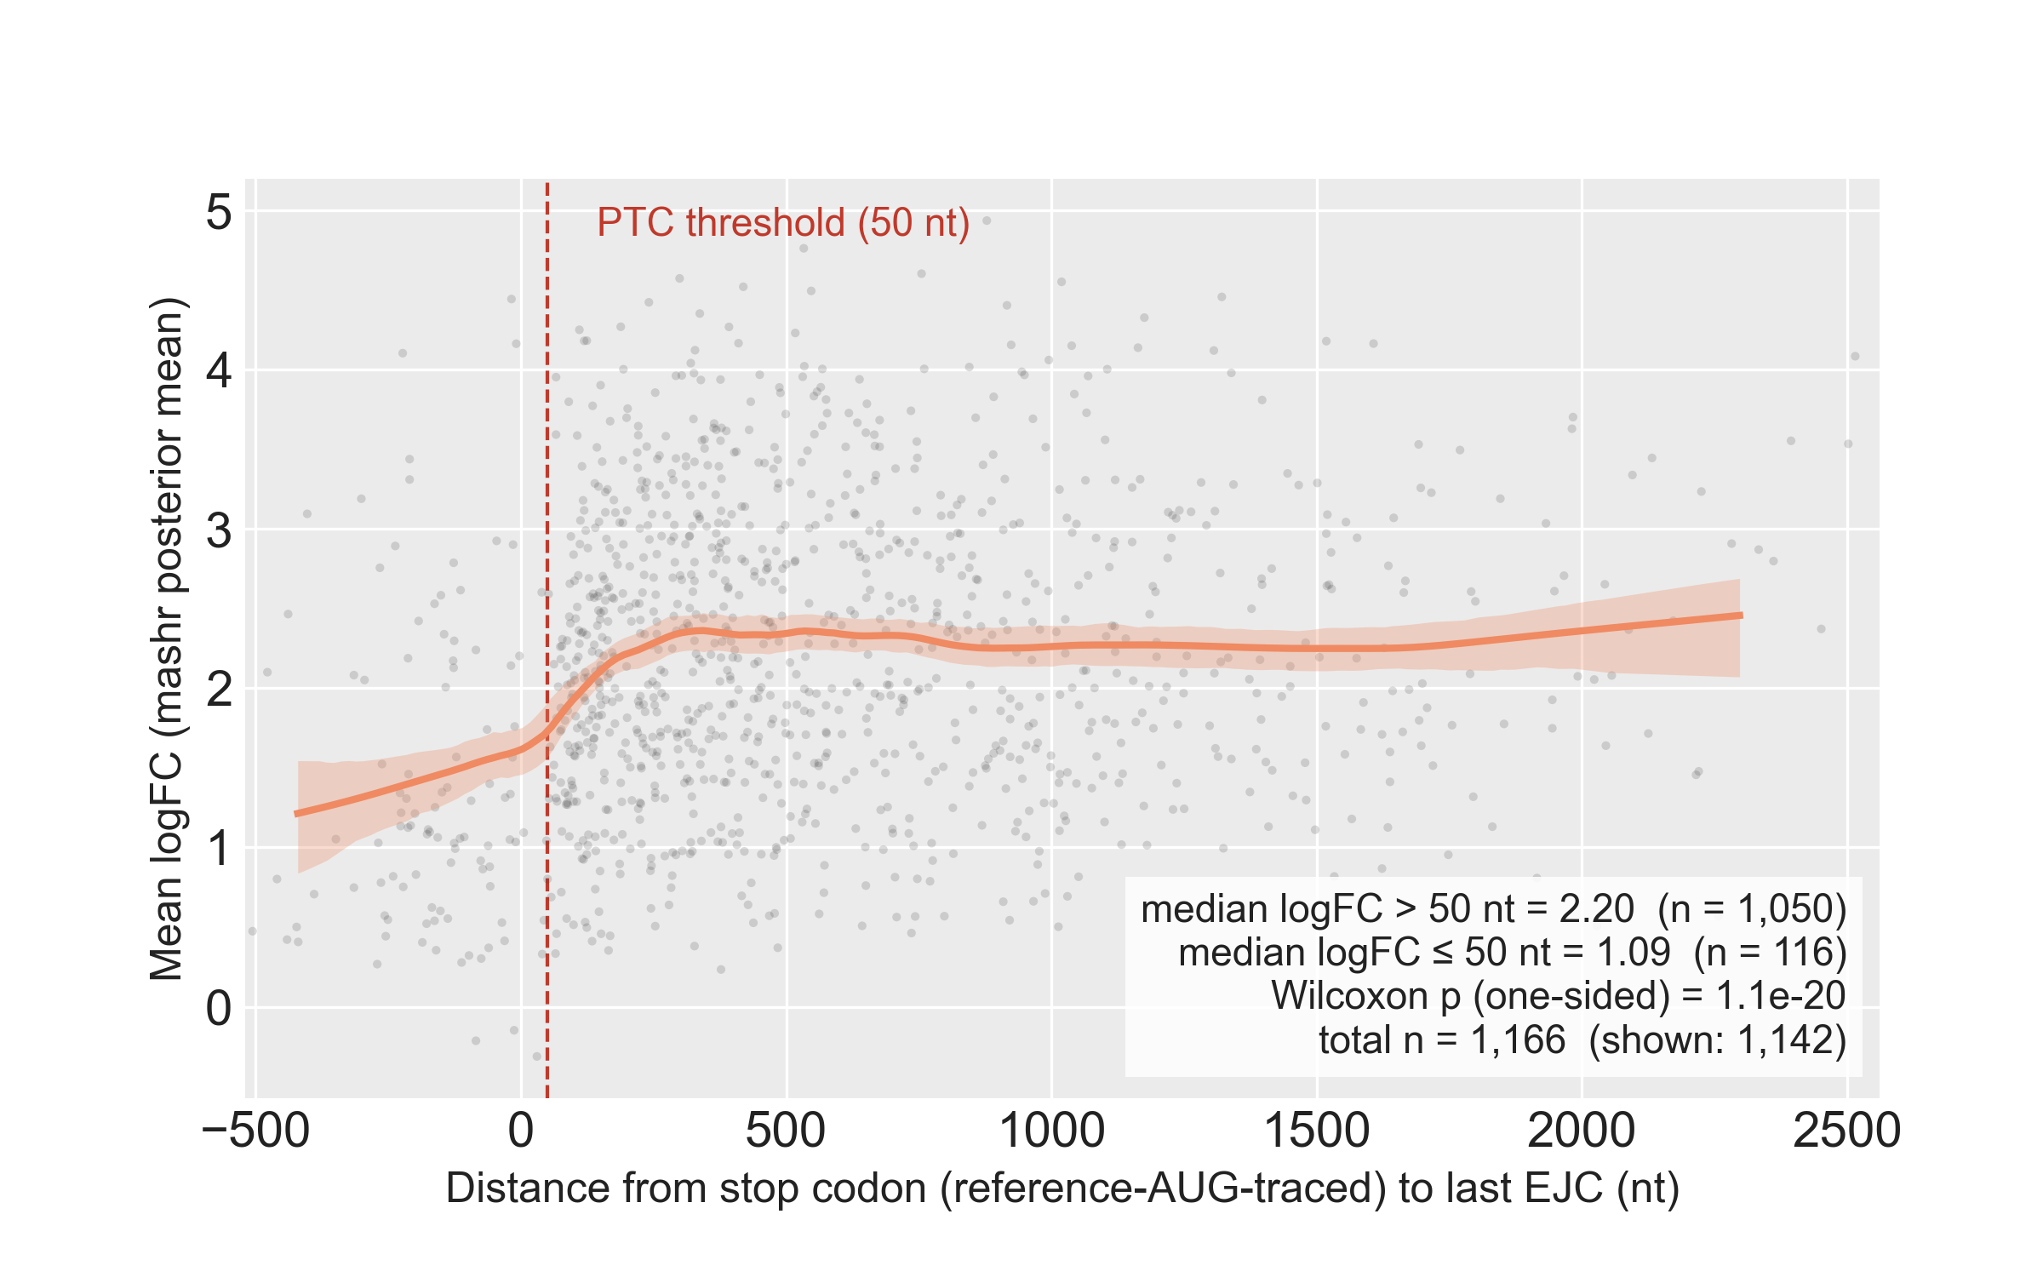
SF30 | NMD-Response Magnitude vs Stop-Codon Distance to Last EJC. Per-comparator NMD-response magnitude (mashr posterior-mean log₂ fold-change under SMG1 inhibition, averaged across AT2, LAE, FB and MV) plotted against the distance from the comparator's stop codon to the transcript's last exon-junction complex. Positive values, stop codon upstream of the last EJC (candidate NMD substrate); negative values, stop codon downstream of the last EJC. Grey points, individual comparators (1st–99th percentile of x-axis shown); orange line, local-linear smoother; orange band, bootstrap 95% CI. Dashed red line, the operational 50-nt PTC threshold. Population: n = 1,166 comparators (all of Subset 2, gene-matched ref-AUG-traceable). Stop anchor: reference-AUG-traced (the first in-frame stop reached after projecting the reference gene's AUG onto the comparator); this avoids the attenuation that would arise from TD2 anchoring on non-PTC main ORFs. Median log₂ fold-change is 2.20 above the 50-nt threshold and 1.09 at or below it (Wilcoxon one-sided p = 1.1 × 10⁻²⁰).

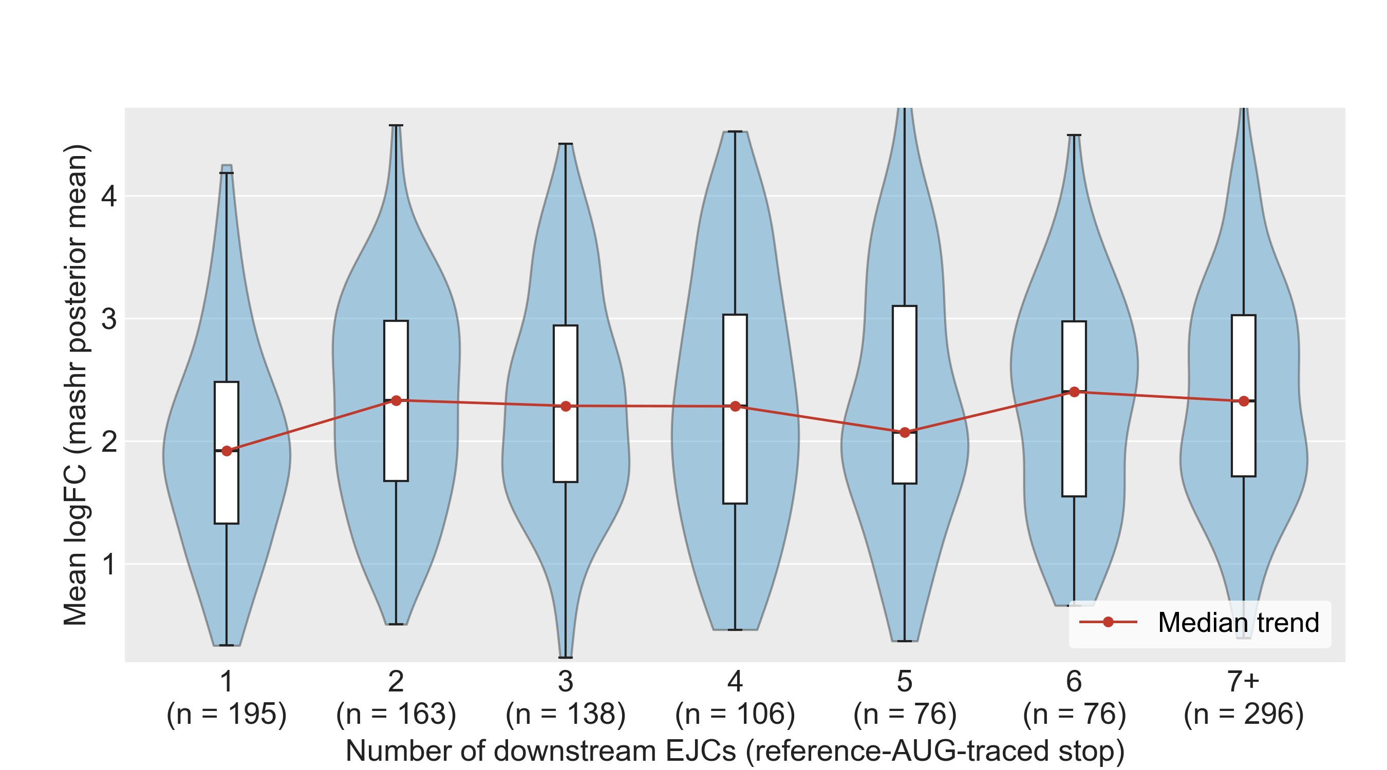
SF31 | NMD Effect Size by Downstream EJC Count in PTC-Positive NMD Comparators. Distribution of NMD-response magnitude (mashr posterior-mean log₂ fold-change under SMG1 inhibition, averaged across AT2, LAE, FB and MV) as a function of the number of exon-junction complexes downstream of the comparator's stop codon. Restricted to comparators with at least one downstream EJC (n = 1,050), drawn from the same Subset 2 population as SF30. Downstream-EJC counts of 7 or more are collapsed into a single "7+" bin. Violin, kernel density; overlaid box, interquartile range and median; red line, per-bin median trend. Per-bin sample counts are shown above each violin. Stop anchor: reference-AUG-traced, matching SF30.

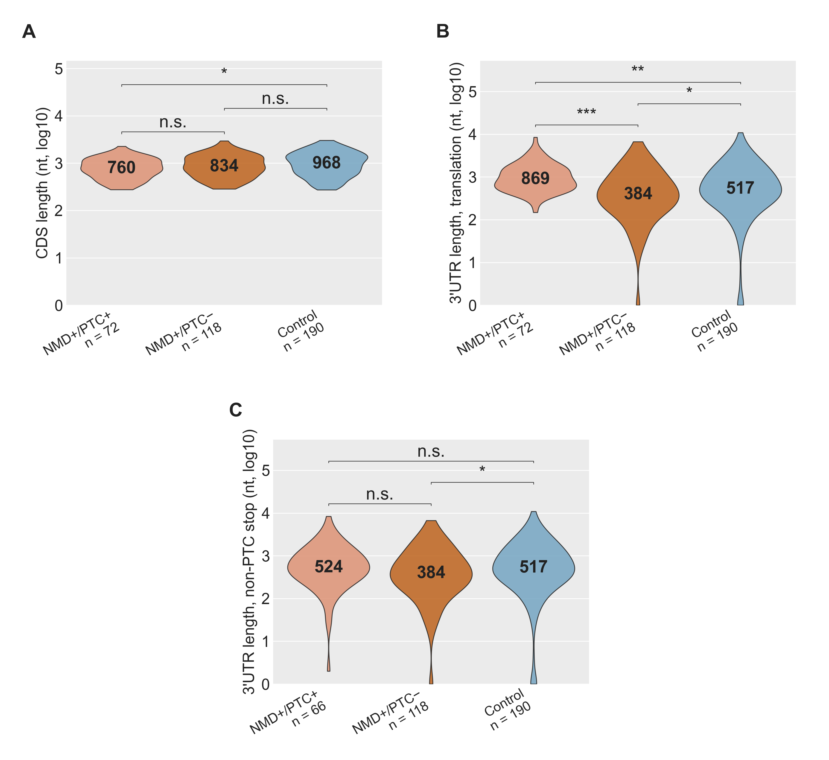
SF32 | CDS and 3′UTR length across isoform classes in the GENCODE-restricted isoform pairs subset. Restricted to triplets in which all three transcripts are annotated coding transcripts (n = 72 NMD+/PTC+, 118 NMD+/PTC−, 190 Control). Stop anchor: each isoform's own annotated CDS. (A) CDS length; (B) 3′UTR length from the annotated stop to transcript end; (C) 3′UTR length after walking past any premature stop to the first non-premature stop (Panel C NMD+/PTC+ n = 66; 6 comparators lack a downstream non-premature stop and are dropped). Solid black bar inside each violin, median. Two-sided Wilcoxon rank-sum: \p < 0.05, \\p < 10⁻³, \\\p < 10⁻⁴; n.s. otherwise. Abbreviations. CDS, coding sequence; PTC, premature termination codon.

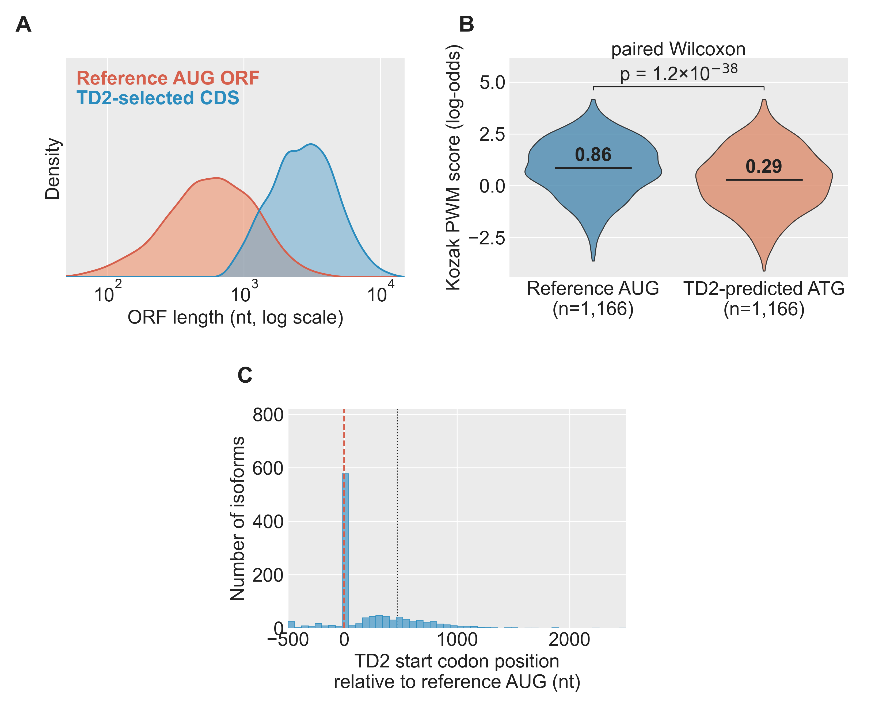
SF33 | TD2 versus reference AUG-traced ORFs, reference AUG-traceable cohort. n = 1,166 gene-matched NMD comparator pairs. (A) ORF-length distribution under the TD2 call versus under the reference AUG projected onto the same transcript. (B) Paired Kozak PWM score at the reference AUG versus at the TD2-predicted start codon. (C) Position of the TD2 AUG relative to the reference AUG (0 = same site). Solid black bar inside each violin, median. Abbreviations. ORF, open reading frame; PWM, position weight matrix; TD2, TransDecoder2.

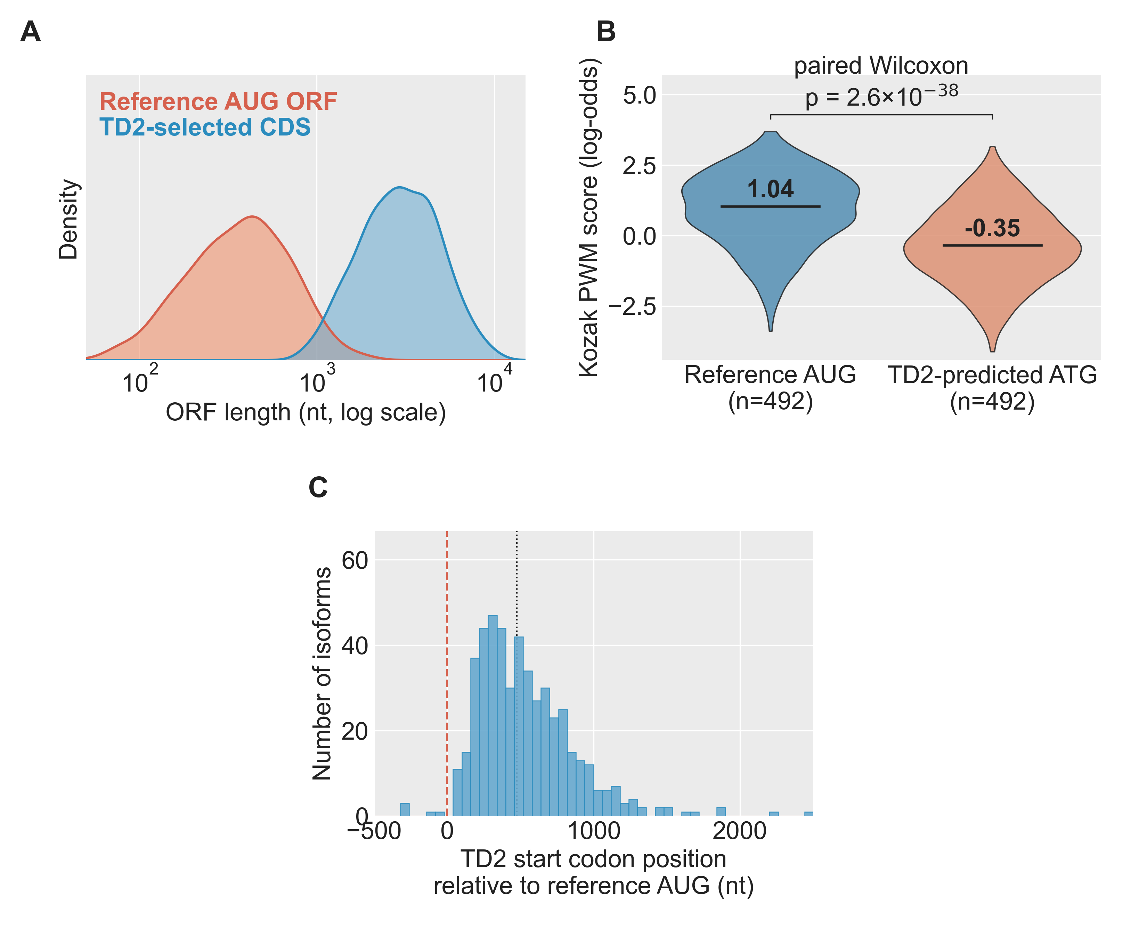
SF34 | TD2 versus reference AUG-traced ORFs, occult-PTC subset. Restricted to the n = 492 comparators in which projecting the reference AUG revealed a PTC that the TD2 CDS call did not. Panels A–C match SF33. Abbreviations. CDS, coding sequence; ORF, open reading frame; PTC, premature termination codon; TD2, TransDecoder2.

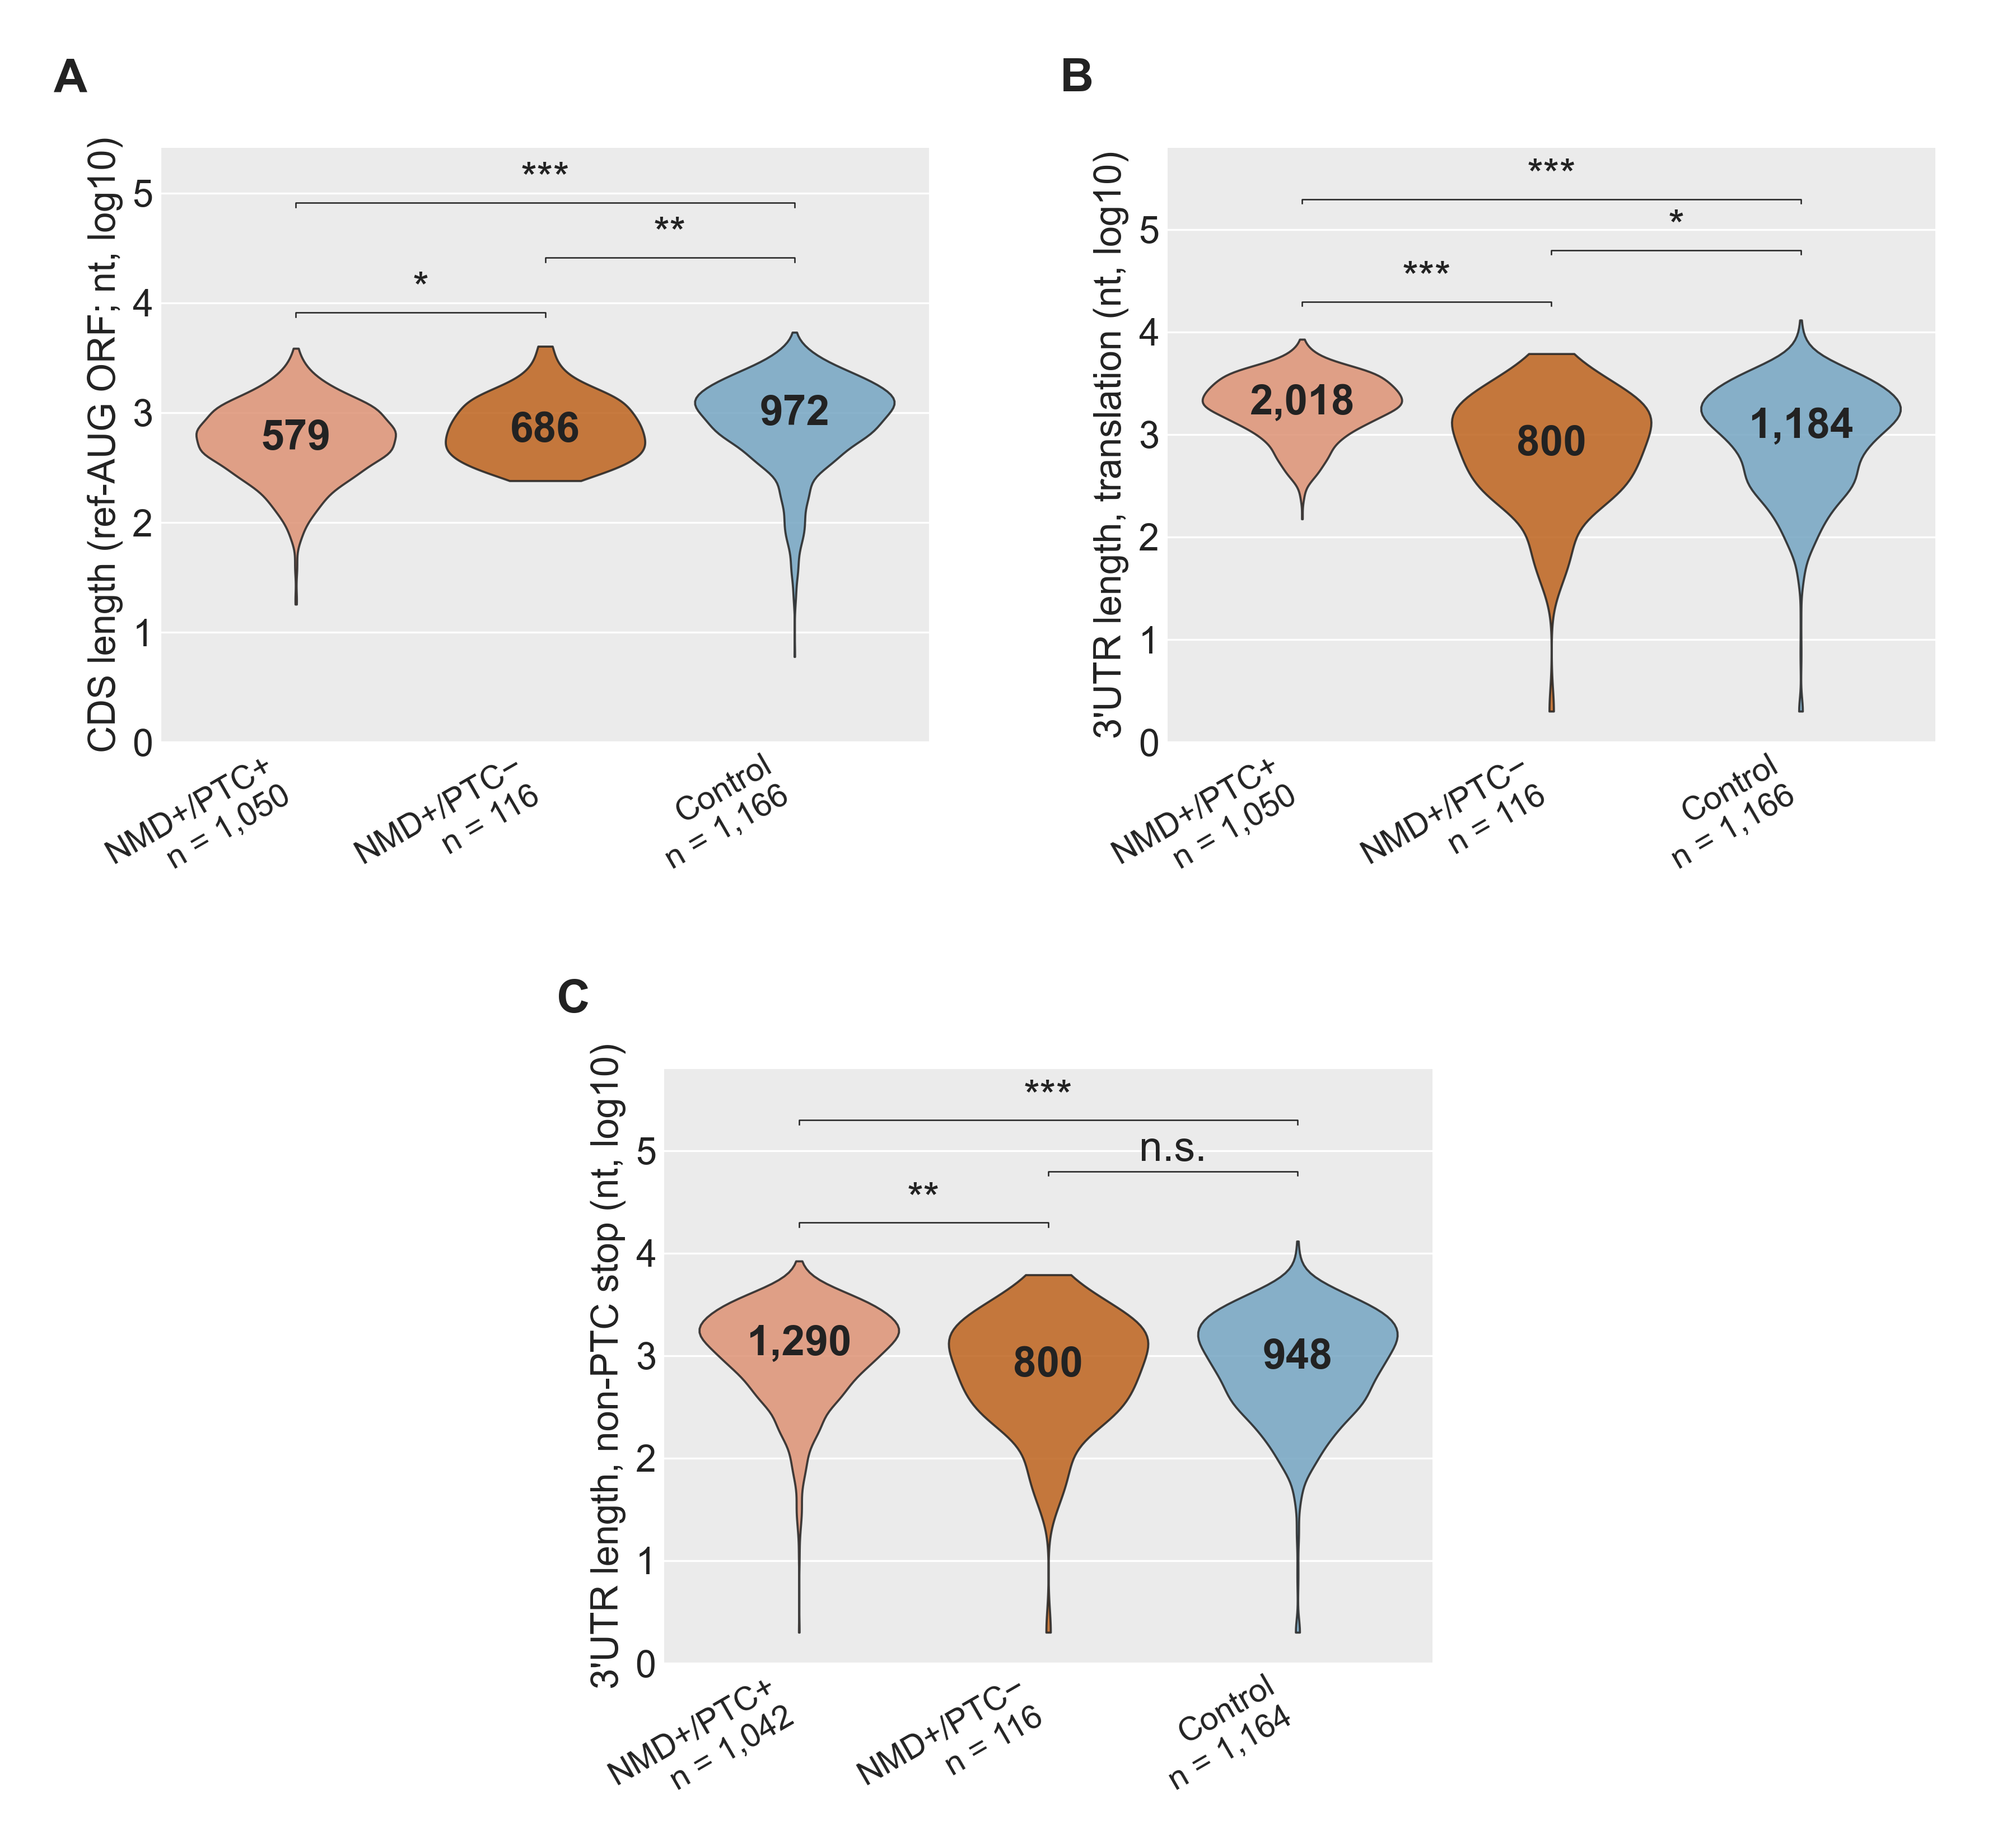
SF35 | CDS and 3′UTR length across isoform classes, reference AUG-traceable cohort. Restricted to gene-matched pairs in which the reference AUG projects onto the comparator transcript (n = 1,050 NMD+/PTC+, 116 NMD+/PTC−, 1,166 Control). Stop anchor: the reference gene's AUG projected onto the comparator, which is unbiased with respect to TD2's PTC-avoidance (see SF33). Panels A–C match SF32. Solid black bar inside each violin, median. (Panel C NMD+/PTC+ n = 1,042 and Control n = 1,164; comparators without a downstream non-premature stop are dropped.) Two-sided Wilcoxon rank-sum: \p < 0.05, \\p < 10⁻³, \\\p < 10⁻⁴; n.s. otherwise. Abbreviations. CDS, coding sequence; PTC, premature termination codon; TD2, TransDecoder2.

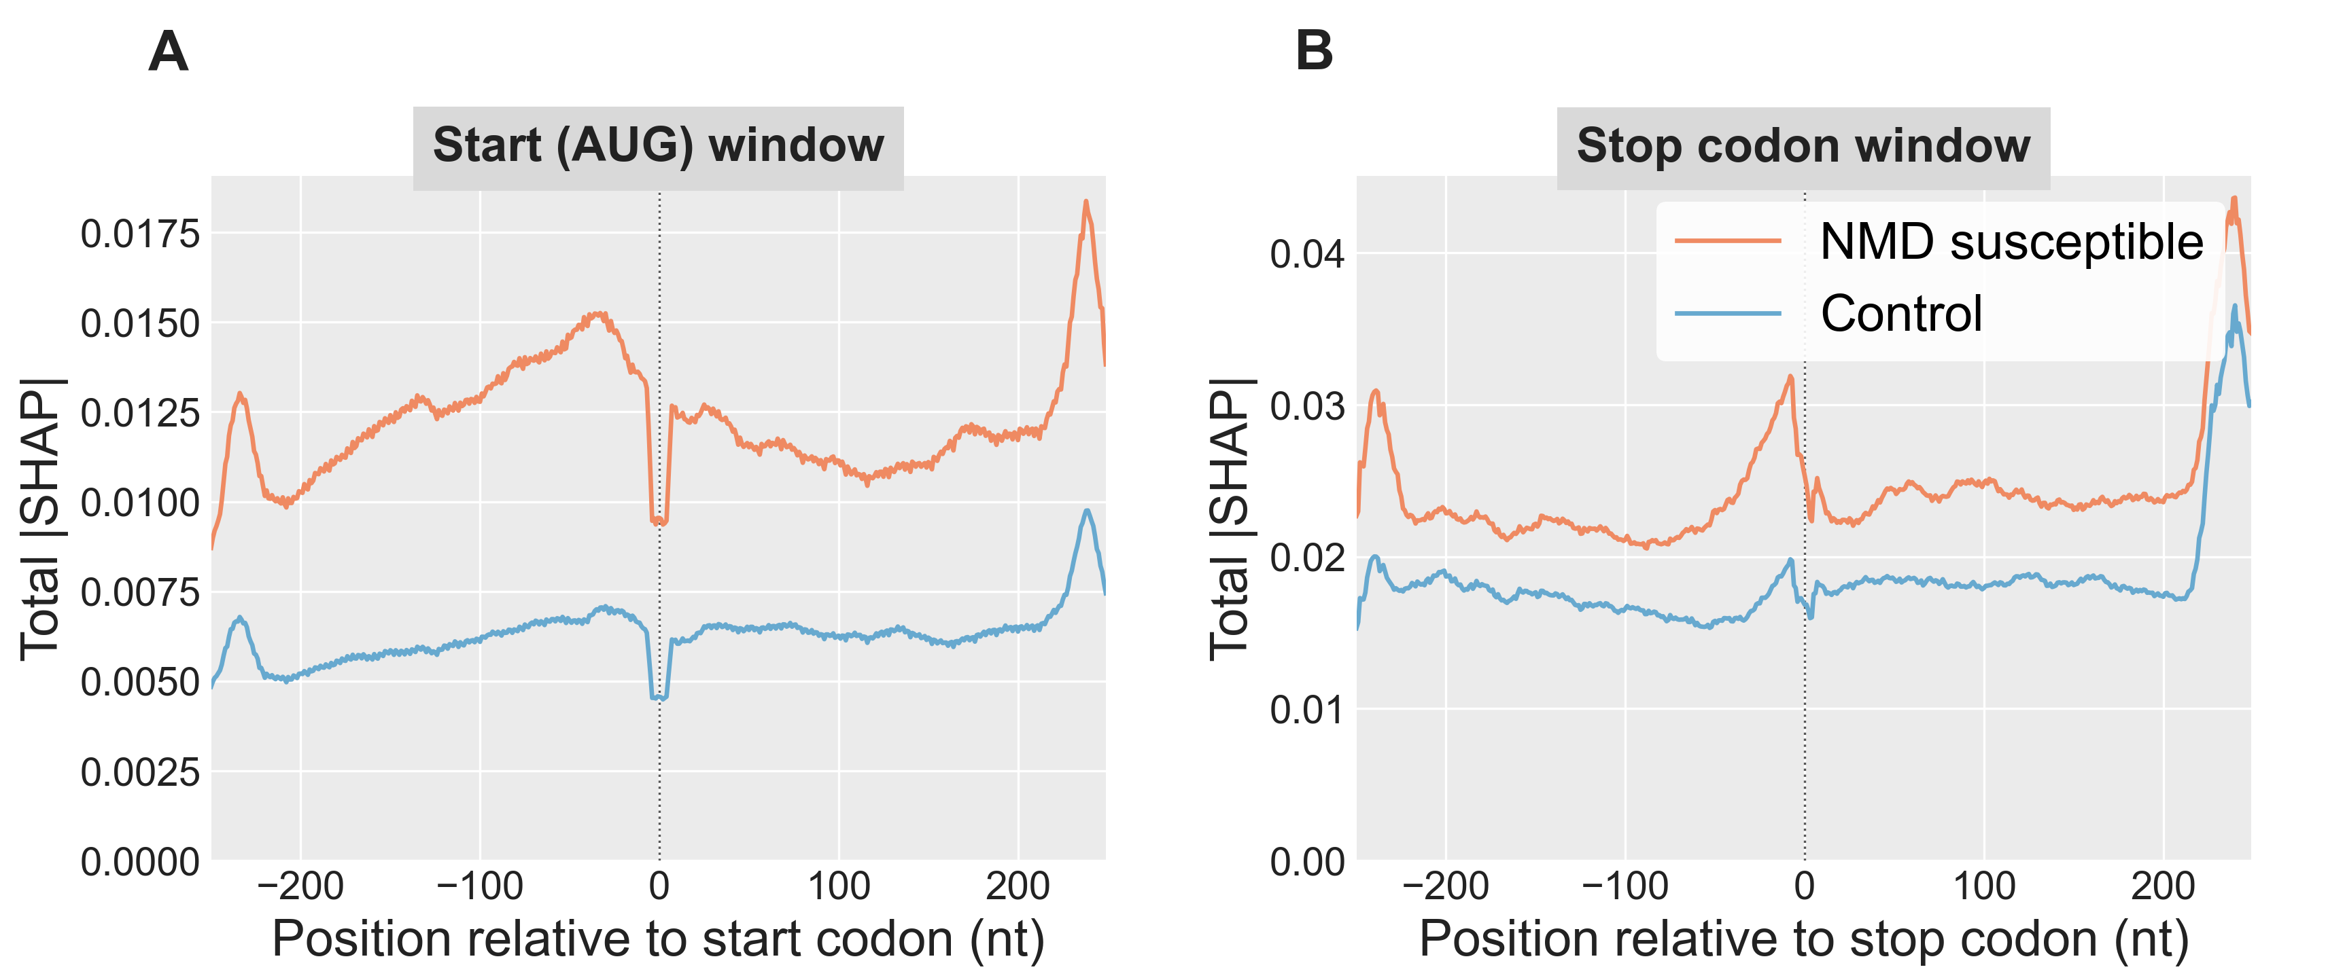
SF36 | Total |SHAP| Across the AUG and Stop-Codon Windows. Per-position |SHAP| summed across the nine input channels of the deep-learning model, comparing NMD susceptible (orange) and Control (blue) transcripts on the held-out test set (NMD n = 2,268, Control n = 7,863). Each transcript's AUG and stop windows are centred on its main open reading frame's start and stop codons. Main open reading frames are chosen with the following priority: the annotated reference CDS (projected from the gene's dominant non-NMD isoform) when available; otherwise the TransDecoder2-called CDS; otherwise the highest-Kozak-scoring open reading frame (see Methods, Main open reading frame selection). Values are smoothed with an 11-nt rolling mean over the raw per-position |SHAP| to abstract over trinucleotide-frame periodicity. A) AUG window covering positions –250 to +249 relative to the start codon. B) Stop-codon window covering the same relative range around the stop codon. Pooled across 5 DeepSHAP runs (500 background samples each).

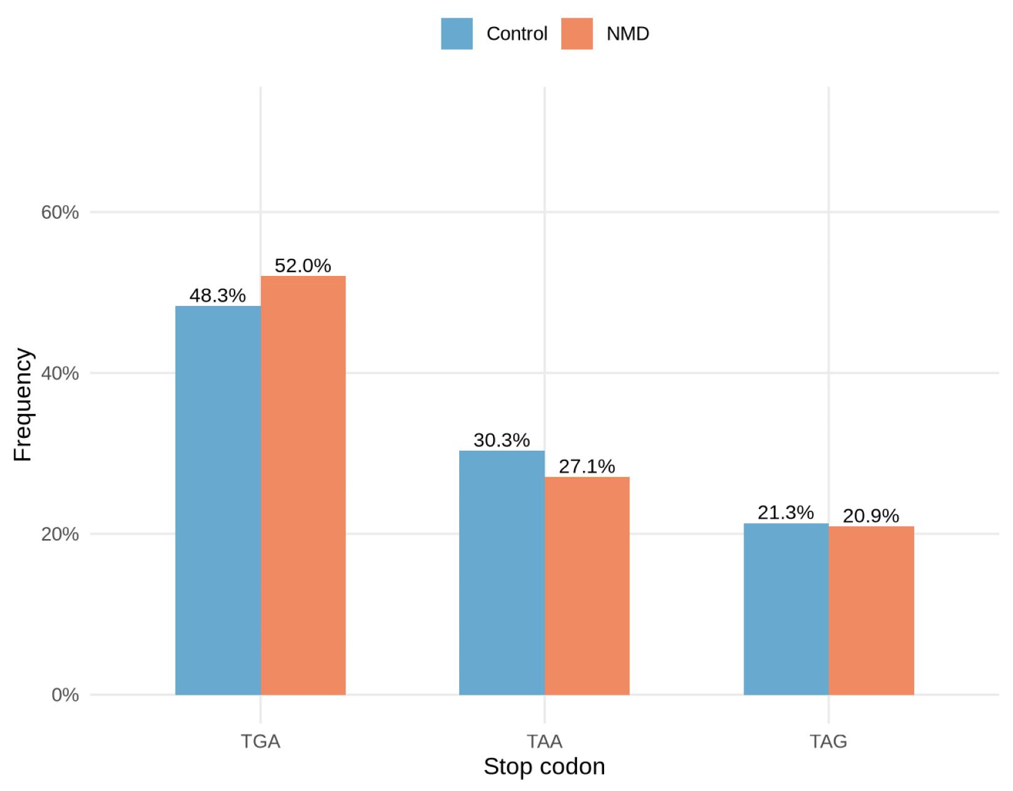
SF37 | Stop-codon usage in NMD susceptible vs non-NMD isoforms. Within-class frequency of the three canonical stop codons (UGA / UAA / UAG) at the main open reading frame of each transcript in the deep-learning model's held-out test set (n = 2,268 NMD susceptible, n = 7,863 non-NMD). Main open reading frames are chosen with the following priority: the annotated reference CDS (projected from the gene's dominant non-NMD isoform) when available; otherwise the TransDecoder2-called CDS; otherwise the highest-Kozak-scoring open reading frame (see Methods, Main open reading frame selection). Percentages: UGA 55.9 % vs 48.1 %; UAA 23.9 % vs 29.9 %; UAG 20.2 % vs 22.0 %.
Abbreviations. NMD, nonsense-mediated decay; UGA / UAA / UAG, the three canonical stop codons in RNA notation.

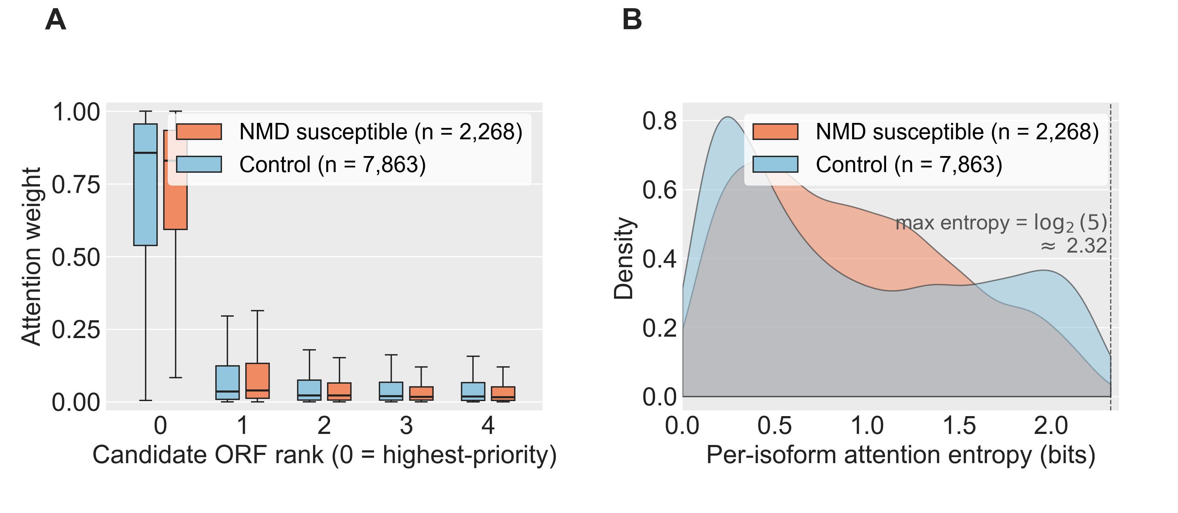
SF38 | Attention distribution across the model's five candidate open reading frames, NMD susceptible vs non-NMD. The deep-learning model evaluates each transcript at up to five candidate open reading frames and learns an attention weight for each. The candidates are ranked by a priority rule that prefers the annotated reference CDS first (projected from the gene's dominant non-NMD isoform when available), then the TransDecoder2-called CDS, then the open reading frame with the strongest Kozak start context. Most attention concentrates at the main (rank-0) open reading frame in both classes.
(A) Attention weight per candidate open reading frame rank, by class (NMD susceptible in coral, non-NMD in blue). Most attention concentrates at the rank-0 open reading frame in both classes (median ~0.74–0.76). The median rank-0 attention is slightly lower in NMD, with a corresponding shift of attention onto ranks 1–4 and a long tail of NMD isoforms placing more than 25 % of attention on a non-rank-0 candidate.
(B) Shannon entropy of the per-isoform attention vector across the five candidate open reading frames (higher entropy, more broadly distributed attention). The NMD density is shifted toward higher entropy than the Control density, quantifying the broader spread shown in Panel A.
Abbreviations. NMD, nonsense-mediated decay.

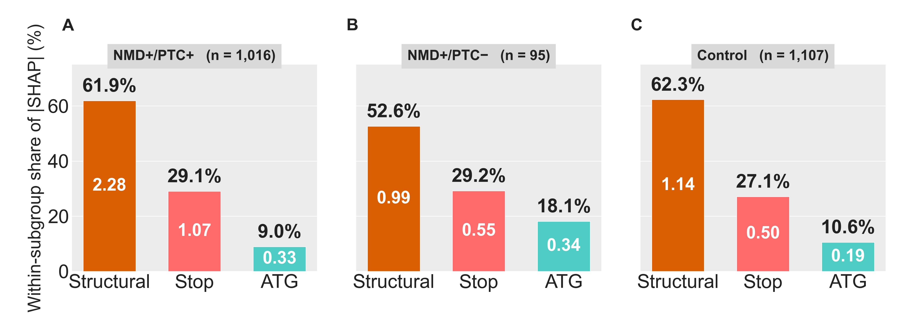
SF39 | Branch-level Shapley attributions of the deep-learning model, stratified by isoform PTC subclass. Shapley attributions of the model's NMD prediction across its three input branches — the start-codon window, the stop-codon window, and a set of structural features — measured at the branch-aggregation point of the trained network (the same attribution method as in Figure 5 Panel C). Attributions are stratified across three isoform subclasses defined in Figure 4 Panels C and D: NMD susceptible with a premature termination codon (NMD+/PTC+, n = 1,016), NMD susceptible without a premature termination codon (NMD+/PTC−, n = 95), and matched non-NMD Controls (n = 1,107). Attributions are computed for every isoform in the subgroup.
Each panel matches the style of Figure 5 Panel C: bars are ordered structural / stop / start; the value inside each bar is the mean absolute Shapley attribution at that branch; the percentage above each bar is that branch's share of the within-subclass total attribution. The vertical scale is identical across the three panels so heights can be compared directly.
(A) NMD susceptible with a premature termination codon (NMD+/PTC+). Structural features dominate (62 % of total branch attribution); the stop-codon window contributes 29 %; the start-codon window contributes 9 %. This pattern mirrors the pooled attribution shown in Figure 5 Panel C — when a premature termination codon is present, the structural and stop-codon features carry the prediction.
(B) NMD susceptible without a premature termination codon (NMD+/PTC−). The structural share drops to 53 % (no premature termination codon means no excess downstream-junction signal); the stop share is essentially unchanged at 29 %; the start-codon-window share doubles to 18 %. The model relies more heavily on start-codon context to call NMD in these isoforms.
(C) Non-NMD Controls. The proportional profile resembles NMD+/PTC+ (62 % / 27 % / 11 %) but at lower absolute magnitude across all three branches.
The start-codon-window share in NMD+/PTC− is ~2-fold higher than in NMD+/PTC+ (18 % vs 9 %), quantifying the shift toward start-codon information when a premature termination codon is not present.
Abbreviations. NMD, nonsense-mediated decay; PTC, premature termination codon.

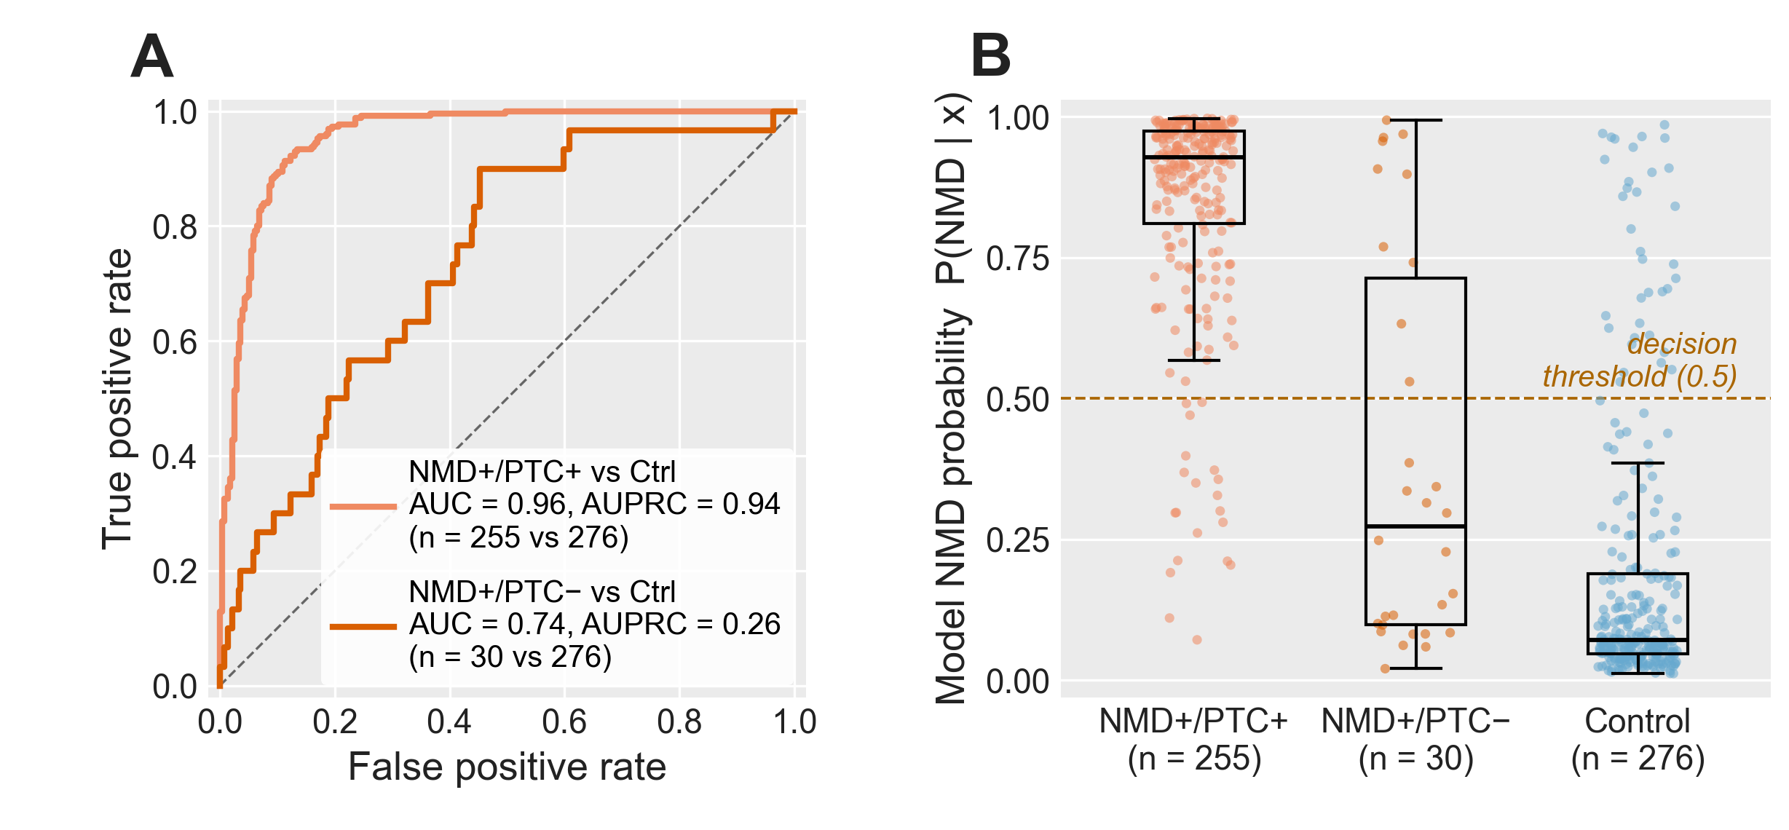
SF40 | Deep-learning model discrimination by PTC subclass on the held-out test set. Held-out test-set performance of the trained NMD predictor, restricted to isoforms in the same 1,166 gene-matched pairs used by Figure 4 Panels C and D and Figure 5 Panel G, and stratified by the same three subclasses: NMD susceptible with a premature termination codon (NMD+/PTC+, n = 255), NMD susceptible without a premature termination codon (NMD+/PTC−, n = 30), and matched non-NMD Controls (n = 276). Subgroup sample sizes reflect held-out-test-set membership rather than the total subgroup.
(A) Receiver-operating-characteristic curves for the two NMD-vs-Control contrasts, using the model's predicted NMD probability as the score. The NMD+/PTC+ vs Control contrast achieves AUC = 0.96 (AUPRC = 0.94). The NMD+/PTC− vs Control contrast achieves AUC = 0.74 (AUPRC = 0.26). Diagonal, chance. The substantial AUC drop indicates that NMD-susceptible isoforms without an annotated premature termination codon are intrinsically harder for the model to discriminate from non-NMD isoforms — consistent with the loss of structural and stop-window signal shown in SF39.
(B) Distribution of the per-isoform predicted NMD probability by subclass. NMD+/PTC+ isoforms cluster at high probability (mean = 0.85), comfortably above the 0.5 decision threshold; non-NMD Controls cluster at low probability (mean = 0.19); NMD+/PTC− isoforms straddle the threshold (mean = 0.39), placing many of them on the Control side of the decision boundary. Boxplots show median, IQR, and 1.5×IQR whiskers; the dashed horizontal line marks the 0.5 default decision threshold.
Abbreviations. AUC, area under the receiver-operating-characteristic curve; AUPRC, area under the precision–recall curve; NMD, nonsense-mediated decay; PTC, premature termination codon; IQR, interquartile range.

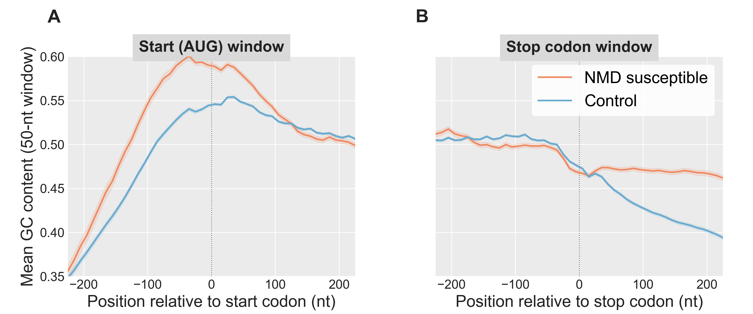
SF41 | Rolling GC Content Across the AUG and Stop-Codon Windows. Mean rolling GC content per position of the transcript sequences supplied to the deep-learning model, comparing NMD susceptible (orange) and Control (blue) transcripts on the held-out test set. Each transcript's window is centred on its main open reading frame's start or stop codon. Main open reading frames are chosen with the following priority: the annotated reference CDS (projected from the gene's dominant non-NMD isoform) when available; otherwise the TransDecoder2-called CDS; otherwise the highest-Kozak-scoring open reading frame (see Methods, Main open reading frame selection). NMD susceptible transcripts are restricted here to those whose main open reading frame is the annotated reference CDS (n = 1,743 of 2,268 NMD test transcripts, 76.9%), so that position 0 is the reference stop codon rather than a downstream TransDecoder2 stop codon; Control transcripts are unrestricted (n = 7,863). GC content is computed in a 50-nt sliding window with a 10-nt step from the model's one-hot nucleotide input channels; shading, ± 1 standard error of the mean. A) AUG window. B) Stop codon window.

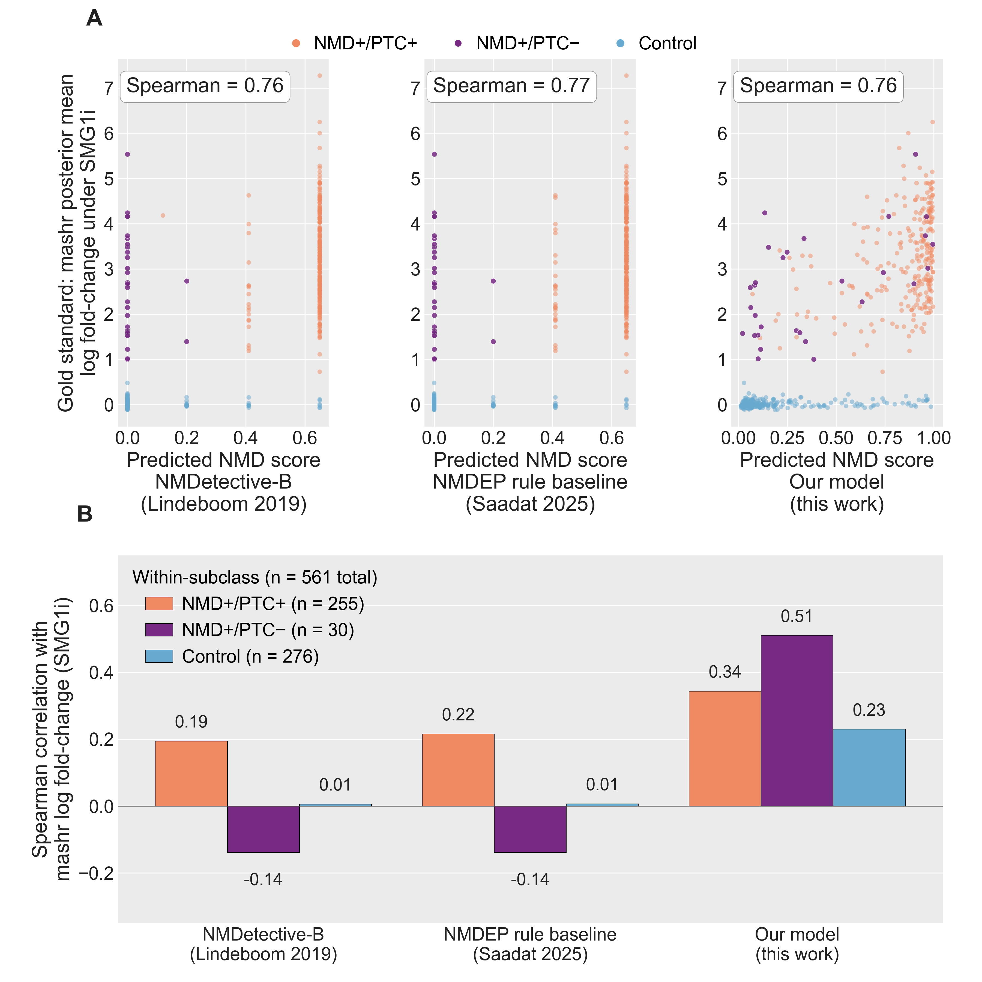
SF42 | Head-to-head correlation of three NMD predictors with the mashr gold standard, pooled and per PTC subclass. Three NMD-prediction models are scored against the same continuous gold standard — the mashr posterior-mean log₂ fold-change of each transcript under SMG1 inhibition — on the held-out test set of long-read-observed transcripts (chromosomes 1, 3, 5, 7; n = 561 total: 255 NMD-susceptible with a premature termination codon (NMD+/PTC+), 30 NMD-susceptible without a premature termination codon (NMD+/PTC−), and 276 non-NMD Controls). The models compared are NMDetective-B (Lindeboom et al. 2019), the NMDEP rule-tree baseline (Saadat & Fellay 2025), and the deep-learning model developed here.
(A) Predicted NMD score (x-axis) versus the gold-standard log fold-change (y-axis), one subpanel per model. Each point is one transcript, coloured by subclass. Pooled Spearman correlation is annotated. All three models reach a similar pooled correlation (0.76–0.77), driven by the easy separation of NMD-susceptible transcripts from Controls.
(B) Within-subclass Spearman correlation per model — the same scoring restricted to one PTC subclass at a time, isolating each model's ability to rank-order NMD susceptibility among transcripts of the same class. The deep-learning model achieves Spearman 0.34 (PTC+), 0.51 (PTC−), and 0.23 (Control). The two rule-tree models achieve ≤0.22 within PTC+, ≤0.01 within Controls, and are anti-correlated with the gold standard within PTC− (Spearman −0.14), because every PTC− transcript is by definition not flagged as a premature stop by the rule cascade despite being a real NMD substrate.
Abbreviations. mashr, multivariate adaptive shrinkage; NMD, nonsense-mediated decay; NMDEP, neural-network NMD efficacy predictor (Saadat & Fellay 2025); PTC, premature termination codon; SMG1, suppressor of morphogenesis in genitalia-1 (the kinase whose inhibition stabilises NMD substrates).

