

**Cairo University**

**Faculty of Computers and**

**Information**



CS352 Software Engineering II

Assignment 2

By

|  |  |  |  |
| --- | --- | --- | --- |
| Student Name | ID | Group | Email |
| Omama Mostafa | 20160063 | CS2 | Omamamostafa8@gmail.com |
| Tasneem Gamal | 20160084 | CS2 | Tasneemagamal@gmail.com |
| Peter Safwat | 20160083 | CS2 | p.pator@outlook.com |

[10-Mar-2019]

Department of Computer Science

Faculty of Computers and Information

Cairo University

# **2018** **2019**

1. Introduction:

The program tends to achieve the Peer-to-peer architecture by implement a Block Chain app, the Block Chain become the most trusted crypto company.

1. Implemented use case:

Use Case 2: Blockchain.

Use cases may be:

1. Sender User or Company: act with the system as send a message contain sender name, receiver name, and the message content.
2. Receiver User or Company: receive another user block chain, ask about the longest chain, and so on.

1. System Architecture:

We have here two main concepts help us to implement our application and they’re Blockchain and PeerToPeer architecture (p2p).

1. PeerToPeer(P2P):
   1. P2P may be used to refer to a single software program designed so that each instance of the program in the network may act as both client and server, with the same responsibilities and status.
   2. P2P concept like what you see in this picture enable you to request anything from any other peer as a client and also provide other peers with the needed request as a server.
   3. In our application we used the p2p architecture so any peer can request another Peer’s copy of the blockchain and can reply with its copy to any request which means that each peer can act as a client and server. We also have a network of peers each one has its own blockchain copy and we can query the longest valid blockchain on the network. We can broadcast the mail to be able to add it on new Blocks.

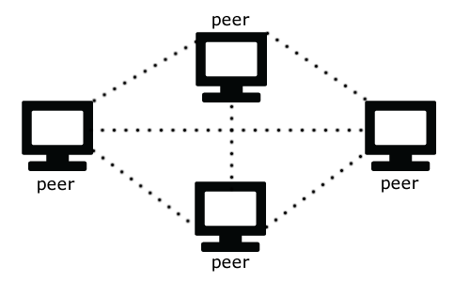

1. Blockchain:
   1. In simple words, Blockchain can be defined as a chain of the block that contains information. The technique is intended to timestamp digital documents so that it's not possible to backdate them or temper them. The blockchain is used for the secure transfer of items like money, property, contracts, etc. without requiring a third-party intermediary like bank or government. Once a data is recorded inside a blockchain, it is very difficult to change it. Here in our application the transaction is mail.

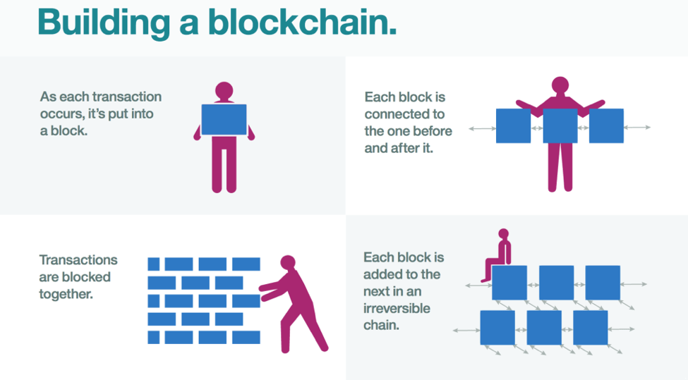

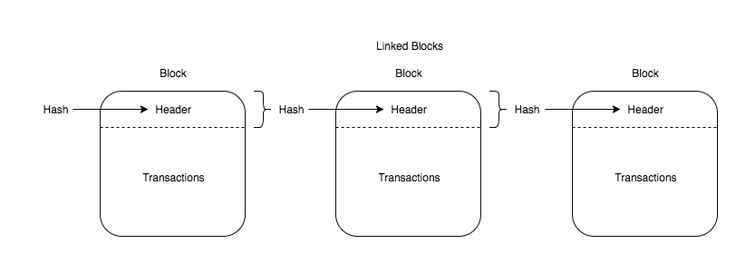

1. System Design:

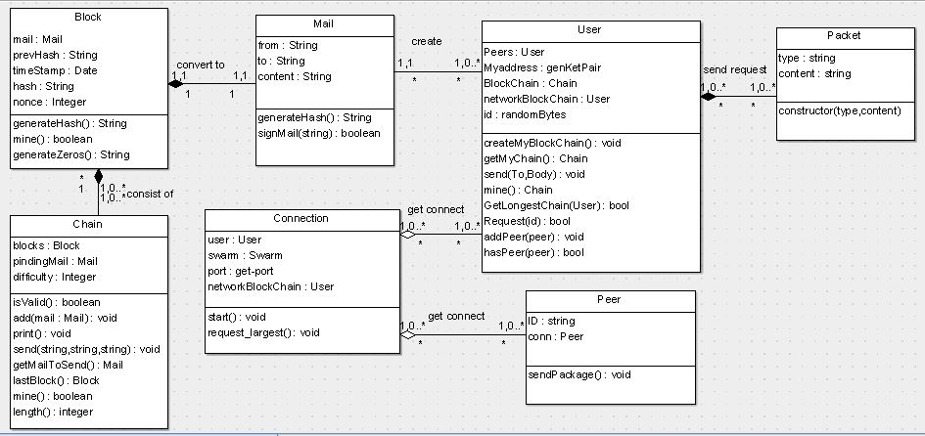

1. Description:

|  |  |
| --- | --- |
| Class Name | Description |
| Block | Response for generate the block hash function, check block difficulty and return the valid block hash. |
| Chain | Contain the chain of blocks, check the hash validation.  Add mail to the pending mails (mails need to be pended to its chain).  Compare blocks to get the block that achieve the existing difficulty. |
| Mail | Get the user’s mail.  Check public key validation, if true generate the mail’s hash. |
| Peer | Write the peer connection details. |
| Log | Handle the user input stream.  Prepare the interface for asking user to send message. |
| Packet | Send the type of user’s request. |
| User | Deal with all user’s requests such as:  Send mail, create a block chain, get longest block chain, and ask another user’s chain copy. |
| Connection | Start the peer’s connection in a synchronization manner. |

1. Installation Guide
   1. You need to install Node js.
   2. Cd project-folder/ then write Npm install and finally Npm start.
   3. Everything now is ready just run the application.

1. Repo Link:

<https://github.com/peter44322/CryptoMail>