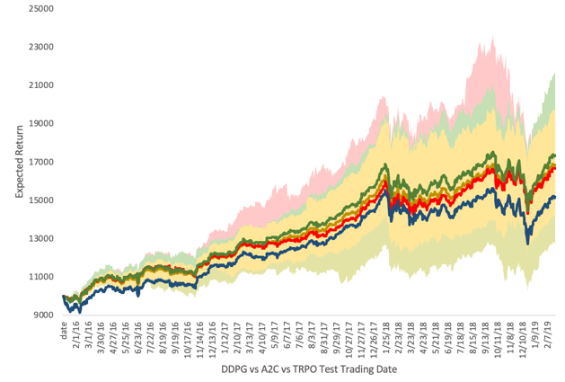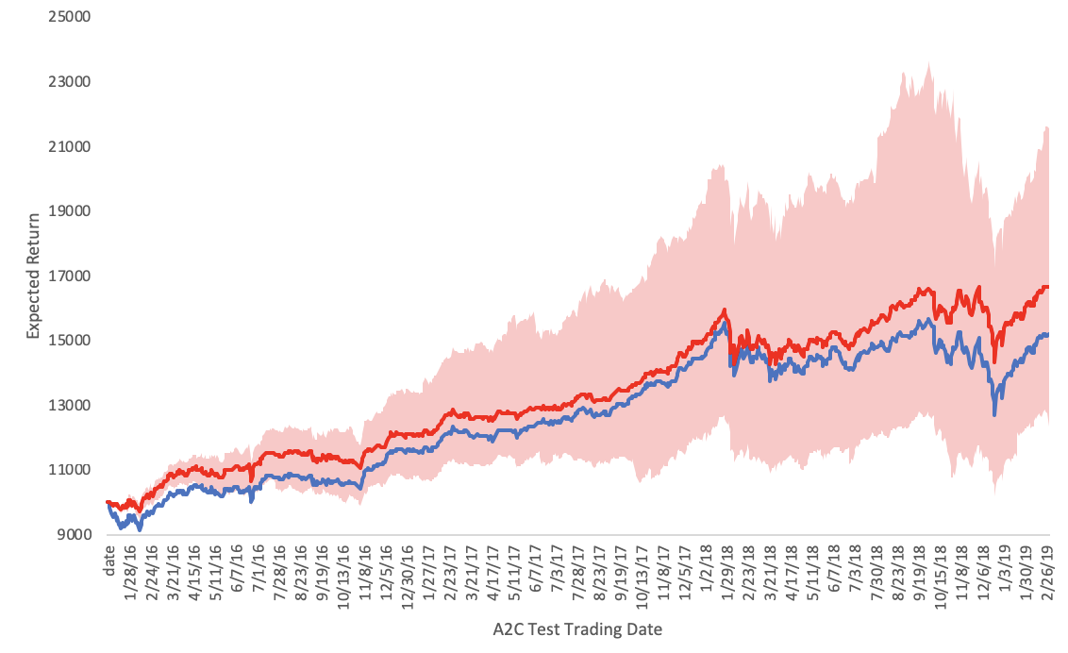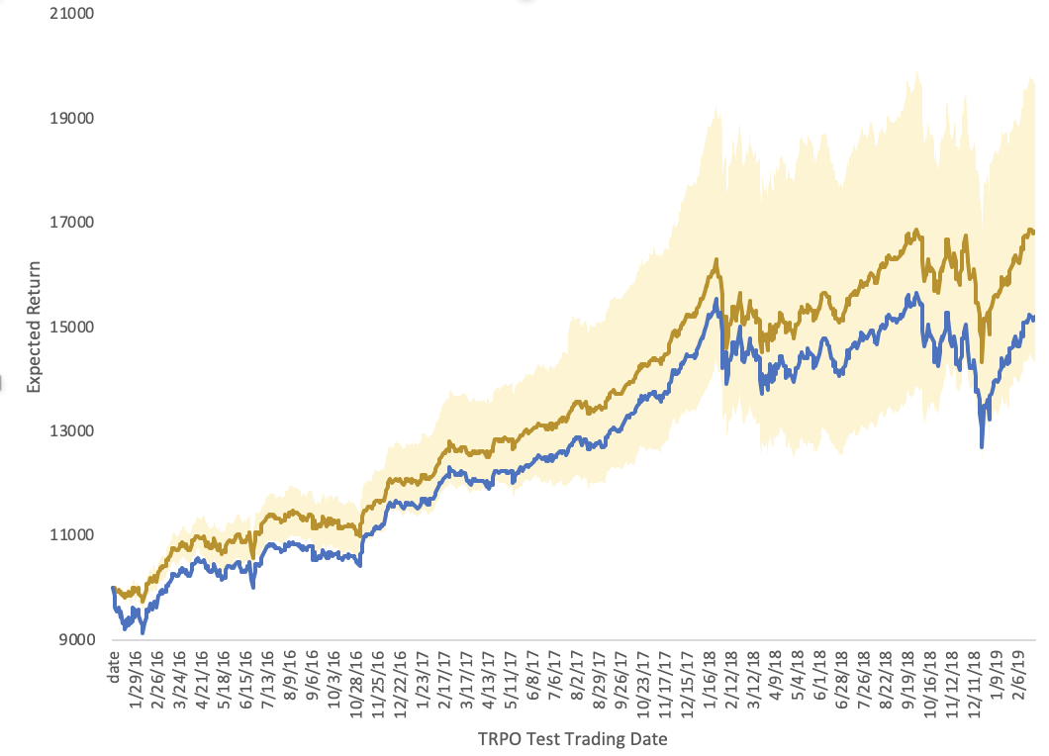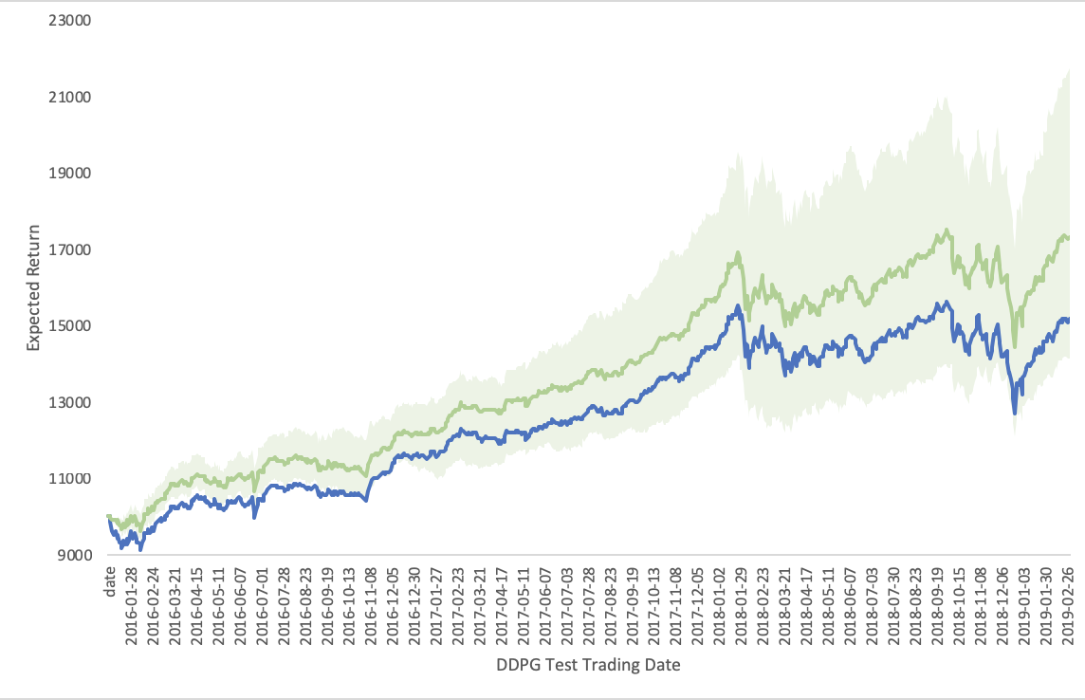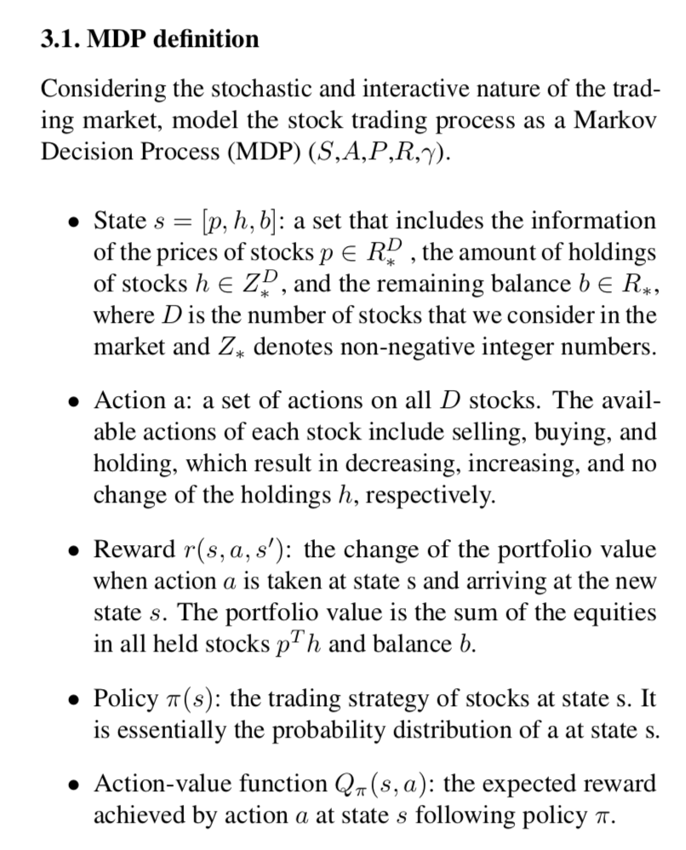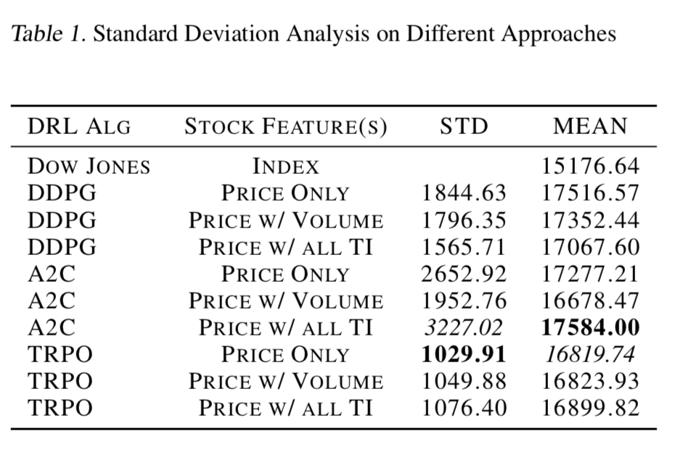

[Peter888@stanford.edu](mailto:Peter888@stanford.edu)

­­

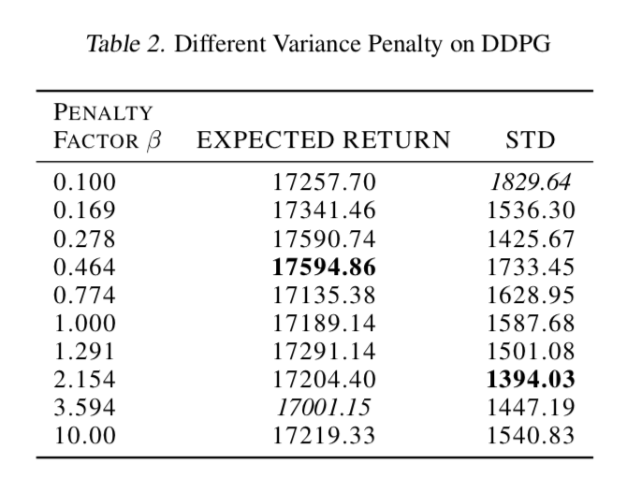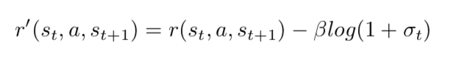

How much money we can earn?

Our start trading money is $10000. Our baseline expected return, which hold $10000 value of stock at the first trading day, will at market value $15176.64, at the last trading day. While our favor approach DDPG Price Volume’s average expected return is $1756.57, which yield yearly return 23.2%, and is 6.9% better than ˆDJI.

Abstract:

Stock trading plays a crucial role in investments. However, it is challenging to obtain optimal strategy in the dynamic and complex stock market, and stock trading is also considered a high-risk investment finance activity. Reinforcement Learning can provide lot of technologies to do optimize at lower risks. In this paper, we explore different deep reinforcement learning based approaches to get optimal and lower risk stock trading strategy, and get approaches beat Dow Jones market index, which use 30 of the stocks historical data. The result shown our approach beat the market baseline and reduced the risk.

Practical Deep Reinforcement Learning at Lower Risk for Stock Trading

­­­­