Supporting Information
Development of a Conformational Sampling Method for Transition State Structures with Diverse Active Bond Lengths
Satoshi Matsutani¹, Taichi Shomura¹, Nobuya Tsuji^{2*}, Satoshi Maeda^{2,3*}
¹Graduate School of Chemical Sciences and Engineering, Hokkaido University, Sapporo, Hokkaido 060-8628, Japan. ²Institute for Chemical Reaction Design and Discovery (WPI-ICReDD), Hokkaido University, Sapporo 001-0021, Japan. ³Department of Chemistry, Graduate School of Science, Hokkaido University, Sapporo, Hokkaido 060-0810, Japan.
*E-mail: tsuji@icredd.hokudai.ac.jp, smaeda@eis.hokudai.ac.jp
Present Address: Taichi Shomura, Research Center, Mitsui Chemicals, Inc., Sodegaura, Chiba 299-0265, Japan

Content
Conformation sampling protocol 3
TS optimization protocol 4
Example of agglomerative clustering 6
Calculation of enantioselectivity using the Boltzmann distribution 7
Additional results for Aldol reactions 8
Additional results for BINOL-catalyzed Mannich-type reaction 10
Initial calculation for IDPi-catalyzed intramolecular hydroamination calculation 12
ONIOM layer for IDPi-catalyzed intramolecular hydroamination reaction 14
Additional calculations for IDPi-catalyzed intramolecular hydroamination reaction 15
Energy diagrams of the calculated reactions 20
References 22

Conformation sampling protocol
Conformational sampling of reactant and TS structures was conducted using the single-component AFIR (SC-AFIR) method implemented in the GRRM program with constraints.^{1,2} Conformational sampling can be performed by adding the “NoBondRearrange” option to the SC-AFIR calculation. This option disables searches starting from structures whose bond connectivity differs from that of the input structure. For more details on the AFIR implementation, see the original reference.¹ In GRRM, a bond between atoms i and j, with covalent radii R_{i} and R_{j}, is defined by default as being present when the interatomic distance is shorter than 1.25 × (R_{i} + R_{j}). For sampling of reactant structures, the “Add Confining Potential” option was applied in the sampling input to prevent undesired bonding between the two reactant molecules. For the neutral aldol reaction (Figure 4B), the forming C-C bond distance was set to 3.4-4.9 Å, allowing the aldehyde and enol to move within this range. For the anionic aldol reaction (Figure 4C) and the aldol reaction using an ester-derived enolate anion (Figure 4D), this distance was set to 3.5-5.5 Å. For the BINOL-catalyzed Mannich-type reaction, a confining potential was applied to the C-C distance in the range of 2.8-4.3 Å, allowing the aldimine and ketene silyl acetal to approach within this range. For the IDPi-catalyzed intramolecular hydroamination reaction, the confining potential was set to 2.8-4.5 Å for the C-N distance.
In the conformational sampling of the reactant structure, the distance between the reacting atoms was intentionally set longer than the active bond lengths expected for the corresponding TS structures, in order to retain TS candidates with relatively long active bond lengths. If the reacting atoms are placed close to each other at this stage, the sampling may become biased by hindering the rotation of substrates, and potentially important TS conformers may be missed. While using longer interatomic distances can lead to longer AFIR pathways and may increase the computational cost of the subsequent path calculation and path optimization, the additional computational cost remains manageable as these steps were performed at a lower level of theory.
In the second stage of TStrail, TS conformational sampling employed the “Add Confining Potential” option to fix the active bond length, together with the “AddKeepPotential” option to apply a harmonic potential along the same bond. For all conformation sampling calculations, an artificial force of 60.0 kJ/mol was applied.
After conformational sampling, agglomerative clustering and connectivity filtering were performed on the calculated conformers to remove similar and structurally broken structures. The removal of broken structures was conducted based on bond connectivity. The connectivity of the initial structure in the input file was used as the reference and represented by a connectivity matrix constructed from interatomic distances. In this matrix, two atoms were regarded as bonded when the distance between them was less than 1.2 times the sum of their covalent radii. The covalent radii were predefined for common elements such as H, C, N, O, F, P, S, Cl, Si, Br, and I. Connectivity matrices were then generated for all obtained conformers using the same criterion and compared with the reference matrix. Conformers with unchanged connectivity were retained for subsequent calculations, whereas those exhibiting changes in connectivity were discarded.

TS optimization protocol
For the aldol and Mannich-type reactions, SaddleFC option during the TS optimization was set to 99999, meaning that an exact Hessian calculation was performed only in the initial step. For the intramolecular hydroamination reaction, SaddleFC was set to 5, resulting in an exact Hessian calculation every five steps during TS optimization.
For all TS calculations, if the TS converged within 100 iterations, subsequent calculations were performed. If the TS did not converge within 100 iterations, the strongest imaginary vibrational mode from all normal mode eigenvalues was examined. If this mode was smaller than -0.0001 Hartree/Bohr²·amu, the calculation was allowed to continue running. If the strongest imaginary vibrational mode was larger than -0.0001 Hartree/Bohr²·amu, the calculation was terminated.
Most TS structures were verified by the presence of a single imaginary vibrational frequency and by intrinsic reaction coordinate (IRC) calculations.³ However, some TS structures calculated using GRRMOnioM exhibit a very small second imaginary vibrational frequency due to finite-grid numerical integration in DFT. For these TS structures, the presence of a dominant imaginary vibrational mode and IRC calculations were used for verification. The minimum imaginary mode was set to (|ν_{imag}| > 25 cm⁻¹), and TS conformers with smaller |ν_{imag}| values were removed.
After the TS optimization and IRC calculation steps in TStrail, the active bond lengths of the TS, reactant, and product structures are calculated to determine whether the calculated IRC properly connects the desired structures. The calculated active bond lengths are then evaluated based on two criteria. The first criterion is that the active bond length in the product structure must be less than 3.0 Å, ensuring that the product structure corresponds to the bond-formed structure. The second criterion is that the active bond length in the TS structure (l_{TS}) must be shorter than that in the reactant structure (l_{reactant}) but longer than that in the product structure (l_{product}), i.e., l_{reactant} > l_{TS} > l_{product}. TS conformers that satisfy both criteria are used for further analysis, whereas those that do not satisfy these criteria are regarded as failed cases.

Example of agglomerative clustering
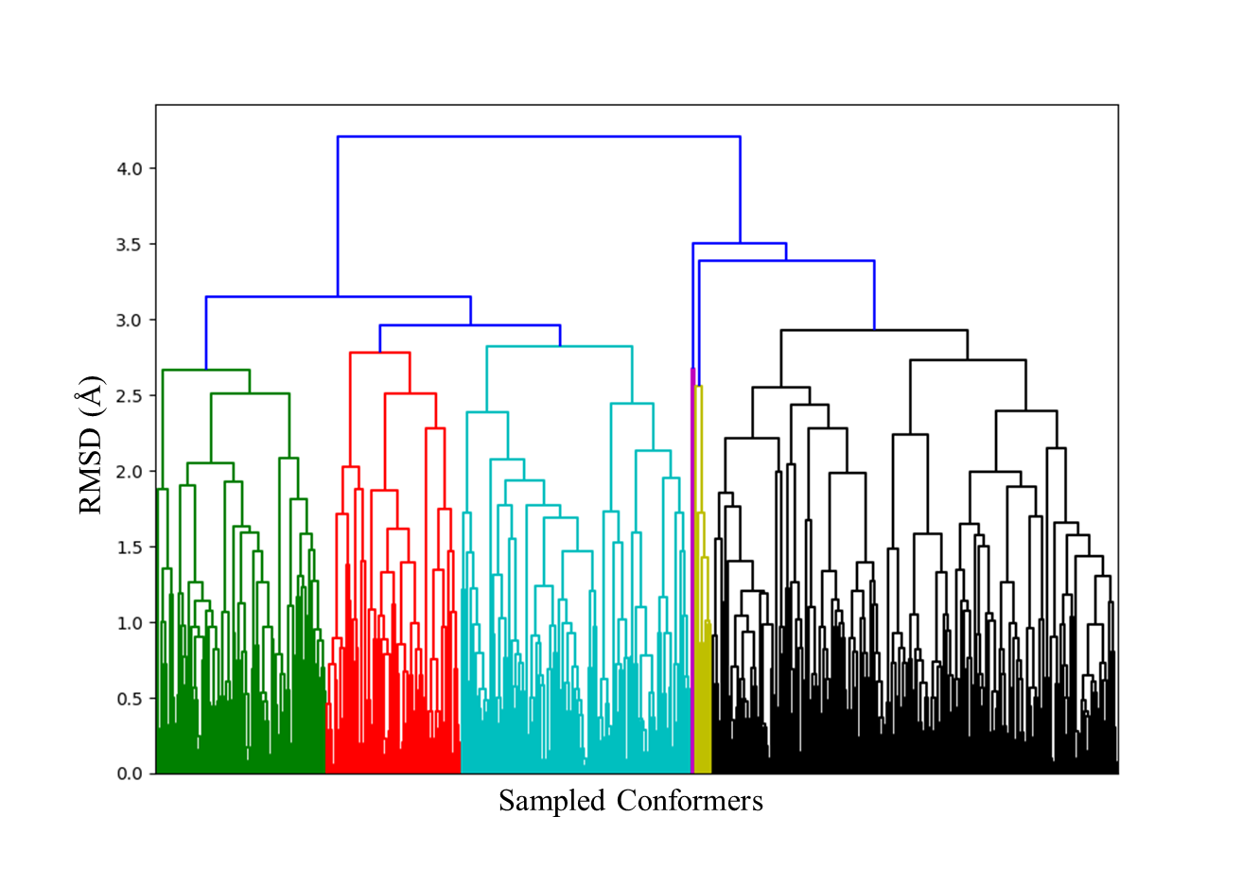
During the TStrail workflow, structurally similar conformers were clustered using agglomerative hierarchical clustering. In this procedure, each conformer is initially treated as an individual cluster. The two clusters with the smallest average pairwise RMSD are then merged, and the distances between the newly formed cluster and all remaining clusters are recalculated as the average of all pairwise RMSD values between the two clusters. Repetition of this process generates a hierarchical clustering tree, as shown in Figure S1. The final conformer clusters are obtained by cutting this hierarchy at a user-defined RMSD threshold, which was set to 0.75 Å in this study. For each resulting cluster, the conformer with the lowest energy is selected as the representative conformer. Only these representative conformers are used to generate input files for the subsequent AFIR pathway searches.
Figure S1. Example of agglomerative clustering. Here, 500 reactant structures were sampled and subjected to agglomerative clustering. Colors indicate the structural similarity of conformers, where conformers with the same color are more similar to each other than to those with different colors.

Calculation of enantioselectivity using the Boltzmann distribution
For the Mannich-type reaction and the intramolecular hydroamination reaction, all TS conformers obtained in the second stage of TStrail were used to calculate the enantioselectivity of the reaction. To do this, TS conformers were Boltzmann-weighted, and the enantioselectivity was evaluated under the assumption of Curtin-Hammett conditions.⁴⁻⁶
First, the Boltzmann weight of each TS conformer was calculated using the following equation:
$$\begin{aligned}ω_{i}=e^{\left[-\frac{{∆G}_{i}^{‡}-{∆G}_{min}^{‡}}{RT}\right]}\#\left(1\right)\end{aligned}$$
Here, ΔG_{i}‡ is the free energy of each TS conformer, ΔG_{min}‡ is the free energy of the most stable TS conformer, R is the gas constant (0.001987 kcal/molK), and T is the reaction temperature (195.15 K for the Mannich-type reaction and 313.15 K for the intramolecular hydroamination reaction). Finally, the enantiomeric ratio was determined by dividing the sum of the Boltzmann weights of all individual pathways leading to the major enantiomer by the corresponding sum for all pathways leading to the minor enantiomer:
$$\begin{aligned}e.r.=\frac{\sum_{i∈S}{ω_{i}}}{\sum_{i∈R}{ω_{i}}}\#\left(2\right)\end{aligned}$$

Additional results for Aldol reactions
The results of the initial and second stages of TStrail for the model aldol reactions are summarized in Figure S2. Black circles represent TS conformers obtained in the initial stage, whereas orange triangles represent TS conformers obtained in the second stage.
Figure S2. Results from the initial and second stages of TStrail for three aldol reactions. (A) Target model aldol reaction yielding the (1S,2R) product. (B-D) TS conformers calculated in the initial and second stages of TStrail. Black circles represent TS conformers calculated in the initial stage, whereas orange triangles represent TS conformers calculated in the second stage of TStrail.

The origin of the relative energy difference was analyzed using distortion-interaction analysis following the Houk-Bickelhaupt protocol.⁷ For this analysis, the most stable TS conformer (TS_{most-stable}) and the least stable TS conformer (TS_{least-stable}) obtained in the initial stage of TStrail were used. Each TS structure was divided into two fragments, namely the aldehyde and the enol/enolate anion, and single-point energy calculations were then performed for these fragments at the ωB97X-V/def2-TZVPP level of theory.
For the reaction between the aldehyde and enol (Figures 4B and 4E), the analysis suggested that the relative energy difference is mainly governed by the distortion energy. This appears to arise primarily from distortion of the enol structure. In particular, the orientation of the long alkyl chain in the less stable TS conformer may induce steric repulsion with the aldehyde fragment, thereby increasing the TS energy (Table S1).

Table S1: Distortion-interaction analysis calculated at the ωB97X-V/def2-TZVPP level of theory for the lowest- and highest-energy TS conformers of the reaction between the aldehyde and enol obtained in the initial stage of TStrail (Energy units in kcal/mol).
 | Single Point Energy | Relative Energy
TS_{most-stable} | -464453.8999 | 5.411199315
TS_{least-stable} | -464448.4887
Aldehyde Only
Aldehyde_{most-stable} | -145868.7702 | 1.083759466
Aldehyde_{least-stable} | -145867.6864
Enol Only
Enol_{most-stable} | -318555.8541 | 5.770314376
Enol_{least-stable} | -318550.0838
Total Distortion | (predominant factor) | 6.854073842
Total Interaction |  | -1.442874527

Similarly, for the reaction between the aldehyde and enolate anion (Figures 4C and 4F), the relative energy difference is also mainly governed by the distortion energy, particularly the distortion of the enolate anion structure (Table S2). As shown in Figure 4F, the enolate anion fragment in the most stable TS conformer, shown in blue, adopts a more compact geometry, whereas that in the least stable TS conformer, shown in red, is more distorted. This difference in the enolate geometry likely contributes to the relative TS energy difference.

Table S2: Distortion-interaction analysis calculated at the ωB97X-V/def2-TZVPP level of theory for the lowest- and highest-energy TS conformers of the reaction between the aldehyde and enolate anion obtained in the initial stage of TStrail (Energy units in kcal/mol).
 | Single Point Energy | Relative Energy
TS_{most-stable} | -464114.231 | 7.164151568
TS_{least-stable} | -464107.0668
Aldehyde Only
Aldehyde_{most-stable} | -145873.0774 | 0.067800557
Aldehyde_{least-stable} | -145873.0096
Enolate Anion Only
Enolate Anion_{most-stable} | -318216.6789 | 5.959554479
Enol Anion_{least-stable} | -318210.7194
Total Distortion | (predominant factor) | 6.027355036
Total Interaction |  | 1.136796532

Additional results for BINOL-catalyzed Mannich-type reaction
The calculated TS conformers for the initial and second stages of the TStrail procedure for the BINOL-catalyzed Mannich-type reaction are summarized in Figure S3. Here, (S)- and (R)-TS₁ represent the TS conformers obtained from the initial stage of TStrail, in which reaction pathways were sampled. Similarly, (S)- and (R)-TS₂ represent the TS conformers calculated during the second stage of TStrail, where conventional TS conformational sampling was performed.
Figure S3. The result from the initial and second stage of TStrail for BINOL-catalyzed Mannich-type reaction, where the TS conformers calculated in the initial stage of TStrail are represented as red circles and blue triangles, while the TS conformers calculated in the second stage of TStrail are represented as red pluses and blue crosses.

The enantioselectivity of BINOL-catalyzed Mannich-type reaction was calculated using the Boltzmann distribution (Figure S4). Here, 103 (S)-TS conformers and 91 (R)-TS conformers calculated at the second stage of TStrail were used for this calculation. The free energies were calculated at CPCM(Toluene)-ωB97X-V/def2-TZVPP//ωB97X-D/def2-SV(P) level of theory. Red lines represent (S)-TS conformers while blue lines represent (R)-TS conformers.
Figure S4. Boltzmann distribution of TS conformers calculated at the second stage of TStrail. The red lines represent (S)-TS conformers while blue lines represent (R)-TS conformers. CPCM(Toluene)-ωB97X-V/def2-TZVPP//ωB97X-D/def2-SV(P) level of theory.

Initial calculation for IDPi-catalyzed intramolecular hydroamination calculation
Previous computational work by Guria et al. suggested that the reaction proceeds via a fully concerted pathway, in which proton transfer and cyclization occur in a single step.⁸ Intrigued by this result, we re-examined the same reaction using the r²SCAN-3c level of theory, in contrast to the earlier study, which employed the GFN1-xTB method for geometry optimization. Using the reported XYZ coordinates as the starting structure, we performed constrained optimization followed by TS optimization at the r²SCAN-3c level of theory and successfully located a TS corresponding to the concerted pathway, as confirmed by IRC calculations.
In parallel, we investigated a stepwise protonation pathway starting from the reactant structure reported in the previous computational study. The structure was first optimized, and the protonation and cyclization TSs were calculated using the AFIR algorithm at the r²SCAN-3c level of theory. TS optimization revealed a more stable alkene protonation pathway, leading to an ionic intermediate in which the carbocationic substrate is stabilized within the anionic catalyst pocket (Figure S5). In this pathway, subsequent cyclization does not occur in a concerted manner, in contrast to the mechanism proposed in the previous study. From this ionic intermediate, we identified a relatively flat cyclization TS that connects the intermediate to the cyclized product.
It should be noted that no additional conformational sampling was performed for either pathway in the initial calculations. The purpose of these calculations was to use the previously reported structures as starting points to compare the energies of the concerted and stepwise pathways. In addition, the initial calculations were conducted to determine which step of the stepwise pathway, protonation or cyclization, is the enantiodetermining step. After confirming that the stepwise pathway is energetically preferred and that the cyclization step is enantiodetermining step, we selected TS2 as the target for conformational sampling using TStrail.
Figure S5. Energy diagram of the IDPi-catalyzed intramolecular hydroamination reaction. The black and gray lines represent the structures obtained from the initial calculations: the black line corresponds to the stepwise pathway, whereas the gray dotted line corresponds to the concerted pathway. Both pathways lead to the (R)-product. The red and blue lines represent the lowest-energy TSs identified in the second stage of TStrail, with the red line corresponding to the lowest-energy (R)-TS and the blue line corresponding to the lowest-energy (S)-TS. The calculations were conducted using CPCM(Toluene)-ωB97X-V/def2-TZVPP//r²SCAN-3c level of theory. Free energies are in kcal/mol.

ONIOM layer for IDPi-catalyzed intramolecular hydroamination reaction
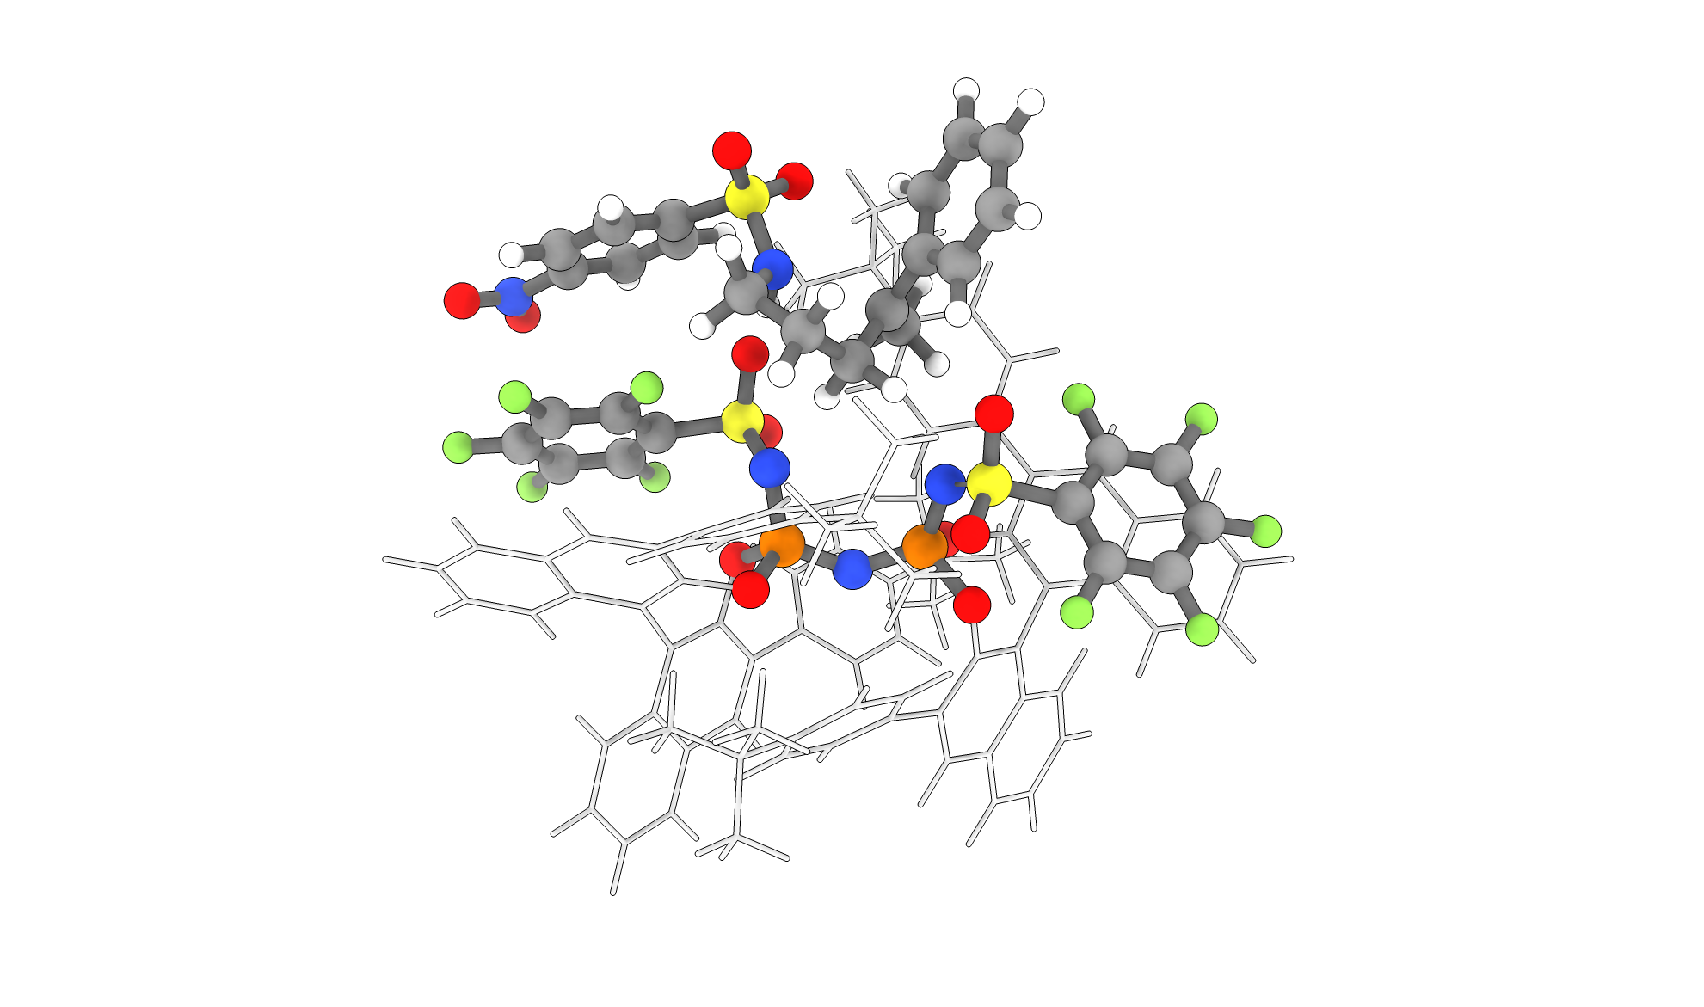
Since the computational cost of the IDPi-catalyzed intramolecular hydroamination reaction is relatively high, the initial TS calculations were performed using our in-house ONIOM program, GRRM-OnioM. The catalyst-substrate complex (232 atoms) was divided into two layers: a high layer consisting of the entire substrate and the heteroatoms of the IDPi catalyst (80 atoms), and a low layer consisting of the backbone and wings of the IDPi catalyst (152 atoms), as depicted in Figure S6. The ωB97X-D/def2-SV(P) level of theory was employed for the high layer, while the GFN2-xTB method was used for the low layer.
Figure S6. ONIOM layer definition for the intramolecular hydroamination reaction. Atoms shown as colored spheres correspond to the high layer, whereas atoms shown in light gray as sticks correspond to the low layer.

Additional calculations for IDPi-catalyzed intramolecular hydroamination reaction
The calculated TS conformers for the initial and second stages of the TStrail procedure for the IDPi-catalyzed intramolecular hydroamination reaction are summarized in Figure S7. Similar to Figure S3, (R)- and (S)-TS₁ represent TS conformers obtained from the initial stage of TStrail, whereas (R)- and (S)-TS₂ represent the TS conformers calculated at the second stage of TStrail.
The enantioselectivity of IDPi-catalyzed intramolecular hydroamination reaction was calculated using the Boltzmann distribution (Figure S8). Here, 5 (R)-TS conformers and 8 (S)-TS conformers calculated at the second stage of TStrail were used for this calculation. The free energies were calculated at CPCM(Toluene)-ωB97X-V/def2-TZVPP//r²SCAN-3c level of theory. Red lines represent (R)-TS conformers while blue lines represent (S)-TS conformers.
Figure S7. The result from the initial and second stage of TStrail for IDPi-catalyzed intramolecular hydroamination reaction, where the TS conformers calculated in the initial stage of TStrail are represented as red circles and blue triangles, while the TS conformers calculated in the second stage of TStrail are represented as green pluses and purple crosses.

Figure S8. Boltzmann distribution of TS conformers calculated at the second stage of TStrail. The red lines represent (R)-TS conformers while blue lines represent (S)-TS conformers. Free energies were calculated at CPCM(Toluene)-ωB97X-V/def2-TZVPP//r²SCAN-3c level of theory.
Distortion-interaction analysis following the Houk-Bickelhaupt protocol was conducted on the lowest energy (R)-TS and (S)-TS conformers to further elucidate the origin of enantioselectivity. The optimized TS structures were divided into a cationic substrate and an anionic catalyst, and single-point energy calculations were subsequently performed on these ionic fragments at the CPCM(Toluene)-ωB97X-V/def2-TZVPP level of theory. The results suggest that the predominant factor influencing the energy difference between the two TSs is the difference in substrate-catalyst interaction, as summarized in Table S3.
To further examine the interaction differences between the two enantiodetermining TSs, IGMH analysis was carried out at the ωB97X-D/def2-TZVPP level of theory using Gaussian 16 package.⁹ The IGMH analysis was performed with Multiwfn 3.8(dev) using default parameters, a grid resolution of 0.15 Bohr, and an isovalue of 0.005 a.u..^{10,11} The calculated intrinsic bond strength index for weak interaction (IBSIW) indices were summed for each TS, and the results are summarized in Table S4. The total weak interaction strength between the substrate and the catalyst is greater for the (R)-TS than for the (S)-TS. Examination of the IGMH maps of the two TSs reveals that the NH proton of the substrate is oriented toward the interior of the anionic pocket in the (R)-TS, whereas it is directed outward in the (S)-TS. The IBSIW value for the interaction between the NH proton and the sulfonyl group of the catalyst is 3.78 a.u./Å², which is comparable to the overall difference in IBSIW values between the two TSs.

Table S3: Distortion-interaction analysis calculated at the CPCM(Toluene)-ωB97X-V/def2-TZVPP level of theory for the lowest energy (R)-TS and (S)-TS from each conformer.
 | Single Point Energy (Hartree) | Relative Energy (kcal/mol)
(R)-TS | -8261.15762126791 | -0.592722859584974
(S)-TS | -8261.1566767047
Substrate Only
Substrate_(R)-TS | -1467.56537498747 | +6.4775929526161
Substrate_(S)-TS | -1467.57569768026
Catalyst Only
Catalyst_(R)-TS | -6793.48275936481 | +0.467615896526086
Catalyst_(S)-TS | -6793.48350455755
Total Distortion |  | +6.94520884914219
Total Interaction | (predominant factor) | -7.53793170872716

Table S4: The sum of IBSIW indices between the anionic catalyst and the cationic substrate for the lowest energy (R)-TS and (S)-TS from each conformer. Values were calculated at ωB97X-D/def2-TZVPP level of theory.
 | Sum of IBSIW indices (a.u./Å²)
(R)-TS | 36.0303769999996
(S)-TS | 32.6302249999997

Although some TS optimizations may have failed due to less favorable or awkward orientations of the reactant structure within the catalytic pocket, TStrail was still able to identify TS conformers with such reactant orientations. To visualize conformational variations of the reactant structure within the catalytic pocket, representative (R)-TS conformers calculated in the initial stage of TStrail were superimposed (Figure S9). This figure shows that groups such as the nosyl and phenyl groups of the reactant can rotate within the catalytic pocket. Three-dimensional representations of the most stable (R)- and (S)-TS structures identified in the initial stage of TStrail are shown in Figure S10.

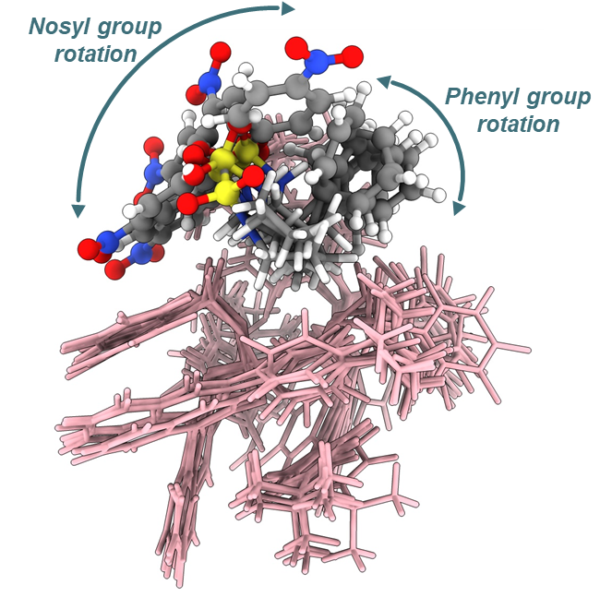
Figure S9. Superimposed (R)-TS conformers obtained in the initial stage of TStrail. The IDPi anion is shown as pink sticks, whereas the nosyl and phenyl groups of the reactant structures are highlighted as ball-and-stick models.

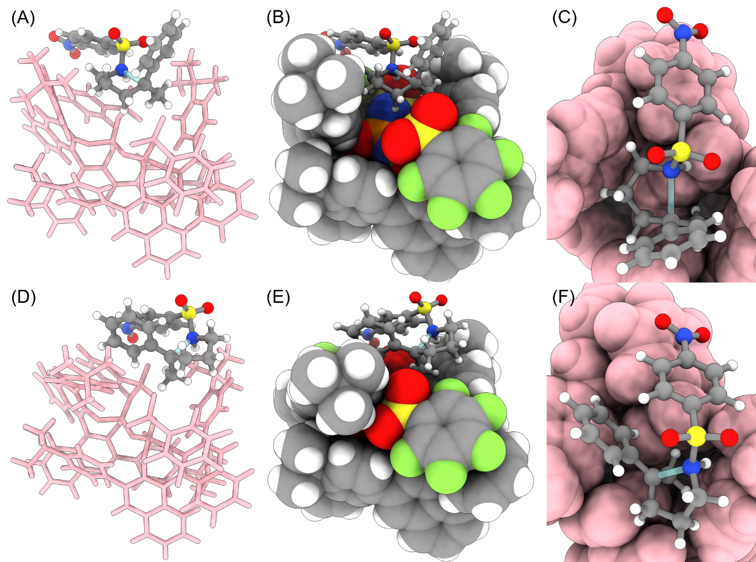
Figure S10. 3D structures of the most stable (R)-TS and (S)-TS identified in the initial stage of TStrail. (A)-(C) Representations of the (R)-TS, with the IDPi catalyst shown in pink and the substrate shown in ball-and-stick representation. (D)-(F) Representations of the (S)-TS, with the IDPi catalyst shown in pink and the substrate shown in ball-and-stick representation.

Energy diagrams of the calculated reactions
The energy diagrams of the reactions investigated in this work are summarized in Figures S11-S13. The most stable TSs obtained from the second stage of TStrail are shown, and their free energies, together with the corresponding reactants and products calculated from IRC, are summarized. In each energy diagram, the TS and product energies are given relative to the reactant energy.
Figure S12. Energy diagram of BINOL-catalyzed Mannich-type reaction calculated in this work. The calculations were conducted using CPCM(Toluene)-ωB97X-V/def2-TZVPP//ωB97X-D/def2-SV(P) level of theory. Thermal corrections have been performed at 195.15 K and 1 atm.

Figure S11. Energy diagram of three aldol reactions calculated in this work. The calculations were conducted using ωB97X-V/def2-TZVPP//ωB97X-D/def2-SV(P) level of theory. Thermal corrections have been performed at 298.15 K and 1 atm.

Figure S13. Energy diagram of IDPi-catalyzed intramolecular hydroamination reaction calculated in this work. The calculations were conducted using CPCM(Toluene)-ωB97X-V/def2-TZVPP//r²SCAN-3c level of theory. Thermal corrections have been performed at 313.15 K and 1 atm.

References
1 S. Maeda, Y. Harabuchi, M. Takagi, K. Saita, K. Suzuki, T. Ichino, Y. Sumiya, K. Sugiyama and Y. Ono, “Implementation and Performance of the Artificial Force Induced Reaction Method in the GRRM17 Program,” Journal of Computational Chemistry 39 (2018): 233-251.
2 S. Maeda and Y. Harabuchi, “Exploring Paths of Chemical Transformations in Molecular and Periodic Systems: An Approach Utilizing Force,” WIREs Computational Molecular Science 11 (2021): e1538.
3 K. Ishida, K. Morokuma and A. Komornicki, “The Intrinsic Reaction Coordinate. An Ab Initio Calculation for HNC→HCN and H⁻+CH₄→CH₄+H⁻,” The Journal of Chemical Physics 66 (1977): 2153-2156.
4 S. Grimme, F. Bohle, A. Hansen, P. Pracht, S. Spicher and M. Stahn, “Efficient Quantum Chemical Calculation of Structure Ensembles and Free Energies for Nonrigid Molecules,” The Journal of Physical Chemistry A 125 (2021): 4039-4054.
5 P. Lv, R. Zhu, D. Zhang and S. E. Wheeler, “Mechanism and Enantioselectivity in QUINOX-Catalyzed Asymmetric Allylations of Aromatic Aldehydes: Solvent and Substituent Effects,” The Journal of Organic Chemistry 89 (2024): 6053-6063.
6 I. H. Williams, “Virtual Transition States: Making Sense of Multiple Transition States in Parallel and Series,” Chemical Society Review 54 (2025): 9145-9160.
7 F. M. Bickelhaupt and K. N. Houk, “Analyzing Reaction Rates with the Distortion/Interaction‐Activation Strain Model,” Angewandte Chemie International Edition 56 (2017): 10070-10086.
8 S. Guria, A. N. Volkov, R. Khudaverdyan, R. Van Lommel, R. Pan, C. G. Daniliuc, F. De Proft and U. Hennecke, “Enantioselective, Brønsted Acid-Catalyzed Anti-Selective Hydroamination of Alkenes,” Journal of the American Chemical Society 146 (2024): 17180-17188.
9 T. Lu and Q. Chen, “Independent Gradient Model Based on Hirshfeld Partition: A New Method for Visual Study of Interactions in Chemical Systems,” Journal of Computational Chemistry 43 (2022): 539-555.
10 T. Lu and F. Chen, “Multiwfn: A Multifunctional Wavefunction Analyzer,” Journal of Computational Chemistry 33 (2012): 580-592.
11 T. Lu, “A Comprehensive Electron Wavefunction Analysis Toolbox for Chemists, Multiwfn,” The Journal of Chemical Physics 161 (2024): 082503.

