

微算機原理及應用實習

期末專題報告書

隨機抽籤機

任課教師：李仁貴 老師

班級：電子二丙

學生：游鎮遠107360734

學生：李彥霖107360741

學生：陳柏宇107360740

組別：第5組

前言：

目錄：

動機與目的：

在國、高中的課程中，老師常會透過抽籤的方式來進行分組或抽人問問題，這樣人為的抽籤往往會有利弊，每個人都當過學生，都會有些投機取巧的心態不想被抽到而把自己的籤偷偷先藏起來，為了讓往後的抽籤更有公平性，我們想到一個辦法來製造隨機抽籤機，讓每個人都有被抽到的機會！

功能原理：

利用開發版上的各項功能，配合程式的編寫來做到抽籤器的效果。按鈕實現輸入。

LCD做為顯示面板，顯示抽籤效果與最終的抽選結果。

LCD亮滅則做為氣氛營造的方式。

系統架構圖：

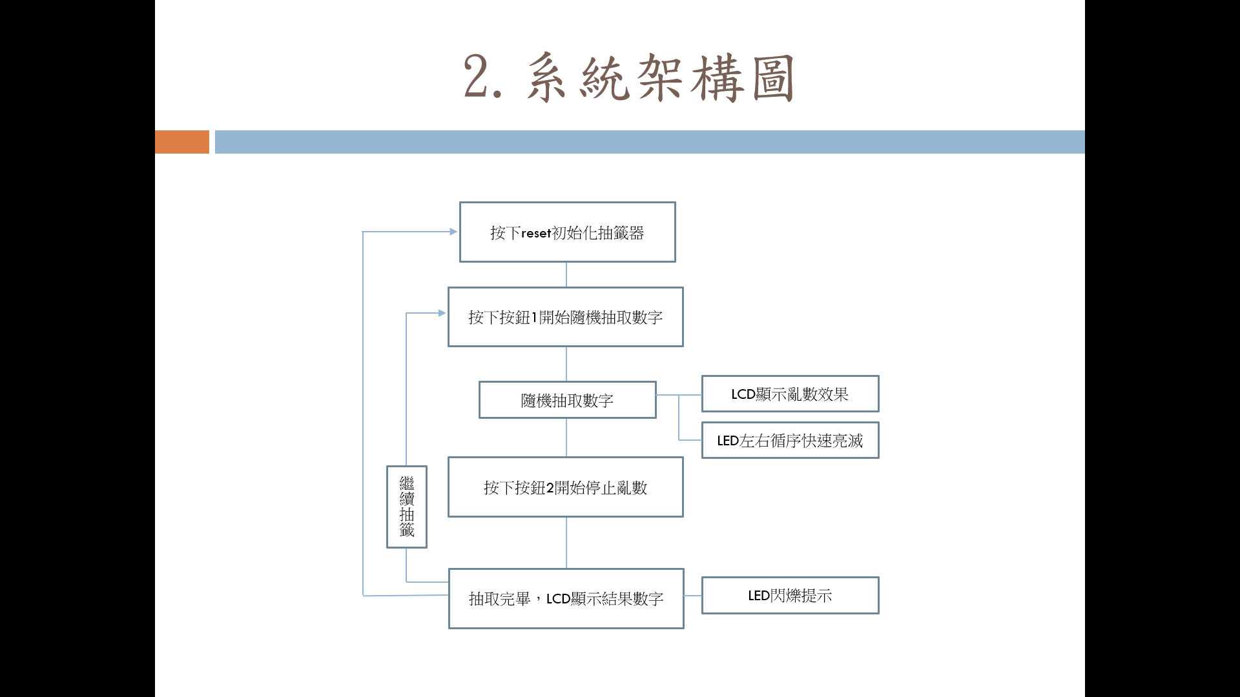

程式流程圖：

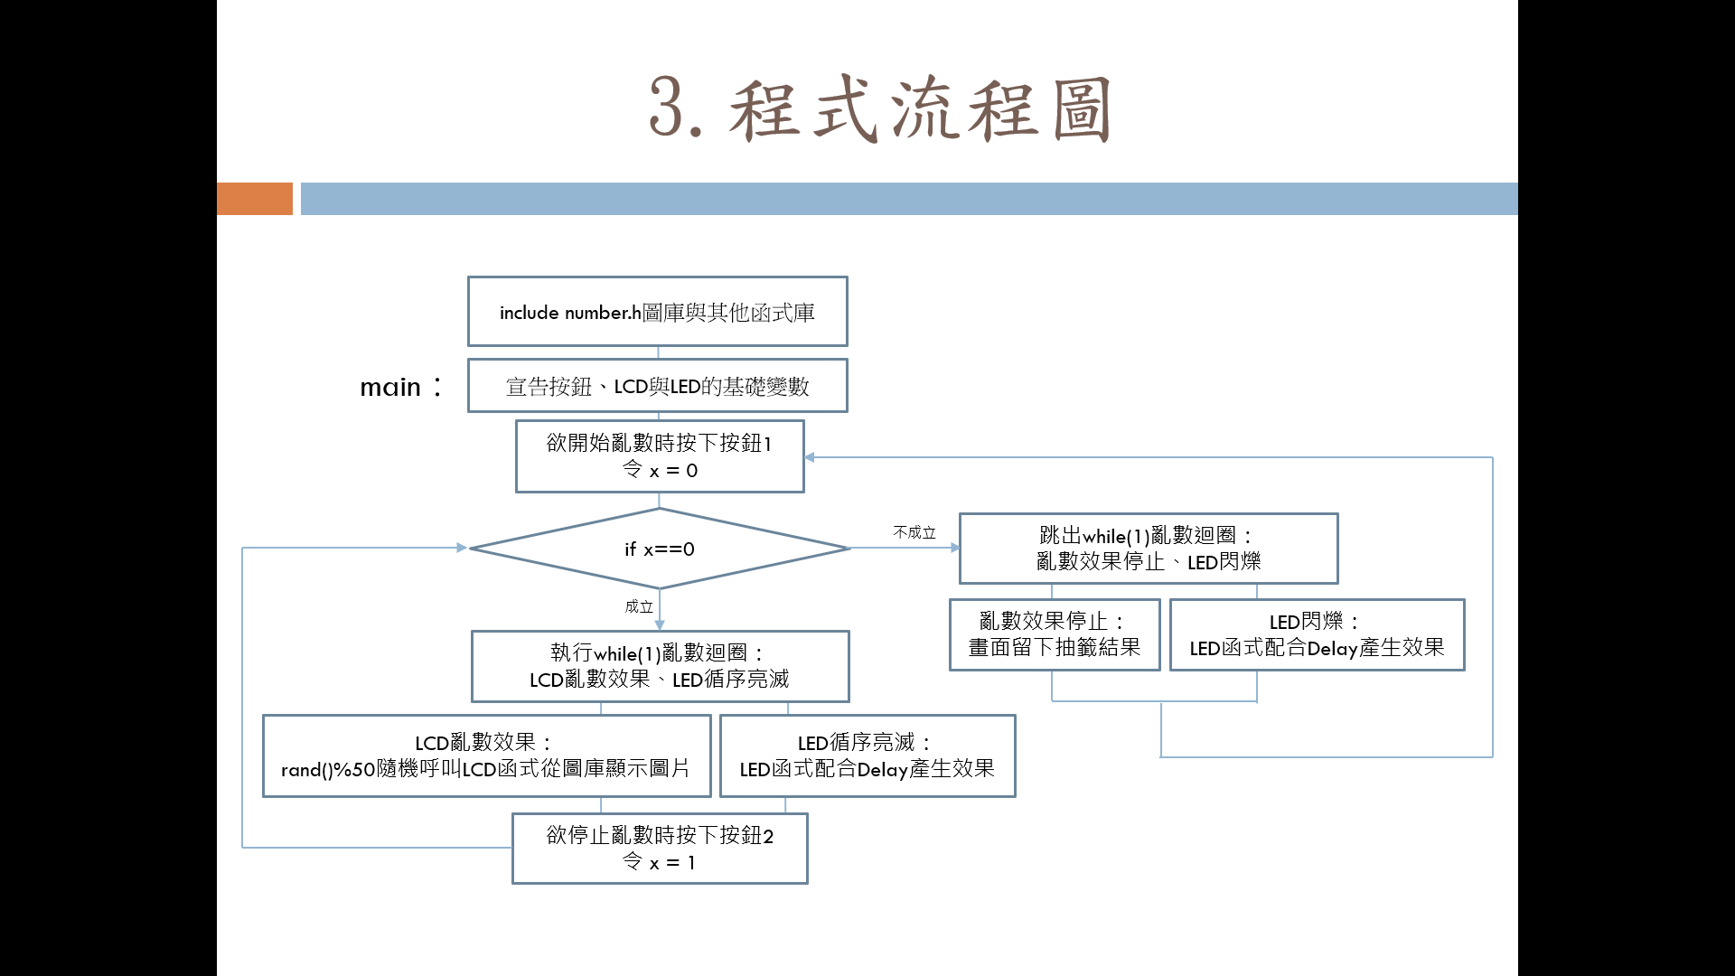

成果展示及說明：

心得：這次的專題報告，剛開始我們有很多想做的東西，但很可惜都被其他組選走了，但最後我們有了抽籤機的想法，雖然這個東西很普通，但也是考驗了我們幾個禮拜，透過程式不斷的更改以及討論，過程中也有助教的幫忙，在最後才能呈現這完美的成果。\

未來展望 :

程式碼：

/* Includes ------------------------------------------------------------------*/

#include "stm32f1xx_hal.h"

#include "main.h"

#include "lcd.h"

#include "number.h"

#include "stdlib.h"

#include "stdio.h"

#ifdef __GNUC__

#define PUTCHAR_PROTOTYPE int __io_putchar(int ch)

#else

#define PUTCHAR_PROTOTYPE int fputc(int ch, FILE *f)

#endif /* __GNUC__ */

/* USER CODE BEGIN Includes */

/* USER CODE END Includes */

/////////////////////////////////////////////////////////////////////////////////////////////////////////////////////////

/* Private variables ---------------------------------------------------------*/

UART_HandleTypeDef huart1;

/////////////////////////////////////////////////////////////////////////////////////////////////////////////////////////

ADC_HandleTypeDef hadc1;

/* USER CODE BEGIN PV */

/* Private variables ---------------------------------------------------------*/

static GPIO_InitTypeDef GPIO_InitStruct;

/* USER CODE END PV */

/* Private function prototypes -----------------------------------------------*/

void SystemClock_Config(void);

static void MX_GPIO_Init(void);

///////////////////////////////////////////////////////////////////////////////////////////////////

static void MX_USART1_UART_Init(void); //+codeAa-E?Y-n|33o|a

///////////////////////////////////////////////////////////////////////////////////////////////////

static void MX_ADC1_Init(void);

int main(void)

{

int z;

int x=0;

GPIO_InitStruct.Pin = TAMPER_BUTTON_PIN;

GPIO_InitStruct.Mode = GPIO_MODE_INPUT;

GPIO_InitStruct.Pull = GPIO_PULLUP;

GPIO_InitStruct.Speed = GPIO_SPEED_FREQ_HIGH;

HAL_GPIO_Init(TAMPER_BUTTON_GPIO_PORT, &GPIO_InitStruct);

TAMPER_BUTTON_GPIO_CLK_ENABLE();

GPIO_InitStruct.Pin = WAKEUP_BUTTON_PIN;

GPIO_InitStruct.Mode = GPIO_MODE_INPUT;

GPIO_InitStruct.Pull = GPIO_PULLDOWN;

GPIO_InitStruct.Speed = GPIO_SPEED_FREQ_HIGH;

HAL_GPIO_Init(WAKEUP_BUTTON_GPIO_PORT, &GPIO_InitStruct);

WAKEUP_BUTTON_GPIO_CLK_ENABLE();

GPIO_InitStruct.Pin = WAKEUP_BUTTON_PIN;

GPIO_InitStruct.Mode = GPIO_MODE_INPUT;

GPIO_InitStruct.Pull = GPIO_PULLDOWN;

GPIO_InitStruct.Speed = GPIO_SPEED_FREQ_HIGH;

HAL_GPIO_Init(WAKEUP_BUTTON_GPIO_PORT, &GPIO_InitStruct);

WAKEUP_BUTTON_GPIO_CLK_ENABLE();

#define c GPIOA

#define v GPIO_PIN_0

#define n GPIOC

#define m GPIO_PIN_13

HAL_Init();

/* Configure the system clock */

SystemClock_Config();

#if 0

LED1_GPIO_CLK_ENABLE();

LED2_GPIO_CLK_ENABLE();

LED3_GPIO_CLK_ENABLE();

LED4_GPIO_CLK_ENABLE();

GPIO_InitStruct.Pin = LED1_PIN;

GPIO_InitStruct.Pin = LED2_PIN;

GPIO_InitStruct.Pin = LED3_PIN;

GPIO_InitStruct.Pin = LED4_PIN;

GPIO_InitStruct.Mode= GPIO_MODE_OUTPUT_PP;

GPIO_InitStruct.Pull= GPIO_PULLUP;

GPIO_InitStruct.Speed=GPIO_SPEED_FREQ_HIGH;

HAL_GPIO_Init(LED1_GPIO_PORT, &GPIO_InitStruct);

HAL_GPIO_Init(LED2_GPIO_PORT, &GPIO_InitStruct);

HAL_GPIO_Init(LED3_GPIO_PORT, &GPIO_InitStruct);

HAL_GPIO_Init(LED4_GPIO_PORT, &GPIO_InitStruct);

#endif

/* Initialize all configured peripherals */

MX_GPIO_Init();

////////////////////////////////////////////////////////////////////////

MX_USART1_UART_Init();

//////////////////////////////////////////////////////////////////////////

MX_ADC1_Init();

LCD_Init();

LCD_Clear();

start:

if(HAL_GPIO_ReadPin(c, v)){

while (x==0){

z=rand()%50;

if(z==0)

LCD_Draw_Logo(Logo0);

else if(z==1)

LCD_Draw_Logo(Logo1);

else if(z==2)

LCD_Draw_Logo(Logo2);

else if(z==3)

LCD_Draw_Logo(Logo3);

else if(z==4)

LCD_Draw_Logo(Logo4);

else if(z==5)

LCD_Draw_Logo(Logo5);

else if(z==6)

LCD_Draw_Logo(Logo6);

else if(z==7)

LCD_Draw_Logo(Logo7);

else if(z==8)

LCD_Draw_Logo(Logo8);

else if(z==9)

LCD_Draw_Logo(Logo9);

else if(z==10)

LCD_Draw_Logo(Logo10);

else if(z==11)

LCD_Draw_Logo(Logo11);

else if(z==12)

LCD_Draw_Logo(Logo12);

else if(z==13)

LCD_Draw_Logo(Logo13);

else if(z==14)

LCD_Draw_Logo(Logo14);

else if(z==15)

LCD_Draw_Logo(Logo15);

else if(z==16)

LCD_Draw_Logo(Logo16);

else if(z==17)

LCD_Draw_Logo(Logo17);

else if(z==18)

LCD_Draw_Logo(Logo18);

else if(z==19)

LCD_Draw_Logo(Logo19);

else if(z==20)

LCD_Draw_Logo(Logo20);

else if(z==21)

LCD_Draw_Logo(Logo21);

else if(z==22)

LCD_Draw_Logo(Logo22);

else if(z==23)

LCD_Draw_Logo(Logo23);

else if(z==24)

LCD_Draw_Logo(Logo24);

else if(z==25)

LCD_Draw_Logo(Logo25);

else if(z==26)

LCD_Draw_Logo(Logo26);

else if(z==27)

LCD_Draw_Logo(Logo27);

else if(z==28)

LCD_Draw_Logo(Logo28);

else if(z==29)

LCD_Draw_Logo(Logo29);

else if(z==30)

LCD_Draw_Logo(Logo30);

else if(z==31)

LCD_Draw_Logo(Logo31);

else if(z==32)

LCD_Draw_Logo(Logo32);

else if(z==33)

LCD_Draw_Logo(Logo33);

else if(z==34)

LCD_Draw_Logo(Logo34);

else if(z==35)

LCD_Draw_Logo(Logo35);

else if(z==36)

LCD_Draw_Logo(Logo36);

else if(z==37)

LCD_Draw_Logo(Logo37);

else if(z==38)

LCD_Draw_Logo(Logo38);

else if(z==39)

LCD_Draw_Logo(Logo39);

else if(z==40)

LCD_Draw_Logo(Logo40);

else if(z==41)

LCD_Draw_Logo(Logo41);

else if(z==42)

LCD_Draw_Logo(Logo42);

else if(z==43)

LCD_Draw_Logo(Logo43);

else if(z==44)

LCD_Draw_Logo(Logo44);

else if(z==45)

LCD_Draw_Logo(Logo45);

else if(z==46)

LCD_Draw_Logo(Logo46);

else if(z==47)

LCD_Draw_Logo(Logo47);

else if(z==48)

LCD_Draw_Logo(Logo48);

else if(z==49)

LCD_Draw_Logo(Logo49);

else if(z==50)

LCD_Draw_Logo(Logo50);

HAL_GPIO_TogglePin(LED1_GPIO_PORT,LED1_PIN);

HAL_Delay(5);

HAL_GPIO_TogglePin(LED1_GPIO_PORT,LED1_PIN);

HAL_Delay(10);

HAL_GPIO_TogglePin(LED2_GPIO_PORT,LED2_PIN);

HAL_Delay(5);

HAL_GPIO_TogglePin(LED2_GPIO_PORT,LED2_PIN);

HAL_Delay(10);

HAL_GPIO_TogglePin(LED3_GPIO_PORT,LED3_PIN);

HAL_Delay(5);

HAL_GPIO_TogglePin(LED3_GPIO_PORT,LED3_PIN);

HAL_Delay(10);

HAL_GPIO_TogglePin(LED4_GPIO_PORT,LED4_PIN);

HAL_Delay(5);

HAL_GPIO_TogglePin(LED4_GPIO_PORT,LED4_PIN);

HAL_Delay(10);

HAL_GPIO_TogglePin(LED3_GPIO_PORT,LED3_PIN);

HAL_Delay(5);

HAL_GPIO_TogglePin(LED3_GPIO_PORT,LED3_PIN);

HAL_Delay(10);

HAL_GPIO_TogglePin(LED2_GPIO_PORT,LED2_PIN);

HAL_Delay(5);

HAL_GPIO_TogglePin(LED2_GPIO_PORT,LED2_PIN);

HAL_Delay(10);

if(HAL_GPIO_ReadPin(n, m)==0){

x=1;

};

};

while(x==1){

HAL_GPIO_TogglePin(LED1_GPIO_PORT,LED1_PIN);

HAL_GPIO_TogglePin(LED2_GPIO_PORT,LED2_PIN);

HAL_GPIO_TogglePin(LED3_GPIO_PORT,LED3_PIN);

HAL_GPIO_TogglePin(LED4_GPIO_PORT,LED4_PIN);

HAL_Delay(500);

HAL_GPIO_TogglePin(LED1_GPIO_PORT,LED1_PIN);

HAL_GPIO_TogglePin(LED2_GPIO_PORT,LED2_PIN);

HAL_GPIO_TogglePin(LED3_GPIO_PORT,LED3_PIN);

HAL_GPIO_TogglePin(LED4_GPIO_PORT,LED4_PIN);

HAL_Delay(500);

if(HAL_GPIO_ReadPin(c, v)){

x=0;

};

};

};

goto start;

};

PUTCHAR_PROTOTYPE

{

/* Place your implementation of fputc here */

/* e.g. write a character to the USART1 and Loop until the end of transmission */

HAL_UART_Transmit(&huart1, (uint8_t *)&ch, 1, 0xffff);

return ch;

}

/** System Clock Configuration

*/

void SystemClock_Config(void)

{

RCC_OscInitTypeDef RCC_OscInitStruct;

RCC_ClkInitTypeDef RCC_ClkInitStruct;

RCC_OscInitStruct.OscillatorType = RCC_OSCILLATORTYPE_HSI;

RCC_OscInitStruct.HSIState = RCC_HSI_ON;

RCC_OscInitStruct.HSICalibrationValue = 16;

RCC_OscInitStruct.PLL.PLLState = RCC_PLL_NONE;

HAL_RCC_OscConfig(&RCC_OscInitStruct);

RCC_ClkInitStruct.ClockType = RCC_CLOCKTYPE_SYSCLK;

RCC_ClkInitStruct.SYSCLKSource = RCC_SYSCLKSOURCE_HSI;

RCC_ClkInitStruct.AHBCLKDivider = RCC_SYSCLK_DIV1;

RCC_ClkInitStruct.APB1CLKDivider = RCC_HCLK_DIV1;

RCC_ClkInitStruct.APB2CLKDivider = RCC_HCLK_DIV1;

HAL_RCC_ClockConfig(&RCC_ClkInitStruct, FLASH_LATENCY_0);

HAL_SYSTICK_Config(HAL_RCC_GetHCLKFreq()/1000);

HAL_SYSTICK_CLKSourceConfig(SYSTICK_CLKSOURCE_HCLK);

}

/* ADC1 init function */

void MX_ADC1_Init(void)

{

ADC_ChannelConfTypeDef sConfig;

/**Common config

*/

hadc1.Instance = ADC1;

hadc1.Init.ScanConvMode = ADC_SCAN_DISABLE;

hadc1.Init.ContinuousConvMode = DISABLE;

hadc1.Init.DiscontinuousConvMode = DISABLE;

hadc1.Init.ExternalTrigConv = ADC_SOFTWARE_START;

hadc1.Init.DataAlign = ADC_DATAALIGN_RIGHT;

hadc1.Init.NbrOfConversion = 1;

HAL_ADC_Init(&hadc1);

/**Configure Regular Channel

*/

sConfig.Channel = ADC_CHANNEL_14;

sConfig.Rank = 1;

sConfig.SamplingTime = ADC_SAMPLETIME_1CYCLE_5;

HAL_ADC_ConfigChannel(&hadc1, &sConfig);

}

//////////////////////////////////////////////////////////////////

/* USART1 init function */

void MX_USART1_UART_Init(void)

{

huart1.Instance = USART1;

huart1.Init.BaudRate = 9600;

huart1.Init.WordLength = UART_WORDLENGTH_9B;

huart1.Init.StopBits = UART_STOPBITS_1;

huart1.Init.Parity = UART_PARITY_NONE;

huart1.Init.Mode = UART_MODE_TX_RX;

huart1.Init.HwFlowCtl = UART_HWCONTROL_NONE;

huart1.Init.OverSampling = UART_OVERSAMPLING_16;

HAL_UART_Init(&huart1);

}

/////////////////////////////////////////////////////////////////////

/** Pinout Configuration

*/

void MX_GPIO_Init(void)

{

// /* GPIO Ports Clock Enable */

// __GPIOA_CLK_ENABLE();

// __GPIOF_CLK_ENABLE();

GPIO_InitTypeDef GPIO_InitStruct;

/* GPIO Ports Clock Enable */

__GPIOF_CLK_ENABLE();

__GPIOC_CLK_ENABLE();

__GPIOA_CLK_ENABLE();

/*Configure GPIO pins : PF6 PF7 PF8 PF9 */

GPIO_InitStruct.Pin = GPIO_PIN_6|GPIO_PIN_7|GPIO_PIN_8|GPIO_PIN_9;

GPIO_InitStruct.Mode = GPIO_MODE_OUTPUT_PP;

GPIO_InitStruct.Speed = GPIO_SPEED_LOW;

HAL_GPIO_Init(GPIOF, &GPIO_InitStruct);

WAKEUP_BUTTON_GPIO_CLK_ENABLE();

GPIO_InitStruct.Pin = WAKEUP_BUTTON_PIN;

HAL_GPIO_Init(WAKEUP_BUTTON_GPIO_PORT, &GPIO_InitStruct);

}

/* USER CODE BEGIN 4 */

/* USER CODE END 4 */

#ifdef USE_FULL_ASSERT

/**

* @brief Reports the name of the source file and the source line number

* where the assert_param error has occurred.

* @param file: pointer to the source file name

* @param line: assert_param error line source number

* @retval None

*/

void assert_failed(uint8_t* file, uint32_t line)

{

}

#endif

/**

* @}

*/

/**

* @}

*/