How To: Battery Change Sequence

How To Change A Battery
STEP 1: Press 7 on the front numerical pad of the AGV to move it to an empty battery bay.
Figure 1
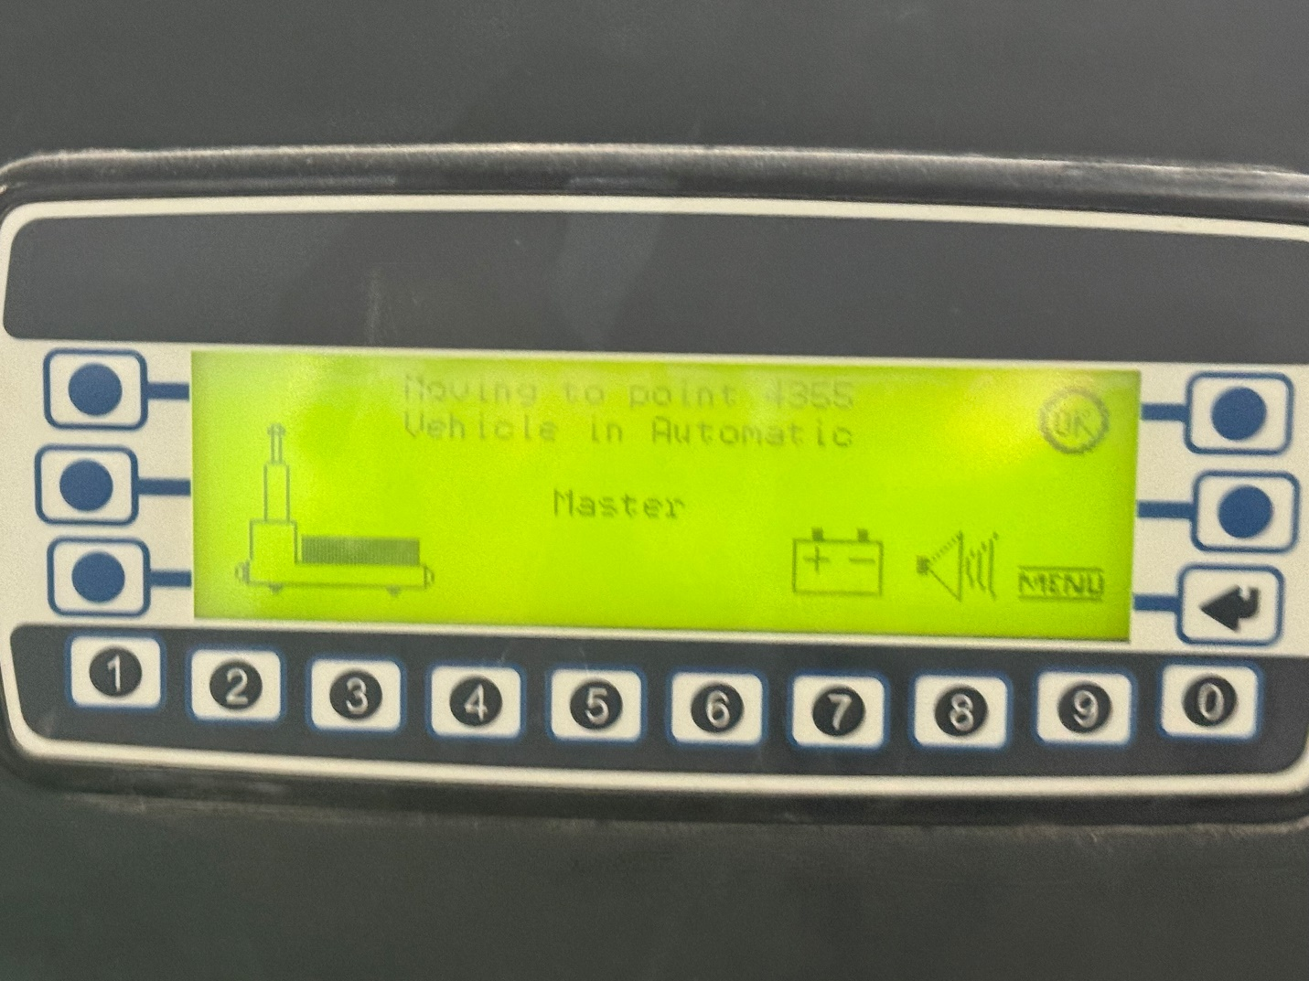
STEP 2: Press and hold the Up/Down Battery Block button until the green indicator light turns off.
Figure 2
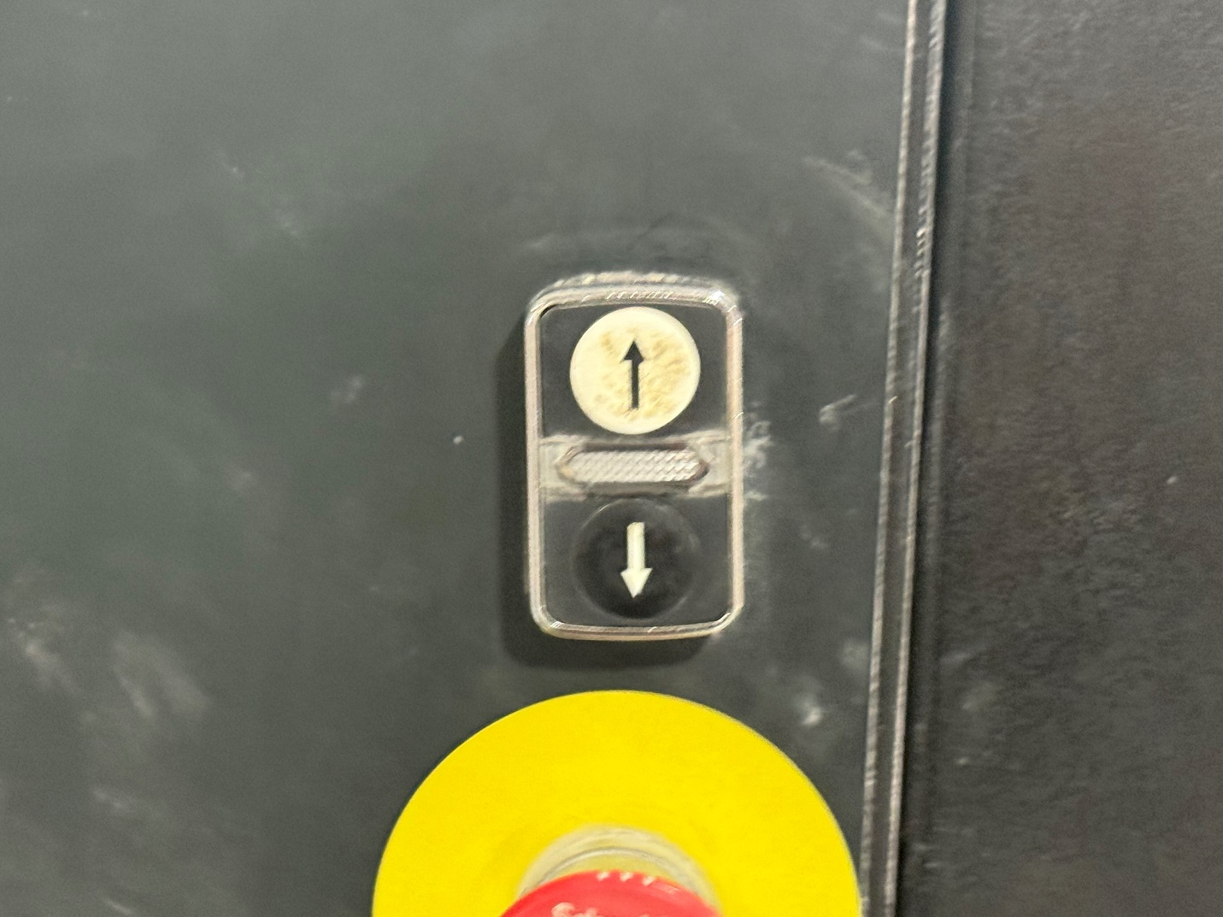
STEP 3: Slide the depleted battery out of the AGV and into the empty bay.
Figure 3
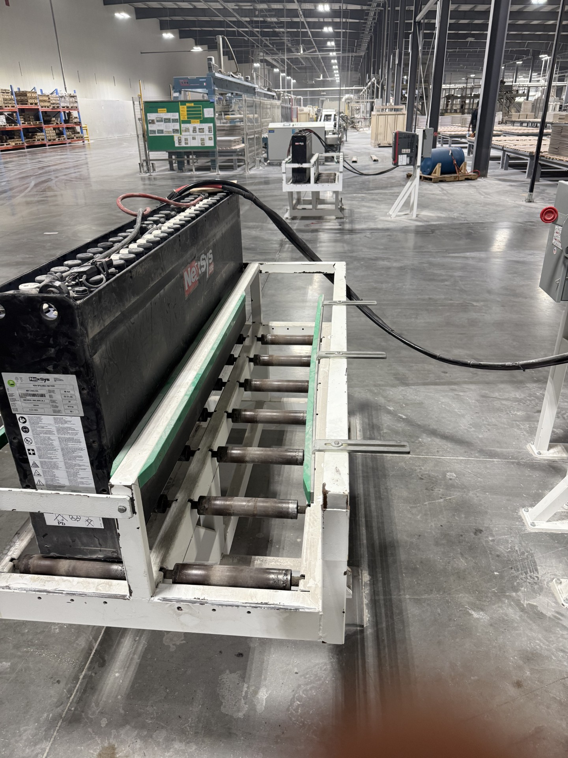
STEP 4: Ensure that all cables are positioned clear of the battery sensor and other moving parts.
STEP 5: Press 7 again on the numerical pad to move to the next battery bay.
STEP 6: Once the AGV is aligned with the correct bay, power off the AGV and swap the connectors to the fully charged battery.
STEP 7: After connecting the new battery:
- Neatly arrange the battery cables on top of the AGV to prevent interference with pinch points.
- Carefully slide the new battery into the AGV.
STEP 8: Power on the AGV and wait for it to complete its startup sequence.
STEP 9: Ensure the battery is not positioned over the battery block and is properly aligned to allow vertical movement.

Figure 9
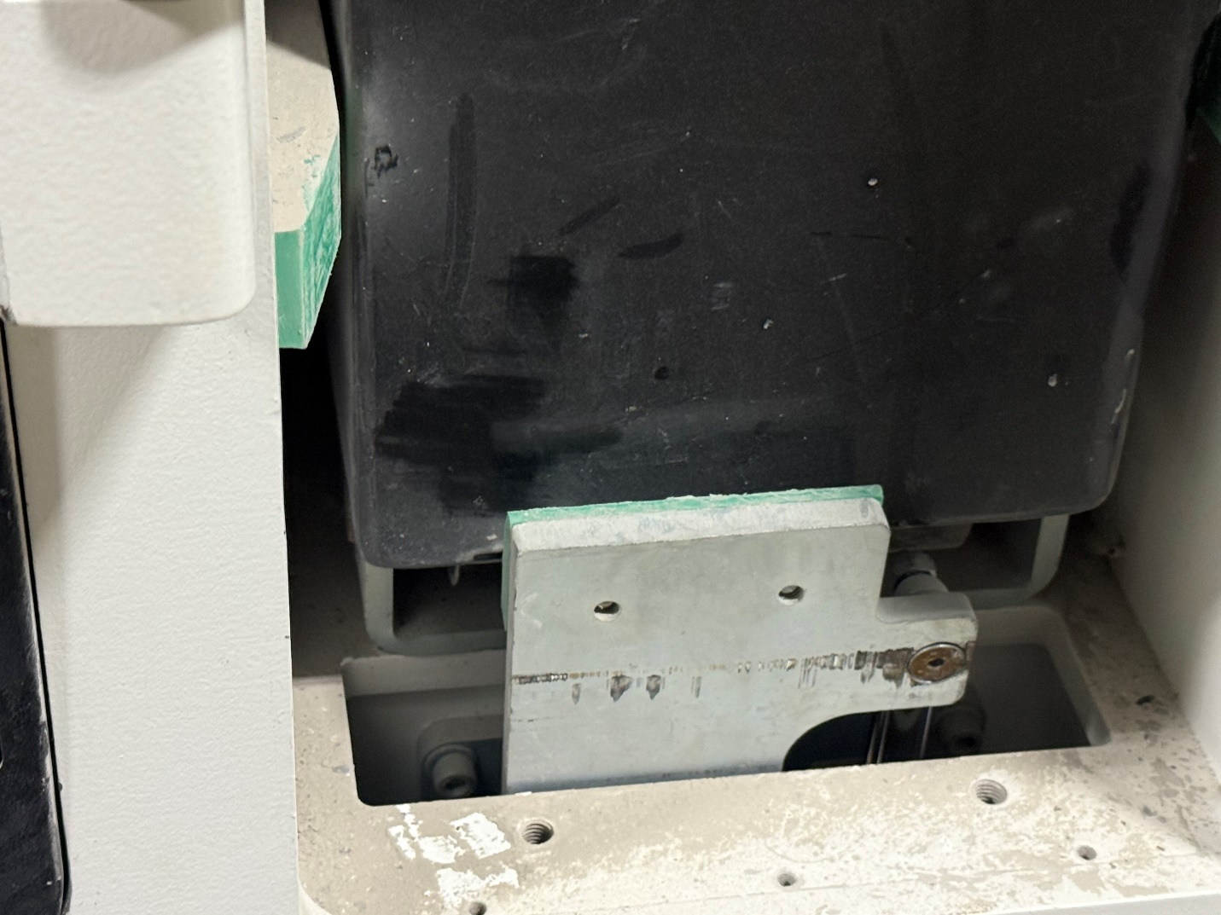
STEP 10: Switch the AGV to Automatic Mode, then:
- Press the blue button, then the green button.
- Use the Up/Down Battery Block button to raise the battery block.
STEP 11: Press the blue button, then the green button again.
Wait for the AGV to reconnect to the system (Master Link Down status should clear).

