**UDOM CYBER CTF2 writeup:**

**$whoami**

**peteChain**

[**click here to go twitte**](https://www.twitter.com/peterChain7)

[click here to visit my github](https://github.com/wolf-chain/)

From the ctf made by **cyrange** and **blackninja23**

I would like to share how I solved these challenges as fast as I done

1.   
................refers to a defender who identifies and patches vulnerabilities into successful breaches.

Since the question requered to measure our googling capacity then it was the issue of talking with google..

I pasted as it is google but found no results

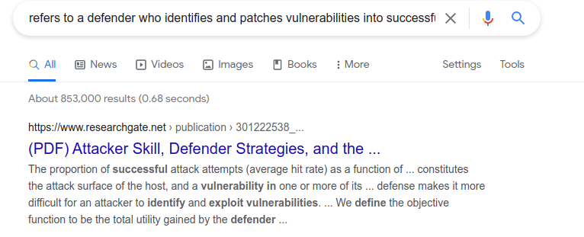

Even if visted the link I din’t get any answer.

**Answer:**

I applied advanced google dorking to solve this, you may check the room in tryhackme platform [click here](https://tryhackme.com/room/googledorking)

So I used Quotation marks to signify  Google that am looking for an exact match

“**refers to a defender who identifies and patches vulnerabilities into successful breaches”**

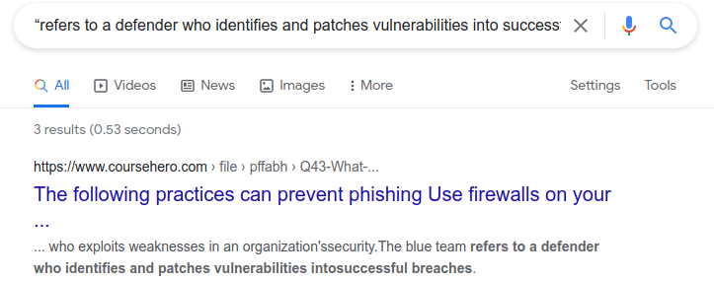**here is our cake**